TITLE OF THE PROJECT
<Font size 18> <1.5 line Spacing>

FIRST REVIEW / SECOND REVIEW REPORT
<Font size 14>

B.Tech Mechanical Engineering /
B.Tech Production and Industrial Engineering

by
<Font size 14> <Italic>

NAME OF THE CANDIDATES (With Reg. No.)
<Font size 16><Bold>

School of Mechanical Engineering
<Font size 14><Bold>

frame-col-ypos:6.976389in; xpos:1.643750in; frame-page-ypos:8.156944in; frame-type:image; frame-page-xpos:2.746528in; ypos:0.169444in; frame-height:1.104167in; frame-pref-page:0; frame-col-xpos:1.643750in; frame-pref-column:0; frame-width:3.337500in

MONTH & YEAR
<Font size 14>(Project Title here)

Project ID | Winter2018/SMEC/B.Tech/Mechanical/
Date of Review
VIT Guide | Prof.
External Guide | Name:  Designation:  Mobile:  Email:  Business Unit:
Project Team Members | Student 1  - Name:  - Reg. No:  - Email:  - Mobile:  Student 2  - Name:  - Reg. No:  - Email:  - Mobile:  Student 3  - Name:  - Reg. No:  - Email:  - Mobile:
Guide’s Remarks
Name and Signature of the guide
Comments of Reviewer(s)

Name and Signature of the Reviewer

Table of Contents

Chapter | Description |  |  | Pg. No.
 | Abstract |  |  | 1
Chapter - I | Introduction and Literature Review
 | 1.1 |  | Introduction | 2
 | 1.2 |  | Literature Review | 3
 | 1.3
 | 1.4
 | 1.5
 | 1.6
 | 1.7
 | 1.8
Chapter - II | Methodology & Experimental Procedure
 | 2.1
Chapter - III | Results and Discussion
 | 3.1 |  | Base Metals
 | 3.2 |  | Microstructure Characterization
 |  | 3.2.1 | Weldments employing Filler A
 |  | 3.2.2. | Weldments employing Filler B
 | 3.3 |  | Microstructure Characterization
 |  | 3.3.1 | Weldments employing Filler A
 |  | 3.3.2 | Weldments employing Filler B
 | 3.4 |  | Work to be done
 |  | 3.4.1 | Gantt Chart
 |  |  |  | 22
 | References |  |  | 23
 | Appendix - A |  |  | 24
 | Appendix - B |  |  | 25

Abstract
Should not exceed 200 words.

Keywords: Welding; Stainless steel; mechanical properties; microstructure; corrosion
[A minimum of 5 keywords to be provided]

CHAPTER –I

INTRODUCTION & LITERATURE REVIEW

Introduction
[Address the importance of the topic in context to national or global scenario]

Literature Review

A study on fatigue crack growth rate for type 304 SS over a temperature range from room to -162 deg C has shown that base metal possesses superior resistance to crack growth relative to weld metals over the entire temperature range [Sadek et al. (2011)]. Another typical application of this material includes its use as bellows used as conduit for liquid fuel and oxidizer in propellant tank of satellite launch vehicle. Chen et al. (2002) found that when Cu–Si enriched type 304 SS (containing 2–2.5 wt.% copper and 1–1.5 wt.% silicon) and a conventional type 304 SS was welded using gas metal arc welding (GMAW), process ductility decreased and ferrite levels increased in both weldments, as the heat input was increased. A comparative study by Yan et al. (2014) on the microstructure and mechanical properties of 304 SS joints by tungsten inert gas (TIG) welding, laser welding and laser-TIG hybrid welding showed that laser welding could give highest tensile strength and smallest dendrite size in all joints whereas TIG welding gave lowest tensile strength and biggest dendrite size. Work reported by Muthupandi et al. (2003) on the effect of weld chemistry and heat input on the structure and properties of duplex stainless steel welds using autogenous-TIG and electron beam welding process shows that chemical composition exerts a greater influence on the ferrite–austenite ratio than the cooling rate. Lee et al. (2011) have reported in their studies on effects of strain rate and failure behaviour of 304L SS SMAW weldments and find that as the strain rate increases, the flow stress increases and the fracture strain decreases.

Knowledge gained from the literature

Gaps in the Literature

From the literature reviewed on the material processing of 304 SS it is observed that scarce works on the effect of heat input on microstructure and tensile properties of gas tungsten arc (GTA) welded have been reported. In view of the fact that arc welding processes like GTAW offer a wide spectrum of thermal energy for joining different thicknesses of steels. Hence it is considered to be important and the present study would be beneficial in gaining an
understanding about the metallurgical aspects that affect the service performance of these welded joints made using different heat input combinations.

Objectives of the Work

[Provide three or four core objectives]

Design Elements included (Atleast one apart from the marked ones)

Engineering Standards* Prototype and Fabrication

Design Analysis* Experimentation

Modelling and Simulation Software Development

Realistic Constraints to be addressed (Atleast two to be selected)
Economic Ethical

Environmental Health and Safety

Social Manufacturability

Political Sustainability

CHAPTER –II

METHODOLOGY AND EXPERIMENTAL PROCEDURE
2.1 Methodology
Begin with the development of a project plan, whereby students define end-user needs, client needs, design objectives and constraints, and metrics for success. Proceeding through concept generation and selection, and then through the system- and component-level design stages, each team ultimately produces a working prototype that is tested and refined to meet the project objectives.
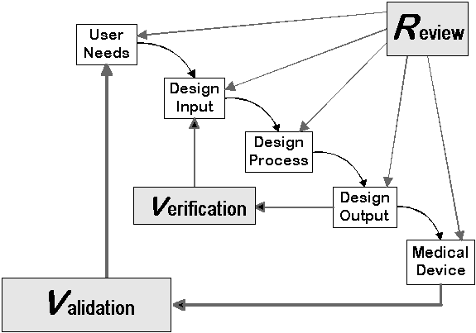
frame-pref-page:6; frame-width:5.000000in; frame-height:3.509028in; xpos:0.116667in; frame-type:image; ypos:0.007692in

2.2 Experimental Procedure

CHAPTER –III

RESULTS AND DISCUSSION

PHASE I

3.1 Base Metal and Welding

3.2 Microstructure Characterization

3.2.1 Weldments employing Filler A

3.2.2 Weldments employing Filler B

3.3 Mechanical Characterization

3.3.1 Weldments employing Filler A

3.3.2 Weldments employing Filler B

3.4 Work to be done

3.5 Gantt chart

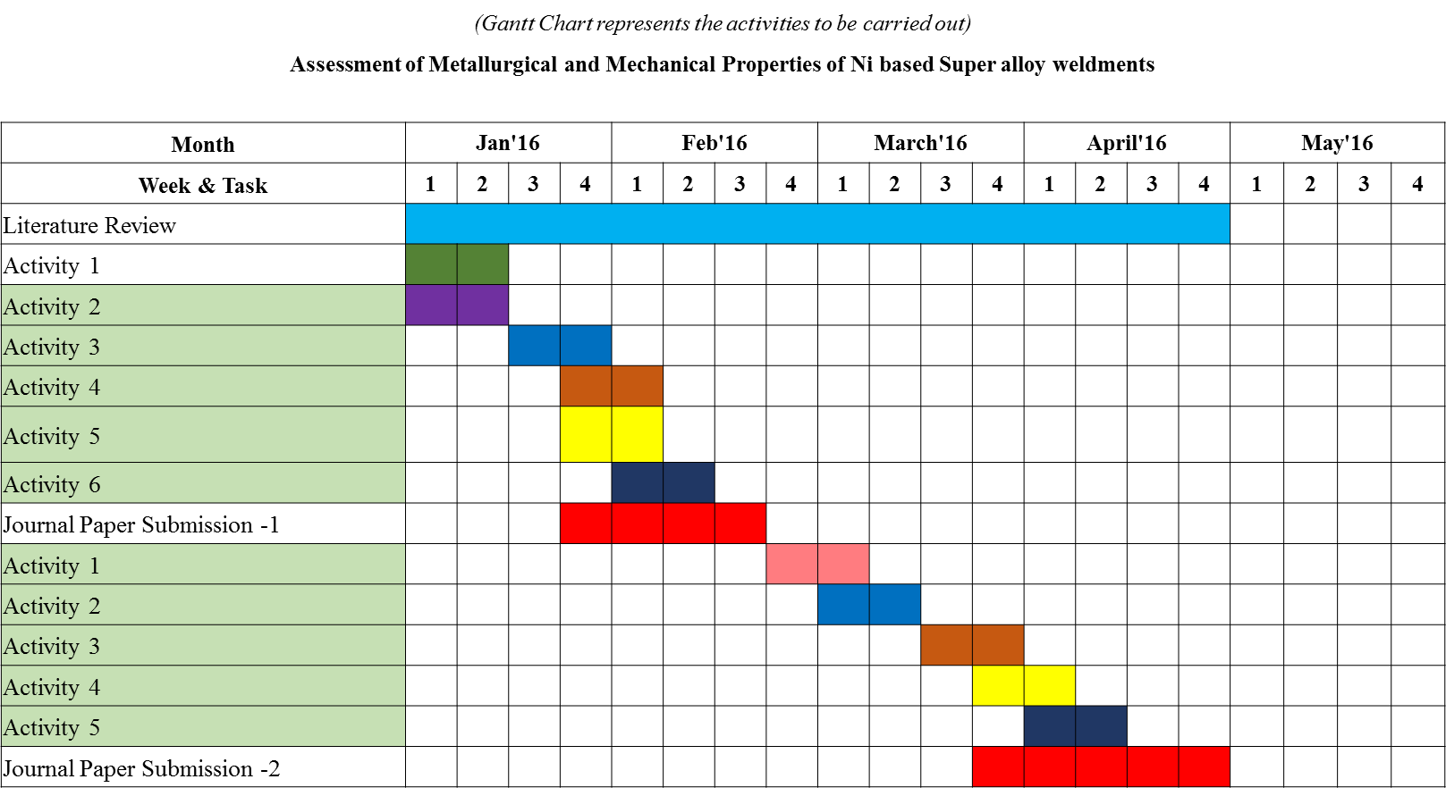
frame-pref-page:8; frame-width:5.905512in; frame-height:3.253832in; xpos:0.337209in; frame-type:image; ypos:0.162161in

References
[To be arranged alphabetically]

Baek Jong-Hyun, Kim Young-Pyo, Kim Woo-Sik, Young-Tai Kho. Fracture toughness and fatigue crack growth properties of the base metal and weld metal of a type 304 stainless steel pipeline for LNG transmission. Int J Press Vessels Pip 2001;78:351–7.

Jha Abhay K, Diwaker V, Sreekumar K. Metallurgical investigation on stainless steel bellows used in satellite launch vehicle. Eng Fail Anal 2006;13:1437–47Chen TF, Chen YR, Wu W. Properties of Cu–Si enriched type 304 stainless steel welds. Sci Technol Weld Joining 1998; 3:75–9.

Muthupandi V, Srinivasan P Bala, Seshadri SK, Sundaresan S. Effect of weld metal chemistry and heat input on the structure and properties of duplex stainless steel welds. Mater Sci Eng, A 2003;358:9–16.

Yan Jun, Gao Ming, Zeng Xiaoyan. Study on microstructure and mechanical properties of 304 stainless steel joints by TIG, laser and laser-TIG hybrid welding. Opt Lasers Eng 2010; 48:512–7.

