**Topic: Please Choose one of the topics of the ICRAEEE 2025 conference**

**Paper title**

First author1*, Second author2, ……….. and Last author3

*1Affiliation*

*2Affiliation*

*3Affiliation*

**Abstract : (The abstract must not exceed 250 words)**

This study investigates the impact of an external magnetic field on the performance and electronic transport properties of two-dimensional Metal-Oxide-Semiconductor Field-Effect Transistors (2D MOSFETs). By incorporating a perpendicular magnetic field during device operation, we explore its effects on carrier mobility, threshold voltage, and current-voltage characteristics. The analysis is conducted using both experimental data and theoretical modeling to understand the interplay between the magnetic field and quantum confinement in the 2D channel. Results indicate significant modulation of electronic properties, suggesting potential applications in spintronic devices and magnetic sensors. This research provides valuable insights for the design of magnetic field-tunable 2D semiconductor devices.

**Keywords: (Five keywords maximum)**

2D MOSFET, electronic transport, threshold voltage, spintronics, magnetic sensors.

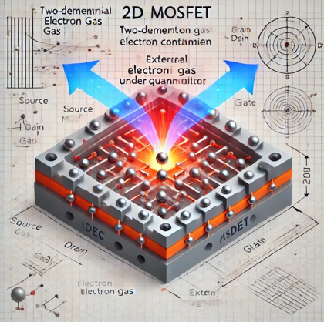

**Fig. 1:** Visualization of Magnetic Field Effects on Electron Transport in a 2D MOSFET

**References:**

1. M.V. Fischetti et al. (1996). Monte Carlo simulation of transport in technologically significant semiconductors of the diamond and zinc-blende structures—Part I: Homogeneous transport. IEEE Transactions on Electron Devices, **38**(3), 650–660.
2. S. Das Sarma and E. H. Hwang (2004). Transport in two-dimensional graphene layers: Theoretical understanding of resistance as a function of temperature and carrier density. Physical Review B, **69**(19), 195305.
3. T. Ando et al. (1982). Electronic properties of two-dimensional systems. *Reviews of Modern Physics*, **54**(2), 437–672.

|  |  |
| --- | --- |
| 1st Author Biography | **First Author**, a Ph.D. student at Chouaib Doukkali University, specializes in semiconductor physics and nanoelectronics. His research focuses on optimizing 2D MOSFET devices under external influences like magnetic fields. With expertise in electronic transport and device modeling, he actively contributes to publications and conferences, aiming to advance the understanding and applications of 2D semiconductor technologies**.**  **\*Corresponding author:** [email**@ucd.ac.ma**](mailto:email@ucd.ac.ma) |
| dummy |