**Joint specifications Help (read till the end) :**

**Task :** Cad a model or find a ready-made CAD of the following piece for this specific servo : MG996R High Torque

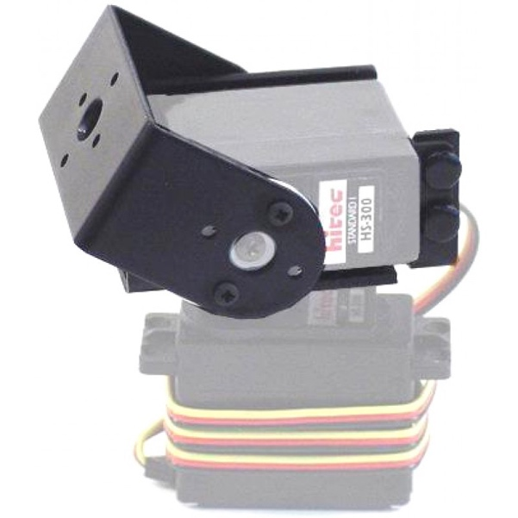

**Dimensions of MG996R High Torque (in cm) :**

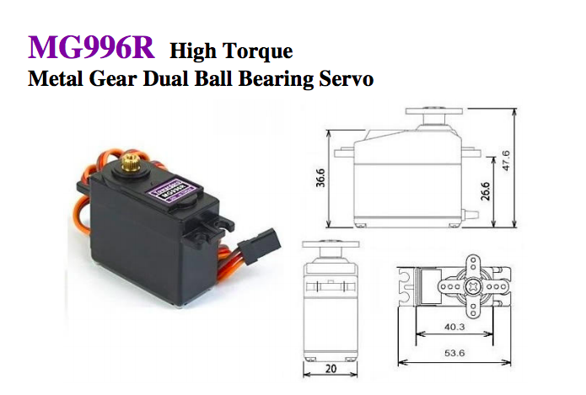

**PS** : if you find a CAD model of the following piece or **something similar** to it, use it instead of Cading the whole thing. I suggest you start by looking online for this piece ( 90 % you’ll find it ).

If you couldn’t find any already made CAD model, use the following pdf file to have a more detailed idea of what the bracket looks like:

<https://www.robotshop.com/media/files/pdf/lynxmotion-pan-and-tilt-assembly.pdf>

**Useful links I found that can lead to the CAD model of the piece:**

<https://www.robotshop.com/en/direct-drive-pan-tilt.html>

**key words you can use for the search:**

pan & tilt servo mount/bracket

**Also check out the following video for another servo pan & tilt bracket :**

<https://www.youtube.com/watch?v=nbJNLVBo_g4&feature=youtu.be>

if you can find this version as a CAD model, it would be even better.

Finally

**Servo specifications :**

<https://www.electronicoscaldas.com/datasheet/MG996R_Tower-Pro.pdf>