**“TO INVESTIGATE THE THERMOLUMINESCENT PROPERTIES OF SYNTHESIZED NANOPHOSPHORS FOR USE IN RADIATION DOSIMETRY”**

*A dissertation project report by:*

***Meemik Roy***

3rd Year, B.Sc. (Hons) Physics

Sri Venkateswara College

*Under the supervision of*

***Prof. Anant Pandey***

Professor, Department of Physics

Sri Venkateswara College

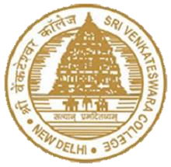

***Sri Venkateswara College***

***University of Delhi***

***Dhaula Kuan***

***New Delhi -110021***

**Meemik Roy**

(Student)

**Dr. Anant Pandey**

(Supervisor) 