**EXP NO:** **1**

**Web Page Development with Map Embedding, Hotspots, Frames, Links, and CSS Styling Techniques**

**AIM:**

To create web pages that demonstrate embedding a map with hotspots, frames, and links, and to apply styling using embedded, external, and inline CSS.

**CODE:**

**hotspot.html**

<!DOCTYPE html>

<html>

 <head>

    <title>Hotspot</title>

    <!-- Link to the external CSS file -->

    <link rel="stylesheet" type="text/css" href="style1.css">

    <style>

        h1 {

            text-align: center;

            color: #333;

            margin-top: 20px;

        }

    </style>

 </head>

 <body>

    <!-- Inline style for the image itself (optional to override or enhance external styles) -->

    <h1>Interactive Map of India</h1>

    <img src="india map.jpg" usemap="#indiamap" width="900" height="720" alt="Map of India">

    <map name="indiamap">

        <area shape="rect" coords="324,578,407,535" alt="Tamil Nadu" href="https://en.wikipedia.org/wiki/Tamil_Nadu">

        <area shape="rect" coords="343,655,398,599" alt="Tamil Nadu" href="https://en.wikipedia.org/wiki/Tamil_Nadu">

        <area shape="rect" coords="407,538,395,602" alt="Tamil Nadu" href="https://en.wikipedia.org/wiki/Tamil_Nadu">

        <area shape="rect" coords="346,653,397,605" alt="Tamil Nadu" href="https://en.wikipedia.org/wiki/Tamil_Nadu">

        <area shape="rect" coords="406,537,324,579" alt="Tamil Nadu" href="https://en.wikipedia.org/wiki/Tamil_Nadu">

    </map>

 </body>

</html>

**style1.css**

@charset "ISO-8859-1";

body {

    font-family: Arial, sans-serif;

    margin: 0;

    padding: 0;

    background-color: #f4f4f4;

}

img {

    display: block;

    margin: 0 auto;

    border-radius: 8px;

    box-shadow: 0 4px 6px rgba(0, 0, 0, 0.1);

}

/* Styling for the map areas */

area {

    outline: none;

    border: none;

    transition: transform 0.3s ease-in-out;

}

area:hover {

    transform: scale(1.1);

}

**OUTPUT:**

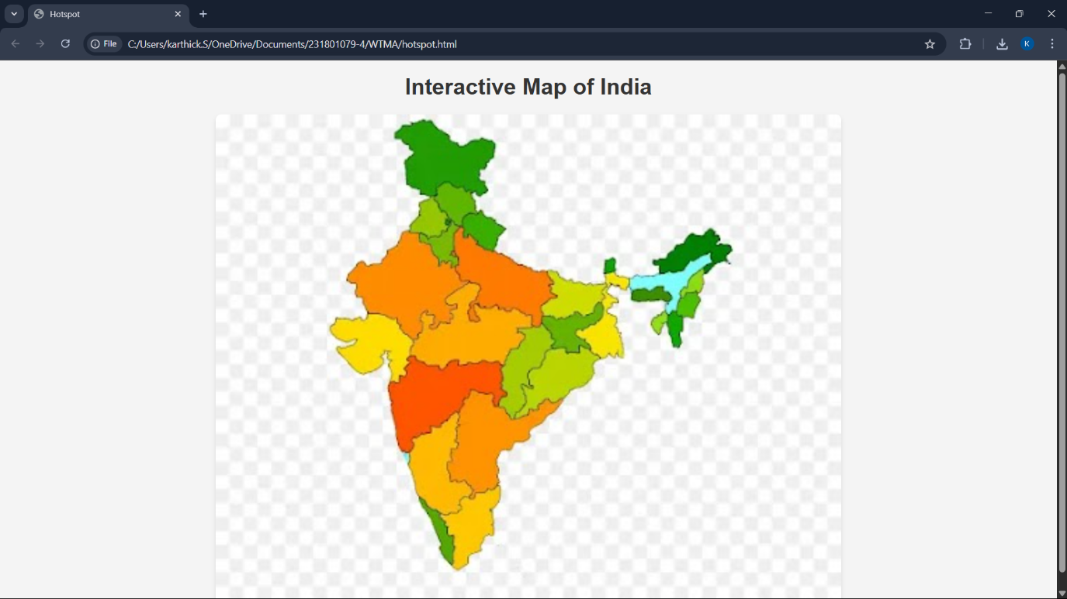

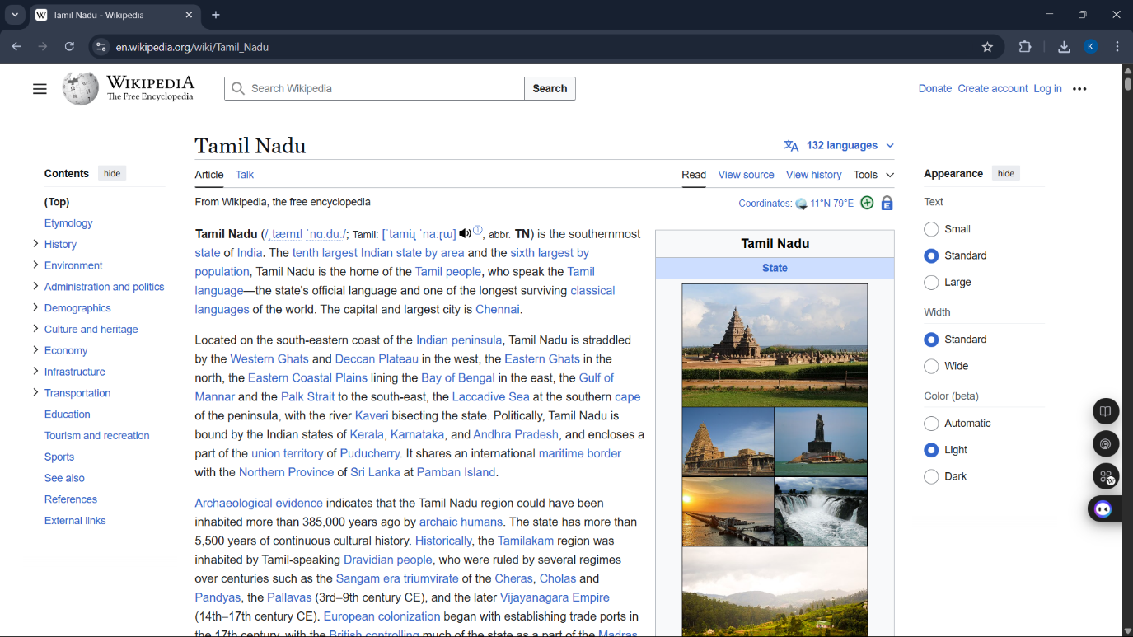

**RESULT:**

Thus, web pages were successfully created with an embedded map, hotspots, frames, and links, and styling was applied using embedded, external, and inline CSS.