|  |  |
| --- | --- |
| **EXP NO:** **1** | **Web Page Development with Map Embedding, Hotspots,**  **Frames, Links, and CSS Styling Techniques** |

**AIM:**

To create web pages that demonstrate embedding a map with hotspots, frames, and links, and to apply styling using embedded, external, and inline CSS.

**CODE:**

**hotspot.html**

<!DOCTYPE html>

<html>

<head>

<title>Hotspot</title>

<!-- Link to the external CSS file -->

<link rel="stylesheet" type="text/css" href="style1.css">

<style>

h1 { text-align: center; color: #333;

margin-top: 20px;

}

</style>

</head>

<body>

<!-- Inline style for the image itself (optional to override or enhance external styles) -->

<h1>Interactive Map of India</h1>

<img src="india map.jpg" usemap="#indiamap" width="900" height="720" alt="Map of India">

<map name="indiamap">

<area shape="rect" coords="324,578,407,535" alt="Tamil Nadu" href="https://en.wikipedia.org/wiki/Tamil_Nadu">

<area shape="rect" coords="343,655,398,599" alt="Tamil Nadu" href="https://en.wikipedia.org/wiki/Tamil_Nadu">

<area shape="rect" coords="407,538,395,602" alt="Tamil Nadu" href="https://en.wikipedia.org/wiki/Tamil_Nadu">

<area shape="rect" coords="346,653,397,605" alt="Tamil Nadu" href="https://en.wikipedia.org/wiki/Tamil_Nadu">

<area shape="rect" coords="406,537,324,579" alt="Tamil Nadu" href="https://en.wikipedia.org/wiki/Tamil_Nadu">

</map>

</body>

</html>

**style1.css**

@charset "ISO-8859-1";

body {

font-family: Arial, sans-serif; margin: 0; padding: 0;

background-color: #f4f4f4;

}

img { display: block; margin: 0 auto; border-radius: 8px;

box-shadow: 0 4px 6px rgba(0, 0, 0, 0.1);

}

/* Styling for the map areas */ area { outline: none; border: none;

transition: transform 0.3s ease-in-out;

}

area:hover {

transform: scale(1.1);

}

**OUTPUT:**

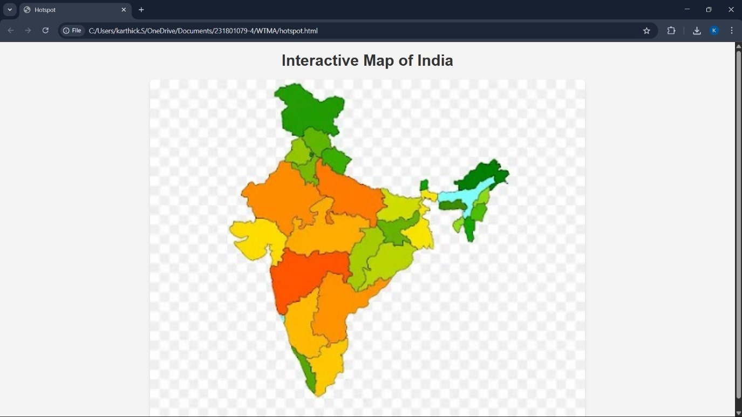

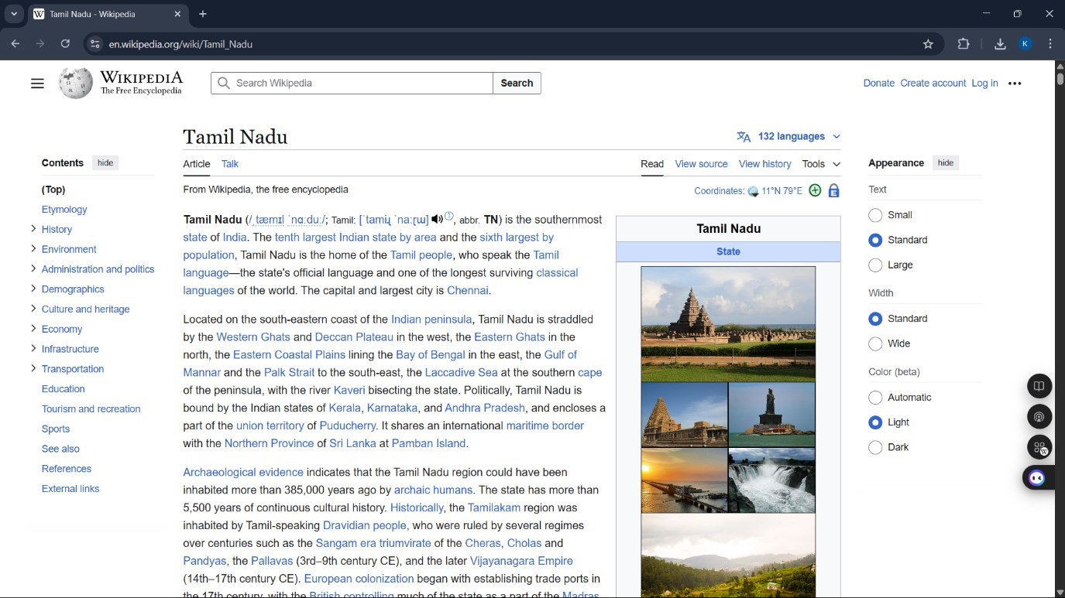

**RESULT:**

Thus, web pages were successfully created with an embedded map, hotspots, frames, and links, and styling was applied using embedded, external, and inline CSS.