IDENTIFYING AND CHARACTERISING PUTATIVE HGT INSERTS

1. ALIGNMENT

Step 1.1.
Chopping up Blattabacterium genomes into 150 nucleotide chunks. 150 bp was chosen as this a conservative way of ensuring that only unique alignments occur.

I did this with the following script I made:
1.1.chopping_genome.sh

Confirming that we should use all ~70 Blattabacterium genomes published in Beasley-Hall et al. (2021) and Bourguingnon et al. (2020)?

Yes, this looks to be the most comprehensive approach.

Step 1.2.
Aligning chopped up Blattabacterium genomes to all of the available cockroach/termite genomes (and multiple versions of a genome where appropriate) using bwa mem:
- Panesthia cribrata Panesthia-cribrata_genome-assembly.fasta
  - from Proc B paper
- Neogeoscapheus hanni Neogeoscapheus-hanni_genome-assembly.fasta
  - from Proc B paper
- Geoscapheus dilatatus Geoscapheus-dilatatus_genome-assembly.fasta
  - from Proc B paper
- Panesthia sloanei Z1_flye_polished_purged_filtered.fasta
  - New genome
- Macropanesthia lithgowae Z4_flye-assembly_polished-it2_filtered.fasta
  - New genome
- Panesthia tryoni tryoni Z5_flye-assembly_polished-it2_filtered.fasta
  - New genome
- Panesthia gigantea Z010_flye_polished_purged_filtered.fasta
  - New genome
- Panesthia_tryoni_tegminifera Z011_flye_polished_purged_filtered.fasta
  - New genome
- Panesthia tryoni tryoni (Eungella) Z012_flye_polished_purged_filtered.fasta
  - New genome
- Neogeoscapheus dahmsi Z014_flye_polished_purged_filtered.fasta
  - New genome
- Panesthia lata M1_flye_polished_purged_filtered.fasta
  - New genome
- Periplaneta americana GCA_025594305.2
  - from NCBI
- Periplaneta americana v2 Periplaneta_americana.genome.fasta
  - from InsectBase
- Periplaneta americana v3 CNA0019281
  - from CNSA (https://db.cngb.org/cnsa/)
- Periplaneta americana v4 PRJNA1098420
  - Raw pacbio HiFi data reassembled by us (genome size = 3.2 Gb, coverage = 50, --no-phase)
- Blattella germanica Blattella_germanica.genome.fasta
  - from InsectBase
- Blattella germanica v2 GCA_000762945.2_Bger_2.0_genomic.fasta
  - From NCBI – NCBI noted that there was contamination
- Zootermopsis nevadensis Zootermopsis_nevadensis.genome.fasta
  - from InsectBase
- Coptotermes formosanus Coptotermes_formosanus.genome.fasta
  - from InsectBase
- Cryptotermes secundus Cryptotermes_secundus.genome.fasta
  - from InsectBase
- Tenodera sinensis GCA_030765045.1 (from NCBI)
  - No annotation available.

Confirming that we should use all of these genomes, even though sampling is quite biased? Are we also using the new termite genomes from your colleagues?

Yes, might as well use whatever is available. I’ve just written to Kiyoto Maekawa about the new termite genomes.

2. CHARACTERISING INSERTS

Step 2.1.
Characterising the putative HGT regions based on where the Blattabacterium chunks aligned.
- The region was elongated where Blattabacterium chunks overlapped, or when there was a gap between neighbouring mapped chunks <200 bp.
- Putative inserts <75 bp were removed (this would happen if less than half of one 150 bp chunk aligned)
I did this with the following script I made:
2.1.extracting-bed.sh

Do the thresholds above (‘200’ and ‘75’) seem reasonable to you?

200 for the elongation sounds good. The lower number is a bit harder to decide upon. 75 seems reasonable, although I guess we could go as low as maybe 50, given that the chances of two sequences being highly similar at 50 bp are extremely low.

Step 2.2.
The genome annotation (when available) was used to annotate the chunks as intergenic or within a gene (and what feature of the gene).

I did this with the following script I made:
2.2.annotating-bed.sh

Step 2.3.
Filtering potential contaminant Blattabacterium contigs that appear as inserts. This is done by comparing the length of the HGT insert and the contig which it sits on. We can remove the insert (and contig) if the insert covers a large proportion (e.g. >40%) of the contig.

Jil and Oscar are working on this. Jil has already made a pipeline and tested it on one genome – only 2 inserts (of >1000) were removed, and it was quite obvious that these were contaminants. I think once they do this on all genomes an appropriate threshold will become obvious.

Nice!

Step 2.4.
Some HGT inserts might be the result of a real duplication event, and some might have ‘jumped’ around the genome with a transposon. Further, given that the most common assembly error is false duplication, some duplicate inserts may be artefacts.

We need to identify and filter duplicated HGT inserts to correctly count inserts per genome and to characterise their age etc. To do this, for each genome, I first extract each insert plus a 300 bp flanking region on either side. I then BLAST each insert (plus flanking region) against all other inserts (plus flanking regions) in the genome. I ignore the top hit, as this will be the insert that I am BLASTing, and extract the second hit (if there is one).

Interpretation:
- Very high hits = possibly false duplication. Note, taking the flanking region will help to differentiate whether they are real inserts or false duplicates (if they are false duplicates, I expect the whole region to be very similar).
- Relatively high hits = real duplication
- No hits = no duplication

Duplicates should then be removed from the putative inserts file so we can count them correctly and age them. To classify as a duplicate insert, we could use BLAST thresholds >70% identity and >70% query coverage. Then for each set of duplicates, we can just select one randomly to carry on to subsequent analysis.

This can be done with the following script I made:
2.4.identifying-duplicates.sh

Does this sound like a reasonable approach?
What do you think about the thresholds? Does 300 bp flanking on either side sound okay? Do you think a hit should be considered a duplicate if it is >70% identity and >70% query coverage? Do you think we can just pull out one insert of a set of duplicates for subsequent analysis?

Yes for the first four questions. For the fifth, we might want to pull out more than one hit, because we might discover an insert that is present across all Panesthiinae/Geoscapheinae species (or perhaps across all cockroaches!). If there are any inserts that are ultra-conservative, I guess they should show up in all analyses as having several hits. Maybe we could use “number of hits in other species” to determine how old they are?

After this section, we will have output files that can be used to count the putative inserts per genome, and identify where in the genome they occur (e.g. intergenic, exon etc.).

3. DATING INSERTS

Step 3.1.
First, the filtered inserts from section 2 are extracted from the genomes (as a fasta file). A prefix of the relevant species name is added before all of the insert names.

I did this with the following script I made:
3.1.extracting-inserts.sh

Step 3.2.
I then investigate whether the insert is similar to the Blattabacterium relevant to the species (e.g. if analysing an insert from P. cribrata, the insert will be compared to the P. cribrata Blattabacterium strain) – if it’s very similar, it’s likely a recent HGT event. I also investigate whether it’s similar to other cockroach HGT inserts – if it’s very similar to an insert in a different species, it’s likely an ancestral insert.

As an example, the pipeline to do this for P. cribrata could be as follows:
- BLAST each P. cribrata insert against the P. cribrata Blattabacterium strain. Only keep the top hit.
- BLAST each P. cribrata insert against all other cockroach inserts (excluding P. cribrata inserts). Only keep the top hit.

These two BLAST result files are inputs for the next step.

I did this with the following script I made:
3.2.BLAST-inserts_blatta-vs-host.sh

Step 3.3.
I then
First, BLAST hits for the two output files from step 3.2 are filtered by query coverage. Hits with query coverage <70% are set to NA. I then combine both files, and set the two % identity alongside each other for each insert. I then calculate the difference between the two % identity:
“Blattabacterium BLAST % identity” - “insert database BLAST % identity”

A negative value (i.e. low Blattabacterium BLAST hit and a high insert database BLAST hit) indicates an ancestral HGT insert, and a positive value indicates a recent HGT insert. Where BLAST hits are similar we can’t infer the age of the insert.

I tried this pipeline with some example sequences. I was analysing P. cribrata inserts, and the insert database (for “all other cockroach inserts”) only contained Macropanesthia lithgowae inserts and N. hanni inserts (so it was very limited!). I also didn’t used the P. cribrata specific Blattabacterium genome for the first BLAST (as I didn’t have it on hand) – instead I used the P. sloanei Blattabactrium genome. So take the plot below with a grain of salt!
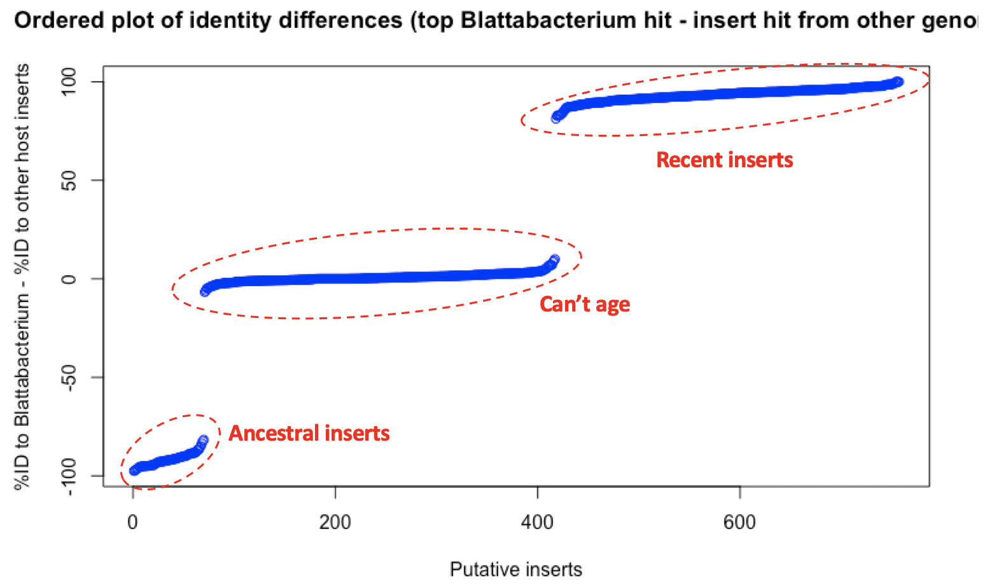

I did this with the following R pipeline I made:
3.3.parse-BLAST_blatta-vs-host.R

Does this sound like a reasonable approach?
Do you filtering based on query coverage <70% is reasonable? I used this threshold to be consistent with step 2.4.
Do you think that for the ancestral inserts we could could go further any be specific about the minimum based on the BLAST top hit of the insert database (i.e. all cockroach inserts) – for example, if BLASTing a P. cribrata insert, and the top hit is N. hanni, the minimum age of the insert is the diverge date of P. cribrata and N. hanni. Is this too much of a stretch? We also might want to consider more than just the top hit for this (as it might hit to numerous other cockroach species’ inserts if it’s ancestral).

Yes to first two questions. For the 3rd, if an insert is ancestral, we’d expect it to be in quite a few of the genomes. It would be odd to see an insert only in P. cribrata and N. hanni, but none of the others, but I guess it is possible.

After this section, we will have output files that can be used to infer the age of the inserts. Several other steps

OTHER
Other key things that need to be done:
- PCRs for a batch of inserts
- Creating a pipeline to count the number of long reads that clearly span the insert with lots of flanking region (i.e. the insert sits within a raw read). This is equivalent to checking the alignments and observing that some truncated reads are clearly of Blattabacterium origin, while others span the insert and beyond into the cockroach contig (with a different haplotype). However, we need some way of automating this instead of visually checking all of the insert alignments.
- Re-assembling some P. americana/B. germanica to confirm they do indeed have very few inserts compared to Blaberids.

Do you agree with the above steps? The first two points might have to be done by someone else given my limited time. Note, for point 2, part of the main pipeline is an alignment file, so half of this is done already.
I am currently re-assembling a P. americana with PacBio reads.

Sounds good.

Other thoughts:
It would be good to look at whether the origin of the inserts is from particular regions of the Blattabacterium genome, or whether they come from any area of genome, randomly.

