**MODULE 4**

What are the main factors that can affect PPC bidding?

ANSWER:

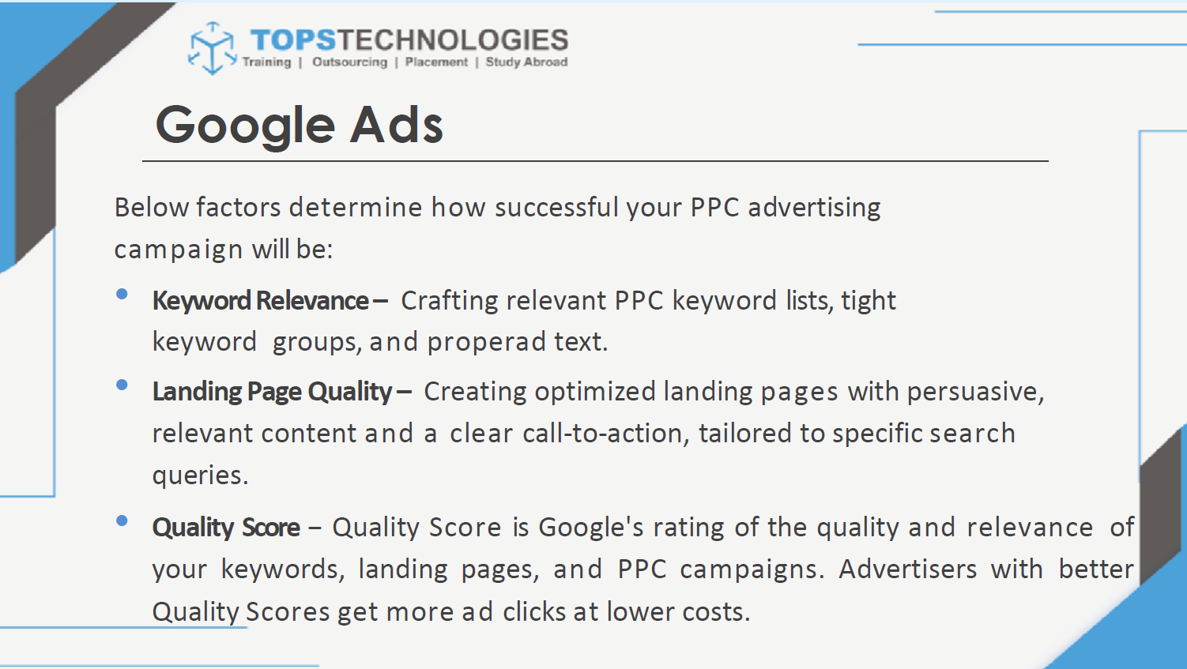

• **Your Maximum Bid / Bid Strategy**

* How much you’re willing to pay per click (or per conversion, depending on strategy) directly affects whether you win auctions.
* Choice of bidding strategy (manual vs automated like Target CPA, Target ROAS, or Maximize Conversions) impacts how the system adjusts your bids. [Ginee+4Raznameh+4PPC Co.+4](https://raznameh.org/everything-about-pay-per-click-ppc-advertising-part-1/?utm_source=chatgpt.com)

• **Quality Score (or Equivalent Metrics)**  
This is a measure of how relevant and good your ad & landing page are. The better the Quality Score: often the less you need to bid to get a high ad position. Components include:

* Expected CTR (click-through rate) [Straight North+1](https://www.straightnorth.com/blog/understanding-the-ppc-bidding-process/?utm_source=chatgpt.com)
* Ad relevance (how well your ad copy matches the keyword) [Wikipedia+2Straight North+2](https://en.wikipedia.org/wiki/Quality_Score?utm_source=chatgpt.com)
* Landing page quality & user experience (relevance, speed, ease of navigation) [Straight North+2Wikipedia+2](https://www.straightnorth.com/blog/understanding-the-ppc-bidding-process/?utm_source=chatgpt.com)
* Historical performance metrics (how your ads & keywords have done in the past) [Raznameh+1](https://raznameh.org/everything-about-pay-per-click-ppc-advertising-part-1/?utm_source=chatgpt.com)

• **Competition / Auction Dynamics**

* More advertisers bidding on the same keywords pushes up the cost per click. [PPC Panos+2Ginee+2](https://ppcpanos.com/what-increases-google-ads-costs/?utm_source=chatgpt.com)
* Changes in competitor behavior over time (new entrants, existing ones increasing bids, etc.) can change how much you need to bid to stay competitive. [REFUGE Marketing & Consulting+3Ginee+3PPC Panos+3](https://ginee.com/my/insights/ppc-strategy/?utm_source=chatgpt.com)

• **Keyword Selection & Match Types**

* Broad vs exact vs phrase match. Broader matches bring more traffic but may bring less precise or lower-intent clicks (hence more wasteful spend). [Straight North+1](https://www.straightnorth.com/blog/understanding-the-ppc-bidding-process/?utm_source=chatgpt.com)
* Choosing high-demand, high-competition keywords tends to cost more. Long-tail or less competitive keywords often cost less but may have lower volume. [PPC Panos+1](https://ppcpanos.com/what-increases-google-ads-costs/?utm_source=chatgpt.com)

• **Budget Constraints / Daily Limits**

* If your daily budget is too low relative to your competition and keyword bids, your ads might not show as often or in the best positions. [Straight North+1](https://www.straightnorth.com/blog/understanding-the-ppc-bidding-process/?utm_source=chatgpt.com)
* Shared budgets across campaigns can dilute performance.

• **Ad Relevance & Ad Copy / Creatives**

* Well-written ads with clear, relevant messaging often get better CTR, which helps Quality Score and thus lower required bids. [Rosh Digital+2Straight North+2](https://www.roshdigital.co.il/factors-influencing-the-performance-of-ppc-advertising-companies/?utm_source=chatgpt.com)
* Use of ad extensions (site links, callouts, etc.) improves visibility and can boost performance without directly raising the bid. [Straight North+1](https://www.straightnorth.com/blog/understanding-the-ppc-bidding-process/?utm_source=chatgpt.com)

• **Landing Page Experience**

* Fast loading, relevant content, mobile friendly, good user experience helps conversion rates and affects Quality Score. If conversions are poor, you might need to increase bids to compensate, or fix the landing page. [Straight North+1](https://www.straightnorth.com/blog/understanding-the-ppc-bidding-process/?utm_source=chatgpt.com)

• **Targeting Settings**

* Geographic targeting: competition, cost, click-prices differ by location. [Invoxico Technologies+1](https://www.invoxico.com/faq/what-factors-influence-the-cost-of-ppc-campaigns/?utm_source=chatgpt.com)
* Device targeting (desktop vs mobile) often has different performance / click costs.
* Time / day scheduling: certain hours or days perform better; you can adjust bids up or down accordingly. [Yell Business+1](https://business.yell.com/insights/ppc/4-ppc-factors-can-influence-bid-modifiers/?utm_source=chatgpt.com)
* Audience targeting or remarketing: showing ads to high-intent or returning users may justify higher bids. [Yell Business+1](https://business.yell.com/insights/ppc/4-ppc-factors-can-influence-bid-modifiers/?utm_source=chatgpt.com)

• **Seasonality / Demand Fluctuations / External Factors**

* For many industries demand is variable (holidays, seasons, events). During peak times, bids often increase as more advertisers compete. [Ginee+2PPC Panos+2](https://ginee.com/my/insights/ppc-strategy/?utm_source=chatgpt.com)
* External socio-economic, market, legal, regulatory changes can cause changes in cost and bidding behavior. [ppc.org+1](https://www.ppc.org/external-factors-that-affect-ppc-campaigns/?utm_source=chatgpt.com)

• **Platform / Auction Rules / Features**

* The ad network’s own algorithmic rules (how it uses bid, quality, ad formats) affect bidding. Ad Rank (Google) is calculated from bid × Quality Score (plus other factors). [Raznameh+1](https://raznameh.org/everything-about-pay-per-click-ppc-advertising-part-1/?utm_source=chatgpt.com)
* Introduction of new ad formats or features (e.g. extensions) can change how auctions work. [PPC Panos+1](https://ppcpanos.com/what-increases-google-ads-costs/?utm_source=chatgpt.com)

• **Conversion Rates & ROI Goals**

* If your goal is conversions (leads, sales etc.), you need to consider how much you’re willing to pay per conversion. Sometimes it's worth a higher bid if conversion rate is good. Poor conversion rate means you’ll need to spend more (or improve the campaign) to meet ROI goals.

QUESTION-2:

How does a search engine calculate actual CPC?

ANSWER:

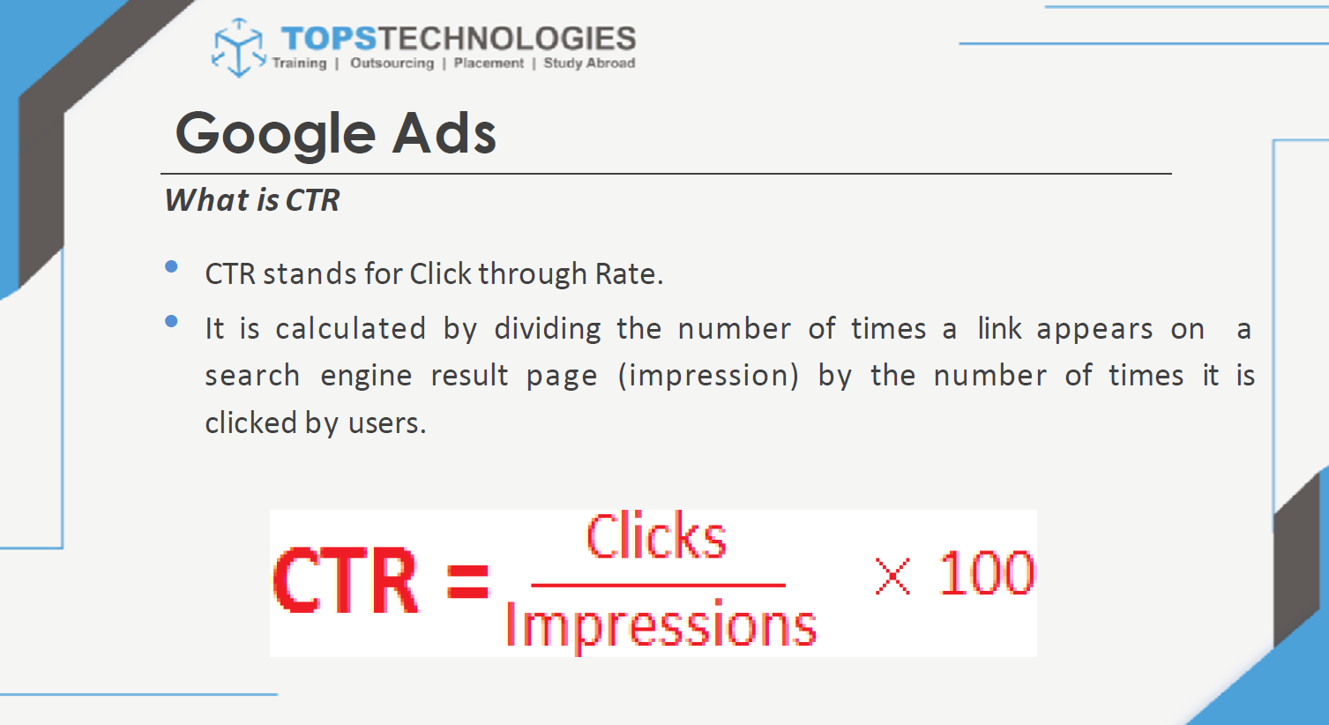

Search engines (Google, Bing, etc.) don’t simply charge you your max bid. Instead, they run an **auction** and you pay just enough to beat the advertiser ranked below you.

The simplified formula is:

Actual CPC=Ad Rank of the competitor below youYour Quality Score+0.01\textbf{Actual CPC} = \frac{\text{Ad Rank of the competitor below you}}{\text{Your Quality Score}} + 0.01Actual CPC=Your Quality ScoreAd Rank of the competitor below you​+0.01

(where **Ad Rank = Max Bid × Quality Score**, plus other factors like ad extensions).

**Step-by-Step Process**

1. **Calculate Ad Rank for all bidders**
   * Each advertiser’s **Ad Rank** = (Max CPC bid × Quality Score) + other relevancy/format factors.
   * Higher Ad Rank means higher position.
2. **Determine Ad Position**
   * Ads are ordered from highest to lowest Ad Rank.
3. **Calculate Actual CPC**
   * You don’t pay your maximum bid.
   * You pay just enough to beat the Ad Rank of the advertiser below you, divided by your Quality Score, plus a minimal increment ($0.01 in Google).

QUESTION 3:

What is a quality score and why it is important for Ads?

ANSWER:

**Quality Score** − Quality Score is Google's rating of the quality and relevance of your keywords, landing pages, and PPC campaigns. Advertisers with better Quality Scores get more ad clicks at lower costs.

