**FACTFACE**

In the 21st century i.e. the age of digitalization we face a lot of problems. But the biggest problem that the community faces is FAKE NEWS. FAKE NEWS is a serious issue with no such relevant/practical or scalable solution. Many companies tried to build a FAKE NEWS DETECTOR but the success rate was not satisfactory. So, We have decided to make this our hackathon project because it is something that needs to be solved. Innocents lose their lives because of hatred that is caused due to fake news.

Step1: Getting the keywords out of the Article(user)

Step2: Use NLP algorithm for Stance detection

Step3: Multilayer perceptron model to find out whether fake or not

Step4: Gives the output (fake/not fake/discuss/unrelated)

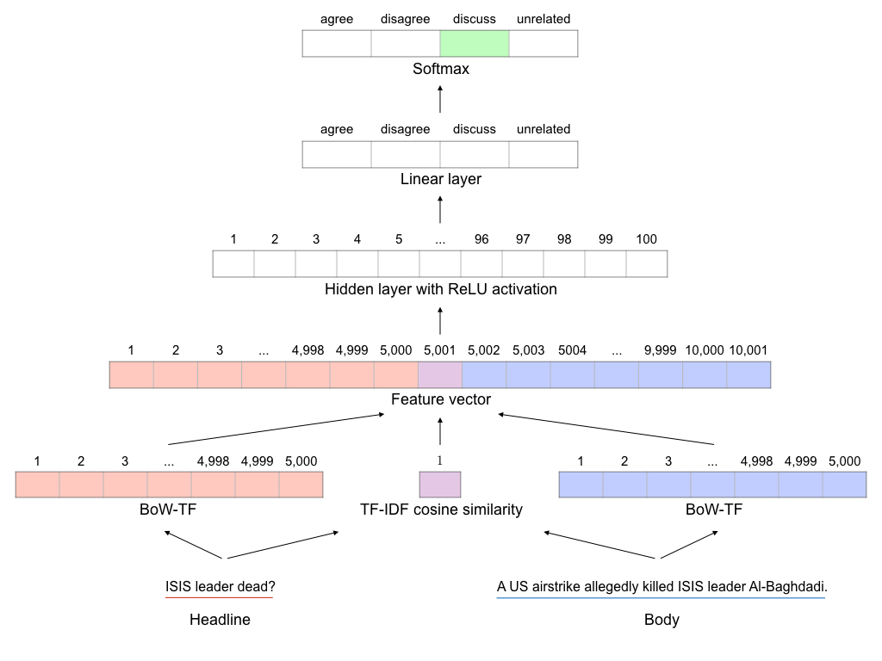

We used a Multi –Layer Perceptron with a softmax function that had the most optimized Hyperparameters. The Model uses “STANCE DETECTION” which no other multi layer perceptron model ever used to Detect FAKE News. We use a state-of-the-art Natural Language Understanding Version 1 for sentiment analysis, and to collect the keywords from the articles. The user inputs the article on our Website and then we use Web scrapping to collect all the relevant articles. The model then uses this data to predict the output. We used Watson technology for this purpose. Web Scrapping is done with Microsoft Azure and the searches are generated from Bing search Engine.

The best part of our model is that we have a loss reducer and an optimizer. Optimization was carried out using Adam and gradient clipping by a global norm clip ratio. The model will have a hidden layer with ReLu activation. BoW-TF (headline) , BoW-TF(body) and TF-IDF cosine similarity contribute to feature vector. The vector is succeeded by ReLu activation followed by a hidden layer and then by a softmax layer. Our model is India’s most unique model. We have a TRAIN SET of 50,000 rows of supervised learning and 25,000 rows of unsupervised learning which makes our Network well trained. Thus, by using NATURAL LANGAUGE PROCESSING, Web Scrapping, IBM WATSON and Multi layer Perceptron we have are building a Fake News Detector to make this digital Community a healthy and happy community.

As the model is not fully developed and integrated with the website it cannot yet run.

The contents attached are :-

* Model
* Training data
* Testing data
* Web Scrapper
* A sample webpage

Thanking You,

Meet Oza

Tarushi Sharma

Achint Srivastava