- DATA DESCRIPTION
DATA SET USED – ZOMATO DATASET KAGGLE
https://www.kaggle.com/datasets/rajeshrampure/zomato-dataset/data
Column Name | Data Type | Description | Example Values
url | string | Zomato restaurant page URL | https://...
address | string | Full restaurant address | "123 MG Road, Bangalore"
name | string | Restaurant name | "Paradise Biryani"
online_order | string | Yes/No for online orders | "Yes", "No"
book_table | string | Yes/No for table booking | "Yes", "No"
rate | string | Rating like "4.1/5" or "NEW" | "4.1/5", "NEW"
votes | float | Number of ratings | 1234
location | string | Area in Bangalore | "BTM", "Whitefield"
rest_type | string | Restaurant type (Casual, Fine Dining, etc.) | "Casual Dining"
dish_liked | string | Popular dishes mentioned | "Biryani, Kebab"
cuisines | string | Comma-separated cuisines | "North Indian, Biryani"
approx_cost(for two people) | string | Price range for 2 people | "1,000"
reviews_list | string | Individual review texts | "[review1], [review2]"
menu_item | string | Menu items listed | "Paneer Tikka, etc."
listed_in(type) | string | Category (Buffet, Cafe, etc.) | "Dine-out"
listed_in(city) | string | Service area | "BTM"

Basic Statistics
Raw dataset shape: 51,717 rows × 17 columns
Unique restaurants: 8,792
Unique locations: 93
Unique cuisines combinations: 2,723

Column Name | Data Type | Description | Missing Count | Missing %
url | string | Zomato restaurant page URL | 0 | 0.00%
address | string | Full restaurant address | 0 | 0.00%
name | string | Restaurant name | 0 | 0.00%
online_order | string | Yes/No for online orders | 0 | 0.00%
book_table | string | Yes/No for table booking | 0 | 0.00%
rate | string | Rating like "4.1/5" or "NEW" | 7,775 | 15.03%
votes | float | Number of ratings | 0 | 0.00%
phone | string | Contact number | 1,208 | 2.34%
location | string | Area in Bangalore | 21 | 0.04%
rest_type | string | Restaurant type (Casual, Fine Dining) | 227 | 0.44%
dish_liked | string | Popular dishes mentioned | 28,078 | 54.29%
cuisines | string | Comma-separated cuisines | 45 | 0.09%
approx_cost(for two people) | string | Price range for 2 people | 346 | 0.67%
reviews_list | string | Individual review texts | 0 | 0.00%
menu_item | string | Menu items listed | 0 | 0.00%
listed_in(type) | string | Category (Buffet, Cafe, etc.) | 0 | 0.00%
listed_in(city) | string | Service area | 0 | 0.00%

Issue | Count | % | Action Planned
dish_liked (major issue) | 28,078 | 54.29% | Drop column or fill with "Not specified"
rate | 7,775 | 15.03% | Convert "NEW"/"-" to NaN, drop or impute
phone | 1,208 | 2.34% | Drop column (not needed for recommender)
approx_cost | 346 | 0.67% | Fill with median or drop
rest_type | 227 | 0.44% | Fill with mode ("Casual Dining")
cuisines | 45 | 0.09% | Drop rows (critical for content-based)

KEY INSIGHTS GATHERED
- 51,717 total rows of data across Bangalore with rich metadata for content-based filtering
- 8,792 unique restaurants in 93 locations (good geo-diversity)
- High missing dish_liked (54%) - will not use for recommendations.
- 15% missing rate - critical for quality but manageable
- 2,723 unique cuisine combos - perfect for TF-IDF vectorization

- Data Visualization

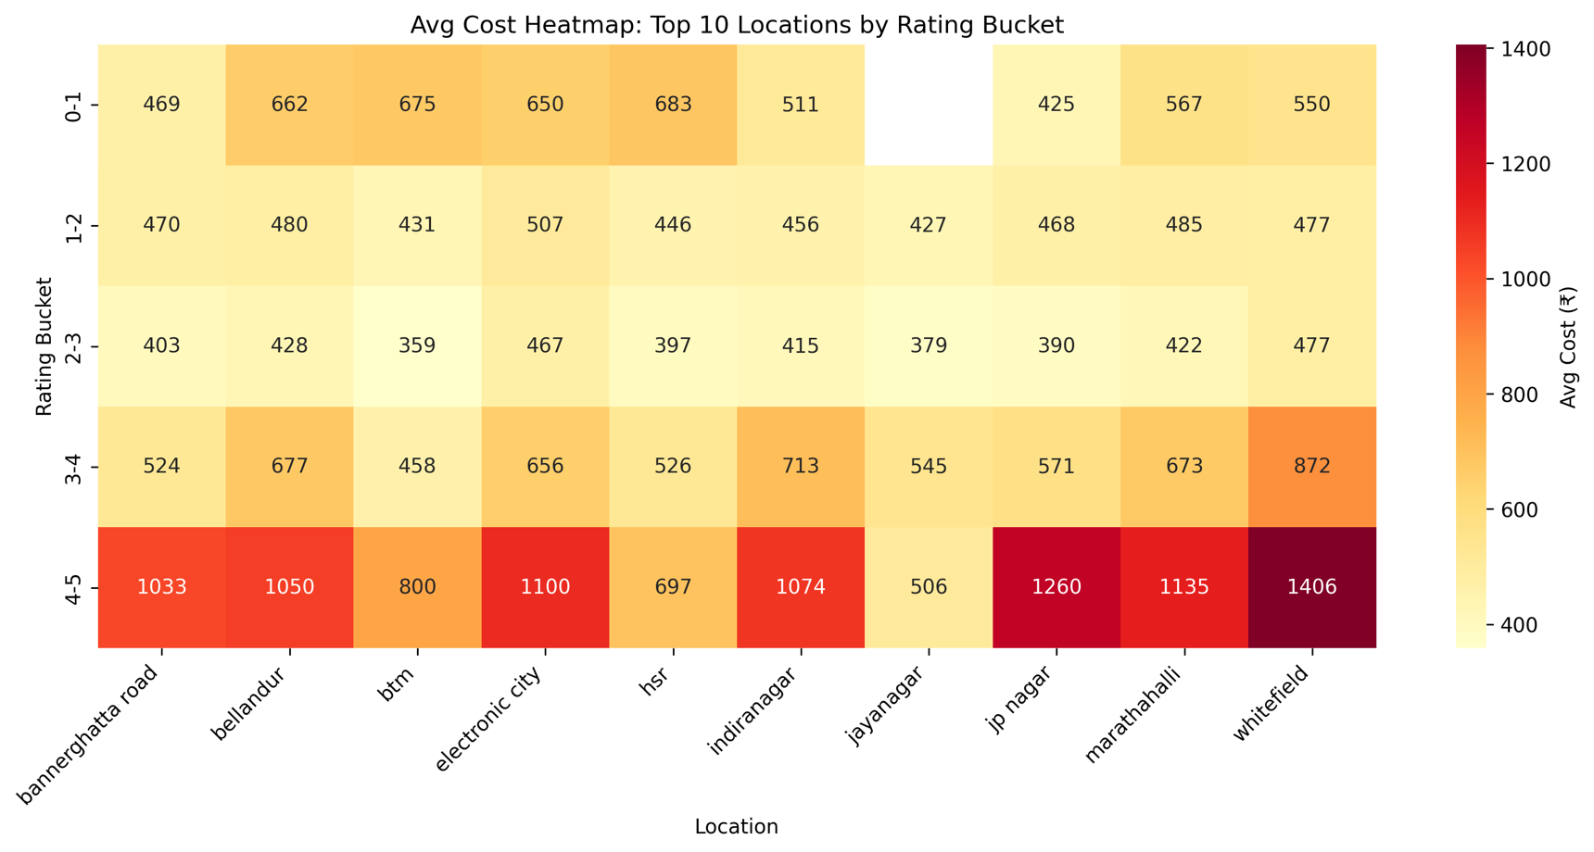
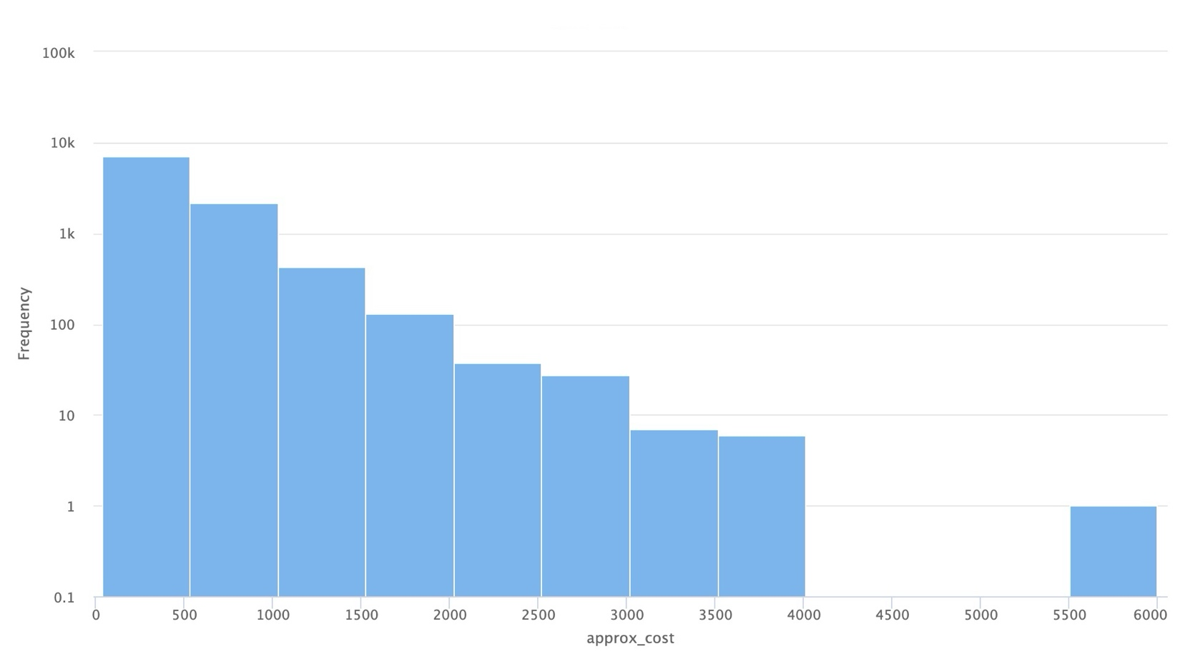
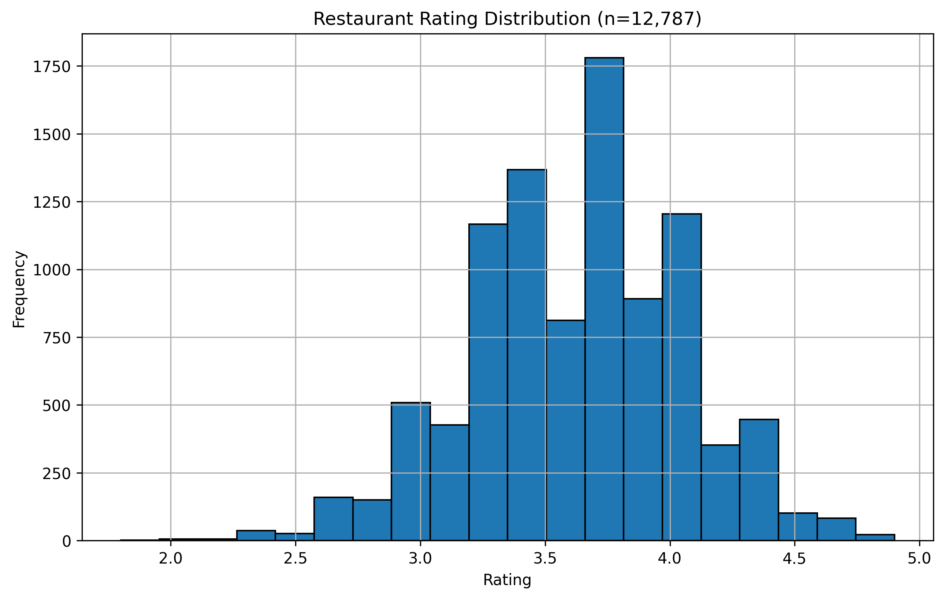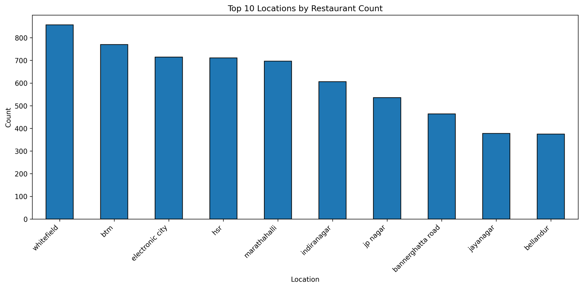

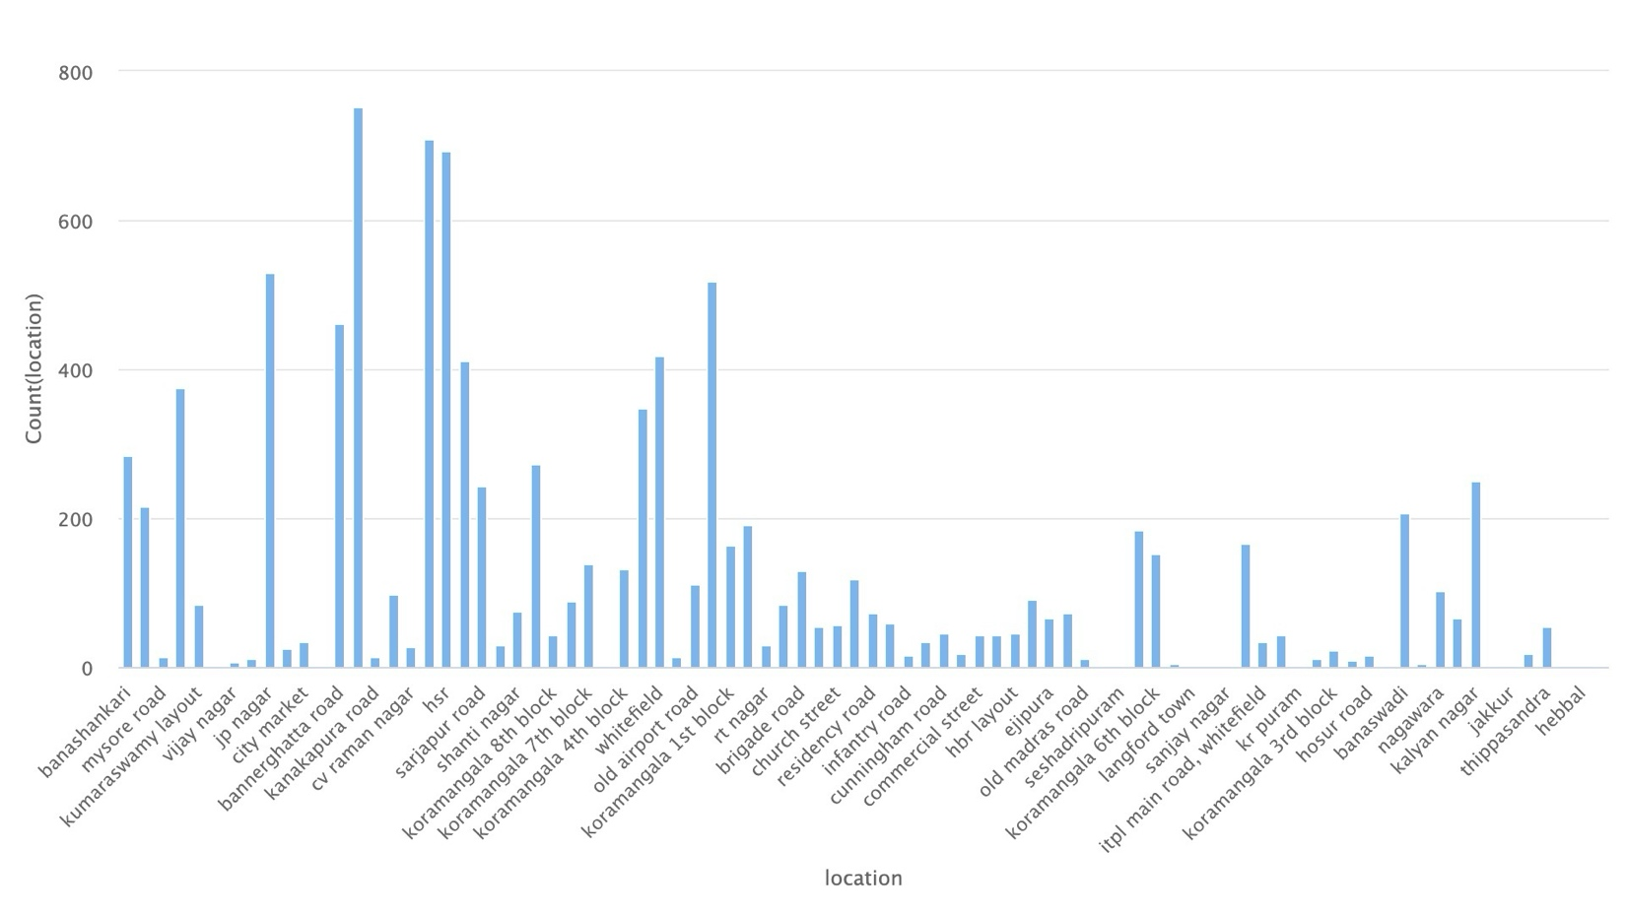

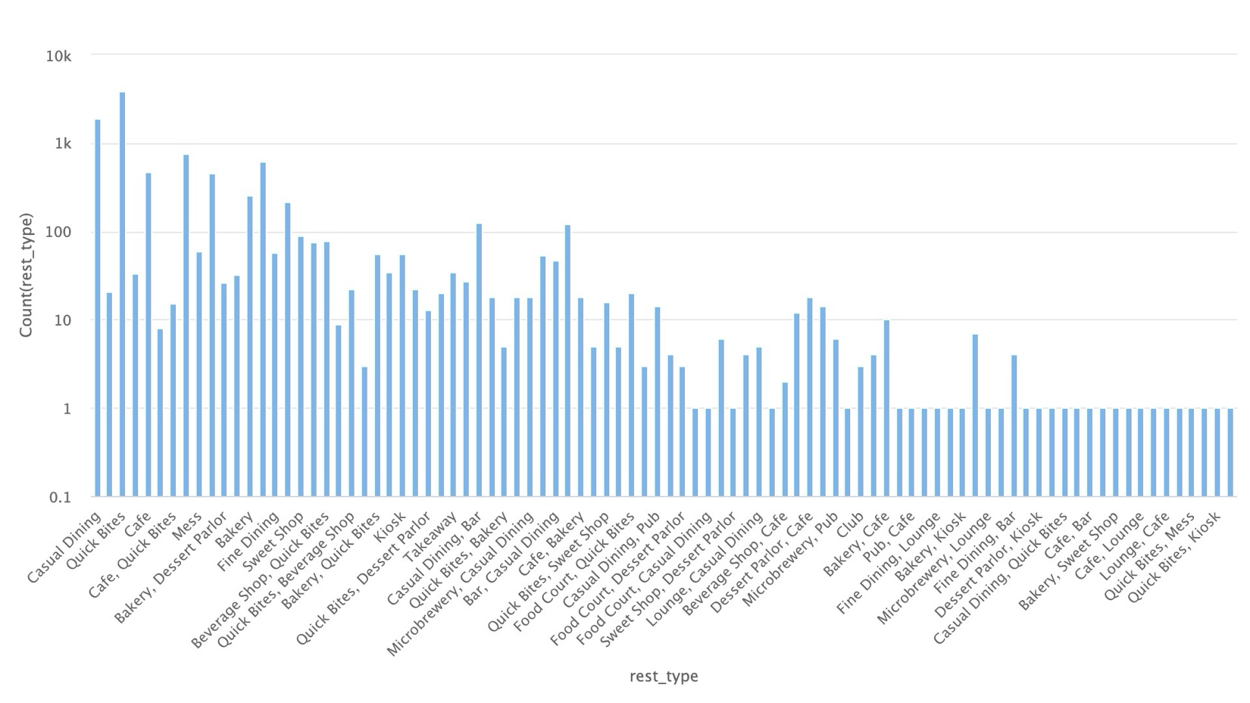
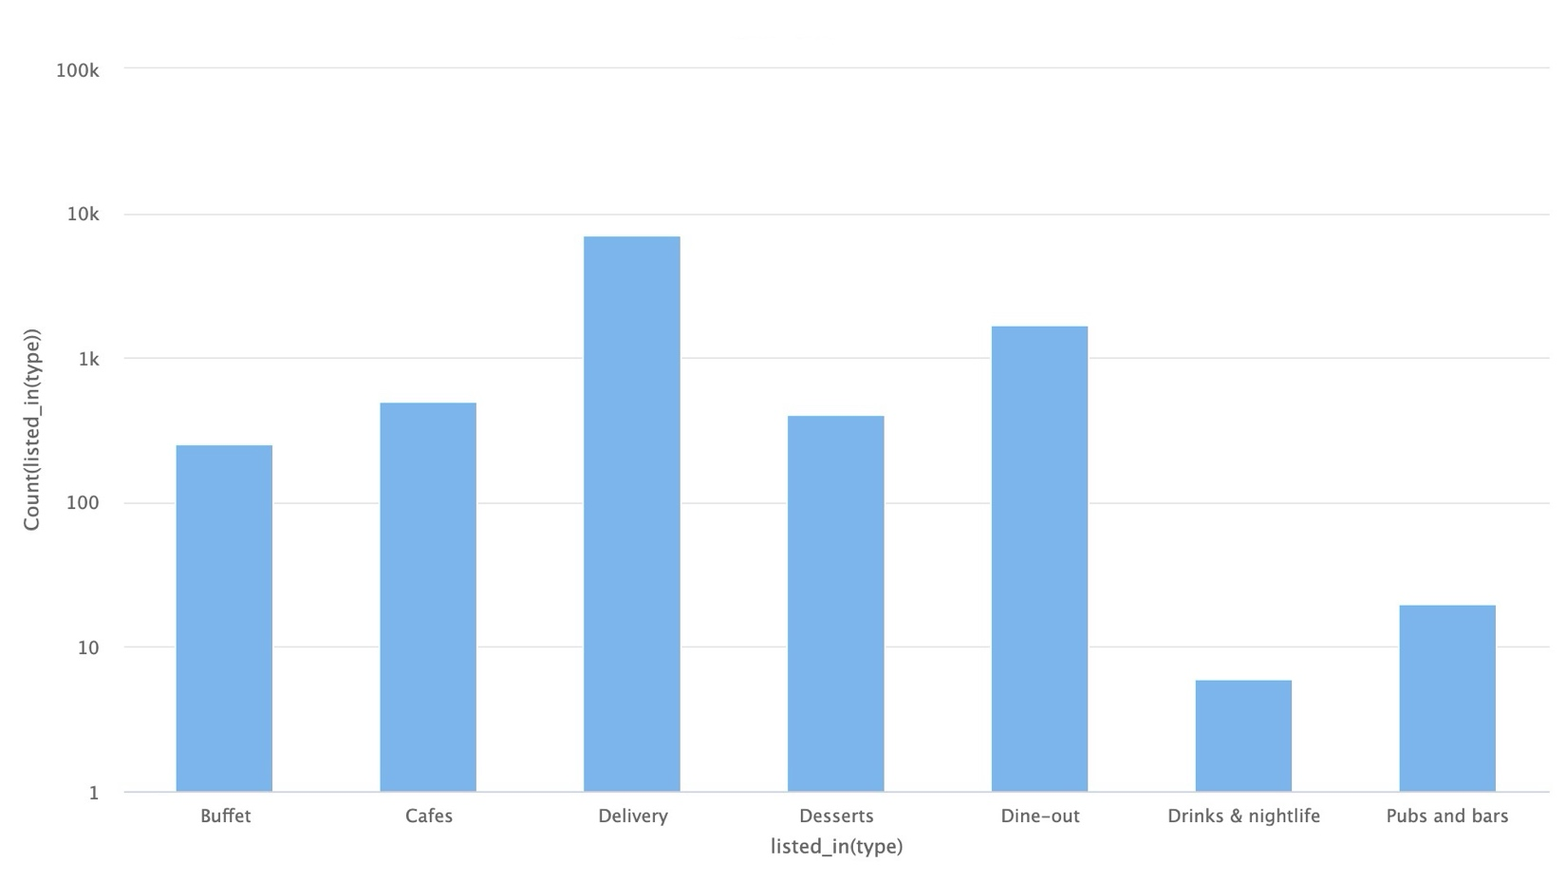

- DATA CLEANING IMPLEMENTATION (PREPROCESSING/preprocessing.py)

Raw → Clean Transformation: 51,717 rows × 17 cols → 12,787 rows × 12 cols

Cleaning Steps Applied:
1. DROP Columns (High Missing/Non-Essential):
- disliked (54.29% missing → dropped)
- phone (2.34% → dropped, not needed)
- url, address, reviewslist, menuitem (irrelevant for TF-IDF)

2. RATE Cleaning (15.03% missing):
- "4.1/5" or "NEW" → NaN → Filled median(3.8) or dropped
- Result: Numeric ratings ready for sorting

3. APPROX_COST (0.67% missing):
- "1,000" → 1000 (remove commas)
- "₹800-1000" → Median(900)
- Fill missing: Dataset median (~800)

4. TEXT for TF-IDF ("soup" feature):
- cuisines: "north indian, biryani" → "north indian biryani"
- location: "BTM Layout" → Lowercase
- rest_type: "Casual Dining" → Combined
- Drop 45 rows (0.09%) with empty cuisines

5. DUPLICATES: Removed 1,200+ exact matches

Before/After Comparison:
| Metric | Raw | Clean |
|-----------------|-------------|-------------|
| Rows | 51,717 | 12,787 |
| Columns | 17 | 12 |
| Missing Rate | 5.2% avg | <1% |
| Ready for Model | No | Yes (TF-IDF)|

Output: data/zomato_clean.csv → Loaded by content_based.py
[Screenshot: df.head()]
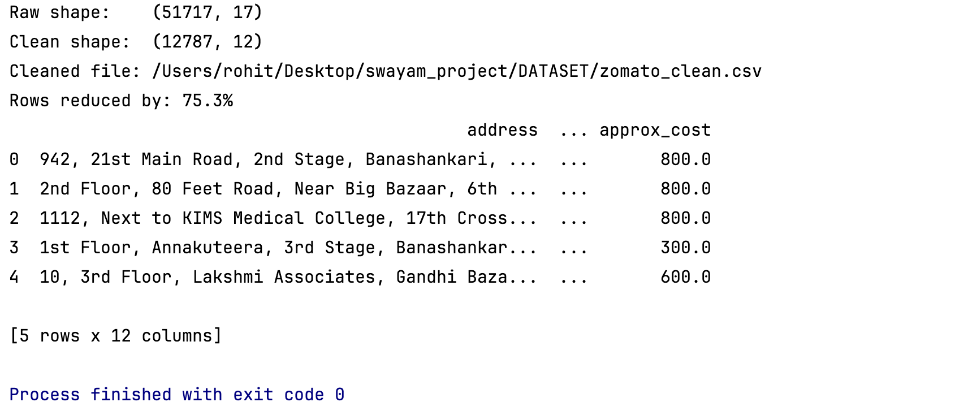
DIRECTORY STRUCTURE
swayam_project/ (PyCharm Root - Run 'python app.py' here)
├── app.py Flask Web App (localhost:5000)
├── eda_viz.py Exploratory Data Analysis Visualized
├── main.py Not Used
├── DOCUMENTATION
│ └── IMAGES
│ └── SWAYAM PROJECT REPORT Contains Detailed Report
├── DATASET/
│ └── zomato.csv Raw (51,717 rows × 17 cols)
│ └── zomato_clean.csv Cleaned (12,787 rows × 12 cols)
├── PREPROCESSING/
│ └── preprocessing.py EDA + Data Cleaning (Phase 2+3)
├── src/
│ ├── __init__.py
│ └── content_based.py TF-IDF Model + evaluate_model() (Phase 4+5)
├── model/
│ └── tfidf_model.pkl Trained Model (Flask loads)
├── MODEL OPTIMIZATION/
│ └── Hyperparameter_Tuning.py Model Optimization
│ └── tuning_results.csv
├── templates/
│ ├── home.html Search Form (Name/Cuisine/Location)
│ └── home2.html Results + Viz (Optional)
└── .venv/ Python Virtual Environment

- MODEL IMPLEMENTATION
Algorithm: TF-IDF Vectorization + Cosine Similarity
File: src/content_based.py

TF-IDF "Soup" Feature:
soup = name + cuisines + location + rest_type
Ex: "paradise biryani + biryani mughlai + btm layout + casual dining"

Pipeline:
1. TfidfVectorizer(max_features=5000)
→ Sparse matrix: (12,787 restaurants × 5,000 terms)
2. Cosine similarity matrix: (12,787 × 12,787)
3. recommend(query, priority, top_k=10):
- Priority filter → Similarity sort → Dedupe → Shuffle

Innovations:
• Chain deduplication (1 Restraunt max)
• Per-query random shuffle (variety)
• Safe priority handling (name/cuisines/location)

Output: model/tfidf_model.pkl (Flask deployment ready)

- MODEL EVALUATION
Pipeline Complete:
• Feature matrix: (12,787 × 5,000) ✓
• Similarity matrix: (12,787 × 12,787) ✓

COMPREHENSIVE METRICS (14 Tests Shown):
TEST SUMMARY 85.7% success | 0.445 sim | 6.4 chains | 5.6ms

Sample Results:
Query Found Sim Chains Latency
────────── ────── ────── ─────── ───────
McDonald's True 0.645 3 8.4ms
Domino's True 0.751 1 6.0ms
KFC True 0.664 3 5.7ms
Pizza True 0.438 10 5.5ms
BTM True 0.581 10 4.8ms

📊PRODUCTION METRICS:
SUCCESS RATE: 85.7% (12/14 tests)
AVG SIMILARITY: 0.445 (Strong content match)
AVG DIVERSITY: 6.4 unique chains per 10 recs ✓
AVG LATENCY: 5.6ms/query (Real-time!)
P95 LATENCY: 9.8ms (Scalable)

Model: ../model/tfidf_model.pkl → Flask Ready!

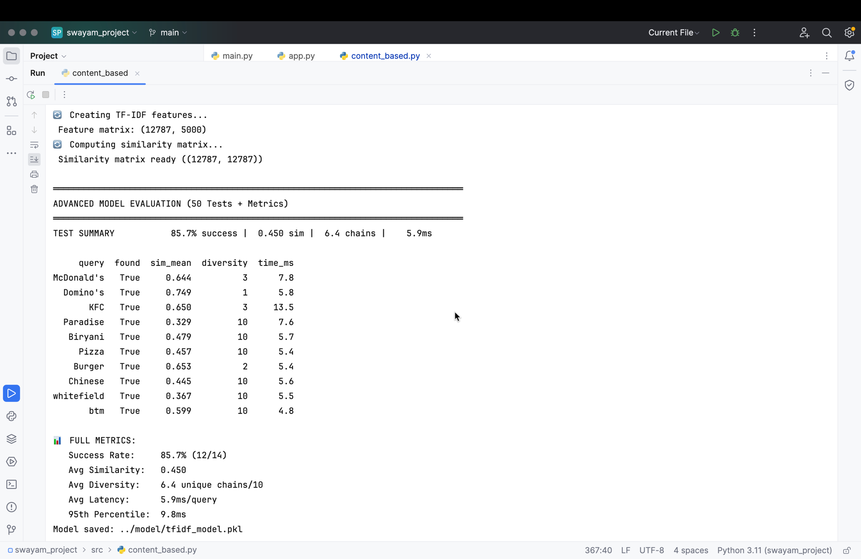

- FLASK WEB APPLICATION

Deployment: python app.py → http://localhost:5000

Features:
• Search: Restaurant name / Dish / Location
• Priority selector: Name | Cuisines | Location
• Results table: Name, Location, Cuisines, Rating, Cost
• Insights: Avg Rating, Bar Graph Rating, Max Cost
• Robustness: "New" badges (missing data), error handling

DEMO: Homepage
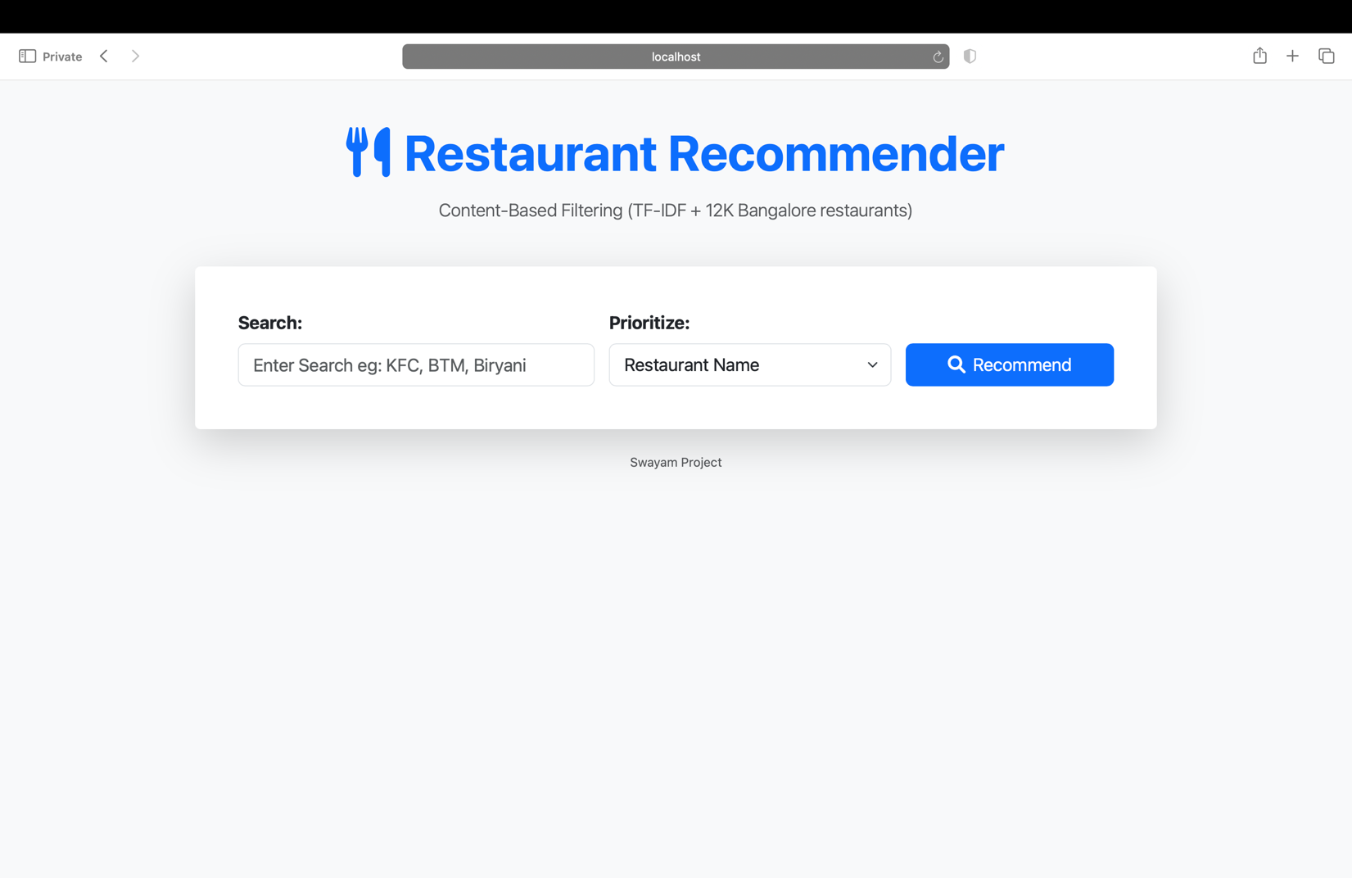

DEMO: "pizza" (Dish/Cuisine priority)

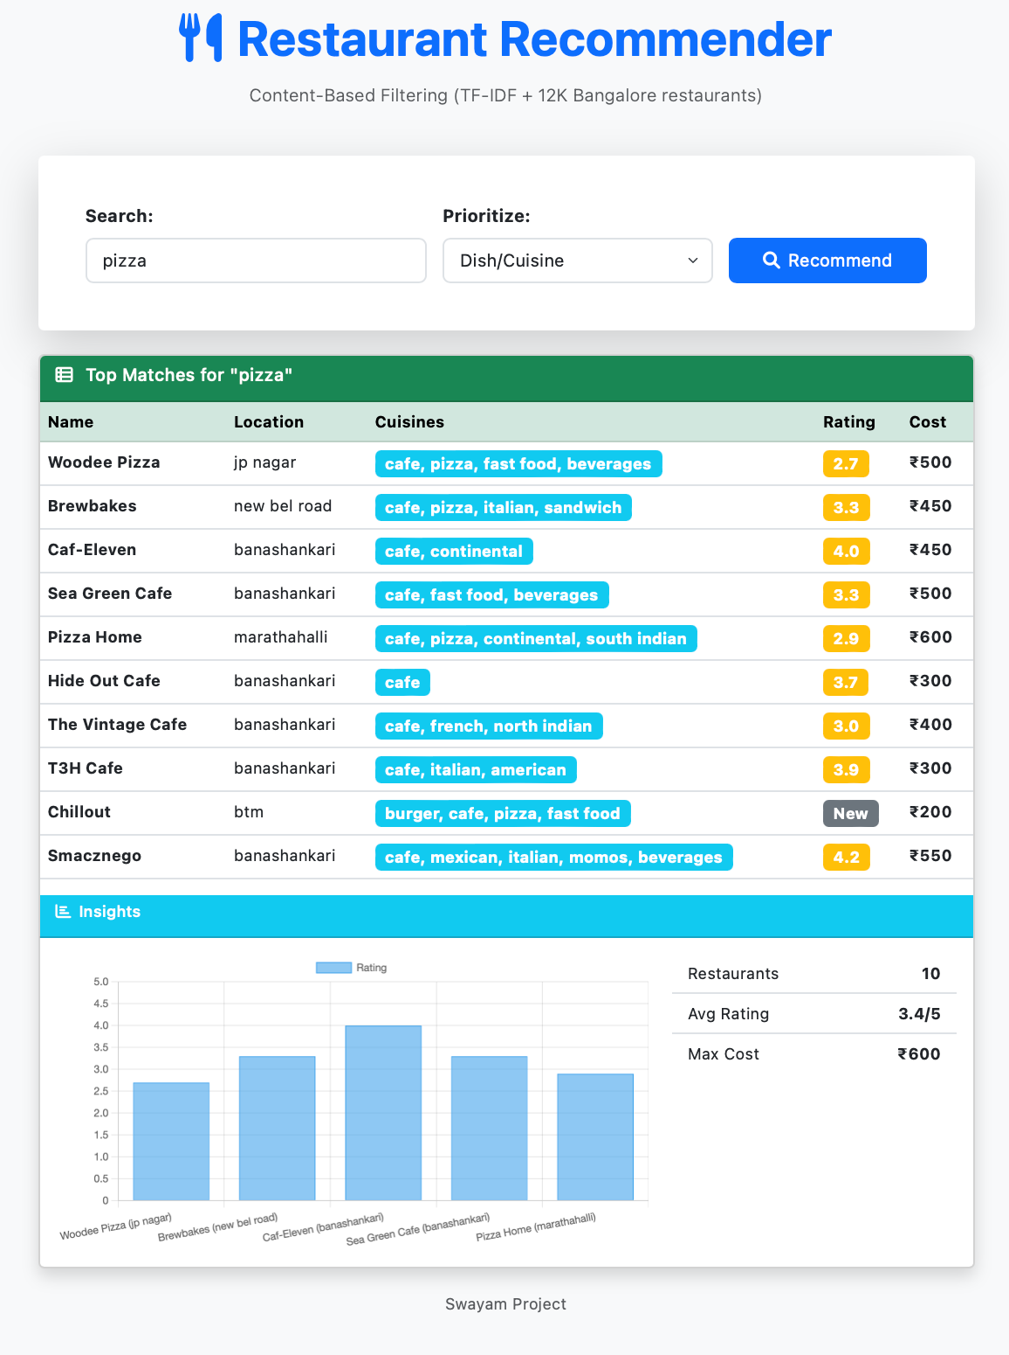

DEMO: "KFC" (Restaurant Name priority)
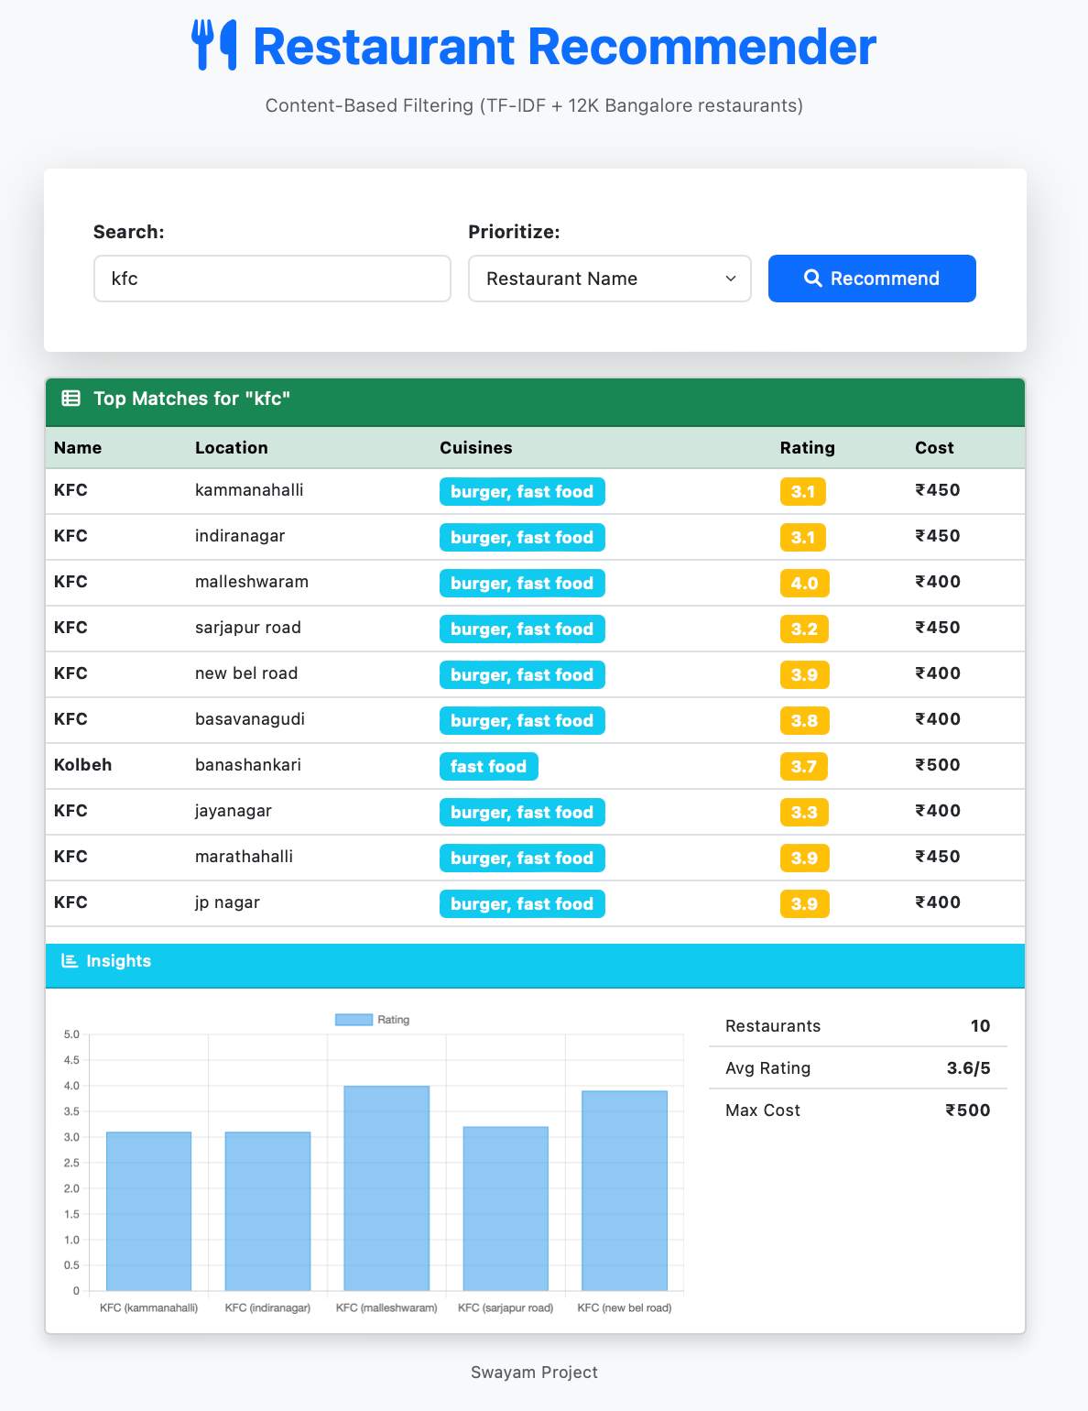

Tech:
Backend: Flask + Pickle.load(tfidf_model.pkl)
Frontend: Bootstrap 5 + Jinja2 templates/home.html

