TQS: Quality Assurance manual
Gonçalo Ribau [119560], Bernardo Lázaro [119230], Rodrigo Costa [119585], Diogo Pinheiro [119907]
v2025/12/19

Contents
TQS: Quality Assurance manual 1
1 Project management 1
1.1 Assigned roles 1
1.2 Backlog grooming and progress monitoring 2
2 Code quality management 3
2.1 Team policy for the use of generative AI 3
2.2 Guidelines for contributors 3
2.3 Code quality metrics and dashboards 4
3 Continuous delivery pipeline (CI/CD) 5
3.1 Development workflow 5
3.2 CI/CD pipeline and tools 5
3.3 System observability 6
4 Software testing 6
4.1 Overall testing strategy 6
4.2 Functional testing and ATDD 7
4.3 Developer facing testes (unit, integration) 7
4.4 Exploratory testing 8
4.5 Non-function and architecture attributes testing 8

Project management

Assigned roles
We have assigned ourselves some roles we think are important to engage in a project such as this one:
- Team Coordinator: Ensures that the tasks are fairly distributed and well executed. Not afraid to take matters into his own hands and assures everything is delivered on time. In our team’s case, it was Gonçalo Ribau.
- Product Owner: Represents the interests of the stakeholders. Understands the product well and should be the main guide when questions about the features arise. In our team’s case, it was Rodrigo Costa.
- QA Engineer: Responsible for articulating with the team, to promote the quality assurance practices and measure the quality of the deployment. Monitors that team follows agreed QA practices. In our team’s case, it was Diogo Pinheiro.
- DevOps Master: Responsible for the infrastructure of the development framework, and leads the preparation of the deployment’s machine(s)/containers, git repository, cloud infrastructure, databases operations, etc. In our team’s case, it was Bernardo Lázaro.
- Developer: Everyone participates in the development of the system.

Backlog grooming and progress monitoring
The project follows an Agile/Scrum methodology, with sprints and tasks in each sprint.
- Work Organization: The requirements, in Jira, are created as Tasks, for stuff not directly related to the development itself, and User Stories for features. Each story is assigned a priority based on story points.
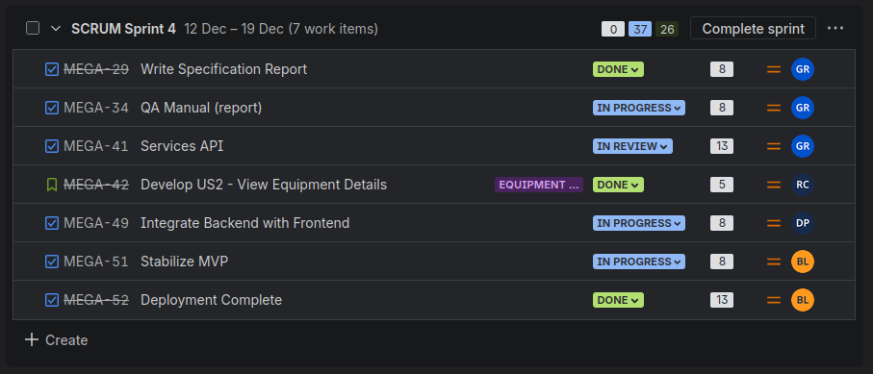
- Progress Tracking: We utilize a Kanban Board in Jira to visualize the workflow stages (to do, in progress, in review, done). Sprint velocity is monitored using the Burndown Chart to ensure the team remains on schedule for the MVP delivery.
- Requirements Coverage: We use Xray for Test Management. For every user storie, there were assigned tests for automatic or manual execution, to ensure no User Storie would be complete without coverage.
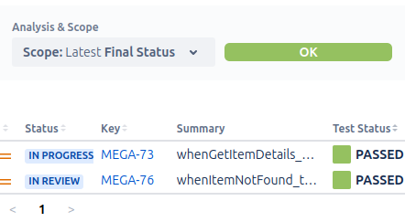

Code quality management

Team policy for the use of generative AI
To maintain academic integrity while also maximizing efficiency, we opted for the use of AI assistance in some cases. For example, one of those being frontend development, as making a UI for the project wasn’t one of the main concerns. The logic on the other hand, frontend and backend, being them the pillars of the project and the main product for the testing, they were developed with more caution, using only AI for generating boilerplate code, debuging complex errors, answering questions and making suggestions for cleaner code.
We made it prohibited to commit code that wasn’t reviewed and understood by a member of the group, as, beyond it making us useless and unknowledgeable, AI is not perfect and most of the time, it can’t code properly.
The developer who commits the code is solely responsible for it. There’s no excuses of “AI wrote it!” if the code has security flaws or bugs.

Guidelines for contributors
Coding style
To ensure codebase consistency and efficient development, the team enforces some guides:
- Backend (Java): Adheres to standard Spring Boot conventions. We utilize Lombok to minimize boilerplate code (getters, setters, constructors).
- Frontend (React): Follows standard React functional component patterns.
- Questions: In case of small questions, refer to docs repository, or ask your colleagues.
- Organization: Keep the code properly organized, clean and commented.
Code reviewing
The code can’t be an “If”, every piece of logic in the project must be tested and reviewed:
- Process: No code can be merged directly into the main or dev branches. A Pull Request must always be opened. A Pull Request can not be directly merged by the developer who opened it. A different developer must review it and mark it as approved.
- Checklist: The reviewer must verify these conditions:
  - The logic satisfies the User Story referenced;
  - No sensitive credentials are hardcoded;
  - The CI pipeline has passed successfully.

In our project’s organization, we put a Ruleset in the repositories to verify these conditions automatically, so there was no workaround.

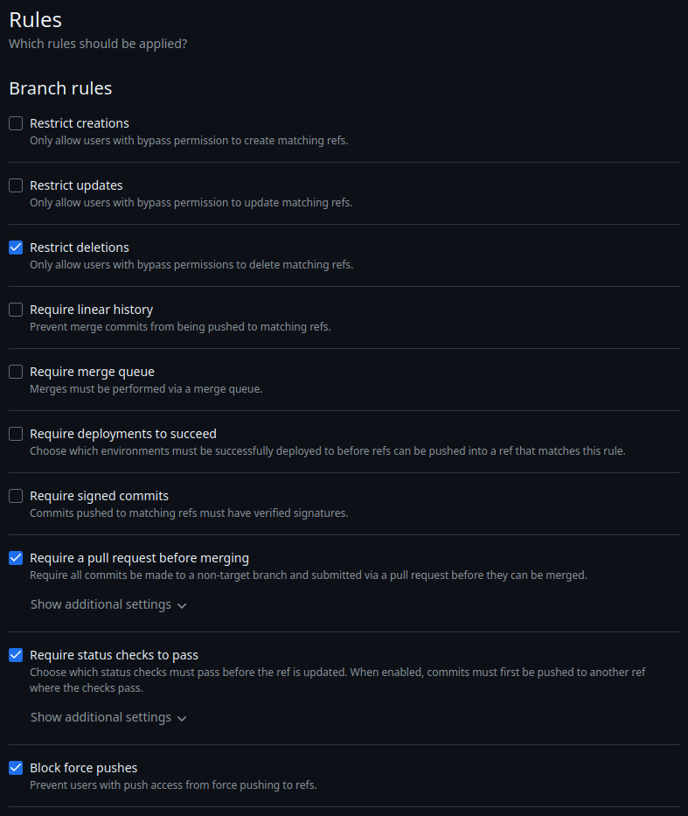
Code quality metrics and dashboards
The project utilizes SonarQube for continuous inspection of code quality. It’s integrated into the CI Pipeline to provide immediate feedback on every pull request.
The pipeline is configured to fail if the following conditions are not met:
- Code Coverage: Must remain above 80% for new code;
- Reliability: No "Blocker" or "Critical" bugs allowed;
- Maintainability: Duplicated lines must be less than 3%.
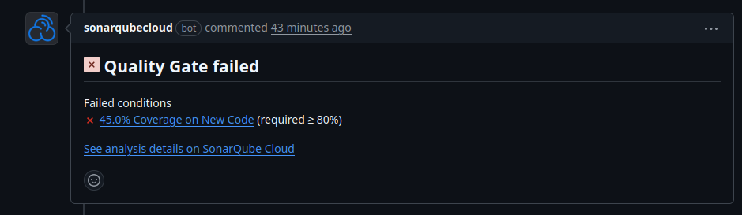

Continuous delivery pipeline (CI/CD)

Development workflow
Coding workflow
Our team has adopted the Feature-Branch Workflow, where we have the main branch for production, the dev branch for testing and feature branches to develop the app’s User Stories.
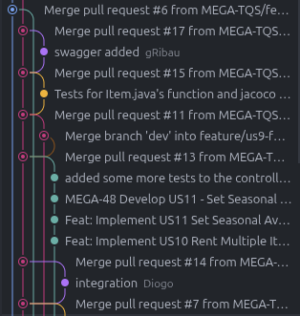
Work is committed to these feature branches, which are, then, requested to merge with the dev branch, when it works well, passes the Quality Gates and is reviewed and approved by another developer.
When we have a stable version ready for production, the dev branch is requested to merge with the main branch, and tested and reviewed again, of course.
Definition of done
A User Story is considered “done” only when all the following criteria are met:
- The code is implemented and committed;
- Tests are written and passing;
- Acceptance Criteria are covered by a BDD test (Cucumber);
- Code coverage meets the 80% threshold;
- Passes all quality gates;
- The feature has been manually verified by another developer.

CI/CD pipeline and tools
The Continuous Integration and Continuous Deployment pipelines are both orchestrated using Github Actions, and are dependent on secrets. They consist on the following automated stages:
- Checkout & Setup: Retrieves the code and sets up the Java JDK and Node.js environments.
- Test Execution:
  - Runs unit and integration tests.
  - Note: Testing uses an in-memory H2 Database configuration to ensure tests are fast and isolated from the production database configuration.
- Quality Analysis: Runs SonarQube analysis and Jacoco coverage reports to verify Quality Gates.
- Build & Package: Compiles the application into a JAR file.
- Containerization (CD): Upon merging to main the pipeline builds the Docker images for the backend, database and frontend and prepares them for deployment.
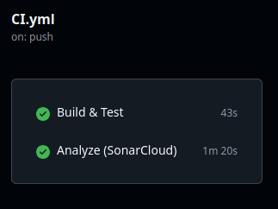
The Deployment Environment, or Production Environment, is located on a Virtual Machine provided by the class, and the Staging Environment is simulated using Docker containers.
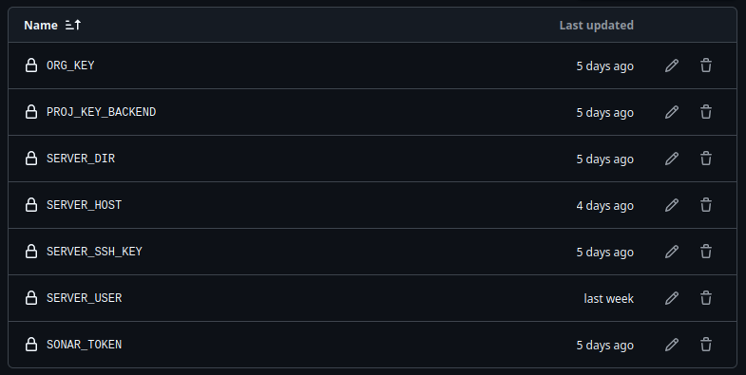

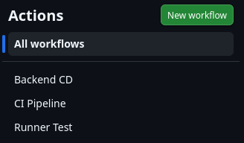
System observability
To ensure the system remains operational, we implemented basic observability practices:
- Logging: All application logs (Spring Boot) and database logs (PostgreSQL) are directed to standard output (stdout), allowing them to be monitored via the Docker console.
- Health Checks: We utilize Spring Boot's internal mechanisms to verify that the application context is up and the database connection is active.
- Grafana: We implemented Grafana to get load statistics on the deployed application.

Continuous testing

Overall testing strategy
The project follows the Testing Pyramid Strategy to ensure a robust and maintainable test suite:
- Unit Tests (70%): Validates isolated business logic (Services and Utility classes) using mocks. These are fast and run on every commit.
- Integration Tests (20%): Validates the interaction between components (Controllers, Services, Repositories) and the database.
- E2E/BDD Tests (10%): Validates full user flows from the user's perspective. These are slower and focus on critical paths.
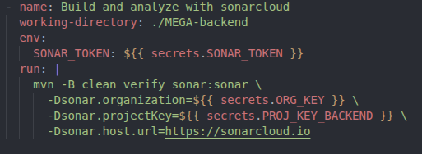
In the backend’s pipeline, we run “mvn verify” that runs unit tests and integration tests.

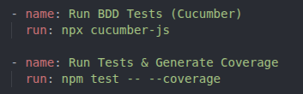
In the frontend’s pipeline, we run “npx cucumber-js” that runs the E2E/BDD tests, and “npm test” that runs normal jsx tests.

Acceptance testing and ATDD
We employ Acceptance Test-Driven Development (ATDD) using Cucumber, in the frontend repository. Before implementation begins, the developer and Product Owner define the Acceptance Criteria in Gherkin syntax (.feature files). These scenarios serve as executable documentation, and the developer should develop these so he ensures the system behaves exactly as specified in the requirements.

Developer facing tests (unit, integration)
Unit Testing:
- Developers are required to write unit tests for all service-layer logic, mocking external dependencies (like repositories) to test in isolation. These tests make up 70% of all the tests for the new code developed. In our project we have implemented them using JUnit 5 and Mockito.

Our most relevant unit tests consist of the ones for the service and data layer, more specifically for the ItemService and ItemRepository, which test the logic in the manipulation of the items and their information.

Integration Testing:
- To ensure stability and speed in the CI environment, these tests run against an H2 in-memory database, while the production application runs against PostgreSQL. This separation ensures that tests do not require a live Docker environment to run. They make up 20% of all the tests for the new code developed. Our Integration Tests are implemented using Spring Boot Test.

Exploratory testing
We use the auto-generated documentation from Swagger (http://deti-tqs-17.ua.pt:8080/docs) for unscripted testing. We set up the database and the backend, and send requests using Swagger to test some edge cases, error messages, and JSON formats, without need for frontend.
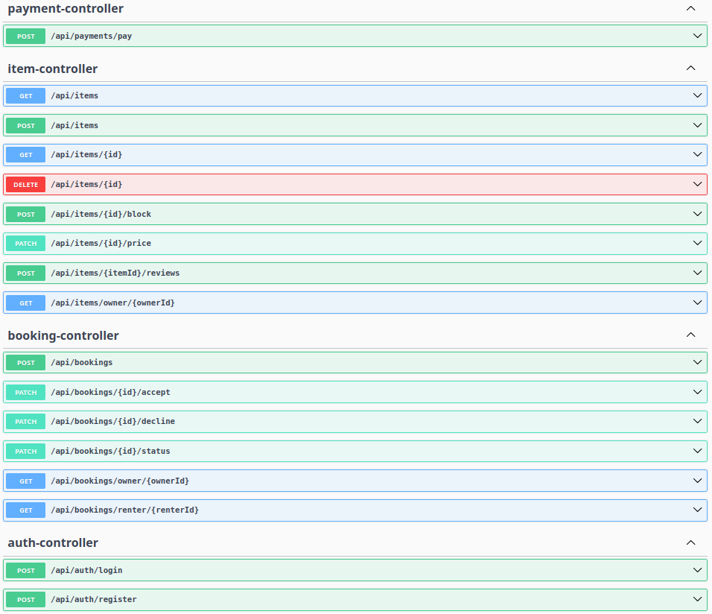

Non-function and architecture attributes testing
We utilize k6 to perform load testing on critical endpoints (for example, search and booking creation). This ensures the system maintains acceptable response times even under concurrent user load.
