# Load the libraries  
library(readxl)

## Warning: package 'readxl' was built under R version 4.4.1

library(ggplot2)

## Warning: package 'ggplot2' was built under R version 4.4.1

# Load the data from the Excel file  
file_path <- "C:\\Users\\ASUS\\Downloads\\megha.xlsx"  
data <- read_excel(file_path, sheet = "Sheet1")  
  
# Display the first few rows of the data  
head(data)

## # A tibble: 6 × 24  
## ID Gender Age `Customer Type` `Type of Travel` Class `Flight Distance`  
## <dbl> <chr> <dbl> <chr> <chr> <chr> <dbl>  
## 1 1 Male 48 First-time Business Business 821  
## 2 2 Female 35 Returning Business Business 821  
## 3 3 Male 41 Returning Business Business 853  
## 4 4 Male 50 Returning Business Business 1905  
## 5 5 Female 49 Returning Business Business 3470  
## 6 6 Male 43 Returning Business Business 3788  
## # ℹ 17 more variables: `Departure Delay` <dbl>, `Arrival Delay` <dbl>,  
## # `Departure and Arrival Time Convenience` <dbl>,  
## # `Ease of Online Booking` <dbl>, `Check-in Service` <dbl>,  
## # `Online Boarding` <dbl>, `Gate Location` <dbl>, `On-board Service` <dbl>,  
## # `Seat Comfort` <dbl>, `Leg Room Service` <dbl>, Cleanliness <dbl>,  
## # `Food and Drink` <dbl>, `In-flight Service` <dbl>,  
## # `In-flight Wifi Service` <dbl>, `In-flight Entertainment` <dbl>, …

# Histogram of Age  
ggplot(data, aes(x = Age)) +  
 geom_histogram(binwidth = 5, fill = "blue", color = "black", alpha = 0.7) +  
 labs(title = "Histogram of Age", x = "Age", y = "Frequency")

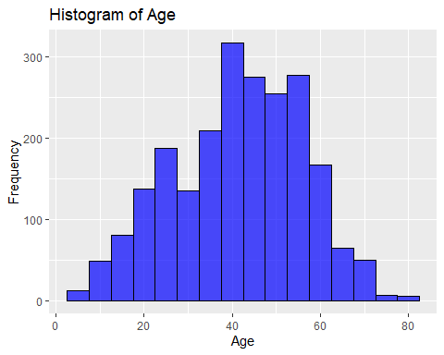

# Bar chart of Customer Type  
ggplot(data, aes(x = `Customer Type`)) +  
 geom_bar(fill = "green", color = "black", alpha = 0.7) +  
 labs(title = "Bar Chart of Customer Type", x = "Customer Type", y = "Count")

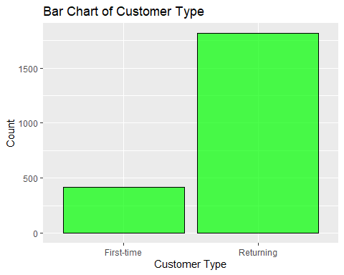

# Scatter plot of Flight Distance vs. Arrival Delay  
ggplot(data, aes(x = `Flight Distance`, y = `Arrival Delay`)) +  
 geom_point(color = "red", alpha = 0.7) +  
 labs(title = "Scatter Plot of Flight Distance vs. Arrival Delay", x = "Flight Distance", y = "Arrival Delay")

## Warning: Removed 3 rows containing missing values or values outside the scale range  
## (`geom_point()`).

