MAD_LAB:2

<?xml version="1.0" encoding="utf-8"?>
<androidx.constraintlayout.widget.ConstraintLayout xmlns:android="http://schemas.android.com/apk/res/android"
xmlns:app="http://schemas.android.com/apk/res-auto"
xmlns:tools="http://schemas.android.com/tools"
android:id="@+id/main"
android:layout_width="match_parent"
android:layout_height="match_parent"
tools:context=".MainActivity">
<EditText
android:id="@+id/editText2"
android:layout_width="wrap_content"
android:layout_height="wrap_content"
android:ems="10"
android:inputType="textPassword"
app:layout_constraintBottom_toBottomOf="parent"
app:layout_constraintEnd_toEndOf="parent"
app:layout_constraintHorizontal_bias="0.786"
app:layout_constraintStart_toStartOf="parent"
app:layout_constraintTop_toTopOf="parent"
app:layout_constraintVertical_bias="0.327" />
<TextView
android:id="@+id/textView"
android:layout_width="89dp"
android:layout_height="15dp"
android:text="USERNAME"
app:layout_constraintBottom_toBottomOf="parent"
app:layout_constraintEnd_toEndOf="parent"
app:layout_constraintHorizontal_bias="0.13"
app:layout_constraintStart_toStartOf="parent"
app:layout_constraintTop_toTopOf="parent"
app:layout_constraintVertical_bias="0.146" />
<EditText
android:id="@+id/editText1"
android:layout_width="wrap_content"
android:layout_height="wrap_content"
android:ems="10"
android:inputType="text"
android:text=""
app:layout_constraintBottom_toBottomOf="parent"
app:layout_constraintEnd_toEndOf="parent"
app:layout_constraintHorizontal_bias="0.791"
app:layout_constraintStart_toStartOf="parent"
app:layout_constraintTop_toTopOf="parent"
app:layout_constraintVertical_bias="0.123" />
<TextView
android:id="@+id/textView2"
android:layout_width="wrap_content"
android:layout_height="wrap_content"
android:text="PASSWORD"
app:layout_constraintBottom_toBottomOf="parent"
app:layout_constraintEnd_toEndOf="parent"
app:layout_constraintHorizontal_bias="0.124"
app:layout_constraintStart_toStartOf="parent"
app:layout_constraintTop_toTopOf="parent"
app:layout_constraintVertical_bias="0.353" />
<Button
android:id="@+id/button"
android:layout_width="wrap_content"
android:layout_height="wrap_content"
android:text="@string/login"
app:layout_constraintBottom_toBottomOf="parent"
app:layout_constraintEnd_toEndOf="parent"
app:layout_constraintHorizontal_bias="0.534"
app:layout_constraintStart_toStartOf="parent"
app:layout_constraintTop_toTopOf="parent"
app:layout_constraintVertical_bias="0.625" />
</androidx.constraintlayout.widget.ConstraintLayout>

package com.example.sec_app;
import android.os.Bundle;
import android.view.View;
import android.widget.Button;
import android.widget.EditText;
import android.widget.Toast;
import androidx.activity.EdgeToEdge;
import androidx.appcompat.app.AppCompatActivity;
import androidx.core.graphics.Insets;
import androidx.core.view.ViewCompat;
import androidx.core.view.WindowInsetsCompat;
public class MainActivity extends AppCompatActivity implements View
.OnClickListener{
EditText e1,e2;
Button b1;
@Override
protected void onCreate(Bundle savedInstanceState) {
super.onCreate(savedInstanceState);
EdgeToEdge.enable(this);
setContentView(R.layout.activity_main);
ViewCompat.setOnApplyWindowInsetsListener(findViewById(R.id.main), (v, insets) -> {
Insets systemBars = insets.getInsets(WindowInsetsCompat.Type.systemBars());
v.setPadding(systemBars.left, systemBars.top, systemBars.right, systemBars.bottom);
return insets;
});
e1=findViewById(R.id.editText1);
e2=findViewById(R.id.editText2);
b1=findViewById(R.id.button);
b1.setOnClickListener(this);
}
@Override
public void onClick(View v) {
String uname,pword;
uname=e1.getText().toString();
pword=e2.getText().toString();
if ((uname.equals("sain")) && (pword.equals("1234")))
{
Toast.makeText(this, "Login Successfull", Toast.LENGTH_LONG).show();
}
else
{
Toast.makeText(this, "Incorrect Login", Toast.LENGTH_LONG).show();
}
}
}

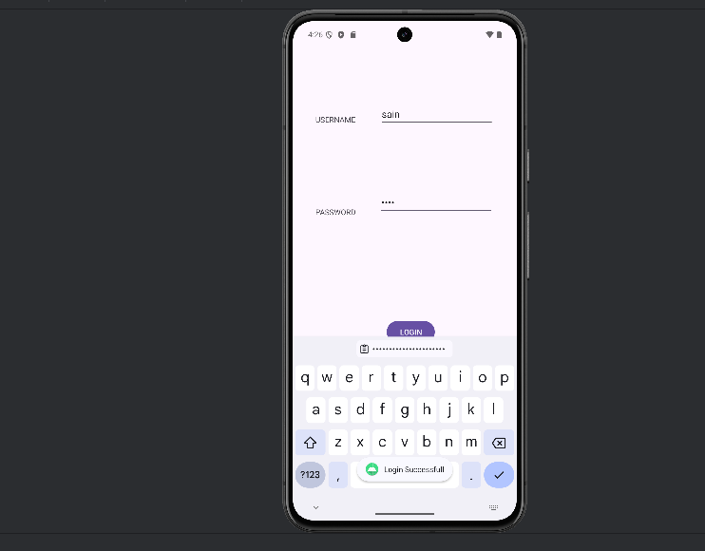
jk

