Business Question and Visualization Report
Date | 31 July 2026
Team ID
Project Name | Food Ordering Behaviour
Maximum Marks | 5 Marks

Business Questions and Visualizations
Q1: Which cities generate the highest order value?
- Visualization: A map chart displaying cities geographically, with the size and intensity of marks representing SUM(Order Value).
- Insight Provided: The visualization identifies the cities contributing the highest order value and makes it easy to compare revenue concentration across locations.
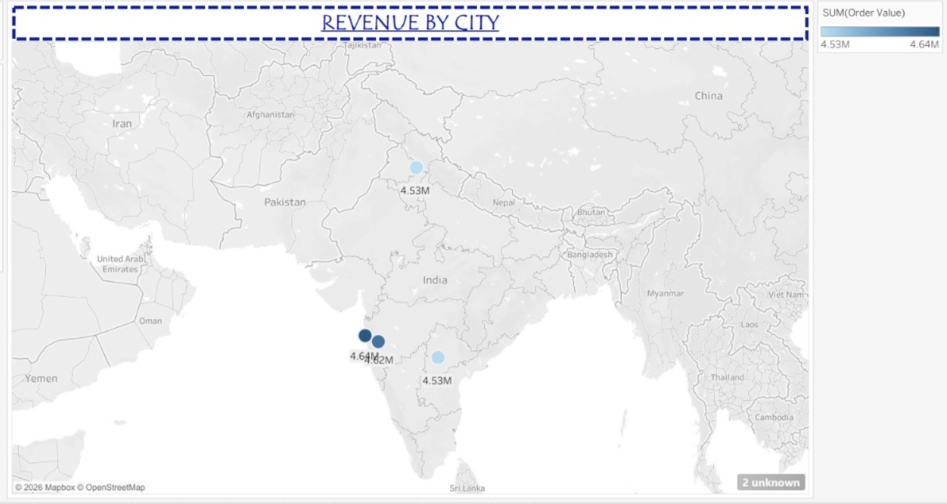

Q2: Which cuisine receives the highest number of customer ratings across different meal types?
- Visualization: A heat map comparing cuisine and meal type, with the cell values showing the volume of customer ratings for each combination.
- Insight Provided: The chart highlights how rating volume changes by cuisine and meal type. Chinese during Dinner and Fast Food during Breakfast are among the strongest combinations visible in the chart.
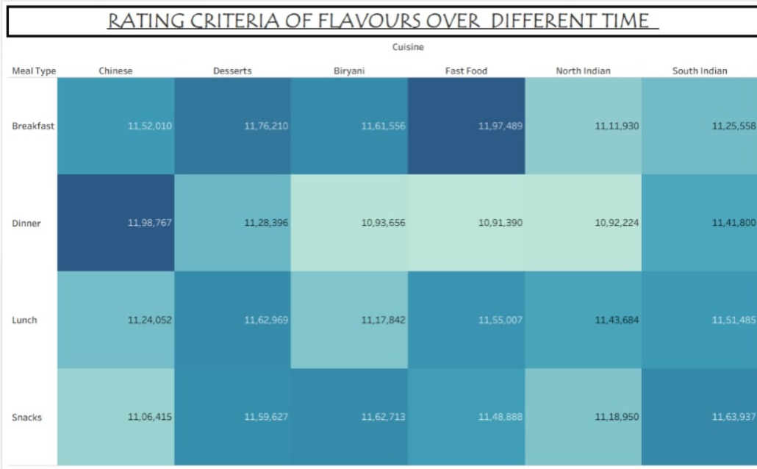

Q3: How does rainy weather influence order value across different times of the day?
- Visualization: A side-by-side bar chart comparing order value across Afternoon, Evening, Morning and Night under rainy and non-rainy weather conditions.
- Insight Provided: The visualization shows that order value varies by both weather and order time. Evening orders are particularly strong during rainy weather, while non-rainy periods remain comparatively consistent across the day.
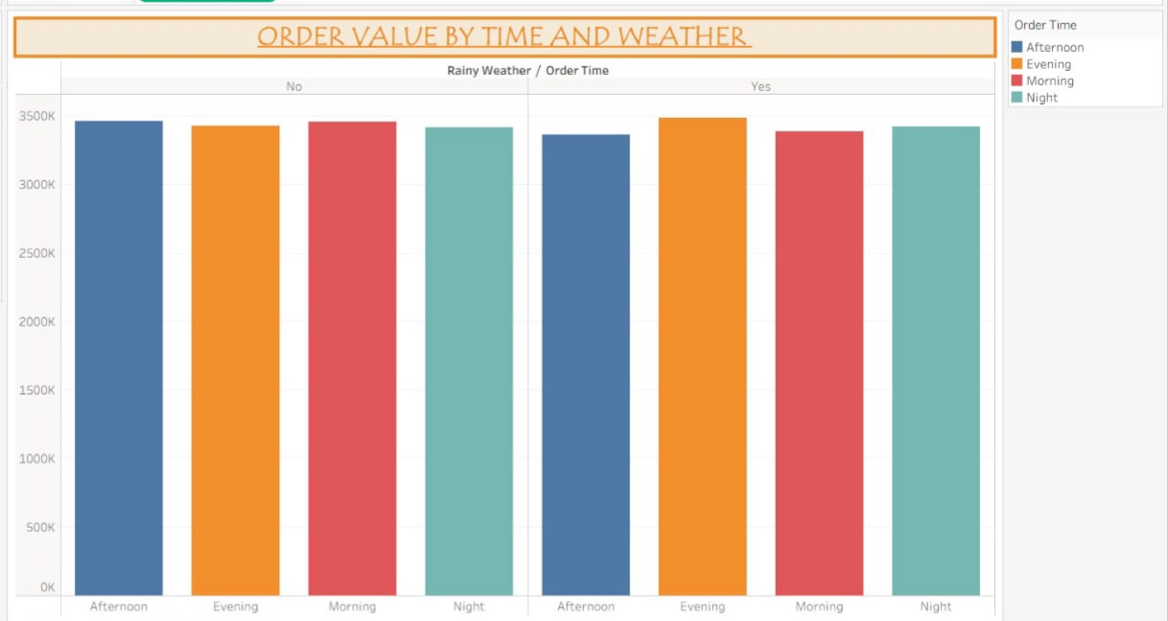

Q4: How do customer ratings influence repeat orders among different age groups?
- Visualization: A stacked bar chart showing repeat-order counts across age groups, segmented into Excellent, Needs Improvement and Satisfactory rating categories.
- Insight Provided: The chart shows how repeat-order behaviour differs across age groups and rating categories, with the 26–40 age groups contributing some of the highest repeat-order totals.
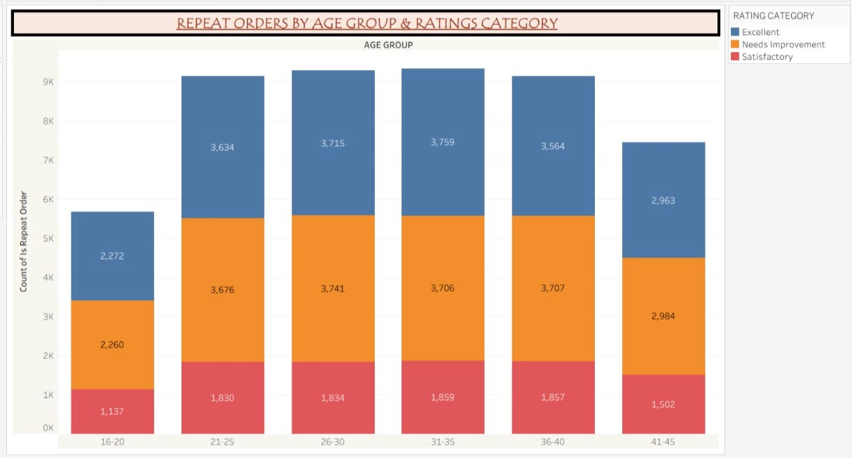

Q5: Does hunger level affect spending on different cuisines?
- Visualization: A horizontal bar chart comparing SUM(Order Value) for Biryani, Chinese, Desserts, Fast Food, North Indian and South Indian cuisines across High, Low and Medium hunger levels.
- Insight Provided: Spending differs across cuisine and hunger combinations. Fast Food records the strongest order value for the High-hunger group, while other cuisines remain close across hunger levels.
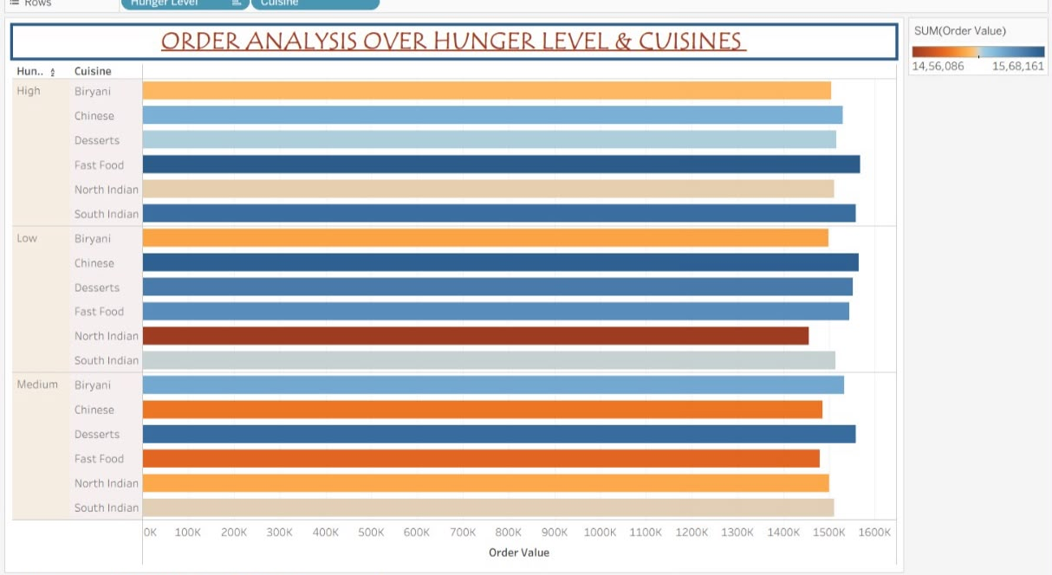

Q6: How do customer rating categories vary across different restaurant types based on the customer’s dining company?
- Visualization: A matrix of pie charts comparing Excellent, Needs Improvement and Satisfactory rating categories across Budget, Mid-range and Premium restaurant types for Alone, Family, Friends and Partner dining groups.
- Insight Provided: The visualization shows the distribution of rating categories across restaurant types and dining companies. The overall pattern is broadly similar across the combinations, with Excellent and Needs Improvement making up the larger shares.
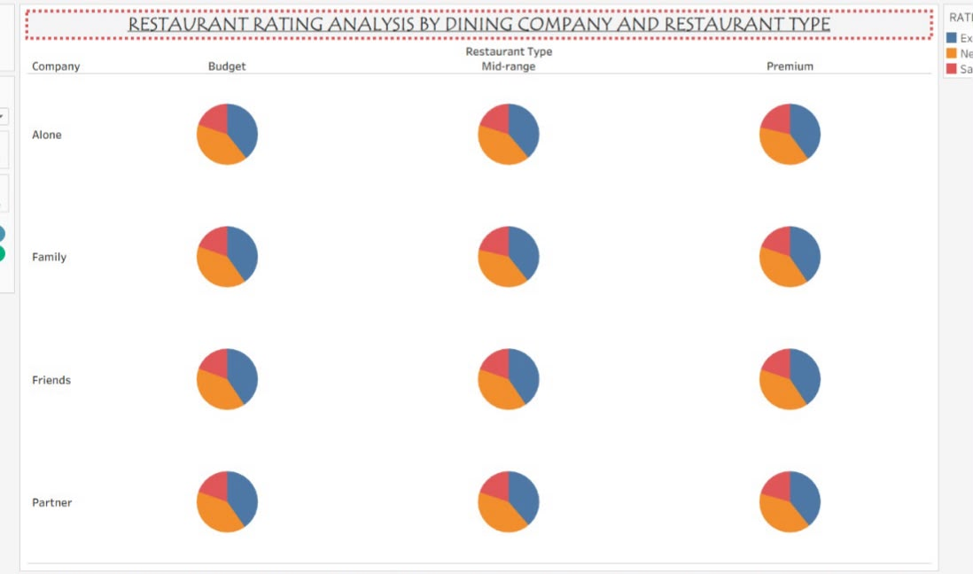

Q7: Which time of day generates the highest order value for each hunger level?
- Visualization: A bubble chart grouping order time by High, Medium and Low hunger levels, with the combinations displayed together for comparison.
- Insight Provided: The chart allows the relationship between hunger level and time of day to be compared at a glance, showing which time periods are associated with each hunger category.
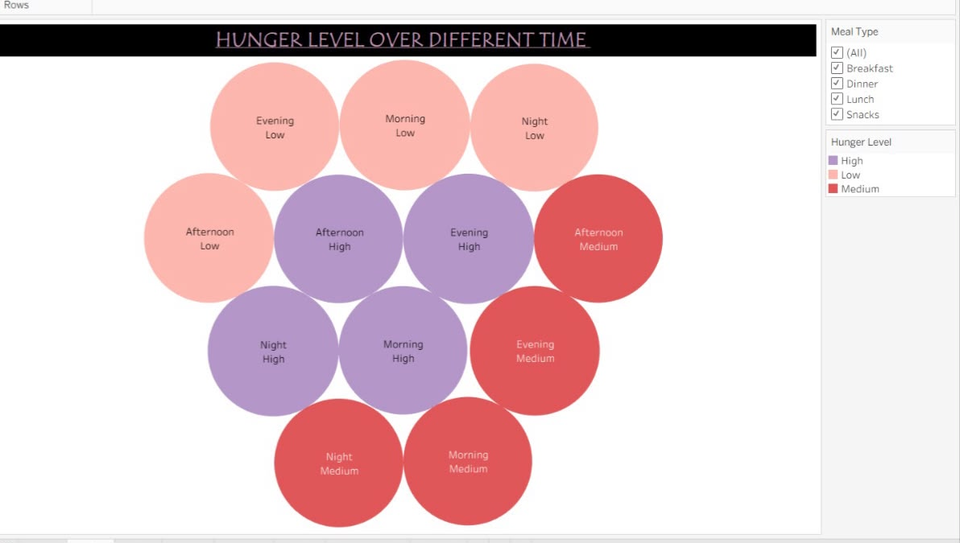

Q8: How do average customer ratings vary across different age groups and cities?
- Visualization: A heat map with age groups on rows and cities on columns, using average customer rating as the cell value and colour intensity.
- Insight Provided: Average ratings remain close to 3 across most age-city combinations, while specific combinations such as the 21–25 group in Hyderabad show comparatively higher average ratings.
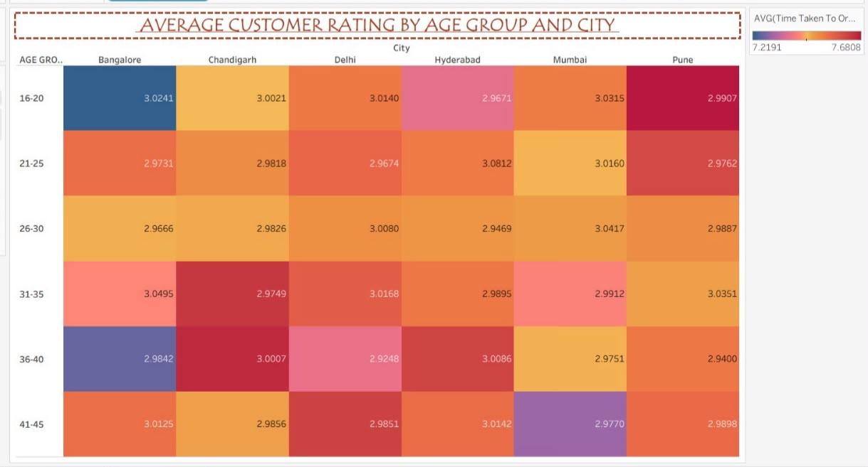

Q9: How do rainy weather, discount offers, and customer mood influence customer spending?
- Visualization: A multi-ring radial chart comparing SUM(Order Value) across combinations of rainy weather, discount application and customer mood.
- Insight Provided: The radial view provides a compact comparison of spending across the three influencing factors and helps identify differences in order value between the displayed conditions.
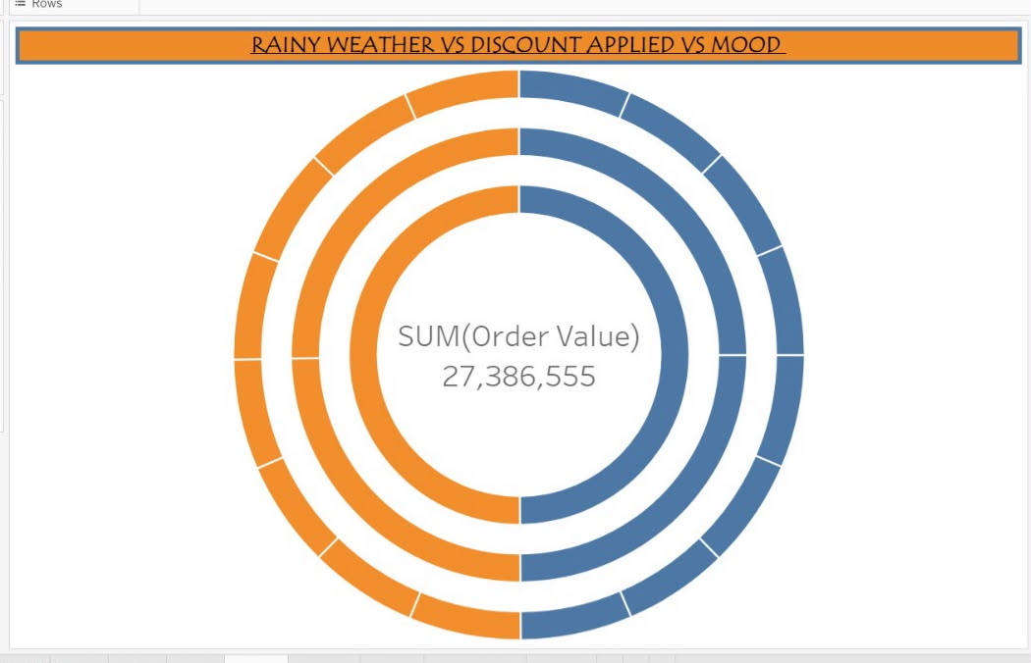

Q10: How do meal type and day type simultaneously affect delivery fee and time taken to order?
- Visualization: A two-part bubble visualization comparing Delivery Fee and Time Taken to Order across meal types and day types, including Breakfast, Dinner, Lunch and Snacks.
- Insight Provided: The visualization compares delivery fees and ordering time across meal and day-type combinations, helping identify where customers experience higher fees or longer ordering times.
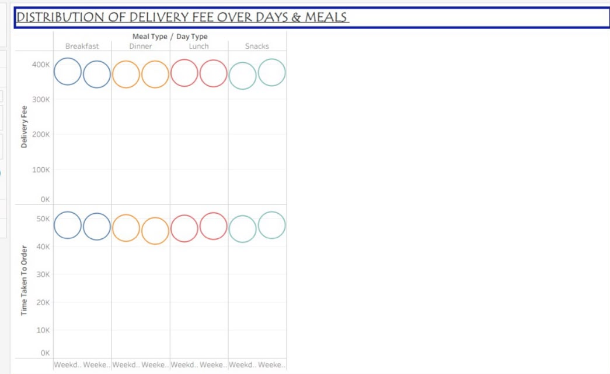

Q11: How does meal type vary with customer mood?
- Visualization: A donut chart showing the distribution of customer moods across Breakfast, Lunch, Dinner and Snacks.
- Insight Provided: The chart shows how moods such as Happy, Lazy, Stressed, Celebrating and Relaxed are distributed across different meal types, revealing the mood patterns associated with ordering occasions.
