Dashboard Design
Date | 31 July 2026
Team ID | Mehek Chop
Project Name | Food Ordering Behaviour Analysis
Maximum Marks | 5 Marks

Activity 1: Interactive and Visually Appealing Dashboards

Activity 1: Interactive and Visually Appealing Dashboards
The Food Ordering Behaviour Analysis dashboard uses interactive Tableau visuals to examine customer ordering patterns across cities, weather, ratings, age groups, cuisines, restaurant types, spending, meal type, day type and customer mood. Of the 11 defined business questions, Questions 2 and 7 were not included in the final dashboard; the remaining 9 questions are represented.
Dashboard Visual Coverage
Question | Business Question | Visual Used
Q1 | Which cities generate the highest order value? | Map Chart
Q3 | How does rainy weather influence order value across different times of the day? | Side-by-Side Bar Chart
Q4 | How do customer ratings influence repeat orders among different age groups? | Stacked Bar Chart
Q5 | Does hunger level affect spending on different cuisines? | Horizontal Bar Chart
Q6 | How do customer rating categories vary across different restaurant types based on the customer’s dining company? | Packed Bubble Chart
Q8 | How do average customer ratings vary across different age groups and cities? | Heat Map
Q9 | How do rainy weather, discount offers, and customer mood influence customer spendings? | Radial Chart
Q10 | Analysis of meal type and day type simultaneously on the basis of delivery fee and time taken to order. | Comparative / Combined Chart
Q11 | Variation of meal type ordered with variation in mood. | Comparison Chart
Excluded from final dashboard: Q2 (cuisine ratings across meal types) and Q7 (highest order value by time of day for each hunger level) were part of the original 11-question analysis set but were not used in the final dashboard.
Key Analytical Areas Covered
• Geographical Order Value (Q1): The map visual supports comparison of order value across cities and helps identify locations with stronger customer spending.
• Weather & Time Behaviour (Q3): The dashboard compares rainy and non-rainy conditions across times of day to evaluate their relationship with order value.
• Ratings & Repeat Ordering (Q4): Age-group comparisons are used to examine how customer rating levels relate to repeat-order behaviour.
• Hunger, Cuisine & Spending (Q5): Cuisine-wise spending is compared across hunger levels to identify differences in customer spending behaviour.
• Restaurant Type & Dining Company (Q6): The packed bubble view compares rating categories across restaurant types and dining-company groups.
• Age, City & Ratings (Q8): The heat map enables simultaneous comparison of average customer ratings by age group and city.
• Weather, Discounts & Mood (Q9): The radial visual brings together rainy weather, discount offers and customer mood in relation to customer spending.
• Meal Type, Day Type & Delivery (Q10): Meal type and day type are analysed together using delivery fee and time taken to place an order.
• Meal Type & Mood (Q11): The dashboard compares how meal-type choices vary with changes in customer mood.
Dashboard Design Principles
The dashboard follows a clear and intuitive layout, consistent visual theming, interactive filtering where applicable, and a compact arrangement of nine analytical visuals. The design is intended to make comparisons across customer characteristics and ordering conditions easy to interpret.
Dashboard Visuals
The following visuals are the dashboard screenshots supplied for the Food Ordering Behaviour Analysis project. They are included as evidence of the nine analytical visuals used in the final dashboard.
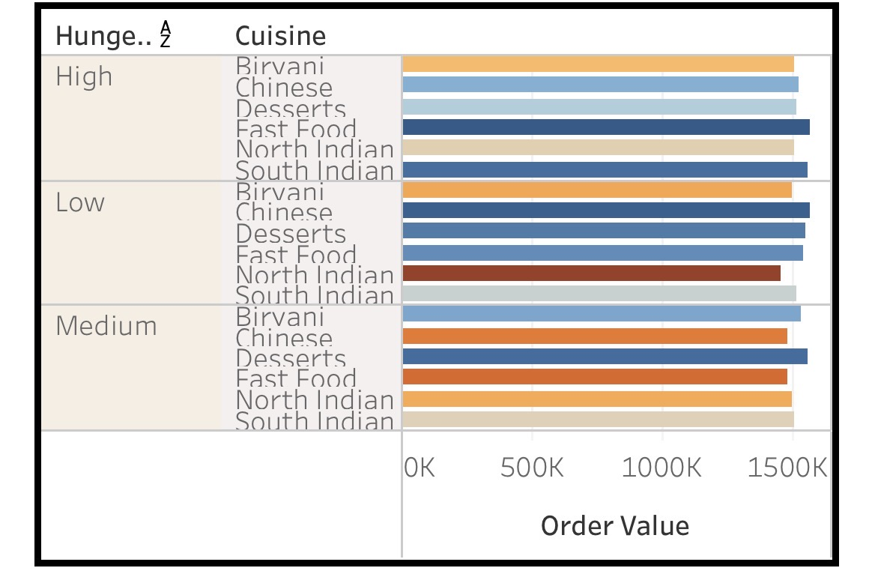

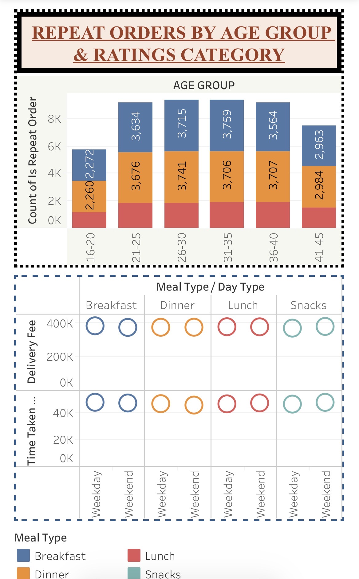

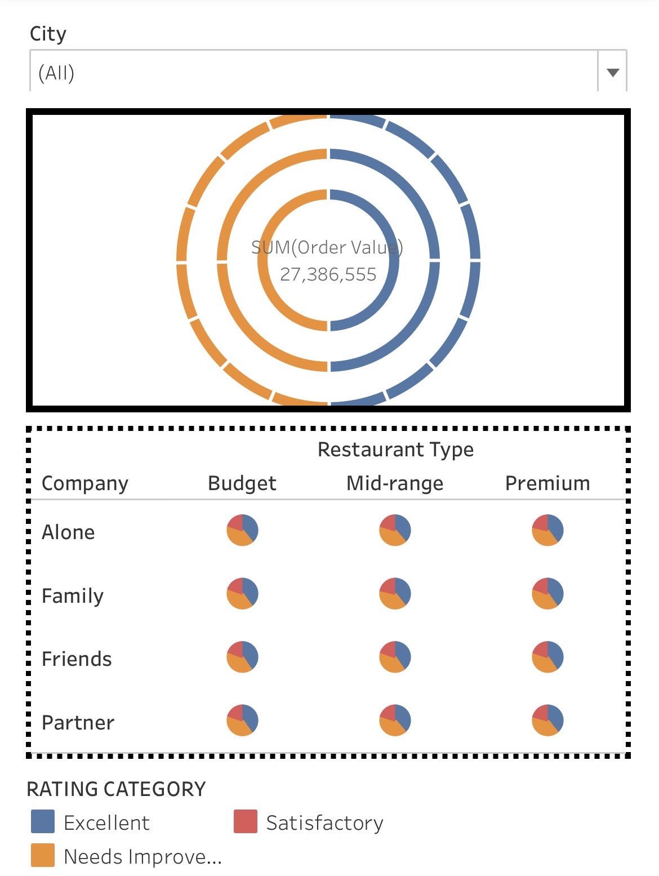

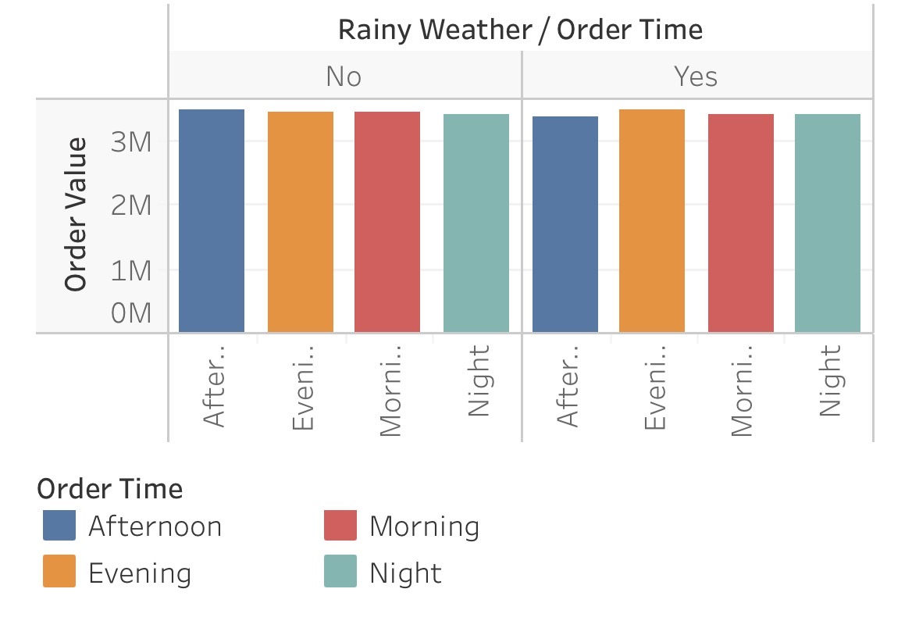

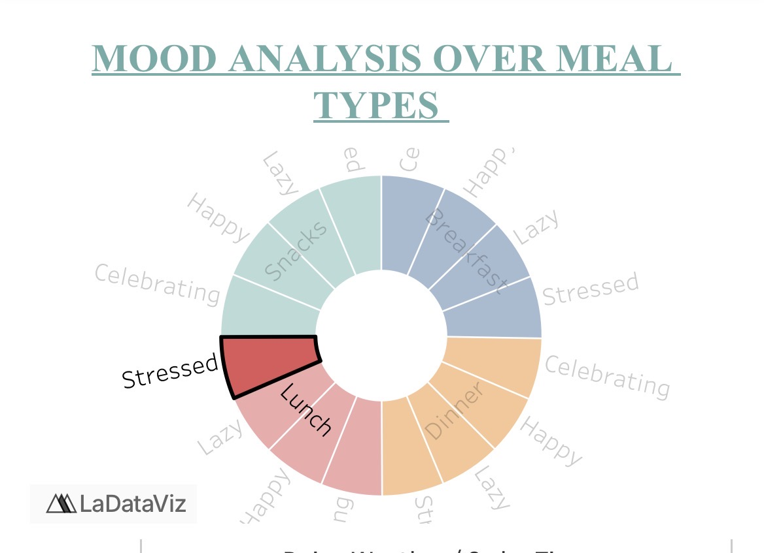

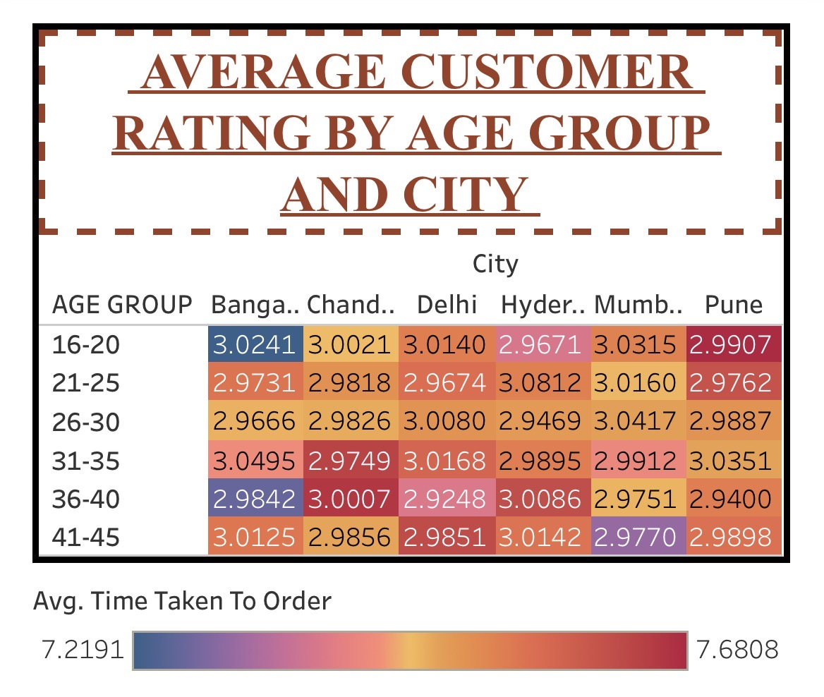

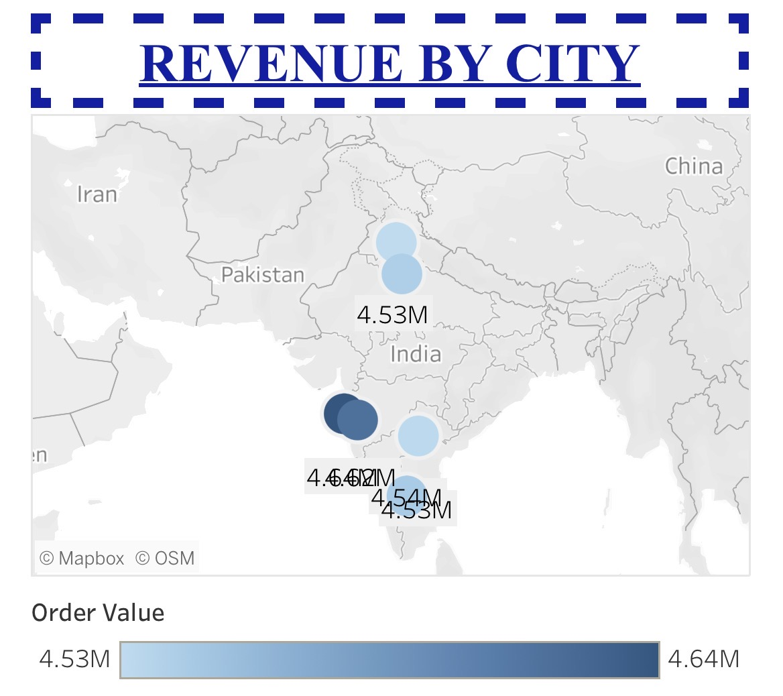
Activity 2: Live Deployment Link
Below is the updated Tableau Public link to the interactive Food Ordering Behaviour dashboard:
Tableau Public Dashboard Link: https://public.tableau.com/app/profile/mehak.chugh/viz/CUSTOMER_ORDERING_ANALYSIS/Dashboard1
Note: Questions 2 and 7 from the original 11-question set remain excluded from the final dashboard, as specified.

