

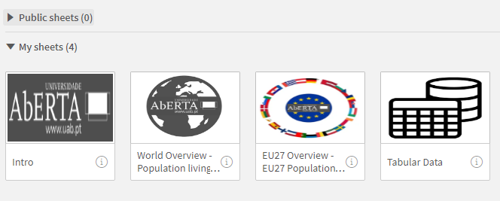

**Intro:**

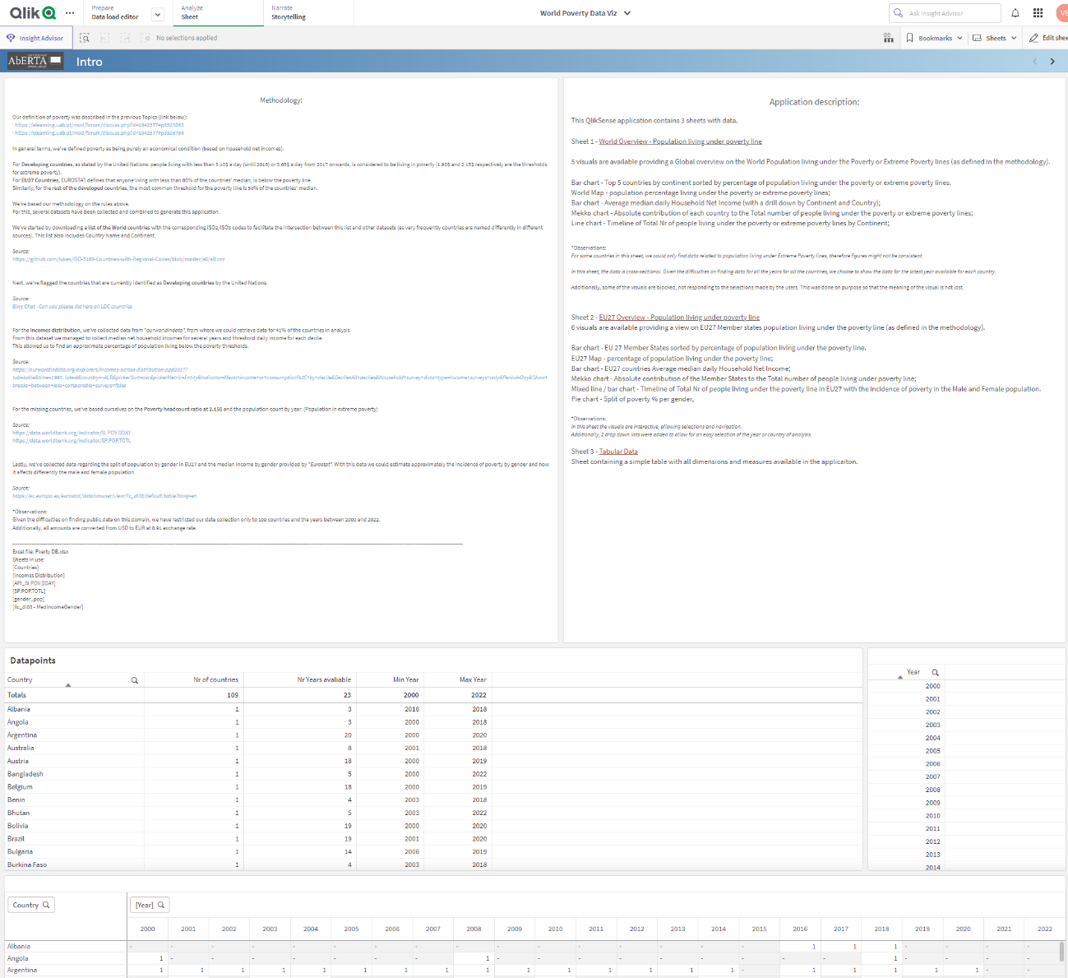

**World Overview:**

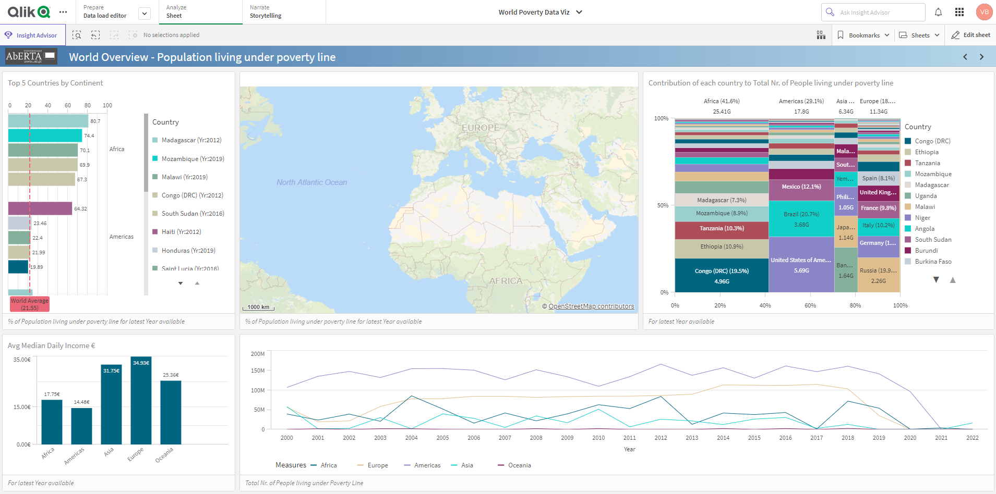

**EU27 Overview:**

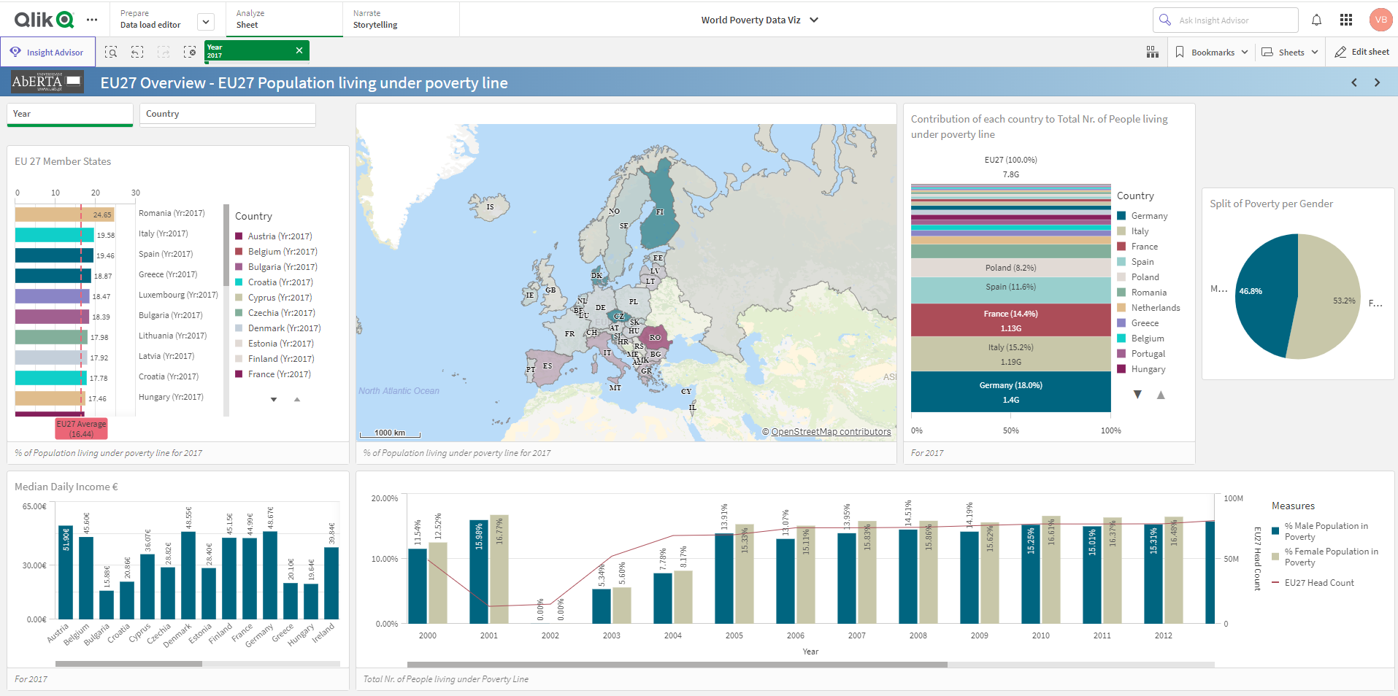

**Portugal:**

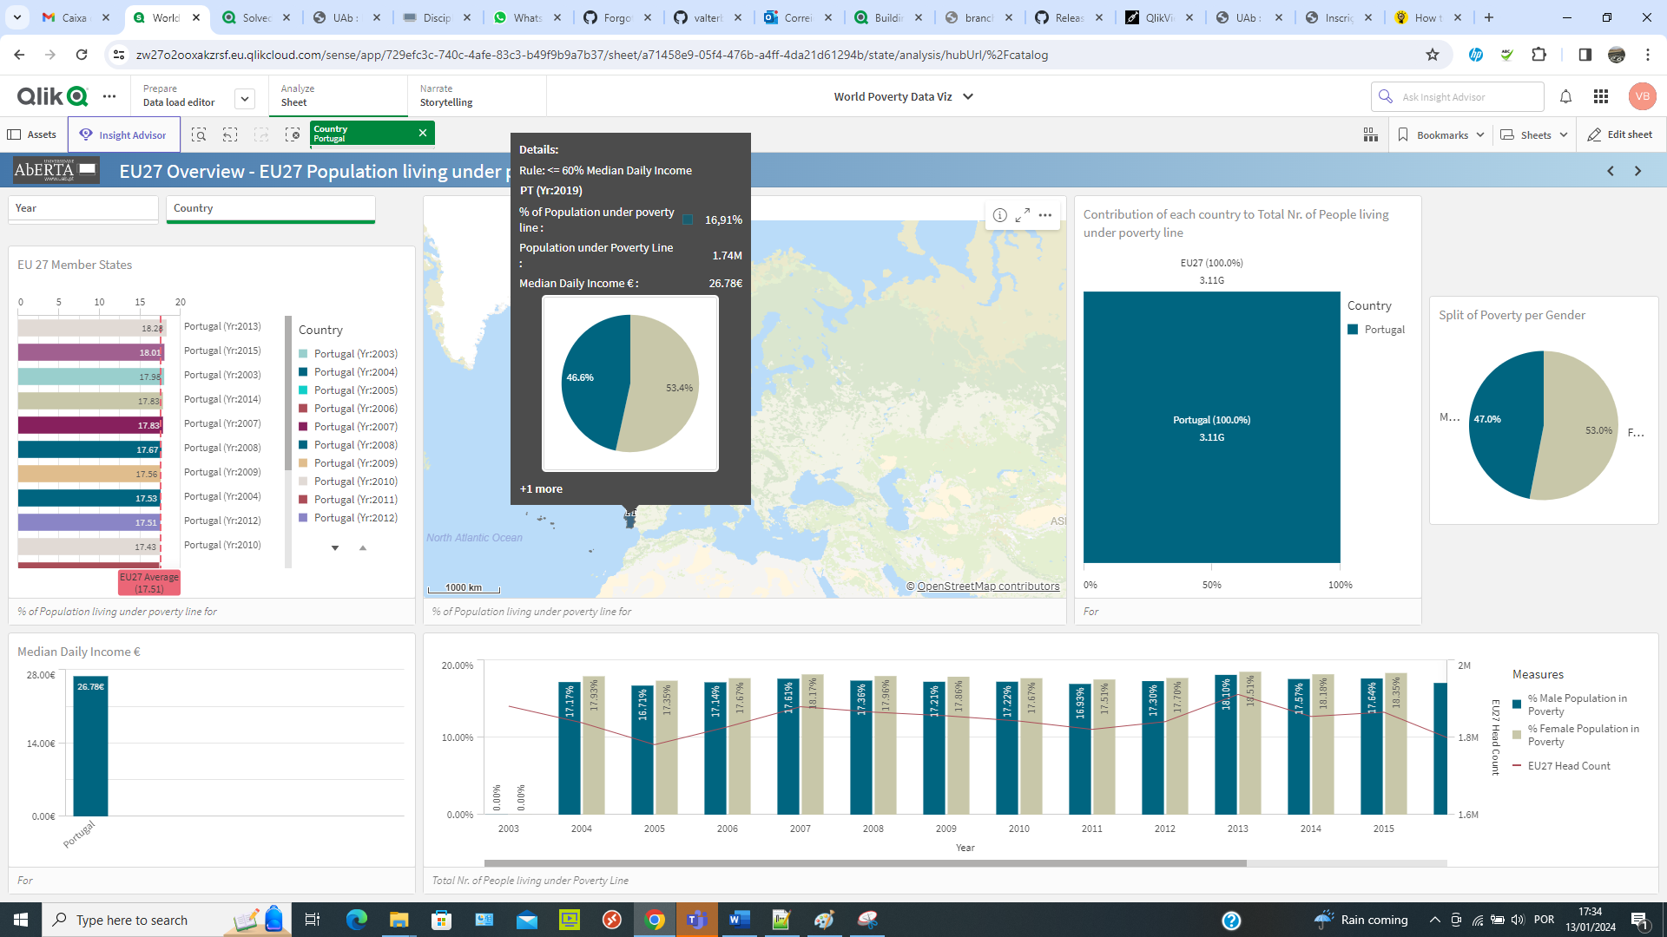

**Tabular Data:**

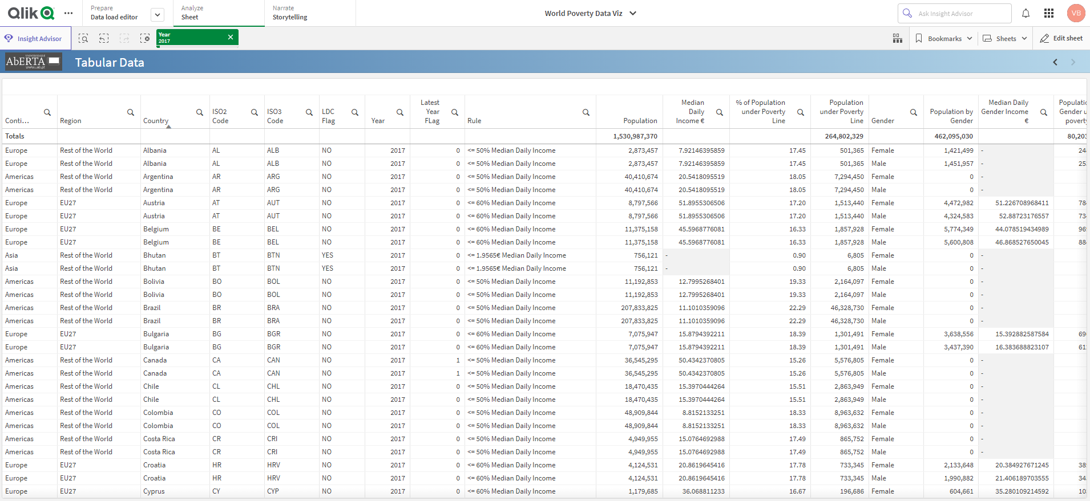

**Fields available:**

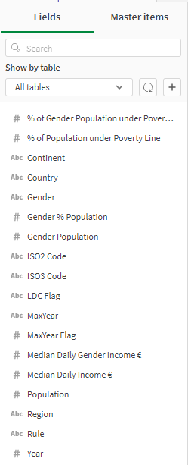

**Loading Script:**

**SET** ***ThousandSep***=',';

**SET** ***DecimalSep***='.';

**SET** ***MoneyThousandSep***=',';

**SET** ***MoneyDecimalSep***='.';

**SET** ***MoneyFormat***='€#,##0.00;-€#,##0.00';

**SET** ***TimeFormat***='hh:mm:ss';

**SET** ***DateFormat***='DD/MM/YYYY';

**SET** ***TimestampFormat***='DD/MM/YYYY hh:mm:ss[.fff]';

**SET** FirstWeekDay=6;

**SET** BrokenWeeks=0;

**SET** ReferenceDay=4;

**SET** FirstMonthOfYear=1;

**SET** CollationLocale='en-IE';

**SET** CreateSearchIndexOnReload=1;

**SET** ***MonthNames***='Jan;Feb;Mar;Apr;May;Jun;Jul;Aug;Sep;Oct;Nov;Dec';

**SET** LongMonthNames='January;February;March;April;May;June;July;August;September;October;November;December';

**SET** ***DayNames***='Mon;Tue;Wed;Thu;Fri;Sat;Sun';

**SET** LongDayNames='Monday;Tuesday;Wednesday;Thursday;Friday;Saturday;Sunday';

**SET** NumericalAbbreviation='3:k;6:M;9:G;12:T;15:P;18:E;21:Z;24:Y;-3:m;-6:μ;-9:n;-12:p;-15:f;-18:a;-21:z;-24:y';

**set** vUSD_to_EUR = 0.91;

//set vPovertyThresholdBefore2017 = 1.90; //Extreme

//set vPovertyThresholdAfter2017 = 2.15; //Extreme

**set** vPovertyThresholdBefore2017 = 3.10; //Poverty

**set** vPovertyThresholdAfter2017 = 3.65; //Poverty

//Create Countries definition table

Countries:

**LOAD distinct**

[Country],

[ISO2_Code],

[ISO3_Code],

[LDC Flag],

[Region],

[Continent]

**FROM** [lib://…/Pverty DB.xlsx]

(ooxml, embedded labels, table is [Countries])

;

Map_Country_ISO3:

**mapping LOAD** distinct [Country], [ISO3_Code] **Resident** Countries;

Map_Country_ISO2:

**mapping LOAD** distinct [Country], [ISO2_Code] **Resident** Countries;

Map_ISO3_LDC:

**mapping LOAD** distinct [ISO3_Code], [LDC Flag] **Resident** Countries;

Map_ISO3_Region:

**mapping LOAD** distinct [ISO3_Code], [Region] **Resident** Countries;

Map_ISO3_Continent:

**mapping LOAD** distinct [ISO3_Code], [Continent] **Resident** Countries;

Map_ISO3_Country:

**mapping LOAD** distinct [ISO3_Code], [Country] **Resident** Countries;

Map_ISO3_ISO2:

**mapping LOAD** distinct [ISO3_Code], [ISO2_Code] **Resident** Countries;

Map_ISO2_ISO3:

**mapping LOAD** distinct [ISO2_Code], [ISO3_Code] **Resident** Countries;

Map_ISO2_Country:

**mapping LOAD** distinct [ISO2_Code], [Country] **Resident** Countries;

Map_ISO2_Region:

**mapping LOAD** distinct [ISO2_Code], [Region] **Resident** Countries;

//Incomes Distribution table

//https://ourworldindata.org/explorers/incomes-across-distribution-ppp2017?tab=table&time=1990..latest&country=~ALB&pickerSort=asc&pickerMetric=Entity&Indicator=Mean+income+or+consumption%2C+by+decile&Decile=All+deciles&Household+survey+data+type=Income+surveys+only&Period=Day&Show+breaks+between+less+comparable+surveys=false

[Incomes Distribution_aux]:

**Load**

[ISO3_Code]&'-'&[Year] **as** [PK_ISO3_YEAR],

ApplyMap('Map_ISO3_LDC', [ISO3_Code],'N/A') **as** [LDC Flag],

ApplyMap('Map_ISO3_Region', [ISO3_Code],'N/A') **as** [Region],

*

**FROM** [lib://…/Pverty DB.xlsx]

(ooxml, embedded labels, header is 1 lines, table is [Incomes Distribution])

**where** NUM#([Year]) >= 2000

;

**drop field** [Entity];

**drop field** [reporting_level];

**drop field** [welfare_type];

**drop field** [Mean income per day $];

**drop field** [Mean income per year $];

**drop field** [Median income per year $];

NoConcatenate

[Incomes Distribution]:

**LOAD**

[PK_ISO3_YEAR] ,

[ISO3_Code] ,

NUM#([Year]) **as** [Year],

**If**([LDC Flag]='YES',

**if**([Year]>=2017, '<= '&$(vPovertyThresholdAfter2017)*$(vUSD_to_EUR)&'€ Median Daily Income', '<= '&$(vPovertyThresholdBefore2017)*$(vUSD_to_EUR)&'€ Median Daily Income'),

**If**([Region]='EU27', '<= 60% Median Daily Income', '<= 50% Median Daily Income')

) **as** [Rule],

[Median income per day $]*$(vUSD_to_EUR) **as** [Median Daily Income €],

[Poorest decile] **as** [1 decile Mean Daily Income],

[2nd decile] **as** [2 decile Mean Daily Income],

[3rd decile] **as** [3 decile Mean Daily Income],

[4th decile] **as** [4 decile Mean Daily Income],

[5th decile] **as** [5 decile Mean Daily Income],

[6th decile] **as** [6 decile Mean Daily Income],

[7th decile] **as** [7 decile Mean Daily Income],

[8th decile] **as** [8 decile Mean Daily Income],

[9th decile] **as** [9 decile Mean Daily Income],

[Richest decile] **as** [10 decile Mean Daily Income],

[Poorest decile1] **as** [1 decile Threshold Daily Income],

[2nd decile1] **as** [2 decile Threshold Daily Income],

[3rd decile1] **as** [3 decile Threshold Daily Income],

[4th decile1] **as** [4 decile Threshold Daily Income],

[5th decile (median)] **as** [5 decile Threshold Daily Income],

[6th decile1] **as** [6 decile Threshold Daily Income],

[7th decile1] **as** [7 decile Threshold Daily Income],

[8th decile1] **as** [8 decile Threshold Daily Income],

[Richest decile1] **as** [9 decile Threshold Daily Income],

[Population]

**Resident** [Incomes Distribution_aux];

**DROP TABLE** [Incomes Distribution_aux];

//Poverty headcount ratio at 2.15usd day

//https://data.worldbank.org/indicator/SI.POV.DDAY

NoConcatenate

[PVT_215_aux0]:

**Load**

*

**FROM** [lib://…/Pverty DB.xlsx]

(ooxml, embedded labels, table is [API_SI.POV.DDAY]);

PVT_215_aux1:

//Cross table from YEAR in columns to YEAR in rows

**crosstable**([Year],[% of Population under 2.15$],1)

**Load** *

**Resident** PVT_215_aux0;

**drop table** PVT_215_aux0;

NoConcatenate

PVT_215:

**LOAD**

[Country Code] **as** [ISO3_Code],

ApplyMap('Map_ISO3_LDC', [Country Code],'N/A') **as** [LDC Flag],

NUM#([Year]) **as** [Year],

[% of Population under 2.15$]

**Resident** [PVT_215_aux1];

**drop table** [PVT_215_aux1];

//Add % of Population under 2.15$ for missing countries in Incomes Distribution

**join**([Incomes Distribution])

**Load**

[ISO3_Code]&'-'&[Year] **as** [PK_ISO3_YEAR] ,

[ISO3_Code] **as** [ISO3_Code] ,

[Year] **as** [Year] ,

'<= '&2.15*$(vUSD_to_EUR)&'€ Median Daily Income' **as** [Rule2],

[% of Population under 2.15$]

**Resident** PVT_215

**Where** [Year]>=2000

**and** [LDC Flag] ='YES';

**drop table** PVT_215;

//---------------------------------------------------------------------------------------

//Country Population Table

//https://data.worldbank.org/indicator/SP_POP_TOTL

NoConcatenate

[population_aux0]:

**Load**

*

**FROM** [lib://…/Pverty DB.xlsx]

(ooxml, embedded labels, table is [SP.POP.TOTL]);

population:

//Cross table from YEAR in columns to YEAR in rows

**crosstable**([Year],[Ctr_Population],1)

**Load** *

**Resident** population_aux0;

**drop table** population_aux0;

//Add Countries population for Newly added countries

**left join**([Incomes Distribution])

**Load**

[Country Code]&'-'&[Year] **as** [PK_ISO3_YEAR] ,

[Country Code] **as** [ISO3_Code] ,

NUM#([Year]) **as** [Year] ,

[Ctr_Population]

**Resident** population

**Where** NUM#([Year])>=2000;

**drop table** population;

//---------------------------------------------------------------------------------------

//Population by gender Table

//https://ec.europa.eu/eurostat/databrowser/view/demo_pjan/default/table?lang=en

NoConcatenate

[gender_population_aux0]:

**Load**

*

**FROM** [lib://…/Pverty DB.xlsx]

(ooxml, embedded labels, table is [gender_pop]);

gender_population_aux:

//Cross table from YEAR in columns to YEAR in rows

**crosstable**([Year],[Gender_Ctr_Population],5)

**Load** *

**Resident** gender_population_aux0;

**drop table** [gender_population_aux0];

NoConcatenate

gender_population:

**Load**

ApplyMap('Map_ISO2_ISO3', [geo],'N/A') **as** [ISO3_Code],

NUM#([Year]) **as** [Year],

[Gender_Ctr_Population] **as** [Gender_Ctr_Total_Population]

**Resident** [gender_population_aux]

**Where** [sex]='T' **and** [Gender_Ctr_Population]<>':';

**LEFT Join**

**Load**

ApplyMap('Map_ISO2_ISO3', [geo],'N/A') **as** [ISO3_Code],

NUM#([Year]) **as** [Year],

[Gender_Ctr_Population] **as** [Gender_Ctr_Female_Population]

**Resident** [gender_population_aux]

**Where** [sex]='F'**and** [Gender_Ctr_Population]<>':';

**LEFT Join**

**Load**

ApplyMap('Map_ISO2_ISO3', [geo],'N/A') **as** [ISO3_Code],

NUM#([Year]) **as** [Year],

[Gender_Ctr_Population] **as** [Gender_Ctr_Male_Population]

**Resident** [gender_population_aux]

**Where** [sex]='M'**and** [Gender_Ctr_Population]<>':';

**drop table** [gender_population_aux];

//Add Countries population by gender for all countries

**left join**([Incomes Distribution])

**Load**

[ISO3_Code]&'-'&[Year] **as** [PK_ISO3_YEAR] ,

[ISO3_Code] **as** [ISO3_Code] ,

NUM#([Year]) **as** [Year] ,

[Gender_Ctr_Total_Population],

[Gender_Ctr_Female_Population],

[Gender_Ctr_Male_Population]

**Resident** gender_population

**Where** NUM#([Year])>=2000;

**drop table** gender_population;

//---------------------------------------------------------------------------------------

//Income by gender

//https://ec.europa.eu/eurostat/databrowser/view/ilc_di03/default/table?lang=en

NoConcatenate

[gender_income_aux0]:

**Load**

*

**FROM** [lib://…/Pverty DB.xlsx]

(ooxml, embedded labels, table is [ilc_di03 - MedIncomeGender])

**Where** [unit] = 'EUR'

**and** [indic_il] = 'MED_E'

**and** [age] = 'TOTAL';

gender_income_aux:

//Cross table from YEAR in columns to YEAR in rows

**crosstable**([Year],[Gender_med_income],6)

**Load** *

**Resident** gender_income_aux0;

**drop table** [gender_income_aux0];

NoConcatenate

gender_income:

**Load**

ApplyMap('Map_ISO2_ISO3', [geo],'N/A') **as** [ISO3_Code],

NUM#([Year]) **as** [Year],

ApplyMap('Map_ISO2_Region', [geo],'N/A') **as** [Region],

[Gender_med_income] **as** [Median Daily Total Income €]

**Resident** [gender_income_aux]

**Where** [sex]='T' **and** [Gender_med_income]<>':';

**LEFT Join**

**Load**

ApplyMap('Map_ISO2_ISO3', [geo],'N/A') **as** [ISO3_Code],

NUM#([Year]) **as** [Year],

ApplyMap('Map_ISO2_Region', [geo],'N/A') **as** [Region],

[Gender_med_income] **as** [Median Daily Female Income €]

**Resident** [gender_income_aux]

**Where** [sex]='F' **and** [Gender_med_income]<>':';

**LEFT Join**

**Load**

ApplyMap('Map_ISO2_ISO3', [geo],'N/A') **as** [ISO3_Code],

NUM#([Year]) **as** [Year],

ApplyMap('Map_ISO2_Region', [geo],'N/A') **as** [Region],

[Gender_med_income] **as** [Median Daily Male Income €]

**Resident** [gender_income_aux]

**Where** [sex]='M' **and** [Gender_med_income]<>':';

**drop table** [gender_income_aux];

//Add median income by gender for all countries

**left join**([Incomes Distribution])

**Load**

[ISO3_Code]&'-'&[Year] **as** [PK_ISO3_YEAR] ,

[ISO3_Code] **as** [ISO3_Code] ,

NUM#([Year]) **as** [Year] ,

[Median Daily Total Income €],

[Median Daily Female Income €],

[Median Daily Male Income €]

**Resident** gender_income

**Where** NUM#([Year])>=2000

**and** Region = 'EU27';

**drop table** gender_income;

//---------------------------------------------------------------------------------------

Map_ISO3_MaxYear:

**mapping LOAD** distinct [ISO3_Code] , max(NUM#([Year])) **as** MaxYear

**Resident** [Incomes Distribution]

**group by** [ISO3_Code] ;

[Population Income]:

**Load**

[ISO2_Code] **as** [ISO2 Code],

[ISO3_Code] **as** [ISO3 Code],

[Country] ,

[Continent] ,

[Region] ,

[LDC Flag] ,

[Year] ,

[Rule] ,

[Median Daily Income €] **as** [Median Daily Income €],

[Median Daily Female Income €] **as** [Median Daily Female Income €],

[Median Daily Male Income €] **as** [Median Daily Male Income €],

[Population] ,

[% Female Population] **as** [% Female Population],

floor([Population]*[% Female Population]) **as** [Female Population],

[% Male Population] **as** [% Male Population],

floor([Population]*[% Male Population]) **as** [Male Population],

Num(**if**(len(keepchar([% of Population under Poverty Line],'0123456789.')) =0 **or** num(keepchar([% of Population under Poverty Line],'0123456789.'))=0,

keepchar([% of Population under 2.15$],'0123456789.'),

keepchar([% of Population under Poverty Line],'0123456789.')

),'##.00') **as** [% of Population under Poverty Line],

Num([% of Female Population under Poverty Line],'##.00') **as** [% of Female Population under Poverty Line],

Num([% of Male Population under Poverty Line],'##.00') **as** [% of Male Population under Poverty Line],

**if**([Year]=ApplyMap('Map_ISO3_MaxYear', [ISO3_Code],'N/A'),1,0) **as** [MaxYear Flag],

**if**([Year]=ApplyMap('Map_ISO3_MaxYear', [ISO3_Code],'N/A'),[Year],'N/A') **as** [MaxYear]

;

**Load**

*,

**IF**( [Poverty Line Amt €] <= [1 decile Threshold Daily Income], [Poverty Line Amt €]/([1 decile Threshold Daily Income]/10),

**IF**( [Poverty Line Amt €] <= [2 decile Threshold Daily Income], [Poverty Line Amt €]/([2 decile Threshold Daily Income]/20),

**IF**( [Poverty Line Amt €] <= [3 decile Threshold Daily Income], [Poverty Line Amt €]/([3 decile Threshold Daily Income]/30),

**IF**( [Poverty Line Amt €] <= [4 decile Threshold Daily Income], [Poverty Line Amt €]/([4 decile Threshold Daily Income]/40),

**IF**( [Poverty Line Amt €] <= [5 decile Threshold Daily Income], [Poverty Line Amt €]/([5 decile Threshold Daily Income]/50),

**IF**( [Poverty Line Amt €] <= [6 decile Threshold Daily Income], [Poverty Line Amt €]/([6 decile Threshold Daily Income]/60),

**IF**( [Poverty Line Amt €] <= [7 decile Threshold Daily Income], [Poverty Line Amt €]/([7 decile Threshold Daily Income]/70),

**IF**( [Poverty Line Amt €] <= [8 decile Threshold Daily Income], [Poverty Line Amt €]/([8 decile Threshold Daily Income]/80),

**IF**( [Poverty Line Amt €] <= [9 decile Threshold Daily Income], [Poverty Line Amt €]/([9 decile Threshold Daily Income]/90),

0))))))))) **as** [% of Population under Poverty Line],

**IF**( [Female Poverty Line Amt €] <= [1 decile Threshold Daily Income], [Female Poverty Line Amt €]/([1 decile Threshold Daily Income]/10),

**IF**( [Female Poverty Line Amt €] <= [2 decile Threshold Daily Income], [Female Poverty Line Amt €]/([2 decile Threshold Daily Income]/20),

**IF**( [Female Poverty Line Amt €] <= [3 decile Threshold Daily Income], [Female Poverty Line Amt €]/([3 decile Threshold Daily Income]/30),

**IF**( [Female Poverty Line Amt €] <= [4 decile Threshold Daily Income], [Female Poverty Line Amt €]/([4 decile Threshold Daily Income]/40),

**IF**( [Female Poverty Line Amt €] <= [5 decile Threshold Daily Income], [Female Poverty Line Amt €]/([5 decile Threshold Daily Income]/50),

**IF**( [Female Poverty Line Amt €] <= [6 decile Threshold Daily Income], [Female Poverty Line Amt €]/([6 decile Threshold Daily Income]/60),

**IF**( [Female Poverty Line Amt €] <= [7 decile Threshold Daily Income], [Female Poverty Line Amt €]/([7 decile Threshold Daily Income]/70),

**IF**( [Female Poverty Line Amt €] <= [8 decile Threshold Daily Income], [Female Poverty Line Amt €]/([8 decile Threshold Daily Income]/80),

**IF**( [Female Poverty Line Amt €] <= [9 decile Threshold Daily Income], [Female Poverty Line Amt €]/([9 decile Threshold Daily Income]/90),

0))))))))) **as** [% of Female Population under Poverty Line],

**IF**( [Male Poverty Line Amt €] <= [1 decile Threshold Daily Income], [Male Poverty Line Amt €]/([1 decile Threshold Daily Income]/10),

**IF**( [Male Poverty Line Amt €] <= [2 decile Threshold Daily Income], [Male Poverty Line Amt €]/([2 decile Threshold Daily Income]/20),

**IF**( [Male Poverty Line Amt €] <= [3 decile Threshold Daily Income], [Male Poverty Line Amt €]/([3 decile Threshold Daily Income]/30),

**IF**( [Male Poverty Line Amt €] <= [4 decile Threshold Daily Income], [Male Poverty Line Amt €]/([4 decile Threshold Daily Income]/40),

**IF**( [Male Poverty Line Amt €] <= [5 decile Threshold Daily Income], [Male Poverty Line Amt €]/([5 decile Threshold Daily Income]/50),

**IF**( [Male Poverty Line Amt €] <= [6 decile Threshold Daily Income], [Male Poverty Line Amt €]/([6 decile Threshold Daily Income]/60),

**IF**( [Male Poverty Line Amt €] <= [7 decile Threshold Daily Income], [Male Poverty Line Amt €]/([7 decile Threshold Daily Income]/70),

**IF**( [Male Poverty Line Amt €] <= [8 decile Threshold Daily Income], [Male Poverty Line Amt €]/([8 decile Threshold Daily Income]/80),

**IF**( [Male Poverty Line Amt €] <= [9 decile Threshold Daily Income], [Male Poverty Line Amt €]/([9 decile Threshold Daily Income]/90),

0))))))))) **as** [% of Male Population under Poverty Line];

**Load**

*,

**If**([LDC Flag]='YES',

**if**([Year]>=2017, $(vPovertyThresholdAfter2017)*$(vUSD_to_EUR), $(vPovertyThresholdBefore2017)*$(vUSD_to_EUR)),

**If**([Region]='EU27', 0.6*([Median Daily Income €])

, 0.5*([Median Daily Income €]))

) **as** [Poverty Line Amt €],

**If**([LDC Flag]='YES',

**if**([Year]>=2017, $(vPovertyThresholdAfter2017)*$(vUSD_to_EUR), $(vPovertyThresholdBefore2017)*$(vUSD_to_EUR)),

**If**([Region]='EU27', 0.6*([Median Daily Income €]+([Median Daily Income €]*[% Male Income]/100))

, 0.5*([Median Daily Income €]))

) **as** [Female Poverty Line Amt €],

**If**([LDC Flag]='YES',

**if**([Year]>=2017, $(vPovertyThresholdAfter2017)*$(vUSD_to_EUR), $(vPovertyThresholdBefore2017)*$(vUSD_to_EUR)),

**If**([Region]='EU27', 0.6*([Median Daily Income €]+([Median Daily Income €]*[% Female Income]/100))

, 0.5*([Median Daily Income €]))

) **as** [Male Poverty Line Amt €],

[Median Daily Income €]+([Median Daily Income €]*[% Female Income]/100) **as** [Median Daily Female Income €],

[Median Daily Income €]+([Median Daily Income €]*[% Male Income]/100) **as** [Median Daily Male Income €]

;

**Load**

ApplyMap('Map_ISO3_ISO2', [ISO3_Code],'N/A') **as** [ISO2_Code],

[ISO3_Code] **as** [ISO3_Code],

ApplyMap('Map_ISO3_Country', [ISO3_Code],'N/A') **as** [Country],

ApplyMap('Map_ISO3_Continent', [ISO3_Code],'N/A') **as** [Continent],

ApplyMap('Map_ISO3_Region', [ISO3_Code],'N/A') **as** [Region],

ApplyMap('Map_ISO3_LDC', [ISO3_Code],'N/A') **as** [LDC Flag],

NUM#([Year]) **as** [Year],

**if**(len([Rule])=0,[Rule2],[Rule]) **as** [Rule],

**if**(len([Median Daily Income €])=0,

keepchar([Median Daily Total Income €],'0123456789.')/365,

[Median Daily Income €]) **as** [Median Daily Income €],

((keepchar([Median Daily Female Income €],'0123456789.')*100)

/

keepchar([Median Daily Total Income €],'0123456789.'))-100 **as** [% Female Income],

((keepchar([Median Daily Male Income €],'0123456789.')*100)

/

keepchar([Median Daily Total Income €],'0123456789.'))-100 **as** [% Male Income],

**if**(len([Population])=0,

keepchar([Ctr_Population],'0123456789.'),

keepchar([Population],'0123456789.')) **as** [Population],

(keepchar([Gender_Ctr_Female_Population],'0123456789.'))

/

keepchar([Gender_Ctr_Total_Population],'0123456789.') **as** [% Female Population],

//-----

(keepchar([Gender_Ctr_Male_Population],'0123456789.'))

/

keepchar([Gender_Ctr_Total_Population],'0123456789.') **as** [% Male Population],

[1 decile Threshold Daily Income] ,

[2 decile Threshold Daily Income] ,

[3 decile Threshold Daily Income] ,

[4 decile Threshold Daily Income] ,

[5 decile Threshold Daily Income] ,

[6 decile Threshold Daily Income] ,

[7 decile Threshold Daily Income] ,

[8 decile Threshold Daily Income] ,

[9 decile Threshold Daily Income] ,

[% of Population under 2.15$]

**Resident** [Incomes Distribution];

**left JOIN** ([Population Income])

**LOAD DISTINCT**

[ISO3 Code],

max(NUM#([Year])) **as** MaxYear

**Resident** [Population Income]

**Group by** [ISO3 Code];

**Drop Table** [Incomes Distribution];

**Drop Table** [Countries];

NoConcatenate

[Gender Incomes Distribution]:

**Load distinct**

[ISO3 Code],

[Year],

'Male' **as** [Gender],

[Male Population] **as** [Gender Population],

[% Male Population] **as** [Gender % Population],

[Median Daily Male Income €] **as** [Median Daily Gender Income €],

[% of Male Population under Poverty Line] **as** [% of Gender Population under Poverty Line]

**Resident** [Population Income];

**Load distinct**

[ISO3 Code],

[Year],

'Female' **as** [Gender],

[Female Population] **as** [Gender Population],

[% Female Population] **as** [Gender % Population],

[Median Daily Female Income €] **as** [Median Daily Gender Income €],

[% of Female Population under Poverty Line] **as** [% of Gender Population under Poverty Line]

**Resident** [Population Income];

**Drop field** [% Male Population] **from** [Population Income];

**Drop field** [Male Population] **from** [Population Income];

**Drop field** [% Female Population] **from** [Population Income];

**Drop field** [Female Population] **from** [Population Income];

**Drop field** [Median Daily Male Income €] **from** [Population Income];

**Drop field** [Median Daily Female Income €] **from** [Population Income];

**Drop field** [% of Male Population under Poverty Line] **from** [Population Income];

**Drop field** [% of Female Population under Poverty Line] **from** [Population Income];