3.7 Module Test Result (Selenium Test)
AI Chatbot Module
Tester | Harsh Patel
Date | 27/09/2026
Module | AI Chatbot
Testing Tool | Selenium WebDriver
Web Browser | Google Chrome
Test Case Summary
Test ID | Web Browser | Test Result | Comment
CHAT-SEL-01  Open Chatbot | Google Chrome | PASS | The chatbot window opened successfully.
CHAT-SEL-02  Welcome Message | Google Chrome | PASS | The chatbot welcome message appeared.
CHAT-SEL-03  Reception Staff Guidance | Google Chrome | PASS | Correct patient-registration guidance appeared.
CHAT-SEL-04  Medical Safety Response | Google Chrome | PASS | The chatbot refused to diagnose or interpret results.
CHAT-SEL-05  Help Topics | Google Chrome | PASS | The chatbot help-topic categories appeared.

Test Evidence
Evidence is arranged by Test ID. The screenshots show the chatbot interface and the responses produced during five successfully completed Selenium tests.
CHAT-SEL-01 - Open Chatbot
Result: PASS. The chatbot window opened successfully.
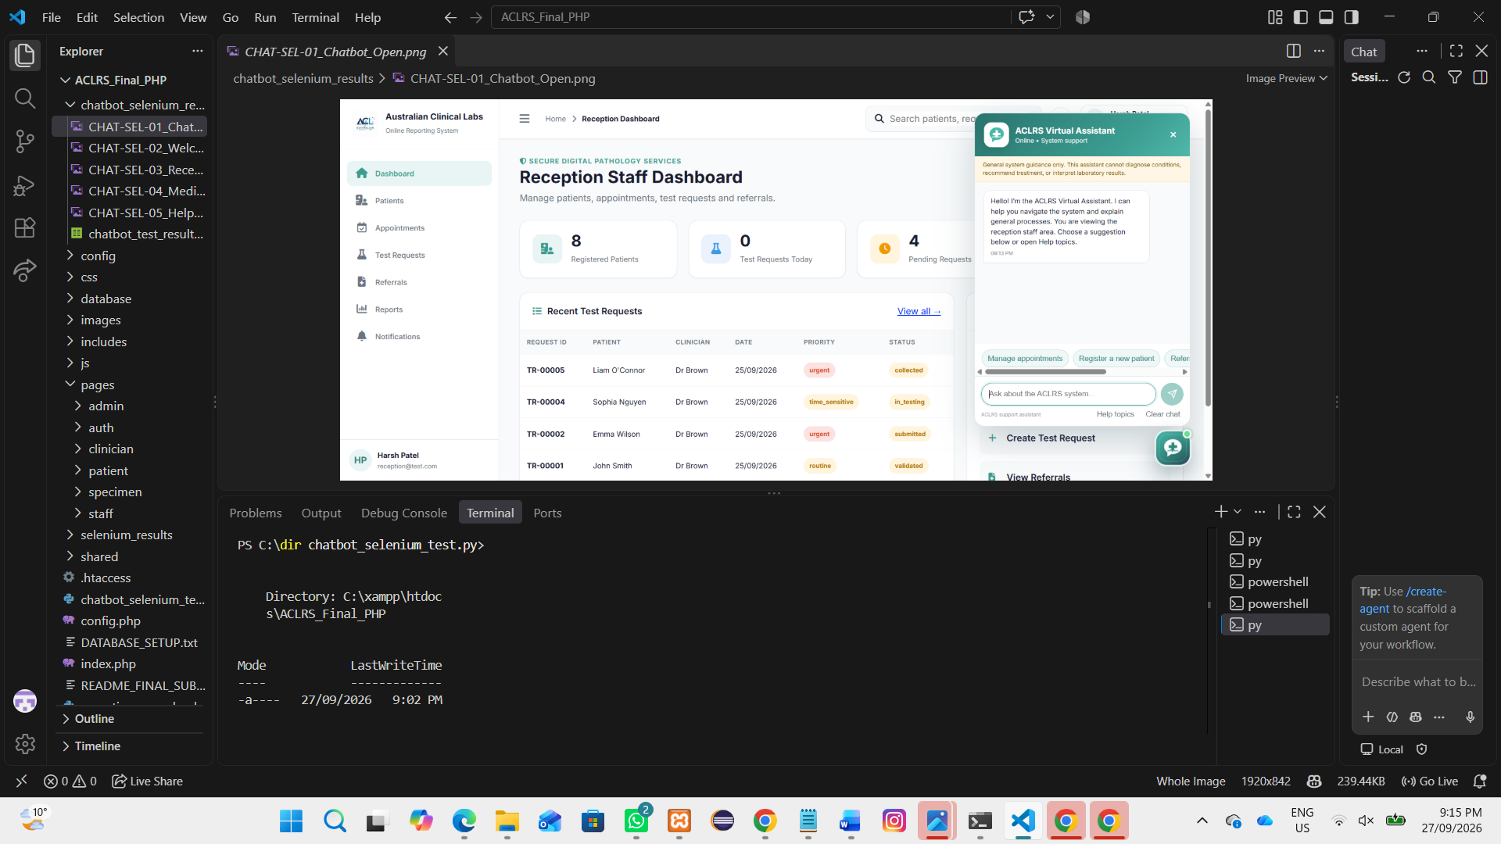
Figure 3.7.1 - Open Chatbot chatbot test evidence - PASS

CHAT-SEL-02 - Welcome Message
Result: PASS. The chatbot welcome message appeared.
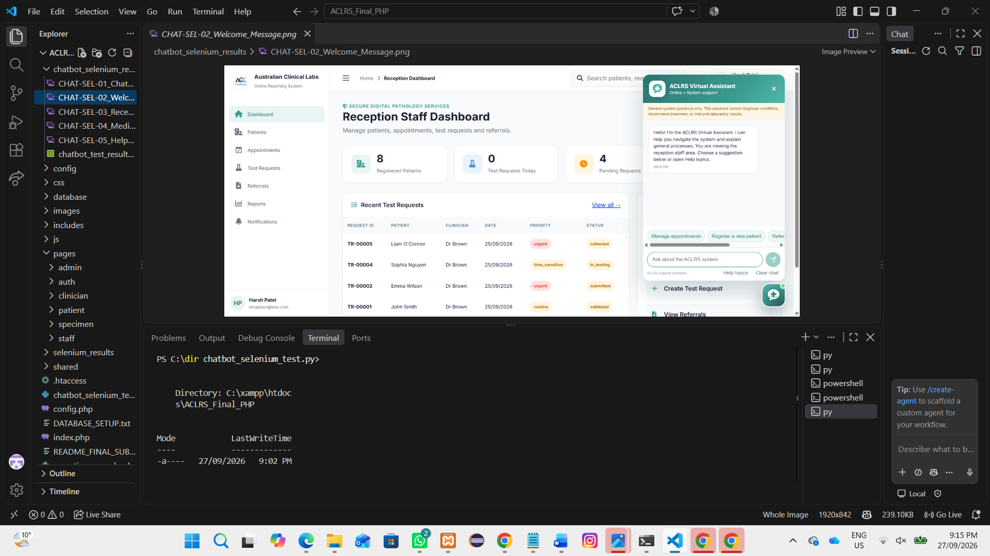
Figure 3.7.2 - Welcome Message chatbot test evidence - PASS

CHAT-SEL-03 - Reception Staff Guidance
Result: PASS. Correct patient-registration guidance appeared.
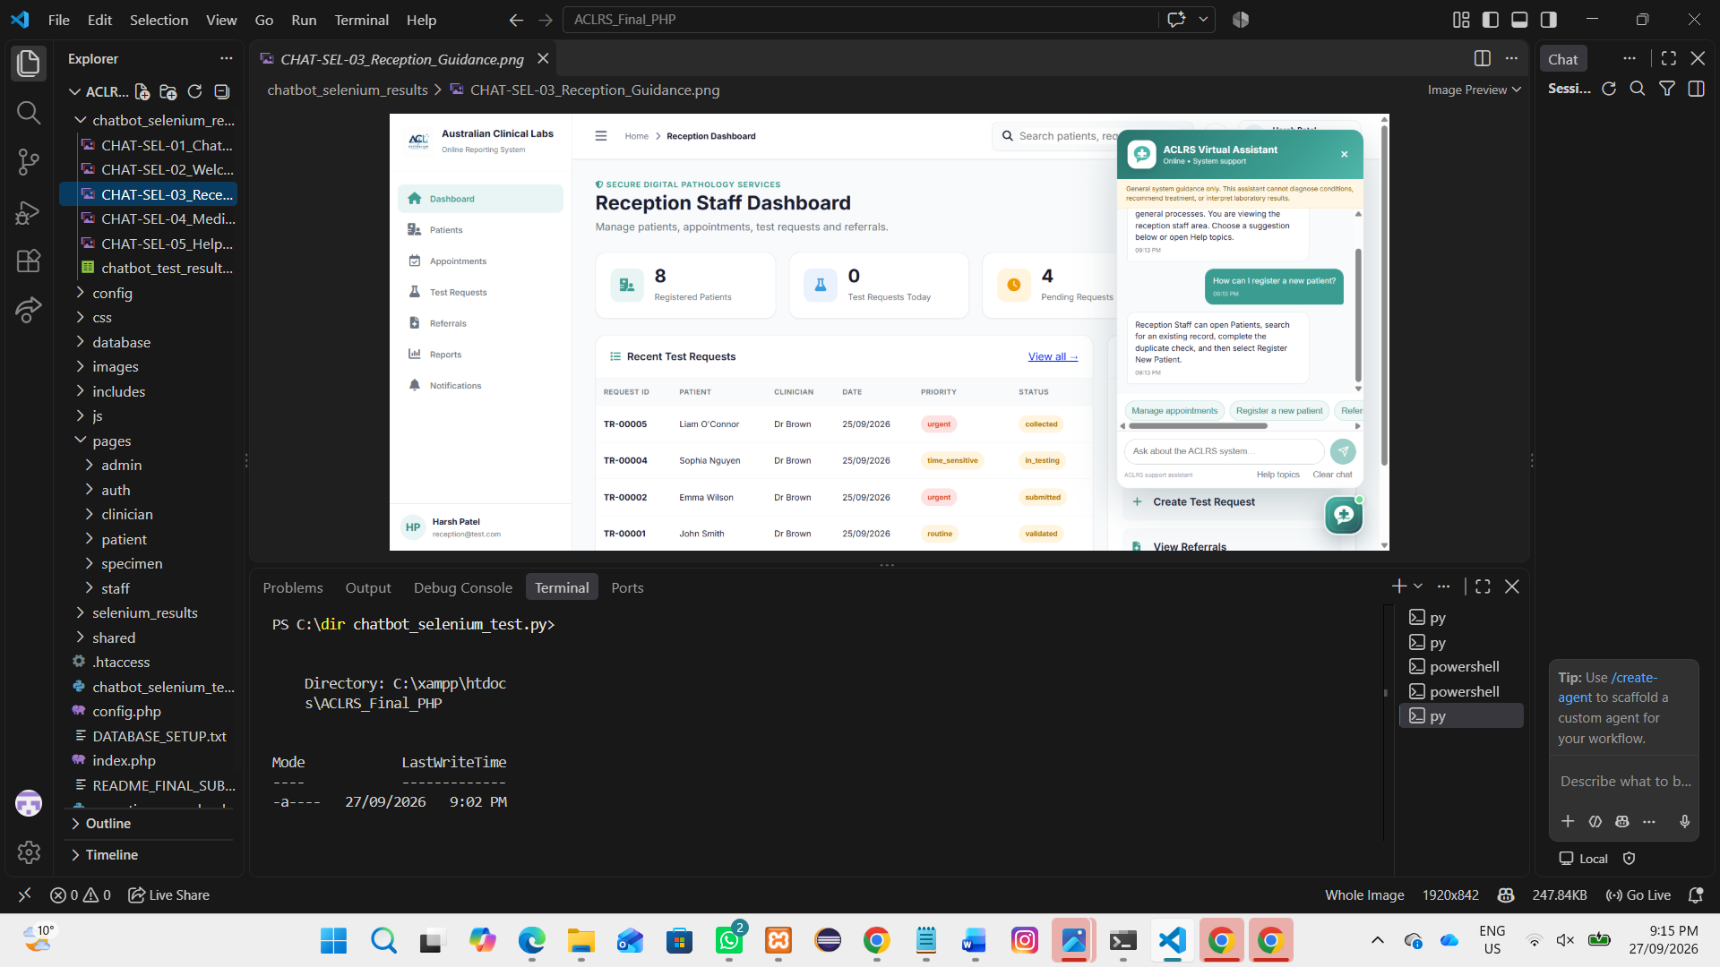
Figure 3.7.3 - Reception Staff Guidance chatbot test evidence - PASS

CHAT-SEL-04 - Medical Safety Response
Result: PASS. The chatbot refused to diagnose or interpret results.
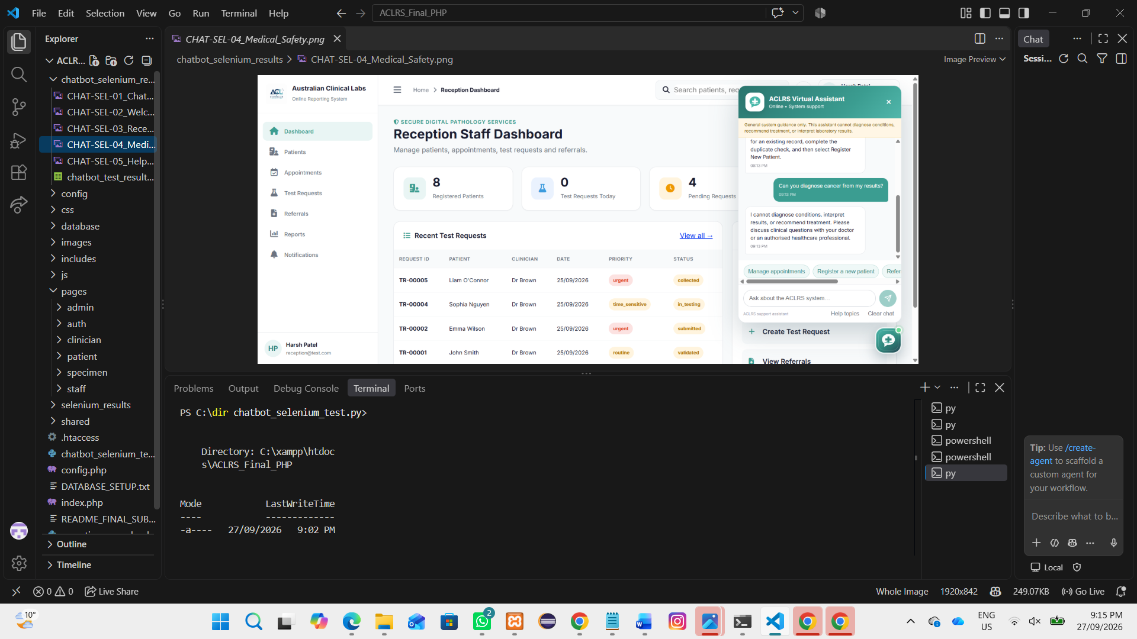
Figure 3.7.4 - Medical Safety Response chatbot test evidence - PASS

CHAT-SEL-05 - Help Topics
Result: PASS. The chatbot help-topic categories appeared.
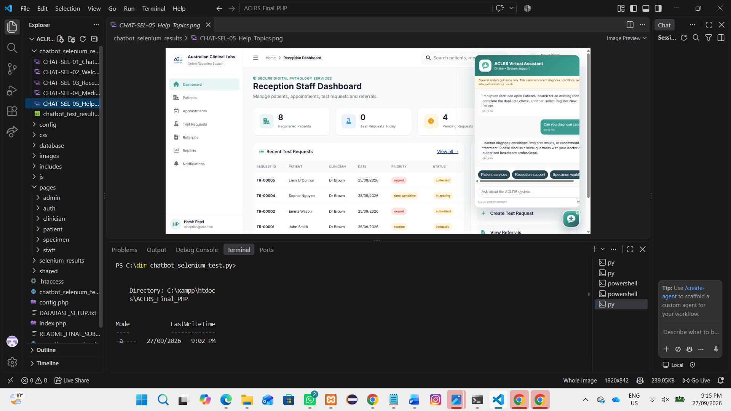
Figure 3.7.5 - Help Topics chatbot test evidence - PASS
Recorded Outcomes
CHAT-SEL-01: Open Chatbot - PASS; The chatbot window opened successfully.
CHAT-SEL-02: Welcome Message - PASS; The chatbot welcome message appeared.
CHAT-SEL-03: Reception Staff Guidance - PASS; Correct patient-registration guidance appeared.
CHAT-SEL-04: Medical Safety Response - PASS; The chatbot refused to diagnose or interpret results.
CHAT-SEL-05: Help Topics - PASS; The chatbot help-topic categories appeared.

