ACLRS — Login & Registration PHP Evidence
PHP-only implementation evidence. Source-code comments have been removed.
PHP 1 — Login Authentication & Role-Based Access
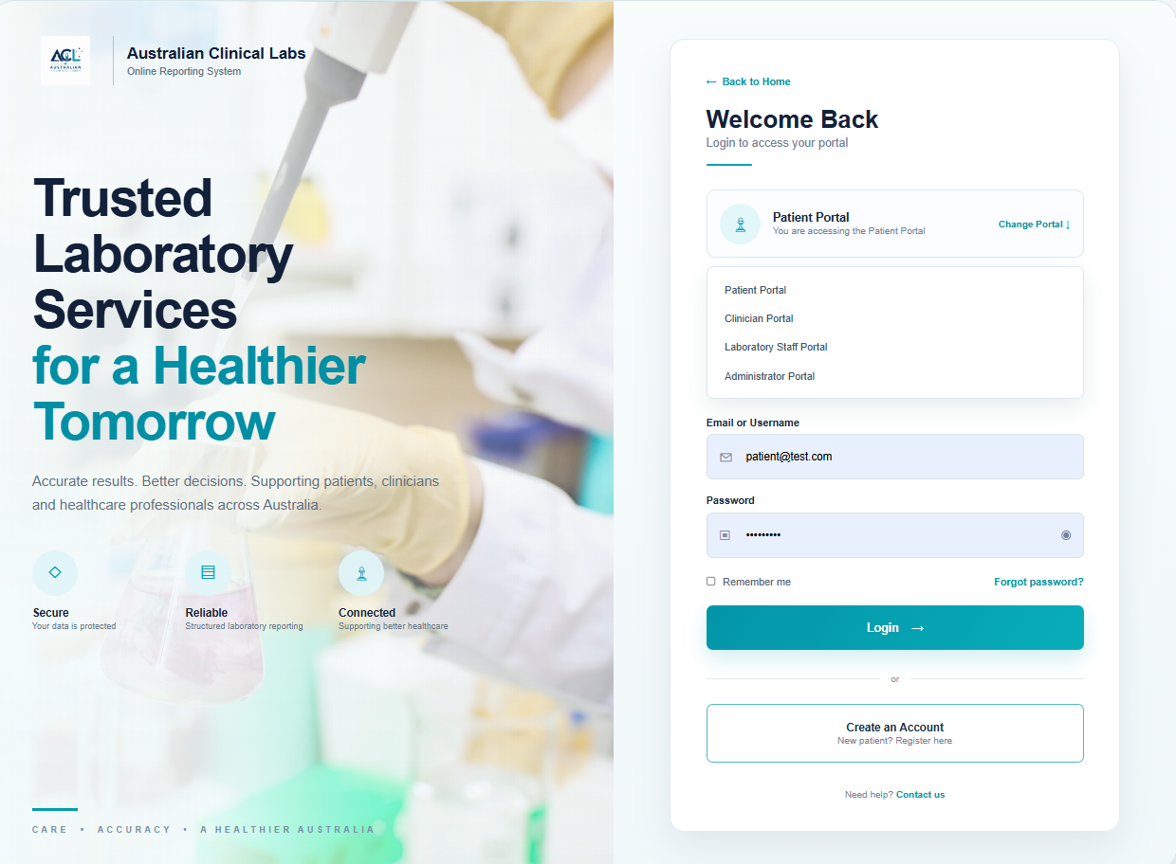
Source file: pages/auth/login.php
Purpose: Login processing, account-status checks, role loading, session creation and MFA routing.
<?php
session_start();

require_once __DIR__ . '/../../config/database.php';

$portal = $_POST['portal'] ?? $_GET['portal'] ?? 'patient';

$allowedPortals = ['patient', 'clinician', 'staff', 'admin'];

if (!in_array($portal, $allowedPortals, true)) {
$portal = 'patient';
}

$portalConfig = [
'patient' => [
'title' => 'Patient Portal',
'subtitle' => 'You are accessing the Patient Portal',
'icon' => '♙',
'showRegister' => true
],
'clinician' => [
'title' => 'Clinician Portal',
'subtitle' => 'You are accessing the Clinician Portal',
'icon' => '⚕',
'showRegister' => false
],
'staff' => [
'title' => 'Laboratory Staff Portal',
'subtitle' => 'You are accessing the Laboratory Staff Portal',
'icon' => '⚗',
'showRegister' => false
],
'admin' => [
'title' => 'Administrator Portal',
'subtitle' => 'You are accessing the Administrator Portal',
'icon' => '◇',
'showRegister' => false
]
];

$portalRoleMap = [
'patient' => [
'patient'
],
'clinician' => [
'clinician'
],
'staff' => [
'specimen_collector',
'laboratory_manager',
'receptionist',
'laboratory_technician'
],
'admin' => [
'system_administrator'
]
];

$currentPortal = $portalConfig[$portal];

$errorMessage = '';
$successMessage = '';
$loginValue = '';

if ($_SERVER['REQUEST_METHOD'] === 'POST') {

$loginValue = trim($_POST['username'] ?? '');
$password = $_POST['password'] ?? '';

if ($loginValue === '' || $password === '') {

$errorMessage = 'Please enter your email or username and password.';

} else {

try {

$userStatement = $pdo->prepare(
"SELECT
user_id,
username,
email,
password_hash,
account_status
FROM users
WHERE email = :email_login
OR username = :username_login
LIMIT 1"
);

$userStatement->execute([
'email_login' => $loginValue,
'username_login' => $loginValue
]);

$user = $userStatement->fetch(PDO::FETCH_ASSOC);

if (
!$user ||
!password_verify($password, $user['password_hash'])
) {

$errorMessage = 'Invalid email/username or password.';

} elseif ($user['account_status'] !== 'active') {

$errorMessage =
'This account is not currently active. Please contact support.';

} else {

$roleStatement = $pdo->prepare(
"SELECT r.role_name
FROM user_roles ur
INNER JOIN roles r
ON r.role_id = ur.role_id
WHERE ur.user_id = :user_id"
);

$roleStatement->execute([
'user_id' => $user['user_id']
]);

$roles = $roleStatement->fetchAll(
PDO::FETCH_COLUMN
);

$allowedRolesForPortal =
$portalRoleMap[$portal];

$matchingRoles =
array_values(
array_intersect(
$roles,
$allowedRolesForPortal
)
);

if (empty($matchingRoles)) {

$errorMessage =
'Access denied. Your account does not have permission to use the selected portal.';

} else {

session_regenerate_id(true);

$_SESSION['authenticated'] = true;
$_SESSION['user_id'] = (int) $user['user_id'];
$_SESSION['username'] = $user['username'];
$_SESSION['email'] = $user['email'];
$_SESSION['roles'] = $roles;
$_SESSION['portal'] = $portal;
$_SESSION['mfa_verified'] = false;

if ($portal === 'patient') {

$_SESSION['mfa_verified'] = true;

$successMessage =
'Login successful. Patient Portal authentication is working.';

} else {

header(
'Location: mfa.php?portal=' .
urlencode($portal)
);
exit;
}
}
}

} catch (PDOException $e) {

$errorMessage =
'Unable to process login at this time. Please try again.';
}
}
}
?>

PHP 2 — Multi-Factor Authentication (MFA)
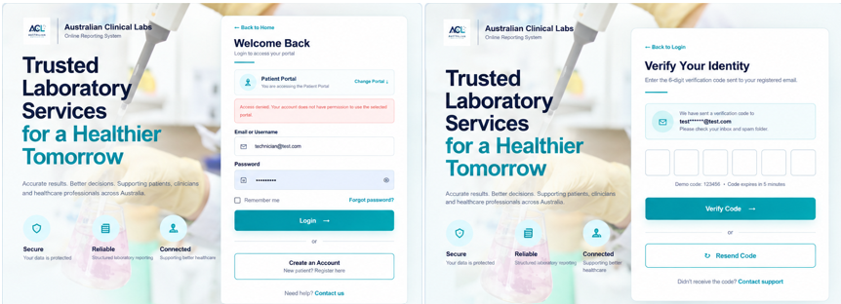
Source file: pages/auth/mfa.php
Purpose: MFA verification and authorised routing after login.
<?php

session_start();

$portal = $_GET['portal'] ?? ($_SESSION['portal'] ?? 'patient');

$allowedPortals = ['patient', 'clinician', 'staff', 'admin'];

if (!in_array($portal, $allowedPortals, true)) {
$portal = 'patient';
}

$userEmail = $_SESSION['email'] ?? 'jo***@gmail.com';

$errorMessage = '';
$successMessage = '';

if ($_SERVER['REQUEST_METHOD'] === 'POST') {

$code = '';

for ($i = 1; $i <= 6; $i++) {
$code .= $_POST["digit{$i}"] ?? '';
}

if ($code === '123456') {

$_SESSION['mfa_verified'] = true;

if ($portal === 'staff') {
$roles = $_SESSION['roles'] ?? [];
if (in_array('laboratory_technician', $roles, true)) {
header('Location: ../staff/technician/index.php');
exit;
}
header('Location: ../staff/staff-role-selection.php');
exit;
}

$successMessage =
'Verification successful. This portal is authentication-ready and can be connected to its dashboard by the team member responsible for that portal.';

} else {
$errorMessage = 'Invalid verification code. Please try again.';
}
}

function maskEmail(string $email): string
{
if (!filter_var($email, FILTER_VALIDATE_EMAIL)) {
return $email;
}

[$name, $domain] = explode('@', $email, 2);

if (strlen($name) <= 2) {
$maskedName = substr($name, 0, 1) . '***';
} else {
$maskedName =
substr($name, 0, 2) .
str_repeat('*', max(3, strlen($name) - 2));
}

return $maskedName . '@' . $domain;
}

$maskedEmail = maskEmail($userEmail);
?>

PHP 3 — Patient Registration Validation
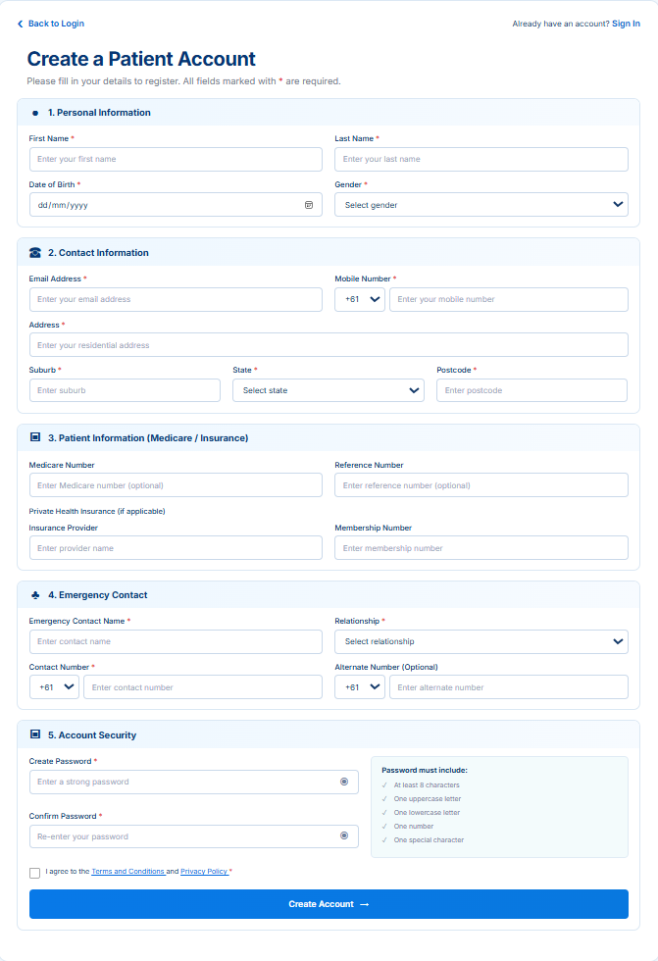
Source file:pages/patient/register.php
Purpose:Patient registration validation, password hashing, verification-code generation and temporary registration session data.
<?php
session_start();

$serverError = '';

if ($_SERVER['REQUEST_METHOD'] === 'POST') {
$requiredFields = [
'first_name', 'last_name', 'date_of_birth', 'gender', 'email', 'mobile',
'address', 'suburb', 'state', 'postcode', 'password', 'confirm_password'
];

foreach ($requiredFields as $field) {
if (!isset($_POST[$field]) || trim((string) $_POST[$field]) === '') {
$serverError = 'Please complete all required fields before continuing.';
break;
}
}

$email = trim((string) ($_POST['email'] ?? ''));
$password = (string) ($_POST['password'] ?? '');
$confirmPassword = (string) ($_POST['confirm_password'] ?? '');
$dateOfBirth = (string) ($_POST['date_of_birth'] ?? '');
$postcode = trim((string) ($_POST['postcode'] ?? ''));

if ($serverError === '' && !filter_var($email, FILTER_VALIDATE_EMAIL)) {
$serverError = 'Please enter a valid email address.';
}

if ($serverError === '' && !preg_match('/^\d{4}$/', $postcode)) {
$serverError = 'Please enter a valid 4-digit postcode.';
}

if ($serverError === '' && $dateOfBirth !== '' && strtotime($dateOfBirth) > strtotime(date('Y-m-d'))) {
$serverError = 'Date of birth cannot be in the future.';
}

$passwordValid =
strlen($password) >= 8 &&
preg_match('/[A-Z]/', $password) &&
preg_match('/[a-z]/', $password) &&
preg_match('/[0-9]/', $password) &&
preg_match('/[^A-Za-z0-9]/', $password);

if ($serverError === '' && !$passwordValid) {
$serverError = 'Password does not meet the required security rules.';
}

if ($serverError === '' && $password !== $confirmPassword) {
$serverError = 'Passwords do not match.';
}

if ($serverError === '' && !isset($_POST['legal_consent'])) {
$serverError = 'Please agree to the Terms and Conditions and Privacy Policy.';
}

if ($serverError === '') {
$pendingRegistration = $_POST;
unset(
$pendingRegistration['password'],
$pendingRegistration['confirm_password'],
$pendingRegistration['legal_consent']
);

foreach ($pendingRegistration as $key => $value) {
if (is_string($value)) {
$pendingRegistration[$key] = trim($value);
}
}

$verificationCode = (string) random_int(100000, 999999);

$_SESSION['pending_registration'] = $pendingRegistration;
$_SESSION['pending_password_hash'] = password_hash($password, PASSWORD_DEFAULT);
$_SESSION['email_verification_code'] = $verificationCode;
$_SESSION['email_verification_created_at'] = time();
$_SESSION['email_verification_email'] = $email;
$_SESSION['email_verification_attempts'] = 0;

header('Location: ../auth/verify-email.php');
exit;
}
}
?>

PHP 4 — Patient Email Verification & Database Account Creation
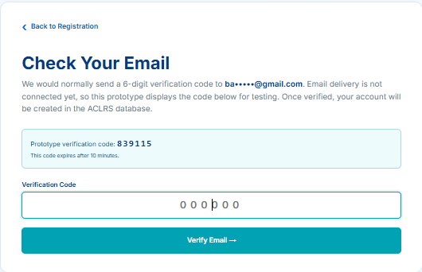
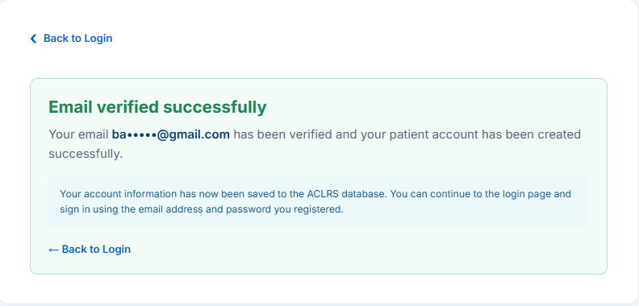
Source file:pages/auth/verify-email.php
Purpose:Verification of the patient registration code and creation of the user account, patient profile and patient role in the database.
<?php
session_start();

$verificationSuccess = isset($_GET['success'], $_SESSION['verification_success_email'])
&& $_GET['success'] === '1';

if (!$verificationSuccess && !isset(
$_SESSION['pending_registration'],
$_SESSION['pending_password_hash'],
$_SESSION['email_verification_code']
)) {
header('Location: ../patient/register.php');
exit;
}

require_once __DIR__ . '/../../config/database.php';

$pending = $_SESSION['pending_registration'] ?? [];
$email = $verificationSuccess
? trim((string) $_SESSION['verification_success_email'])
: trim((string) ($_SESSION['email_verification_email'] ?? ($pending['email'] ?? '')));
$verificationCode = (string) ($_SESSION['email_verification_code'] ?? '');
$error = '';

function maskEmail(string $email): string
{
if (strpos($email, '@') === false) {
return $email;
}

[$name, $domain] = explode('@', $email, 2);
$visible = substr($name, 0, min(2, strlen($name)));
return $visible . str_repeat('•', max(3, strlen($name) - strlen($visible))) . '@' . $domain;
}

function combinePhone(?string $countryCode, ?string $number): ?string
{
$countryCode = trim((string) $countryCode);
$number = trim((string) $number);

if ($number === '') {
return null;
}

if ($countryCode === '') {
return $number;
}

return $countryCode . ' ' . $number;
}

if (!$verificationSuccess && $_SERVER['REQUEST_METHOD'] === 'POST') {
$submittedCode = preg_replace('/\D/', '', (string) ($_POST['verification_code'] ?? ''));
$_SESSION['email_verification_attempts'] = (int) ($_SESSION['email_verification_attempts'] ?? 0) + 1;

$createdAt = (int) ($_SESSION['email_verification_created_at'] ?? 0);
$expired = $createdAt === 0 || (time() - $createdAt) > 600;

if ($expired) {
$error = 'This verification code has expired. Please return to registration and create a new code.';
} elseif (strlen($submittedCode) !== 6) {
$error = 'Please enter the 6-digit verification code.';
} elseif (!hash_equals($verificationCode, $submittedCode)) {
$error = 'The verification code is incorrect. Please try again.';
} else {
try {
$pdo->beginTransaction();
$checkUser = $pdo->prepare('SELECT user_id FROM users WHERE email = :email LIMIT 1');
$checkUser->execute(['email' => $email]);

if ($checkUser->fetch()) {
throw new RuntimeException('An account with this email address already exists. Please log in instead.');
}
$insertUser = $pdo->prepare(
"INSERT INTO users (
email,
password_hash,
account_status,
email_verified_at,
mfa_enabled
) VALUES (
:email,
:password_hash,
'active',
NOW(),
FALSE
)"
);

$insertUser->execute([
'email' => $email,
'password_hash' => (string) $_SESSION['pending_password_hash'],
]);

$userId = (int) $pdo->lastInsertId();
$insertPatient = $pdo->prepare(
"INSERT INTO patients (
user_id,
first_name,
last_name,
date_of_birth,
gender,
phone_number,
email,
address,
suburb,
state,
postcode,
medicare_number,
medicare_reference,
insurance_provider,
insurance_membership_number,
emergency_contact_name,
emergency_relationship,
emergency_phone,
alternate_phone
) VALUES (
:user_id,
:first_name,
:last_name,
:date_of_birth,
:gender,
:phone_number,
:email,
:address,
:suburb,
:state,
:postcode,
:medicare_number,
:medicare_reference,
:insurance_provider,
:insurance_membership_number,
:emergency_contact_name,
:emergency_relationship,
:emergency_phone,
:alternate_phone
)"
);

$insertPatient->execute([
'user_id' => $userId,
'first_name' => trim((string) ($pending['first_name'] ?? '')),
'last_name' => trim((string) ($pending['last_name'] ?? '')),
'date_of_birth' => (string) ($pending['date_of_birth'] ?? ''),
'gender' => (($pending['gender'] ?? '') !== '') ? trim((string) $pending['gender']) : null,
'phone_number' => combinePhone($pending['mobile_country_code'] ?? '', $pending['mobile'] ?? ''),
'email' => $email,
'address' => (($pending['address'] ?? '') !== '') ? trim((string) $pending['address']) : null,
'suburb' => (($pending['suburb'] ?? '') !== '') ? trim((string) $pending['suburb']) : null,
'state' => (($pending['state'] ?? '') !== '') ? trim((string) $pending['state']) : null,
'postcode' => (($pending['postcode'] ?? '') !== '') ? trim((string) $pending['postcode']) : null,
'medicare_number' => (($pending['medicare_number'] ?? '') !== '') ? trim((string) $pending['medicare_number']) : null,
'medicare_reference' => (($pending['medicare_reference'] ?? '') !== '') ? trim((string) $pending['medicare_reference']) : null,
'insurance_provider' => (($pending['insurance_provider'] ?? '') !== '') ? trim((string) $pending['insurance_provider']) : null,
'insurance_membership_number' => (($pending['insurance_membership_number'] ?? '') !== '') ? trim((string) $pending['insurance_membership_number']) : null,
'emergency_contact_name' => (($pending['emergency_contact_name'] ?? '') !== '') ? trim((string) $pending['emergency_contact_name']) : null,
'emergency_relationship' => (($pending['emergency_relationship'] ?? '') !== '') ? trim((string) $pending['emergency_relationship']) : null,
'emergency_phone' => combinePhone($pending['emergency_country_code'] ?? '', $pending['emergency_phone'] ?? ''),
'alternate_phone' => combinePhone($pending['alternate_country_code'] ?? '', $pending['alternate_phone'] ?? ''),
]);
$roleStatement = $pdo->prepare("SELECT role_id FROM roles WHERE role_name = 'patient' LIMIT 1");
$roleStatement->execute();
$roleId = $roleStatement->fetchColumn();

if (!$roleId) {
throw new RuntimeException('The patient role is missing from the database. Please import the default roles from the ACLRS schema.');
}

$insertRole = $pdo->prepare(
'INSERT INTO user_roles (user_id, role_id, assigned_by_user_id) VALUES (:user_id, :role_id, NULL)'
);
$insertRole->execute([
'user_id' => $userId,
'role_id' => (int) $roleId,
]);

$pdo->commit();
unset(
$_SESSION['pending_registration'],
$_SESSION['pending_password_hash'],
$_SESSION['email_verification_code'],
$_SESSION['email_verification_created_at'],
$_SESSION['email_verification_email'],
$_SESSION['email_verification_attempts'],
$_SESSION['registration_email_verified']
);
$_SESSION['verification_success_email'] = $email;
$_SESSION['registration_success'] = 'Email verified and account created successfully. Please log in.';
$_SESSION['registration_email'] = $email;
header('Location: verify-email.php?success=1');
exit;

} catch (Throwable $e) {
if ($pdo->inTransaction()) {
$pdo->rollBack();
}

if ($e instanceof RuntimeException) {
$error = $e->getMessage();
} elseif ($e instanceof PDOException && $e->getCode() === '23000') {
$error = 'This registration conflicts with an existing account or patient record. Please check your details or log in.';
} else {
$error = 'We could not create your account at this time. Please try again.';
}
}
}
}
?>

PHP 5 — Staff Registration Validation
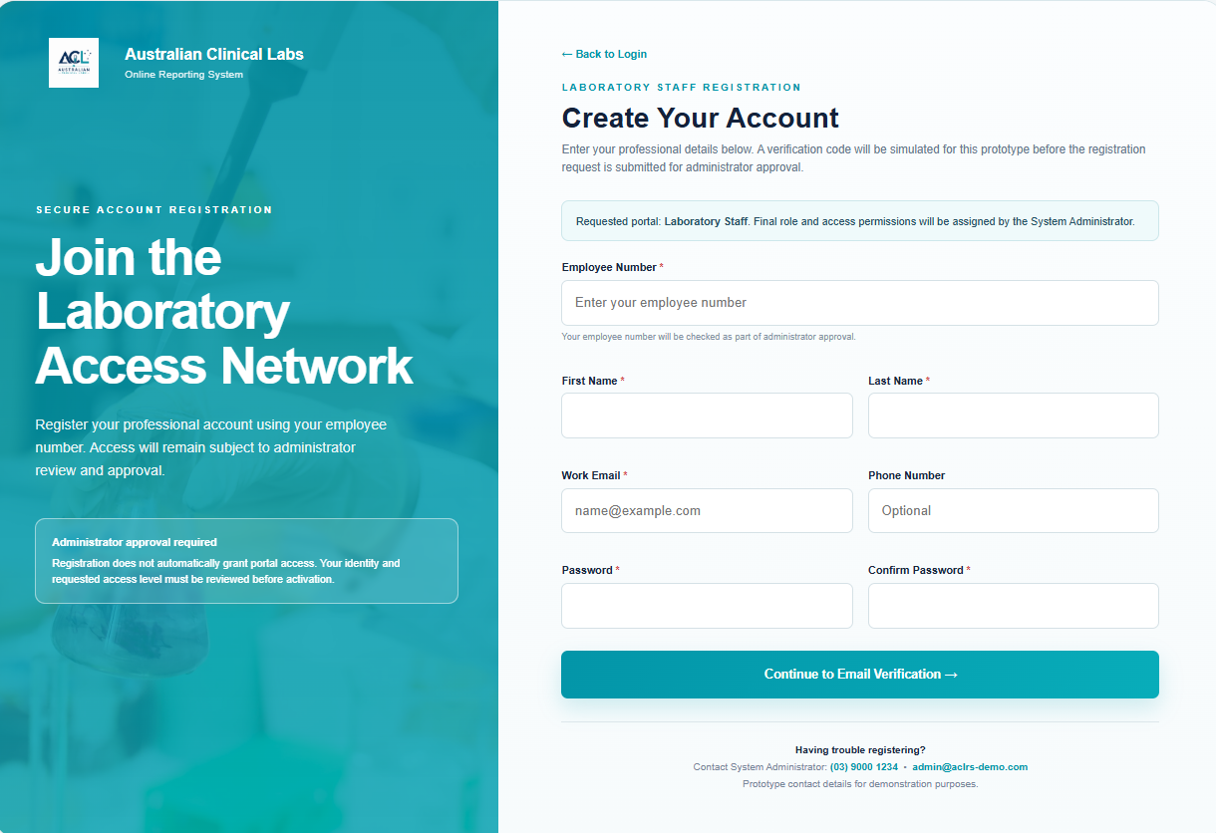
Source file: pages/staff/register.php
Purpose: Registration validation, password hashing, verification-code generation and pending registration session data.
<?php
session_start();

$portal = $_GET['portal'] ?? $_POST['portal'] ?? 'staff';
$allowedPortals = ['clinician', 'staff', 'admin'];

if (!in_array($portal, $allowedPortals, true)) {
$portal = 'staff';
}

$portalLabels = [
'clinician' => 'Clinician',
'staff' => 'Laboratory Staff',
'admin' => 'Administrator'
];

$errors = [];
$values = [
'employee_number' => '',
'first_name' => '',
'last_name' => '',
'email' => '',
'phone_number' => ''
];

if ($_SERVER['REQUEST_METHOD'] === 'POST') {

foreach ($values as $key => $value) {
$values[$key] = trim($_POST[$key] ?? '');
}

$password = $_POST['password'] ?? '';
$confirmPassword = $_POST['confirm_password'] ?? '';

if ($values['employee_number'] === '') {
$errors[] = 'Employee number is required.';
}

if ($values['first_name'] === '') {
$errors[] = 'First name is required.';
}

if ($values['last_name'] === '') {
$errors[] = 'Last name is required.';
}

if ($values['email'] === '' || !filter_var($values['email'], FILTER_VALIDATE_EMAIL)) {
$errors[] = 'Please enter a valid email address.';
}

if (strlen($password) < 8) {
$errors[] = 'Password must contain at least 8 characters.';
}

if ($password !== $confirmPassword) {
$errors[] = 'Password confirmation does not match.';
}

if (empty($errors)) {

$verificationCode = (string) random_int(100000, 999999);

$_SESSION['staff_registration_data'] = [
'portal' => $portal,
'employee_number' => $values['employee_number'],
'first_name' => $values['first_name'],
'last_name' => $values['last_name'],
'email' => $values['email'],
'phone_number' => $values['phone_number'],
'password_hash' => password_hash($password, PASSWORD_DEFAULT)
];

$_SESSION['staff_verification_code'] = $verificationCode;
$_SESSION['staff_verification_expires_at'] = time() + 600;

header(
'Location: ../auth/verify-staff-email.php?portal=' .
urlencode($portal)
);
exit;
}
}
?>

PHP 6 — Staff Email Verification & Database Registration
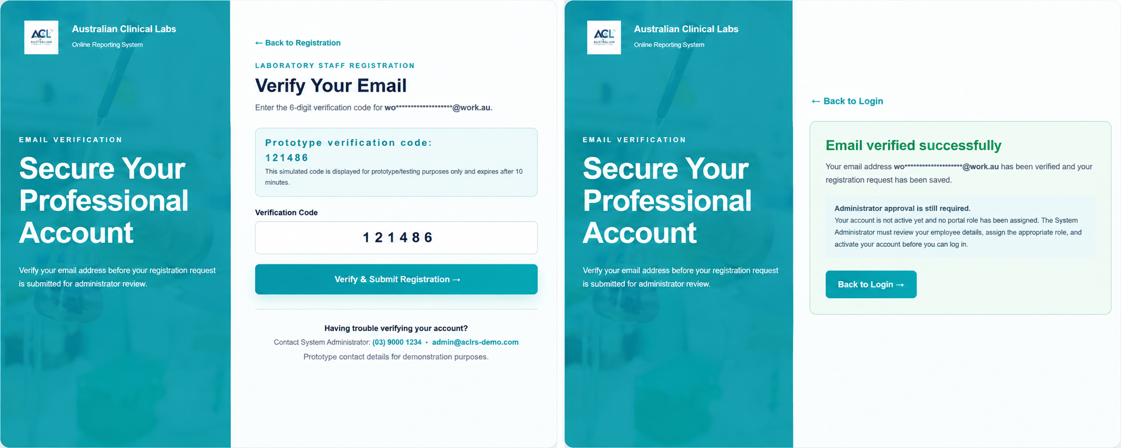
Source file: pages/auth/verify-staff-email.php
Purpose: Verification of registration code and creation of the staff user/profile in the database.
<?php
session_start();

require_once __DIR__ . '/../../config/database.php';

$portal = $_GET['portal'] ?? $_POST['portal'] ?? ($_SESSION['staff_registration_data']['portal'] ?? 'staff');

$allowedPortals = ['clinician', 'staff', 'admin'];

if (!in_array($portal, $allowedPortals, true)) {
$portal = 'staff';
}

$portalLabels = [
'clinician' => 'Clinician',
'staff' => 'Laboratory Staff',
'admin' => 'Administrator'
];

$errorMessage = '';
$successState = false;
$maskedEmail = '';

$registrationData = $_SESSION['staff_registration_data'] ?? null;
$verificationCode = $_SESSION['staff_verification_code'] ?? null;
$expiresAt = $_SESSION['staff_verification_expires_at'] ?? null;

if ($registrationData) {
$maskedEmail = $registrationData['email'] ?? '';
}

function maskEmail(string $email): string
{
if (!filter_var($email, FILTER_VALIDATE_EMAIL)) {
return $email;
}

[$name, $domain] = explode('@', $email, 2);

if (strlen($name) <= 2) {
$maskedName = substr($name, 0, 1) . '••';
} else {
$maskedName =
substr($name, 0, 2) .
str_repeat('•', max(4, strlen($name) - 2));
}

return $maskedName . '@' . $domain;
}

if ($_SERVER['REQUEST_METHOD'] === 'POST' && isset($_POST['verification_code'])) {

if (!$registrationData || !$verificationCode || !$expiresAt) {

$errorMessage =
'Your registration session has expired. Please return to registration and try again.';

} elseif (time() > (int) $expiresAt) {

$errorMessage =
'The verification code has expired. Please return to registration and request a new code.';

} else {

$enteredCode = trim($_POST['verification_code'] ?? '');

if (!preg_match('/^\d{6}$/', $enteredCode)) {

$errorMessage = 'Please enter the 6-digit verification code.';

} elseif (!hash_equals((string) $verificationCode, $enteredCode)) {

$errorMessage = 'The verification code is incorrect. Please try again.';

} else {

try {

$pdo->beginTransaction();

$email = $registrationData['email'];
$employeeNumber = $registrationData['employee_number'];
$firstName = $registrationData['first_name'];
$lastName = $registrationData['last_name'];
$phoneNumber = $registrationData['phone_number'] ?: null;
$passwordHash = $registrationData['password_hash'];

$duplicateStatement = $pdo->prepare(
"SELECT user_id
FROM users
WHERE email = :email
OR username = :employee_number
LIMIT 1"
);

$duplicateStatement->execute([
'email' => $email,
'employee_number' => $employeeNumber
]);

if ($duplicateStatement->fetch(PDO::FETCH_ASSOC)) {
throw new RuntimeException(
'An account already exists with this email address or employee number.'
);
}

$userStatement = $pdo->prepare(
"INSERT INTO users (
username,
email,
password_hash,
account_status,
email_verified_at,
mfa_enabled
) VALUES (
:username,
:email,
:password_hash,
'pending_verification',
NOW(),
FALSE
)"
);

$userStatement->execute([
'username' => $employeeNumber,
'email' => $email,
'password_hash' => $passwordHash
]);

$userId = (int) $pdo->lastInsertId();

if ($portal === 'clinician') {

$profileStatement = $pdo->prepare(
"INSERT INTO clinicians (
user_id,
first_name,
last_name,
phone_number,
email
) VALUES (
:user_id,
:first_name,
:last_name,
:phone_number,
:email
)"
);

$profileStatement->execute([
'user_id' => $userId,
'first_name' => $firstName,
'last_name' => $lastName,
'phone_number' => $phoneNumber,
'email' => $email
]);

} else {

$profileStatement = $pdo->prepare(
"INSERT INTO staff (
user_id,
employee_number,
first_name,
last_name,
employment_status
) VALUES (
:user_id,
:employee_number,
:first_name,
:last_name,
'inactive'
)"
);

$profileStatement->execute([
'user_id' => $userId,
'employee_number' => $employeeNumber,
'first_name' => $firstName,
'last_name' => $lastName
]);
}

$pdo->commit();

$_SESSION['staff_registration_success'] = [
'portal' => $portal,
'email' => $email
];

unset($_SESSION['staff_registration_data']);
unset($_SESSION['staff_verification_code']);
unset($_SESSION['staff_verification_expires_at']);

$successState = true;
$maskedEmail = $email;

} catch (RuntimeException $e) {

if ($pdo->inTransaction()) {
$pdo->rollBack();
}

$errorMessage = $e->getMessage();

} catch (PDOException $e) {

if ($pdo->inTransaction()) {
$pdo->rollBack();
}

$errorMessage =
'Unable to submit the registration request at this time. Please try again.';
}
}
}
}

if (!$registrationData && !$successState && isset($_SESSION['staff_registration_success'])) {

$savedSuccess = $_SESSION['staff_registration_success'];

if (($savedSuccess['portal'] ?? '') === $portal) {
$successState = true;
$maskedEmail = $savedSuccess['email'] ?? '';
}
}
?>

PHP 7 — Staff Role Selection Security Gate
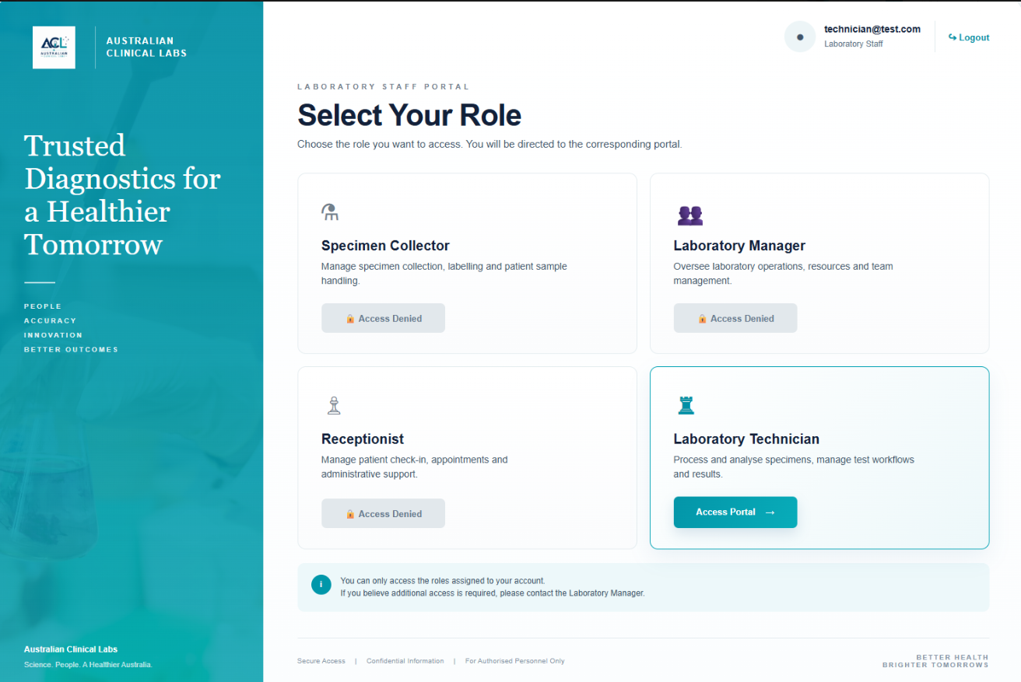

Source file: pages/staff/staff-role-selection.php
Purpose: Authentication/MFA gate and staff-role routing after successful login.
<?php

session_start();

if (
empty($_SESSION['authenticated']) ||
($_SESSION['portal'] ?? '') !== 'staff'
) {
header('Location: ../auth/login.php?portal=staff');
exit;
}

if (empty($_SESSION['mfa_verified'])) {
header('Location: ../auth/mfa.php?portal=staff');
exit;
}

if (($_GET['action'] ?? '') === 'logout') {
$_SESSION = [];

if (ini_get('session.use_cookies')) {
$params = session_get_cookie_params();

setcookie(
session_name(),
'',
time() - 42000,
$params['path'],
$params['domain'],
$params['secure'],
$params['httponly']
);
}

session_destroy();

header('Location: ../auth/login.php?portal=staff');
exit;
}

$userEmail = $_SESSION['email'] ?? 'Unknown user';
$userRoles = $_SESSION['roles'] ?? [];

$staffRoles = [
'specimen_collector' => [
'title' => 'Specimen Collector',
'icon' => '⚗',
'description' => 'Manage specimen collection, labelling and patient sample handling.',
'target' => 'specimen/index.php'
],

'laboratory_manager' => [
'title' => 'Laboratory Manager',
'icon' => '👥',
'description' => 'Oversee laboratory operations, resources and team management.',
'target' => 'manager/index.php'
],

'receptionist' => [
'title' => 'Receptionist',
'icon' => '♙',
'description' => 'Manage patient check-in, appointments and administrative support.',
'target' => 'reception/index.php'
],

'laboratory_technician' => [
'title' => 'Laboratory Technician',
'icon' => '♜',
'description' => 'Process and analyse specimens, manage test workflows and results.',
'target' => 'technician/index.php'
]
];

$selectedRole = $_GET['role'] ?? '';
$portalMessage = '';

if ($selectedRole !== '') {
if (
isset($staffRoles[$selectedRole]) &&
in_array($selectedRole, $userRoles, true)
) {
$portalMessage =
$staffRoles[$selectedRole]['title'] .
' access confirmed. This role portal will be connected in the next development stage.';
} else {
$portalMessage =
'Access denied. Your account is not authorised for the selected role.';
}
}

?>

