3.7 Module Test (Selenium Test)
Lab Worklist
Tester | THI ANH PHAM
Date | 24/09/2026
Module | Lab Worklist
Testing Tool | Selenium IDE
Web Browser | Microsoft Edge

Test Case Summary
Test ID | Tool | Test Result | Comment
TEST 01 – Dashboard | Selenium IDE (Microsoft Edge) | PASS | Dashboard functions were performed and interacted with smoothly. The calendar was used to view monthly test statistics and reporting data. The search bar functioned effectively.
TEST 02 – Assigned Tests | Selenium IDE (Microsoft Edge) | PASS | Functions within Assigned Tests operated smoothly. Filters were successfully used to search for tests and view reports.
TEST 03 – Import Results | Selenium IDE (Microsoft Edge) | PASS | Results were successfully imported into the system, and a new test result was confirmed to appear in the system.
TEST 04 – Validation & Alerts | Selenium IDE (Microsoft Edge) | PASS | The available filters were used successfully and functioned as expected.
TEST 05 – Reports | Selenium IDE (Microsoft Edge) | PASS | Reports could be successfully reviewed, marked, and submitted.
TEST 06 – Profile, Settings and Logout | Selenium IDE (Microsoft Edge) | PASS | Technician information was displayed correctly. Settings functions operated successfully, and the logout function was completed successfully.

Test Evidence
Evidence is arranged by Test ID. Each screenshot shows the tested Lab Worklist interface together with the Selenium IDE execution record.
TEST 01 – Dashboard
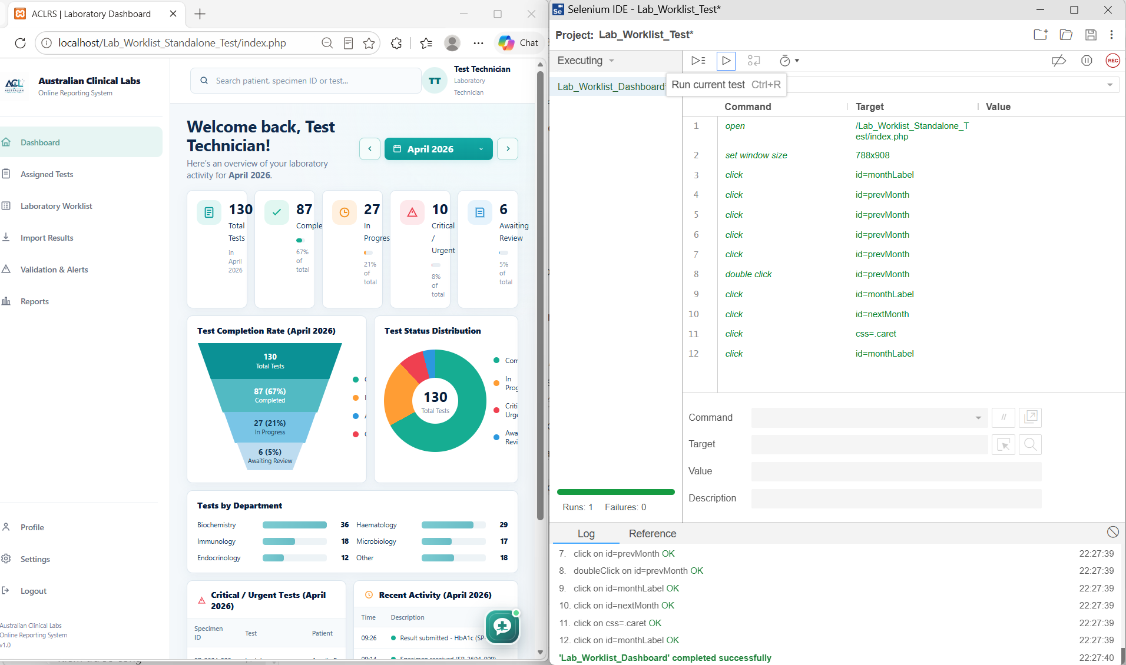

Figure – Selenium IDE interface and execution evidence for Test 01 – Dashboard
TEST 02 – Assigned Tests
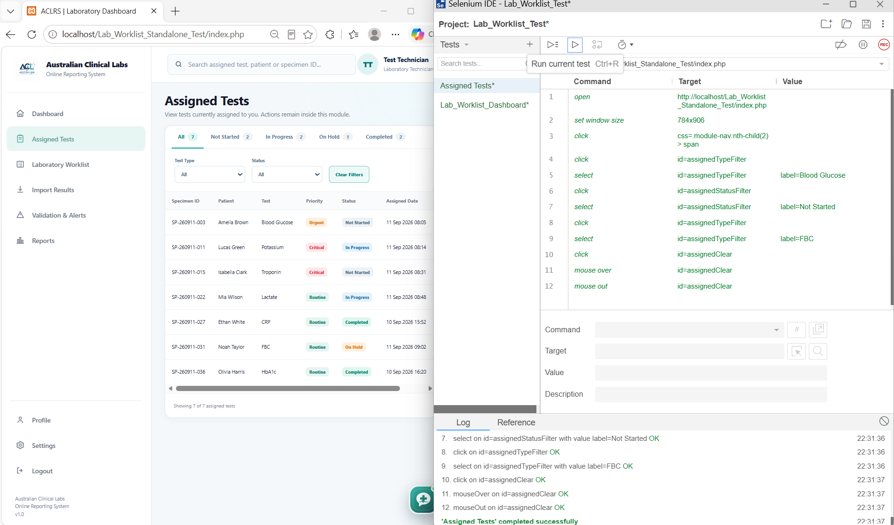

TEST 03 - Import Results

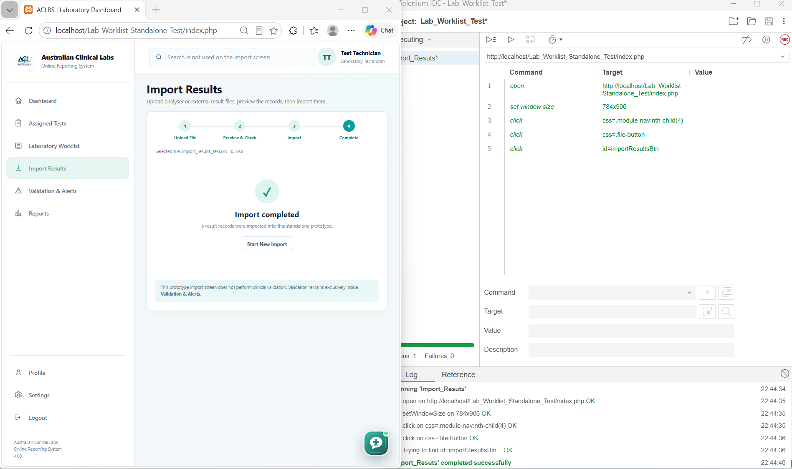
Figure – Selenium IDE interface and execution evidence for Test 03 – Import Results
TEST 04 – Validation & Alerts
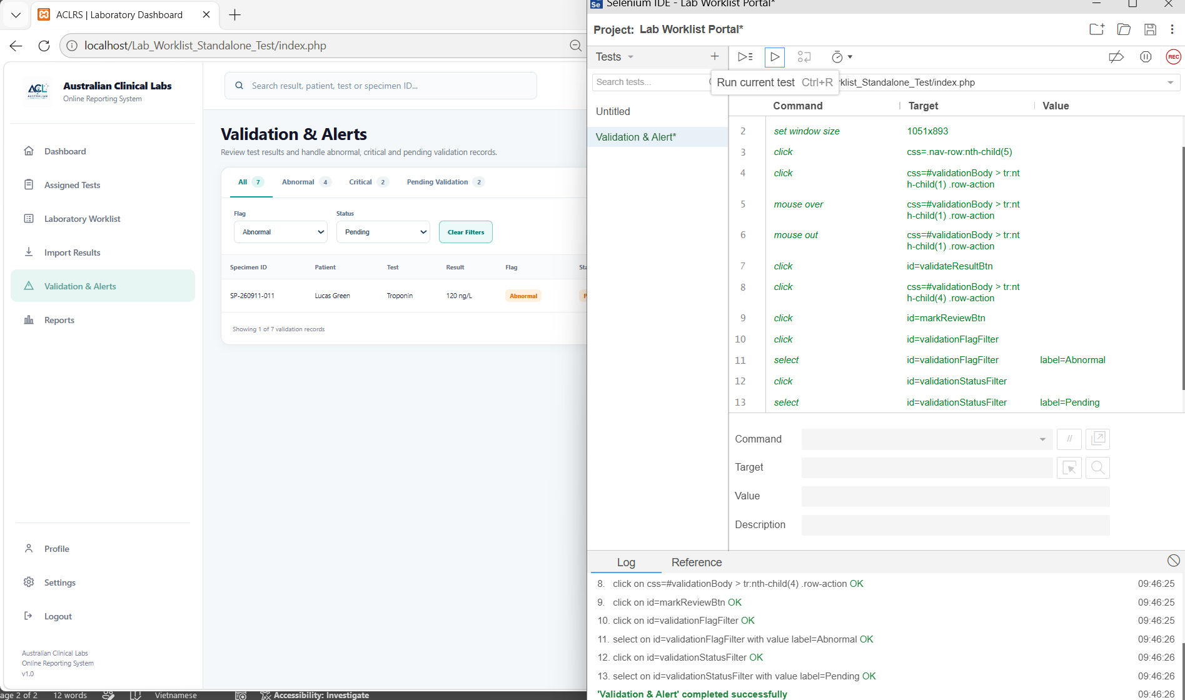

TEST 05 – Reports

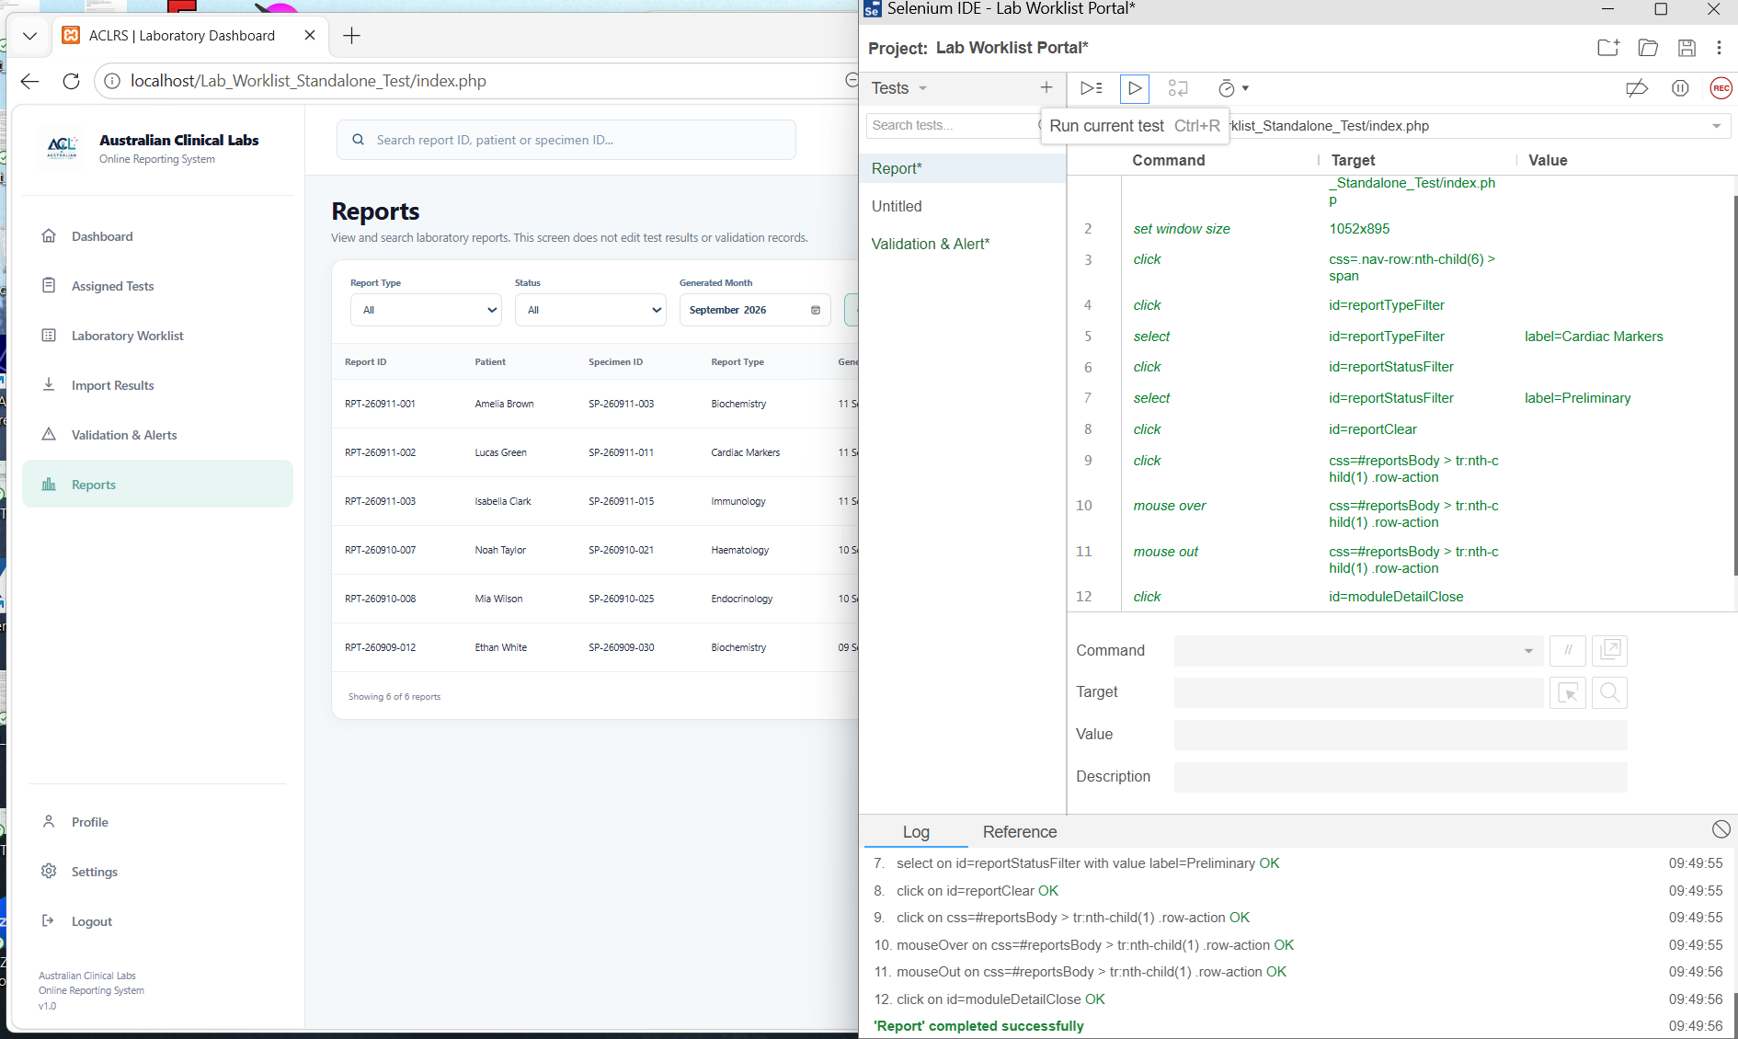
Figure – Selenium IDE interface and execution evidence for Test 05 – Reports
TEST 06 – Profile, Settings and Logout
Evidence is included in the composite screenshot above.
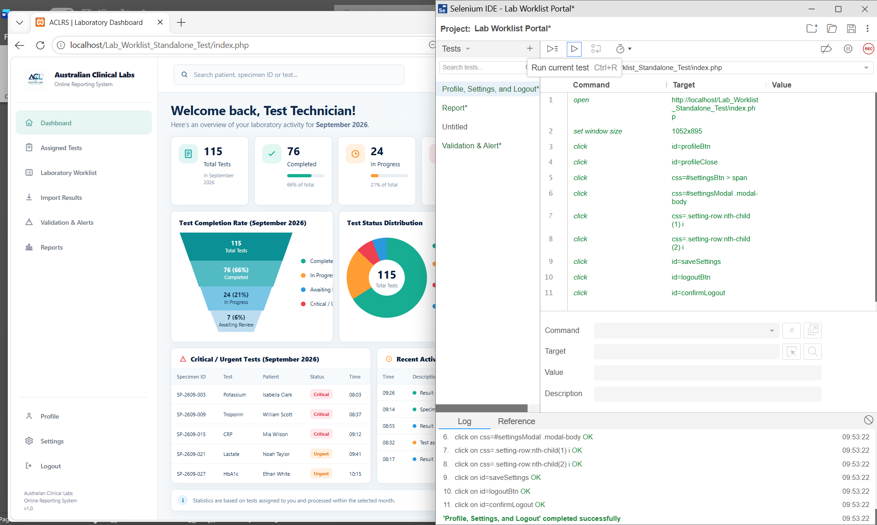

Recorded Outcomes
- TEST 01 – Dashboard: PASS.
- TEST 02 – Assigned Tests: PASS.
- TEST 03 – Import Results: PASS.
- TEST 04 – Validation & Alerts: PASS.
- TEST 05 – Reports: PASS.
- TEST 06 – Profile, Settings and Logout: PASS.

