Section 2.2

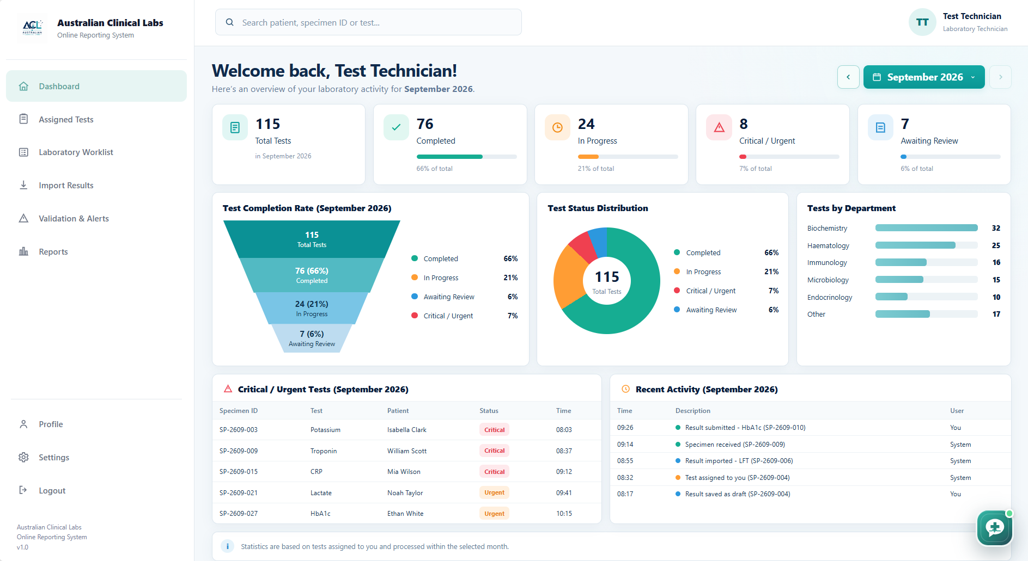

<?php
session_start();
require_once 'db_connection.php';
// Authentication
if (
!isset($_SESSION['aclrs_authenticated']) ||
$_SESSION['aclrs_authenticated'] !== true
) {
header('Location: ../../auth/login.php?portal=staff');
exit;
}
// Logged-in laboratory staff
$userId = $_SESSION['user_id'] ?? null;
// Assigned Tests
$stmt = $conn->prepare("
SELECT *
FROM test_requests
WHERE assigned_to = ?
");
$stmt->bind_param("i", $userId);
$stmt->execute();
$assignedTests = $stmt->get_result()->fetch_all(MYSQLI_ASSOC);
// Laboratory Worklist
$stmt = $conn->prepare("
SELECT *
FROM specimens
ORDER BY collection_date DESC
");
$stmt->execute();
$worklist = $stmt->get_result()->fetch_all(MYSQLI_ASSOC);
// Results awaiting validation
$stmt = $conn->prepare("
SELECT *
FROM test_results
WHERE validation_status IN ('pending', 'in_review')
");
$stmt->execute();
$validationResults = $stmt->get_result()->fetch_all(MYSQLI_ASSOC);
// Laboratory Reports
$stmt = $conn->prepare("
SELECT *
FROM test_reports
ORDER BY generated_date DESC
");
$stmt->execute();
$reports = $stmt->get_result()->fetch_all(MYSQLI_ASSOC);
?>

