3.7 Module Test (Selenium Test)
Login And Registration
Tester | THI ANH PHAM
Date | 24/09/2026
Module | Login And Registration
Testing Tool | Selenium WebDriver
Web Browser | Microsoft Edge

Test Case Summary
Test ID | Tool | Test Result | Comment
TEST 01 – Landing Page to Patient Login | Selenium WebDriver | PASS
TEST 02 – Valid Patient Login | Selenium WebDriver | PASS | Used Selenium WebDriver with Python Manager to execute code-based automated tests in CMD (Command Prompt), for login portals requiring MFA and verification codes, preventing Selenium from losing connection with the test browser during the recording process.
TEST 03 – New Patient Registration + Email Verification | Selenium WebDriver | PASS | Used Selenium WebDriver with Python Manager to execute code-based automated tests in CMD (Command Prompt), for login portals requiring MFA and verification codes, preventing Selenium from losing connection with the test browser during the recording process.
TEST 04 – Staff Login + Verification + Role Access | Selenium WebDriver | PASS | Used Selenium WebDriver with Python Manager to execute code-based automated tests in CMD (Command Prompt), for login portals requiring MFA and verification codes, preventing Selenium from losing connection with the test browser during the recording process.
TEST 05 – New Laboratory Staff Registration | Selenium WebDriver | PASS | Used Selenium WebDriver with Python Manager to execute code-based automated tests in CMD (Command Prompt), for login portals requiring MFA and verification codes, preventing Selenium from losing connection with the test browser during the recording process.
TEST 06 – Patient Forgot Password / Password Reset | Selenium WebDriver | PASS | Used Selenium WebDriver with Python Manager to execute code-based automated tests in CMD (Command Prompt), for login portals requiring MFA and verification codes, preventing Selenium from losing connection with the test browser during the recording process.

Test Evidence
Evidence is arranged by Test ID. Interface evidence is shown together with the Selenium/CMD execution evidence available in the original test record.

TEST 01 – Landing Page to Patient Login
The original record confirms RESULT: PASS for the Landing Page → Patient Portal test. No separate standalone screenshot was available in the supplied source document.

TEST 02 – Valid Patient Login
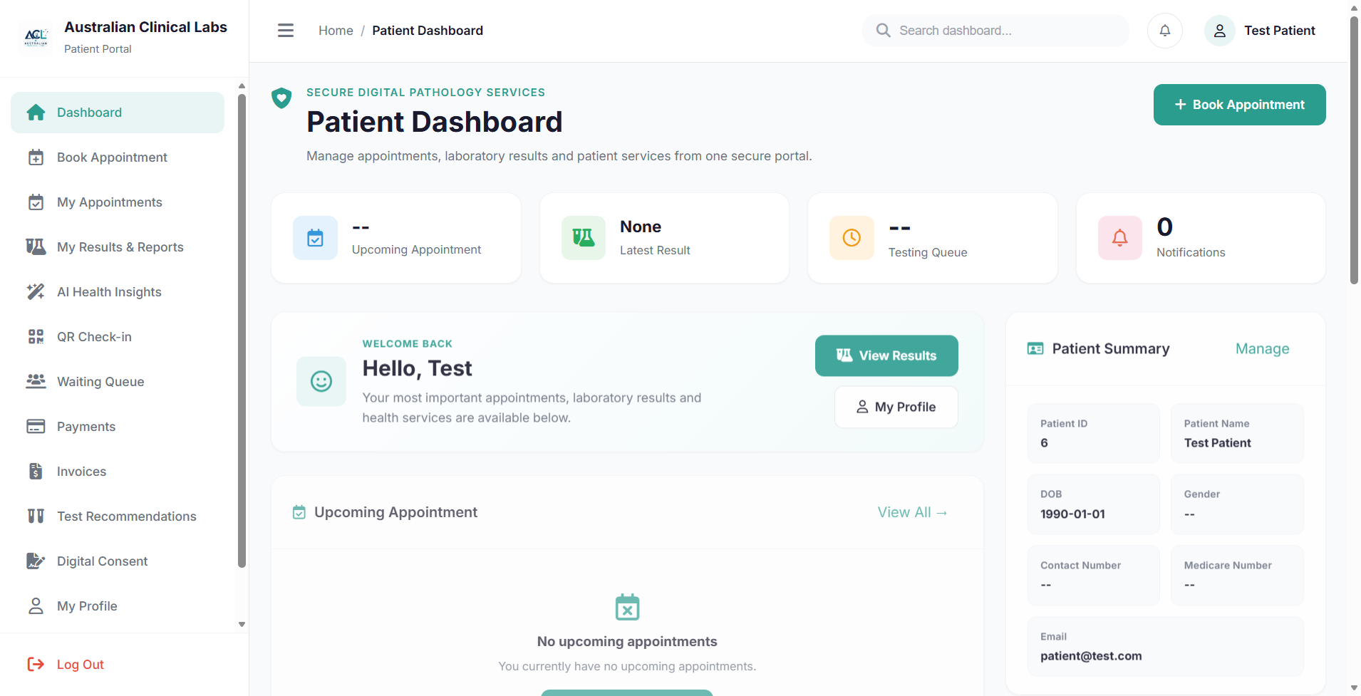
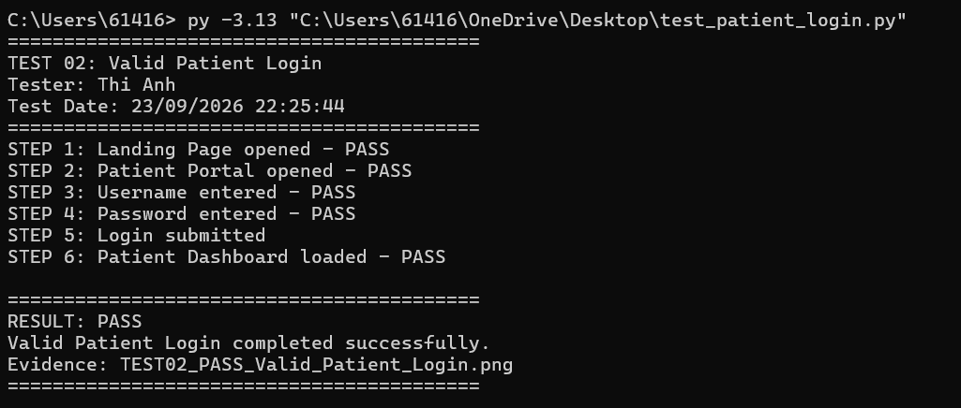
Figure 3.7.2 – Selenium CMD execution result – PASS

TEST 03 – New Patient Registration + Email Verification
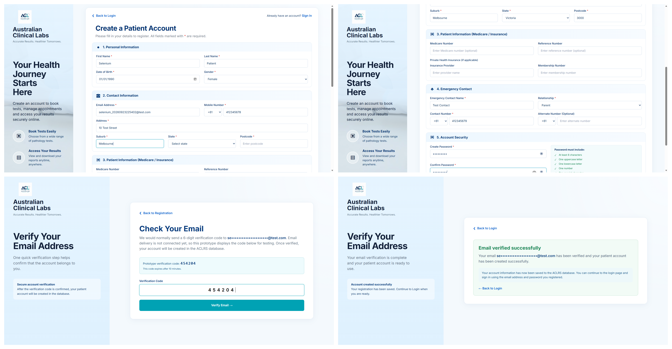
Figure 3.7.3a – Combined registration and email verification interface evidence
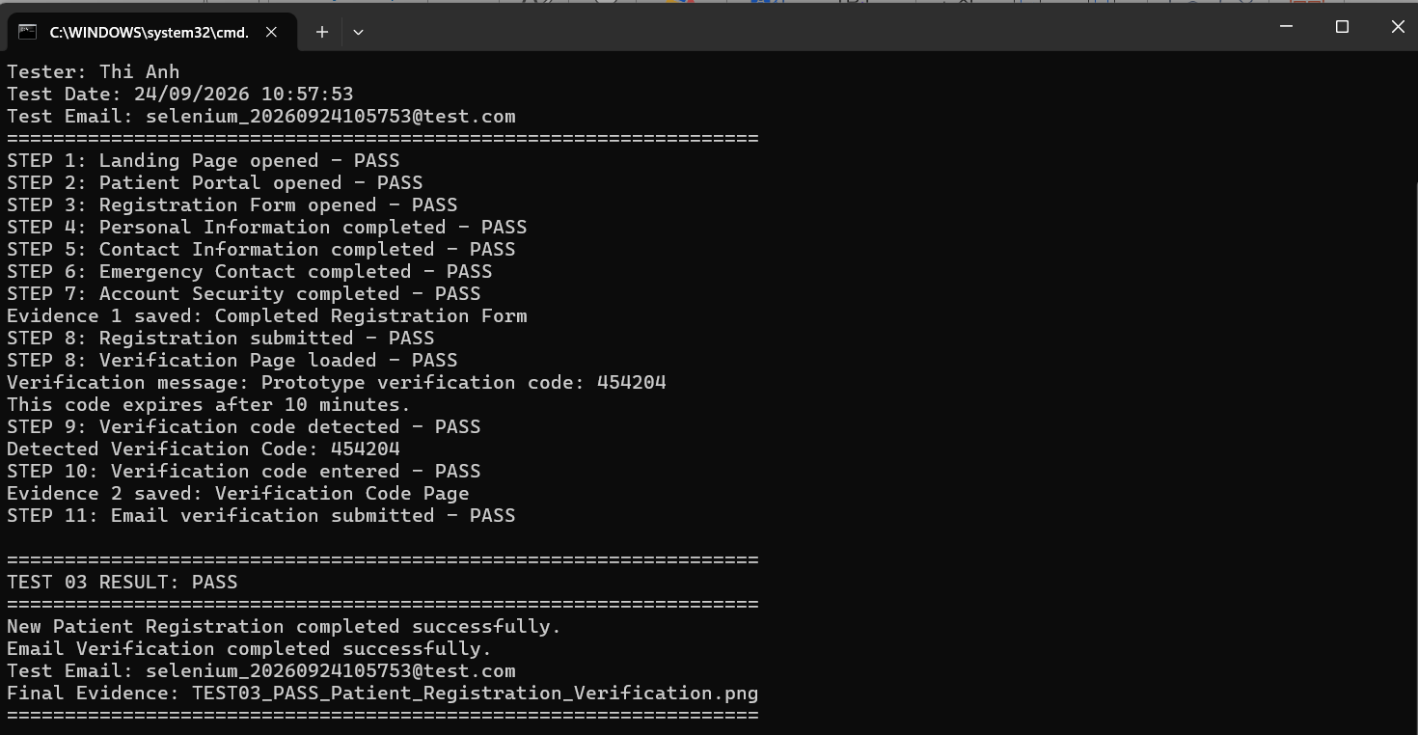
Figure 3.7.3b – Selenium CMD execution result – PASS

TEST 04 – Staff Login + Verification + Role Access
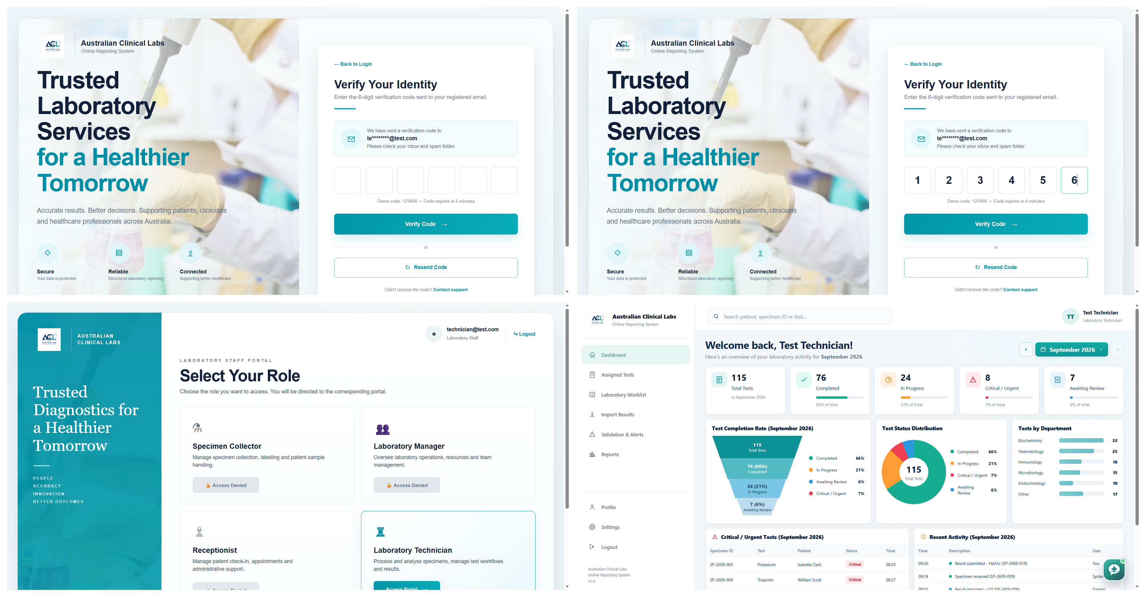
Figure 3.7.4a – Combined verification, role selection and dashboard evidence
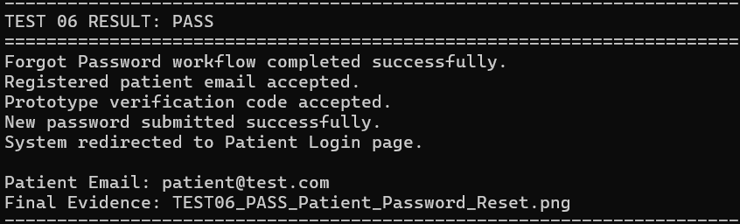
Figure 3.7.4b – Selenium CMD execution result – PASS

TEST 05 – New Laboratory Staff Registration
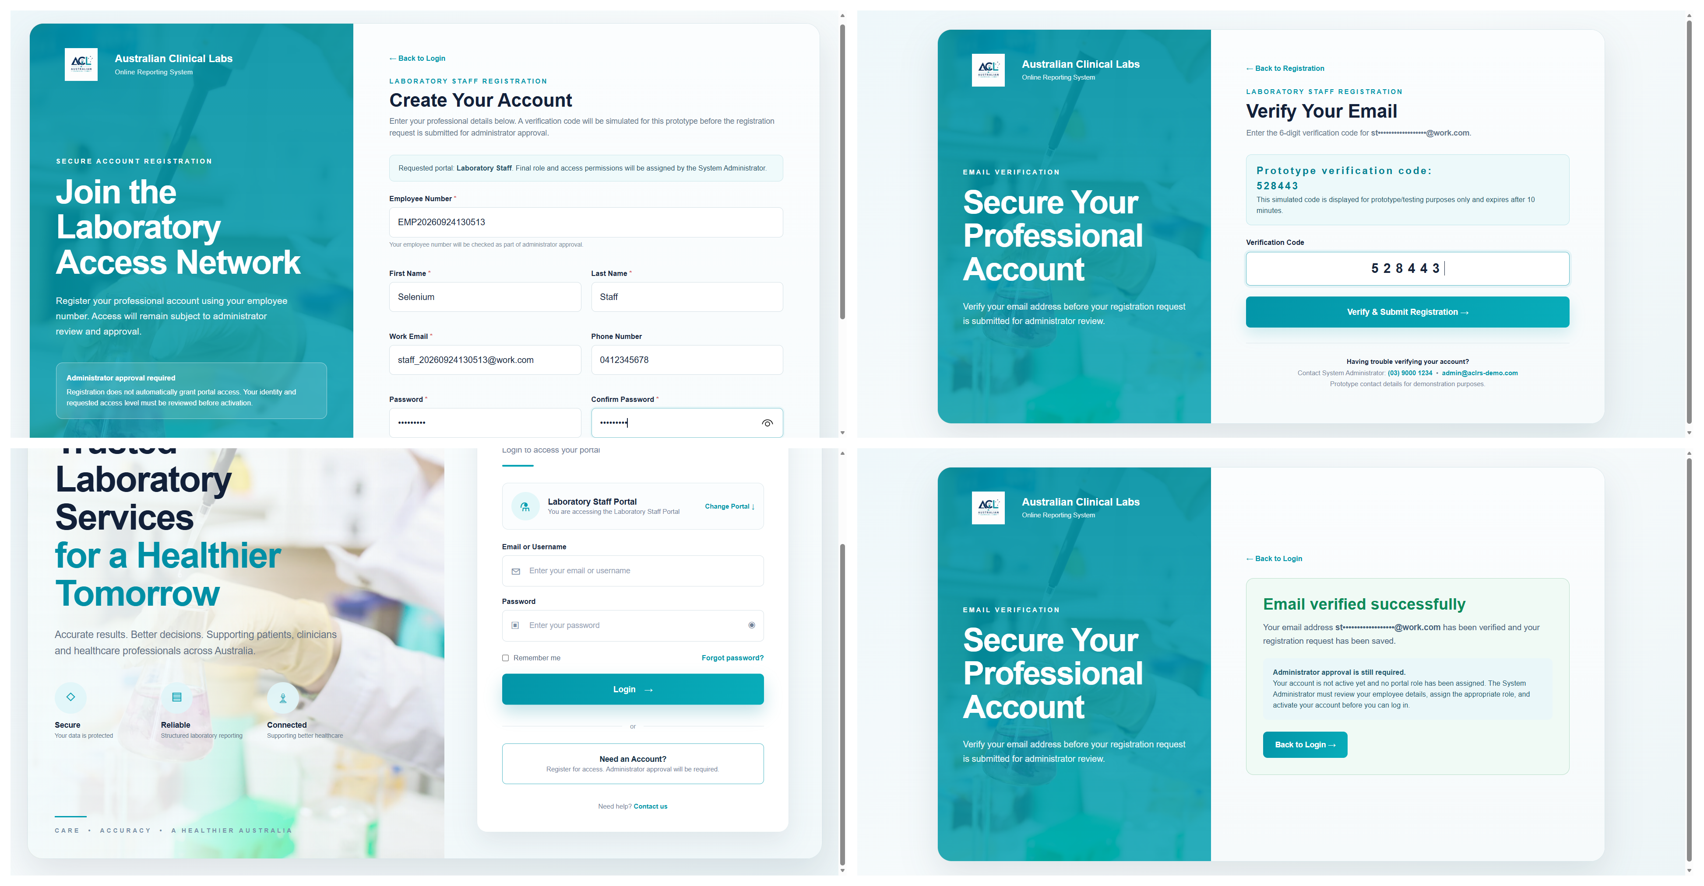
Figure 3.7.5a – Combined staff registration and email verification evidence
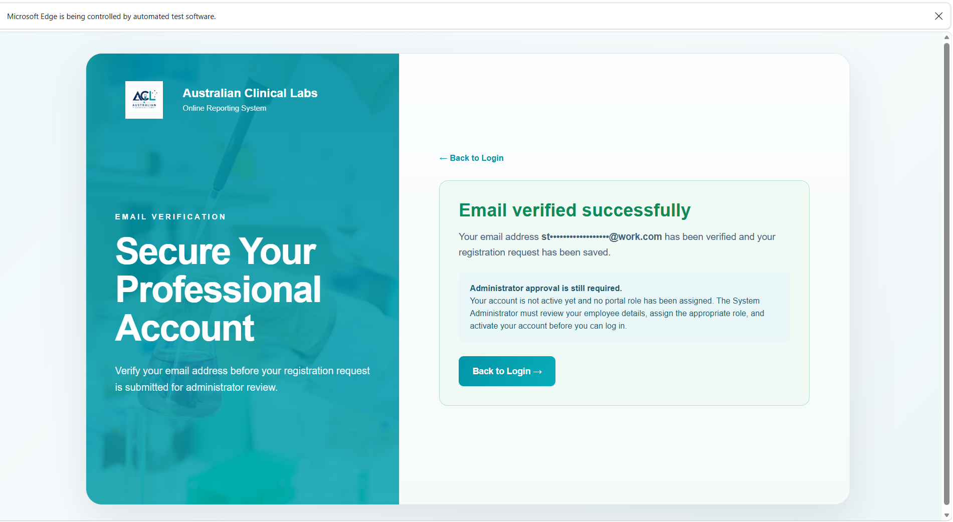
Figure 3.7.5b – Selenium CMD execution result / pending administrator approval – PASS

TEST 06 – Patient Forgot Password / Password Reset
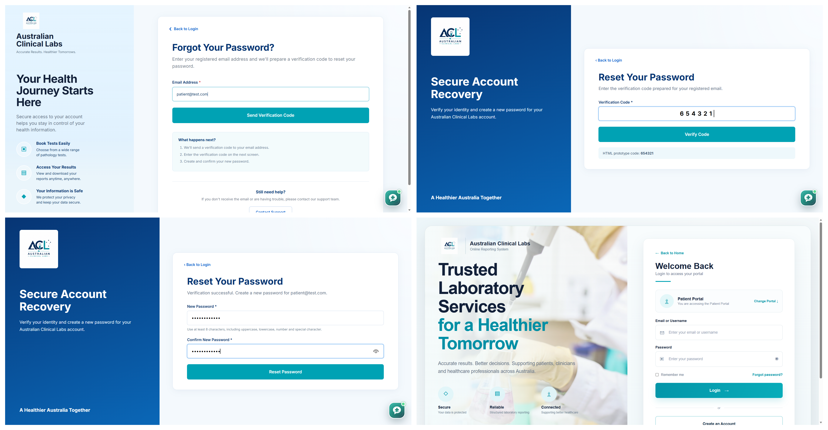
Figure 3.7.6a – Combined forgot-password and password-reset interface evidence
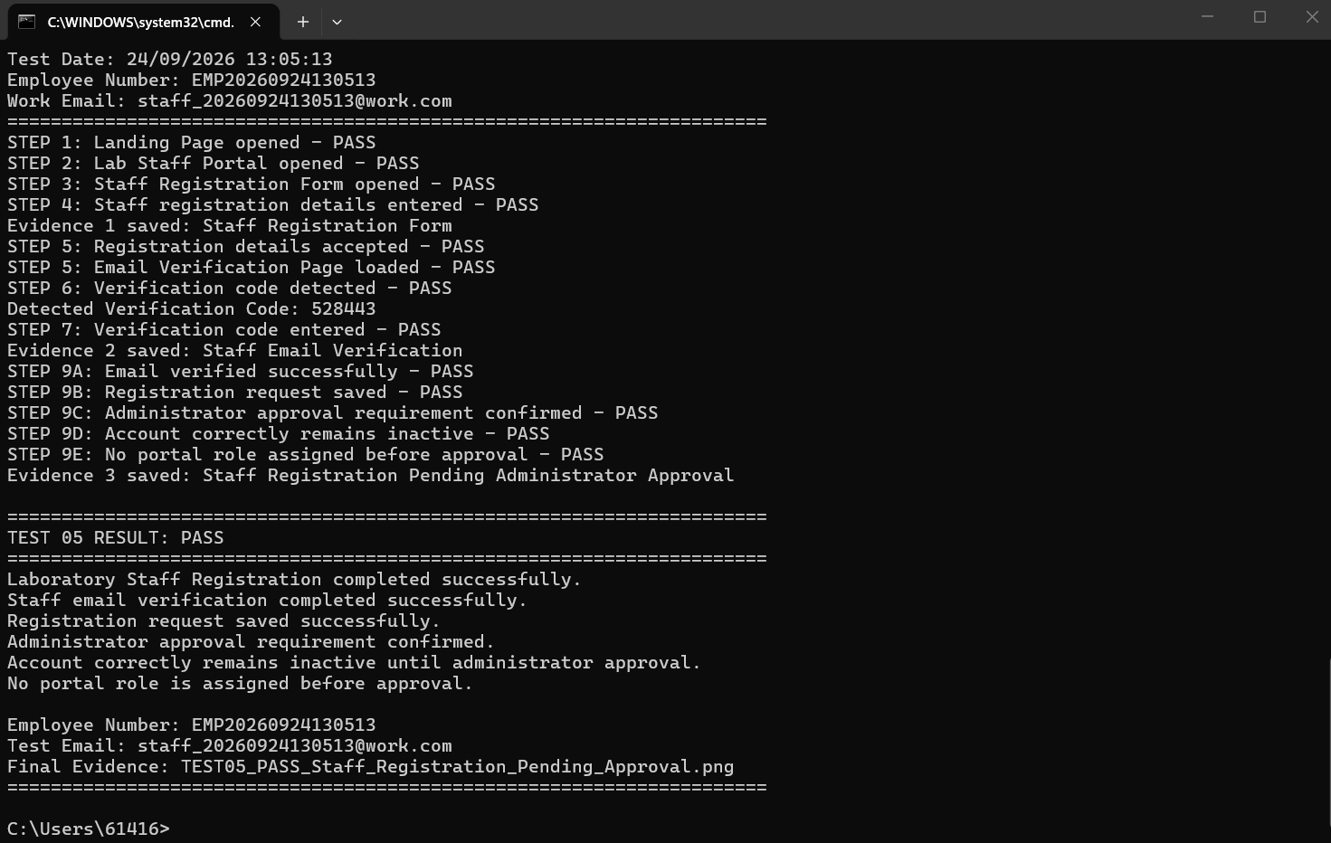
Figure 3.7.6b – Selenium CMD execution result – PASS

Recorded Outcomes
- TEST 01: Landing Page to Patient Login – PASS.
- TEST 02: Valid Patient Login – PASS; Patient Dashboard loaded successfully.
- TEST 03: New Patient Registration and Email Verification – PASS.
- TEST 04: Staff Login, six-digit identity verification, role-based access control and Laboratory Technician Dashboard access – PASS.
- TEST 05: Laboratory Staff Registration – PASS; the registration request was saved and the account remains inactive until administrator approval.
- TEST 06: Patient Forgot Password / Password Reset – PASS; the system redirected to the Patient Login page after password reset.

