ACLRS Chatbot PHP Code
File: shared/chatbot-api.php
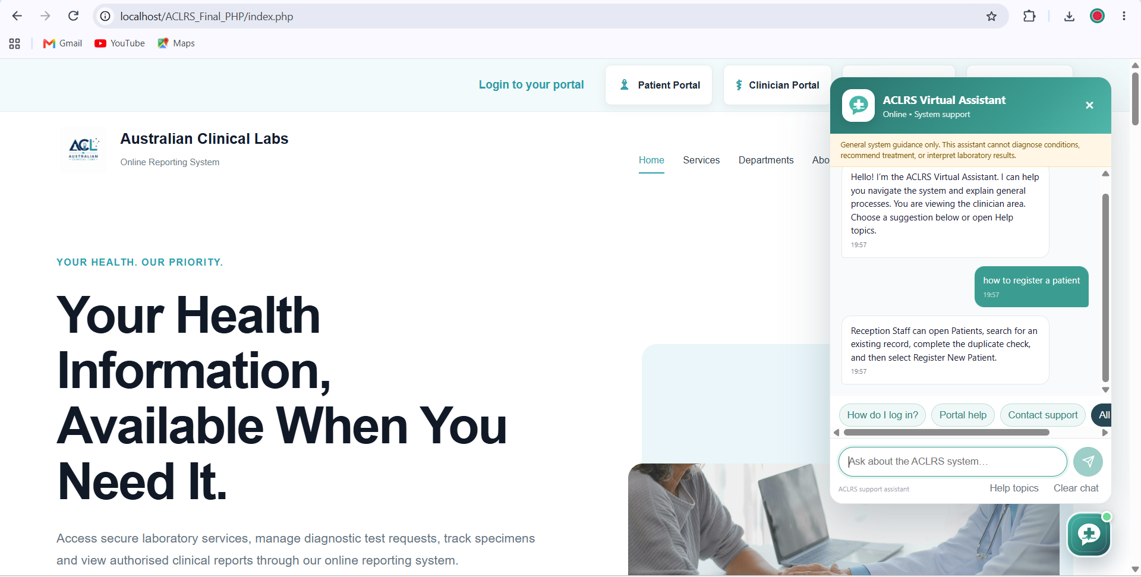
Purpose: Receives a chatbot question, validates it, selects a safe ACLRS support answer and returns the response to the chatbot interface.
<?php
declare(strict_types=1);

header('Content-Type: application/json; charset=utf-8');
header('X-Content-Type-Options: nosniff');
header('Cache-Control: no-store');

if ($_SERVER['REQUEST_METHOD'] !== 'POST') {
http_response_code(405);
echo json_encode(['success' => false, 'message' => 'Only POST requests are allowed.']);
exit;
}

$payload = json_decode((string) file_get_contents('php://input'), true);
$message = trim((string) ($payload['message'] ?? ''));
$role = trim((string) ($payload['role'] ?? 'visitor'));

if ($message === '' || mb_strlen($message) > 300) {
http_response_code(422);
echo json_encode(['success' => false, 'message' => 'Enter a message between 1 and 300 characters.']);
exit;
}

$question = mb_strtolower($message);
$rules = [
['/(emergency|chest pain|cannot breathe|suicide)/i', 'This assistant cannot provide emergency help. In Australia, call 000 for an emergency or contact a qualified healthcare professional immediately.'],
['/(diagnos|interpret|medicine|treatment|cancer|disease)/i', 'I cannot diagnose conditions, interpret results, or recommend treatment. Please discuss clinical questions with your doctor or an authorised healthcare professional.'],
['/(register.*patient|new patient)/i', 'Reception Staff can open Patients, search for an existing record, complete the duplicate check, and then select Register New Patient.'],
['/(test request|request.*test)/i', 'To create a test request, select the patient, test and clinician, enter the priority and referral details, review the information, and submit it.'],
['/referral/i', 'Referral information is linked to the patient and test request. Reception Staff can search, review and update the appropriate referral record.'],
['/(search.*patient|patient.*search)/i', 'Open Patients, enter a patient ID, name, date of birth, phone number or referral number, and select Search Patient. Verify the details before selecting the record.'],
['/(book|appointment)/i', $role === 'reception staff' ? 'Open Appointments to view, confirm, complete, cancel or mark a booking as no-show when authorised.' : 'Open Appointments, choose the service, date and time, then review and confirm the booking.'],
['/(track.*specimen|specimen.*track)/i', 'Open Specimen Tracking and search using the specimen ID or barcode to view its current stage.'],
['/(report|result)/i', 'Authorised users can open Results or Reports to view approved laboratory reports. Draft results must not be treated as final.'],
['/(password|forgot)/i', 'Select Forgot Password on the login page, verify the account, set a new password and return to the login page.'],
['/(login|sign in)/i', 'Choose the correct ACLRS portal and sign in using the account assigned to your role.'],
['/(privacy|security|confidential)/i', 'Use only your authorised account, access only required records, do not share patient data through unsecured channels, and log out when finished.'],
['/(hello|hi|hey)/i', 'Hello! How can I help you use the ACLRS system today?'],
['/thank/i', 'You are welcome. Is there anything else you need help finding in ACLRS?'],
];

$answer = 'I can help with ACLRS navigation, login, patient registration, test requests, referrals, appointments, specimens, reports and account support. Please enter a short system-related question.';
foreach ($rules as [$pattern, $response]) {
if (preg_match($pattern, $question) === 1) {
$answer = $response;
break;
}
}

echo json_encode([
'success' => true,
'answer' => $answer,
], JSON_UNESCAPED_SLASHES | JSON_UNESCAPED_UNICODE);

