5.1 User Interface Design: Login and Registration
Functional Mapping Integrated with Wireframes
1. Main Login Page
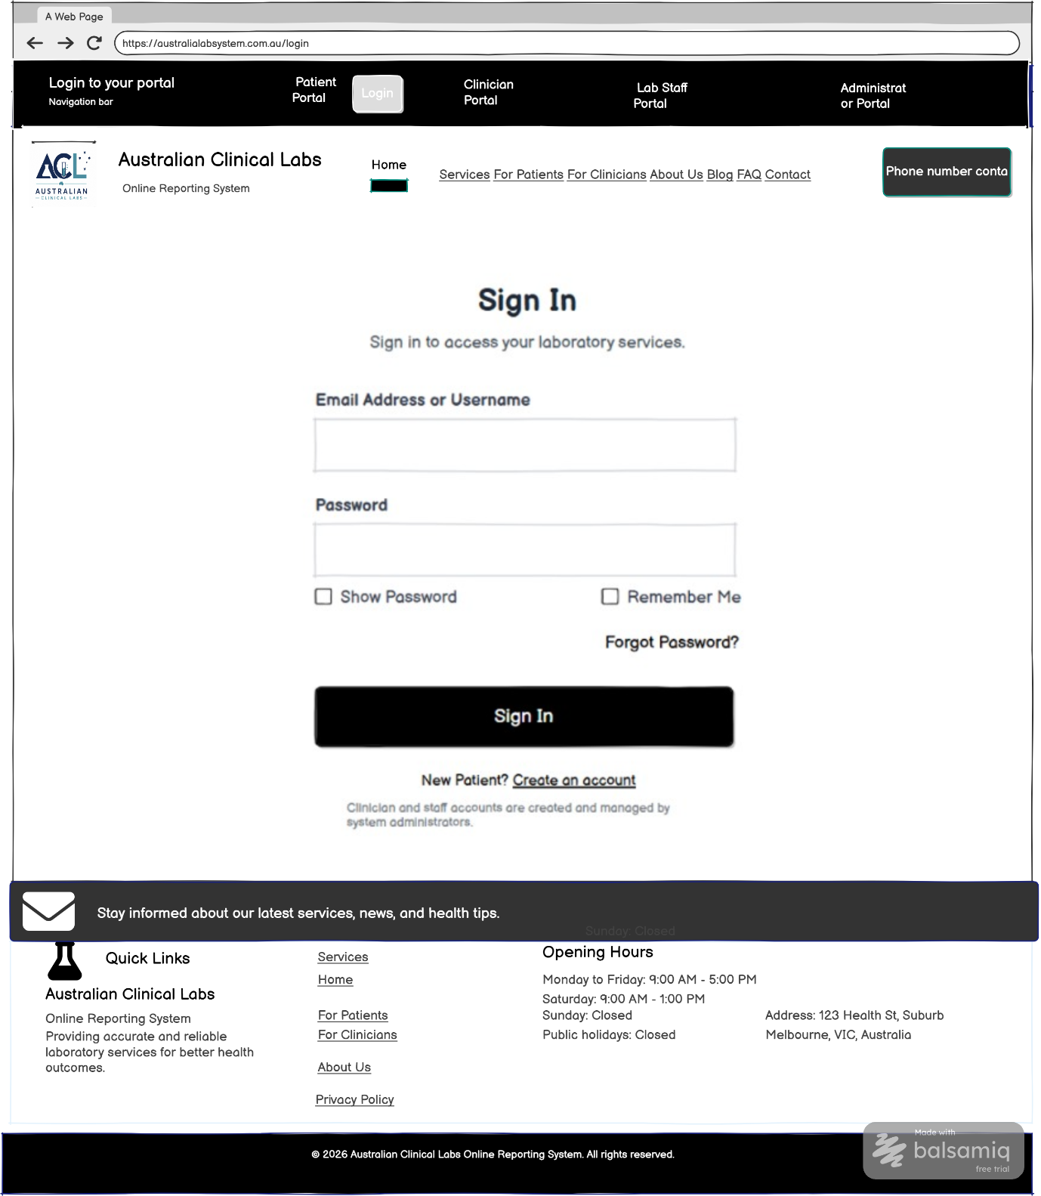
Functional mapping for the wireframe above
UI Component / Area | Primary Functionality | Mapped Requirements | CRUD
Main Login Page | Allows registered patients and authorised users to sign in using email/username and password. | FR2, NFR1 | Read

2. Patient Registration Form
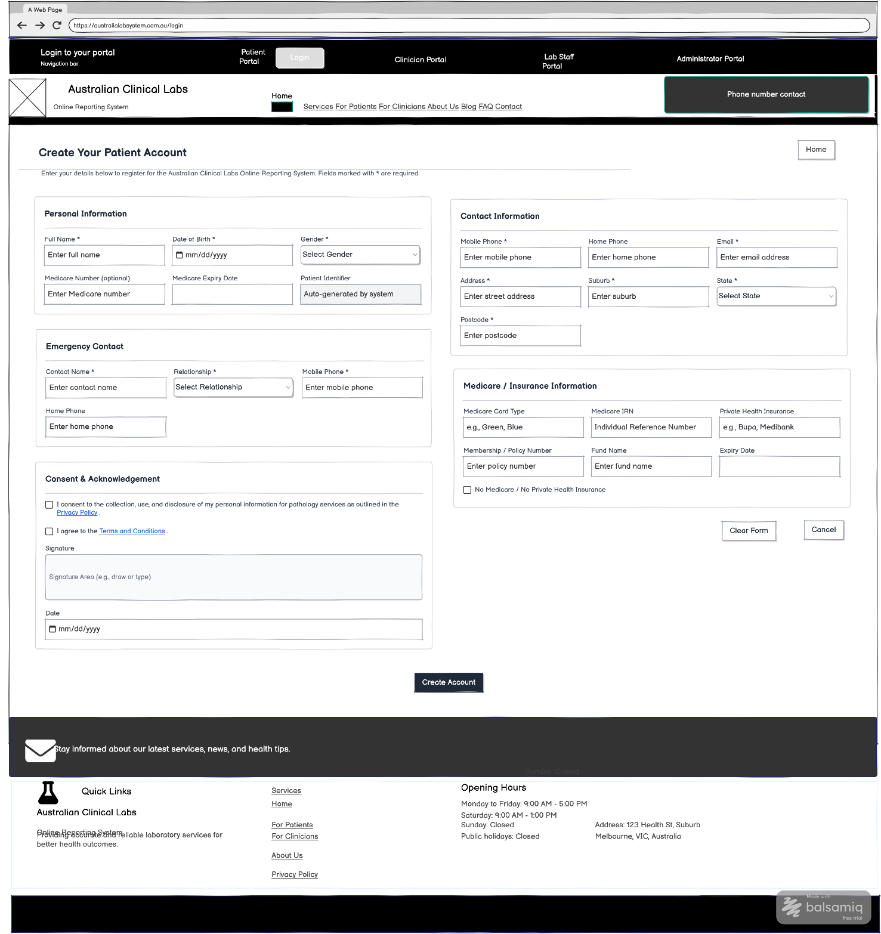
Functional mapping for the wireframe above
UI Component / Area | Primary Functionality | Mapped Requirements | CRUD
Patient Registration Form | Allows new patients to create an account by entering personal, contact, emergency contact and Medicare/insurance information. | FR1, FR7 | Create

3. Email Verification
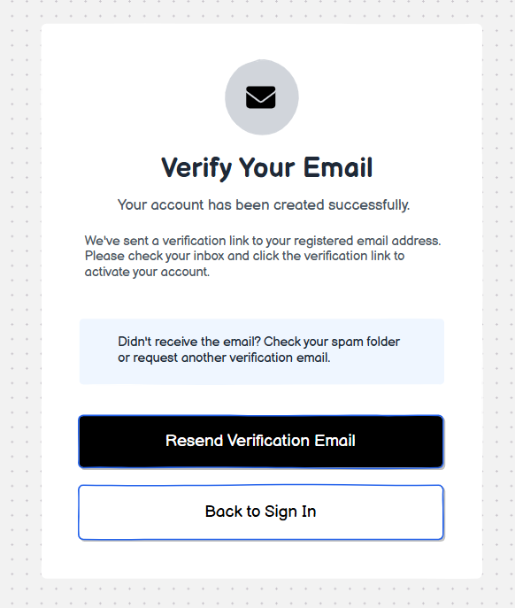
Functional mapping for the wireframe above
UI Component / Area | Primary Functionality | Mapped Requirements | CRUD
Email Verification Screen | Verifies the patient's registered email after account creation before system access. | FR1, NFR2 | Read / Update

4. Multi-Factor Authentication
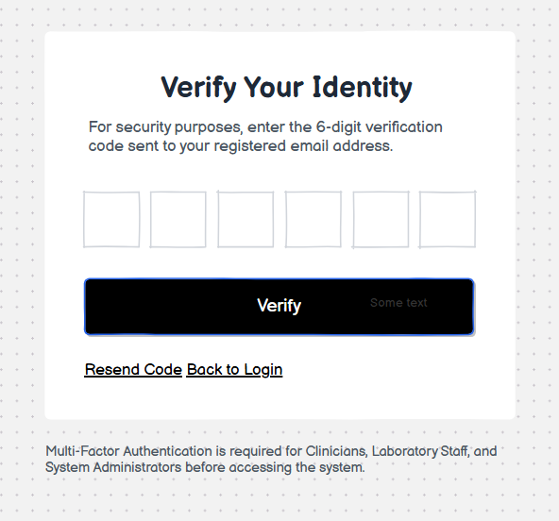
Functional mapping for the wireframe above
UI Component / Area | Primary Functionality | Mapped Requirements | CRUD
Multi-Factor Authentication Screen | Requires clinicians, laboratory staff and administrators to enter a verification code before accessing the system. | FR3 | Read

5. Reset Password
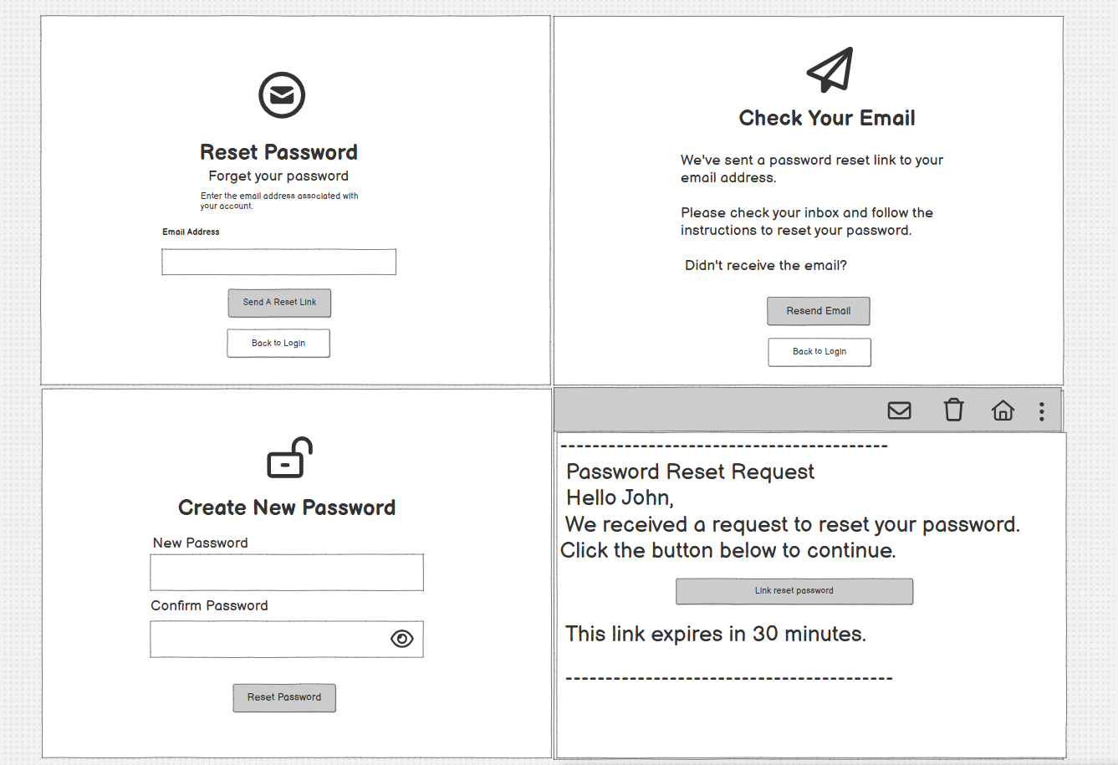
Functional mapping for the wireframe above
UI Component / Area | Primary Functionality | Mapped Requirements | CRUD
Password Reset Interface | Allows users to request a password reset by email and create a new password. | FR5 | Update

6. Clinician and Staff Login
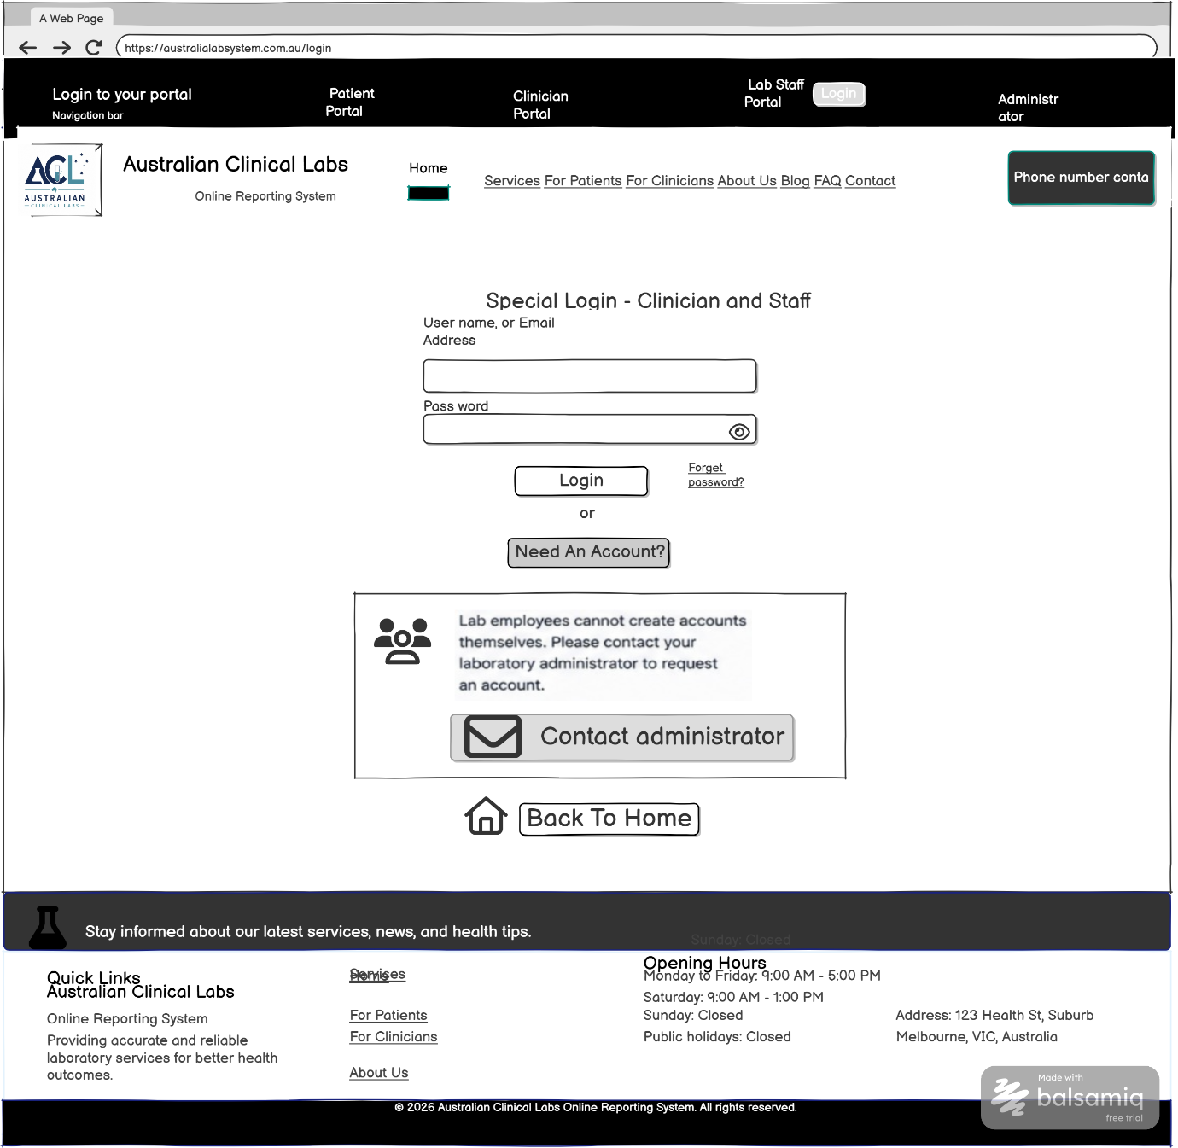
Functional mapping for the wireframe above
UI Component / Area | Primary Functionality | Mapped Requirements | CRUD
Clinician & Staff Login | Provides a dedicated secure login interface for clinicians and laboratory staff. | FR2, FR3, NFR1 | Read
Staff Account Request / Contact Administrator | Allows staff without an account to request account creation through the administrator. | FR5 | Create

7. Contact Administrator
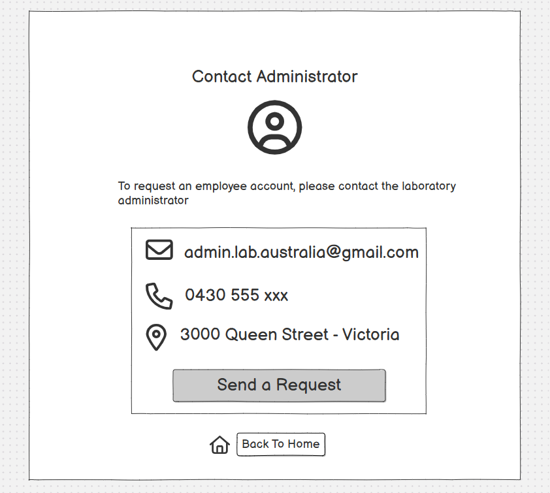
Functional mapping for the wireframe above
UI Component / Area | Primary Functionality | Mapped Requirements | CRUD
Staff Account Request / Contact Administrator | Provides staff with administrator contact details and a request action when an employee account is required. | FR5 | Create

8. Register New Staff
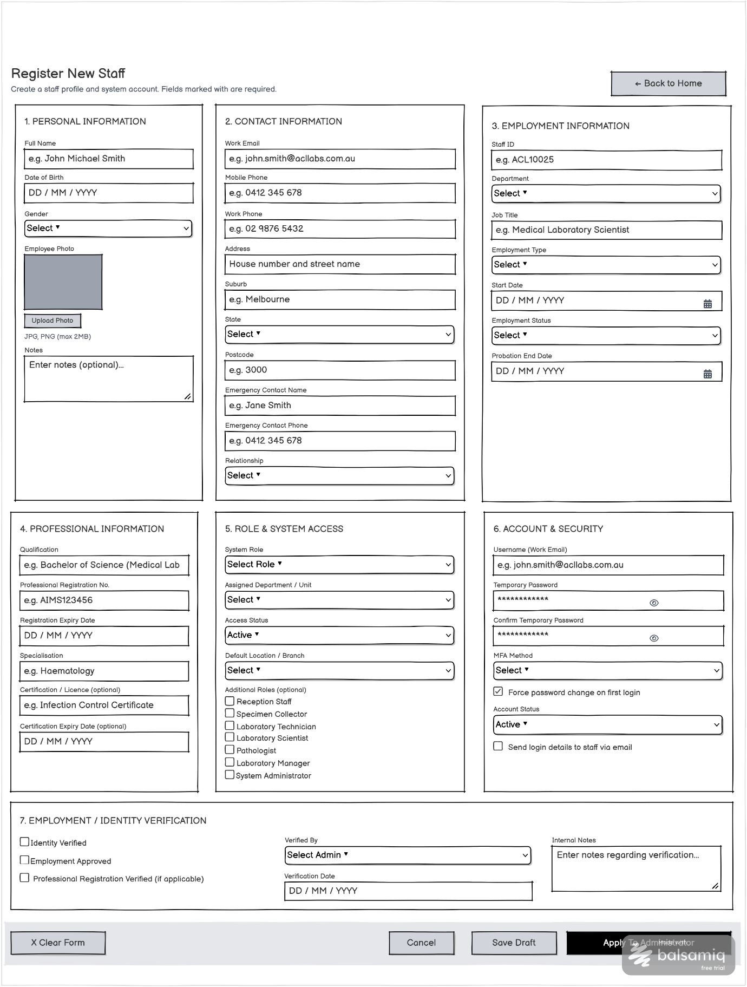
Functional mapping for the wireframe above
UI Component / Area | Primary Functionality | Mapped Requirements | CRUD
Staff Registration Form | Allows administrators to create staff accounts containing personal, contact, employment, professional and security information. | FR5 | Create
Role & System Access Section | Allows administrators to assign system roles, departments, account status and permissions to staff. | FR4, FR5, NFR3 | Create / Update
Employment / Identity Verification Section | Allows administrators to verify staff identity, employment approval and professional registration. | FR1, FR5 | Read / Update

9. Staff Account Request Confirmation
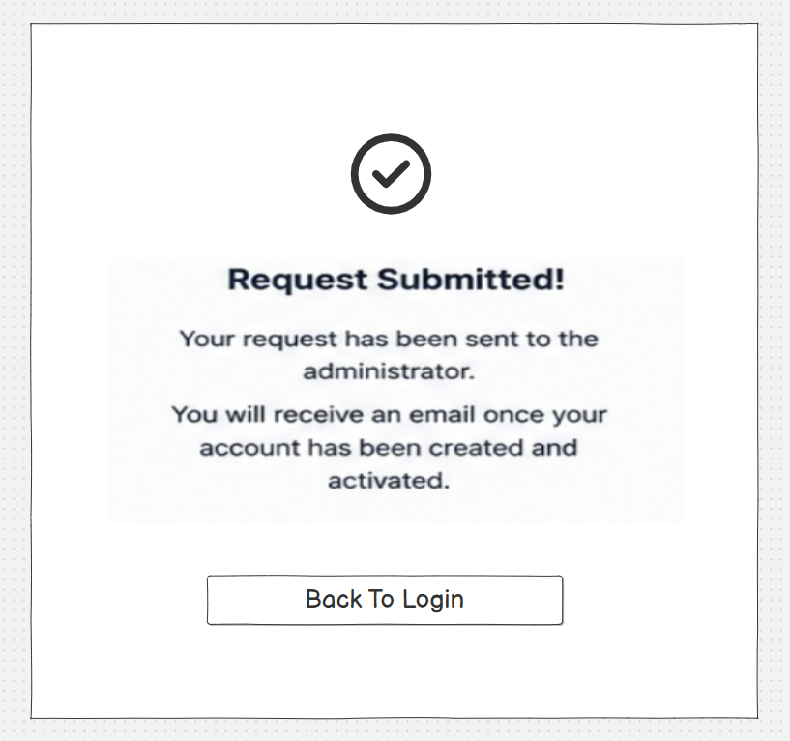
Functional mapping for the wireframe above
UI Component / Area | Primary Functionality | Mapped Requirements | CRUD
Account Request Confirmation | Confirms that a staff account request has been submitted to the administrator and advises that activation will be communicated by email. | FR5 | Read

10. Multi-User Staff Portal
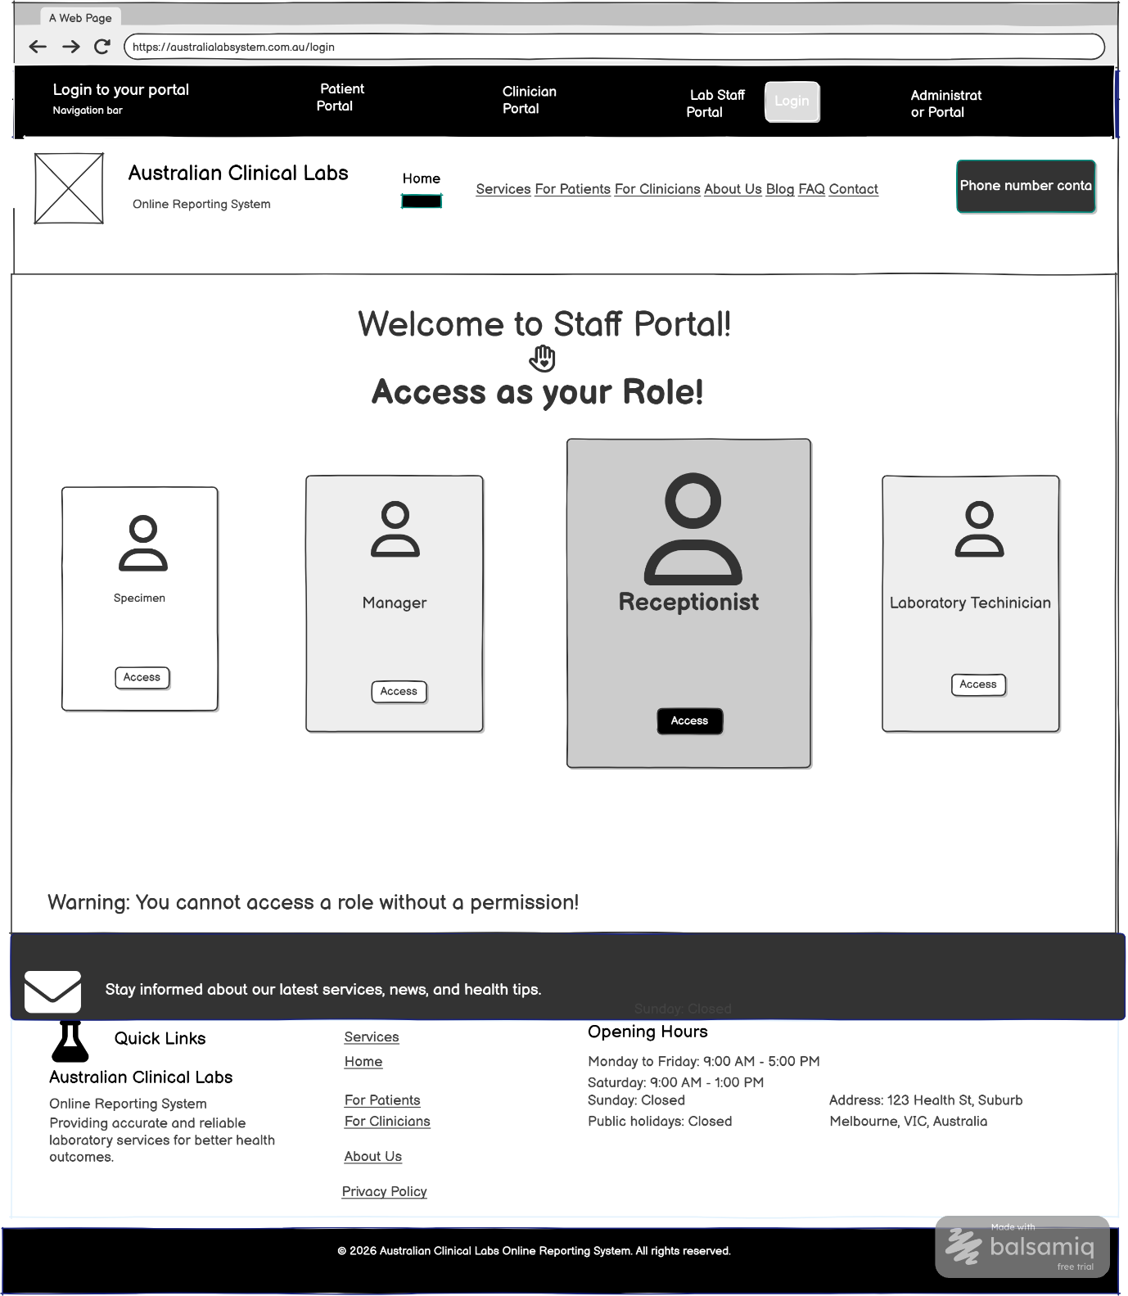
Functional mapping for the wireframe above
UI Component / Area | Primary Functionality | Mapped Requirements | CRUD
Staff Portal Role Selection | Displays authorised staff roles and allows users to access functions according to their assigned role. | FR4, NFR3 | Read

11. Access Denied Message
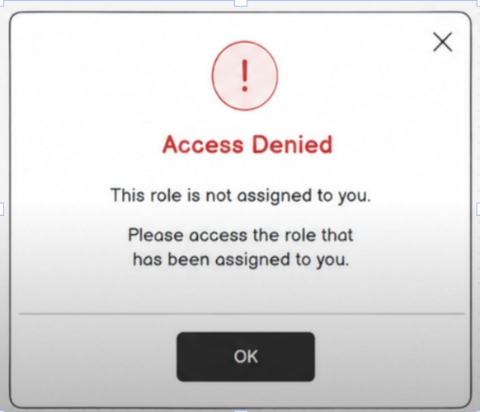
Functional mapping for the wireframe above
UI Component / Area | Primary Functionality | Mapped Requirements | CRUD
Access Denied Message | Prevents users from opening a portal or role that has not been assigned to them. | FR4, NFR3 | Read

Mapping Scope Note
FR6 is not mapped because the current wireframes do not show a post-login profile view/update screen. NFR4-NFR11, NFR13 and NFR14 cannot be demonstrated by these wireframes alone. NFR12 may be discussed as a general usability/design-quality requirement rather than mapped to a single screen.

