5.1 UI Wireframe: Lab Worklist & Result Entry Screen
Functional Mapping Integrated with Wireframes
1. Laboratory Worklist Screen
Centralised worklist of specimens awaiting processing, with filters for department, priority, status and collection date.
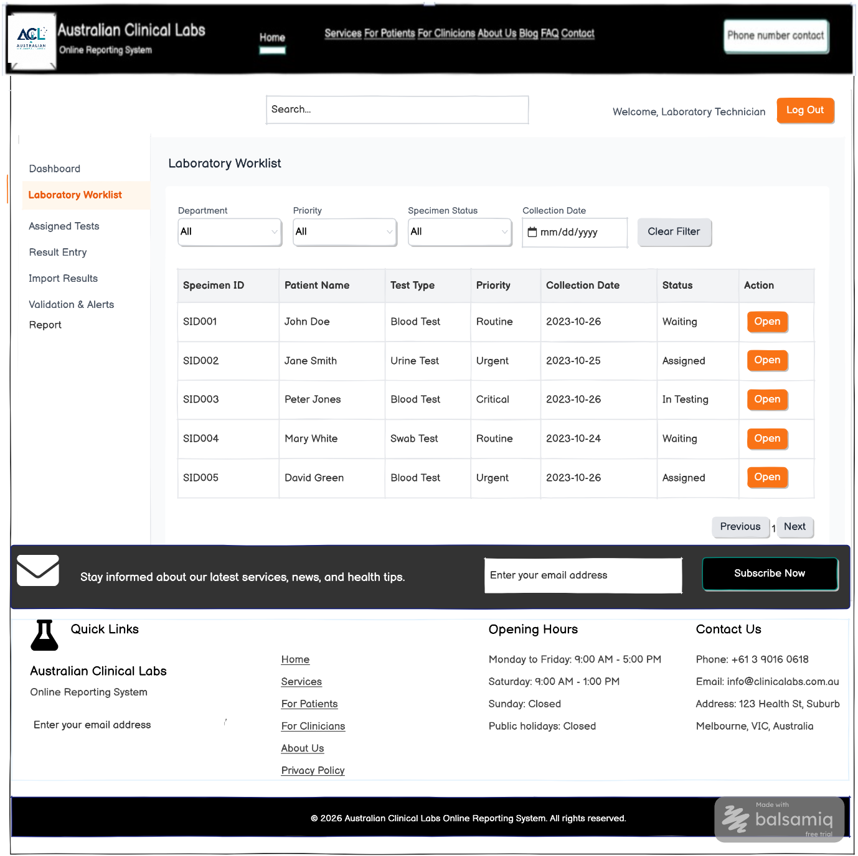
Functional mapping for the wireframe above
UI Component / Area | Primary Functionality | Mapped Requirements | CRUD
Laboratory Worklist | Displays and filters the laboratory worklist and opens specimens for processing. | FR25, FR21 | Read

2. Result Entry Screen
Allows authorised laboratory staff to enter and save test results before validation.
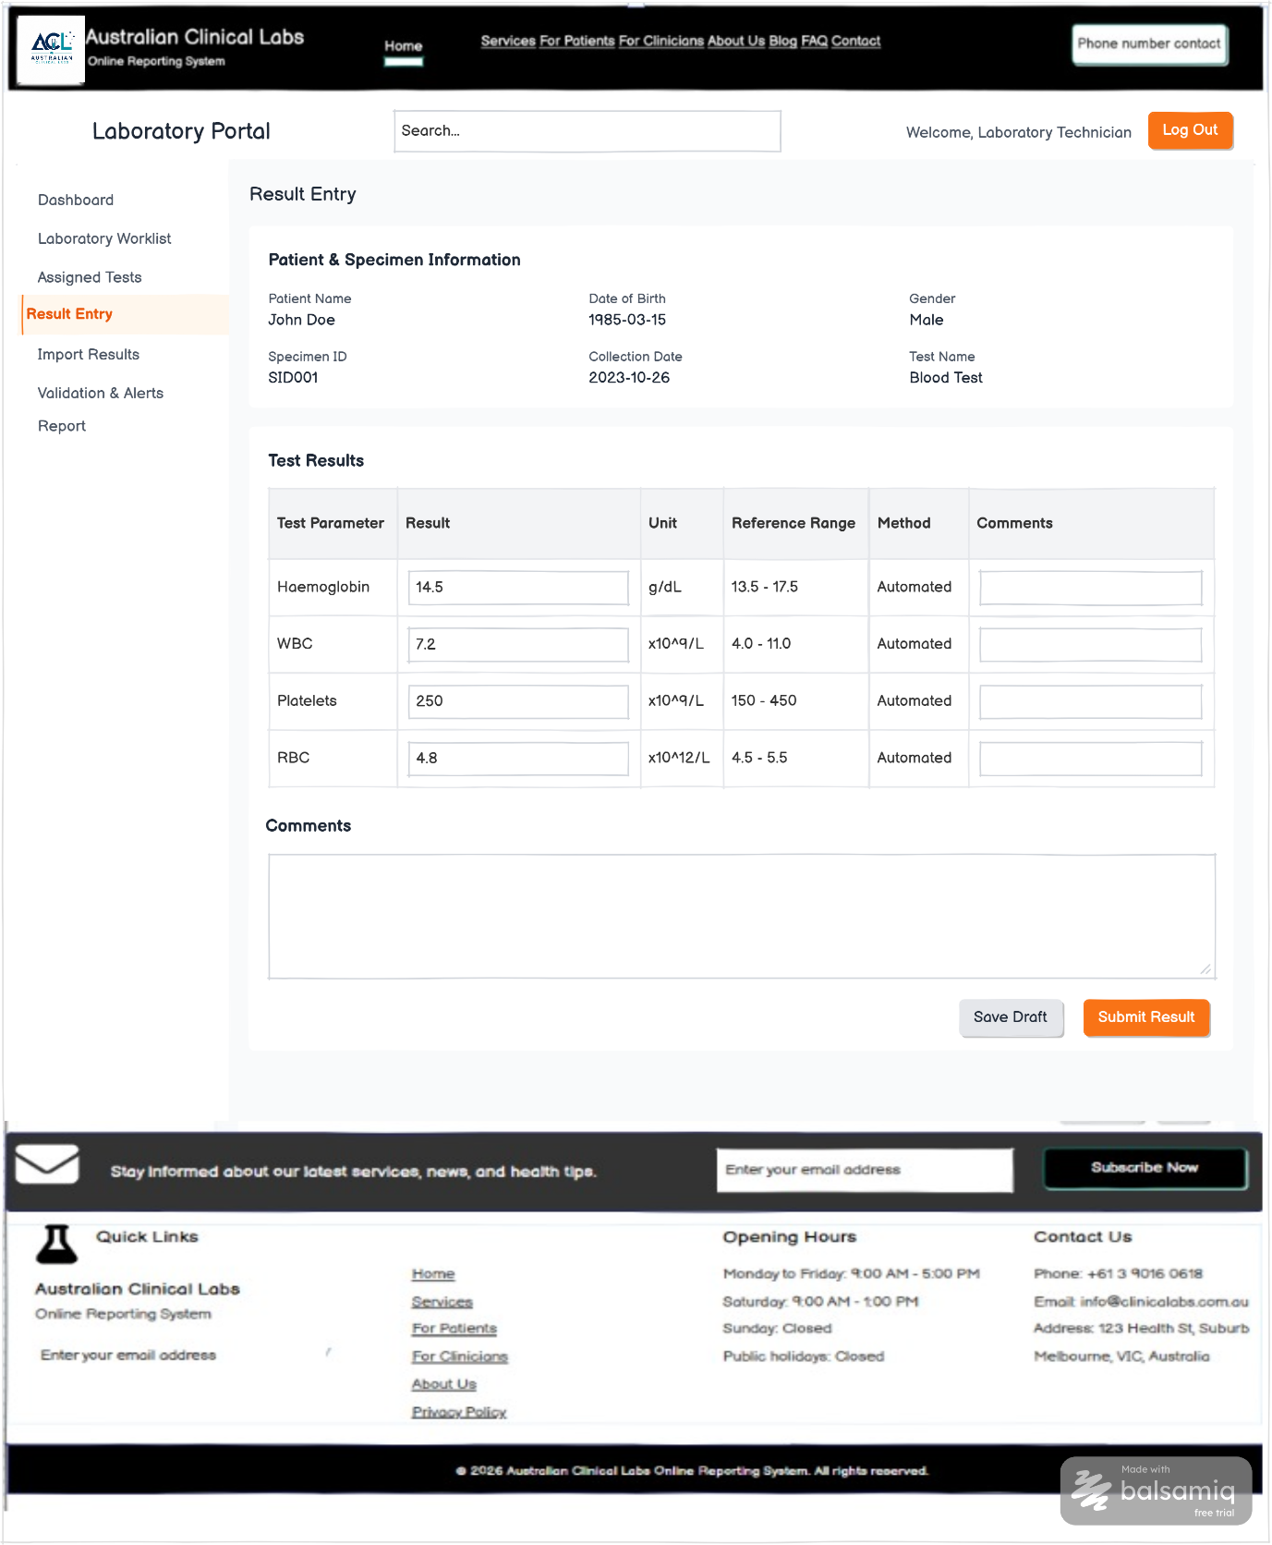
Functional mapping for the wireframe above
UI Component / Area | Primary Functionality | Mapped Requirements | CRUD
Result Entry | Enters numerical results, units, methods and comments, then saves or submits the result. | FR27 | Create / Update

3. Assigned Tests Screen
Shows tests allocated to the logged-in technician or scientist, including priority and due time.
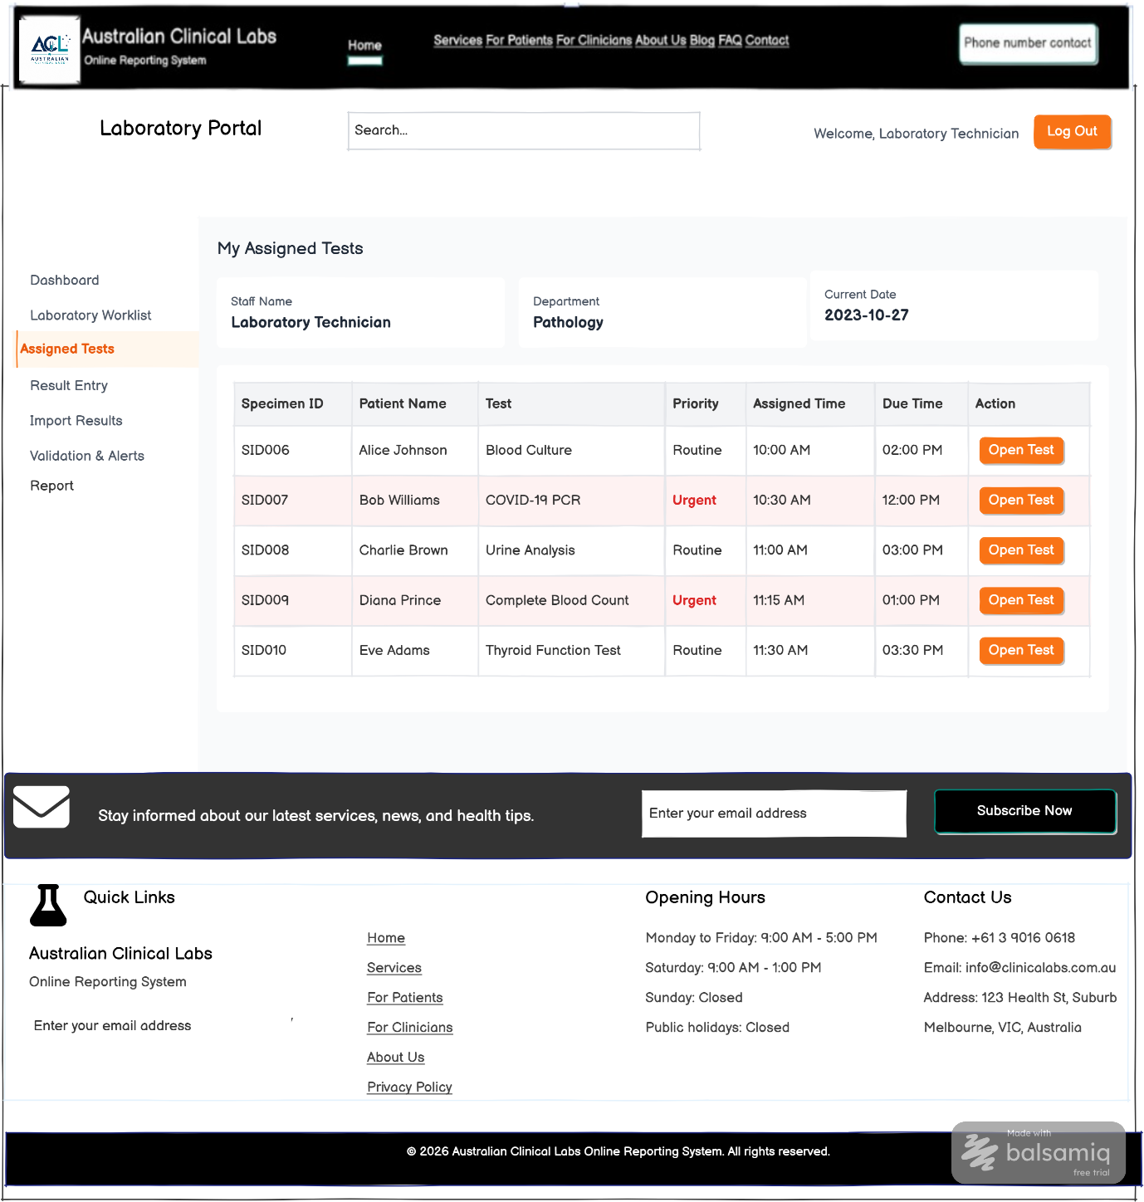
Functional mapping for the wireframe above
UI Component / Area | Primary Functionality | Mapped Requirements | CRUD
Assigned Tests | Displays assigned specimens/tests and opens an individual test for processing. | FR26 | Read

4. Validation & Alerts Screen
Reviews entered results against validation rules and reference ranges and highlights abnormal values.
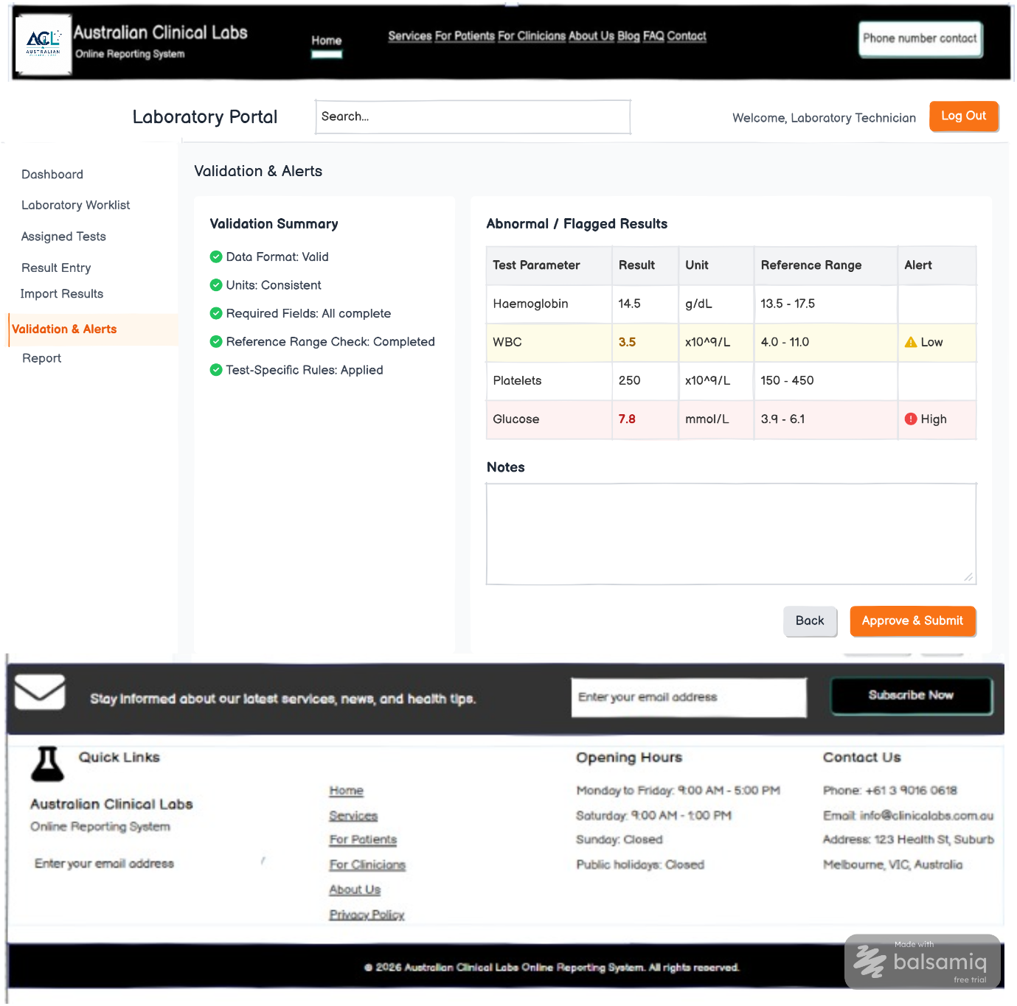
Functional mapping for the wireframe above
UI Component / Area | Primary Functionality | Mapped Requirements | CRUD
Validation Summary | Shows data-format, unit, required-field, reference-range and test-rule checks. | FR29 | Read / Update
Abnormal / Flagged Results | Flags results outside the applicable reference range. | FR30 | Read
Validation Notes & Approval | Adds review notes and approves/submits validated results to the next stage. | FR29 | Update

Mapping scope note: Only functions visibly implemented in these four wireframes are mapped. FR28, FR31 and report-generation functions are not mapped because dedicated screens are not shown. NFRs requiring implementation evidence are also excluded.

