5.1 - UI Wireframe: Admin/System Config Screen
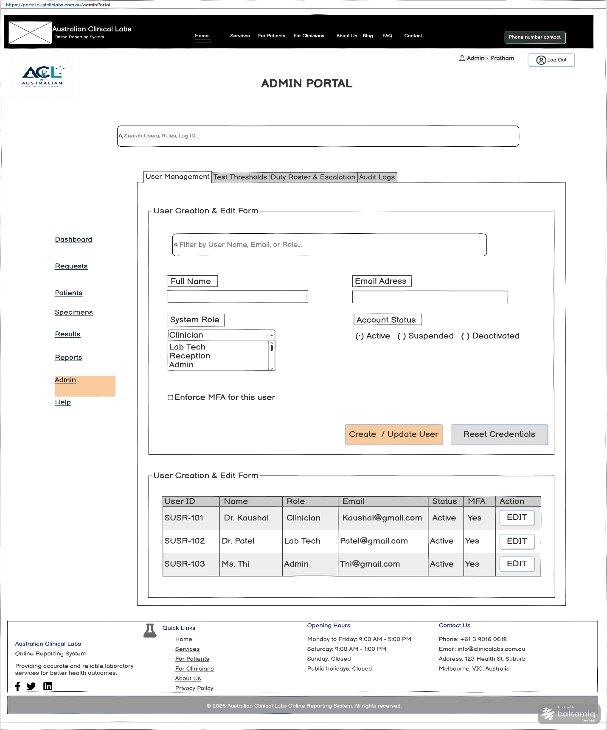

FR Mapping Table

UI Component / Area | Primary Functionality | Mapped Requirements | CRUD
Global Admin Search | Quick look up across admin portal assets and entities. | FR5, NFR5 | Read
User Creation & Edit Form | Allows Admins to provision new accounts, edit role permissions, reset credentials, and enforce MFA. | FR1, FR2, FR3, FR4, FR5 | Create/Update
User Accounts Table | Displays existing system users and opens their profiles for modification. | FR4, FR5, FR6 | Read / Update

Test Parameter & Critical Limit Configuration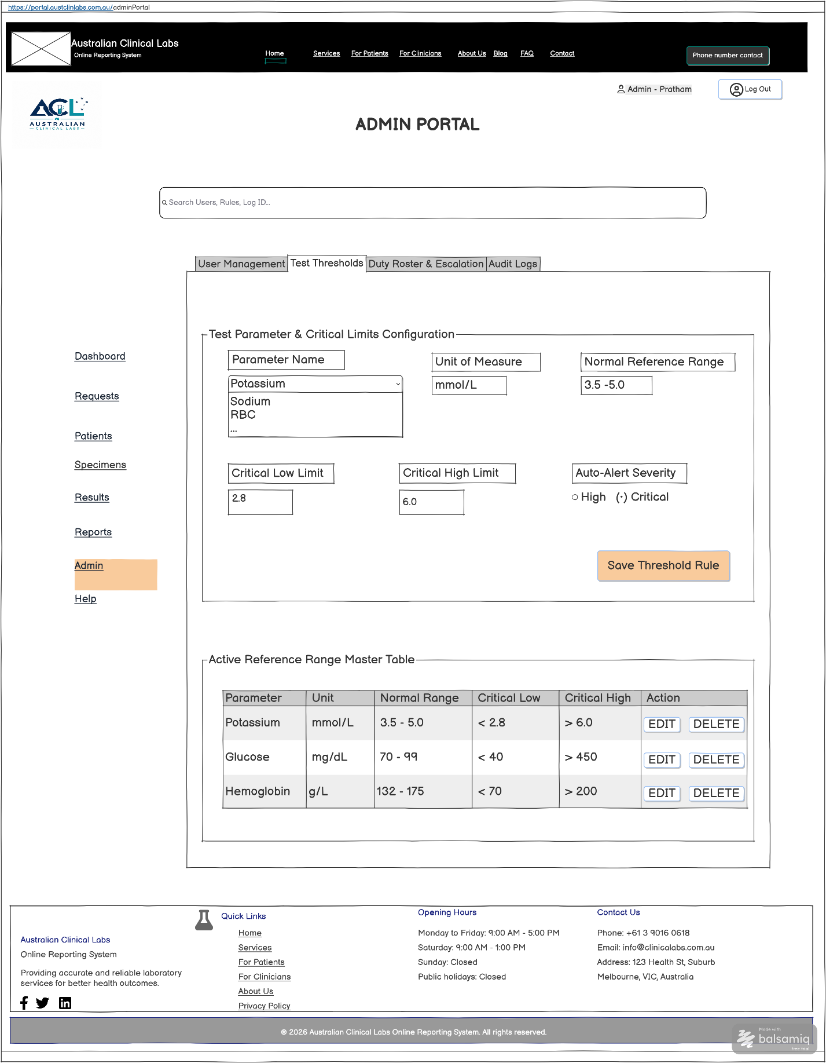

FR Mapping Table

UI Component / Area | Primary Functionality | Mapped Requirements | CRUD
Test Parameter & Critical Limits Configuration | Configures reference ranges and automated triggers for critical lab value alerting. | FR29, FR30, FR31 | Create/ Read
Active Reference Range Master Table | Displays active diagnostic thresholds and allows inline modification or removal of rules. | FR29  FR30  FR11 | Read/Update

Duty Roster & Escalation Schedule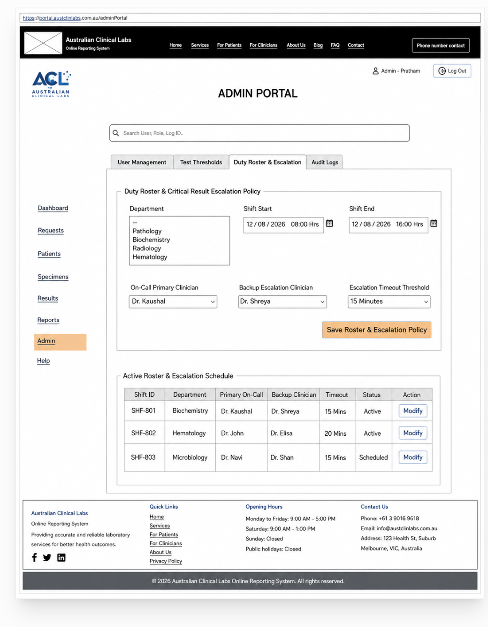

FR Mapping Table

UI Component / Area | Primary Functionality | Mapped Requirements | CRUD
Duty Roster & Escalation Policy Form | Configures laboratory staff shift schedules and defines automated escalation pathways for unacknowledged critical alerts | FR31  FR32  FR62 | Create / Update
Active Roster & Escalation Schedule Table | Displays live shift assignments, primary on-call clinicians, backup contacts, and timeout thresholds | FR31  FR62 | Read / Update

System Audit Logs
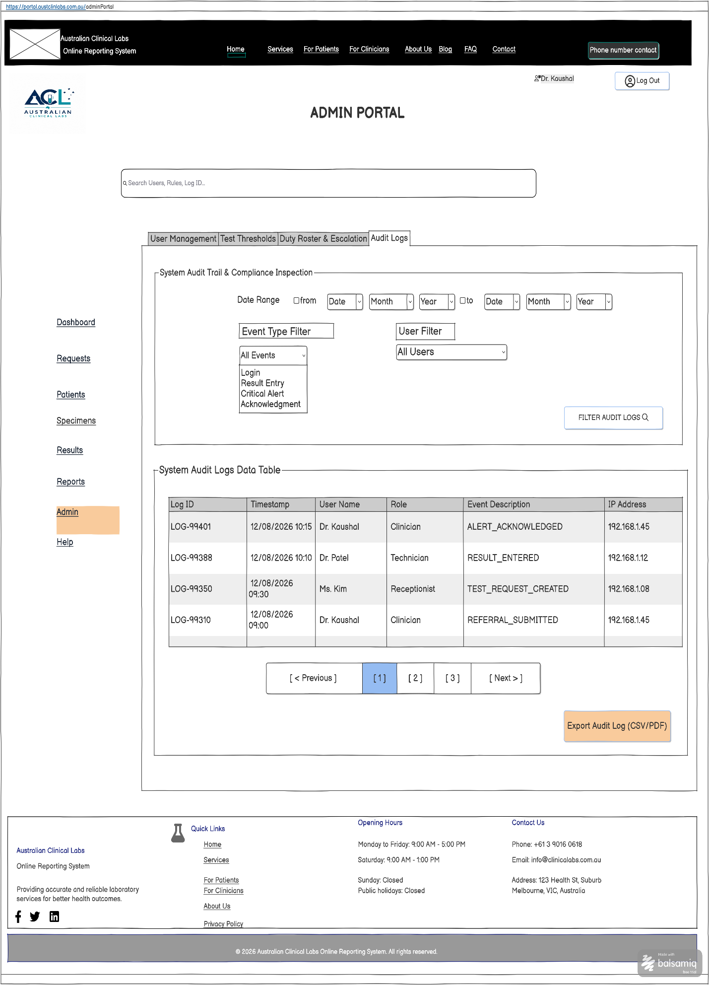

FR Mapping Table

UI Component / Area | Primary Functionality | Mapped Requirements | CRUD
System Audit Trail Filter Panel | Filters system activity logs, security events, backup history, and data restoration triggers | NFR9 | Read
System Audit Logs Data Table & Export | Displays time-stamped activity records, system errors, and data sync statuses for governance and troubleshooting | FR66,  FR67,  NFR9,  NFR11 | Read
Export & System Maintenance Actions | Triggers export of audit logs and execute system data restoration / backup recovery operations | FR66,  FR67,  NFR8,  NFR9 | Read / Update

