9. Sequence Diagram: Test Request & Specimen Collection

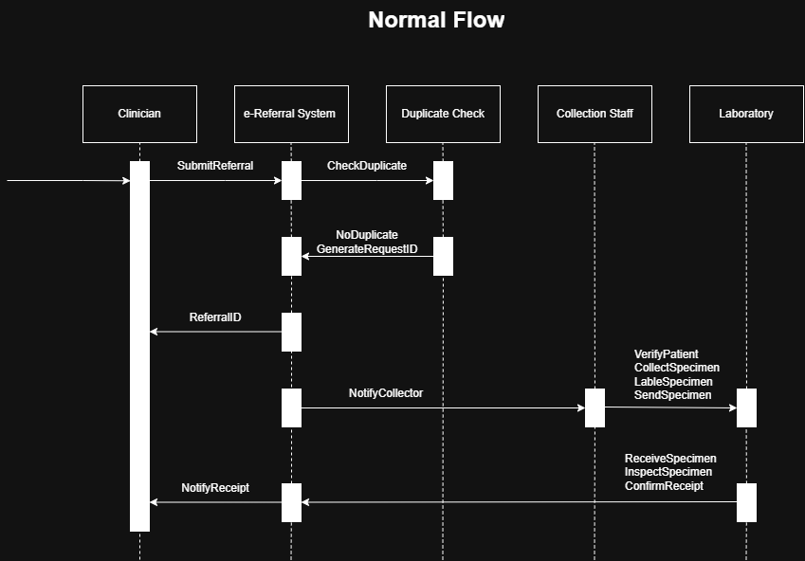
Figure 1. Sequence Diagram - Normal Flow

This diagram illustrates the standard workflow for processing a laboratory test referral. The clinician submits a referral through the e-Referral System, which performs a duplicate check. If no duplicate is found, the system generates a unique Referral ID and returns it to the clinician. The e-Referral System then notifies the collection staff to collect and label the specimen before sending it to the laboratory. The laboratory receives, inspects, and confirms the specimen, after which a receipt notification is sent back to the clinician.

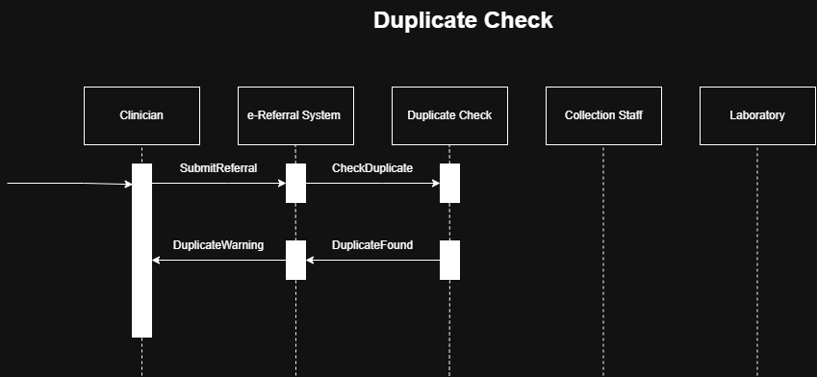
Figure 2. Sequence Diagram – Duplication

This diagram illustrates the scenario where a duplicate referral is detected. After the clinician submits a referral, the e-Referral System performs a duplicate check. If an existing referral is found, the duplicate check component returns a duplicate warning to the e-Referral System, which then notifies the clinician. No Referral ID is generated, and the referral process stops to prevent duplicate test requests.

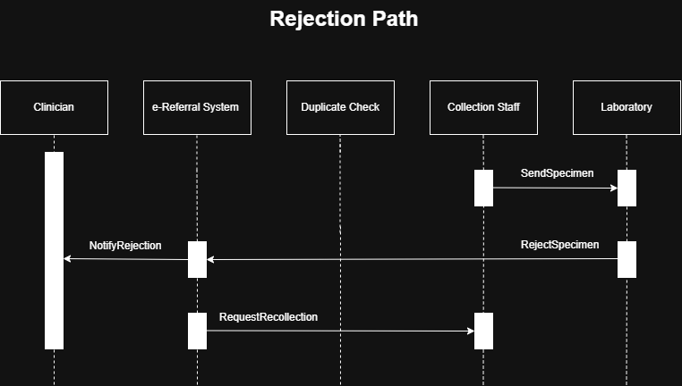
Figure 3. Sequence Diagram – Rejection Path

This diagram illustrates the workflow when a submitted specimen is rejected by the laboratory. After the collection staff sends the specimen, the laboratory identifies a problem with the specimen and rejects it. The rejection message is sent to the e-Referral System, which notifies the clinician of the rejection and requests the collection staff to recollect a new specimen. This ensures that an acceptable specimen is obtained before laboratory testing proceeds.

