5.1 User Interface Design: Patient Portal
Functional Mapping Integrated with Wireframes
1. Patient Dashboard
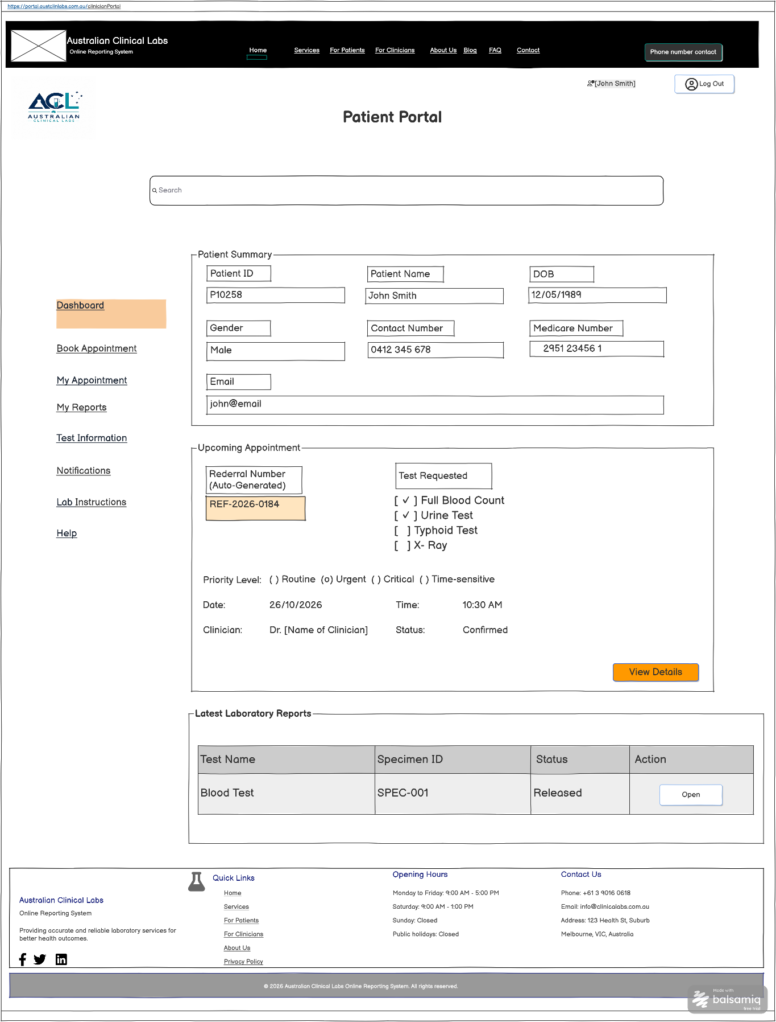
Functional mapping for the wireframe above
UI Component / Area | Primary Functionality | Mapped Requirements | CRUD
Patient Dashboard | Displays patient information, upcoming appointments and the latest released laboratory reports from the patient portal. | FR41, FR42 | Read

2. Book Appointment
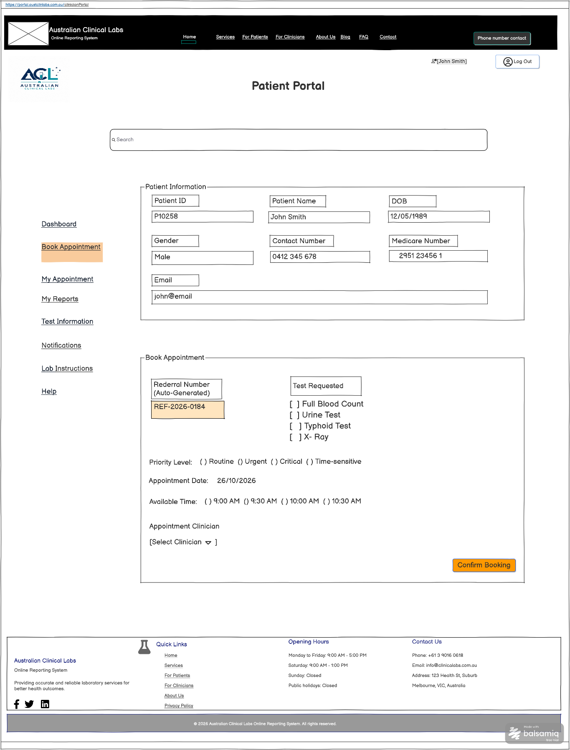
Functional mapping for the wireframe above
UI Component / Area | Primary Functionality | Mapped Requirements | CRUD
Book Appointment | Allows patients to select requested tests, appointment date/time and clinician, then confirm a laboratory specimen collection appointment. | FR48 | Create

3. My Appointment
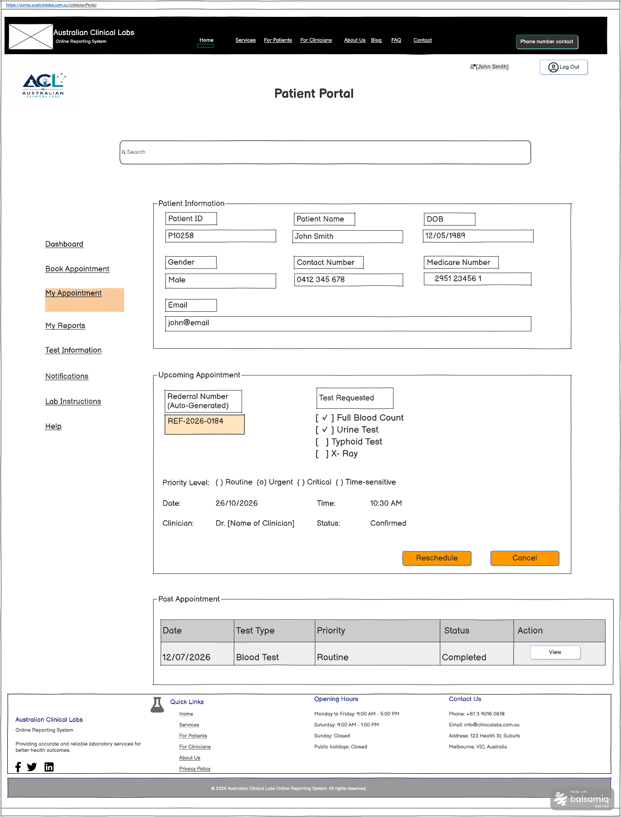
Functional mapping for the wireframe above
UI Component / Area | Primary Functionality | Mapped Requirements | CRUD
My Appointment | Allows patients to view upcoming and previous appointments and to reschedule or cancel an existing laboratory collection appointment. | FR48 | Read / Update / Delete

4. My Reports
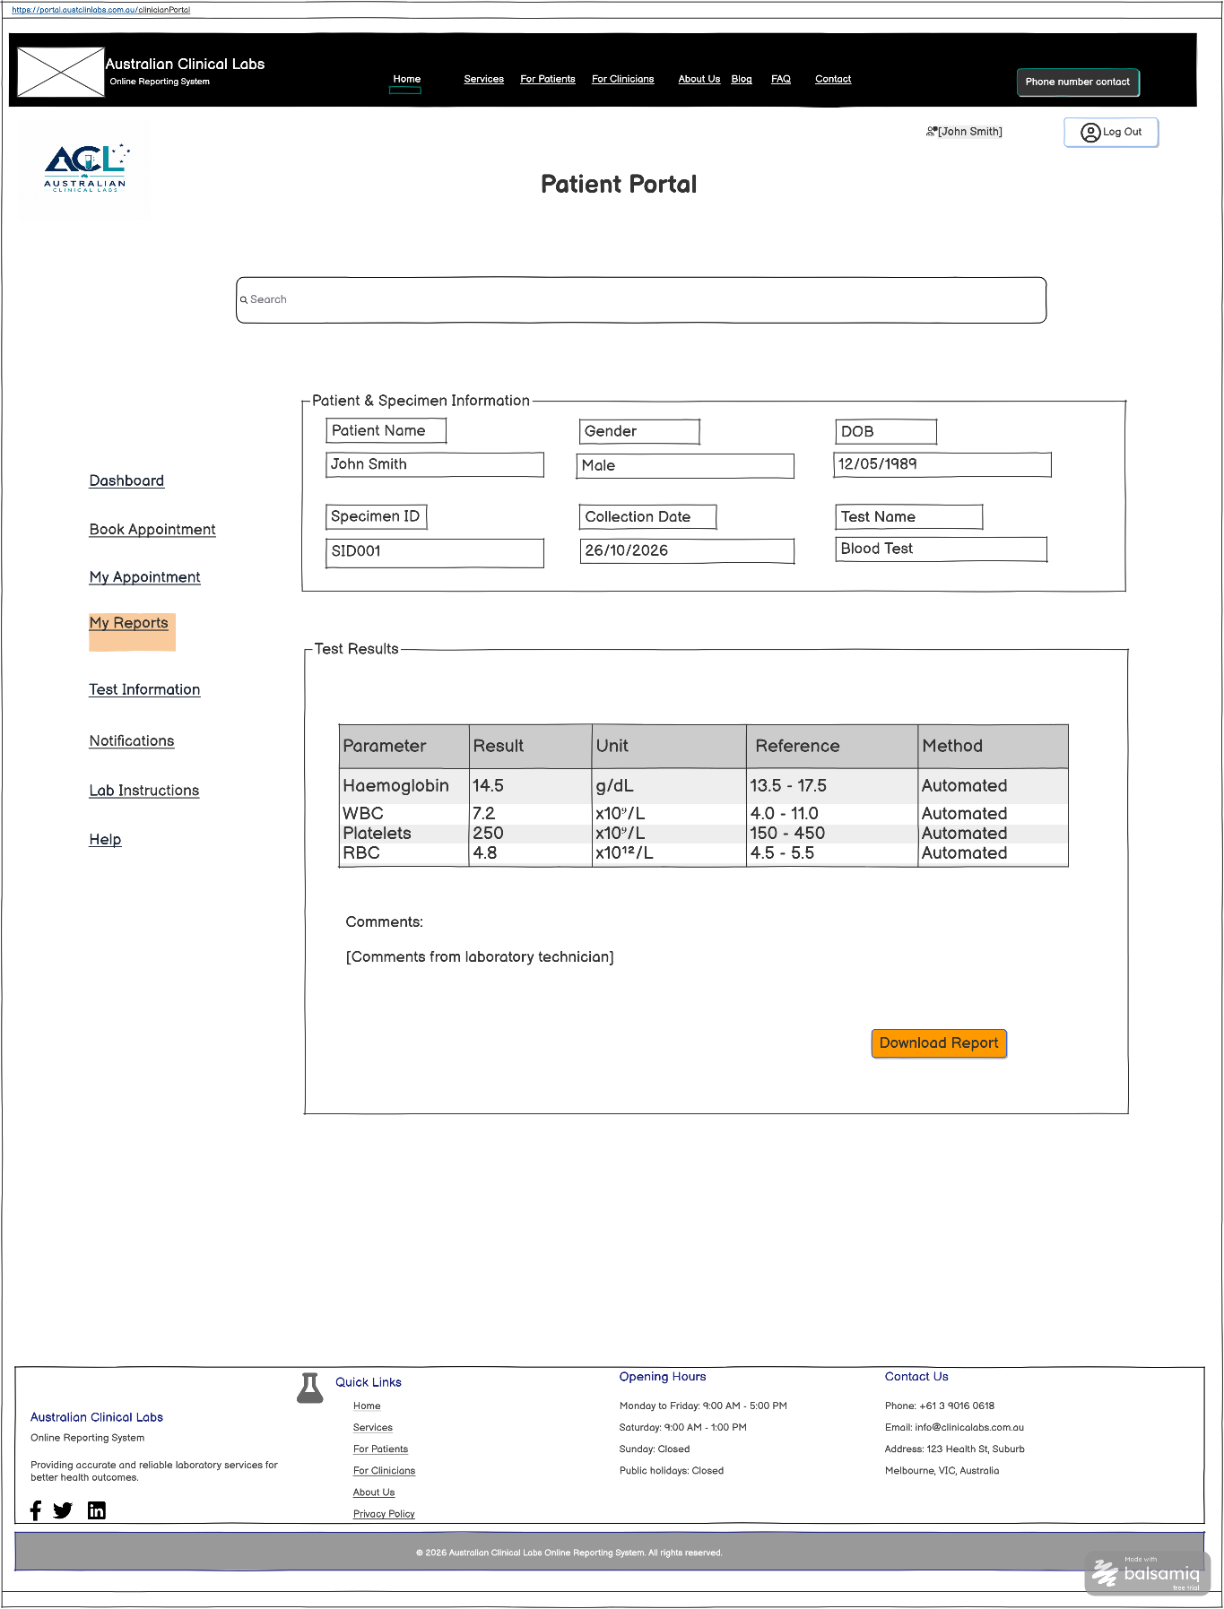
Functional mapping for the wireframe above
UI Component / Area | Primary Functionality | Mapped Requirements | CRUD
My Reports | Allows patients to view released test results, specimen information, reference values and laboratory comments, and download the authorised report. | FR39, FR41, FR42 | Read

5. Test Information
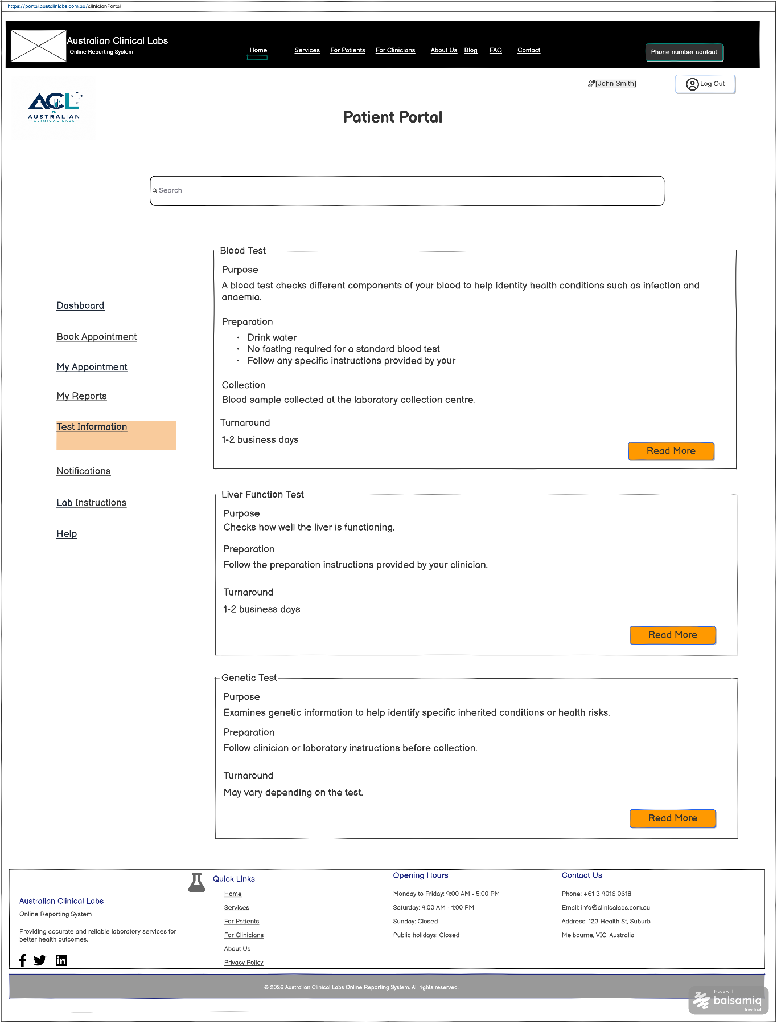
Functional mapping for the wireframe above
UI Component / Area | Primary Functionality | Mapped Requirements | CRUD
Test Information | Provides patients with plain-language information about laboratory tests, including purpose, preparation, collection and expected turnaround information. | FR11, FR41 | Read

6. Notification Preferences
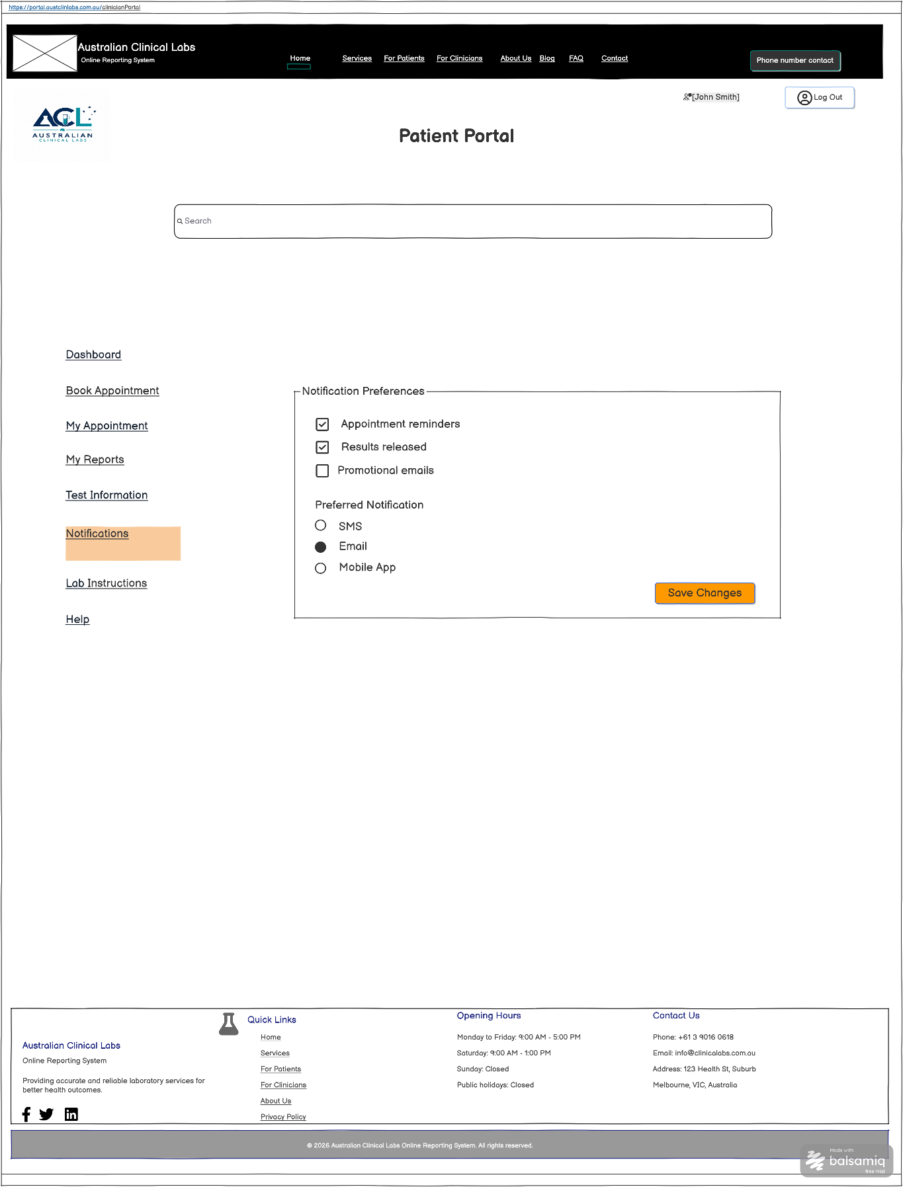
Functional mapping for the wireframe above
UI Component / Area | Primary Functionality | Mapped Requirements | CRUD
Notification Preferences | Allows patients to choose notification events and preferred communication methods such as SMS, email or mobile app. | FR6, FR41, FR43, FR49 | Read / Update

7. Lab Instructions
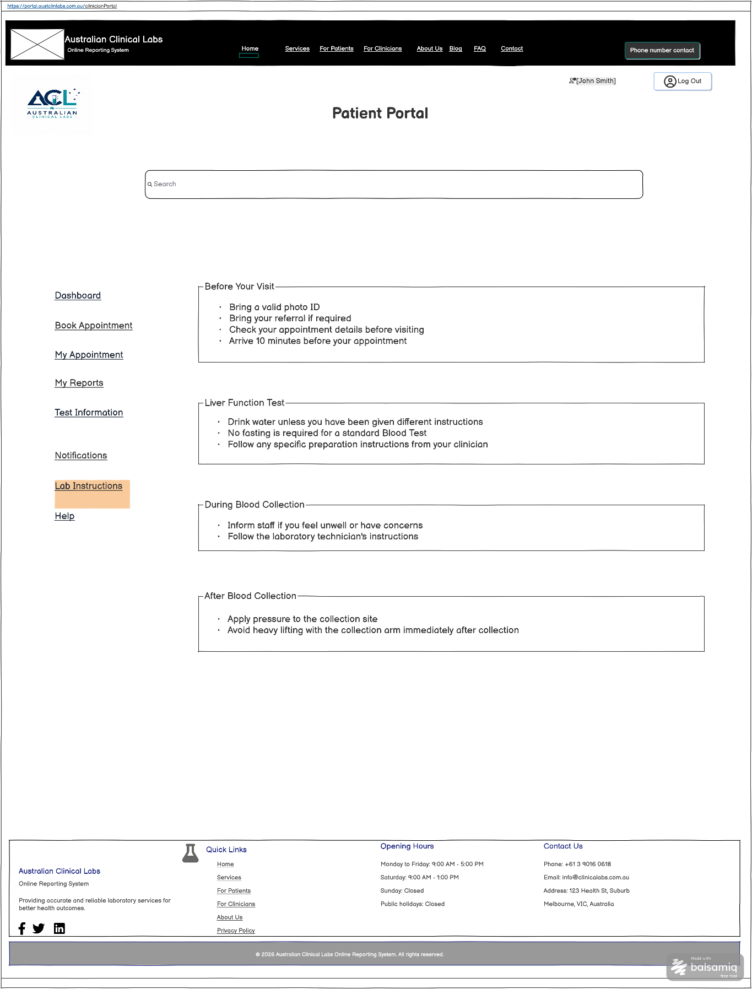
Functional mapping for the wireframe above
UI Component / Area | Primary Functionality | Mapped Requirements | CRUD
Lab Instructions | Provides patients with laboratory preparation, pre-visit, collection and after-collection instructions. | FR11, FR41 | Read

Mapping Scope Note
Only requirements that are visibly supported by the Patient Portal wireframes are mapped above. Security, encryption, response-time, capacity, backup, availability and recovery NFRs are not mapped merely from the wireframe because their implementation cannot be demonstrated visually.

