5.1 UI Wireframe: Reports Dashboard
Functional Mapping Integrated with Wireframes
1. Staff Workload Report
Displays laboratory staff workload metrics, including tests processed, average turnaround time and abnormal-result counts, with an option to download the report.
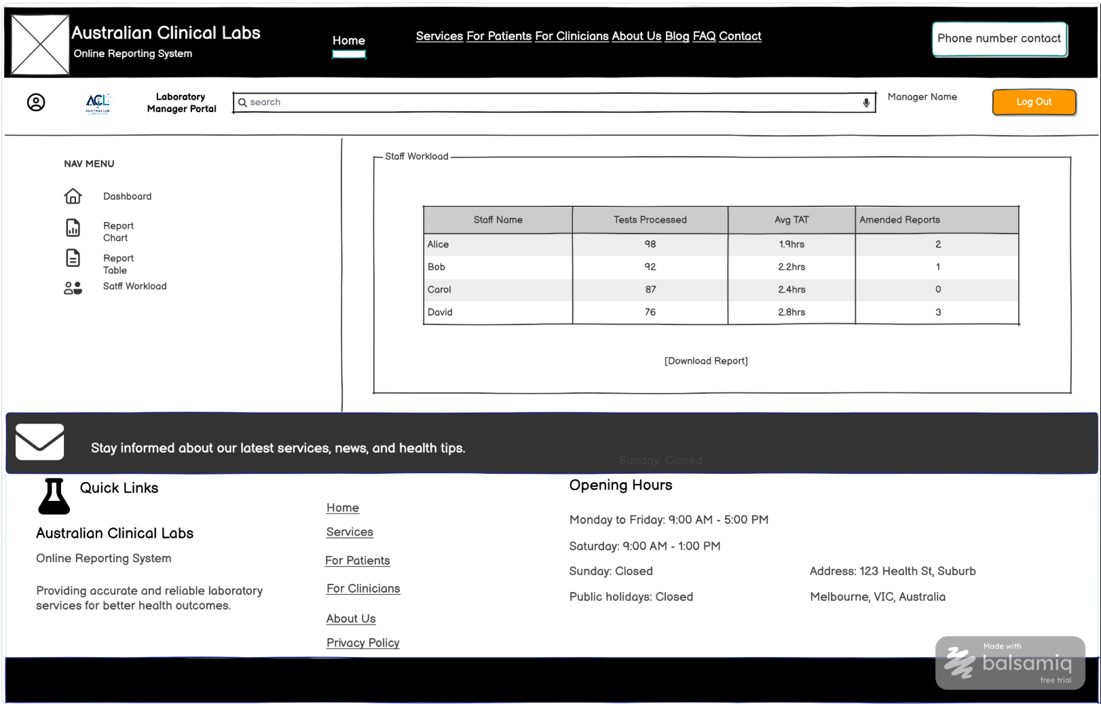
Functional mapping for the wireframe above
UI Component / Area | Primary Functionality | Mapped Requirements | CRUD
Staff Workload Report | Provides laboratory managers with staff workload and operational performance statistics for reporting and analysis. | FR45 | Read

2. KPI Summary and Report Filters
Allows laboratory managers to filter operational reporting data by date, department, test type and location, and view summary KPIs such as tests requested/completed, turnaround time, rejected samples, critical results and delayed tests.
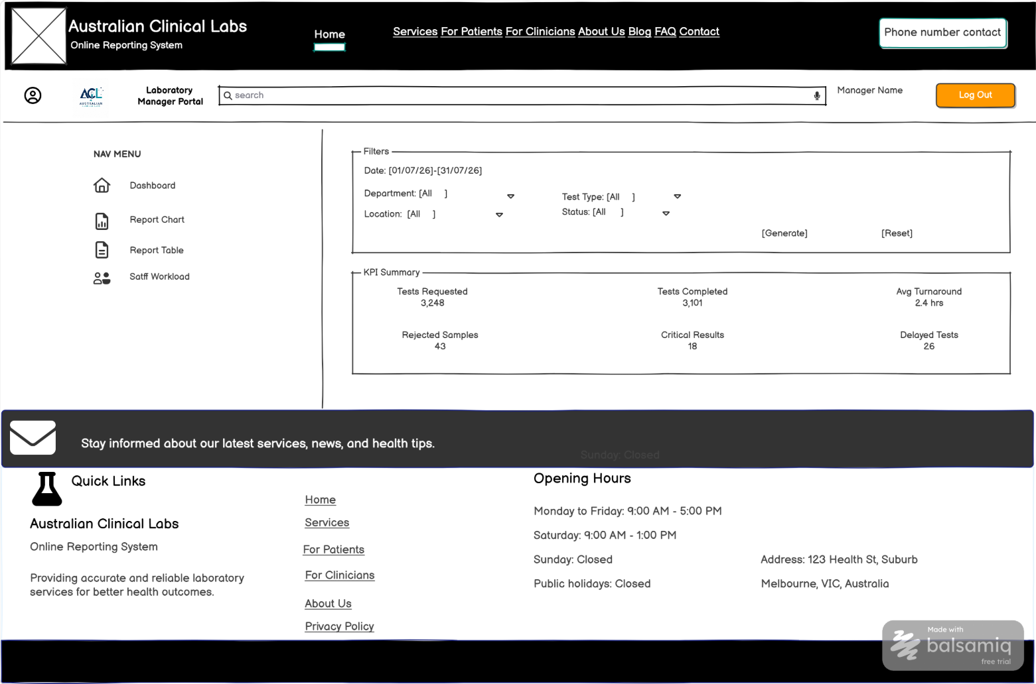
Functional mapping for the wireframe above
UI Component / Area | Primary Functionality | Mapped Requirements | CRUD
Report Filters | Filters laboratory operational reporting information by selected reporting criteria. | FR45 | Read
KPI Summary | Displays laboratory workload and operational performance indicators for management analysis. | FR45 | Read

3. Report Charts and Operational Dashboard
Visualises turnaround time, test volume by department, staff workload and rejected-specimen information in charts and summary panels.
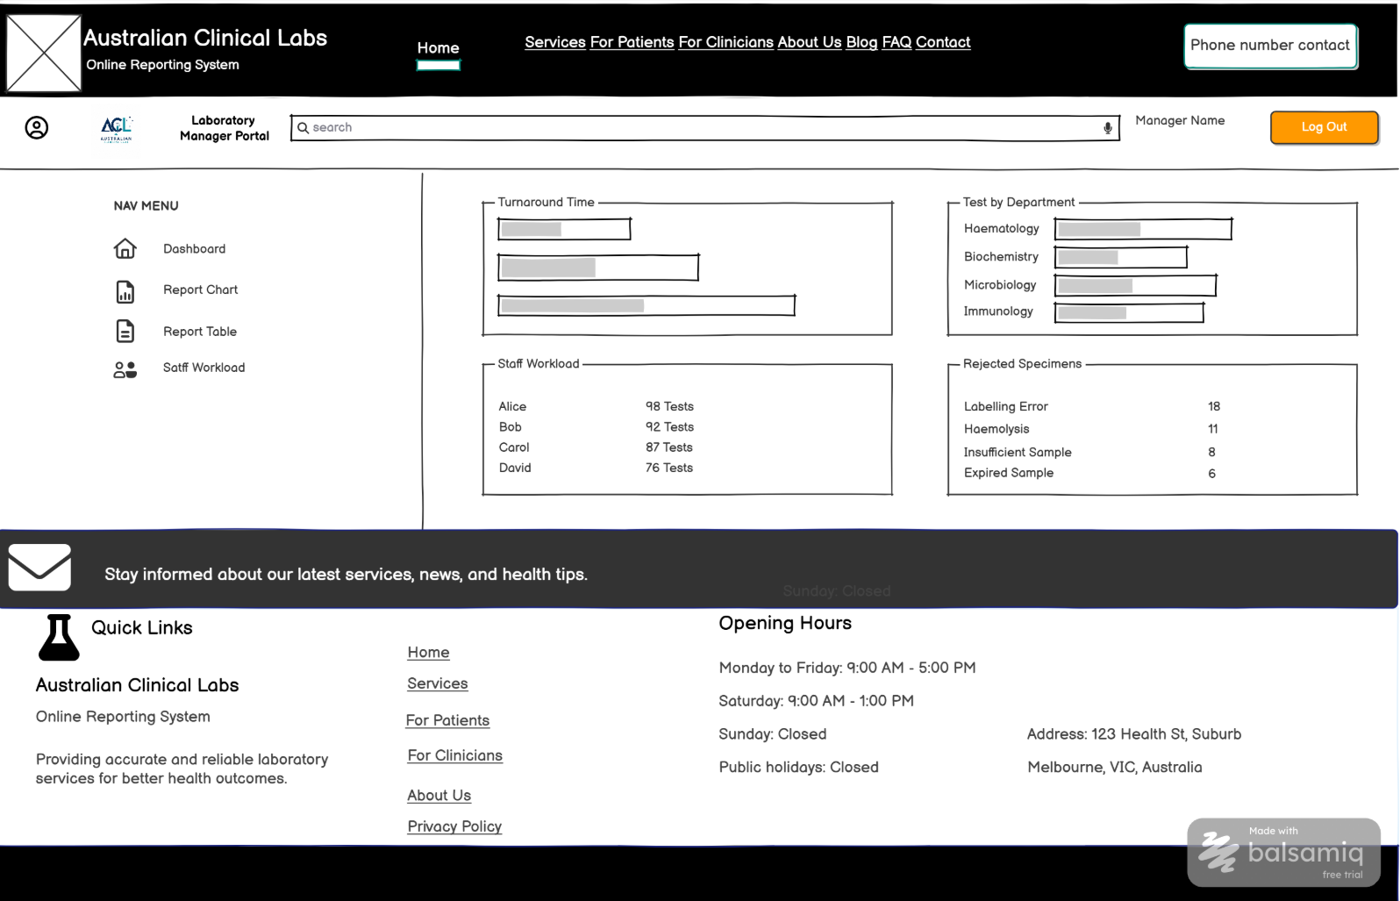
Functional mapping for the wireframe above
UI Component / Area | Primary Functionality | Mapped Requirements | CRUD
Turnaround Time Chart | Displays turnaround-time performance trends for laboratory operations. | FR45 | Read
Tests by Department | Displays laboratory test volumes by department for operational analysis. | FR45 | Read
Staff Workload Summary | Displays workload distribution across laboratory staff. | FR45 | Read
Rejected Specimen Summary | Displays rejected-specimen counts/categories as part of operational reporting. | FR45 | Read

Mapping scope note: These wireframes primarily implement FR45 (Reporting and Analytics). Other report-related requirements are not mapped unless the screen visibly demonstrates those functions. NFRs requiring implementation evidence are excluded from the visual mapping.

