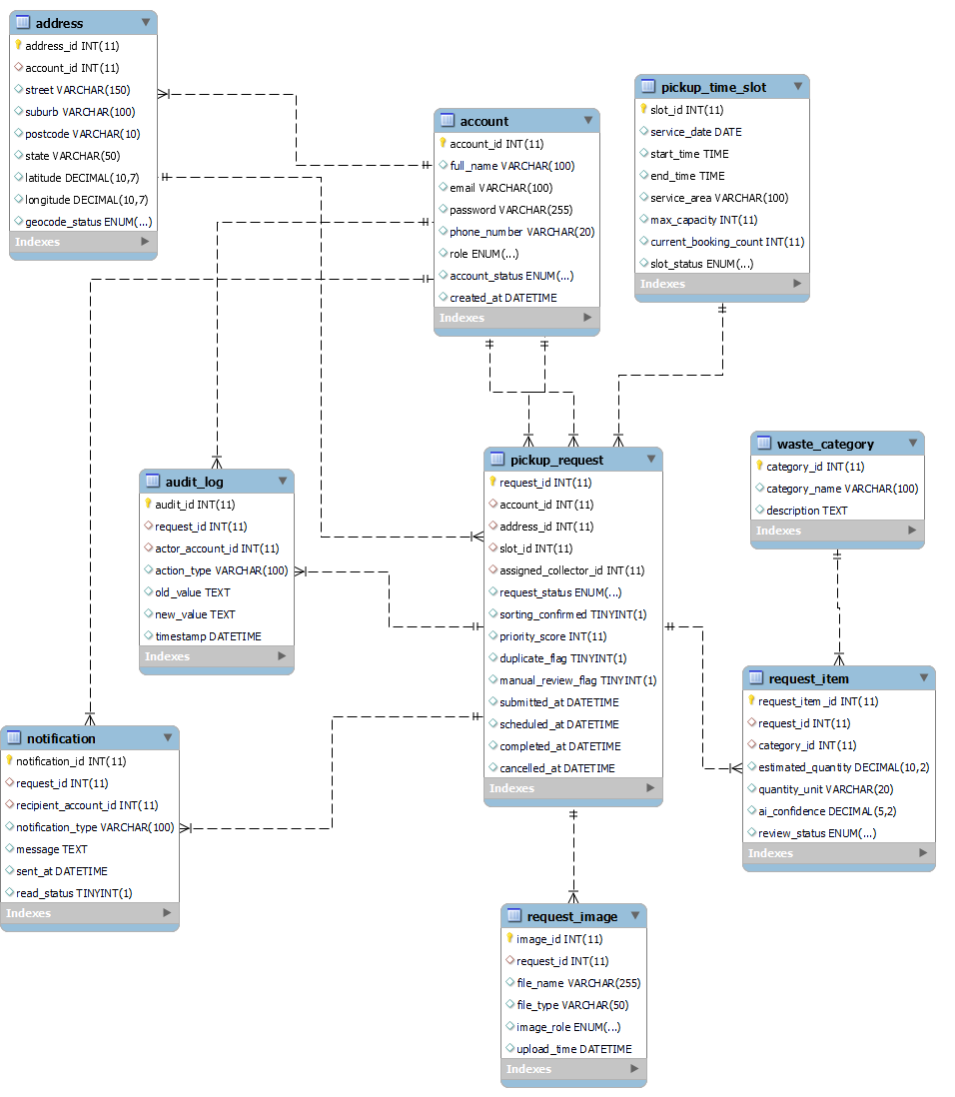
The ERD for the Recycling Pickup Scheduler shows how the system stores and organises its data. It focuses on the main activities of the system, such as managing users, scheduling pickups, and handling different types of recyclable waste.
The central part of the diagram is the Pickup_Request entity. This is because most of the system’s operations are based on creating and managing pickup requests. Each request is created by a user (stored in the Account entity) and is linked to a specific Address, which represents where the pickup will take place.
Each user can have multiple addresses and can submit multiple pickup requests. This allows flexibility for users who may request pickups from different locations.
The system also includes a Pickup_Time_Slot entity, which is used to manage scheduling. Each request is assigned to one time slot, while a time slot can handle multiple requests depending on its capacity.
To manage recyclable materials, the system uses the Waste_Category entity. Since a single pickup request can include multiple types of waste, a bridge entity called Request_Item is used. This allows the system to store multiple waste categories for one request, along with details such as quantity and classification.
Additional entities such as Request_Image, Notification, and Audit_Log support the system’s functionality. Images are used to provide evidence of waste or completion, notifications are used to inform users about updates, and audit logs help track system activities for transparency and control.
Overall, the ERD is designed to keep the data structured and connected, while still being flexible enough to support different users, multiple requests, and system operations.

