📄 1.10 Work Activities (Work Breakdown Structure)
The Work Breakdown Structure (WBS) outlines the major tasks and sub-tasks required to complete the Recycling Pickup Scheduler system.

1.10.1 Project Planning
1.1 Define project scope
1.2 Identify stakeholders
1.3 Develop project schedule

1.10.2 Requirements Analysis
2.1 Gather functional requirements
2.2 Gather non-functional requirements
2.3 Define use cases

1.10.3 System Design
3.1 Design system architecture
3.2 Design database schema
3.3 Design user interface (UI/UX)

1.10.4 Development
4.1 Develop frontend components
4.2 Develop backend services
4.3 Implement API development
4.4 Develop scheduling module

1.10.5 Testing
5.1 Perform unit testing
5.2 Perform integration testing
5.3 Fix identified bugs

1.10.6 Deployment
6.1 Configure database
6.2 Deploy backend services
6.3 Deploy frontend application
6.4 Conduct final system testing
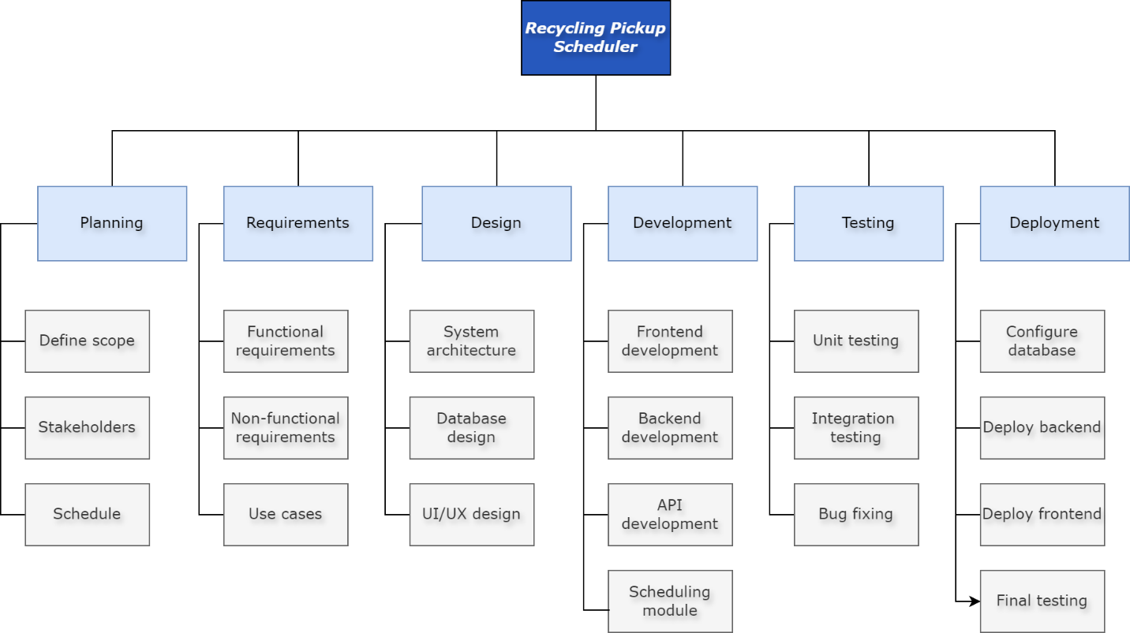Figure 1. Work Breakdown Structure (WBS) of the Recycling Pickup Scheduler System

