Relationships Explanation
Relationship | Type | Explanation | Implementation
Users Student | One-to-One (1:1) | Each student record will be associated with one account. | student.user_id users.user_id
Users Tutor | One-to-One (1:1) | Each tutor record will be associated with the one account. | tutor.user_id users.user_id
Users Admin | One-to-One (1:1) | Each administrator is a system user and each administrator table references the user tables | admin.user_id users.user_id
Student Session | One-to-Many (1:M) | One student can attend multiple tutoring sessions | session.student_id student.student.user_id
Tutor Session | One-to-Many (1:M) | One tutor can deliver multiple tutoring sessions | session.tutor_id tutor.tutor_id
Student Tutor | Many-to-Many (M:M) | Students can take the session of multiple tutors  A tutor may teach multiple students | student session tutor
Session Message | One-to-Many (1:M) | A single session may have multiple exchanges of messages during the users | message.session_id session.session_id
User Message | One-to-Many (1:M) | The user can send and receive multiple messages | message.sender_id users.user_id  message.receiver_id users.user_id
Session Review | One-to-Many (1:M) | Each tutoring session may have multiple reviews | review.session_id session.session_id
Student Review | One-to-Many (1:M) | Students can submit multiple reviews | review.students_id student.student_id
Tutor Review | One-to-Many (1:M) | Tutor can receive multiple reviews | review.tutor_id tutor.titor_id

ERD Diagram
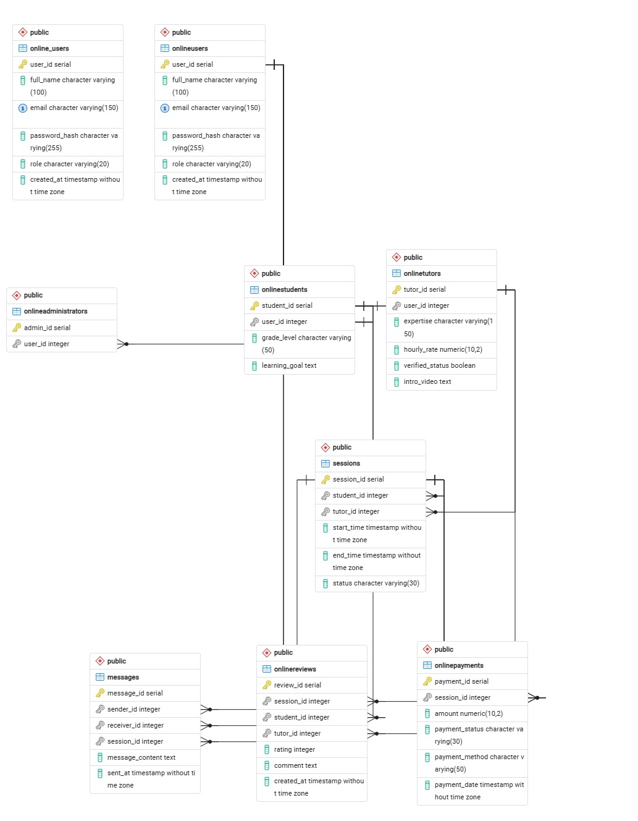
Table Structures (PK, FK)
Table Name | onlineusers (online user)
Columns | Name Data Type Constraints  user_id Integer Not Null  full_name Varchar (255) Not Null  email Varchar (255) Not Null  password Varchar (255) Not Null  role Varchar (255) Not Null
Primary Key | user_id
Foreign Key | None

Table Name | onlinestudents (online students)
Columns | Name Data Type Constraints  student_id Integer Not Null  user_id Integer Not Null
Primary Key | student_id
Foreign Key | user_id -> onlinestudents(user_id)

Table Name | onlinetutors (online tutors)
Columns | Name Data Type Constraints  tutor_id Integer Not Null  user_id Integer Not Null  expertise Varchar (255)
Primary Key | tutor_id
Foreign Key | user_id -> onlinestudents(user_id)

Table Name | onlineadministrators (online administrator)
Columns | Name Data Type Constraints  admin_id Integer Not Null  user_id Integer Not Null
Primary Key | admin_id
Foreign Key | user_id -> onlinestudents(user_id)

Table Name | sessions
Columns | Name Data Type Constraints  session_id Integer Not Null  student_id Integer Not Null  Tutor_id Integer Not Null  Start_time Timestapm  End_time Timestamp  Status Varchar(255) Not Null
Primary Key | session_id
Foreign Key | student_id -> onlinestudents(student_id)  tutor_id->onlinetutors(tutors_id)

Table Name | Onlinereview (online_reviews_
Columns | Name Data Type Constraints  review_id Integer Not Null  session_id Integer Not Null  student_id Integer Not Null  tutor_id Integer Not Null  rating Integer  comment Varchar(255)
Primary Key | review_id
Foreign Key | student_id -> onlinestudents(student_id)  tutor_id->onlinetutors(tutors_id)  session_id->sessions(session_id)

Table Name | Onlinepayments (online_payments)
Columns | Name Data Type Constraints  payment_id Integer Not Null  session_id Integer Not Null  ammount Integer Numeric  payment_status Varchar(255) Not Null  payment_method Varchar(255) Not Null  payment_date Timestamp Not Null
Primary Key | payment_id
Foreign Key | session_id->sessions(session_id)

Table Name | messages
Columns | Name Data Type Constraints  message_id Integer Not Null  session_id Integer Not Null  receiver_id Integer Not Null  sender_id Integer Not Null  message_content Varchar(255) Not Null  sent_at Timestamp Not Null
Primary Key | payment_id
Foreign Key | reciever_id->onlineusers(user_id)  sender_id->onlineusers(user_id)  session_id->sessions(session_id)

SQL Script
-- This script was generated by the ERD tool in pgAdmin 4.
-- Please log an issue at https://github.com/pgadmin-org/pgadmin4/issues/new/choose if you find any bugs, including reproduction steps.
BEGIN;

CREATE TABLE IF NOT EXISTS public.messages
(
message_id serial NOT NULL,
sender_id integer NOT NULL,
receiver_id integer NOT NULL,
session_id integer,
message_content text COLLATE pg_catalog."default" NOT NULL,
sent_at timestamp without time zone DEFAULT CURRENT_TIMESTAMP,
CONSTRAINT messages_pkey PRIMARY KEY (message_id)
);

CREATE TABLE IF NOT EXISTS public.online_users
(
user_id serial NOT NULL,
full_name character varying(100) COLLATE pg_catalog."default" NOT NULL,
email character varying(150) COLLATE pg_catalog."default" NOT NULL,
password_hash character varying(255) COLLATE pg_catalog."default" NOT NULL,
role character varying(20) COLLATE pg_catalog."default" NOT NULL,
created_at timestamp without time zone DEFAULT CURRENT_TIMESTAMP,
CONSTRAINT online_users_pkey PRIMARY KEY (user_id),
CONSTRAINT online_users_email_key UNIQUE (email)
);

CREATE TABLE IF NOT EXISTS public.onlineadministrators
(
admin_id serial NOT NULL,
user_id integer,
CONSTRAINT onlineadministrators_pkey PRIMARY KEY (admin_id)
);

CREATE TABLE IF NOT EXISTS public.onlinepayments
(
payment_id serial NOT NULL,
session_id integer NOT NULL,
amount numeric(10, 2) NOT NULL,
payment_status character varying(30) COLLATE pg_catalog."default" NOT NULL,
payment_method character varying(50) COLLATE pg_catalog."default",
payment_date timestamp without time zone DEFAULT CURRENT_TIMESTAMP,
CONSTRAINT onlinepayments_pkey PRIMARY KEY (payment_id)
);

CREATE TABLE IF NOT EXISTS public.onlinereviews
(
review_id serial NOT NULL,
session_id integer NOT NULL,
student_id integer NOT NULL,
tutor_id integer NOT NULL,
rating integer,
comment text COLLATE pg_catalog."default",
created_at timestamp without time zone DEFAULT CURRENT_TIMESTAMP,
CONSTRAINT onlinereviews_pkey PRIMARY KEY (review_id)
);

CREATE TABLE IF NOT EXISTS public.onlinestudents
(
student_id serial NOT NULL,
user_id integer NOT NULL,
grade_level character varying(50) COLLATE pg_catalog."default",
learning_goal text COLLATE pg_catalog."default",
CONSTRAINT onlinestudents_pkey PRIMARY KEY (student_id),
CONSTRAINT onlinestudents_user_id_key UNIQUE (user_id)
);

CREATE TABLE IF NOT EXISTS public.onlinetutors
(
tutor_id serial NOT NULL,
user_id integer NOT NULL,
expertise character varying(150) COLLATE pg_catalog."default" NOT NULL,
hourly_rate numeric(10, 2) NOT NULL,
verified_status boolean DEFAULT false,
intro_video text COLLATE pg_catalog."default",
CONSTRAINT onlinetutors_pkey PRIMARY KEY (tutor_id),
CONSTRAINT onlinetutors_user_id_key UNIQUE (user_id)
);

CREATE TABLE IF NOT EXISTS public.onlineusers
(
user_id serial NOT NULL,
full_name character varying(100) COLLATE pg_catalog."default" NOT NULL,
email character varying(150) COLLATE pg_catalog."default" NOT NULL,
password_hash character varying(255) COLLATE pg_catalog."default" NOT NULL,
role character varying(20) COLLATE pg_catalog."default" NOT NULL,
created_at timestamp without time zone DEFAULT CURRENT_TIMESTAMP,
CONSTRAINT onlineusers_pkey PRIMARY KEY (user_id),
CONSTRAINT onlineusers_email_key UNIQUE (email)
);

CREATE TABLE IF NOT EXISTS public.sessions
(
session_id serial NOT NULL,
student_id integer NOT NULL,
tutor_id integer NOT NULL,
start_time timestamp without time zone NOT NULL,
end_time timestamp without time zone NOT NULL,
status character varying(30) COLLATE pg_catalog."default" DEFAULT 'Pending'::character varying,
CONSTRAINT sessions_pkey PRIMARY KEY (session_id)
);

ALTER TABLE IF EXISTS public.messages
ADD CONSTRAINT fk_message_receiver FOREIGN KEY (receiver_id)
REFERENCES public.onlineusers (user_id) MATCH SIMPLE
ON UPDATE NO ACTION
ON DELETE CASCADE;

ALTER TABLE IF EXISTS public.messages
ADD CONSTRAINT fk_message_sender FOREIGN KEY (sender_id)
REFERENCES public.onlineusers (user_id) MATCH SIMPLE
ON UPDATE NO ACTION
ON DELETE CASCADE;

ALTER TABLE IF EXISTS public.messages
ADD CONSTRAINT fk_message_session FOREIGN KEY (session_id)
REFERENCES public.sessions (session_id) MATCH SIMPLE
ON UPDATE NO ACTION
ON DELETE CASCADE;

ALTER TABLE IF EXISTS public.onlineadministrators
ADD CONSTRAINT fk FOREIGN KEY (user_id)
REFERENCES public.onlineusers (user_id) MATCH SIMPLE
ON UPDATE NO ACTION
ON DELETE CASCADE;

ALTER TABLE IF EXISTS public.onlinepayments
ADD CONSTRAINT fk FOREIGN KEY (session_id)
REFERENCES public.sessions (session_id) MATCH SIMPLE
ON UPDATE NO ACTION
ON DELETE CASCADE;

ALTER TABLE IF EXISTS public.onlinepayments
ADD CONSTRAINT fk_payment_session FOREIGN KEY (session_id)
REFERENCES public.sessions (session_id) MATCH SIMPLE
ON UPDATE NO ACTION
ON DELETE NO ACTION;

ALTER TABLE IF EXISTS public.onlinereviews
ADD CONSTRAINT fk FOREIGN KEY (session_id)
REFERENCES public.sessions (session_id) MATCH SIMPLE
ON UPDATE NO ACTION
ON DELETE CASCADE;

ALTER TABLE IF EXISTS public.onlinereviews
ADD CONSTRAINT fk_review_student FOREIGN KEY (student_id)
REFERENCES public.onlinestudents (student_id) MATCH SIMPLE
ON UPDATE NO ACTION
ON DELETE CASCADE;

ALTER TABLE IF EXISTS public.onlinereviews
ADD CONSTRAINT fk_review_tutor FOREIGN KEY (tutor_id)
REFERENCES public.onlinetutors (tutor_id) MATCH SIMPLE
ON UPDATE NO ACTION
ON DELETE CASCADE;

ALTER TABLE IF EXISTS public.onlinestudents
ADD CONSTRAINT fk FOREIGN KEY (user_id)
REFERENCES public.onlineusers (user_id) MATCH SIMPLE
ON UPDATE NO ACTION
ON DELETE NO ACTION;
CREATE INDEX IF NOT EXISTS onlinestudents_user_id_key
ON public.onlinestudents(user_id);

ALTER TABLE IF EXISTS public.onlinetutors
ADD CONSTRAINT fk FOREIGN KEY (user_id)
REFERENCES public.onlineusers (user_id) MATCH SIMPLE
ON UPDATE NO ACTION
ON DELETE NO ACTION;
CREATE INDEX IF NOT EXISTS onlinetutors_user_id_key
ON public.onlinetutors(user_id);

ALTER TABLE IF EXISTS public.sessions
ADD CONSTRAINT fk_student FOREIGN KEY (student_id)
REFERENCES public.onlinestudents (student_id) MATCH SIMPLE
ON UPDATE NO ACTION
ON DELETE CASCADE;

ALTER TABLE IF EXISTS public.sessions
ADD CONSTRAINT fk_tutor FOREIGN KEY (tutor_id)
REFERENCES public.onlinetutors (tutor_id) MATCH SIMPLE
ON UPDATE NO ACTION
ON DELETE CASCADE;

END;

