2.6 Functional View of System by Component
The functional view of the Online Tutor Marketplace system demonstrates how different system components interact to process user requests and perform major platform operations. The system functionality is supported through communication between frontend interfaces, backend processing modules, databases, and AI integration components. This section illustrates the operational flow of core platform functionalities including authentication, tutor searching, booking management, messaging, and AI-based tutor recommendations.
2.6.1 Authentication Flow
Users submit login credentials through the frontend login interface, and the backend authentication module validates the request by communicating with the user database. If the credentials are verified successfully, the system grants access to the appropriate dashboard based on the user role. If the credentials are invalid, the system returns an authentication error message and requests the user to re-enter login details.
Authentication Functional Flow Diagram
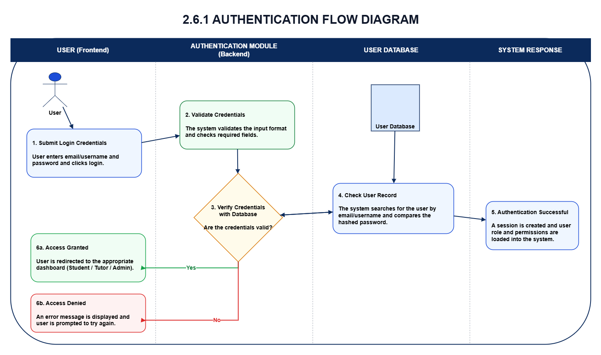
Diagram Explanation
The authentication flow diagram shows how login requests are processed within the system. User credentials submitted through the frontend interface are validated by the backend authentication module before access is granted or denied based on database verification results.
2.6.2 Tutor Search Flow
Students can search tutors based on subject, availability, learning level, and ratings through the frontend search interface. The backend search module processes the request and retrieves matching tutor records from the tutor database before displaying the results to the student.
Tutor Search Functional Flow Diagram
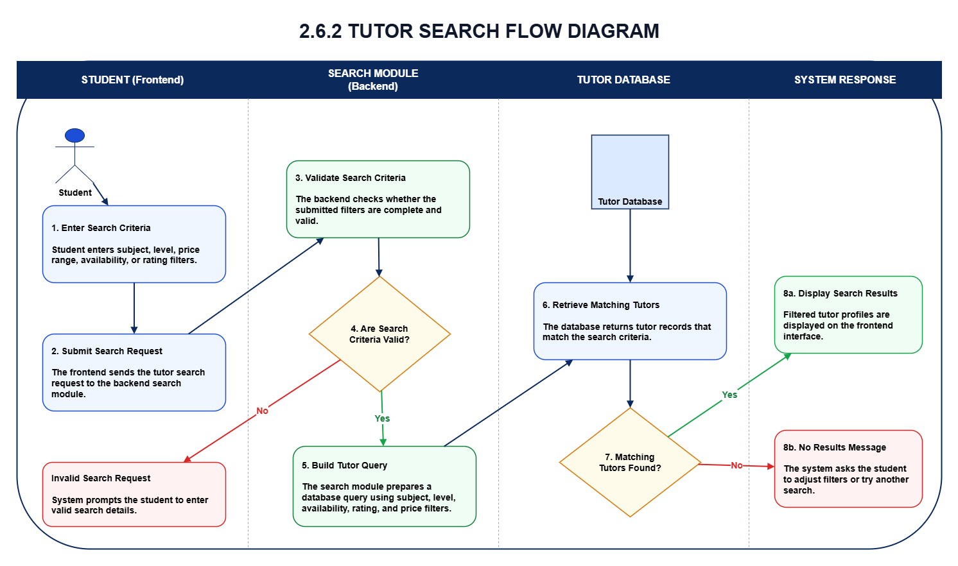
Diagram Explanation
The tutor search flow diagram demonstrates how tutor search requests are processed within the system. Search criteria entered by the user are processed by the backend search module, which retrieves matching tutor information from the database and returns the results to the frontend interface.
2.6.3 Booking Flow
Students can select tutors, choose available time slots, and submit booking requests through the booking interface. The backend booking module validates tutor availability and stores booking information within the booking database before returning a booking confirmation response to the user.

Booking Functional Flow Diagram
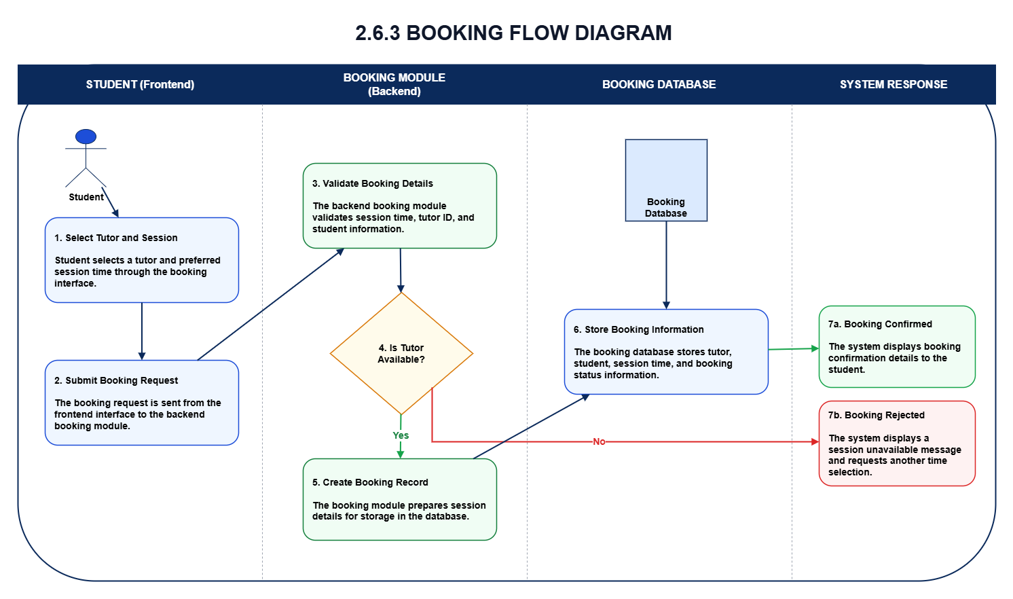
Diagram Explanation
The booking flow diagram explains how tutoring session bookings are processed within the system. Booking requests are validated by the backend booking module, stored within the booking database, and returned to the frontend interface as confirmation results.
2.6.4 Messaging Flow
The messaging component allows students and tutors to communicate through the chat interface. Messages submitted through the frontend interface are validated by the backend messaging module and stored within the message database before being retrieved and displayed to users.

Messaging Functional Flow Diagram
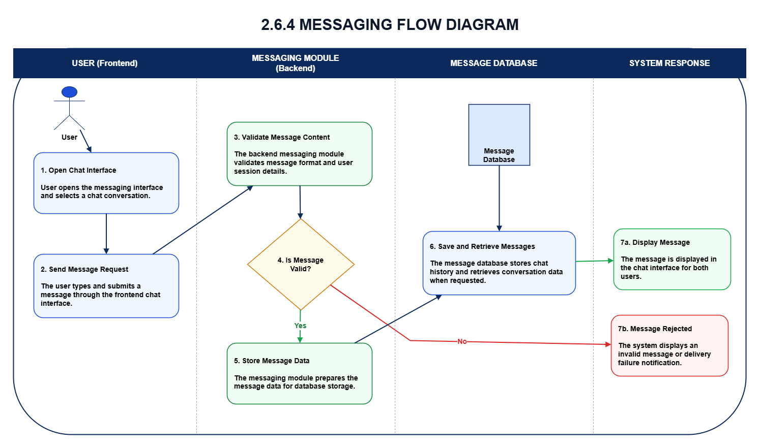
Diagram Explanation
The messaging flow diagram illustrates how messages are processed, stored, and retrieved within the system. The backend messaging module manages communication between the frontend interface and message database to support secure user interaction.
2.6.5 AI Recommendation Flow
Students submit learning requirements through the AI recommendation interface, and the backend AI processing module communicates with the OpenAI API to generate tutor recommendations. The generated recommendation results are then returned to the frontend interface and displayed to the user.

AI Recommendation Functional Flow Diagram
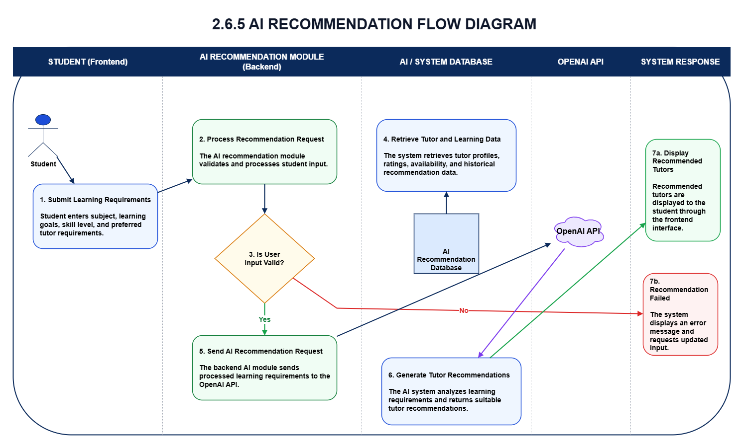
Diagram Explanation
The AI recommendation flow diagram presents how AI-based tutor recommendations are generated within the system. User input is processed by the backend AI module, which communicates with the OpenAI API before returning recommendation results to the frontend interface.
The functional view of the Online Tutor Marketplace system demonstrates how frontend interfaces, backend processing modules, databases, and AI integration components interact to support major platform functionalities. The structured communication between system components ensures secure request handling, reliable data processing, efficient system performance, and scalable architecture across the platform.

