invoice payment page

bincol.com.au

BINCOL Dashboard Requests Schedule Invoices Support Priya S

Dashboard > Invoices > INV-1043
Invoice INV-1043

Download PDF

Billed to
Unpaid
Acme Logistics Pty Ltd
ABN 51 824 753 556
22 Sample Street, Richmond VIC 3121

Issue date 05 Aug 2026
Due date 19 Aug 2026
Pickup ref PU-1048

Pay this invoice
Amount due
$462.00
Payment method Credit or debit card PayPal
Card number

4242 4242 4242 4242
Expiry CVC
Description | Qty | Unit price | Amount
240L general waste collection | 2 | $95.00 | $190.00
Bin hire - 240L weekly | 2 | $45.00 | $90.00
Contamination surcharge | 1 | $140.00 | $140.00

MM / YY
123
Name on card
P Sharma

Pay $462.00
Subtotal | $420.00
GST 10% | $42.00
Total due | $462.00







Payment terms: 14 days from issue date
Secured by HTTPS. Card details are never stored on BINCOL servers.







feedback response page
You can edit your rating for 7 days after submitting.
Submit feedback
What went well?
Arrived on time Driver was courteous
Bins handled carefully Kept us informed
Comments (optional)
o4 of 5
*
* *
•
Overall rating
Customer view - rate this pickup
PU-1048 | 05 Aug 2026 | Head office

bincol.com.au

BINCOL Dashboard Requests Schedule Invoices Support Priya S

Feedback

Staff view - review and respond

Pickup | Customer | Rating | Status
PU-1048 | Acme Logistics | 4 of 5 | Awaiting response
PU-1044 | GreenCo Pty Ltd | 5 of 5 | Responded
PU-1040 | OldCo | 2 of 5 | Escalated
PU-1036 | Acme Logistics | 4 of 5 | Responded

Responding to PU-1048
Driver was great but arrived 20 minutes after the window closed.
Driver was great but arrived 20 minutes after the window closed.
Thanks for letting us know Priya. We have flagged the late start with the depot...

Send a copy to the customer by email

Post response


analytics dashboard page






bincol.com.au/admin/analytics

BINCOL [ Admin ] Dashboard Users Companies Waste categories Reports Audit log Settings Admin

Analytics Last 30 days
38
Pickups today
$18,420
Revenue this month
12
Active drivers
42 min
Avg completion time

Daily pickups - last 30 days

line chart placeholder

Revenue by waste type

bar chart placeholder

Driver performance

Driver | Jobs completed | On-time % | Avg time per job | Avg rating
Tom Nguyen | 142 | 96% | 38 min | 4.8
David Chen | 128 | 91% | 44 min | 4.5
Mei Lin | 119 | 88% | 47 min | 4.3
Sam Otto | 97 | 94% | 41 min | 4.6
Jake Ryan | 84 | 82% | 53 min | 3.9







reports export page
Build a report
Report type
Total pickups
Date range
01 Jul 2026
Branch
All branches
Waste category
All categories
Group by
Week
Generate report
Export PDF
Export Excel

bincol.com.au

BINCOL Dashboard Requests Schedule Invoices Support Priya S

Reports

Total pickups - July 2026
Generated 05 Aug 2026 09:14 | All branches | All categories

bar chart placeholder - pickups per week
31 Jul 2026

Week | Pickups | Bins collected | Tonnes | Revenue
01 - 07 Jul | 12 | 26 | 4.8 | $1140.00
08 - 14 Jul | 14 | 31 | 5.6 | $1310.00
15 - 21 Jul | 11 | 24 | 4.1 | $1020.00
22 - 28 Jul | 15 | 33 | 6.0 | $1420.00
Total | 52 | 114 | 20.5 | $4890.00







contact support page

bincol.com.au

BINCOL Dashboard Requests Schedule Invoices Support Priya S

Support New message

Missed pickup - Warehouse 2
Search messages
With BINCOL Melbourne | Ref PU-1051 | Status: Open
Type your reply...
Subject | Last reply
Missed pickup - Warehouse 2 | 2 hours ago
Invoice query INV-1039 | Yesterday
Add new branch address | 3 days ago
Bin size change request | 1 week ago
Hazardous waste permit | 2 weeks ago

Priya Sharma - 2 days ago
The truck did not arrive for our Tuesday pickup at Warehouse 2. The bins are still full.
BINCOL Melbourne - 1 day ago
Apologies - the truck broke down. We have rebooked you for Thursday morning at no extra charge.
Priya Sharma - 2 hours ago Thanks, Thursday works for us.

Closed conversations are kept for 12 months and remain searchable.

Attach a file Send

Replies are also sent to your registered email address.






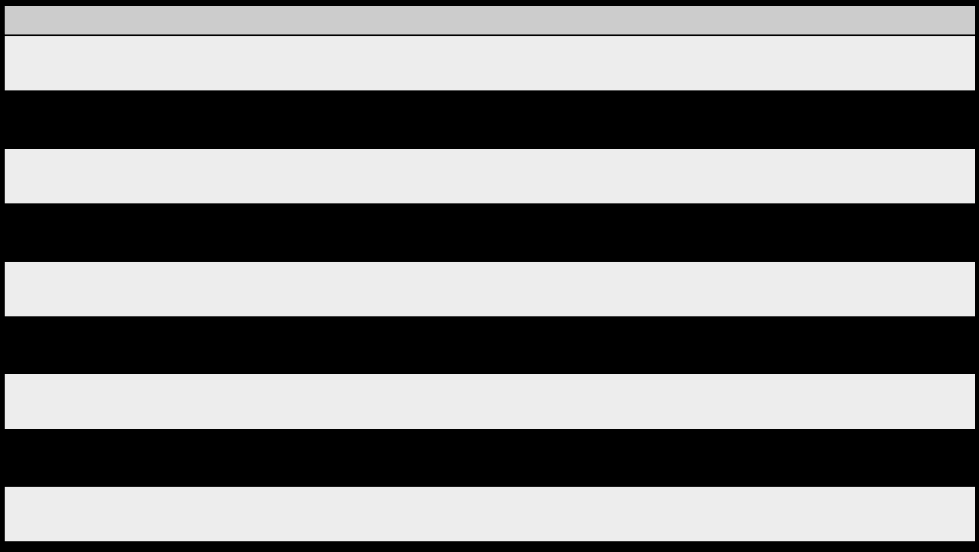

alert settings page
Choose how you are notified
Event
Pickup request approved
Email
Dashboard
Truck and driver assigned Collection completed Invoice issued
Payment reminder Feedback response
Schedule change
Dashboard alerts cannot be switched off for overdue payments.
Save preferences

bincol.com.au

BINCOL Dashboard Requests Schedule Invoices Support Priya S

Alert settings

Email alert preview
From: no-reply@bincol.com.au
Subject: Your pickup PU-1052 has been approved
Hi Priya,
Your pickup for Thursday 12 August has been approved
and assigned to a truck. You can track it in your
dashboard.
[ View pickup ]

Dashboard alert styles

(tick) Payment received - $462.00

(!) Invoice INV-1039 is 6 days overdue

(i) Your pickup was rescheduled to 14 August

notifications centre page






bincol.com.au

BINCOL Dashboard Requests Schedule Invoices Support Priya S

Notifications Mark all as read
All (23) selected Unread (5)

Type: All
Search notifications

Type | Notification | When | Read
Approval | Pickup PU-1052 approved by BINCOL Melbourne | 10 min ago | Unread
Assignment | Truck TRK-04 and driver Tom Nguyen assigned to PU-1052 | 8 min ago | Unread
Collection | PU-1051 marked In progress - driver en route | 1 hour ago | Unread
Payment | Invoice INV-1043 issued - $462.00 due 19 Aug | 2 hours ago | Unread
Payment | Reminder - INV-1039 is 6 days overdue | Yesterday | Unread
Collection | PU-1048 collected - 2 x 240L general | 2 days ago | Read
Approval | Recurring weekly schedule confirmed | 3 days ago | Read
Feedback | BINCOL Melbourne responded to your feedback on PU-1044 | 4 days ago | Read


Showing 1 to 10 of 23 < 1 2 3 >

payment history page






bincol.com.au

BINCOL Dashboard Requests Schedule Invoices Support Priya S

Payments

$690.00
$5,180.00
Paid in last 12 months
2
Invoices overdue
Outstanding balance

! 2 invoices are overdue. The oldest is 6 days past its due date. Pay all outstanding

Outstanding payments

Invoice | Due date | Days overdue | Amount | Reminder sent | Action
INV-1039 | 05 Aug 2026 | 6 | $228.00 | 3 reminders | Pay now
INV-1041 | 12 Aug 2026 | 0 | $310.00 | 1 reminder | Pay now
INV-1043 | 19 Aug 2026 | 0 | $462.00 | None yet | Pay now

Payment history

Transaction ID | Date and time | Method | Invoice | Amount | Status
TXN-8841 | 29 Jul 2026 14:22 | Visa ending 4242 | INV-1036 | $405.00 | Succeeded
TXN-8802 | 22 Jul 2026 09:07 | PayPal | INV-1032 | $390.00 | Succeeded
TXN-8780 | 18 Jul 2026 16:44 | Visa ending 4242 | INV-1029 | $285.00 | Succeeded
TXN-8779 | 18 Jul 2026 16:41 | Visa ending 4242 | INV-1029 | $285.00 | Declined
TXN-8744 | 08 Jul 2026 11:15 | Bank transfer | INV-1025 | $512.00 | Succeeded


Showing 1 to 10 of 34 < 1 2 3 4 >

invoice history page






bincol.com.au

BINCOL Dashboard Requests Schedule Invoices Support Priya S

Invoices Export

$462.00
19 Aug 2026
Next payment due
$5,180.00
Paid this financial year
Outstanding balance
To
From

All (18) selected Unpaid (2) Paid (16)

Status: All
Search by invoice or pickup reference
Apply

Invoice | Issue date | Due date | Pickup ref | Amount | Status | Action
INV-1043 | 05 Aug 2026 | 19 Aug 2026 | PU-1048 | $462.00 | Unpaid | Pay | Download
INV-1041 | 29 Jul 2026 | 12 Aug 2026 | PU-1044 | $310.00 | Unpaid | Pay | Download
INV-1039 | 22 Jul 2026 | 05 Aug 2026 | PU-1040 | $228.00 | Overdue | Pay | Download
INV-1036 | 15 Jul 2026 | 29 Jul 2026 | PU-1035 | $405.00 | Paid | Download
INV-1032 | 08 Jul 2026 | 22 Jul 2026 | PU-1031 | $390.00 | Paid | Download


Showing 1 to 10 of 18 < 1 2 >

