6. Use Case Diagrams

6.1 Actors
Before the diagrams, it helps to be clear about who uses the system. Four types of people work with the BCWCS, and three outside systems it talks to. The outside systems are shown as external actors because the BCWCS depends on them but does not control them.
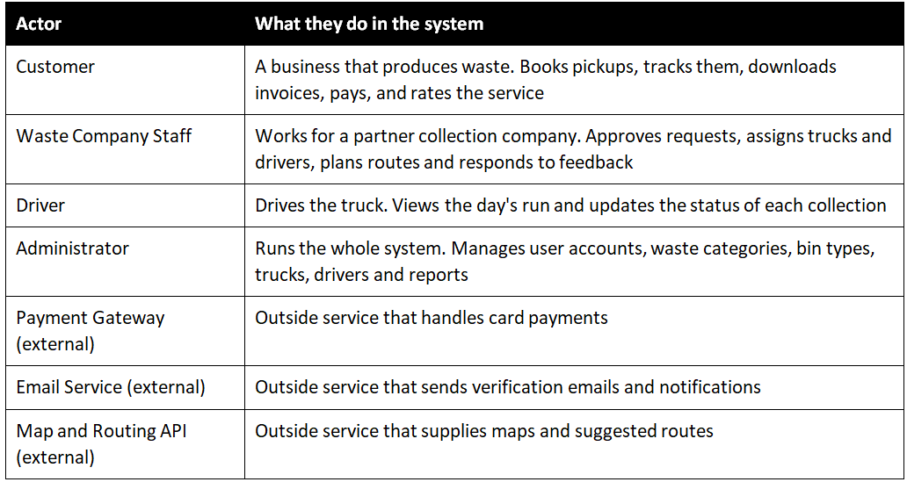
Table 6.1: Actors in the BCWCS
Because the system has eleven modules, one diagram containing everything would be unreadable. Section 6.2 gives the overall picture, then sections 6.3 to 6.6 break the system into four smaller diagrams grouped by the kind of work being done.

6.2 System Overview Use Case Diagram
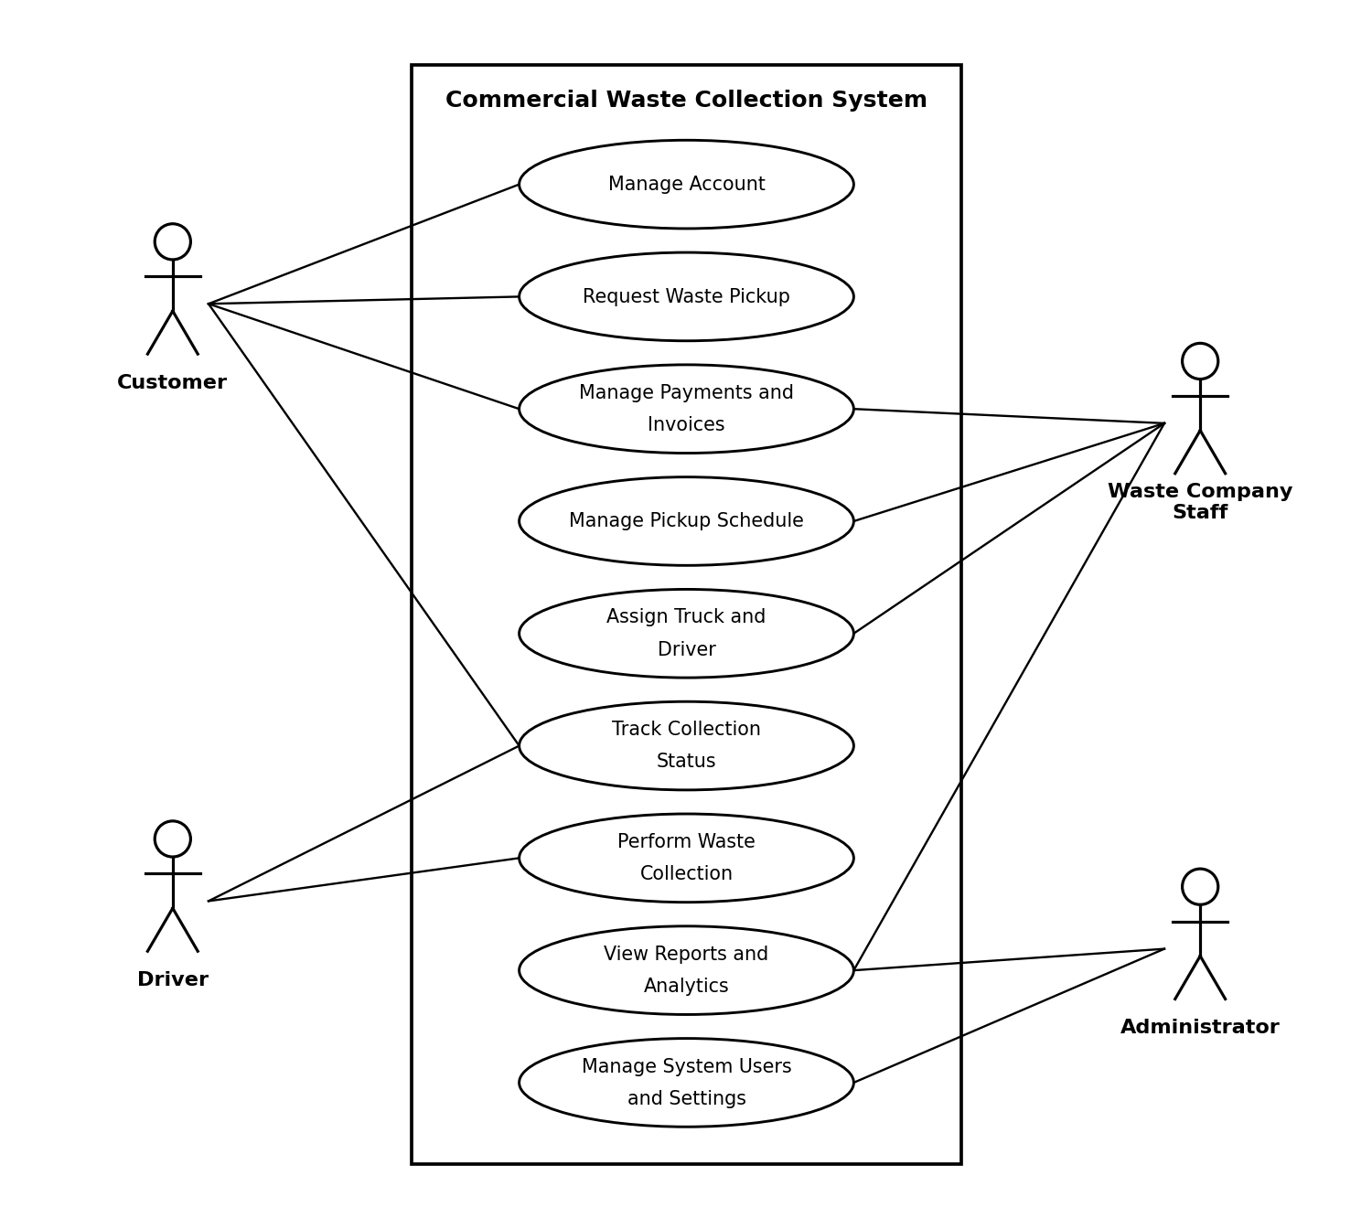
Figure 6.1: System overview use case diagram
This is a general overview of the whole system; the major tasks are not included individually. The customer logs into his/her account, arranges for pickups, monitors activity and handles invoices. Staff organizes the schedule, schedules trucks and drivers, reviews reports. The driver does the collection, and updates the status: the driver puts the status in, the customer reads it out. The administrator is somewhat removed from the picture because their role is more about the operation of the system than its everyday applications, account management, settings and reports.

6.3 User and Business Customer Management
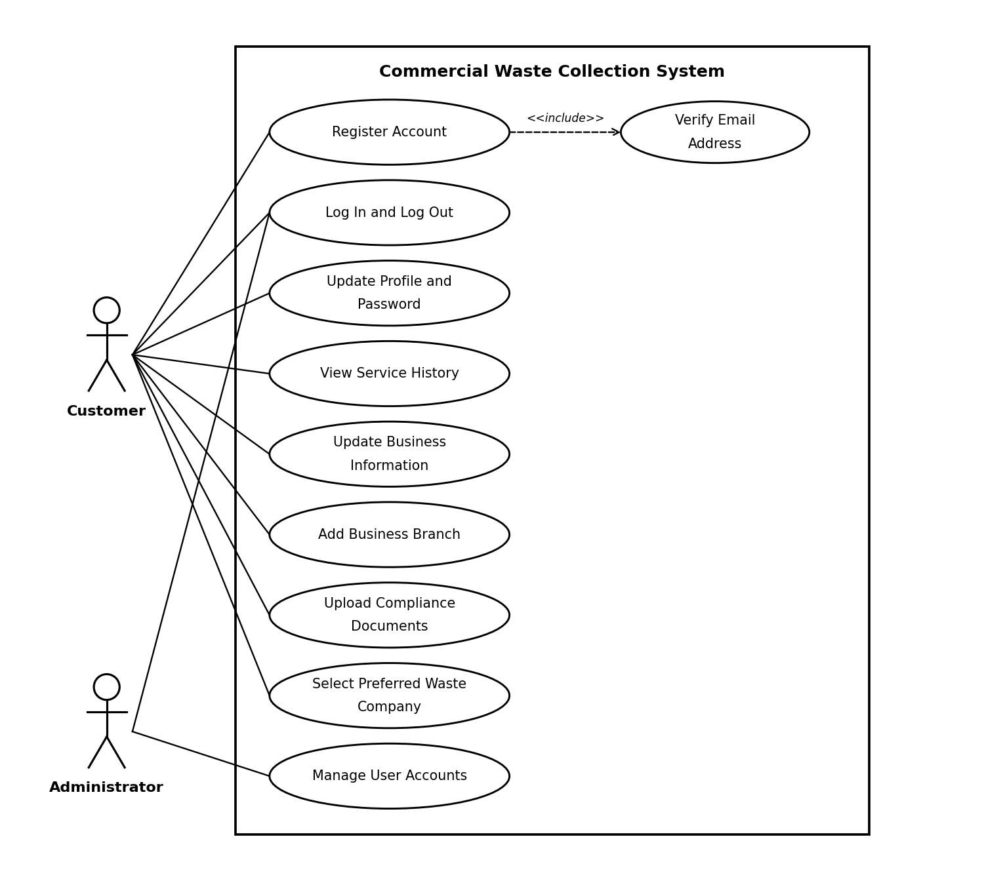
Figure 6.2: User and business customer management use case diagram
It encompasses all aspects related to accounts and business information. When a customer registers, Register Account includes an arrow to Verify Email Address, as it is a part of the registration process and not optional. The customer will then log in, update their profile, maintain their business details, add additional branches, upload permits and compliance documents and select the waste company to work with. The only reason this administrator will show up here is to add, edit and deactivate any user account. This diagram pertains to FR1 – FR12.

6.4 Pickup Request and Scheduling
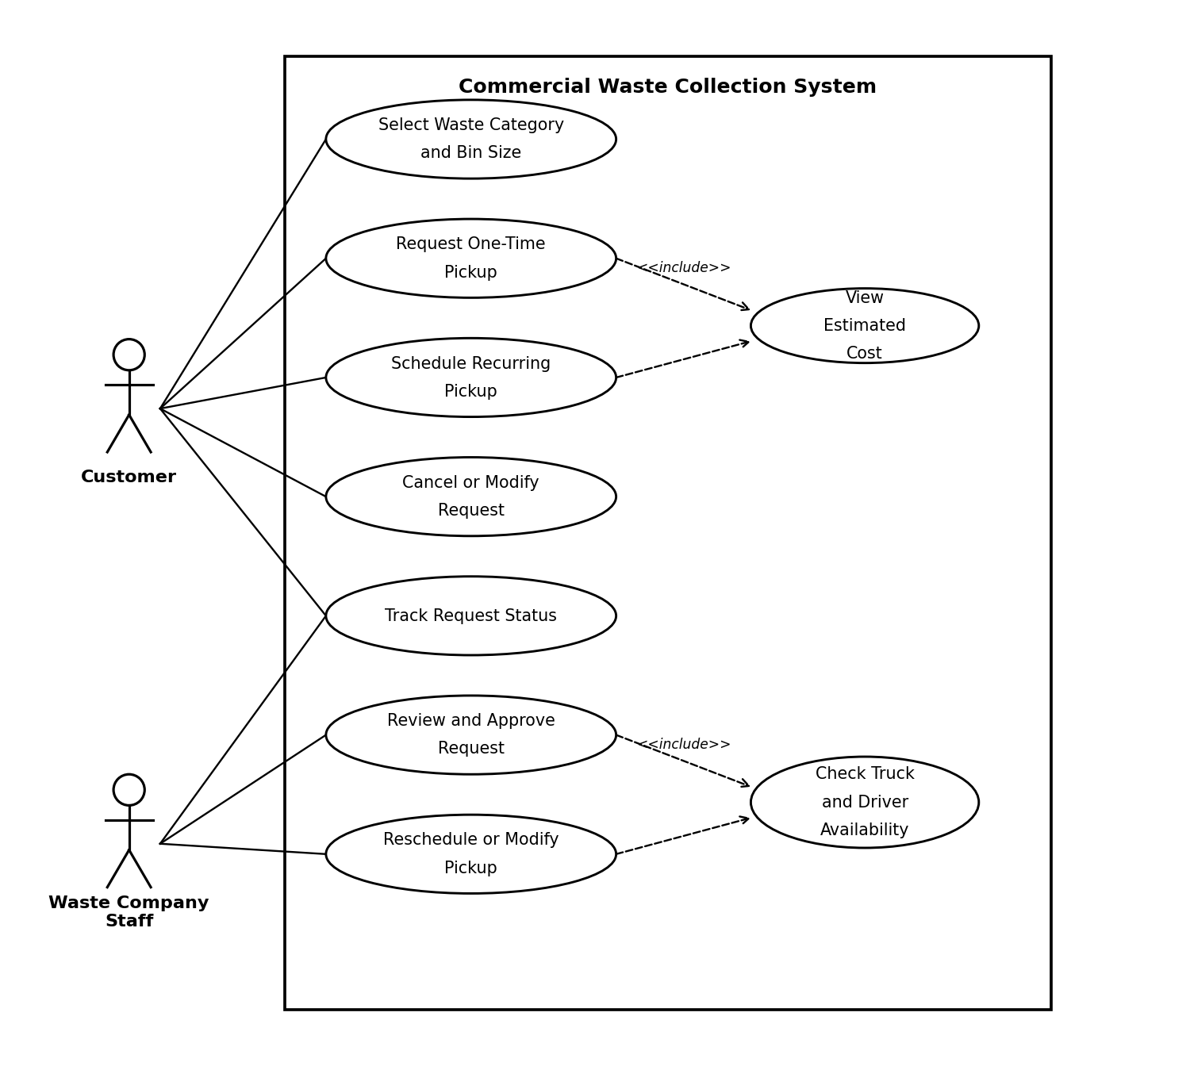
Figure 6.3: Pickup request and scheduling use case diagram
This is the most crowded section of the system. A customer selects an item type and size of bin and schedules one-time pickup or a recurring pick up. Both of those include View Estimated Cost, because FR21 requires the estimated cost to be shown before the customer confirms. It happens on every booking rather than only some of them, which is why this is an include and not an extend. The customer can cancel or change the request while it is in pending status and track the request status. The same truck cannot be promised two jobs at once because the review and approval of a request and the rescheduling of a request both contain Check Truck and Driver Availability. This diagram includes FR15 and FR18-FR26.

6.5 Service Assignment, Drivers and Route Planning
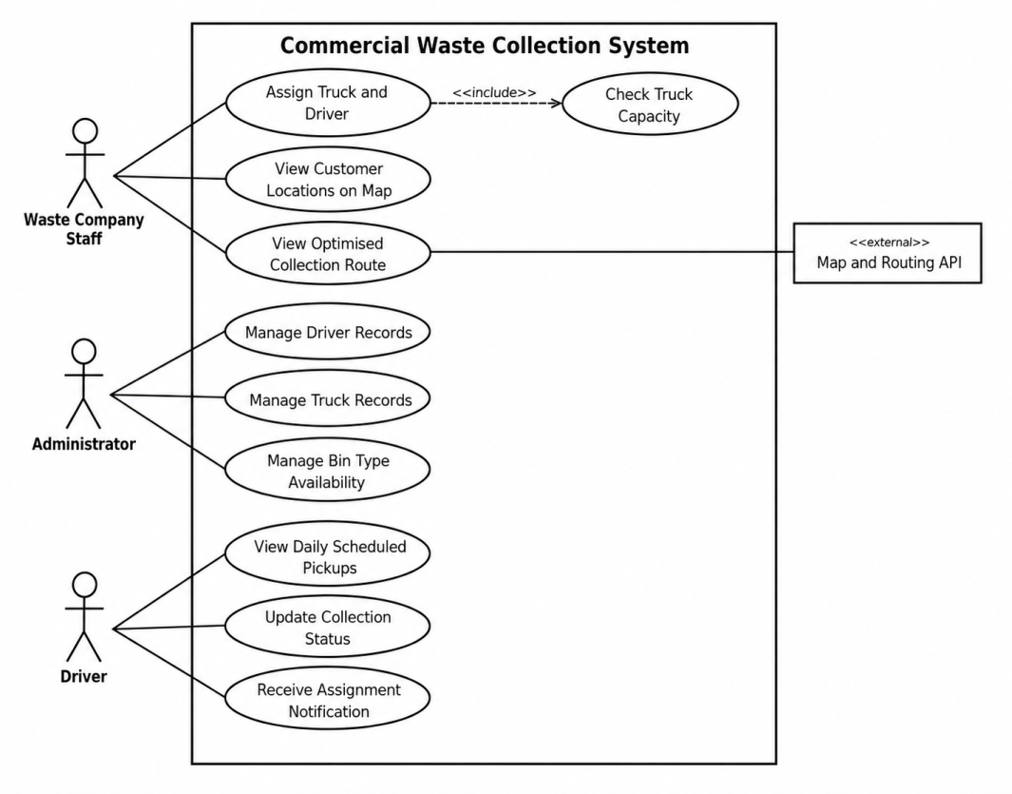
Figure 6.4: Service assignment, driver and route planning use case diagram
In this occasion it is evenly divided amongst the three actors. Staff will get a truck/driver allocation approved and include the include arrow – as always, finding a truck big enough for the load is part of the process. Also, staff will interact with the map and suggested routes, which is where the external map service comes in. The administrator is responsible for the reference data: Driver Records, Truck Records, Bin Type Availability. The driver has only three things to do, and for good reason, they have a cell phone in a truck. This diagram relates to FR17 and FR27 to FR36.

6.6 Payment, Reports and Feedback
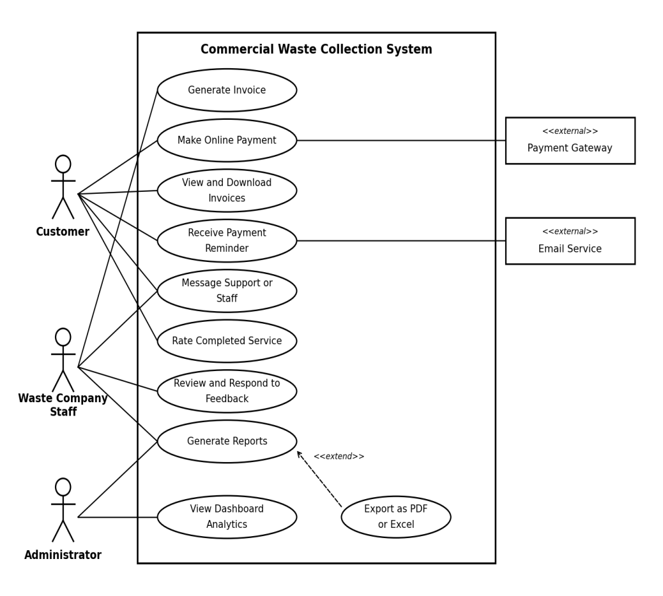
Figure 6.5: Payment, billing, reporting and feedback use case diagram
The final diagram amalgamates all that occurs once a collection has been completed. When a job is finished, an invoice is created and the customer will be able to view or download past invoices whenever they want, while paying the invoice via the payment gateway. On this diagram, the email service is included; reminders and other notifications are sent via the email service. Customers give feedback on service and staff review and respond to that feedback. Reports are listed below, including Export as PDF/Excel and dashboard analytics which is a view of the dashboard. This diagram is for FR37-FR49.

