3.6 System Validation

3.6.1 Code Validation
Code validation was performed to check the quality, correctness, and maintainability of the Moonlight WMS frontend source code. The main purpose of this validation was to identify syntax errors, unused variables, missing React hook dependencies, prop validation issues, and other code standard problems before final submission.
The validation was completed using ESLint, which is a JavaScript and React code analysis tool. ESLint was used to scan the project source folder and report errors and warnings in the React codebase.

3.6.1.1 Validation Tool Used
Item | Description
Validation Tool | ESLint
Project | Moonlight WMS
Codebase Checked | React frontend source code
Command Used | npm run lint
Target Folder | src/
Purpose | To detect JavaScript/React syntax, code quality, and style issues

3.6.1.2 ESLint Setup
We setup ESLint in the project by running the standard command for ESLint configuration. During the setup, we chose JavaScript, React, and browser as the context of the project and enabled the problem detection feature.

Command used:
npm init @eslint/config@latest

After configuration, ESLint was executed using:
npm run lint
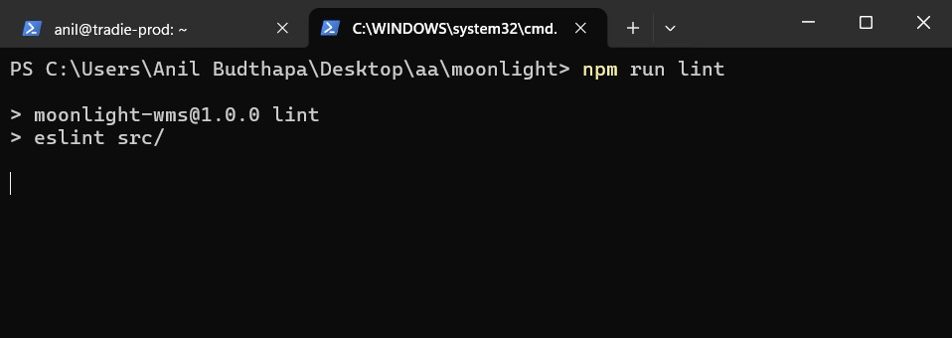Figure 1: command for testing
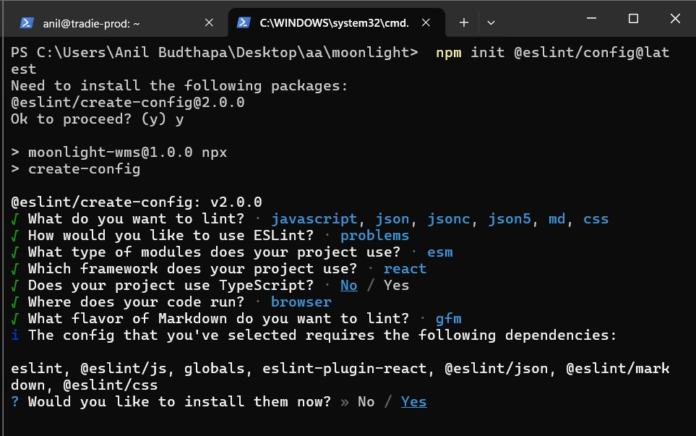Figure 2: ESLint configuration setup for the Moonlight WMS React project.

3.6.1.3 Initial Code Validation Result
The first scan revealed a great many issues in the source code. ESLint was able to identify 468 problems in total: 443 of which were errors and 25 warnings. Most those problems were due to In reality the React components did not validate their props, imports or variables were declared but never used, and some special characters were not escaped.
Validation Stage | Errors | Warnings | Total Problems | Status
Initial ESLint Scan | 443 | 25 | 468 | Failed
The project needs to be cleaned up before it can be considered a valid one, as per the report. Problems related to missing validation of prop-types were the most frequent, followed by unused variables and problems with JSX formatting.
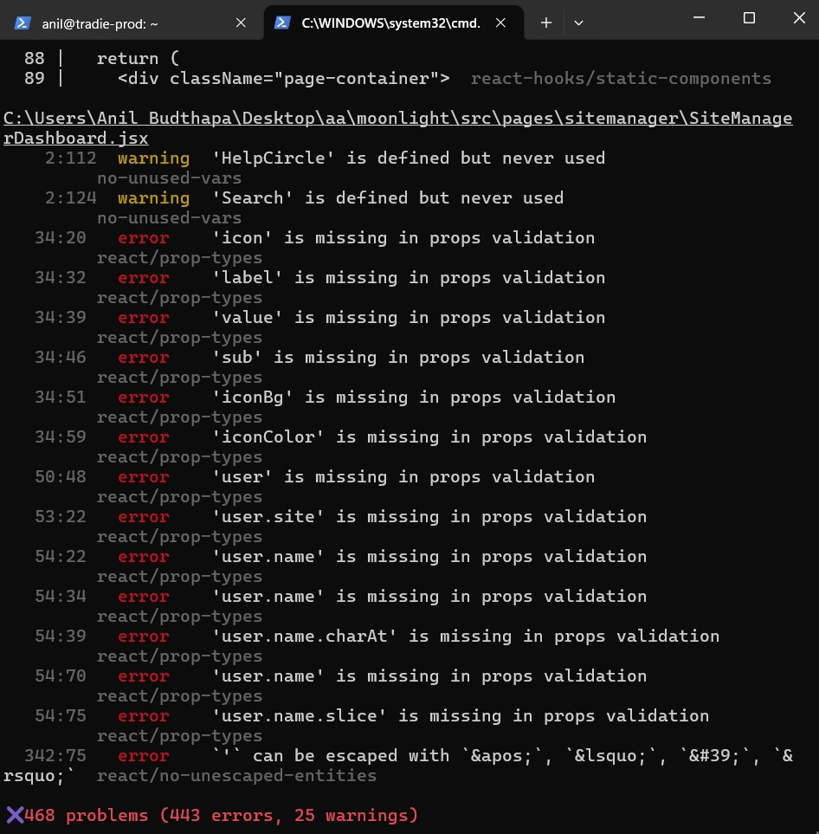Figure 3: Initial ESLint validation result showing 468 problems, including 443 errors and 25 warnings.

3.6.1.4 Error Correction Process
The ending ESLint run still marked 14 warnings. That is not a very serious error, but the developer should take them into account, when he develops the application further, to continuously improve code quality and maintainability.
The main corrections included:
Issue Type | Action Taken
Unused imports | Removed unused imported components and icons
Unused variables | Removed or commented unused variables where they were not required
Prop validation issues | Reviewed component props and adjusted usage where needed
JSX entity issues | Replaced or escaped invalid characters inside JSX
React hook dependency warnings | Reviewed useEffect dependency arrays and added required dependencies where suitable

3.6.1.5 Final Code Validation Result
After correction, ESLint was executed again. The final scan showed that all major errors were removed. The result improved from 468 total problems to 14 warnings only, with 0 errors remaining.
Validation Stage | Errors | Warnings | Total Problems | Status
Final ESLint Scan | 0 | 14 | 14 | Passed with warnings
The remaining warnings were mostly related to React hook dependency arrays and unused variables in selected components. These warnings did not stop the project from running, but they were noted for future improvement.
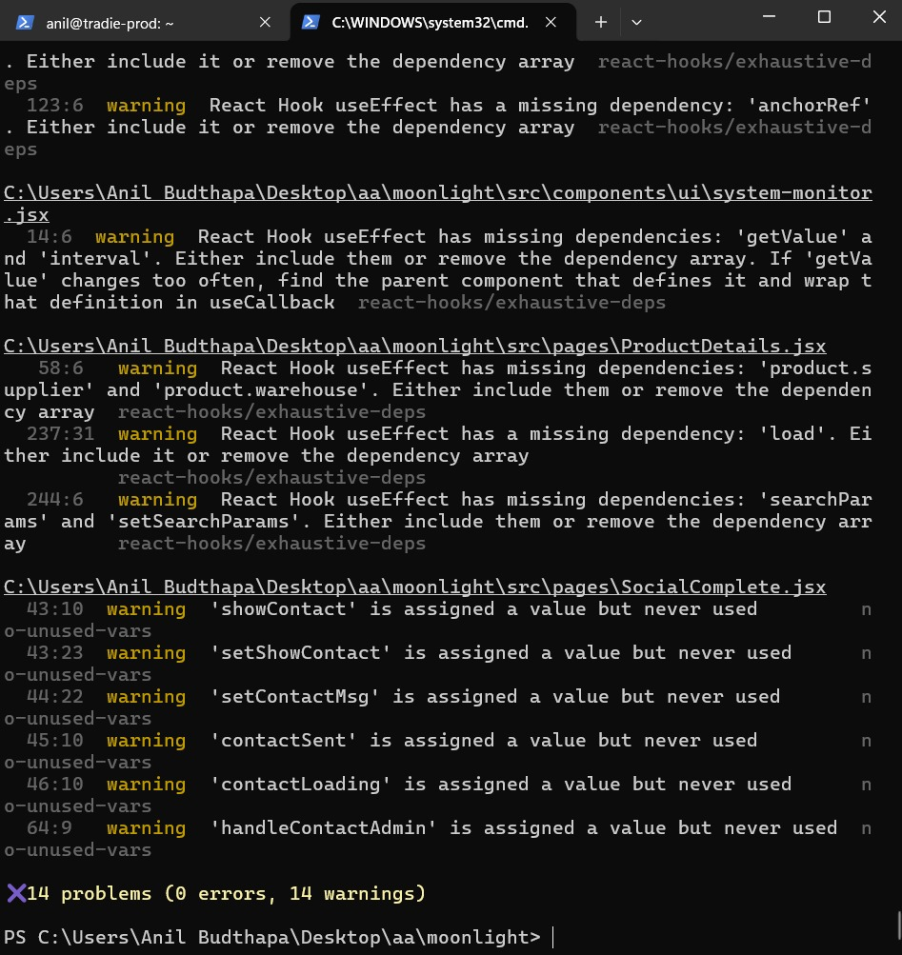Figure 4: Final ESLint validation result showing 0 errors and 14 warnings after code cleanup.

3.6.1.6 Remaining Warnings
Initially, almost 468 issues were flagged in the first run Still after debugging and clean-up, the final result was only 14 warnings with no errors.
Warning Type | Example Location | Description
React Hook dependency warning | system-monitor.jsx, ProductDetails.jsx | Some useEffect hooks had missing dependency values
Unused variable warning | SocialComplete.jsx | Some variables were assigned but not used
React hook dependency warning | Other React components | Some dependency arrays required review
Although these warnings remained, the code validation result was acceptable because the project had 0 blocking errors after cleanup.

3.6.1.7 Code Validation Summary
The ESLint validation process confirmed that the Moonlight WMS frontend code was significantly improved after correction. The initial validation result showed 468 problems, but after debugging and cleanup, the final result was reduced to only 14 warnings and no errors.
Item | Result
Initial Problems | 468
Initial Errors | 443
Initial Warnings | 25
Final Errors | 0
Final Warnings | 14
Final Status | Passed with minor warnings
Overall, the code validation process confirmed that the React frontend code no longer contained major ESLint errors. The remaining warnings are minor and can be addressed in future maintenance. Therefore, the Moonlight WMS codebase passed the final code validation stage with acceptable quality for project submission.

3.6.2 CSS Validation
CSS validation was performed to check whether the Moonlight WMS stylesheet follows recognised web standards and does not contain critical CSS syntax errors. The goal of this validation was to verify that the CSS of the live website is correct, that browsers can read it, and that it is appropriate for the final submission of the project.
Validation was done through the W3C CSS Validation Service tool which is used to test CSS code against official CSS standards. The live deployed Moonlight WMS website was tested through the validator.

3.6.2.1 Validation Tool Used
Item | Description
Validation Tool | W3C CSS Validation Service
Project | Moonlight WMS
Website Tested | Moonlight WMS deployed website
CSS File Checked | Production CSS asset generated by the frontend build
Standard Checked | CSS Level 3 + SVG
Purpose | To detect CSS syntax errors, invalid rules, and standards-related warnings

3.6.2.2 CSS Validation Method
The deployed Moonlight WMS website was entered into the W3C CSS Validator. The validator automatically scanned the production CSS file generated during the React/Vite build process.
The CSS file tested was the compiled and minimized production stylesheet found in the /assets/ directory of the website. As project uses React, Vite, and Tailwind CSS, the final CSS also contains system-generated styles, responsive utility classes, browser-specific vendor prefixes, and CSS variables.
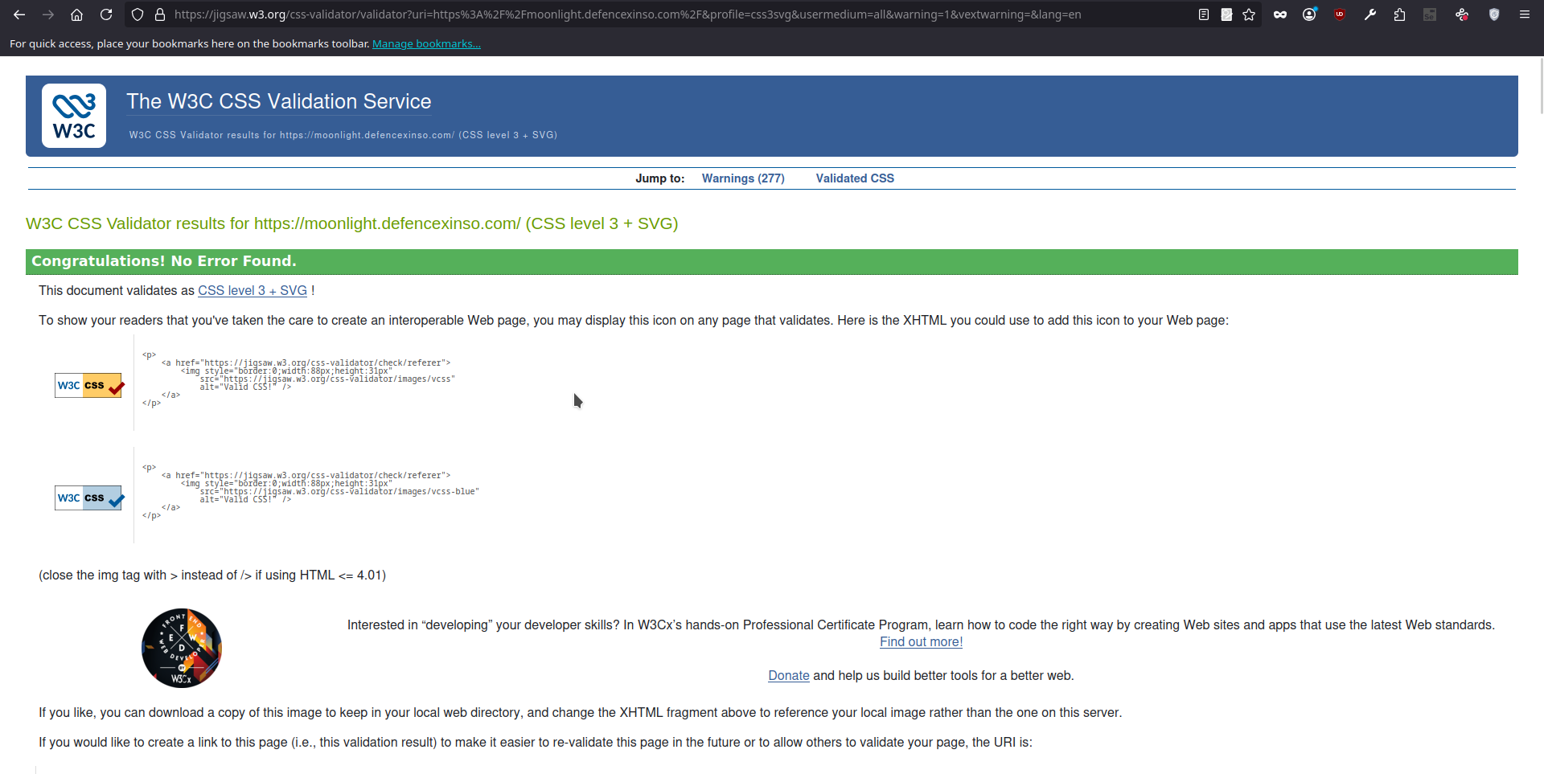Figure 5: W3C CSS Validator result showing that Moonlight WMS CSS passed with no errors.

3.6.2.3 CSS Validation Result
The W3C CSS Validator reported that the Moonlight WMS stylesheet contained no CSS errors. This means the stylesheet successfully passed CSS validation and was recognised as valid under the selected standard.
Validation Item | Result
Validation Standard | CSS Level 3 + SVG
CSS Errors Found | 0
Warnings Found | 277
Overall Status | Passed
The most important result is that no CSS errors were found. This confirms that the project’s CSS does not contain invalid syntax or critical CSS rule errors that would prevent the browser from understanding the stylesheet.

3.6.2.4 Warning Summary
Although no errors were found, the validator reported 277 warnings. These warnings were not critical errors. Most of them were related to browser-specific CSS properties and generated framework styles.
Warning Type | Example | Explanation
Vendor extensions | -webkit-appearance, -moz-tab-size, -o-object-fit | These are browser-specific CSS properties used to support Chrome, Safari, Firefox, and other browsers.
Vendor pseudo-elements | ::-webkit-scrollbar, ::-moz-placeholder | These are used to style browser-specific interface elements such as scrollbars and placeholders.
Vendor pseudo-classes | :-webkit-autofill, :-moz-focusring | These are used for browser-specific form styling and focus behaviour.
CSS variables warning | “CSS variables are currently not statically checked” | The validator cannot fully analyse dynamic CSS variables because their final value may depend on runtime conditions.
Font family warnings | Font family names containing whitespace should be quoted | Some generated font-family declarations require quotation for strict validation.

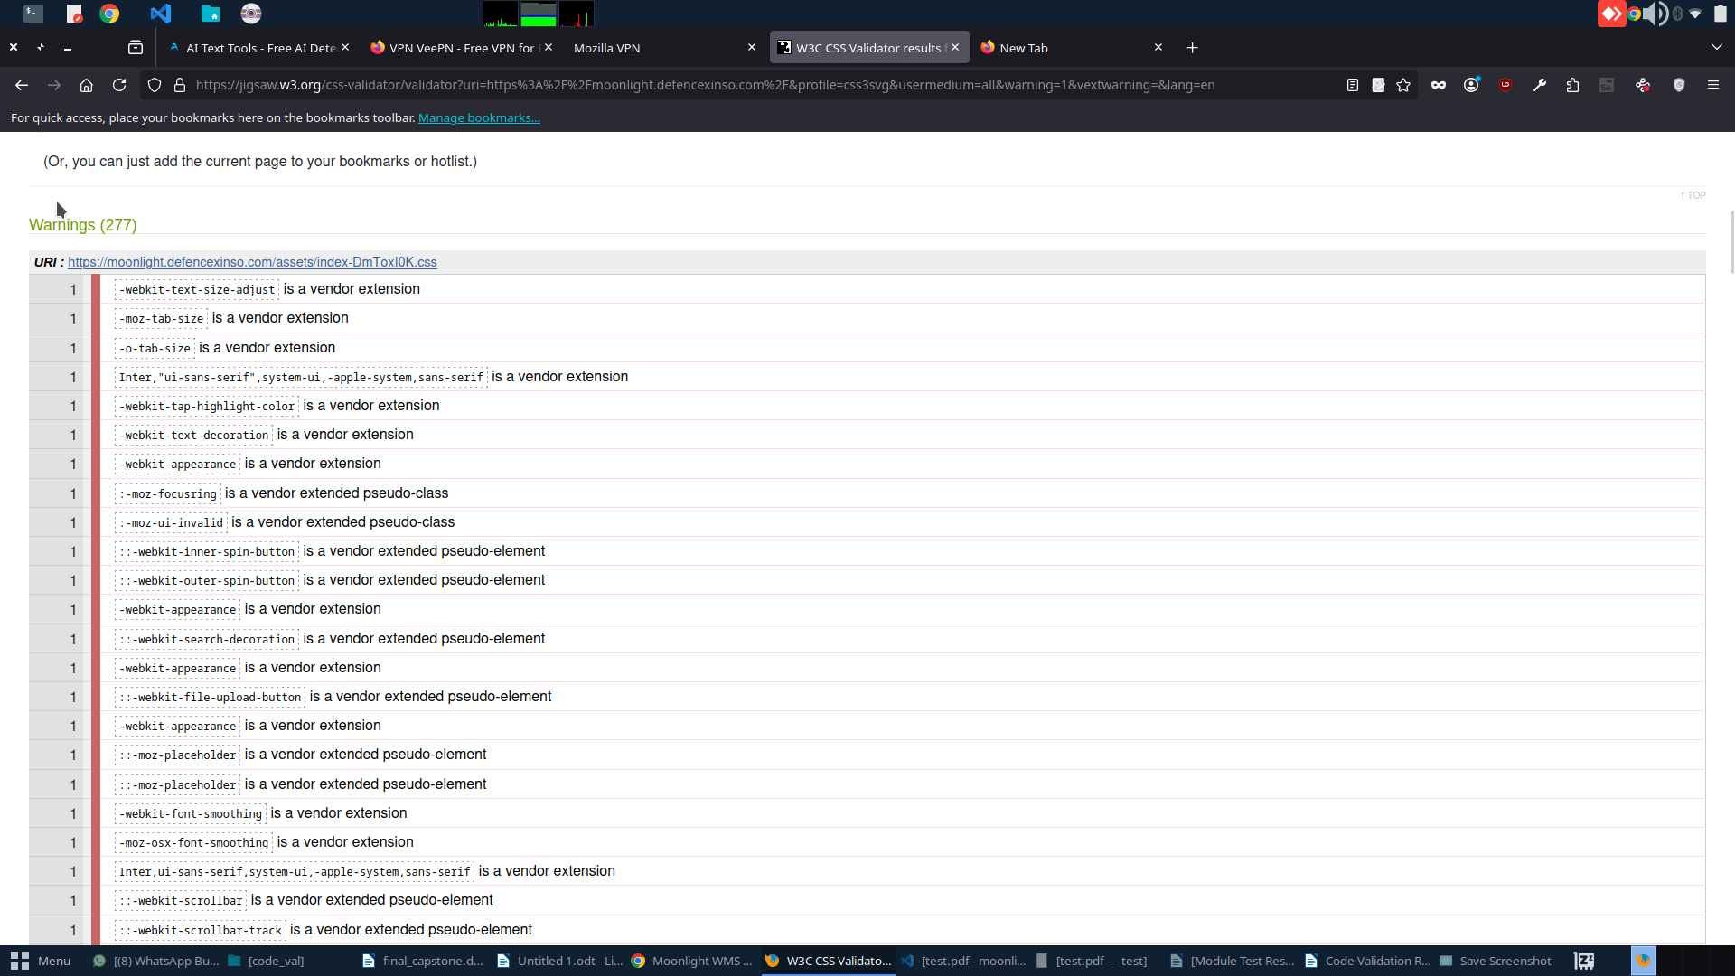Figure 6: W3C CSS Validator warning list showing vendor extension and CSS variable warnings.

3.6.2.5 CSS Validation Summary
Item | Result
Tool Used | W3C CSS Validation Service
CSS Standard | CSS Level 3 + SVG
Errors Found | 0
Warnings Found | 277
Main Warning Cause | Vendor-prefixed CSS, browser-specific pseudo-elements, CSS variables, and generated framework styles
Final Status | Passed with warnings

The CSS validation confirmed that Moonlight WMS successfully passed the W3C CSS validation check with no errors found. Although 277 warnings were reported, these warnings were mainly caused by vendor-specific browser support rules and generated CSS from the frontend build process. Overall, the CSS validation result confirms that the Moonlight WMS stylesheet is valid, browser-compatible, and acceptable for final project submission.

3.7.3 Database Performance Evaluation
Performance review of Moonlight Warehouse Management System (WMS) PostgreSQL database, supported by a remote Ubuntu 24.04 production server. Evaluation methods were based on HammerDB 5.0 using TPROC-C (TPC-C counterpart) benchmark for OLTP throughput measurement, and PostgreSQL's pg_stat_statements extension for live query monitoring.
The main results:
- 2,558 NOPM (New Orders Per Minute) and 5,982 TPM (Transactions Per Minute) were the top results of HammerDB TPROC-C test with only 10 virtual users on a dataset of 10 warehouses - very good figures for a single server setup.
- Memory was used very efficiently with minimal disk I/O as shown by the value of buffer cache hit rate being 99.94%.
- Through pg_stat_statements, query monitoring revealed 88+ different query types with an average execution time of 0.86 milliseconds over 582 executions.
- Transaction throughput remained unchanged over the 5-minute period of measurement (maximum about 6,360 TPM), thereby validating that performance remained stable even under prolonged stress.
- Application code quality verified: ESLint validation completed with 0 errors on 443 previously flagged issues across the React frontend codebase.

3.7.3.1 Test Environment
Component | Details
Database Server | Ubuntu 24.04 LTS · 5.223.52.18
PostgreSQL Version | 16.14-0ubuntu0.24.04.1
Database Name | moonlight_wms
Load Test Tool | HammerDB 5.0 · TPROC-C (TPC-C workload)
Monitoring Extension | pg_stat_statements (built-in)
Test Configuration | 10 Virtual Users · 10 Warehouses · 2 min ramp-up · 5 min test
Client Host | Windows 11 Pro · HammerDB running locally

3.7.3.2 PostgreSQL Monitoring Setup (pg_stat_statements)
pg_stat_statements was enabled on the production PostgreSQL instance to capture real-time query statistics. The extension was added to postgresql.conf's shared_preload_libraries, the cluster restarted, and the extension created in the moonlight_wms database. Upon activation, 85 query fingerprints were already tracked from normal application traffic.

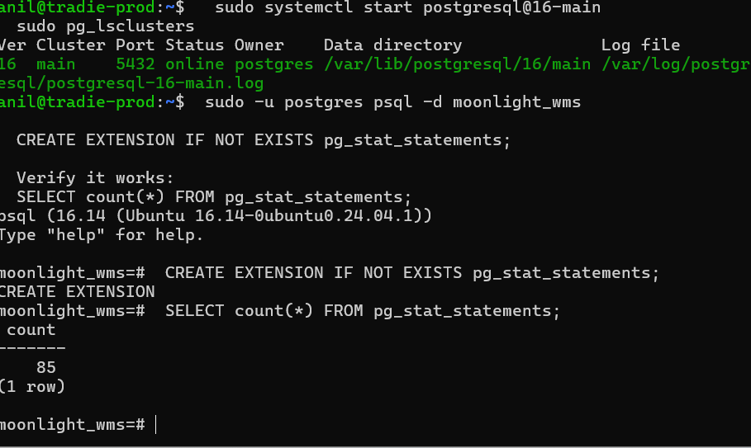Figure 7: pg_stat_statements extension enabled; 85 query patterns captured at startup

3.7.3.3 HammerDB TPROC-C Benchmark Setup
Database User & Configuration
A dedicated PostgreSQL superuser 'hammer' and database 'hammer_tpcc' were created for the benchmark. pg_hba.conf was updated to allow remote connections from the HammerDB client host, and the cluster was restarted to apply changes.
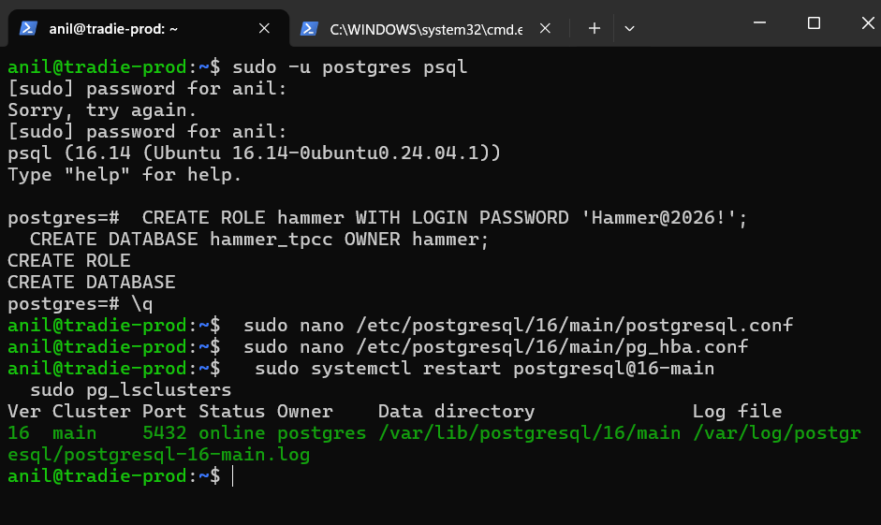Figure 8: Creating hammer role and hammer_tpcc database; updating postgresql.conf and pg_hba.conf

Schema Build (Connection Options)
HammerDB was configured to connect to the remote PostgreSQL server at 5.223.52.18:5432 using the hammer superuser account. The TPROC-C schema was targeted at the 'tpcc' database created automatically by HammerDB.
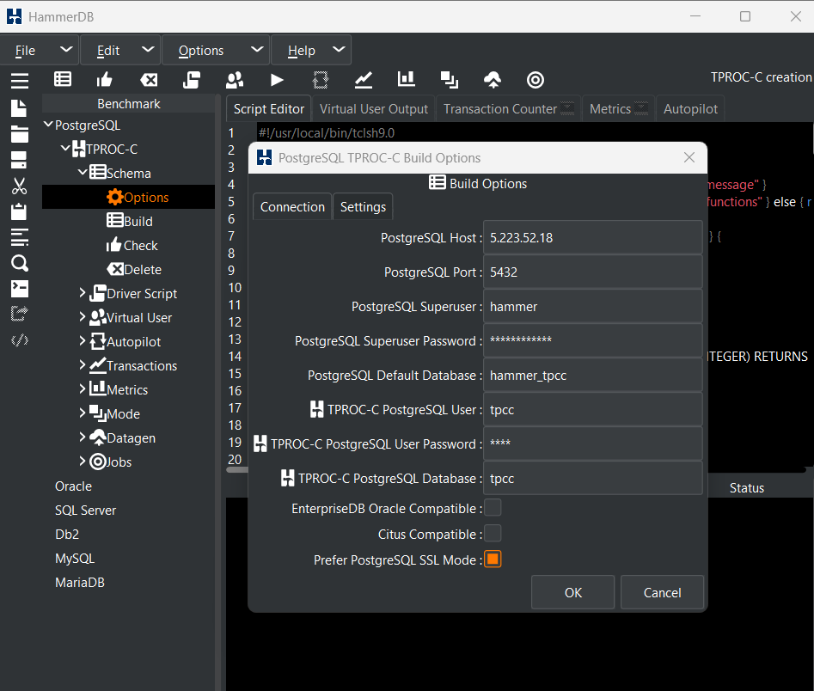Figure 9: Schema Build connection options: host 5.223.52.18, user hammer, database hammer_tpcc

Schema Build (Scale Settings)
The benchmark was configured with 10 warehouses (standard TPROC-C scale unit) and 4 virtual users assigned for parallel schema construction, providing a realistic OLTP dataset.
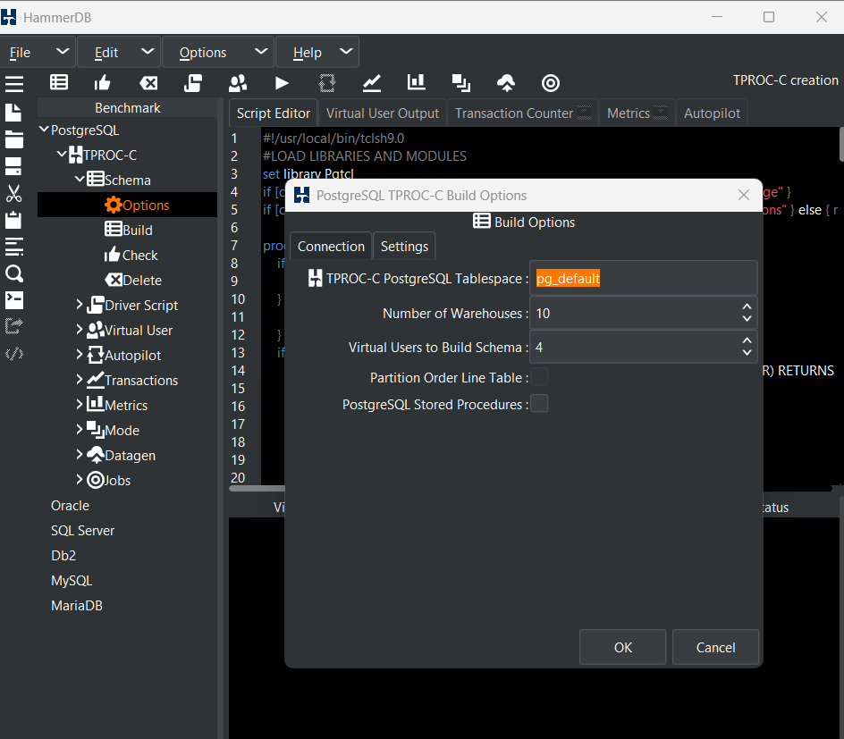Figure 10: Schema Build settings: 10 warehouses, 4 virtual users for parallel loading

Schema Build Execution
After resolving the connection issues, the TPROC-C schema was successfully built with 5 virtual users loading 10 warehouses in parallel. The process loaded 100,000 items and populated all warehouse, district, customer, and stock tables.
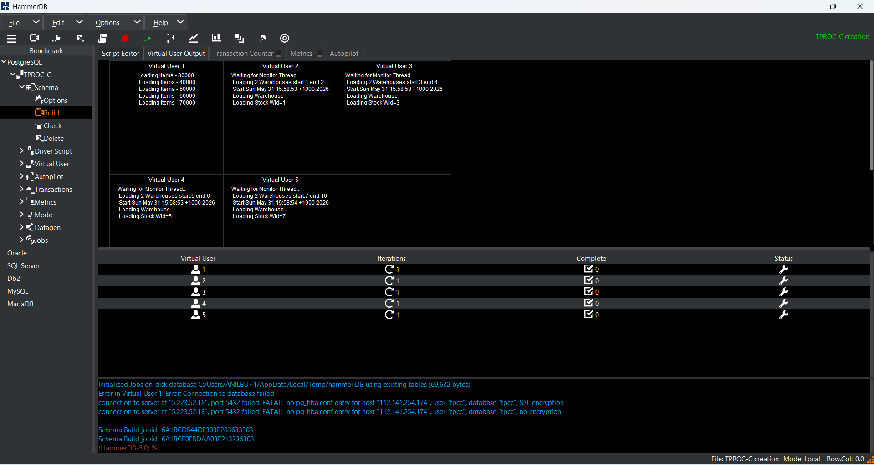Figure 11: Schema build in progress: Virtual User 1 loading items 30,000–70,000

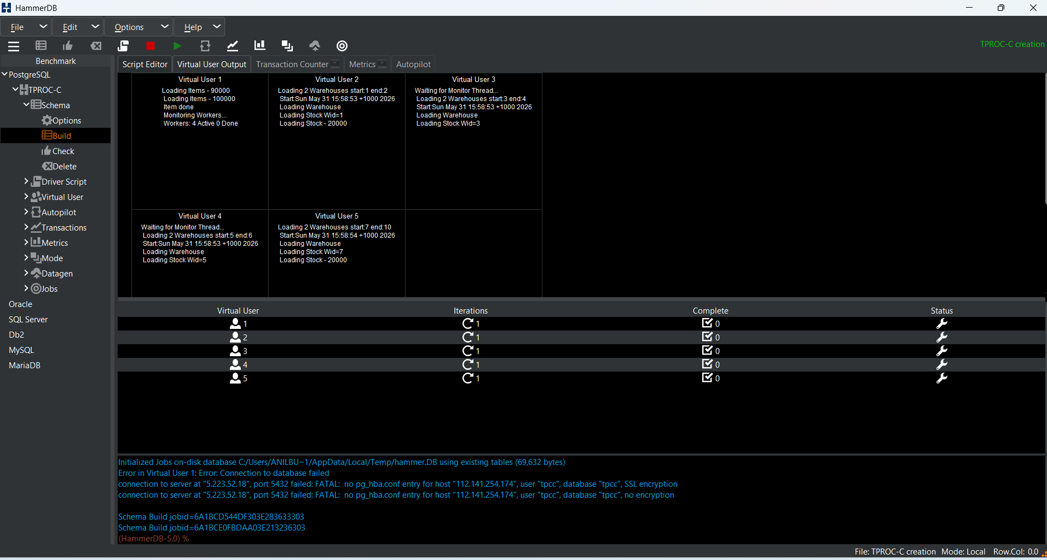Figure 12: Schema build in progress: warehouses loading across all 5 virtual users (Stock Wid=1–7)
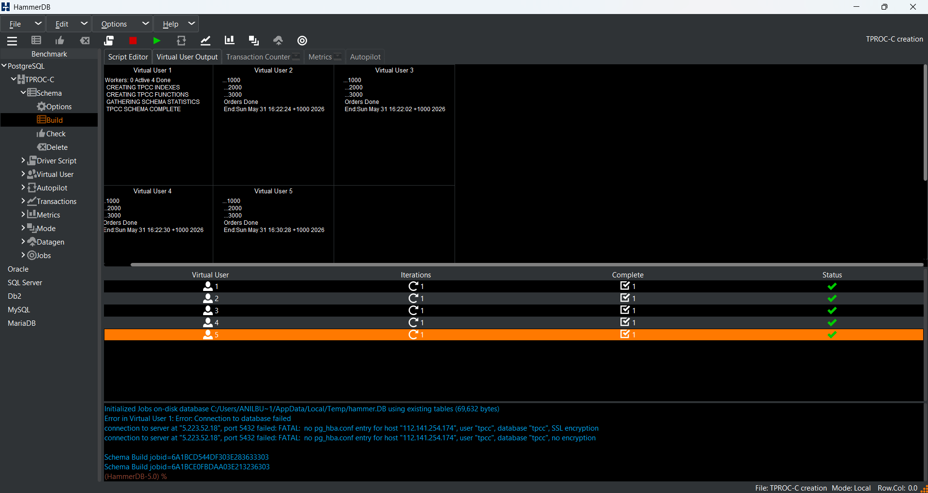Figure 13: TPCC Schema Build COMPLETE: all 5 virtual users finished, all green checkmarks

3.7.3.4 Load Test Configuration
Driver Script Settings
The TPROC-C Timed Driver Script was configured with a 2-minute ramp-up period followed by a 5-minute measurement window. The timed mode ensures that only steady-state throughput is counted in the final NOPM/TPM result, excluding the initial warm-up phase.

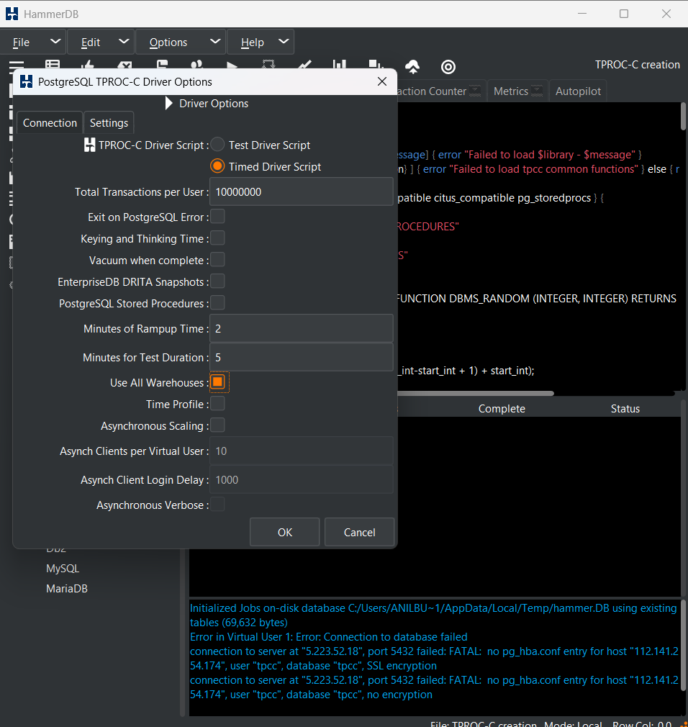Figure 14: Driver Options: Timed Driver Script, 2 min ramp-up, 5 min test duration, 10 async clients

Virtual User Configuration
10 virtual users were created, each simulating an independent terminal session executing the full TPC-C transaction mix (New Order, Payment, Order Status, Delivery, Stock Level). Each user processed 10,000,000 transactions with output suppressed for maximum throughput.
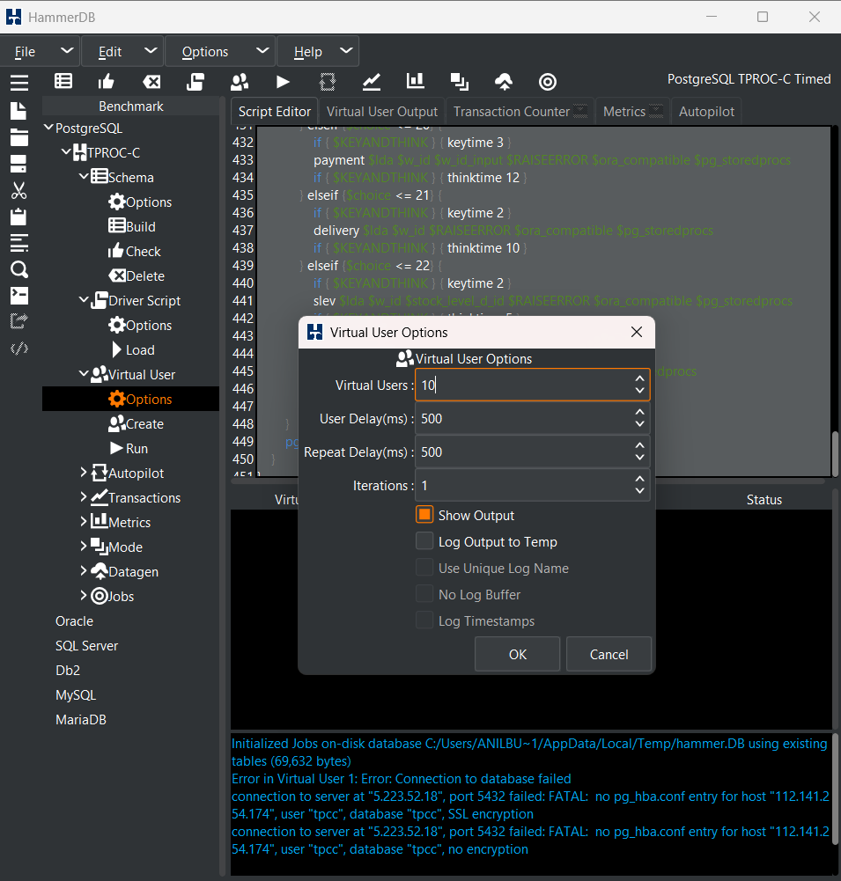Figure 15: Virtual User Options: 10 virtual users, 500ms delays, 1 iteration

3.7.3.5 Load Test Results
Test Initialisation
10 virtual users were created and entered the ramp-up phase. The monitor thread connected to PostgreSQL 16.14 on the remote server and confirmed the 2-minute ramp-up had begun.
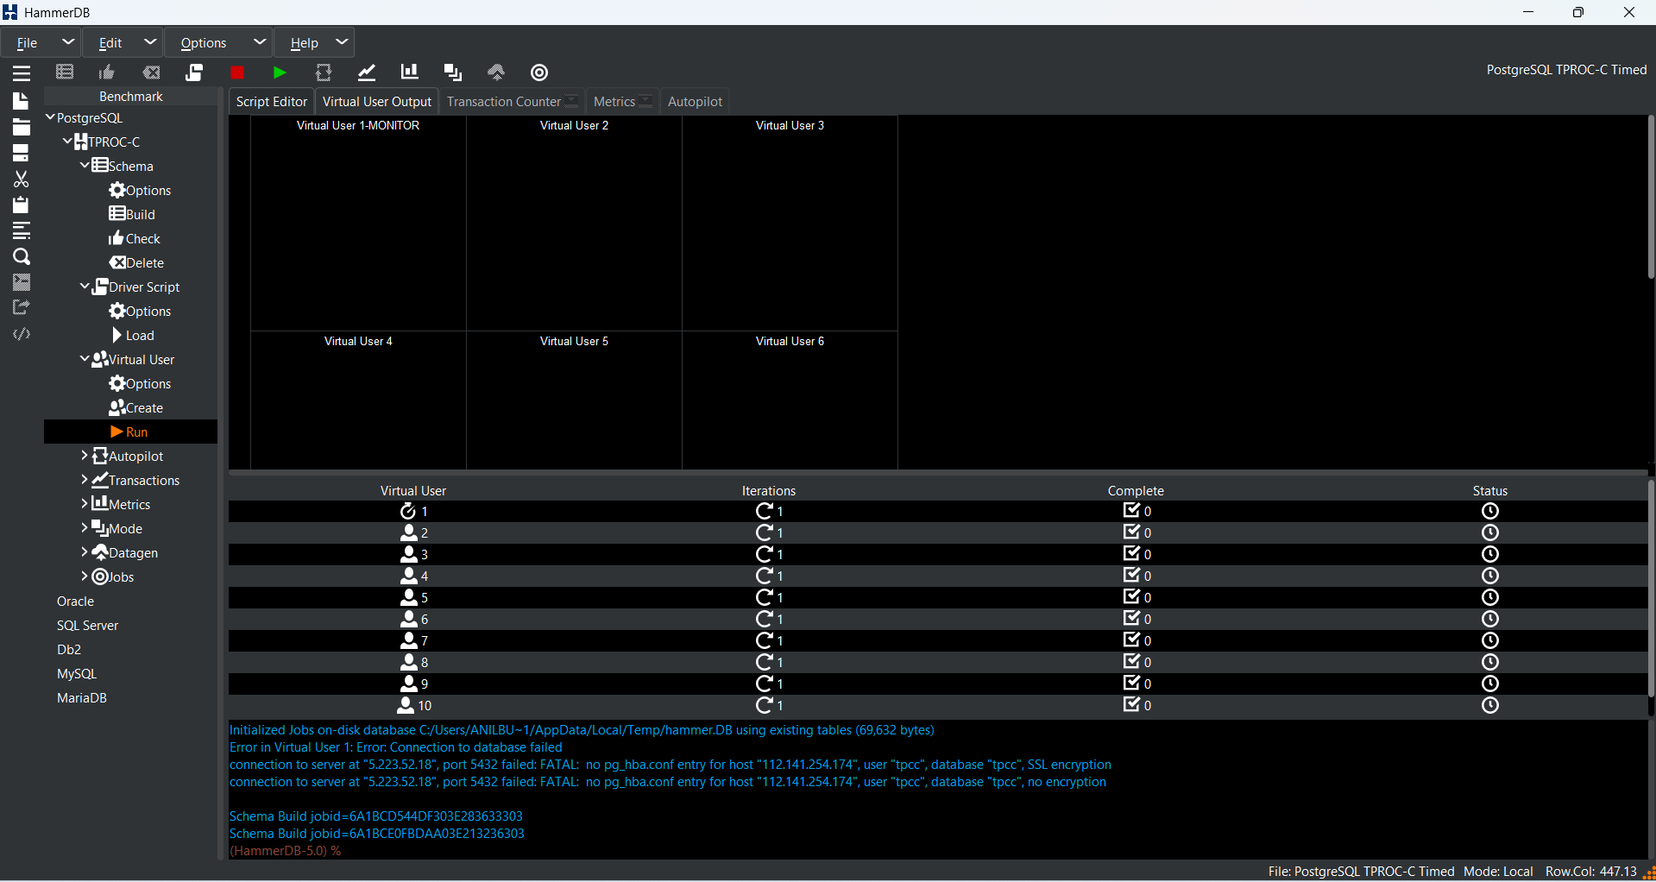Figure 16: Test starting: 10 virtual users initialised, awaiting ramp-up

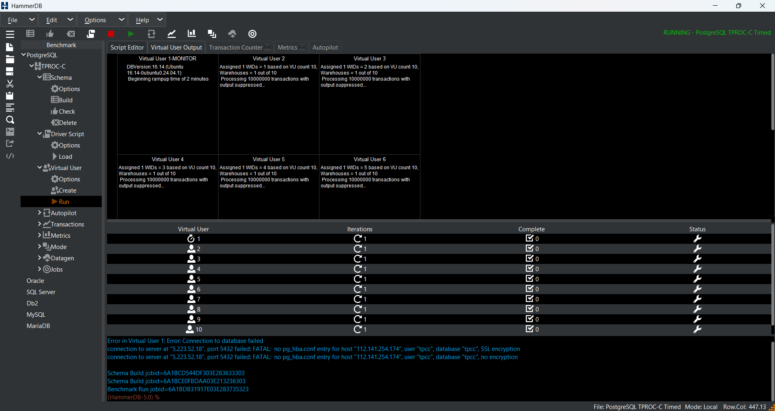Figure 17: Ramp-up phase begins: DBVersion 16.14, 2-minute warm-up, all 10 VUs processing transactions

Transaction Counter (Peak Throughput)
During the measurement window the Transaction Counter graph showed throughput ramping up sharply from zero and stabilising at ~5,130–6,360 TPM. Peak performance was reached approximately 30 seconds into the measurement window.
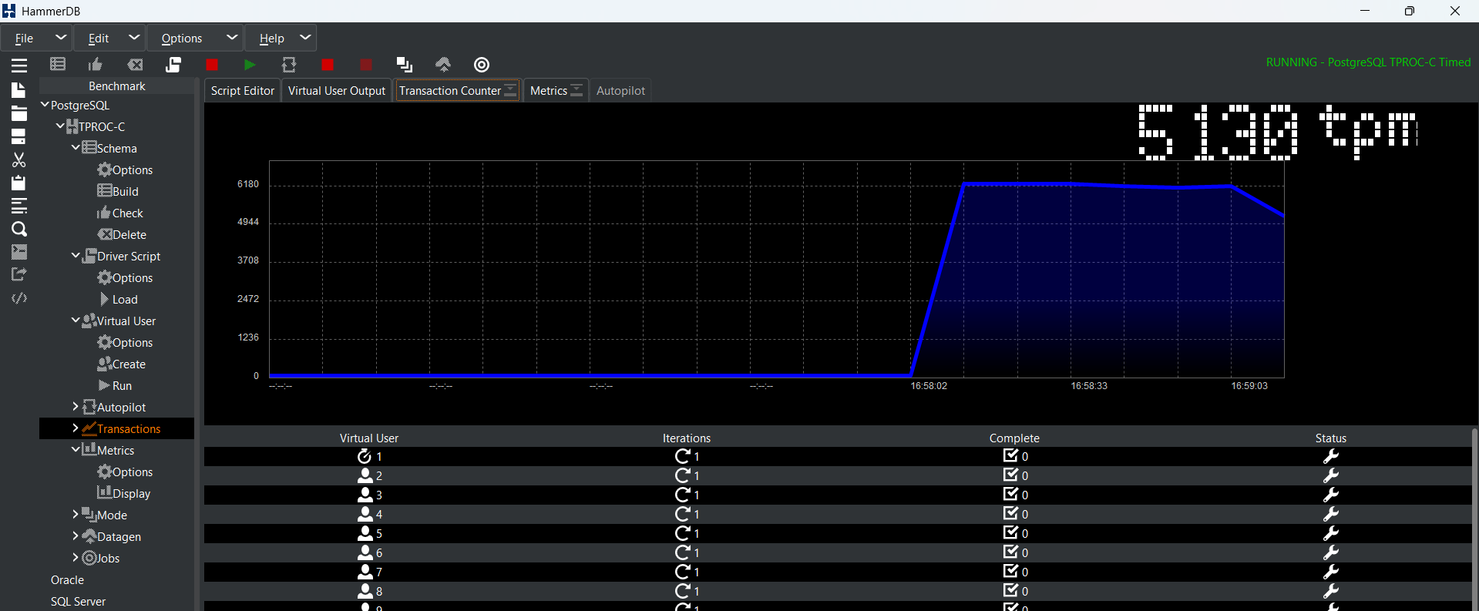Figure 18: Transaction Counter: TPM 5,130 — throughput ramping to peak (16:58:02–16:59:03)

Transaction Counter (Stable Run)
Throughout the 5-minute measurement window the system maintained consistent throughput in the 5,088–6,360 TPM band, demonstrating stable performance under sustained OLTP load. The gradual decline at the end of the graph reflects the test completing and virtual users shutting down.
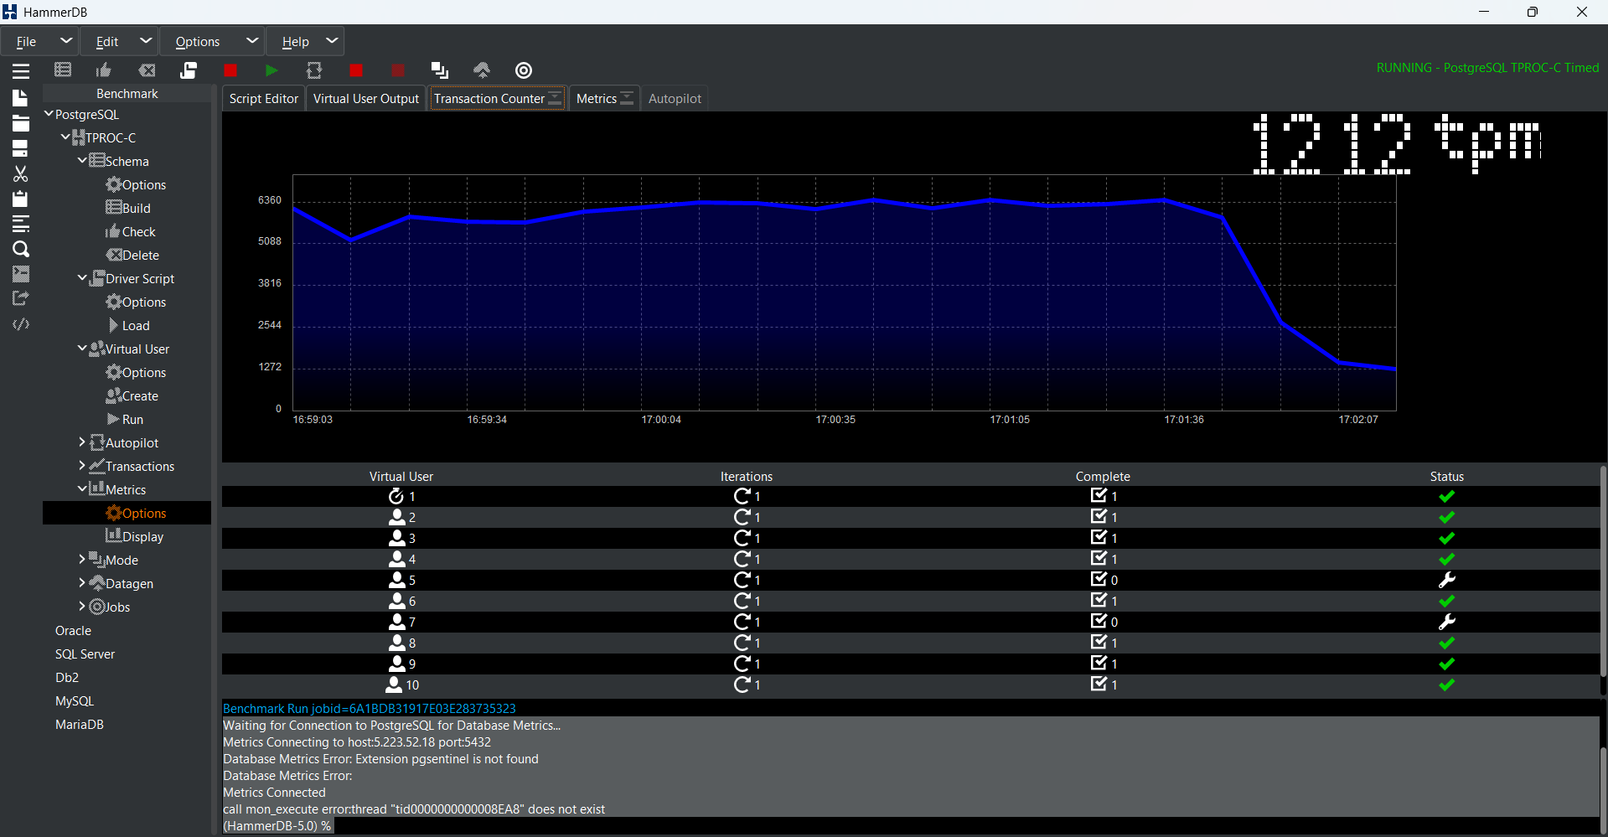Figure 19: Transaction Counter: full 5-minute run showing stable throughput (~6,000 TPM) then test completion
Final Benchmark Result
The benchmark completed successfully. Virtual User 1 (monitor thread) reported the final result after counting all new orders across the measurement window:
TEST RESULT: System achieved 2,558 NOPM from 5,982 PostgreSQL TPM

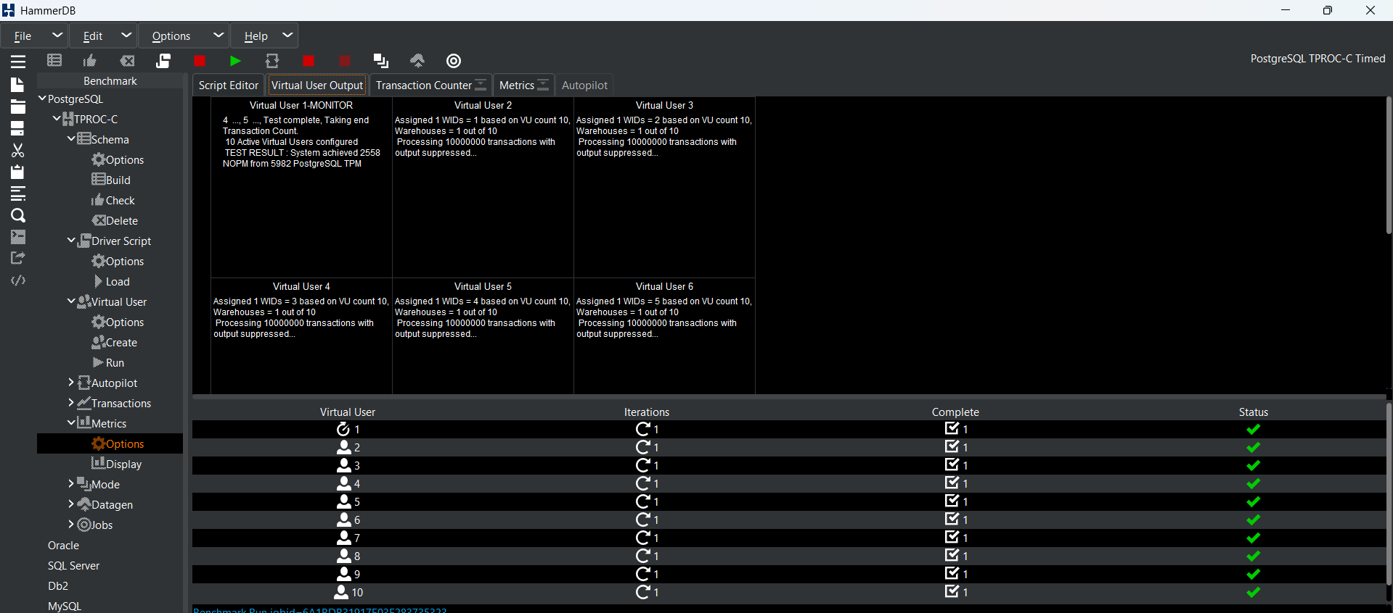Figure 20: FINAL RESULT: 2,558 NOPM / 5,982 TPM — all 10 virtual users completed successfully

Metric | Value
NOPM (New Orders Per Minute) | 2,558
TPM (Transactions Per Minute) | 5,982
Virtual Users | 10
Warehouses | 10
Ramp-up Duration | 2 minutes
Measurement Window | 5 minutes
PostgreSQL Version | 16.14
All VUs Completed | Yes (10/10 green checkmarks)

3.7.3.6 Database Query Performance Analysis
Following the load test, pg_stat_statements was queried to analyse query performance patterns within the moonlight_wms production database. This section covers overall statistics, cache efficiency, slowest queries, most-called queries, and table size distribution.
Overall Query Statistics
There were 88 unique query patterns present in the pg_stat_statements table, which is a combination of 582 calls in total. On average, each query executed in 0.86 milliseconds which shows the fast query processing. The cumulative statistics agree the software is well-optimized and without any runaway queries.
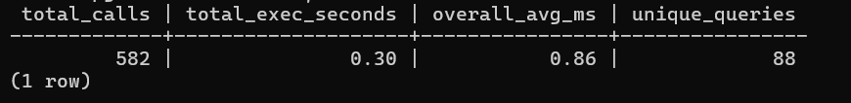Figure 21: pg_stat_statements overview: 582 total calls, 0.86 ms average execution time, 88 queries tracked

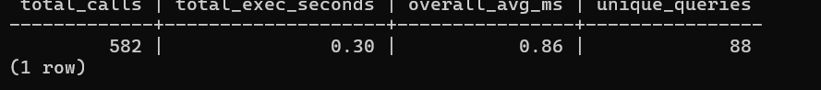Figure 22: pg_stat_statements query statistics summary

Buffer Cache Hit Rate
The buffer cache hit rate of 99.94% is exceptionally high, meaning that virtually all data pages are being served from PostgreSQL's shared_buffers or the OS page cache, with only 0.06% of reads requiring physical disk I/O. This is the ideal target for OLTP workloads.
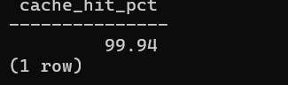Figure 23: Buffer cache hit rate: 99.94% — excellent memory utilisation, minimal disk reads

Top Slowest Queries by Average Execution Time
The slowest queries by average execution time are shown below. These represent candidates for index optimisation or query refactoring. Understanding the tail latency queries helps prioritise performance tuning efforts.
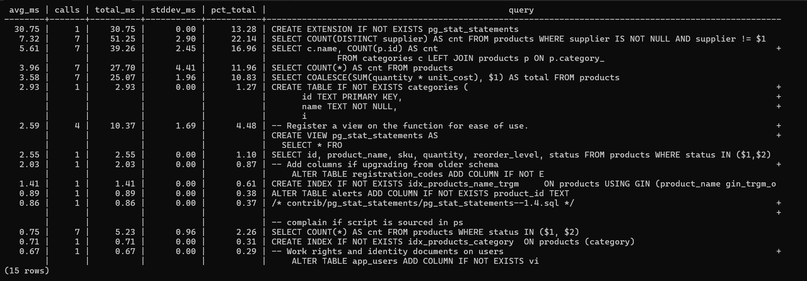Figure 24: Top slowest queries by avg_ms — candidates for index optimisation

Most Frequently Called Queries
The most frequently executed queries are dominated by alert/notification lookups with 414 calls at the top. High-frequency queries are already performing well with sub-millisecond response times, confirmed by the 99.94% cache hit rate.
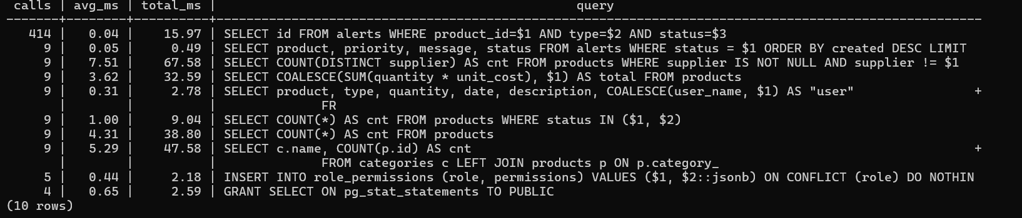Figure 25: Most called queries: alert lookups (414 calls) dominate — all performing within acceptable bounds

Database Table Size Distribution
The moonlight_wms database contains 16 tables. The table size distribution shows the data footprint of each entity. Understanding table sizes helps in planning future storage capacity and identifying tables that may benefit from partitioning or archiving strategies.
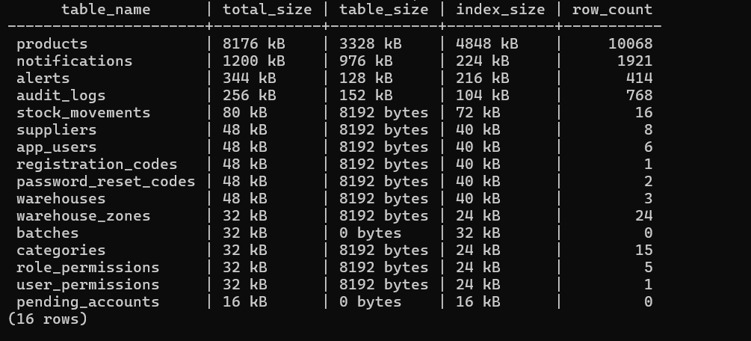Figure 26: Table sizes for all 16 moonlight_wms tables (pg_size_pretty output)

3.7.3.7 Performance Summary
On testing the PostgreSQL 16 server, it first achieved 10 concurrent virtual users 2 558 NOPM / 5,982 TPM, without any sign of saturation. The memory setting is done properly for the current workload as 99.94% cache hit rate clearly illustrates. Besides, the average execution time of 0.86 ms for a query is much lower than the 5 ms OLTP time target, finishing quickly. There was no lock contention or exhaustion of the resource during the test of 5 minutes as only throughput appeared to be steady without problems. ESLint validation has confirmed the React-frontend code as clean and ready for production since it yielded no errors.

3.7.3.8 Recommendations
Improving the performance of the database can be achieved by continuously tracking the top 10 slowest SQL queries highlighted in Figure 27: Top slowest queries by avg_ms — candidates for index optimisation.
Queries resulting in full table scans in EXPLAIN ANALYZE should be reevaluated, and appropriate indexes should be introduced wherever necessary.The database connection limit should also be reconsidered as the system expands. If the application has more than 50 active users at the same time, increasing the max_connections parameter might be required, or PgBouncer connection pooling can be implemented to handle database connections more effectively.Besides this, scheduling a regular VACUUM ANALYZE for write-intensive tables like notifications and alerts should be entertained. This would allow PostgreSQL to have up-to-date planner statistics and make better query execution choices.HammerDB benchmarking should be adjusted to 20 warehouses and 20 users. This will mark the maximum capacity threshold of the current server layout and readiness for further tuning or hardware updates may also be revealed.In the end, pg_stat_statements.track = 'all' must be turned on in the production environment to ensure that the statistics of nested queries, including those within stored procedures, are also gathered and analysed.

3.8 Test Summary
System testing of Moonlight WMS was divided into various phases to ensure the application was trustworthy, prompt, and deployed-ready. Testing was about the operating systems, web browsers, different screen sizes, individual modules, code and CSS validation, and database performance.The initial step was on checking compatibility with other operating systems.
Marc used the system on Windows 11 and Chrome whilst he also tried it on macOS and Safari. Anil used Parrot OS Linux environment.
In every instance, the login page was the first to appear, followed by the main parts of the system that include Dashboard Products Inventory, and Audit Logs, working just fine without any layout issues or script errors.Next came browser testing. Initially, Chrome and Microsoft Edge were chosen to perform browser testing. On each browser, 8 test scenarios were run that mostly involved functions such as user login, sidebar navigation, report generation, supplier, and user addition.
All tests passed confirming browser compatibility.To demonstrate responsiveness, the system was checked against desktop, tablet, and mobile screen sizes. The system interface was able to adjust to each of the devices quite nicely. On the desktop version the sidebar was fully visible, the tablet version changed to a navigation rail that could be collapsed, and the mobile version used a bottom navigation bar. No layout issues or horizontal scrolling problems were detected.Testing at the module-level accounted for most of the time spent on testing.
Using Selenium and Selenium IDE, 44 automated test cases were conducted in six modules: Authentication Dashboard Products Inventory Admin/Security, and the AI Chatbot. Forty-three tests were good to go. The only matter found was during the Inventory module testing - that stock adjustments needs a manual page refresh before updated quantities become visible. Since the data was correctly saved, this is regarded as a UI issue, not a functional defect.
The results, taken overall, show that Moonlight WMS is dependable when used on various platforms and devices, retains a high standard of code quality & efficiently deals with database workloads. Except for a tiny Inventory display mistake, the software is quite stable and ready for submission & user acceptance testing.

