Section 1. Project Management Plan

1.1 Team Management
Moonlight WMS was run by a well-organized, team-based approach. Right from the start of the project, the tasks and responsibilities were assigned clearly so each member not only knew what they had to do individually but also understood how their part contributes to the whole system.

It made the team stay on target, decrease duplicate efforts, and ensure that the project stays well-organized throughout the development phase.Team members were: Anil Budthapa, Anil KC, Diwas Phuyal, Thi Phuong Thanh Bui, Ashima Basnet, Marc, and Ritesh. Anil Budthapa took charge as the project manager and was a backend developer also. Anil KC was involved both as a frontend developer and a test engineer. Diwas Phuyal was responsible for frontend development and quality assurance person. Thi Phuong Thanh Bui helped with DevOps and deployment engineering. Ashima Basnet was a backend developer. Marc's work was centered on the AI assistant chatbot feature.

Ritesh was the database administrator and handled anything related to the database.The main tool for team communication was WhatsApp. The team used the group chat for daily updates, quick discussions, meeting arrangement, sharing screenshots, reporting bugs, and discussing lecturer feedback. This enabled the members to solve problems promptly including database issues, frontend errors, API hiccups, deployment difficulties, and GitHub workflow questions.However, GitHub served as the official collaboration platform.

It was the place where project files were kept, source code was managed, tasks were tracked, and development history was preserved. The project was handled within the MEL15-Avengers GitHub organisation, which was the central repository for assignment-related materials.

GitHub organisation link:
https://github.com/MEL15-Avengers
GitHub repositories link:
https://github.com/orgs/MEL15-Avengers/repositories
The organisation contained separate repositories such as Assignment3, Assignment4, and Assignment5. This helped the team separate different stages of project work instead of mixing everything into one unstructured repository.
Assignment3 repository link:
https://github.com/MEL15-Avengers/Assignment3
Assignment4 repository link:
https://github.com/MEL15-Avengers/Assignment4
Assignment5 repository link:
https://github.com/MEL15-Avengers/Assignment5
This team management approach helped the group stay organised and accountable. WhatsApp supported quick communication, while GitHub provided a formal record of repositories, issues, tasks, and progress. Together, these tools allowed the team to manage the Moonlight WMS project in a structured and professional way.
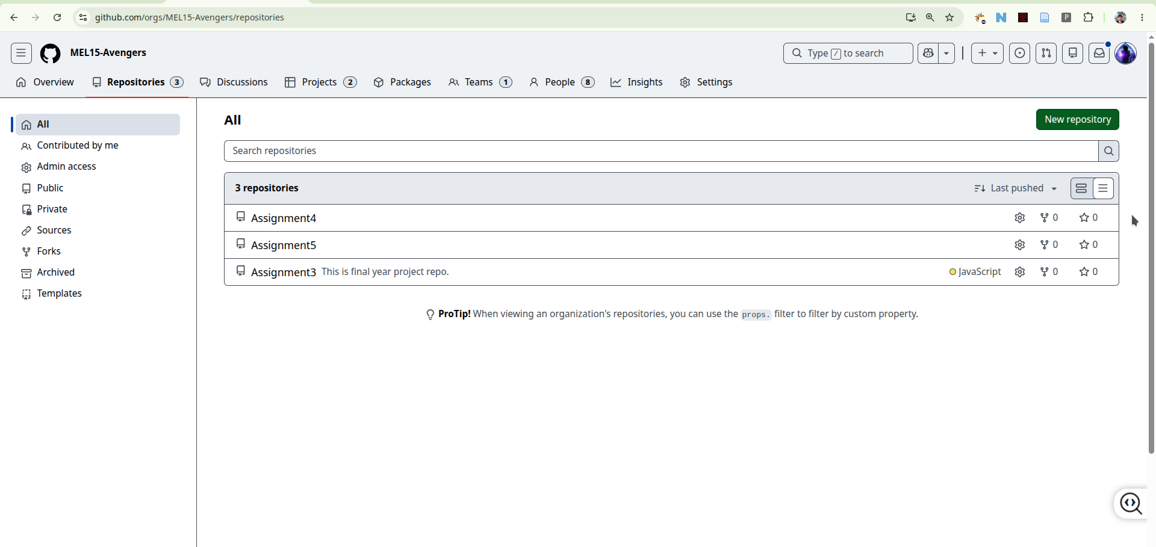Figure 1: MEL15-Avengers GitHub organisation showing Assignment3, Assignment4, and Assignment5 repositories
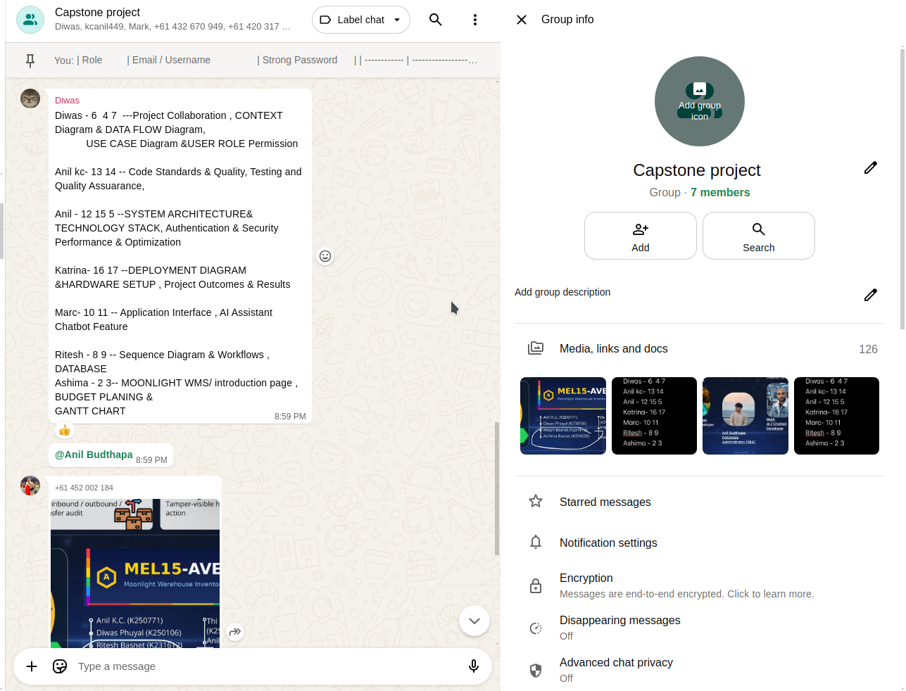Figure 2: WhatsApp group communication showing project discussion, updates, or shared screenshots

1.2 Task Management
MEL15-Avengers Organisation's Assignment project board on GitHub Projects was used to handle task management of the Moonlight WMS project.
GitHub Project 4 link:
https://github.com/orgs/MEL15-Avengers/projects/4
https://github.com/orgs/MEL15-Avengers/projects/9
Besides informal discussion, a project board was employed by the team to arrange tasks, follow progress, and record things to be completed.The leading step of task management involved team task formation. During the team conference, the main features of the Moonlight WMS system were discussed and the work was fragmented into distinct task areas Because of this. Linking each task with a particular system module ensured that every member had a well-defined task area. that this situation helped the avoidance of confusions since everyone understood which part of the system they would be working on.The project tasks were structured by the system's core modules like authentication dashboard product catalogue inventory stock movement alerts search, AI support, admin and security deployment database setup, and hosting.
Thanks to this arrangement, the team was able to split up their work because they could dedicate themselves to the development of their own module but, at the same time, contribute to the final product.Task workflow was handled with GitHub Project.
The team could monitor tasks by their stages using a project board i.e. planned, in progress, under review, or done. It turned out very helpful to get an overview of which parts of the system have already been completed and which parts require further work.The use of GitHub Projects led to a higher level of openness within the team.

Without the need to individually request updates, members were able to simply take a look at the project board to see the work progress of different modules. As a result, the team was better able to keep pace with the project timeline and the progress recording was more systematic.
This task management approach helped the team manage the project in a structured way. GitHub Project provided the formal tracking system, while WhatsApp supported quick communication when issues or blockers appeared. By combining both tools, the team was able to plan tasks, monitor progress, solve problems, and complete the Moonlight WMS project more effectively.
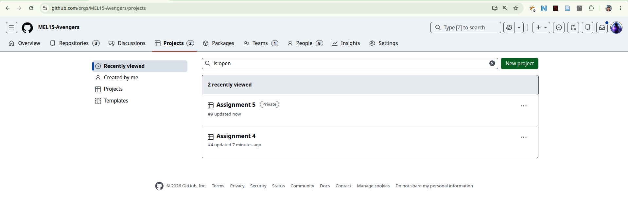Figure 3: GitHub Project
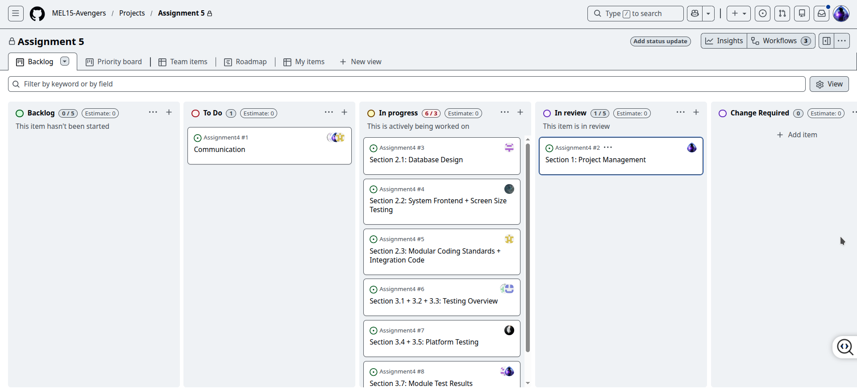Figure 4: GitHub Project task cards showing module-based task management

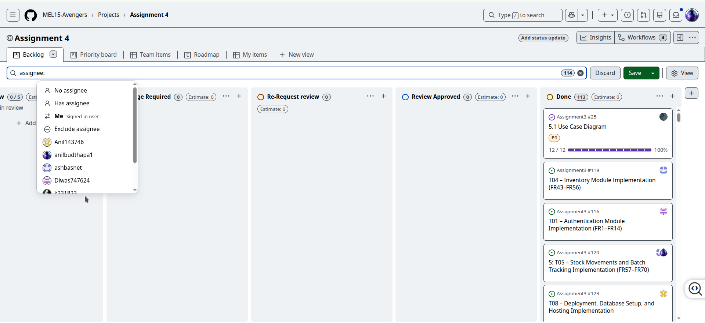Figure 5: GitHub Project columns showing task progress such as planned, in progress, review, and completed

1.3 GitHub for Code Management
GitHub was used as the main platform for managing the source code. It acted as the central place where all project files were stored and updated. The team used GitHub to manage frontend code, backend code, database files, documentation, and task-related updates.
A feature-based workflow was followed. Members were expected to work on their assigned task or module and then push their changes to the repository. This helped keep the project organised and reduced the risk of losing code.
GitHub also allowed the team to track commit history. This was important because it showed when changes were made and which files were updated. The commit history provided evidence of progress and helped trace individual contributions.

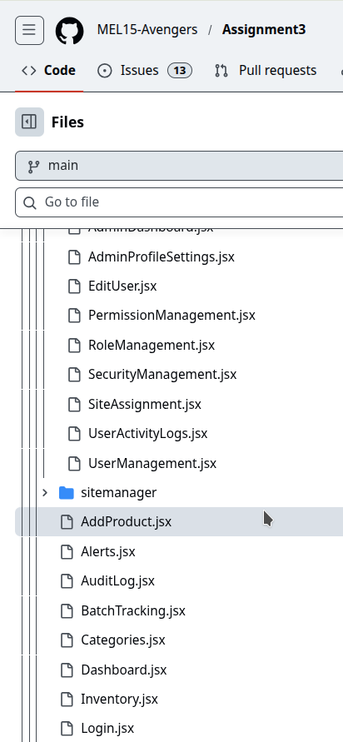
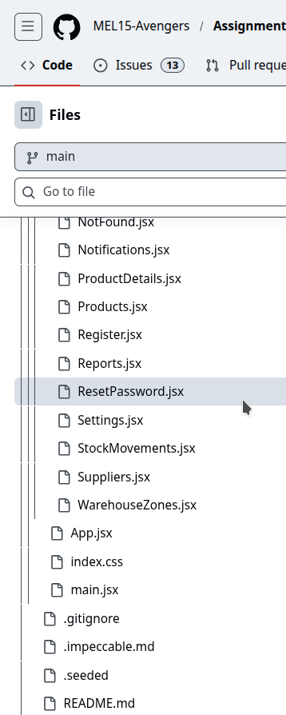
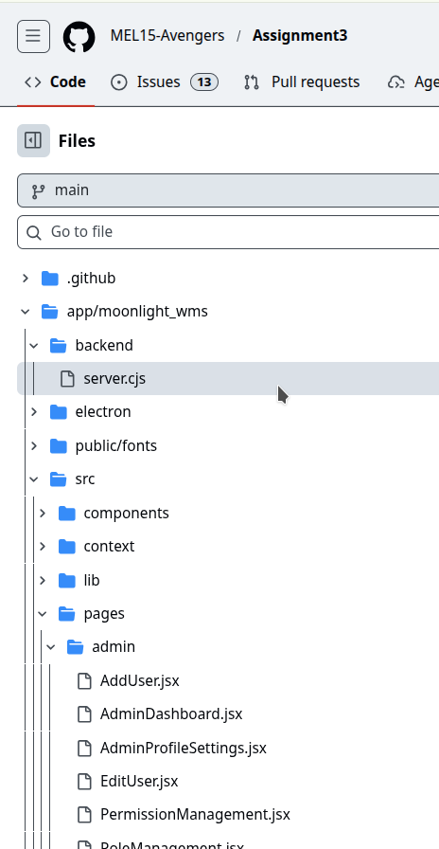Figure 6: Tree view of Code in github

1.4 Tools Used to Manage and Build the Project
During this project, we took advantage of a number of tools that helped us with different things such as planning the development and testing phases designing managing the database, and deployment. For example, GitHub was utilized for repository management, code versioning, issue tracking, and collaboration. WhatsApp served as the team's medium for everyday communication, instant updates, sharing screenshots, and discussing problems. Visual Studio Code was the team's primary code editing tool. For backend development, Node.js and npm were selected as the runtime environment and package manager, respectively. React together with Vite were chosen for the frontend as these technologies allow fast development cycles and efficient production builds. The team opted for PostgreSQL as the database platform, whereas pgAdmin and DBeaver were the tools aiding them in managing and exploring data visually.The final release was done on a Linux machine dualing Apache2, Cloudflare Tunnel, PostgreSQL, and systemd service components. The role of Apache2 was to deliver frontend pages and also be the reverse proxy for backend calls. Cloudflare Tunnel provided a publicly reachable secured URL to our system, while systemd was used to ensure the continuous operation of critical services. Test execution and error fixing involved using browser dev.tools, shell commands, and automated UI tests with Selenium. Figma and Canva were the tools supporting UI/UX design and visual presentations. Besides these tools, we also employed Draw.io, Lucidchart, and Microsoft Visio to create diagrams, flowcharts, and system architecture drawings.

Tools Links
S.N | Tool | Link
1 | GitHub | https://github.com/
2 | WhatsApp | https://www.whatsapp.com/
3 | Visual Studio Code | https://code.visualstudio.com/
4 | Node.js | https://nodejs.org/
5 | npm | https://www.npmjs.com/
6 | React | https://react.dev/
7 | Vite | https://vite.dev/
8 | PostgreSQL | https://www.postgresql.org/docs/
9 | Apache HTTP Server | https://httpd.apache.org/
10 | Cloudflare Tunnel | https://developers.cloudflare.com/tunnel/
11 | systemd | https://systemd.io/
12 | Selenium | https://www.selenium.dev/
13 | Chrome DevTools | https://developer.chrome.com/docs/devtools/
14 | pgAdmin | https://www.pgadmin.org/
15 | DBeaver | https://dbeaver.io/
16 | Figma | https://www.figma.com/
17 | Canva | https://www.canva.com/
18 | Draw.io | https://www.drawio.com/
19 | Lucidchart | https://www.lucidchart.com/
20 | Microsoft Visio | https://www.microsoft.com/en-us/microsoft-365/visio/

1.5 Deployment Management
The deployment was carried out through a special production server on Hetzner Cloud.
The server was labeled Moonlight and was located at the Singapore ap-southeast region. The server hardware specification was 2 vCPU, 4 GB RAM and 80 GB local disk, which was adequate for hosting the Moonlight WMS, API and database server.The platform was run on a Linux server, and the team operated the application via terminal commands and SSH. React 18 with Vite was used for the frontend, Node.js Express was the backend structure, and PostgreSQL was the database.GitHub was the tool to track deployment changes.
When the code got updated, the latest version was fetched from the repo, dependencies got installed, the frontend was rebuilt, and backend services were restarted.Apache2 was deployed to the serve frontend and forward API requests to the backend. Environment variables helped to manage key settings like database connection, API configuration, and application security values.The server status, public IP, hardware resources, traffic usage location backups, and server activity were controlled via the Hetzner Console.
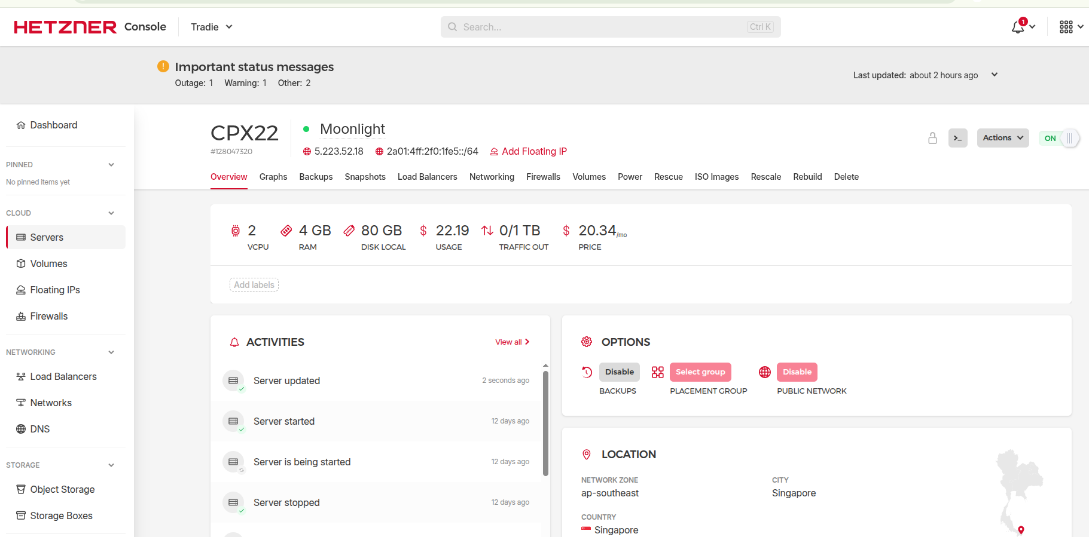Figure 7: Deployment Server

Overall Project Management Summary
In summary, management of the Moonlight WMS project was done through a set of technologies, including assignment-wise GitHub repos, GitHub Issues, GitHub Projects, WhatsApp chats docs testing and deployment checklists.Initially, the team identified tasks based on the primary modules of the system. Later they separated the work via GitHub Issues and managed it assignment-wise in the MEL15-Avengers organisation. WhatsApp facilitated daily communication and closed-door problem-solving, while GitHub offered formal tracking, code control, and contributors history. The method employed for project management not only provided the means to keep the team organised and create clear divisions of responsibilities but also allowed them to incorporate changes in the system efficiently, deal with technical problems and eventually achieve the goal of the Moonlight WMS system as a single application ready for deployment.

