2.6.7 Digital Signature and New Prescription Notification
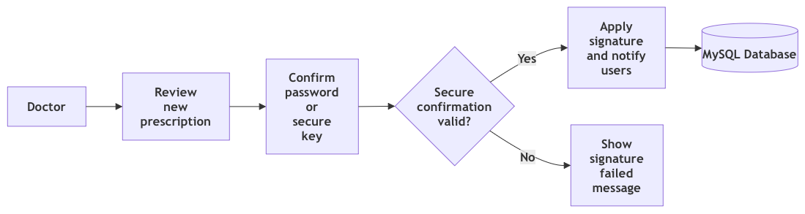
Figure 7: Functional view for digital signature and new prescription notification

2.6.8 Patient Prescriptions and Profile
Figure 8: Functional view for patient prescriptions and profile

2.6.9 Medication Tracking and Missed Dose Alert
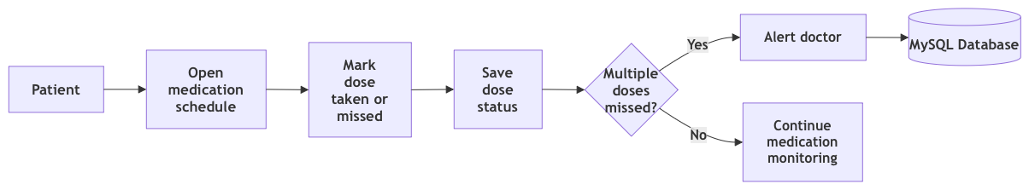
Figure 9: Functional view for medication tracking and missed dose alert

2.6.10 Prescription Renewal and Refill Alert
Figure 10: Functional view for prescription renewal and refill alert

2.6.11 Pharmacist Prescription Verification
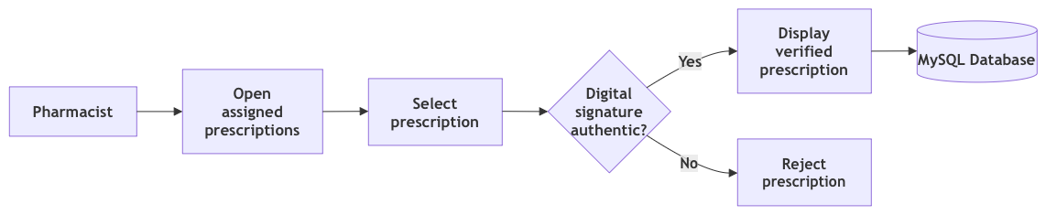
Figure 11: Functional view for pharmacist prescription verification

