3.2 Database design - model reconciliation
The existing ERD and Darpan’s dictionary are not interchangeable. The ERD has user_account, pharmacy, pharmacist, medicine_batch, dispensing and inventory_transaction. The dictionary uses Users, Pharmacists, Inventory_Batches, Dispensings and Dispensing_Items, and also lists tables absent from that ERD. This section proposes one pharmacy model using the ERD’s singular names; it is a design specification, not an applied migration.
Dictionary name | ERD / proposed name | Reconciliation
Users | user_account | Use the ERD account key; agree single-role versus User_Roles separately.
Pharmacists | pharmacist | Retain pharmacy_id, registration and user_id membership from ERD.
Inventory_Batches | medicine_batch | Retain medicine_id, pharmacy_id, batch number, expiry and quantity.
Prescriptions / Prescription_Items | prescription / prescription_item | Keep header/items separate. Do not store prescribed medicines in patient rows.
Dispensings | dispensing | Use fulfilment header; preserve pharmacist and prescription references.
Dispensing_Items | dispensing_item (proposed) | Preserve multiple medicine/batch allocations per fulfilment. Move item quantity/batch references here.
Not in dictionary | pharmacy / inventory_transaction | Carry forward ERD entities into the reconciled dictionary.
Not in either baseline model | prescription_assignment / stock_reservation | Add explicit pharmacy allocation and reservation lifecycle.

The proposed dispensing_item resolves a limitation of the ERD’s single batch_id on dispensing. One prescription can contain several medicines and one medicine may be supplied from multiple batches. The issued prescription remains the clinical authority; fulfilment and inventory rows record what was actually supplied.

3.2 Pharmacy data relationships
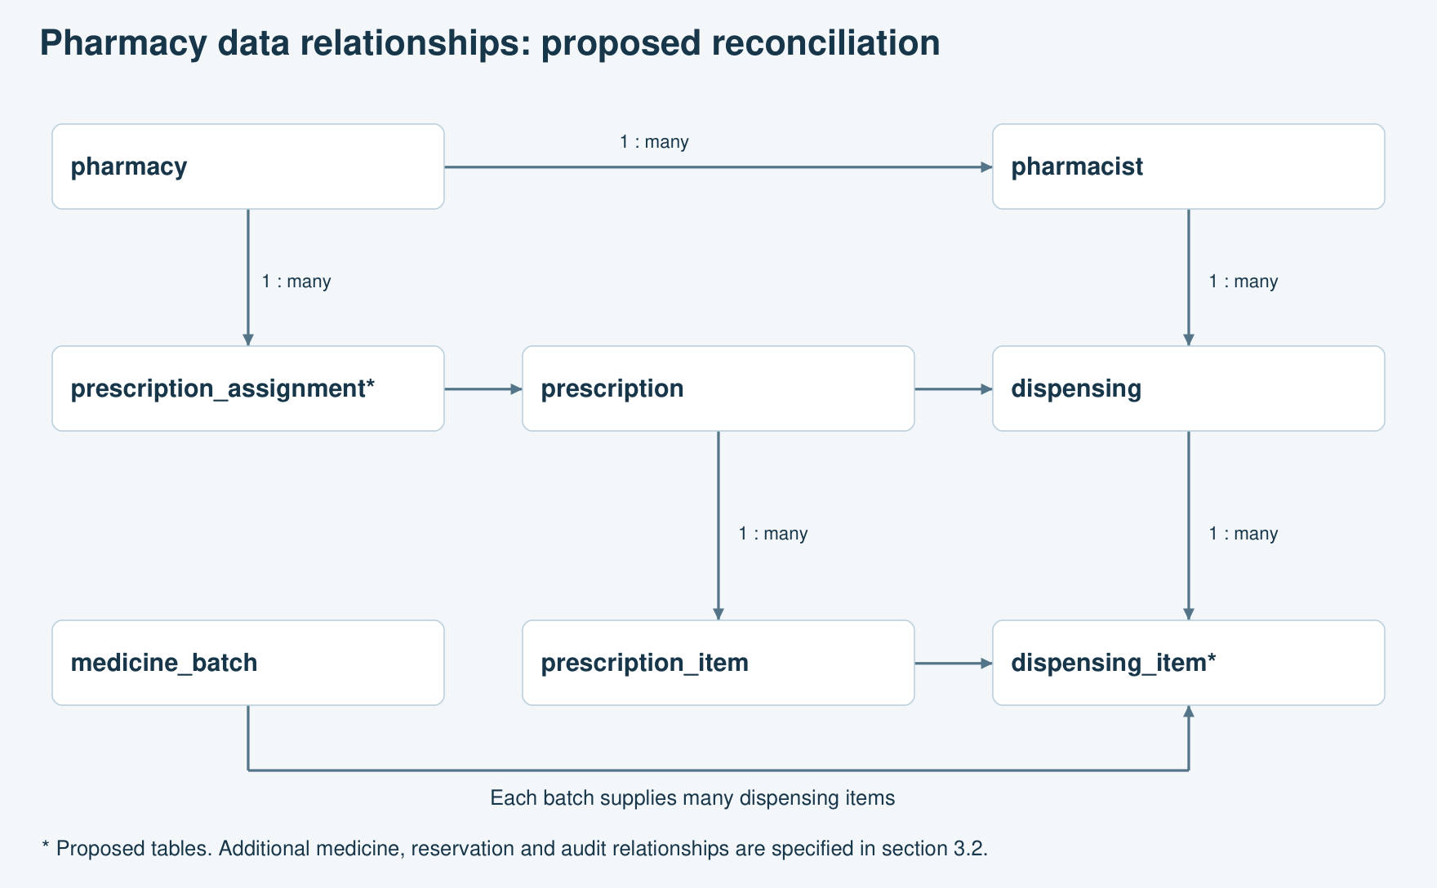
Figure 2. Focused pharmacy relationships. The relationship rules below are authoritative.

Additional relationships and ownership
Each medicine has many medicine_batch and prescription_item rows. Each pharmacy has many batches and pharmacist memberships. Each dispensing belongs to one prescription, one pharmacist and one pharmacy; each dispensing_item belongs to one dispensing, one prescription_item and one batch. The prescription item’s medicine must match the batch medicine, and the batch pharmacy must match the fulfilment pharmacy.
Each stock_reservation links a prescription item to a pharmacy batch. A reservation has a positive quantity, expiry and lifecycle status. Each inventory_transaction references the affected batch, actor and business event; collection movements also reference the dispensing item. A unique movement reference prevents a duplicate stock adjustment.
An assignment identifies the pharmacy authorised to fulfil the prescription before any dispensing exists. Only one active assignment is allowed per prescription in the proposed single-pharmacy fulfilment policy. Reassignment releases the previous pharmacy’s holds and creates a history-preserving replacement. Cross-pharmacy partial fulfilment requires a separately agreed extension.

3.2 Entity fields and integrity rules
PK means primary key; FK means foreign key; UQ means unique constraint. Existing entity fields below come from the ERD; additions are explicitly labelled. Keys may use BIGINT, timestamps use DATETIME and quantities use DECIMAL(12,3) if fractional inventory units are needed. These physical types are proposed because the ERD does not specify them.
Entity | Key fields and design rules
pharmacy / pharmacist | pharmacy_id PK; pharmacist_id PK; pharmacist.user_id FK/UQ; pharmacist.pharmacy_id FK. An active account and membership are required for pharmacy access.
medicine / medicine_batch | medicine_id PK; batch_id PK; medicine_id FK; pharmacy_id FK; batch_number; expiry_date; quantity; status. UQ(pharmacy_id, medicine_id, batch_number). Quantity is physical on-hand stock and must be non-negative.
prescription / prescription_item | prescription_id PK; patient_id FK; doctor_id FK; issue/expiry dates; status; signature evidence. Item PK, prescription_id FK, medicine_id FK, dosage/frequency/duration, quantity. Add issued_version for verification binding.
dispensing | dispensing_id PK; prescription_id FK; pharmacist_id FK; pharmacy_id FK (proposed); status; collected_at (proposed, nullable until collected); request_key UQ (proposed).
dispensing_item (proposed) | dispensing_item_id PK; dispensing_id FK; prescription_item_id FK; batch_id FK; quantity_dispensed > 0. UQ(dispensing_id, prescription_item_id, batch_id).
prescription_assignment (proposed) | assignment_id PK; prescription_id FK; pharmacy_id FK; assigned_by FK; assigned_at; ended_at. Enforce one active assignment through a transaction and an appropriate unique-key strategy.
stock_reservation (proposed) | reservation_id PK; prescription_item_id FK; batch_id FK; quantity > 0; status; expires_at; dispensing_id FK nullable; request_key UQ. Status: Active, Released, Expired or Consumed.
inventory_transaction / audit_log | Use existing ERD entities; add immutable business-event reference and dispensing_item_id where needed. Store quantity delta, actor, timestamp and reason; avoid raw clinical content in audit payloads.

Verification requires a stored result tied to prescription ID, issued version, verifier and time. A signature string without signer/key/version metadata is insufficient. Account and medicine identifiers referenced by historical clinical records must not be cascade-deleted.

3.2 Availability, normalisation and query design

Availability calculation
For an eligible batch, available quantity equals physical on-hand quantity minus the sum of unexpired Active reservations. For an expired, recalled or quarantined batch, available quantity is zero. Availability across a pharmacy is the sum of its eligible batches. Expiry must use an agreed clinic-local policy. The system must prevent reservations from exceeding usable stock under concurrent requests.
Example with synthetic stock: batch B-001 has 30 units and an active hold of 10. Available stock is 20. Collecting those 10 units changes on-hand stock to 20 and the hold to Consumed; available stock stays 20. Repeating the same collection request must leave both values unchanged.

Normalisation and history
Medicine identity is stored once in medicine, while batch number and expiry belong to medicine_batch. Prescribed instructions belong to prescription_item, and actual supply belongs to dispensing_item. Pharmacy details are stored once in pharmacy. These separations reduce duplicated values and update anomalies. Issued clinical content must be versioned or preserved so later catalogue edits cannot silently change the meaning of a signed prescription.
Low-stock thresholds need one agreed level of ownership. The ERD puts reorder_level on medicine; the dictionary places minimum_stock_level on a batch. For multiple pharmacies, propose a pharmacy_medicine policy with UQ(pharmacy_id, medicine_id), inventory unit and reorder level. This avoids different batch thresholds producing conflicting alerts for the same medicine.

Indexes and constraints
Access pattern | Proposed index / control
Pharmacy queue | prescription_assignment(pharmacy_id, ended_at, prescription_id)
Eligible batches | medicine_batch(pharmacy_id, medicine_id, status, expiry_date)
Reservation calculation | stock_reservation(batch_id, status, expires_at)
Dispensing report | dispensing(pharmacy_id, status, collected_at)
Fulfilment totals | dispensing_item(prescription_item_id); join only committed Collected fulfilments
Duplicate requests | Unique request_key and unique inventory business-event reference

Cross-table rules such as matching medicine and pharmacy, valid prescription state, and total supplied quantity require service-level validation within the same transaction, supported by database constraints where possible. Index benefits must be measured with representative data rather than claimed from the design alone.

