4. Pharmacist Portal

4.1 Pharmacist Dashboard

[Code]
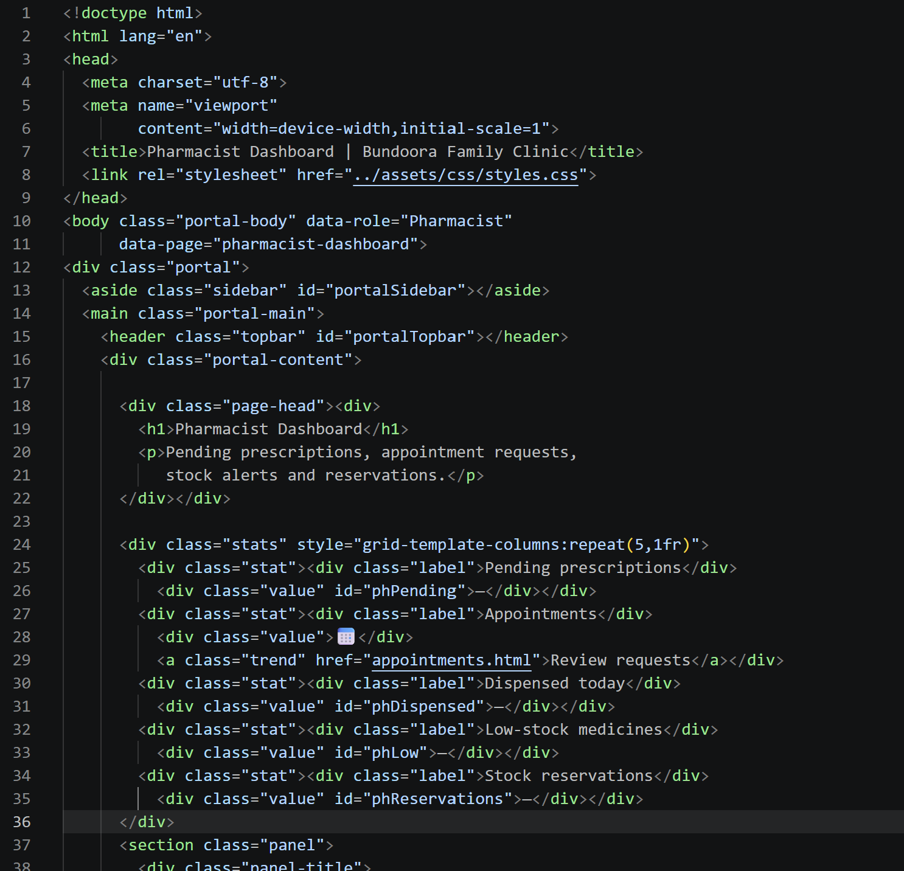
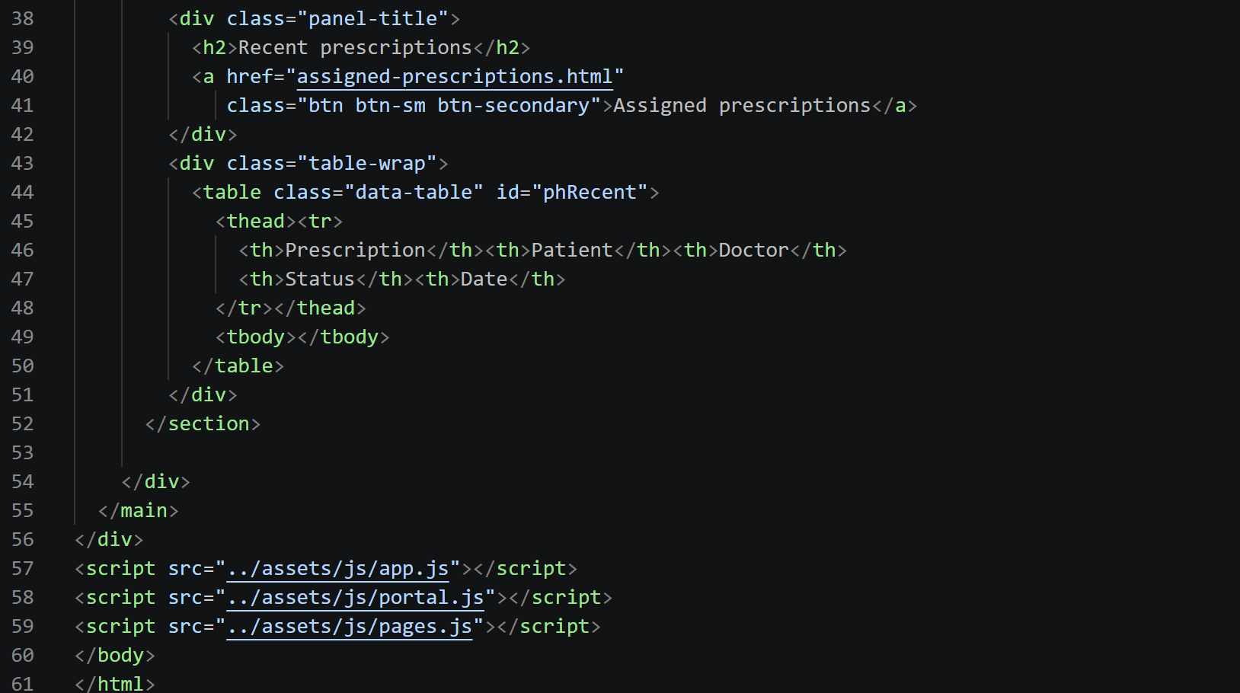

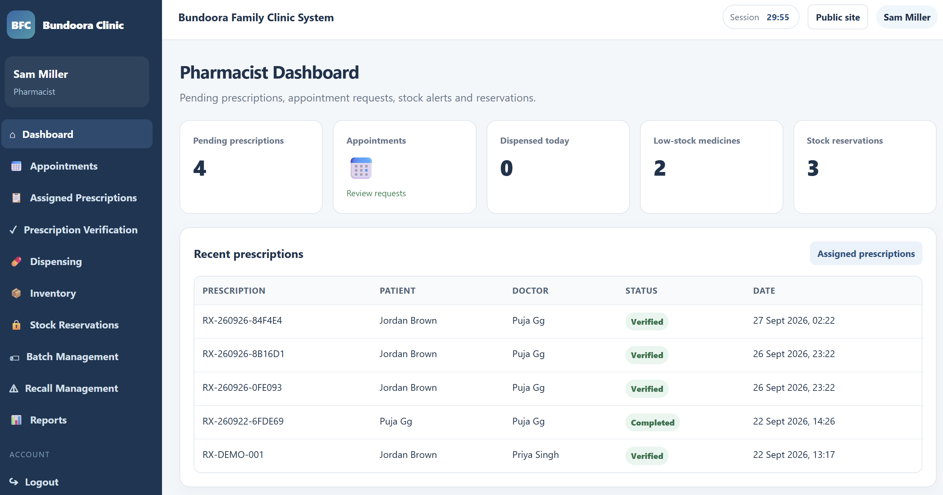Fig: Pharmacist dashboard

4.2 Verifying a Prescription

[Code]
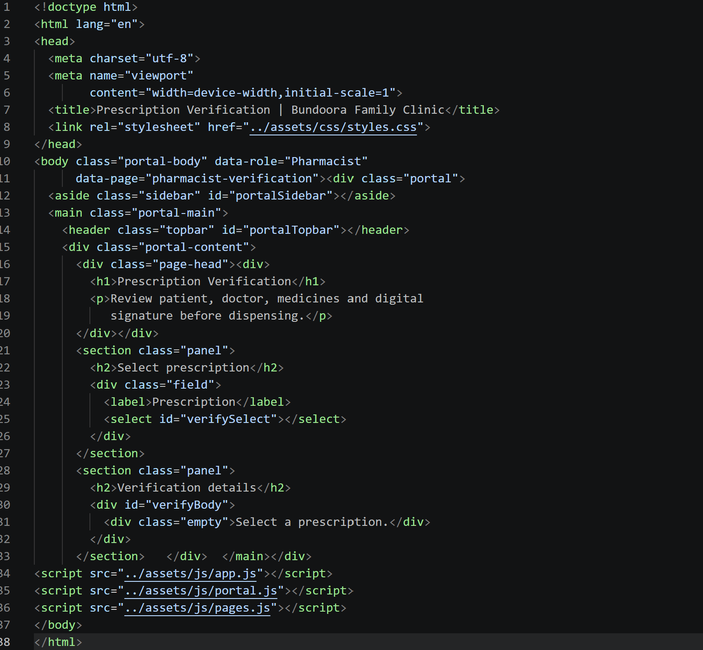

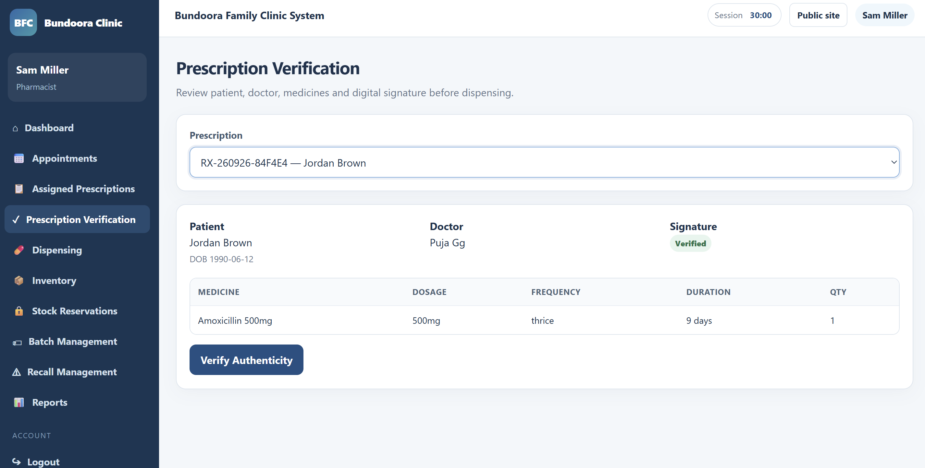

4.3 Dispensing Medication

[Code]
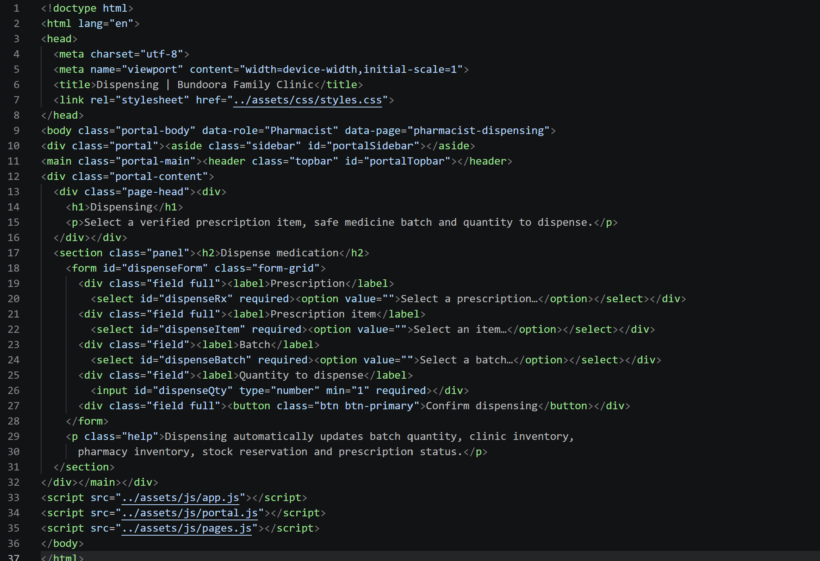

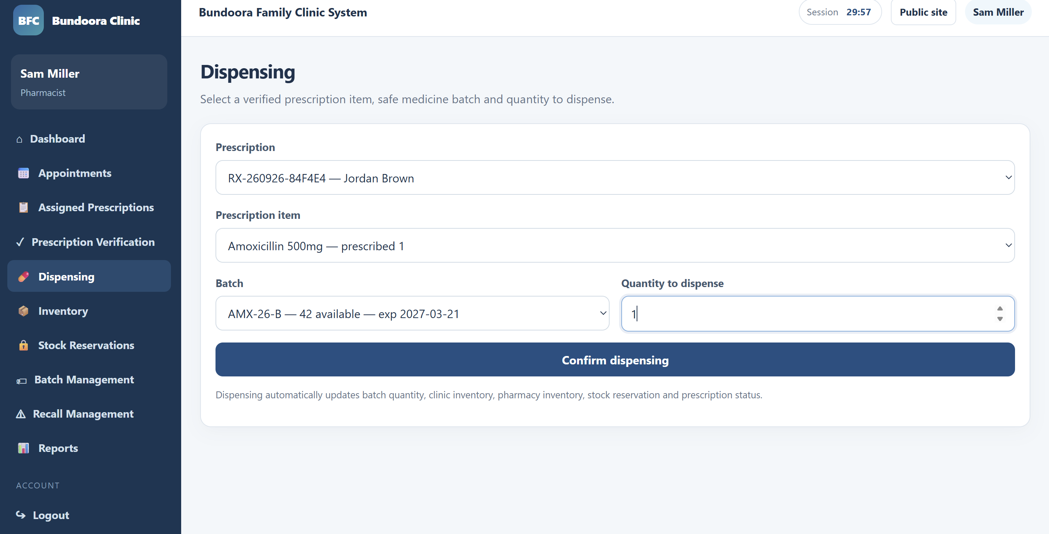Fig: Dispensing form with batch selection

4.4 Appointments

[Code]
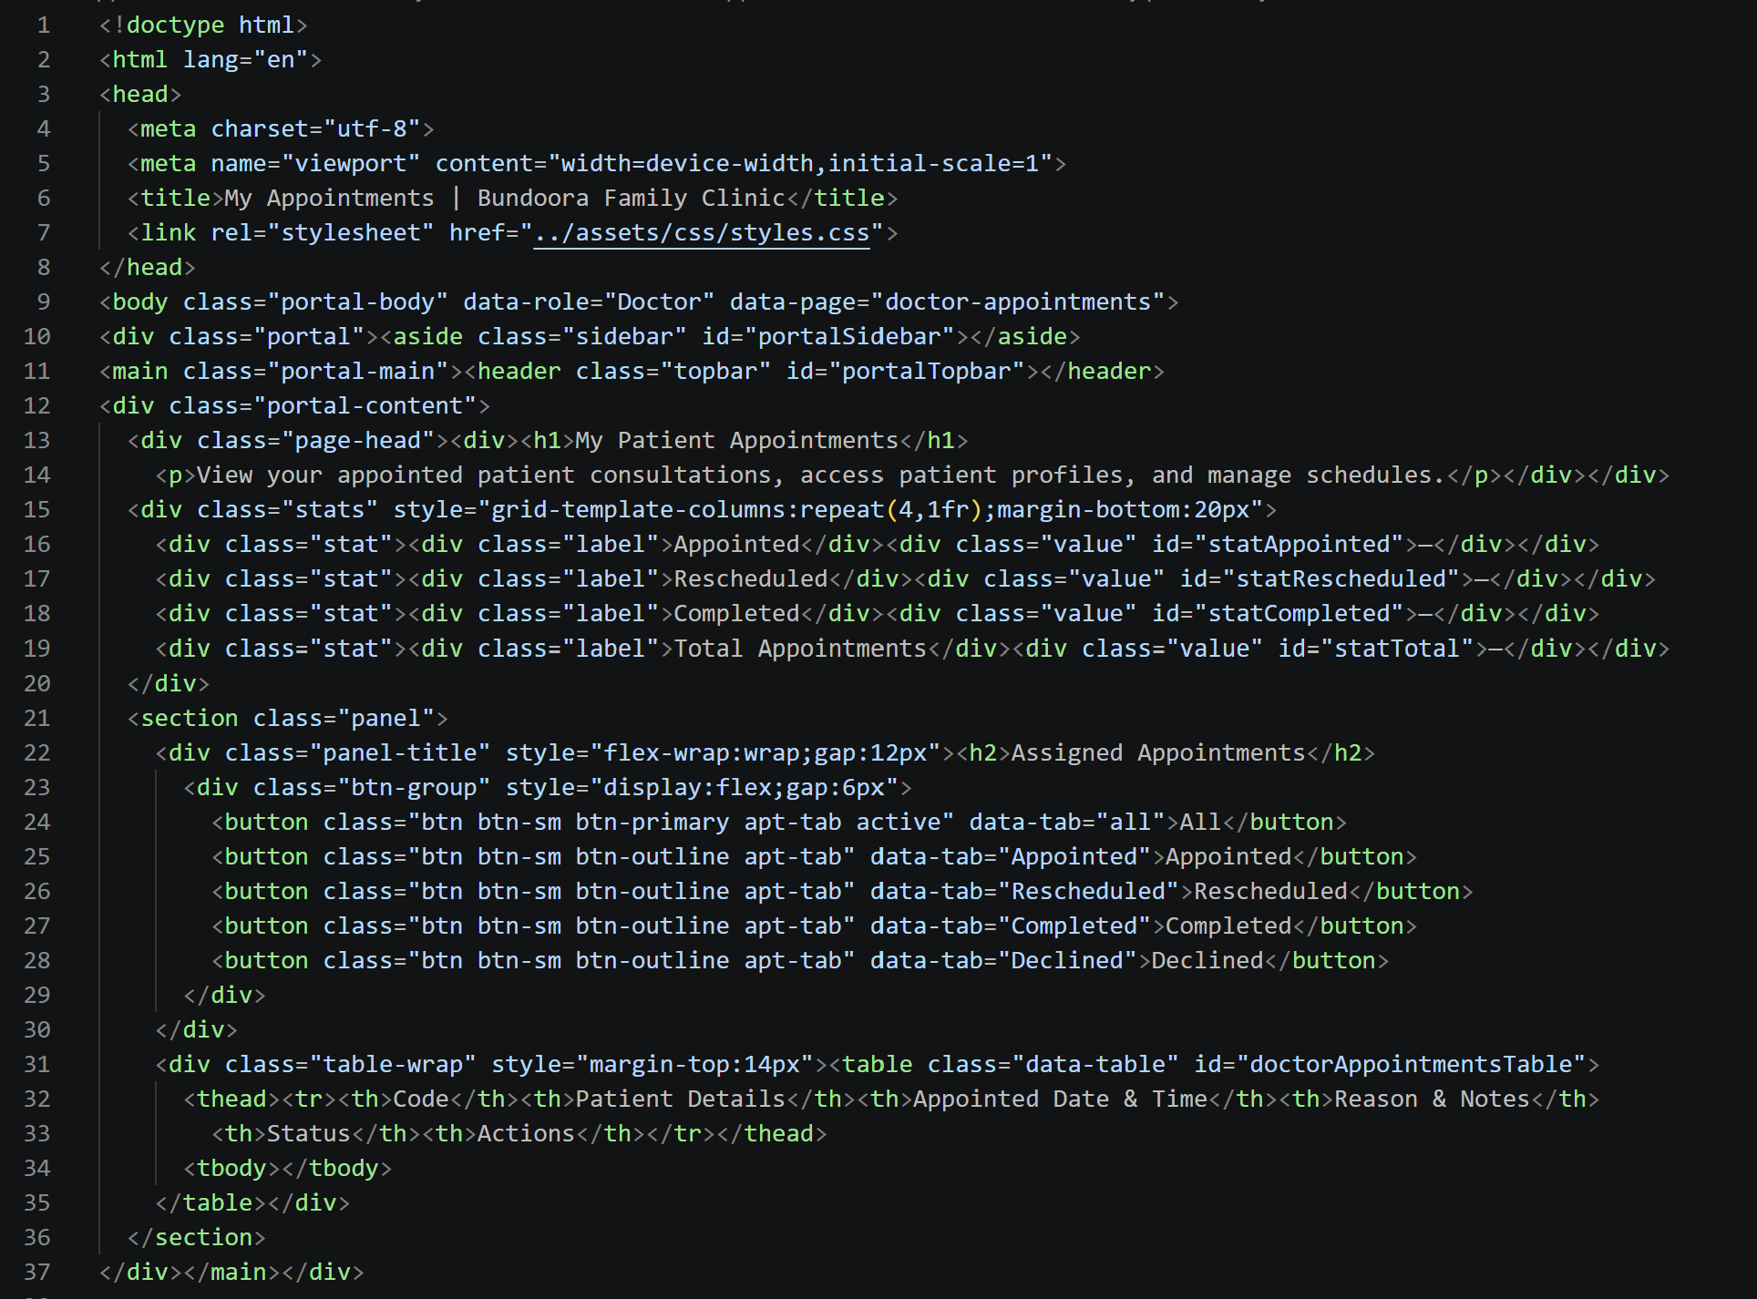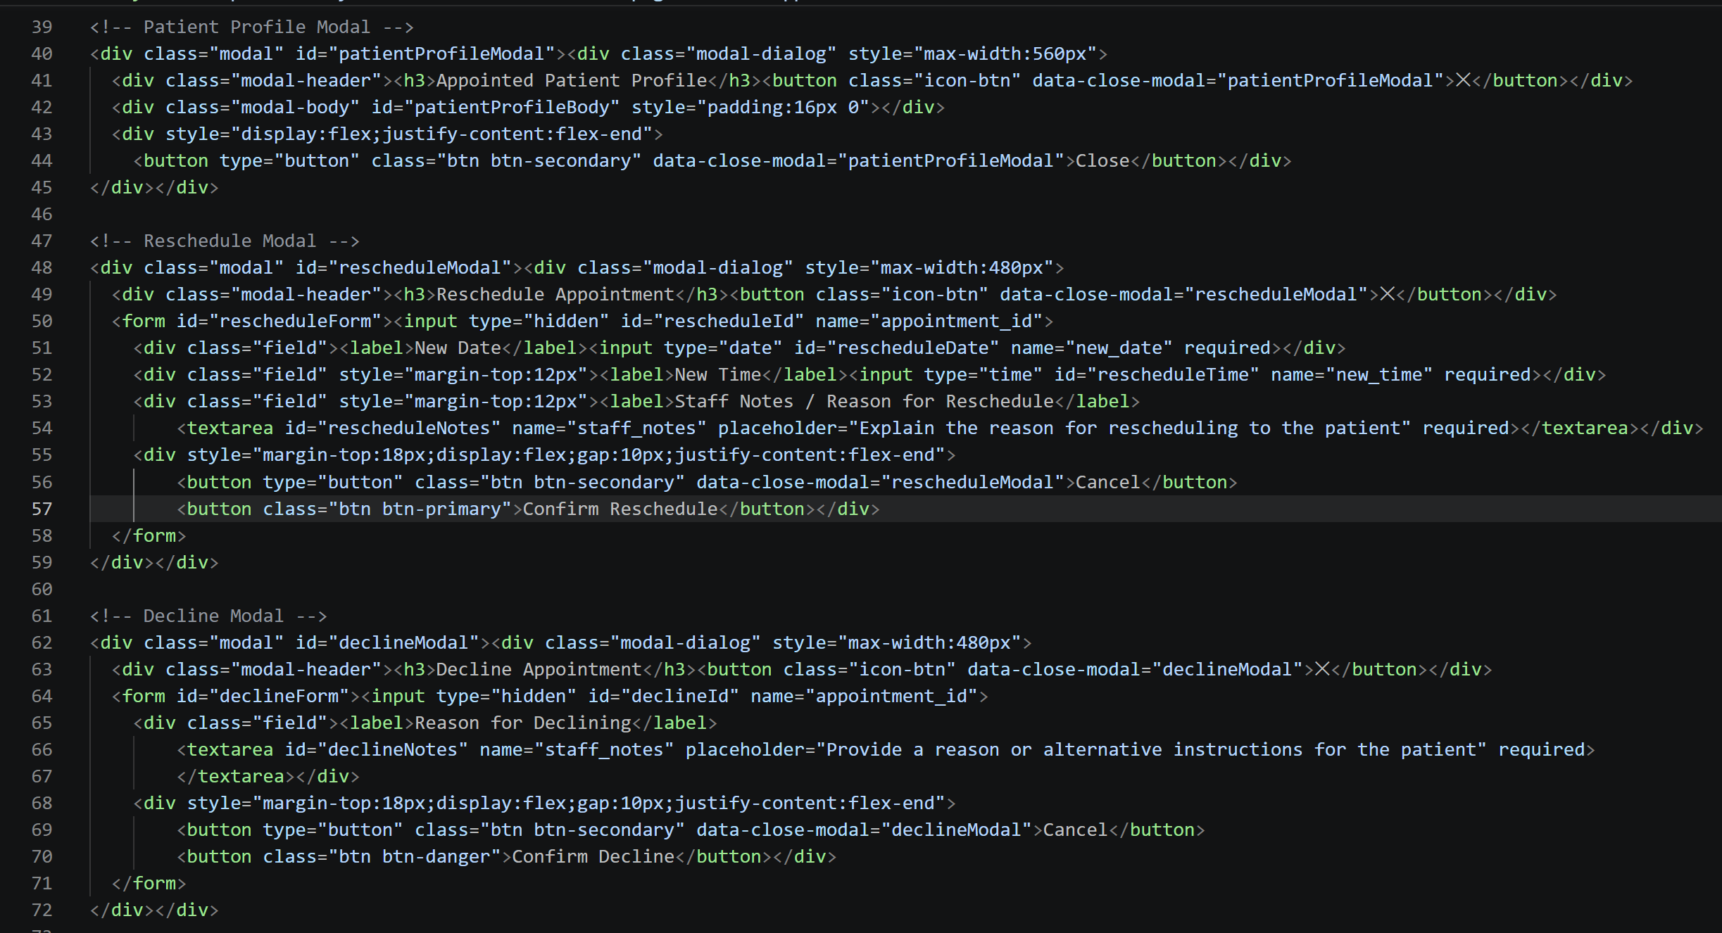

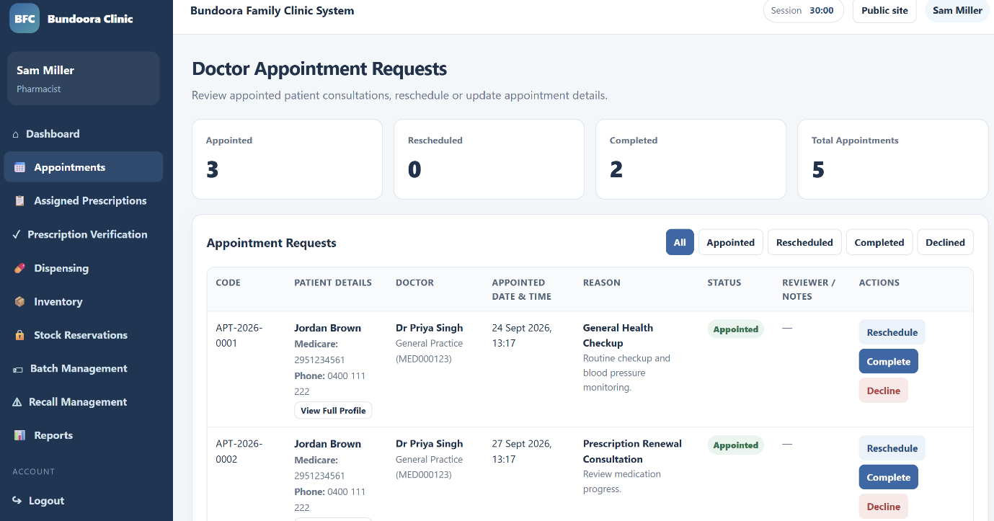

4.5 Assigned Prescriptions

[Code]
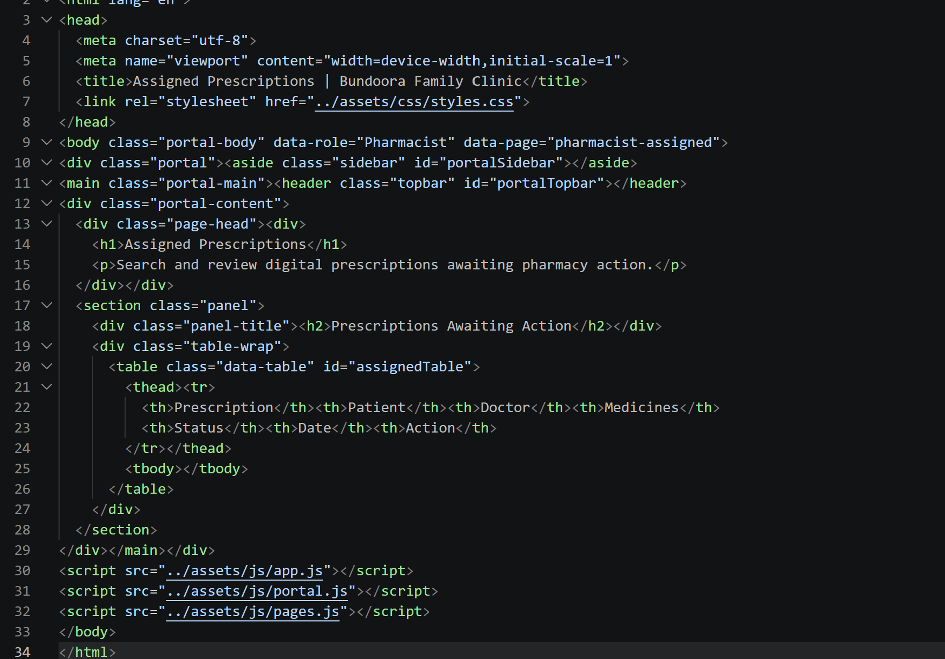

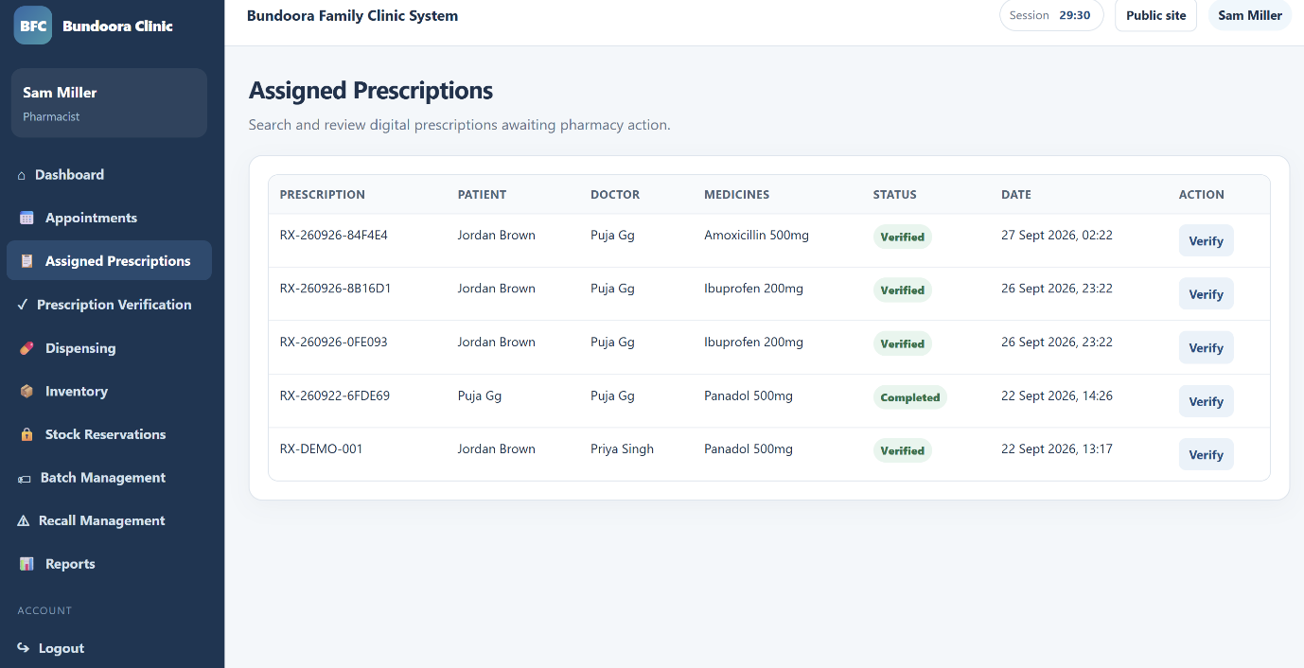
Fig: Assigning prescription

4.6 Inventory

[Code]
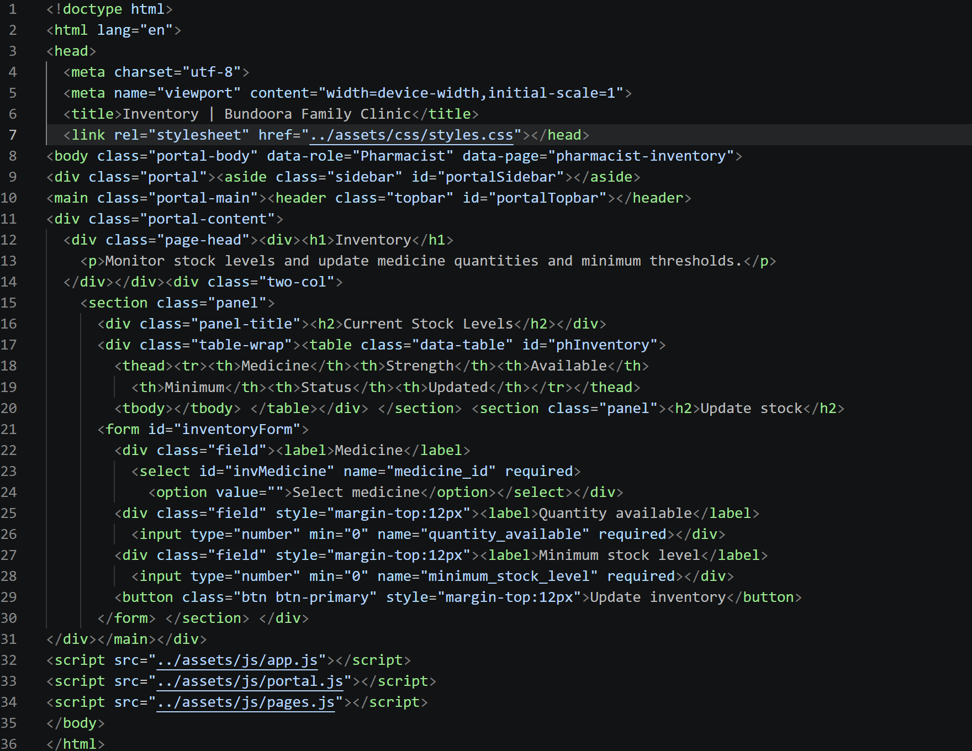

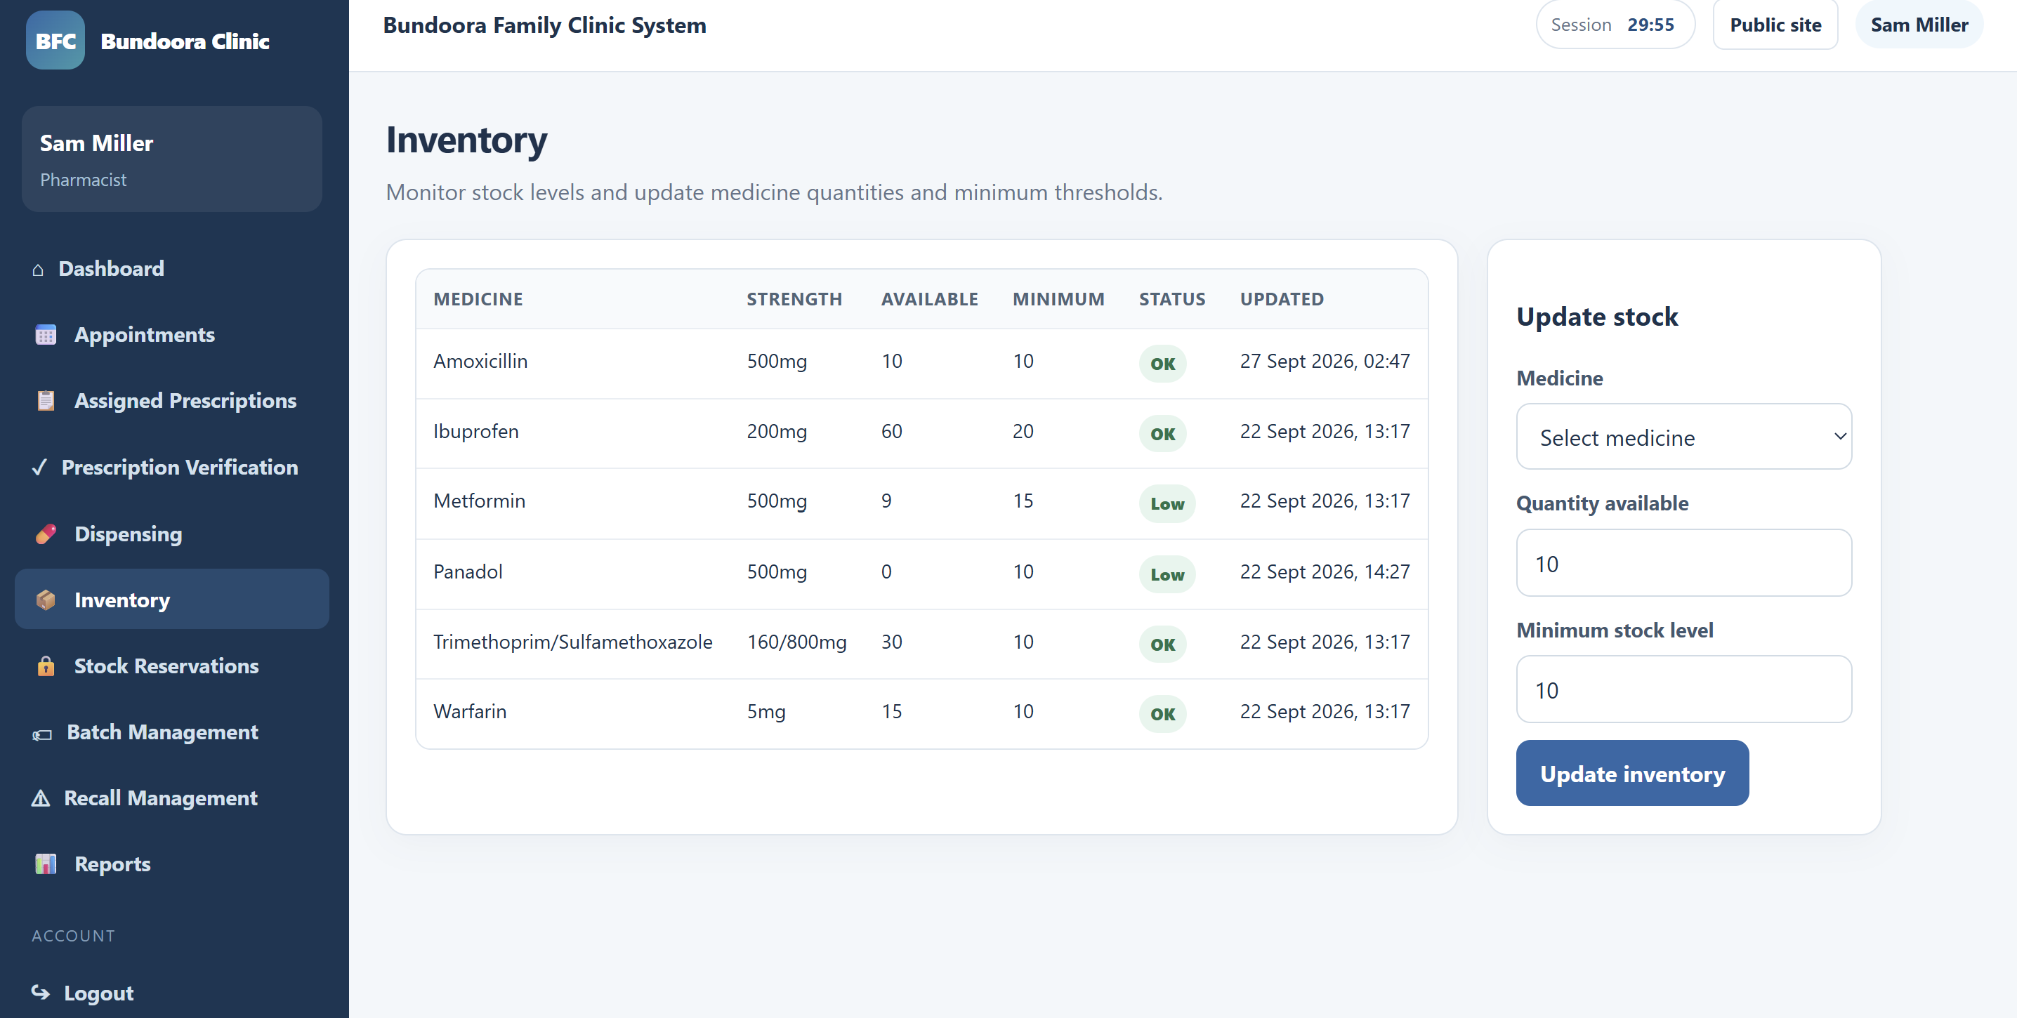
Fig: Inventory tracking

4.7 Stock Reservations

[Code]
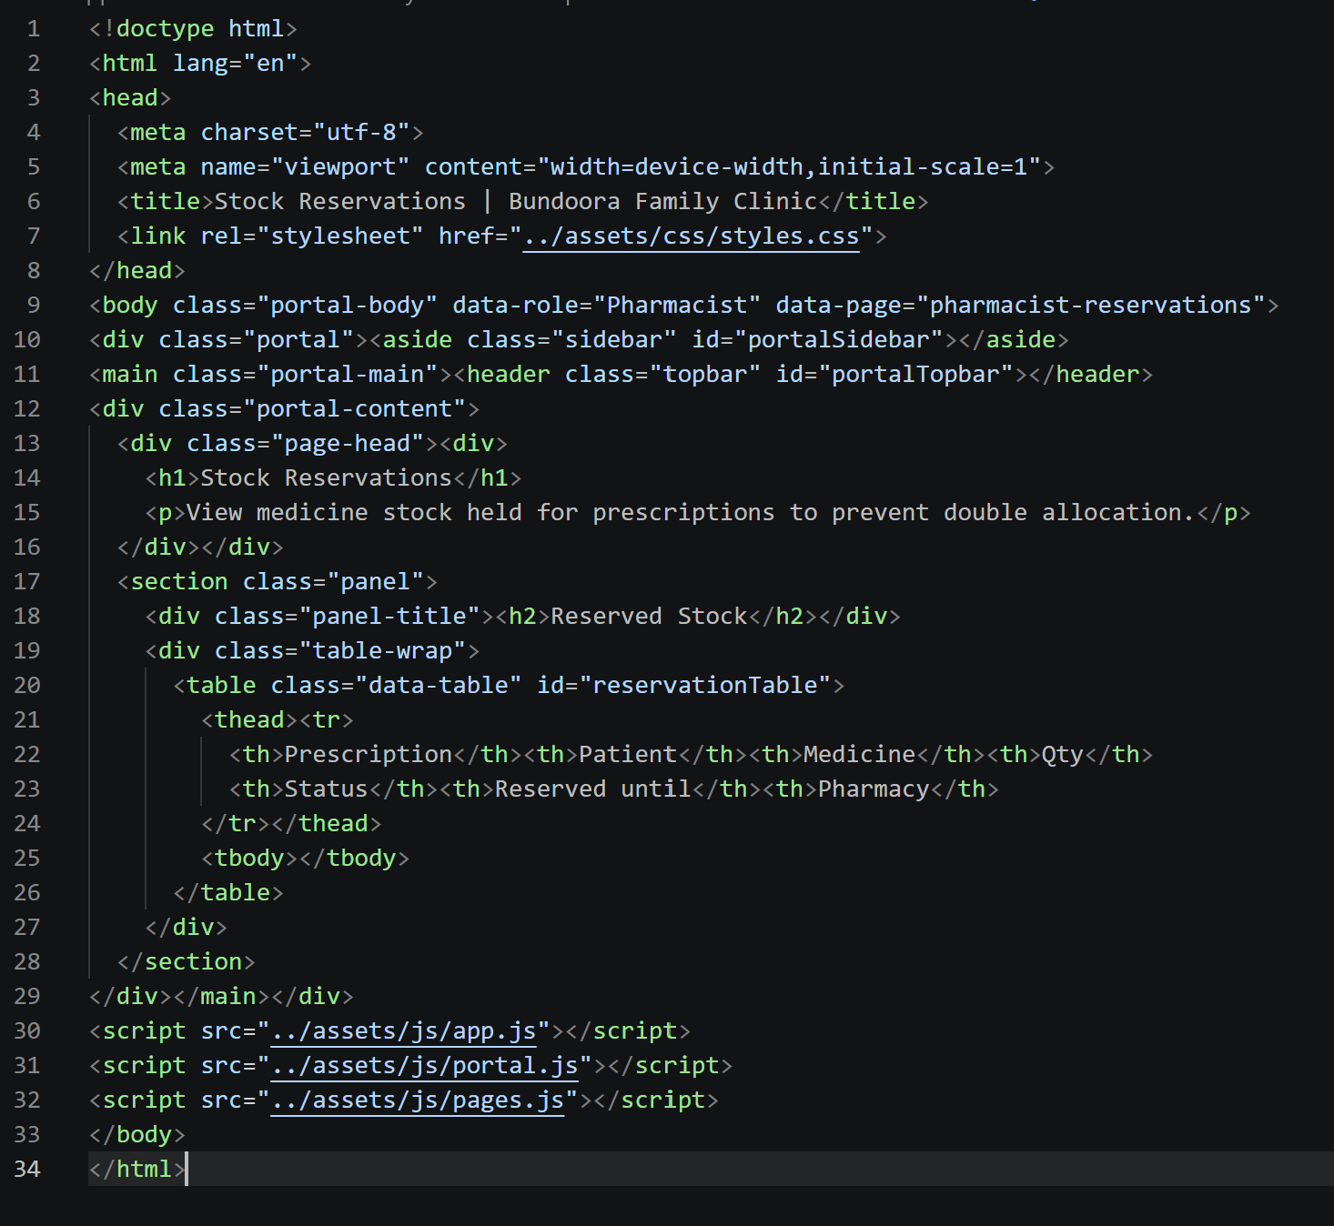

The Stock Reservations page, accessed from the sidebar, displays medicine stock held for prescriptions to prevent double allocation. For each reservation, the table shows the prescription code, patient, medicine, quantity, status, the date the reservation is held until, and the pharmacy.

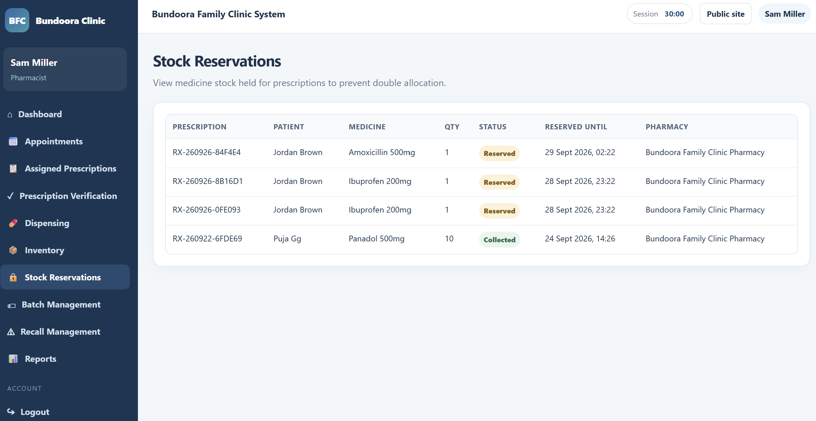
Fig: stock reservation

4.8 Batch Management

[Code]
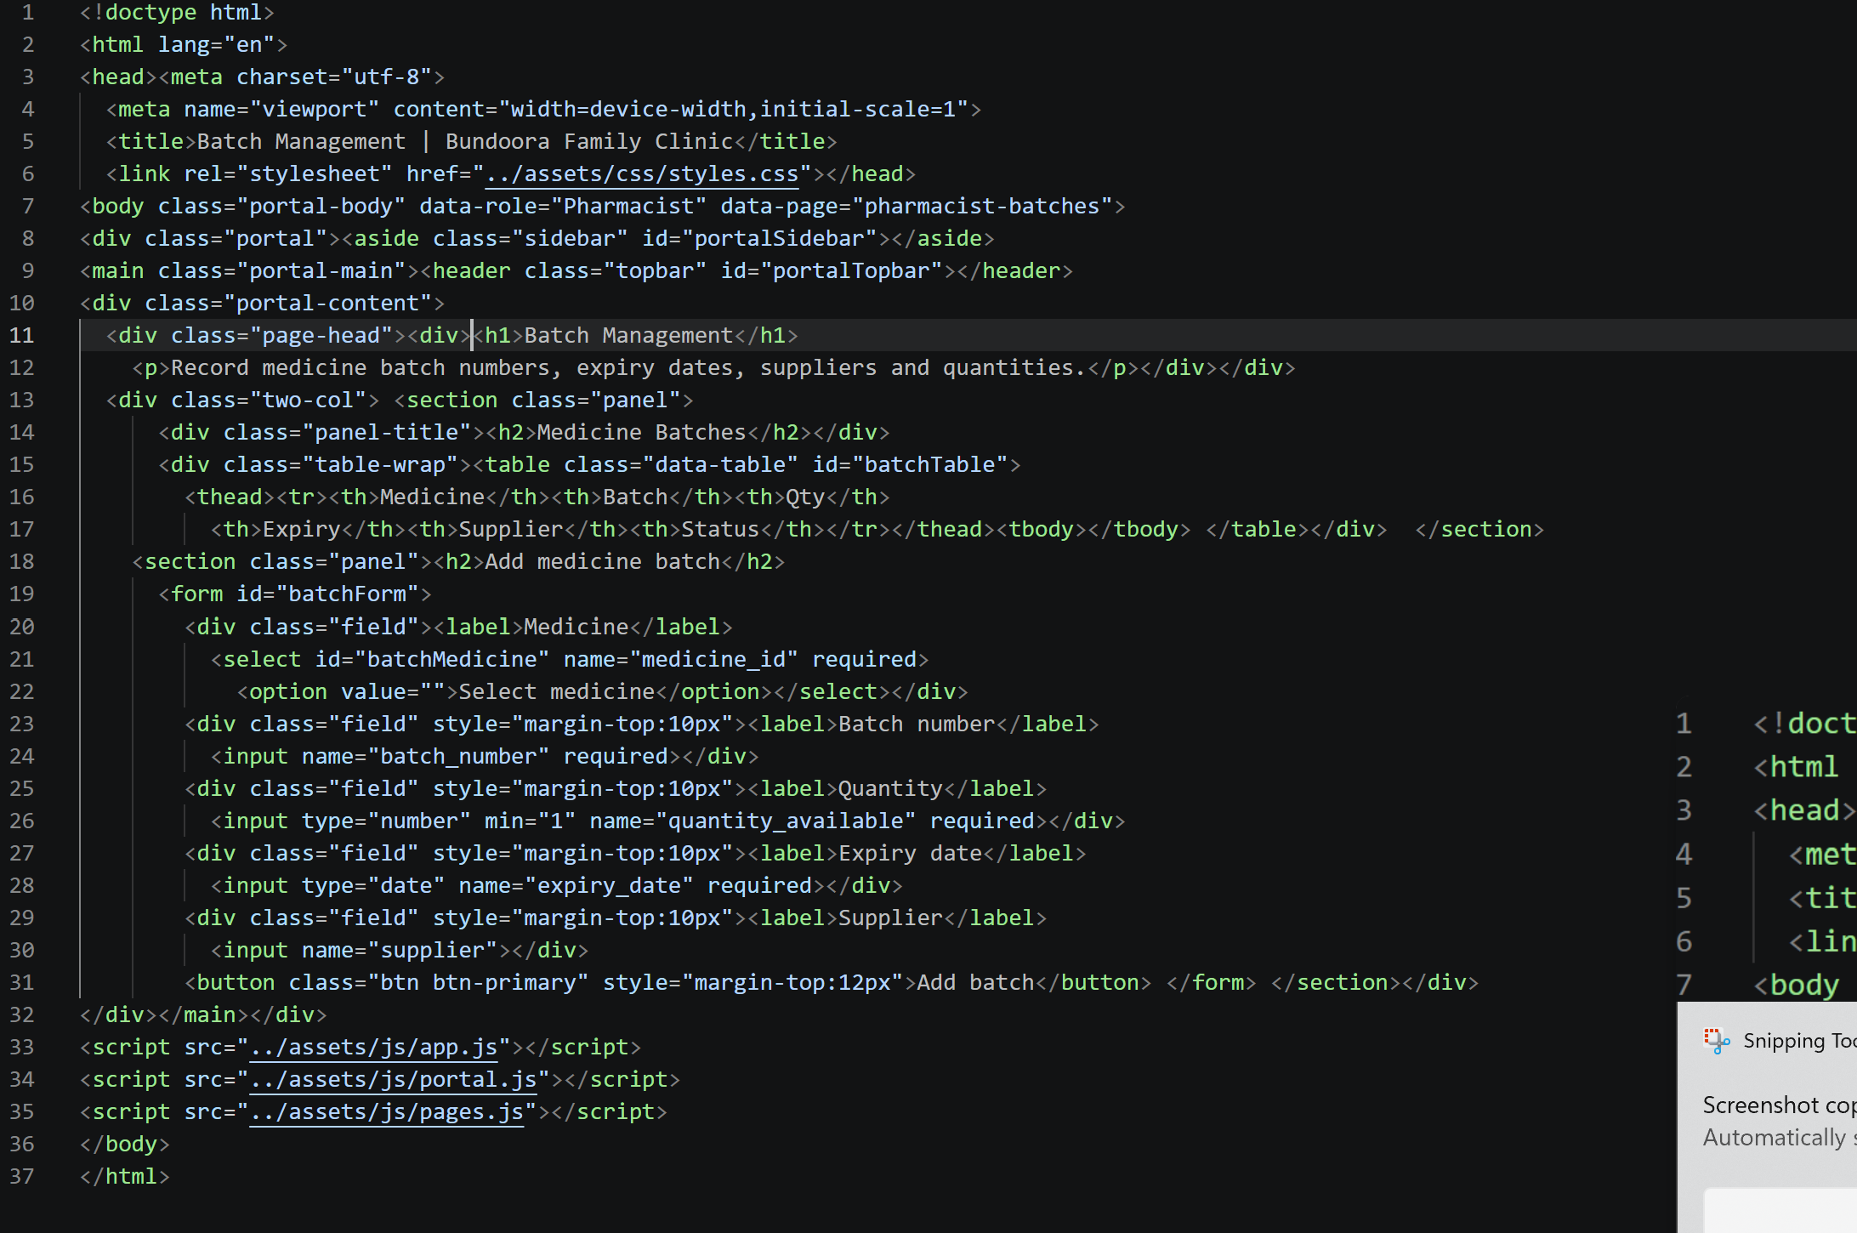

The Batch Management page records each medicine batch's number, quantity, expiry date, supplier and status. To add a delivery, complete the Add medicine batch form and select Add batch. New batches are marked Available, and recalled batches cannot be dispensed.

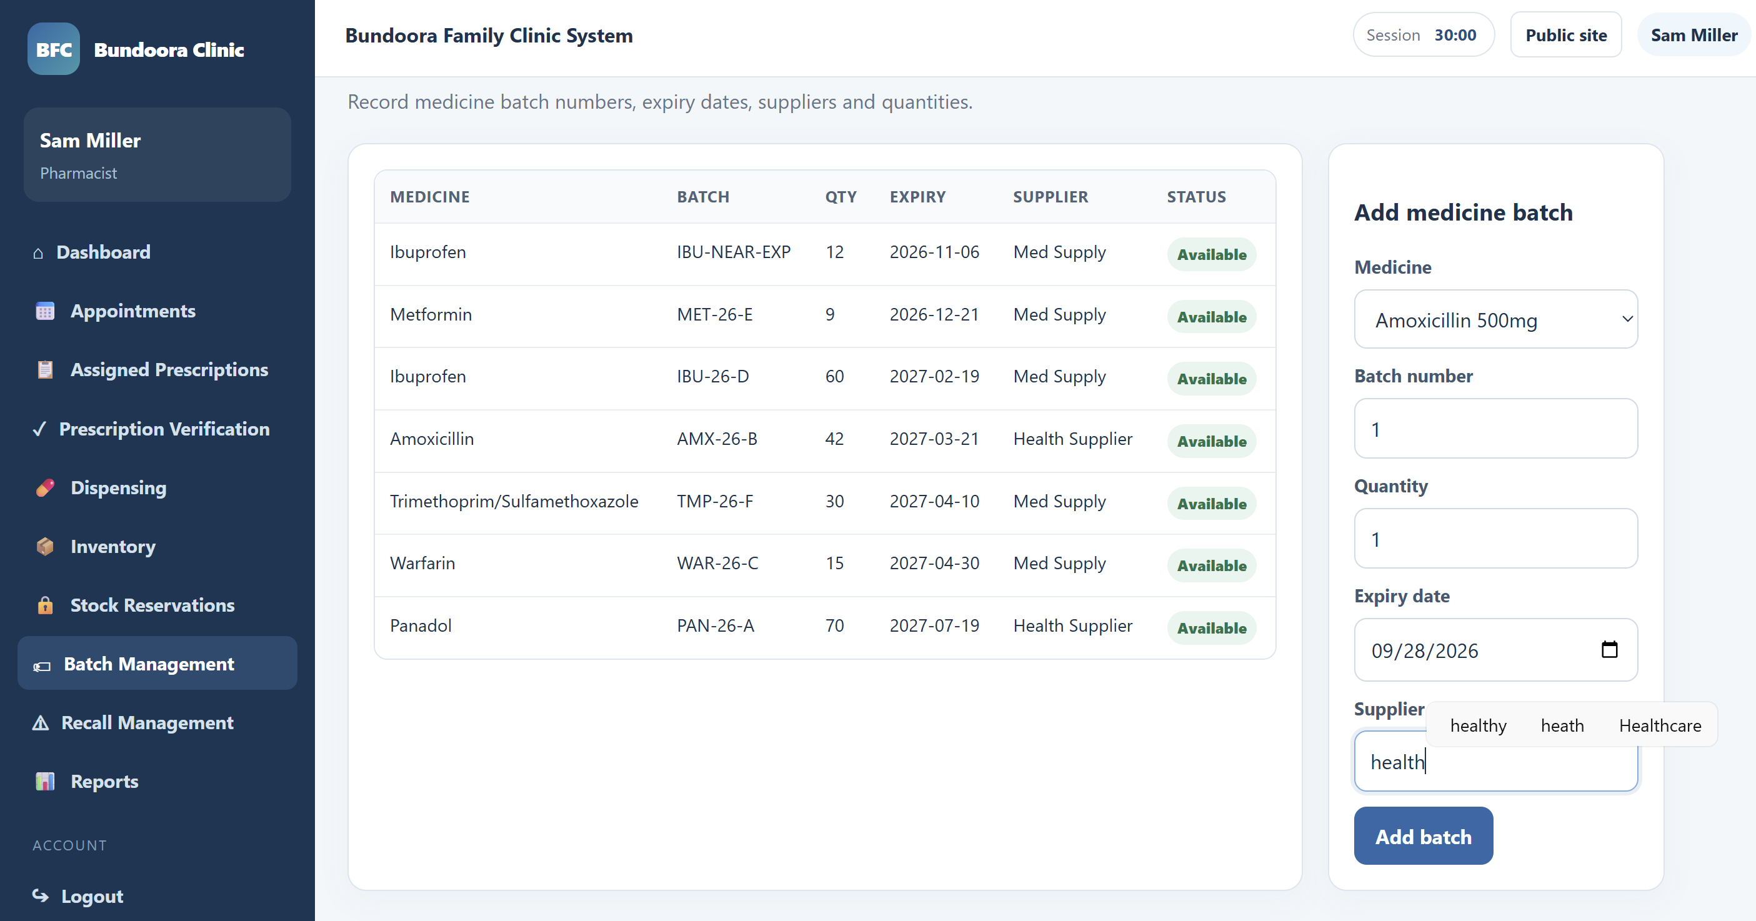
Fig: Medicine batch records

4.9 Recall Management

[Code]
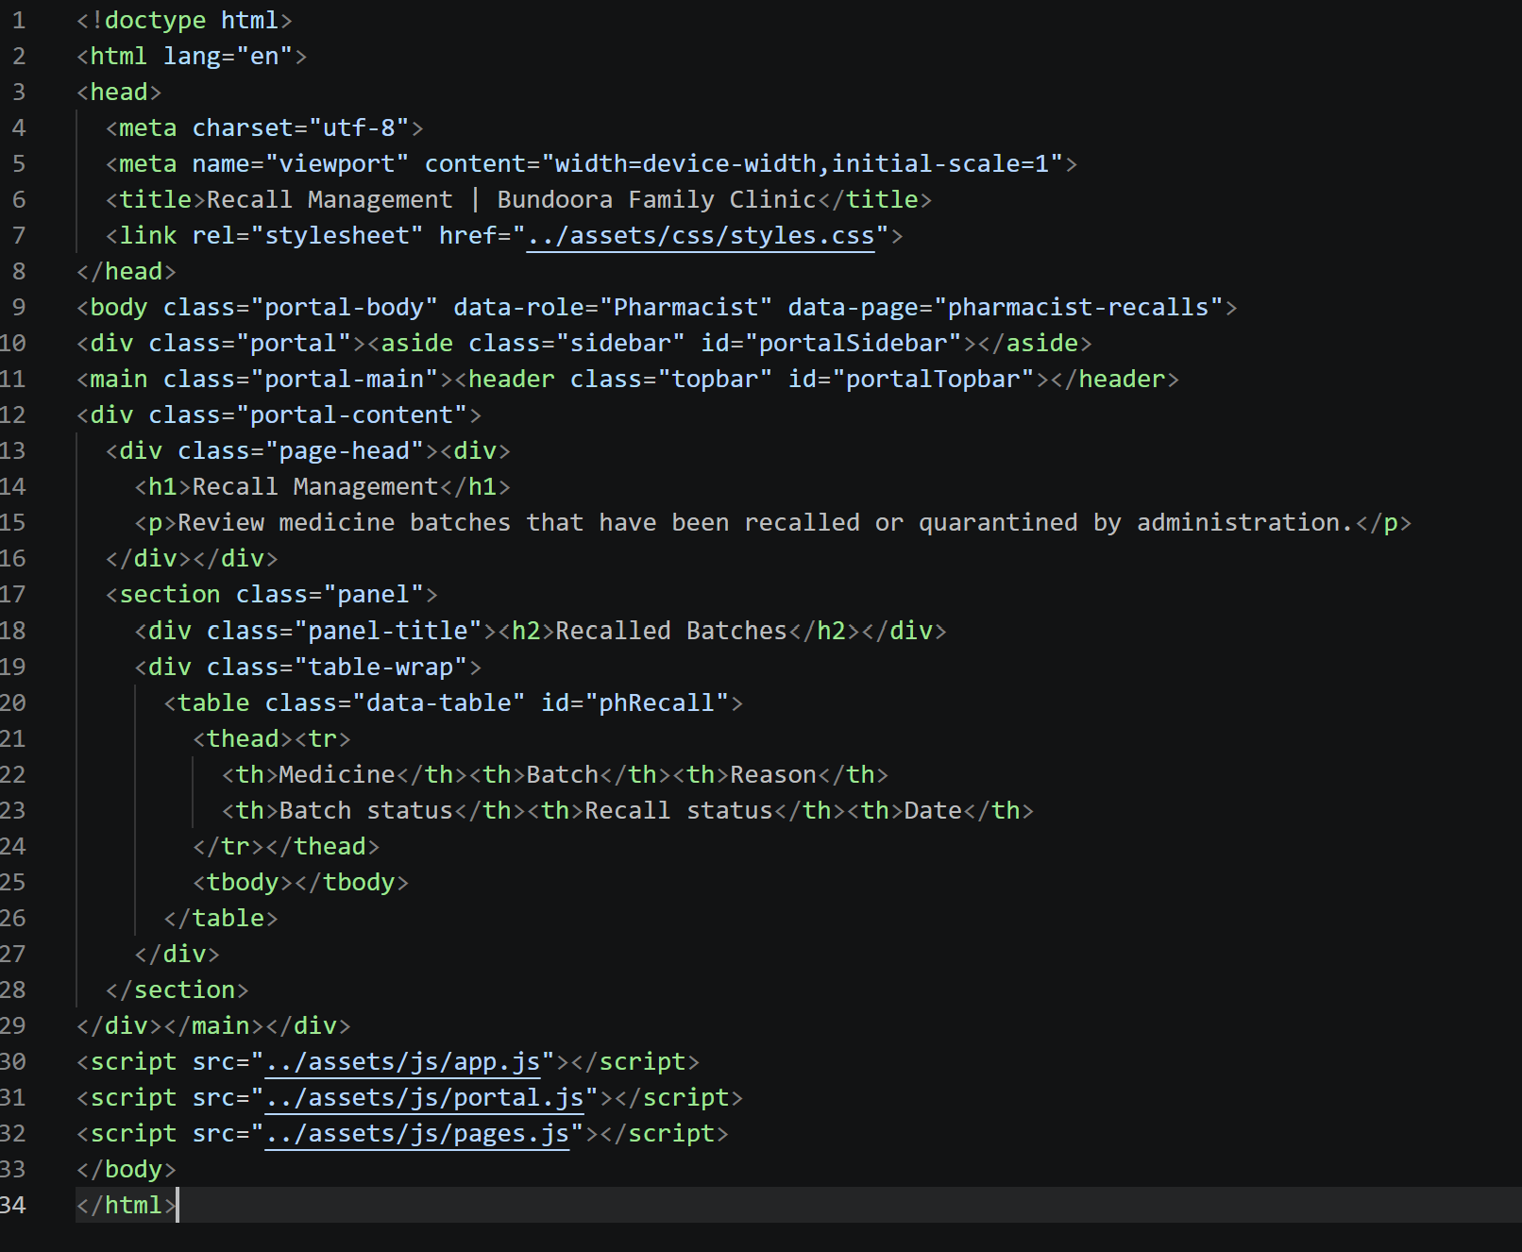

The Recall Management page lists medicine batches recalled or quarantined by the Administrator, showing the medicine, batch, reason, batch status, recall status and date.
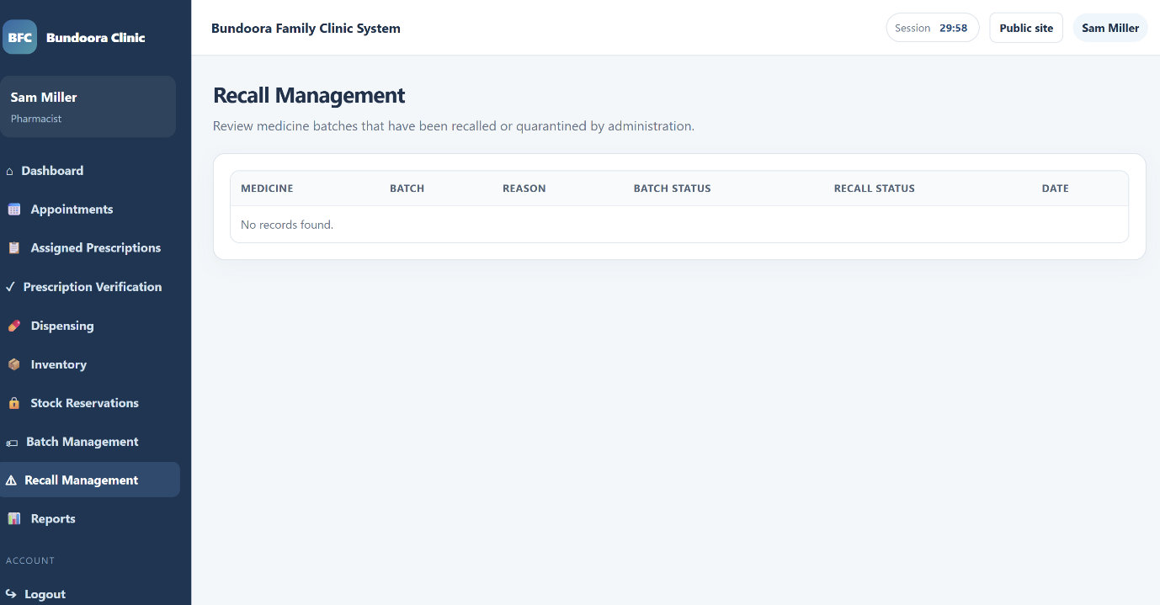

4.10 Reports

[Code]

The Reports page shows the pharmacist's daily dispensing activity, with the number of dispensing transactions and units dispensed each day. Select Export inventory CSV to download the current inventory as a spreadsheet file.
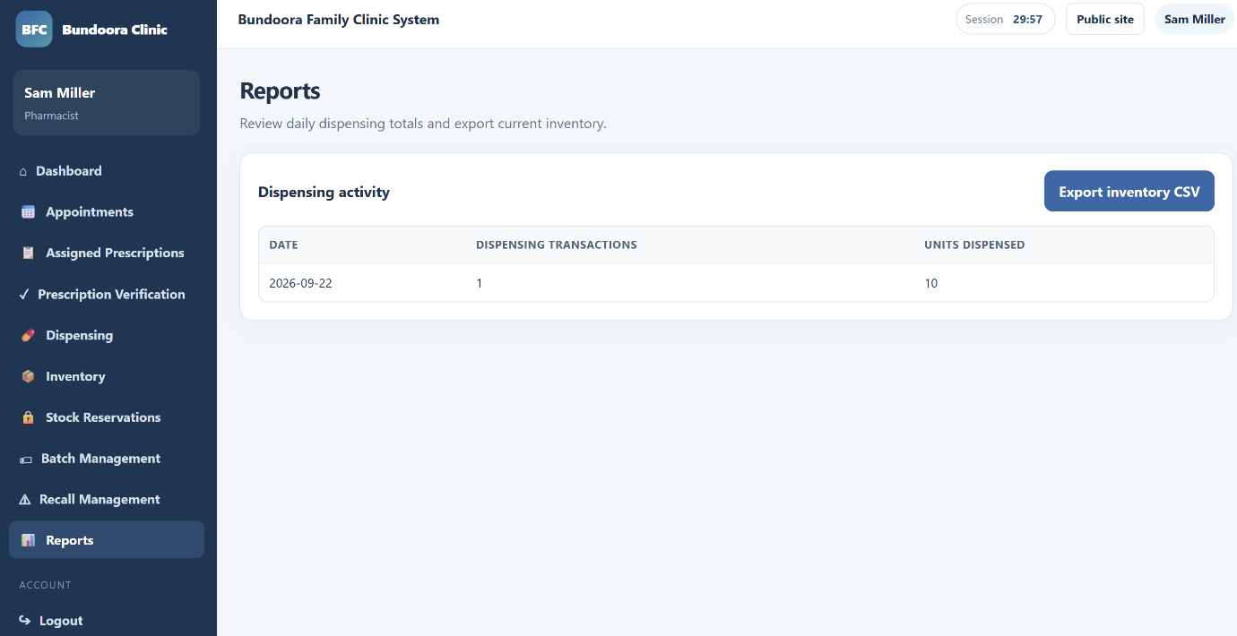
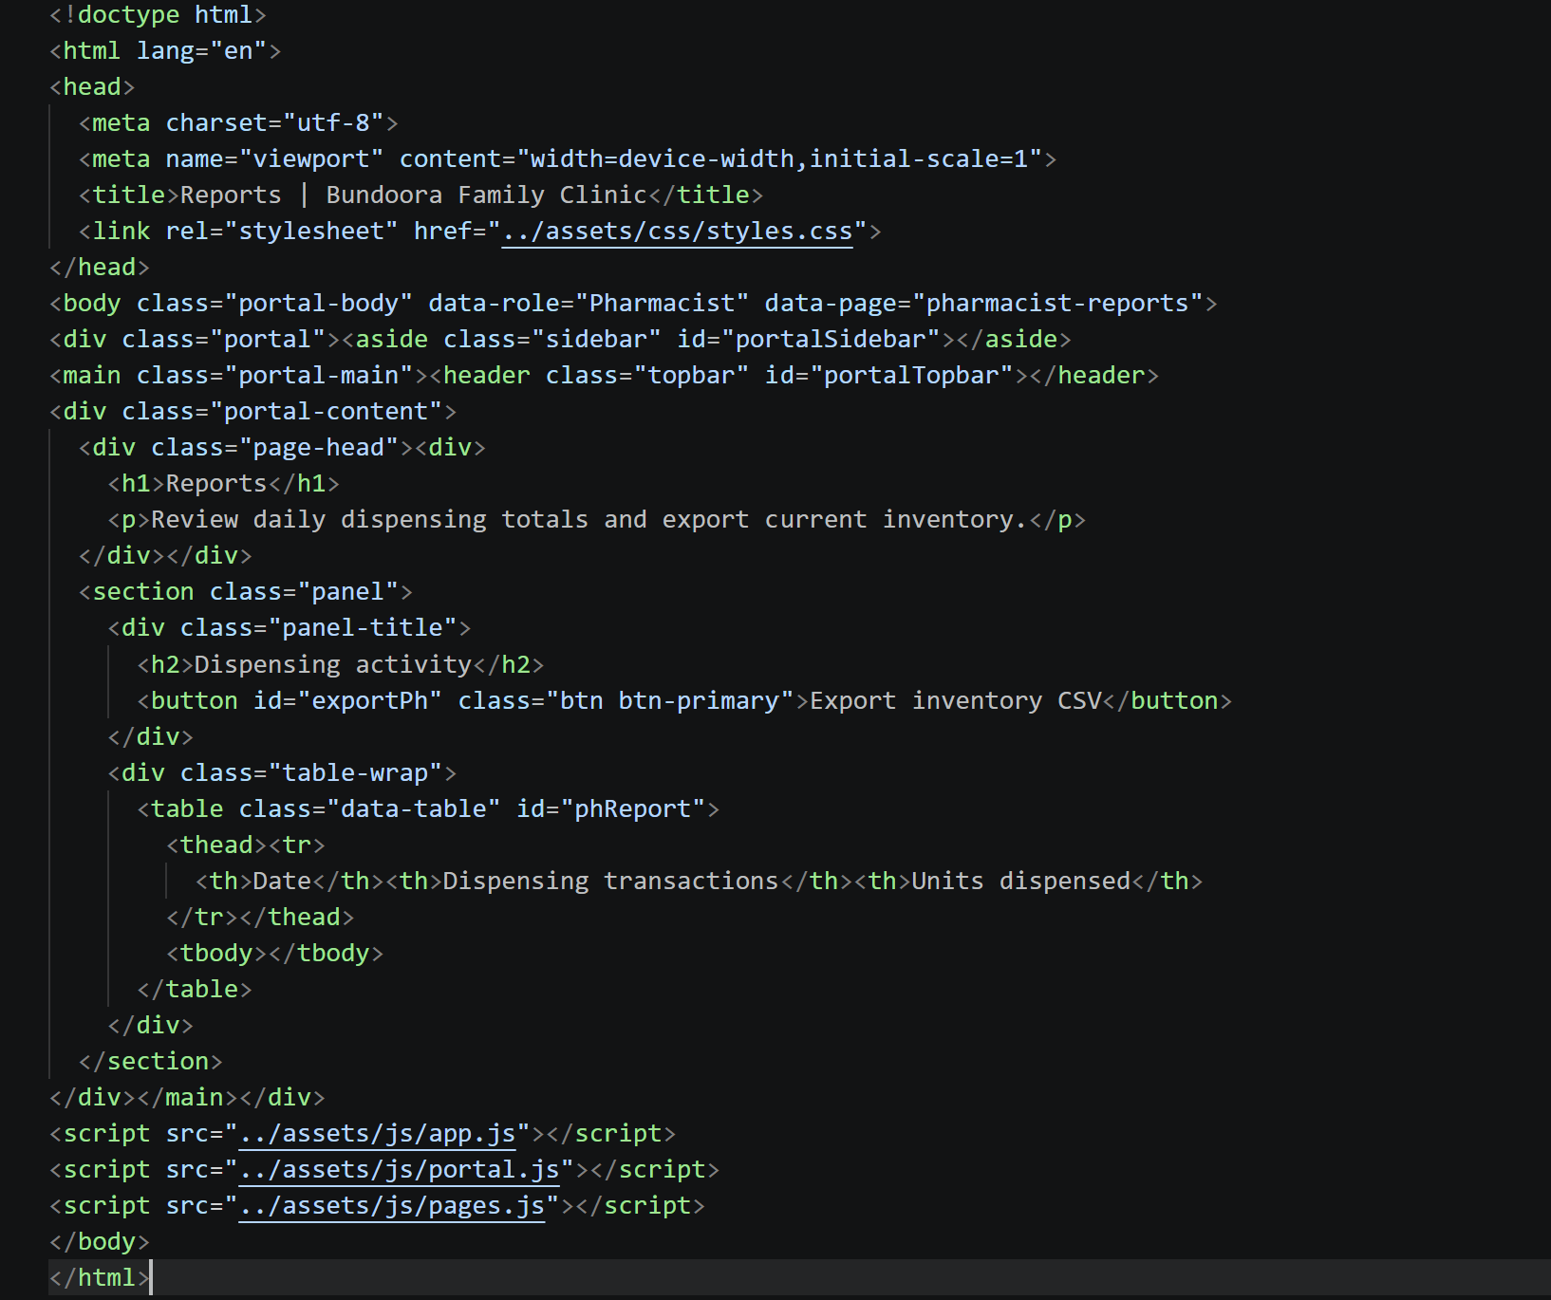
5. Administrator Portal
5.1 Administrator Dashboard
[Code]
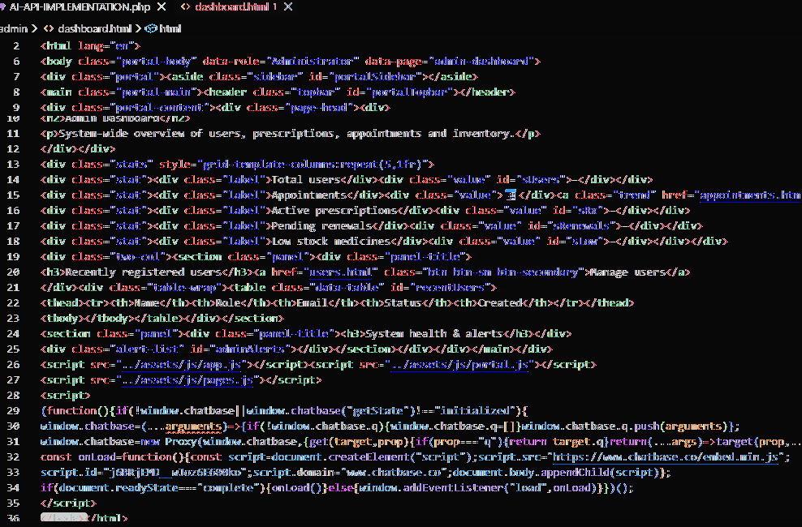
The Administrator Dashboard provides a system-wide overview of users, prescriptions, appointments, renewals, low-stock medicines, recently registered users and system health alerts.
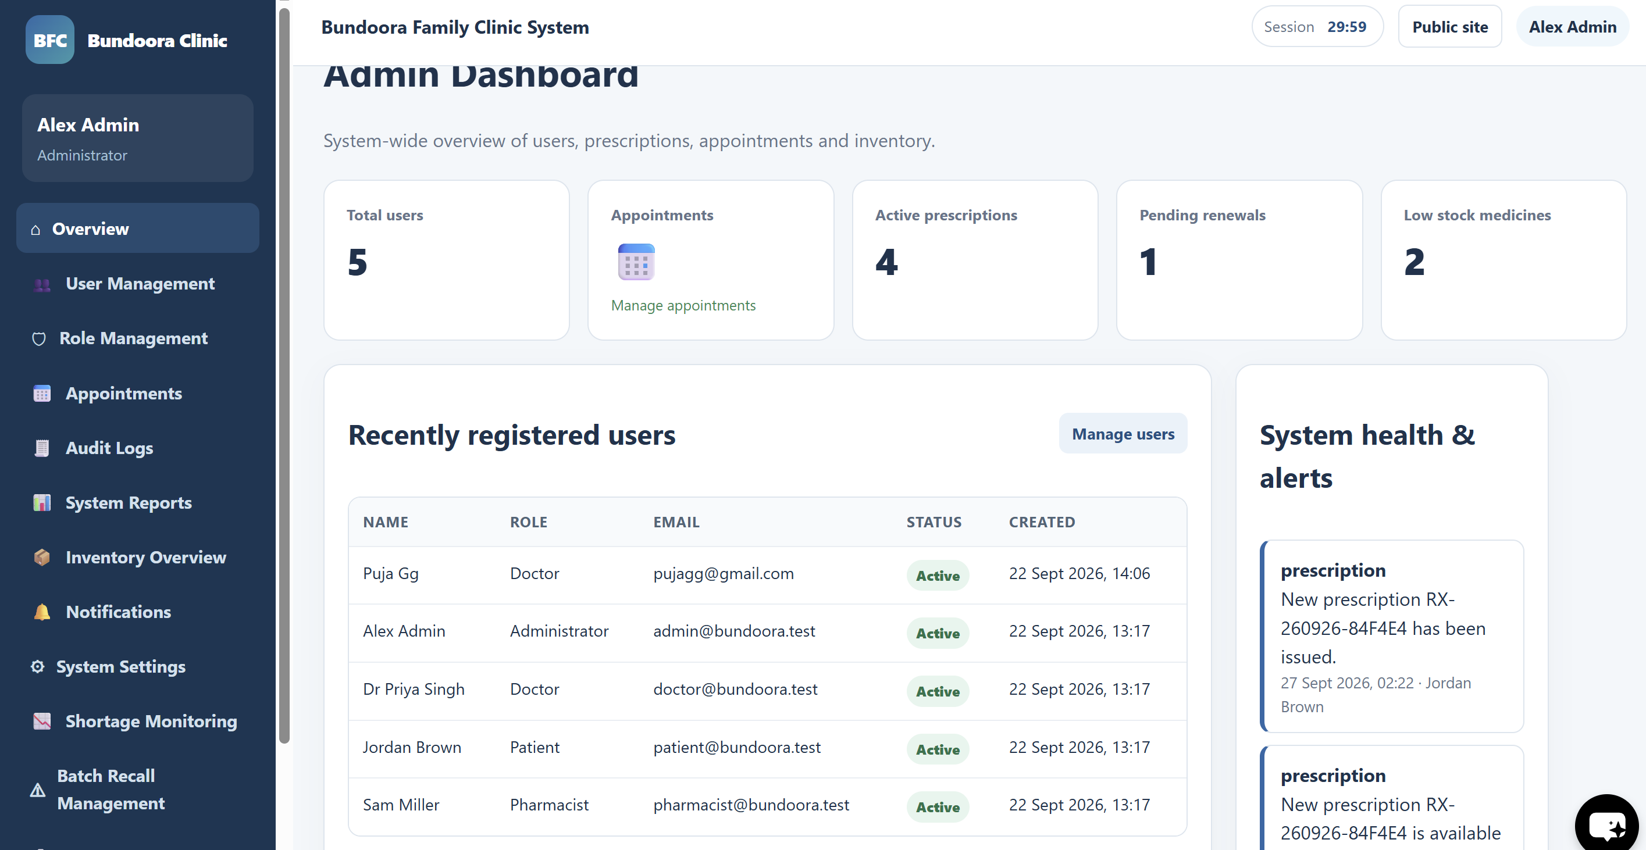Fig: Administrator dashboard
Fig: Administrator dashboard
5.2 Creating and Managing User Accounts
[Code]
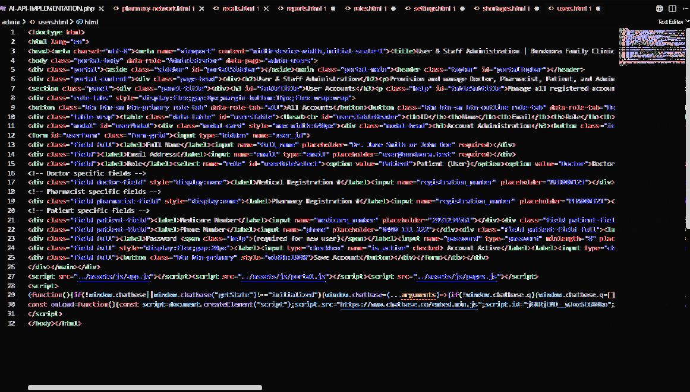
User & Staff Administration allows the administrator to create and manage Doctor, Pharmacist, Patient and Administrator accounts, including role-specific details, status and verification.
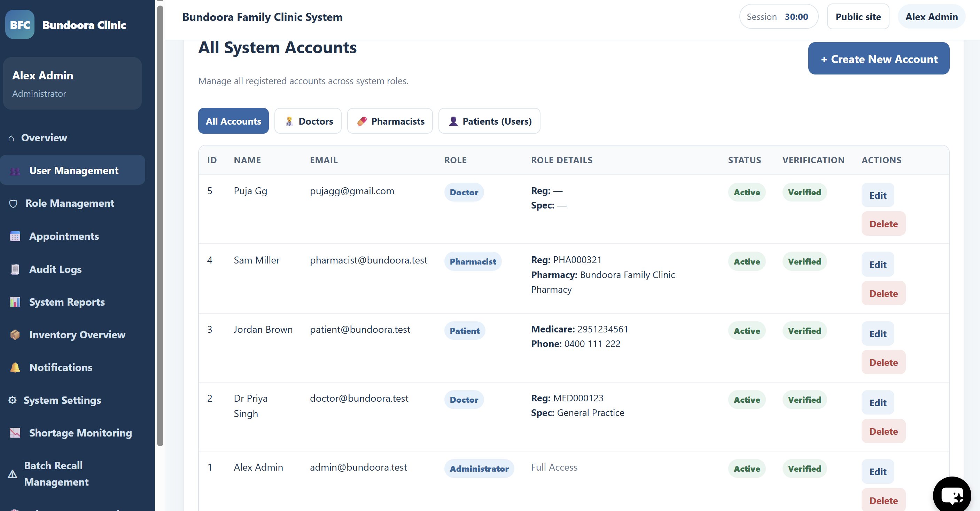Figure 18: User & Staff Administration with Account Administration window
Figure: User & Staff Administration
5.3 Role Management
[Code]
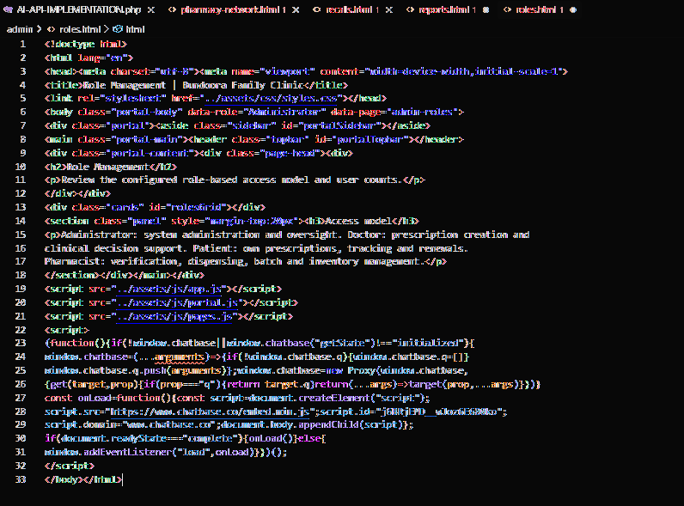
Role Management displays the configured role-based access model and supports review of user roles across the clinic system.
5.4 Appointment Oversight
[Code]
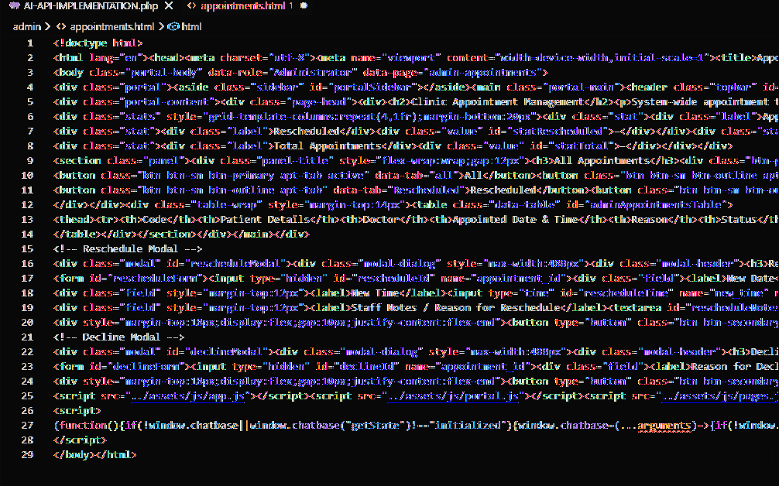
Appointment Oversight provides system-wide appointment tracking and allows appointments to be filtered by status, rescheduled, completed or declined.
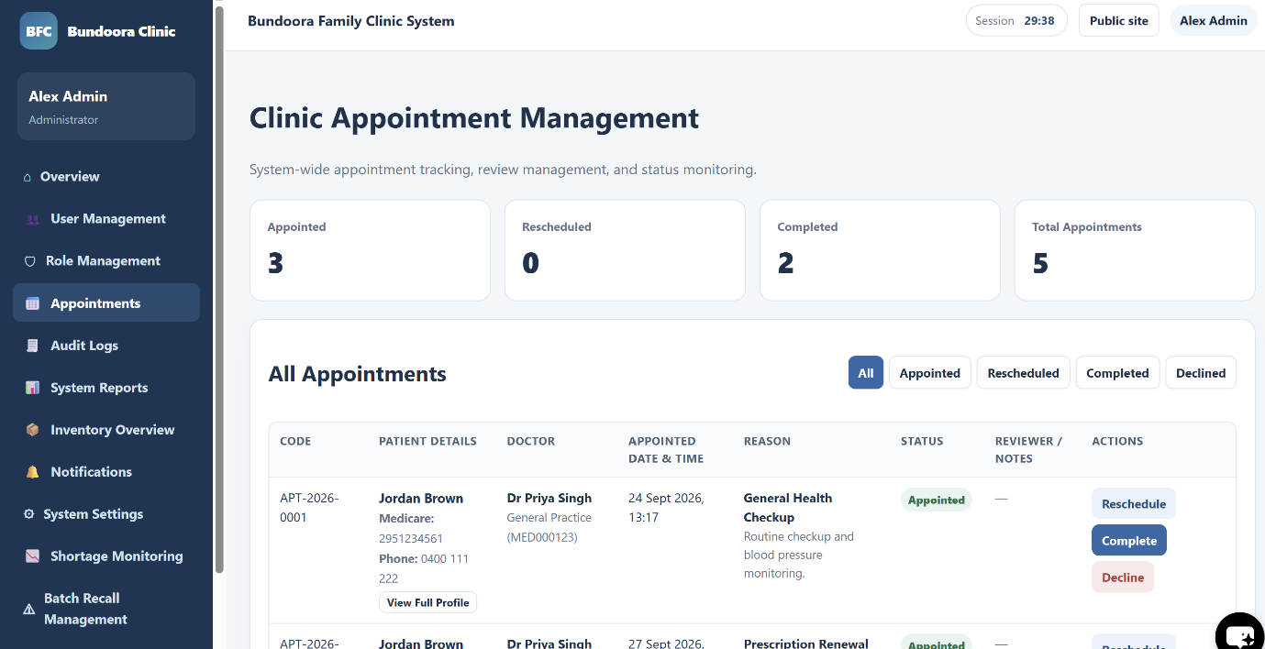
Fig: Clinic Appointment Management
5.5 Audit Logs
[Code]
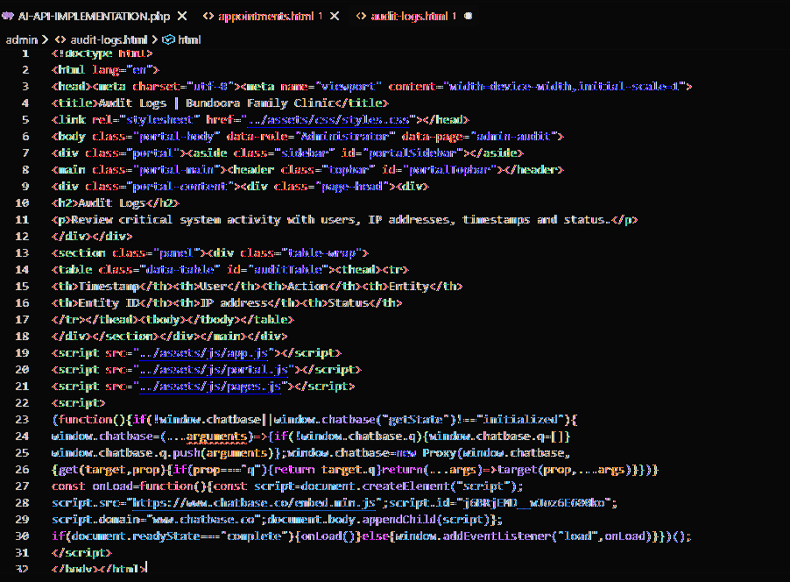
Audit Logs record critical system activity, including timestamp, user, action, entity, entity ID, IP address and status for administrative review.
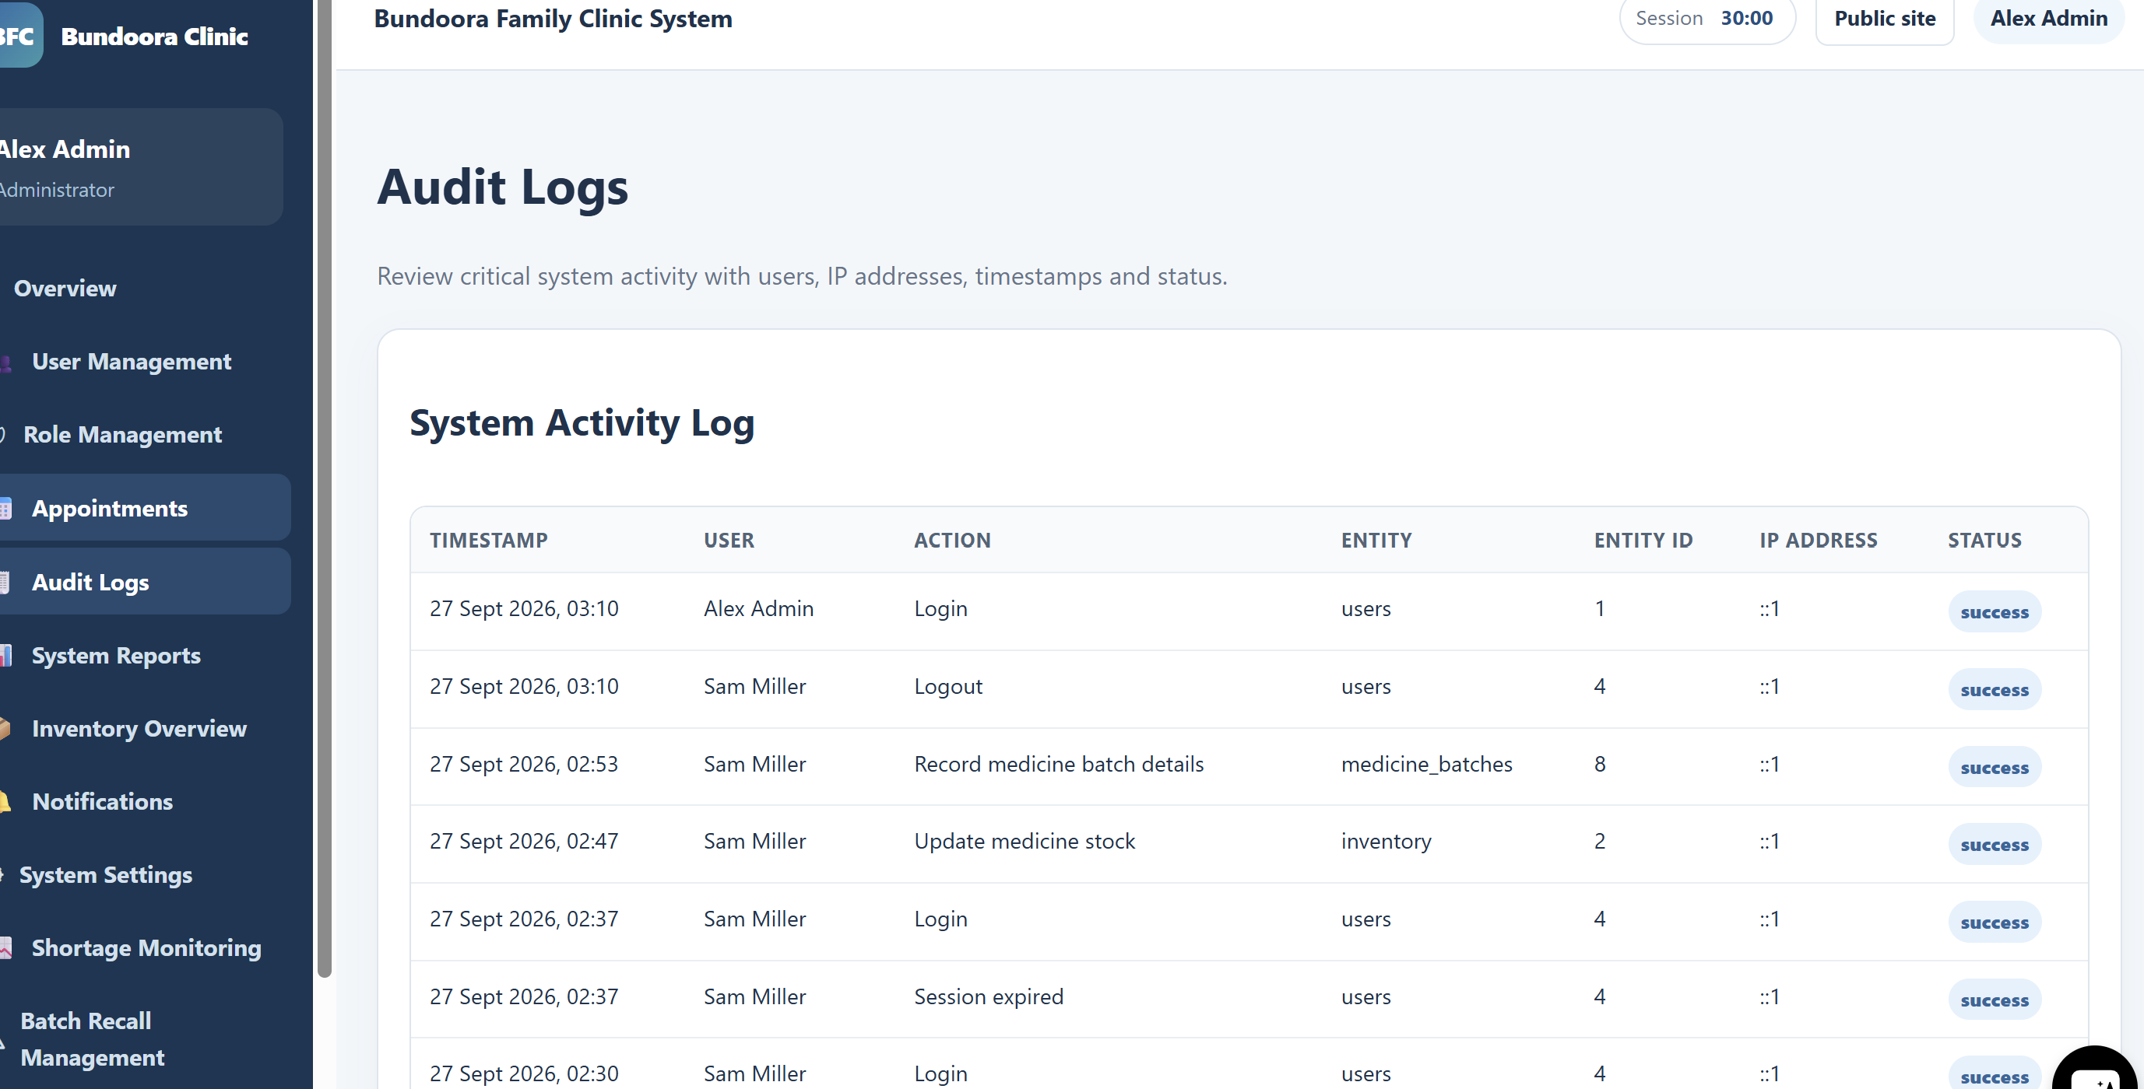Fig: audit logs
Fig: Audit logs
5.6 System Reports
[Code]
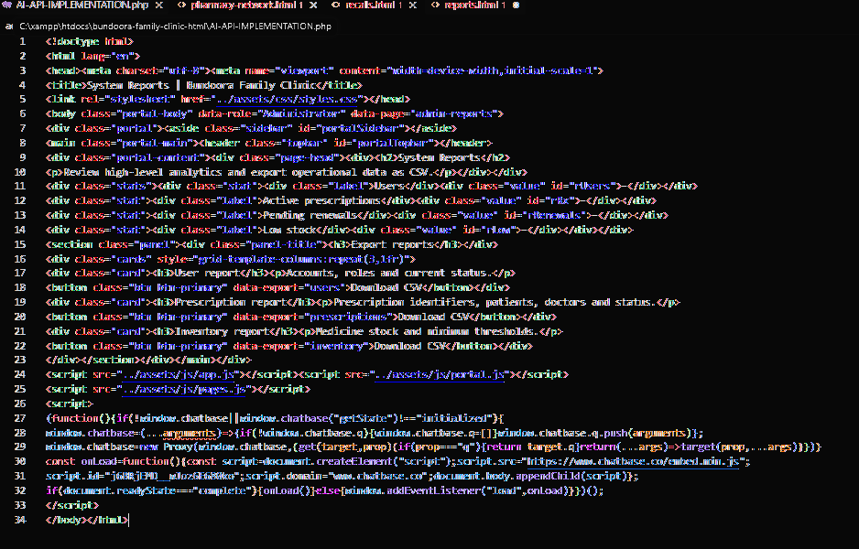
System Reports provides high-level operational statistics and CSV export options for users, prescriptions and inventory.
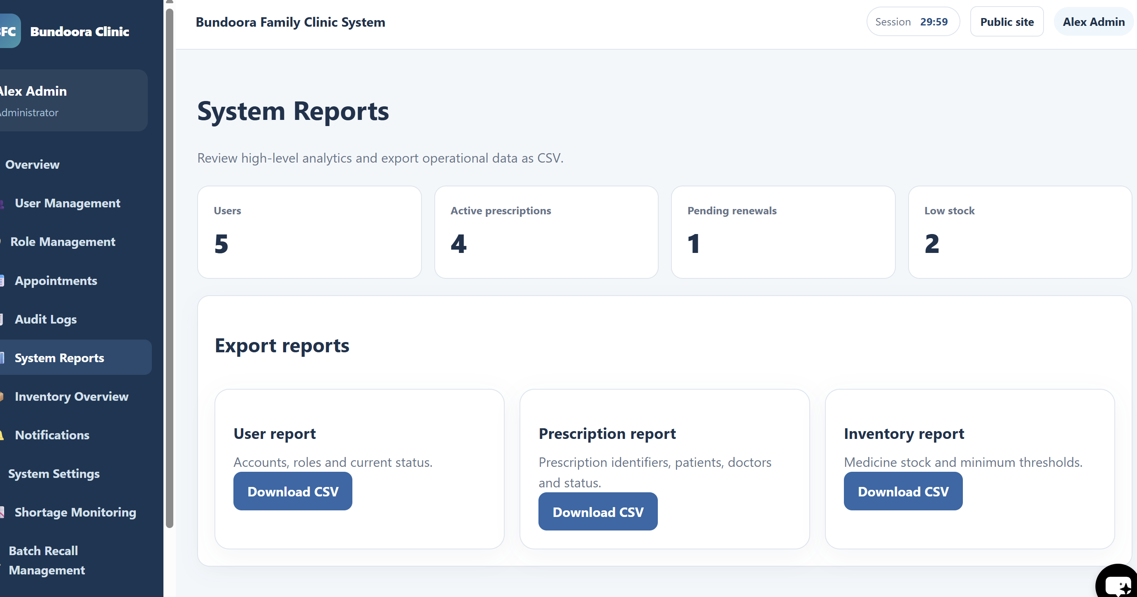Fig: system reports
Fig: System reports
5.7 Inventory Overview
[Code]
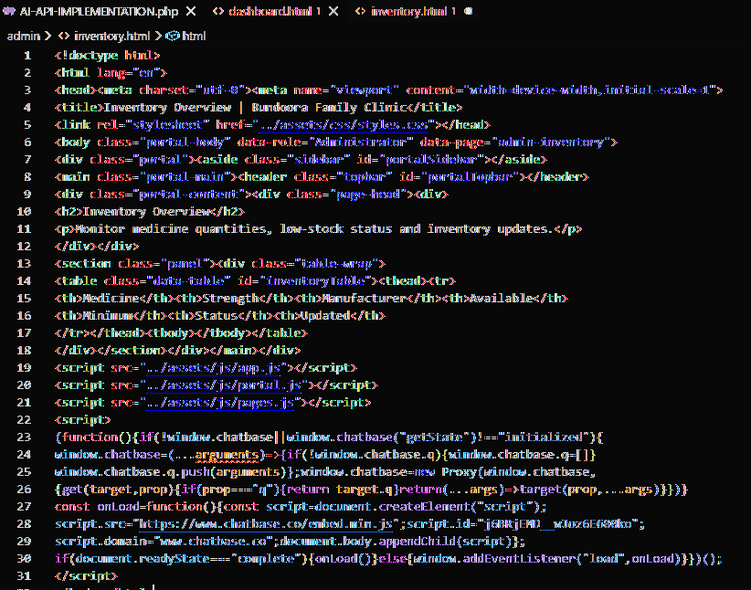
Inventory Overview lists medicine stock levels, minimum thresholds, status and latest update information for administrative monitoring.
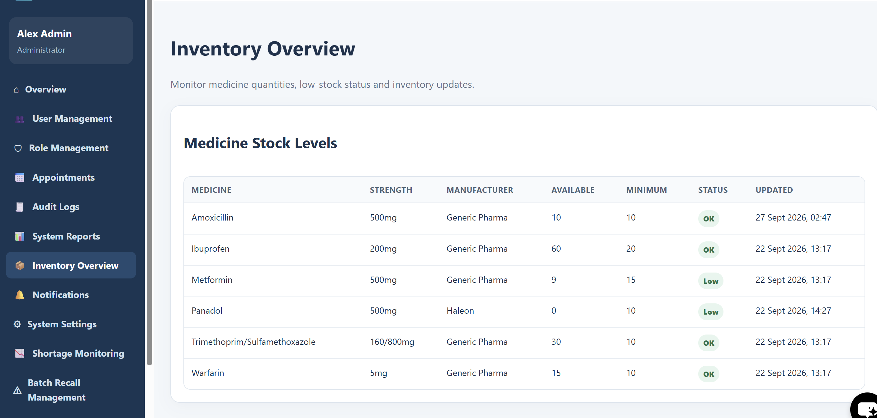
Fig: Inventory overview
5.8 Notifications
[Code]
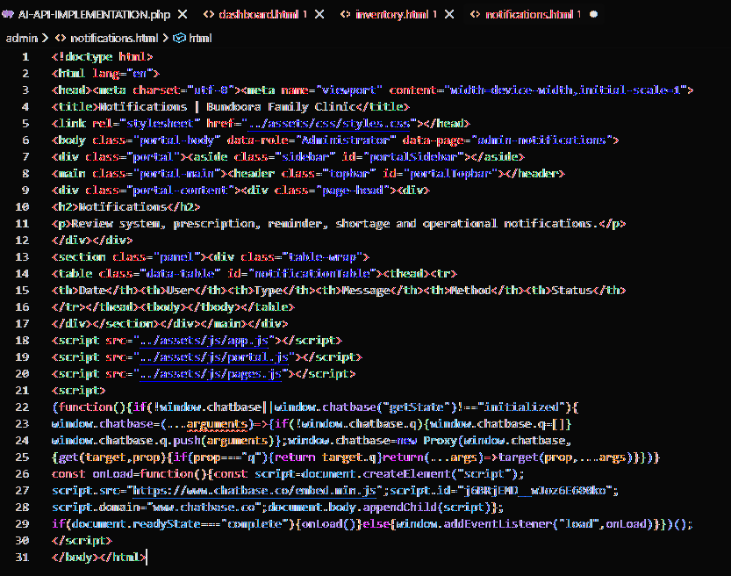
Notifications allows the administrator to review system, prescription, reminder, shortage and operational notifications.

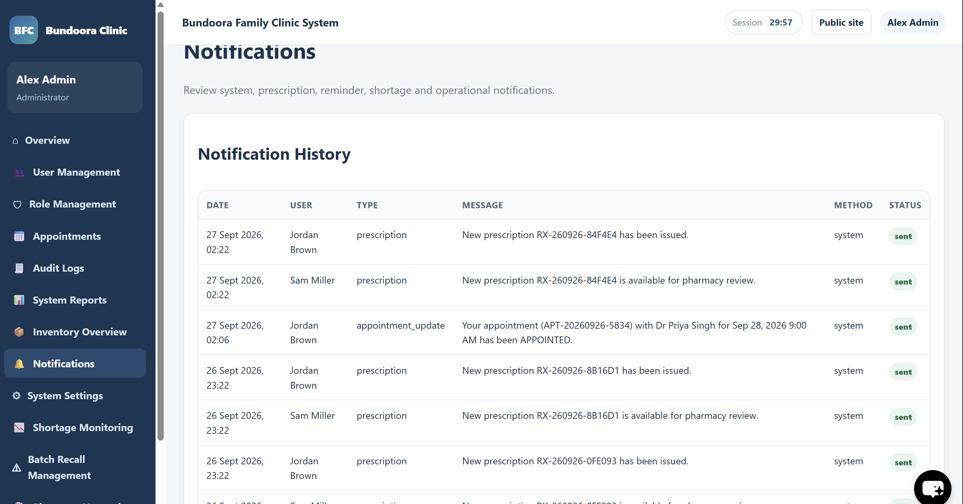
Fig: Notifications
5.9 Pharmacy Network Overview
[Code]
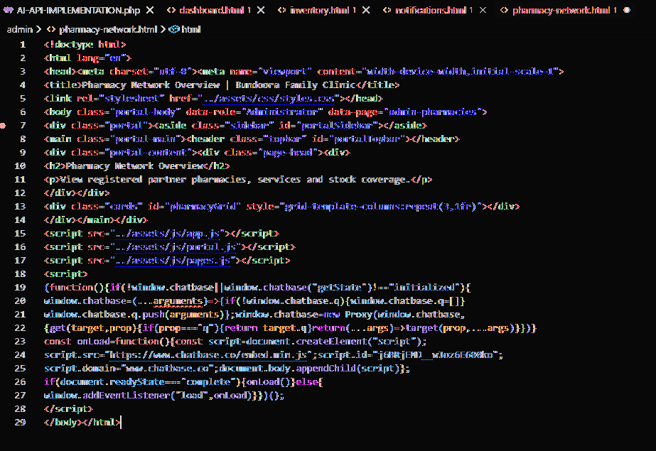
Pharmacy Network Overview displays registered partner pharmacies, available services and stock coverage across the network.
5.10 System Settings
[Code]
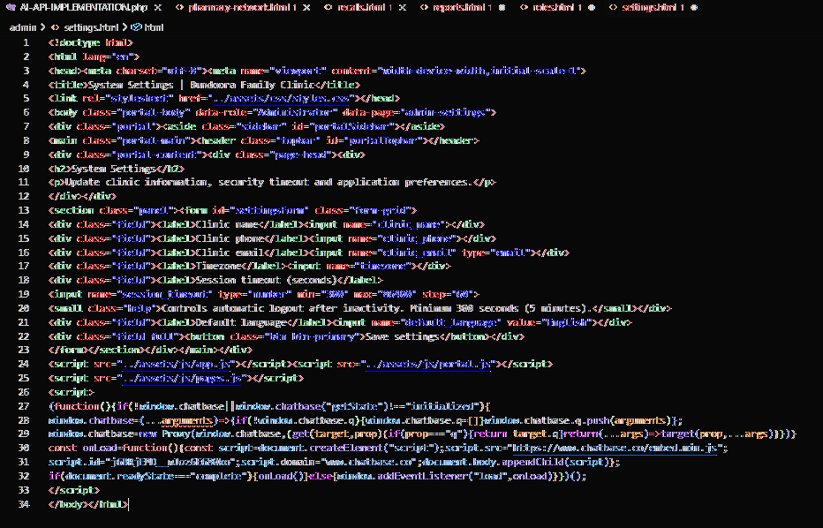
System Settings allows clinic information, timezone, session timeout and application preferences to be reviewed and updated.

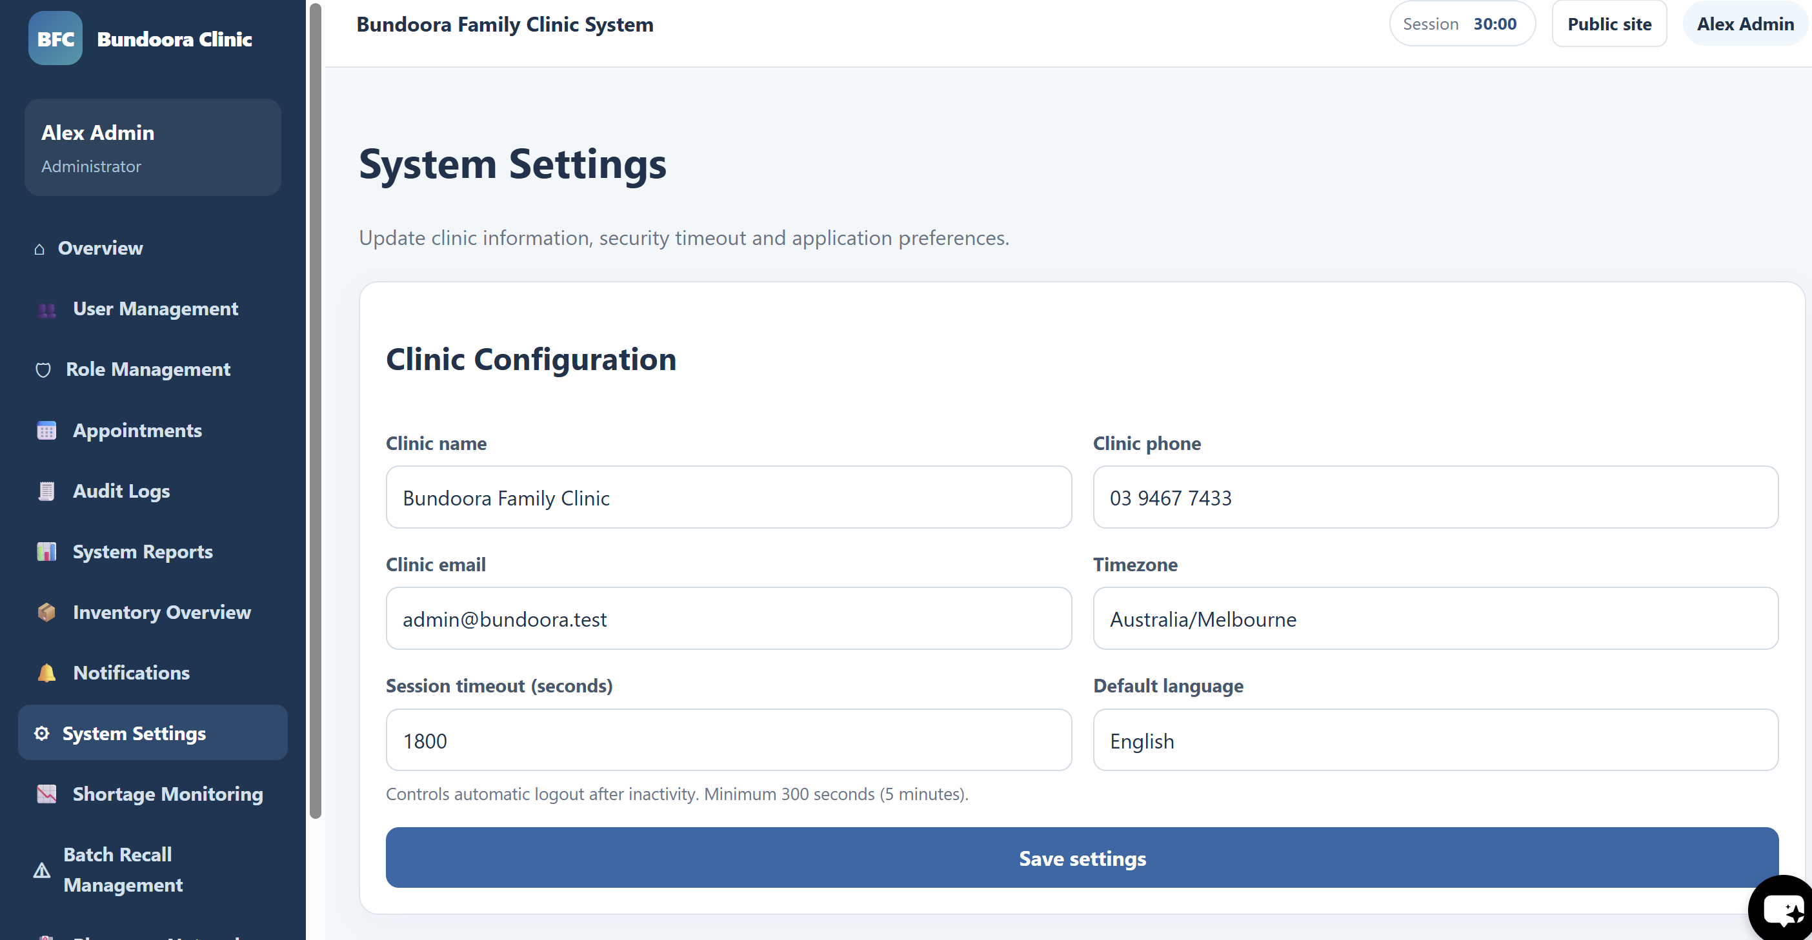
Fig: System settings
5.11 Shortage Monitoring
[Code]
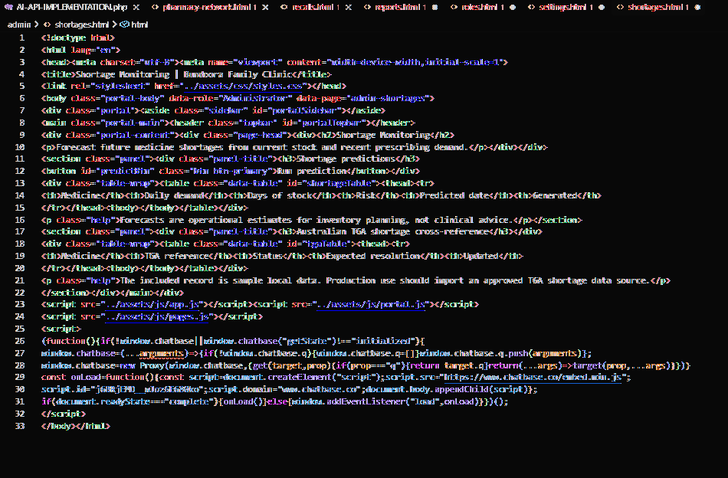
Shortage Monitoring forecasts potential medicine shortages from current stock and recent prescribing demand and includes an Australian TGA shortage cross-reference area.
5.12 Batch Recall Management
[Code]
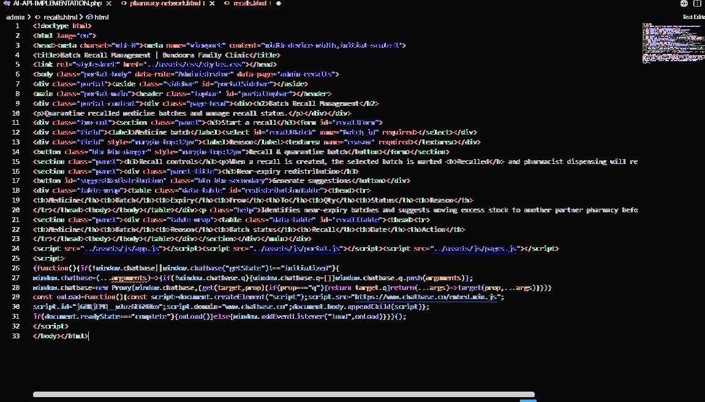
Batch Recall Management supports medicine batch recall and quarantine controls and near-expiry stock redistribution suggestions.

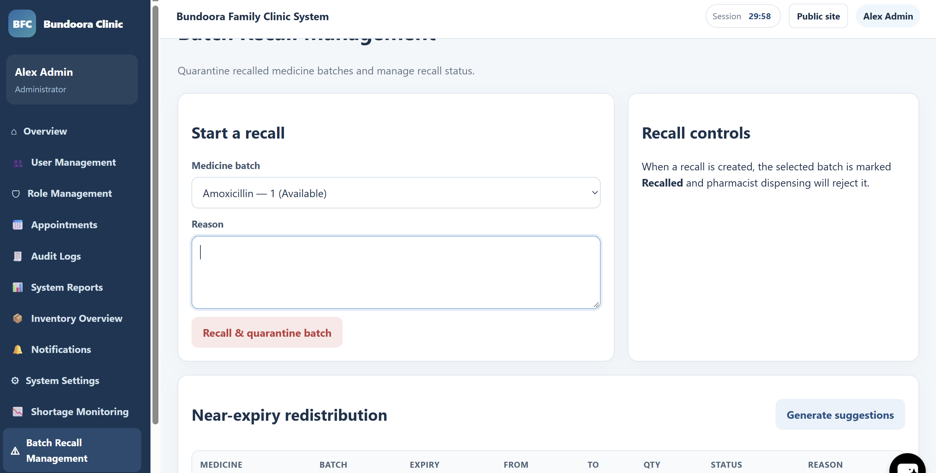
Figure: Batch Recall Management

