3.4 OPERATING SYSTEM PLATFORM TESTING
AND RESULTS
Bundoora Family Clinic Management System

3.4.1 Purpose of Platform Testing
Operating system platform testing was performed to check whether the Bundoora Family Clinic Management System remains usable and visually consistent when accessed from different end-user environments. Because the application is web based, the test focused on the behaviour of the frontend when accessed from a Windows desktop environment and an iOS mobile environment. The testing considered page loading, authentication screens, role-based access, dashboard presentation, navigation, responsive behaviour and the visibility of important controls.
The system was accessed through the local Apache web server. Windows testing used the localhost deployment on the development computer, while the iPhone accessed the same application over the local Wi-Fi network using the computer's local network address. This allowed the same application build to be observed on both desktop and mobile platforms without changing the system code.

3.4.2 Test Environment
Environment | Platform / Device | Browser | Test Connection
Desktop | Windows desktop computer | Google Chrome | Localhost / local Apache server
Mobile | iPhone 15 Pro Max (iOS) | Safari | Local Wi-Fi connection to the same Apache server

3.4.3 Testing Criteria
The following criteria were used when reviewing the evidence: successful page loading; readable text and controls; correct display of login fields; access to the patient dashboard after authentication; availability of role-specific navigation; responsive adaptation on the mobile screen; and absence of obvious overlapping, missing or unusable interface elements. A PASS result indicates that the tested interface met the expected visual or access behaviour shown in the evidence. It does not imply that every backend function on that page was exhaustively tested.

3.4.4 Operating System Platform Testing Results
Test ID | Platform | Test Area | Expected Result | Observed Result | Status
OS-WIN-01 | Windows / Chrome | Login interface | Login page loads with all authentication controls visible and usable. | Login interface loaded correctly. Email/password fields, sign-in control and account links were clearly displayed. | PASS
OS-WIN-02 | Windows / Chrome | Patient dashboard | Authenticated patient can access the role-based dashboard with navigation and dashboard content. | Patient dashboard loaded with sidebar navigation, session controls, status cards, prescriptions area and medication tracking section. | PASS
OS-WIN-03 | Windows / Chrome | Pharmacy Recommendation interface | Patient can open the pharmacy recommendation screen and view its main input controls. | Medicine selector, accessibility options, Find Pharmacy control, map area and patient navigation displayed correctly. | PASS
OS-IOS-01 | iOS / Safari | Mobile login interface | Login page adapts to the mobile viewport while keeping authentication controls readable and accessible. | Login form adapted to the iPhone screen. Fields, sign-in button, password recovery and registration links remained readable and accessible. | PASS
OS-IOS-02 | iOS / Safari | Patient dashboard | Patient dashboard loads on the mobile platform and key dashboard content remains accessible. | Dashboard loaded successfully on iPhone. Header, patient information, dashboard cards and content areas were visible in the mobile viewport. | PASS
OS-IOS-03 | iOS / Safari | Responsive navigation | Role-based navigation can be opened and used on the mobile interface. | Mobile menu opened successfully and displayed Dashboard, Appointments, Prescriptions, Medication Tracking, Renewals, Profile, Pharmacy Recommendation and Logout options. | PASS

3.4.5 Windows Platform Evidence
Windows testing demonstrates the desktop presentation of the system. The screenshots below show the authentication interface, the authenticated Patient Dashboard and the Pharmacy Recommendation interface. The browser viewport provides sufficient horizontal space for the two-column login design and the full portal sidebar.
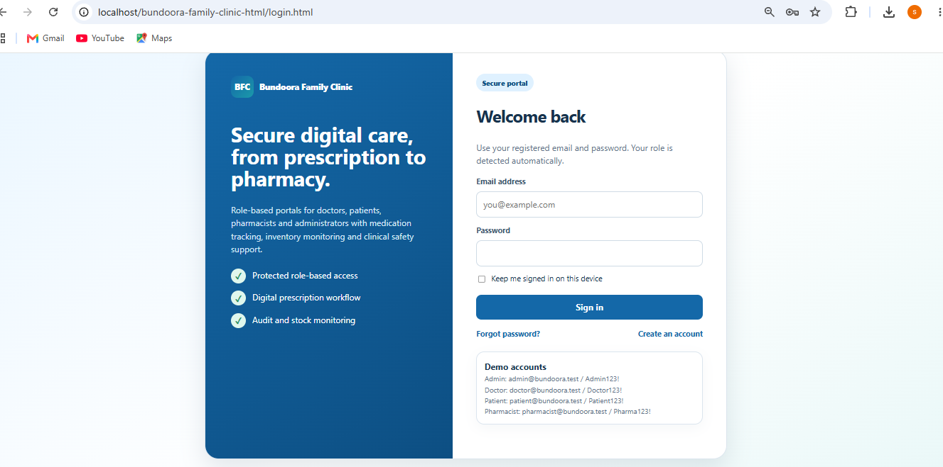
Figure 1. Windows - Login Interface
The Bundoora Family Clinic login screen is displayed in Google Chrome on the Windows desktop environment. The interface is aligned correctly and the main authentication controls are visible.
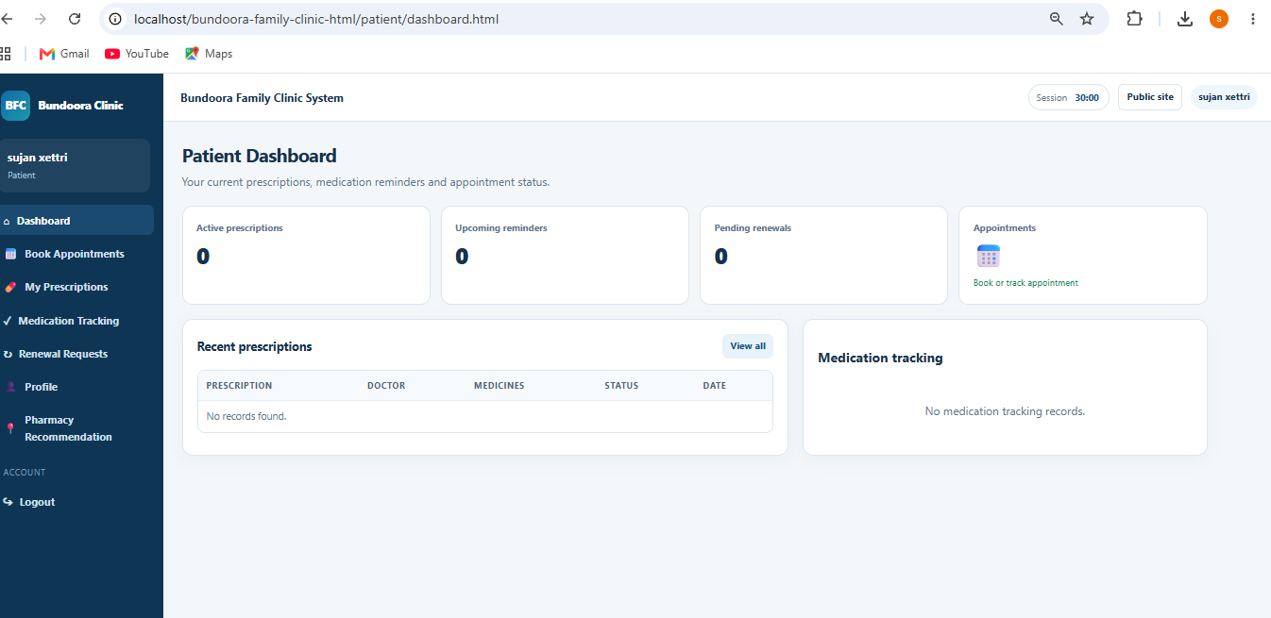
Figure 2. Windows - Patient Dashboard
The authenticated Patient Dashboard displays the role-specific sidebar, dashboard cards, recent prescriptions and medication-tracking area.
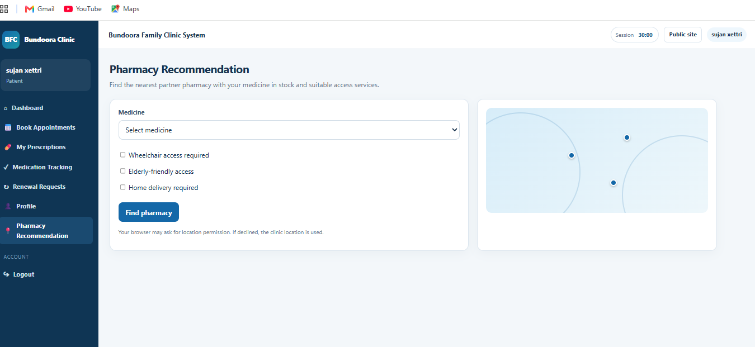
Figure 3. Windows - Pharmacy Recommendation
The patient Pharmacy Recommendation screen displays its medicine selector, accessibility options, action button and map area in the desktop layout.

3.4.6 iOS Platform Evidence
iOS testing was performed on an iPhone 15 Pro Max using Safari. The phone connected to the same local web server over Wi-Fi. The evidence shows that the authentication page changes to a mobile-friendly single-column presentation and that the authenticated portal provides a mobile menu for the patient's role-based navigation.
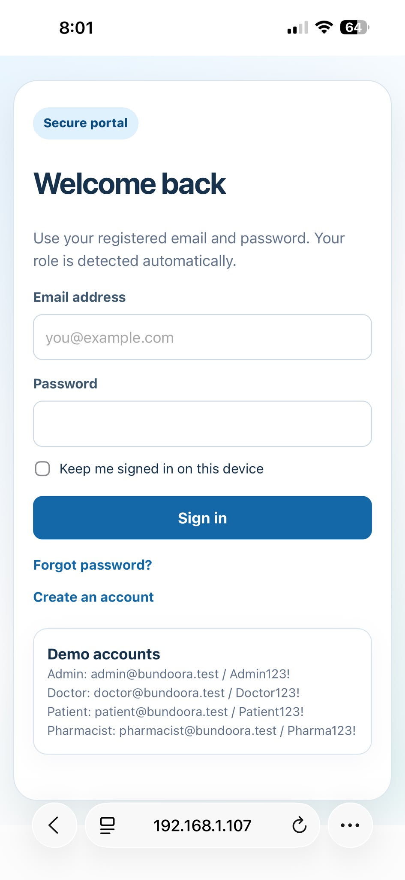
Figure 4. iOS Safari - Mobile Login Interface
The login form adapts to the narrow mobile viewport. Authentication fields and account links remain clearly readable and usable.
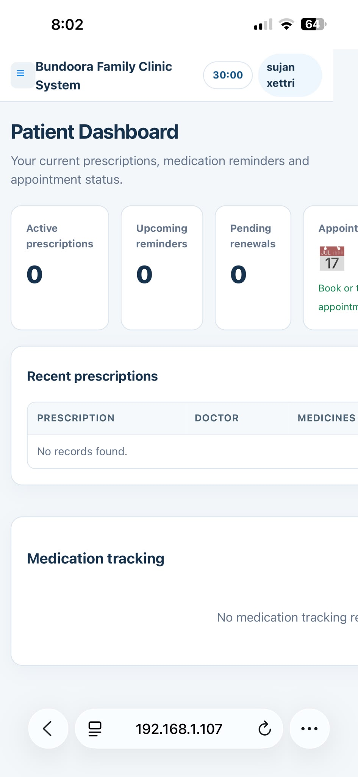
Figure 5. iOS Safari - Patient Dashboard
The Patient Dashboard loads on the iPhone and presents dashboard information in the mobile viewport.
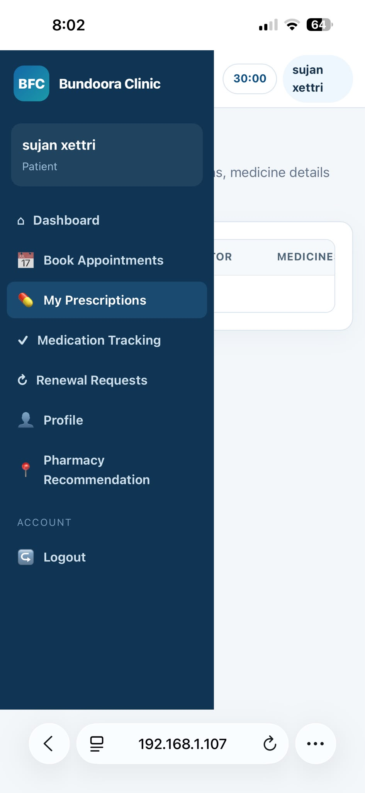
Figure 6. iOS Safari - Responsive Patient Navigation
The mobile navigation drawer opens and provides access to the patient's major functions, demonstrating responsive role-based navigation.

3.4.7 Result Analysis
The collected evidence shows that the tested Bundoora Family Clinic frontend can be accessed successfully from both the Windows desktop environment and the iOS mobile environment. On Windows, the wider desktop layout displays the full patient navigation and content areas simultaneously. On iOS, the layout adapts by prioritising the main content and providing navigation through a mobile menu. The login form also changes from the wider desktop presentation to a mobile-friendly layout while retaining the required authentication controls.
No critical visual failure was observed in the supplied screenshots. The tested pages remained readable and the main controls were available on both platforms. Some dashboard content extends beyond the initial mobile viewport, which is expected for information-rich portal pages and can be reached through normal mobile scrolling or horizontal presentation where applicable. Further testing could extend coverage to additional operating systems and browsers if those devices become available.

3.4.8 Conclusion
Based on the completed platform tests and supplied screenshots, the Bundoora Family Clinic Management System passed the selected Windows and iOS frontend platform checks. The login interface, authenticated Patient Dashboard and role-based navigation were successfully displayed in the tested environments. The results provide evidence that the web frontend supports both desktop and mobile access while maintaining the main interface functions required by the patient portal. These results are limited to the platforms, browsers and functions actually tested and should not be interpreted as exhaustive testing of every operating system or every backend feature.

