1. Signing In - Email Address
The process begins on the Bundoora Family Clinic login page. The doctor enters the registered doctor email address in the Email address field. This identifies the account that will be authenticated and allows the system to open the correct role-based portal after successful sign-in.
- Open the Bundoora Family Clinic sign-in page.
- Select the Email address field.
- Enter the registered doctor email address shown in the workflow: doctor@bundoora.test.
Note: Use only the account assigned to the doctor. The password is not shown in the process document and should remain confidential.

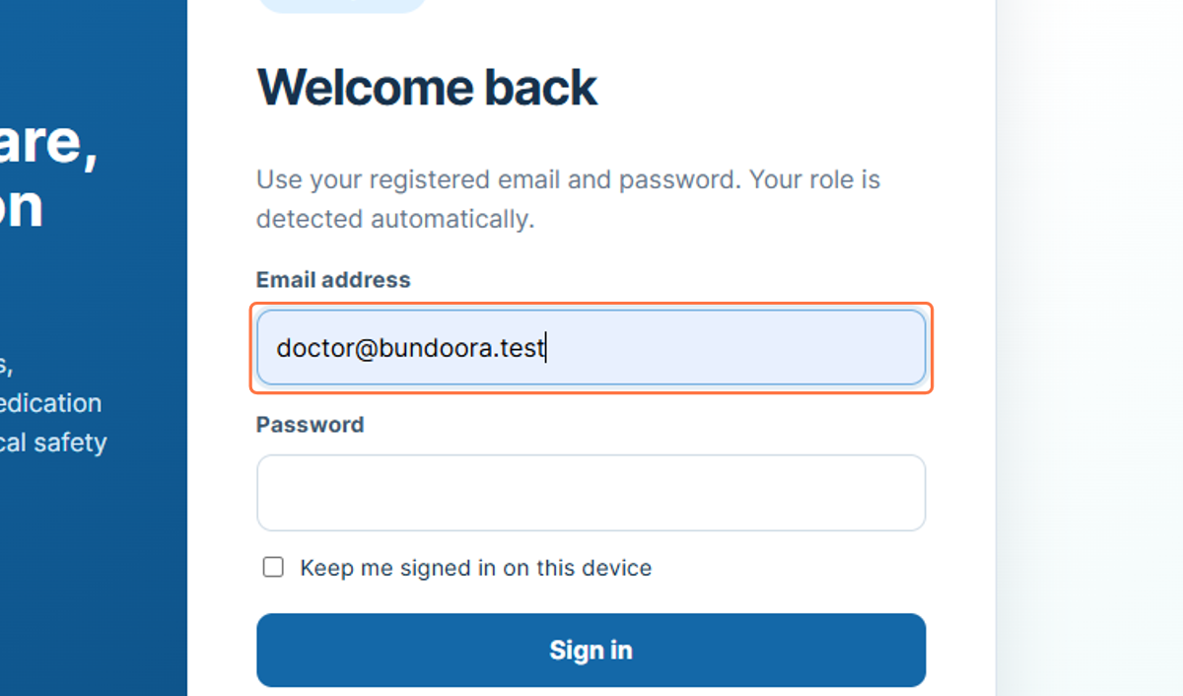
Figure 1: Entering the doctor email address

2. Signing In - Password
After the email address has been entered, the doctor provides the password for the account. In the supplied workflow, the instruction is shown as Paste input, while the screenshot displays the password as masked characters. Masking protects the password from being visible on screen.
- Select the Password field.
- Enter or paste the password associated with the doctor account.
- Check that the email address is still correct before continuing.
Note: Do not include passwords in screenshots, reports, or shared documentation.

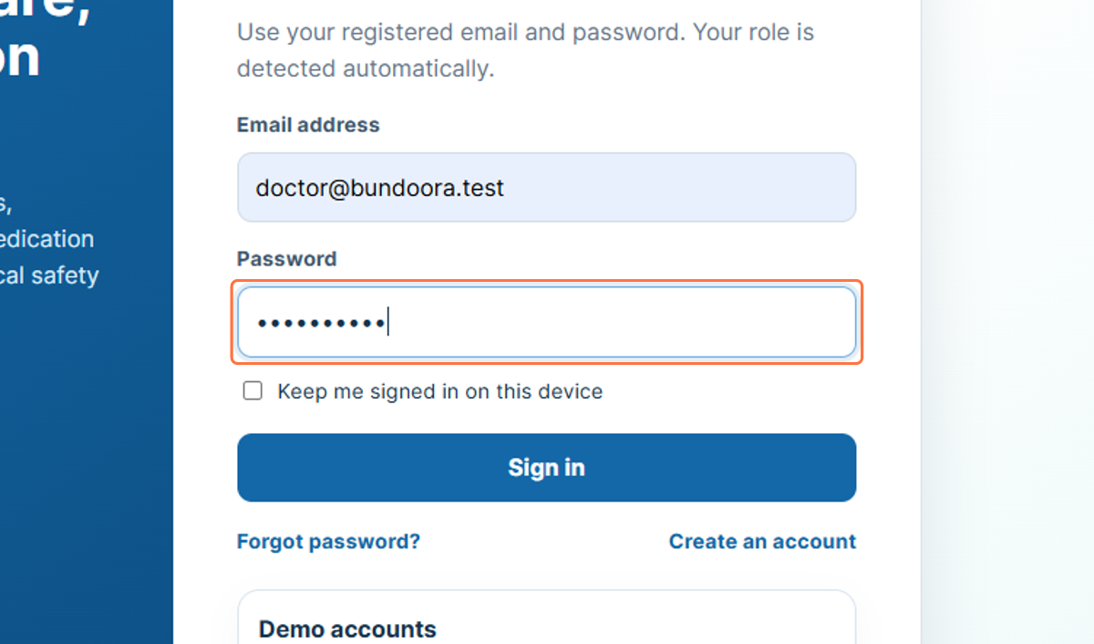
Figure 2: Entering the doctor account password

3. Signing In - Submit Credentials
Selecting Sign in submits the entered credentials for authentication. When the credentials are accepted, the system opens the Doctor Portal automatically. The portal uses role-based access, so a doctor account is directed to doctor-specific functions rather than patient, pharmacist, or administrator functions.
- Review the email address and password fields.
- Select Sign in.
- Wait for the Doctor Dashboard to load.
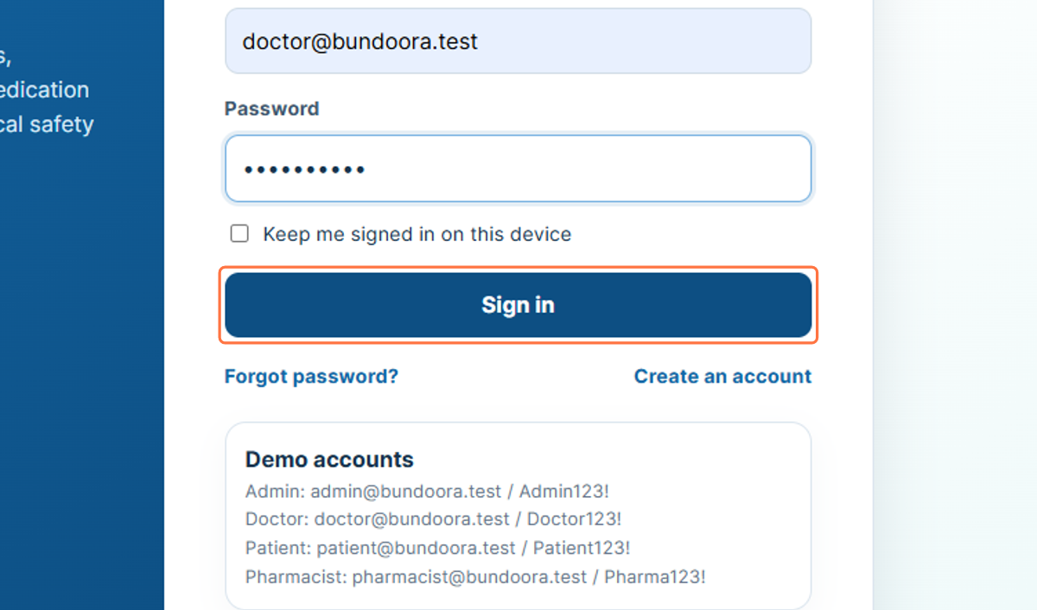
Figure 3: Selecting Sign in

4. Doctor Profile Area
The doctor profile card in the left sidebar identifies the user currently signed in. In the workflow, it displays Dr Priya Singh and the role Doctor. This area helps the user confirm that the correct account is active before working with appointments, prescriptions, reports, or safety checks.
- Confirm the doctor name shown in the sidebar.
- Confirm that the role displayed is Doctor.
- Use the sidebar below the profile card to move between doctor functions.
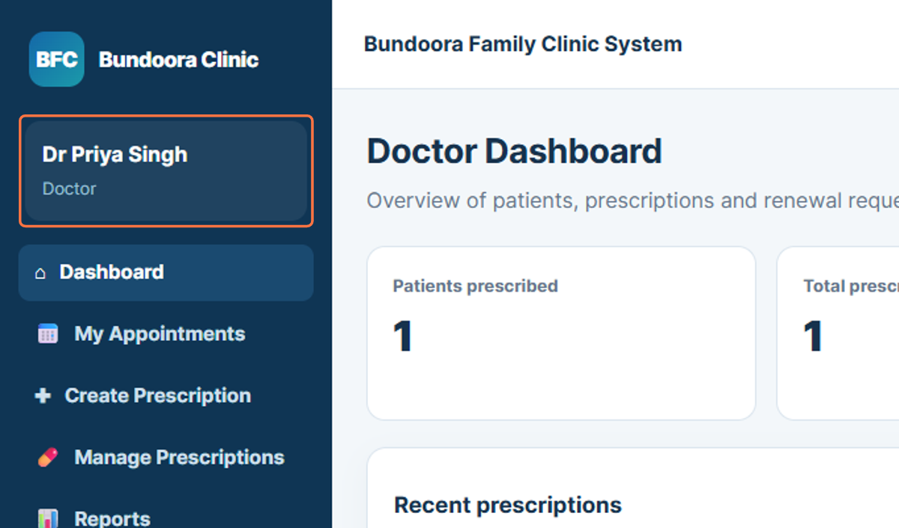
Figure 4: Doctor identity and role shown in the sidebar

5. Dashboard
The Doctor Dashboard is the main overview page for the doctor account. It provides summary information about patients and prescriptions and acts as the starting point for the doctor workflow. From the sidebar, the doctor can open appointments, prescription tools, reports, and the AI Safety Check module.
- Select Dashboard from the sidebar.
- Review the summary information and recent prescription activity.
- Use the sidebar to continue to the required doctor function.
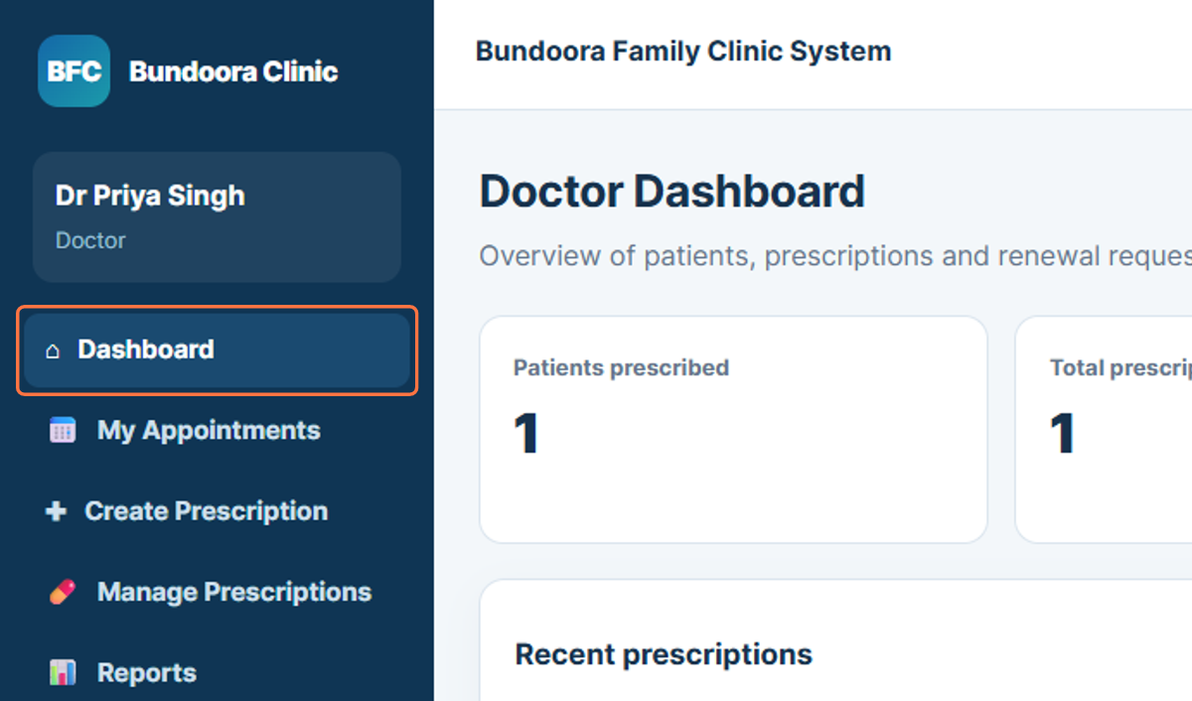
Figure 5: Doctor Dashboard navigation

6. My Appointments
My Appointments displays consultations assigned to the signed-in doctor. The full user manual describes filters for appointment status, including Appointed, Rescheduled, Completed, and Declined. This section allows the doctor to review the patient consultation schedule before prescribing or completing other clinical tasks.
- Select My Appointments from the sidebar.
- Review the assigned appointments and their current status.
- Use the available status filters when the list needs to be narrowed.
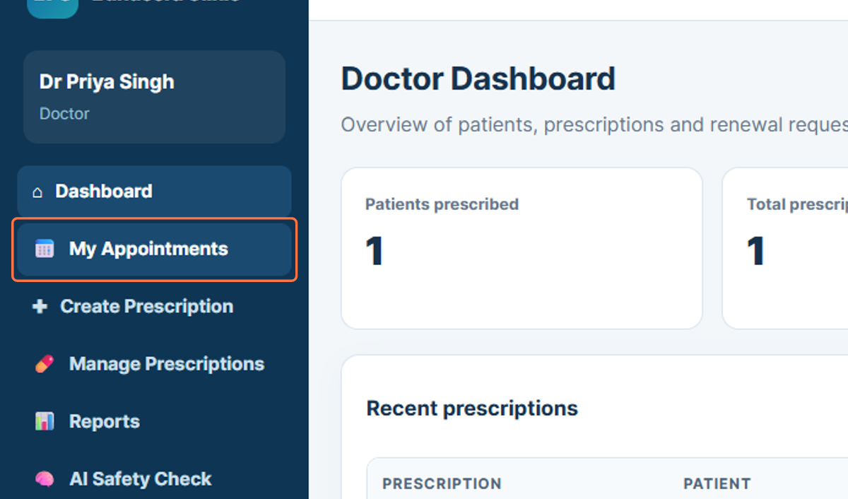
Figure 6: Opening My Appointments

7. Create Prescription
Create Prescription opens the digital prescription form. The doctor can select a patient, record the diagnosis and clinical notes, add one or more medicines, and specify medicine details. The complete user manual also shows that the doctor can run an AI and safety check before digitally signing the prescription.
- Select Create Prescription from the sidebar.
- Choose the patient and enter the relevant clinical information.
- Add the required medicine details, including dosage, frequency, duration, quantity, and instructions.
- Run the safety check and review the result before finalising the prescription.
- Create and digitally sign the prescription when the details are correct.
Note: The AI-assisted check is decision support. The doctor remains responsible for reviewing the prescription and clinical context.

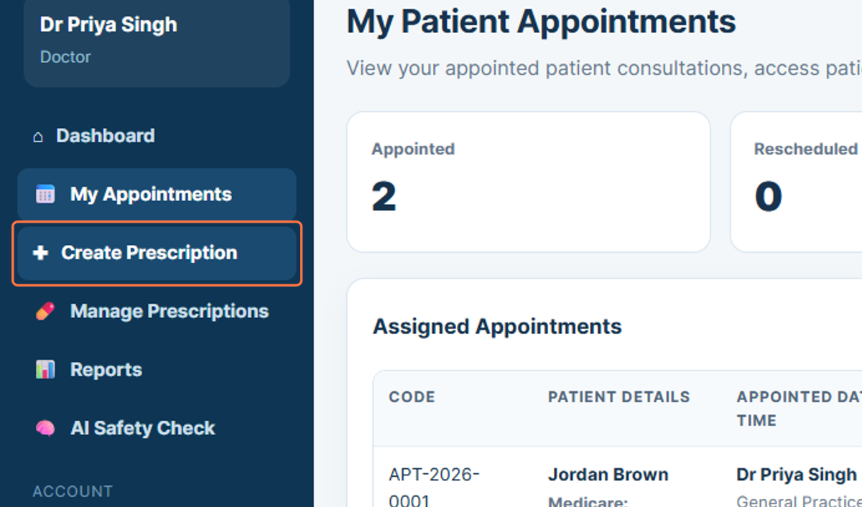
Figure 7: Opening the Create Prescription page

8. Manage Prescriptions
Manage Prescriptions provides a list of prescriptions that have already been created. It allows the doctor to review prescription records, status information, issue dates, and prescription details. This is useful when checking a previous prescription before moving to reporting or a separate safety review.
- Select Manage Prescriptions from the sidebar.
- Review the issued prescription list.
- Open a prescription when its details need to be checked.
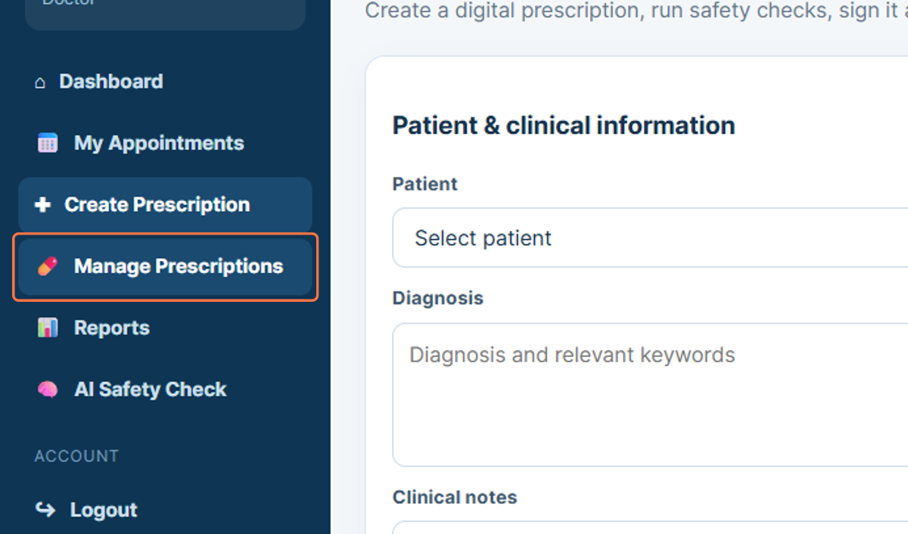
Figure 8: Opening Manage Prescriptions

9. Reports
The Reports module presents the doctor’s prescribing activity. The full user manual describes a daily report covering prescriptions, patients, and units prescribed for the most recent 30 days, with an option to export the report as a CSV file. This section supports routine review of prescribing activity.
- Select Reports from the sidebar.
- Review the prescribing activity shown in the report.
- Use the export option when a downloadable data file is required.
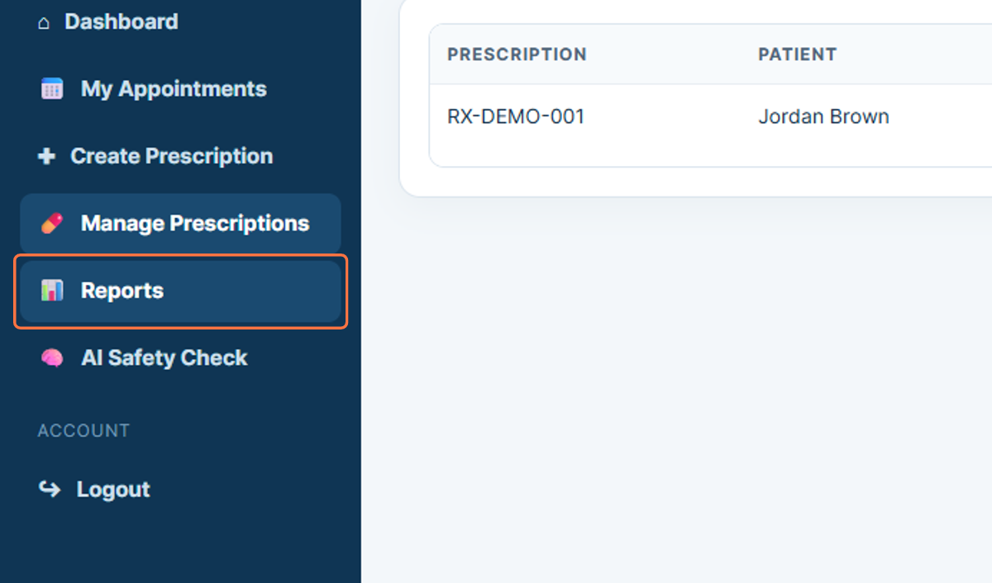
Figure 9: Opening Doctor Reports

10. AI Safety Check
AI Safety Check opens the dedicated medication safety review area. The supplied workflow shows medicines available for evaluation and a Run AI safety analysis button. The broader user manual explains that the safety process combines the clinic’s local safety rules with an optional AI-generated decision-support summary. Local rules run independently and are not overridden by the AI output.
- Select AI Safety Check from the sidebar.
- Review the medicines available for evaluation.
- Select the relevant medicine or medicines using the checkboxes.
- Select Run AI safety analysis.
- Review the displayed safety findings before making a clinical decision.
Note: The AI result should be treated as decision support. Any local safety warning must still be reviewed before a prescription is finalised.

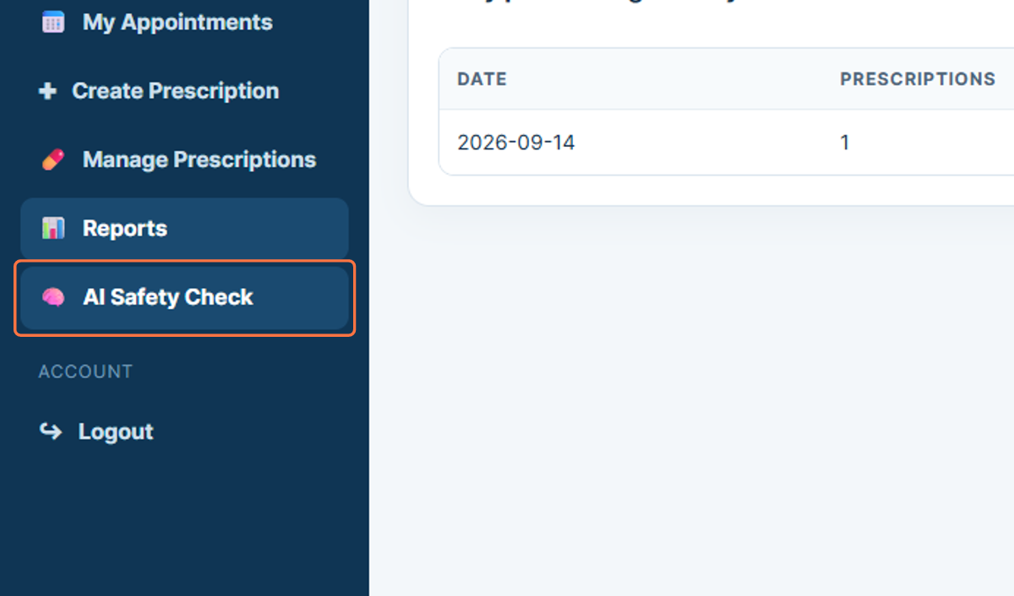
Figure 10: AI Safety Check module

11. Logout
Logout ends the current authenticated session. Signing out is important after completing the doctor workflow, especially on a shared or clinic workstation, because it prevents another person from using the active doctor account.
- Select Logout from the sidebar.
- Confirm that the session closes and the portal returns to the sign-in area.
- Close the browser window if the workstation is shared.
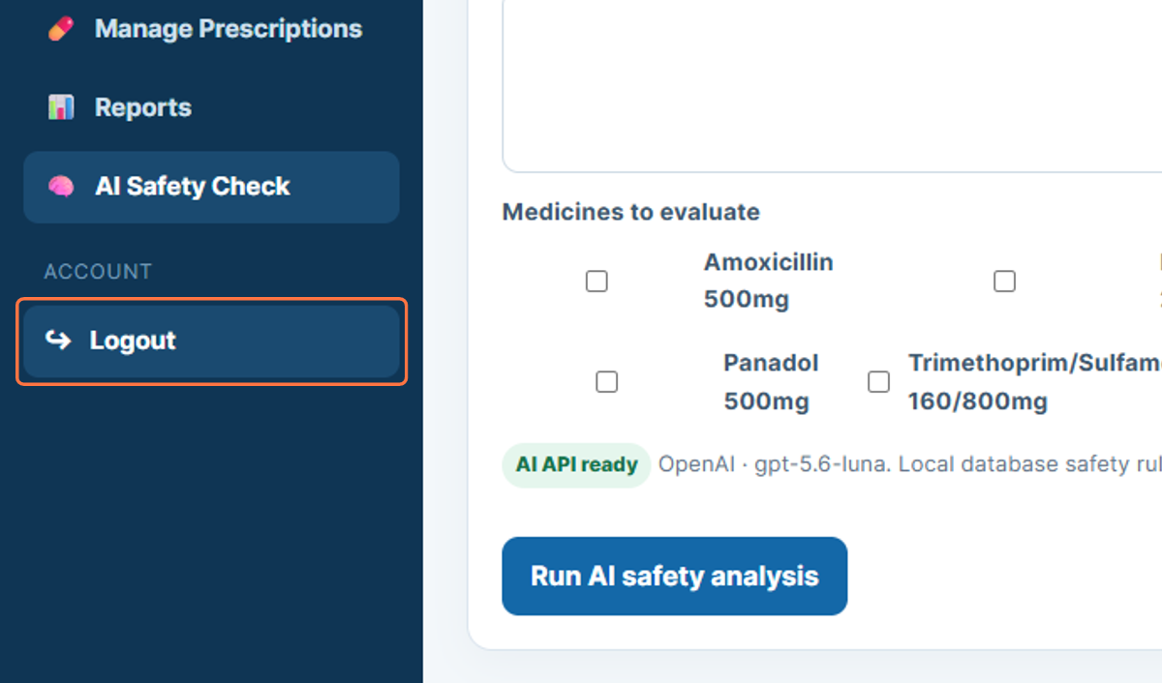
Figure 11: Logging out of the Doctor Portal

