12 Steps

Manage Medication Renewals in Bundoora

Created By
Yam Bahadur Mohatra
Updated
Sep 21, 2026
View latest
Open in Tango

Login | Bundoora Family Clinic


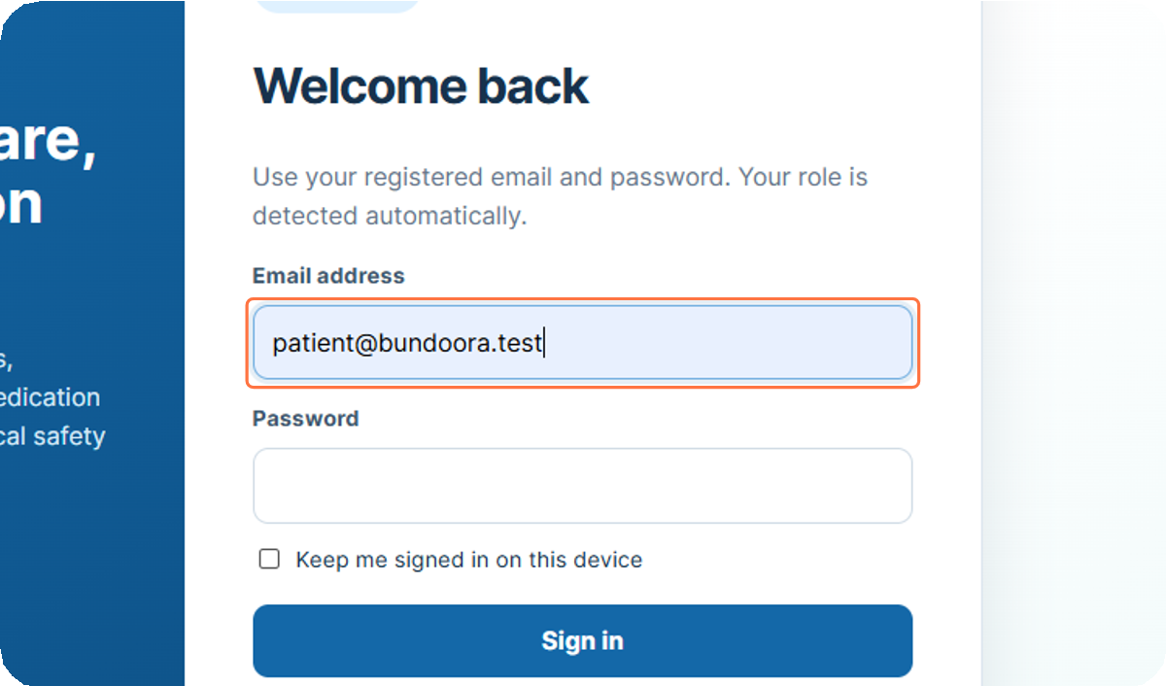
Type "patient@bundoora.test"
1

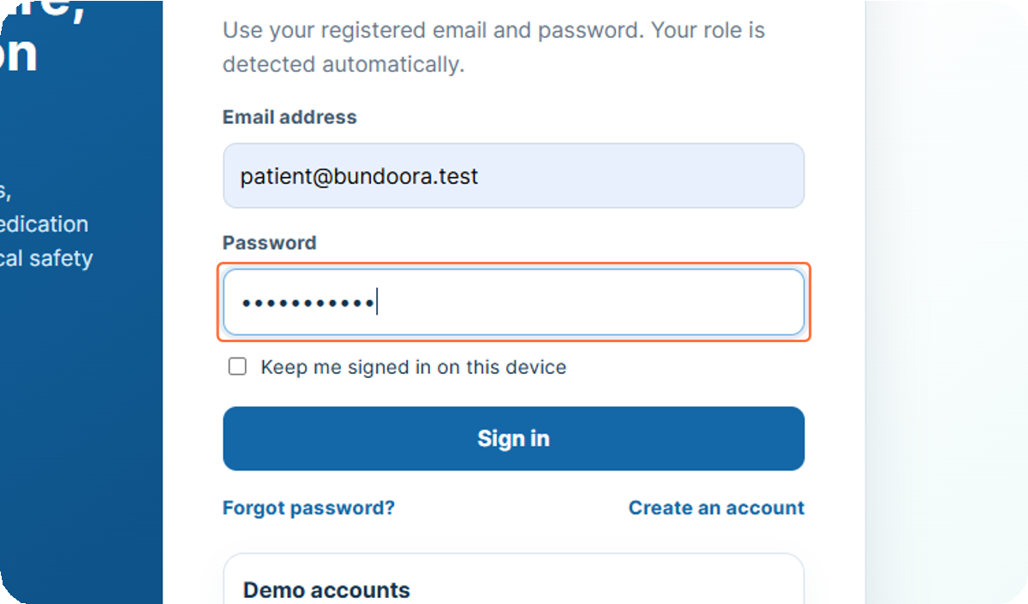
Paste input
2

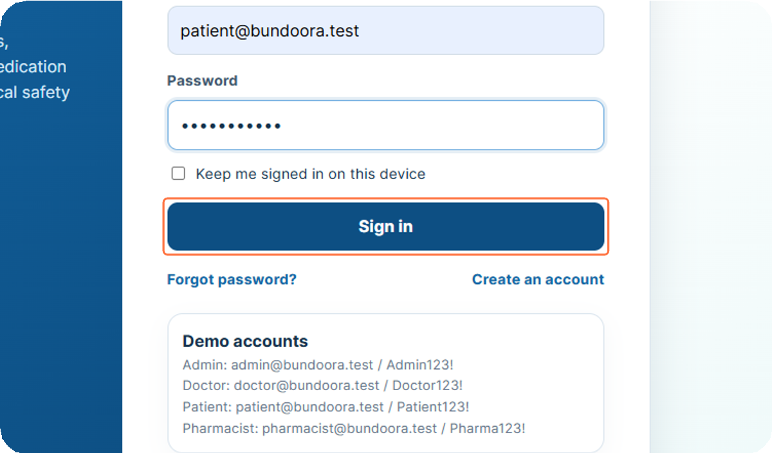
Click on Sign in

3

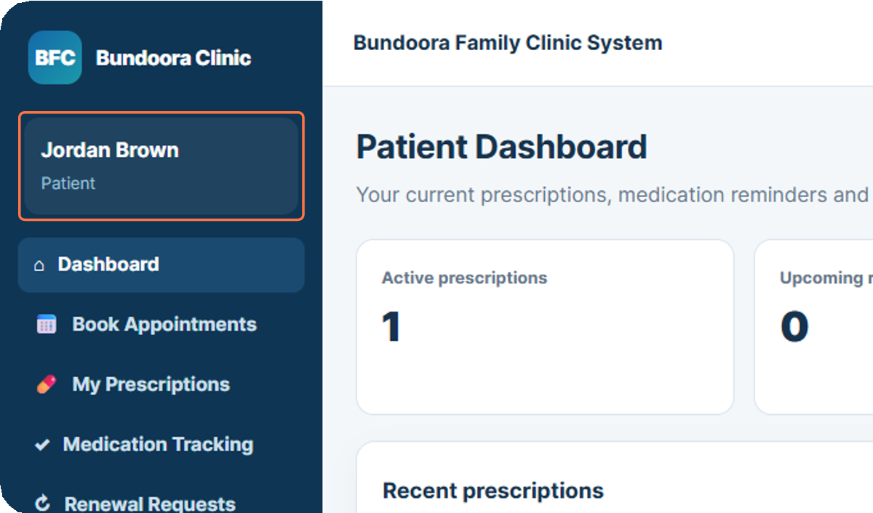
Click on Jordan Brown…
4


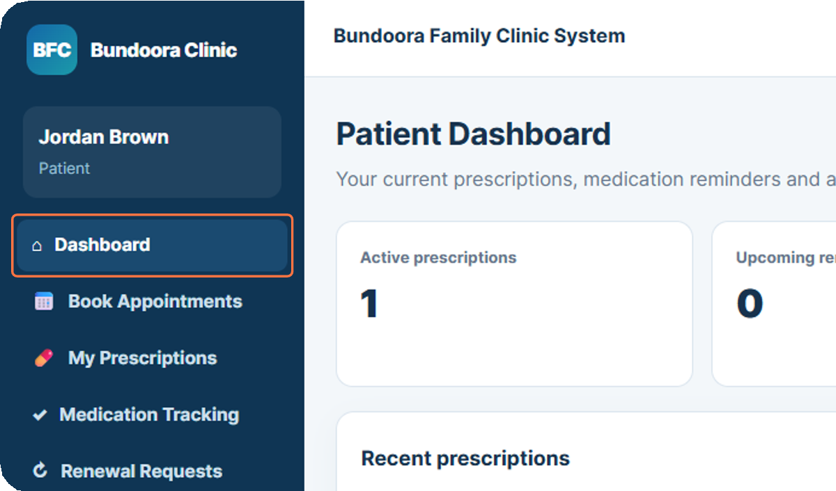
Click on Dashboard
5

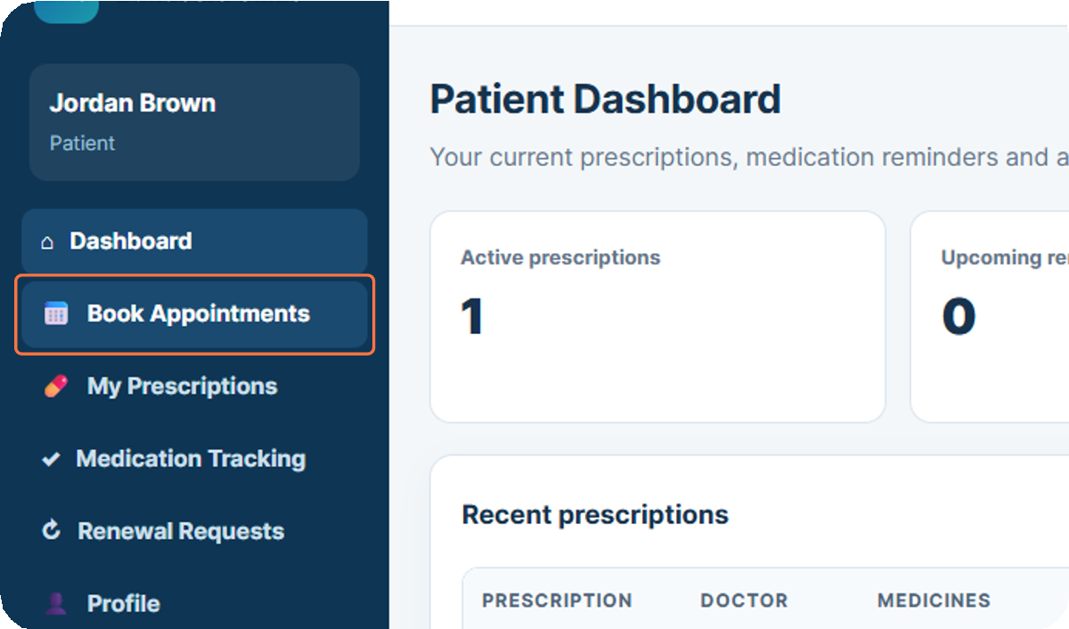
Click on Book Appointments

6

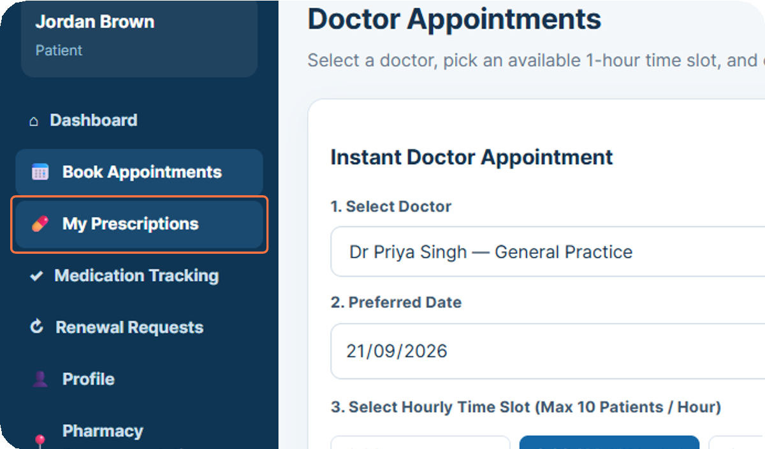
Click on My Prescriptions
7

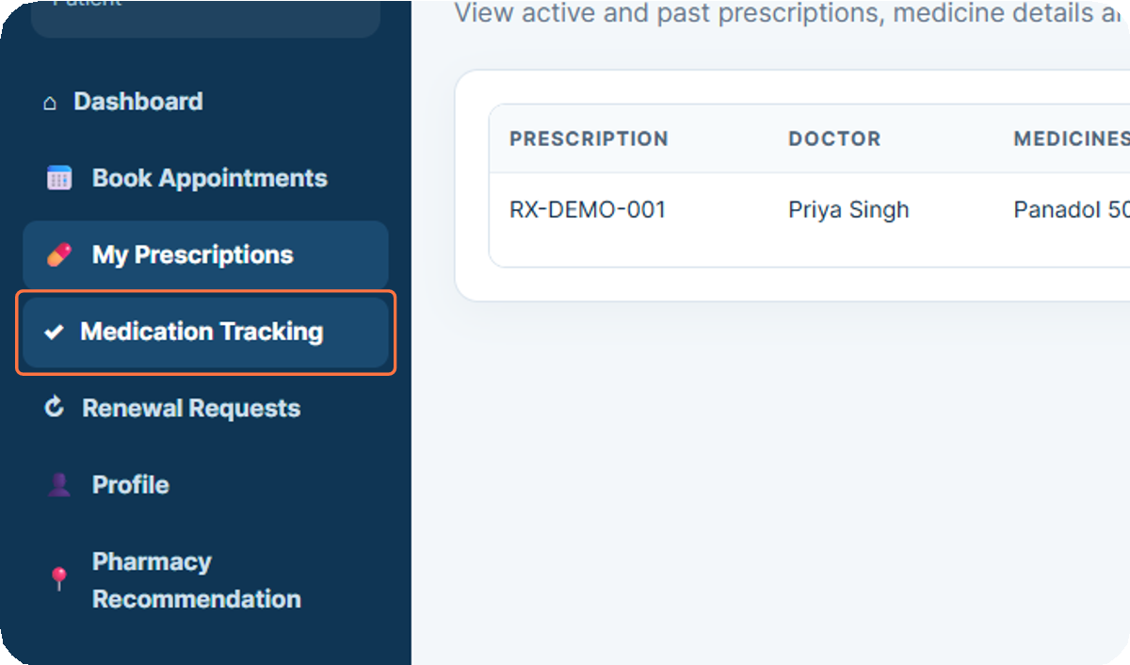
Click on Medication Tracking

8

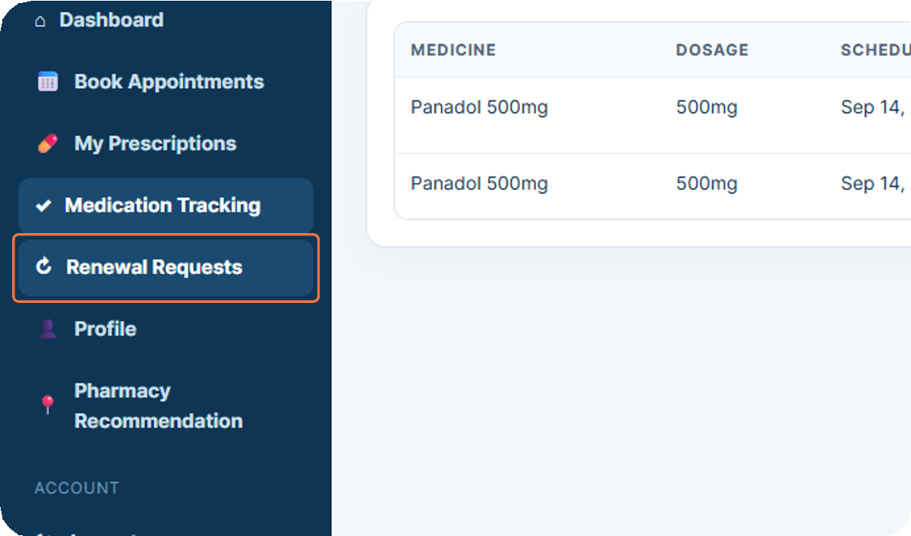
Click on Renewal Requests
9

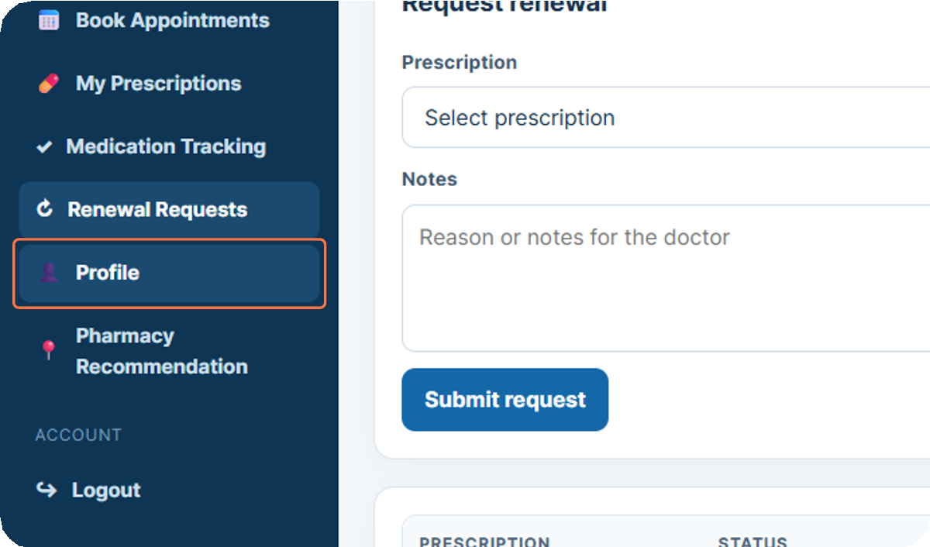
Click on Profile
10

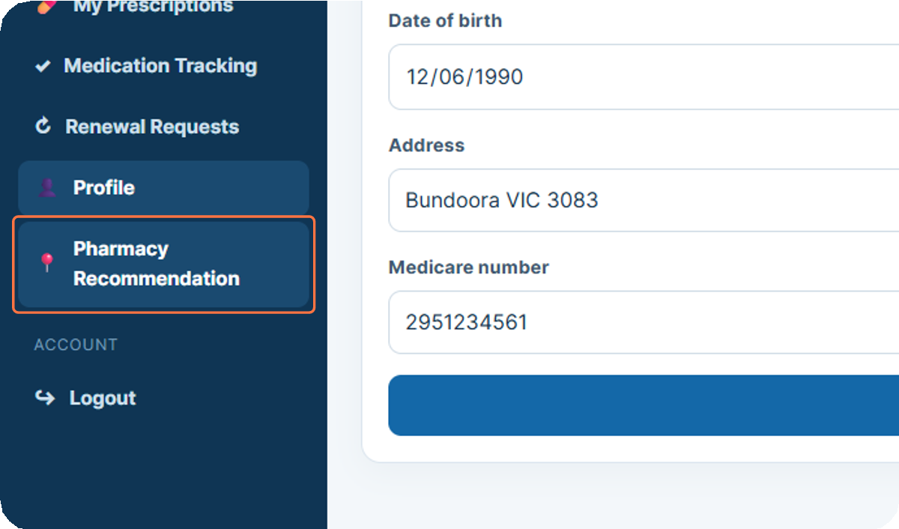
Click on Pharmacy Recommen-dation

11

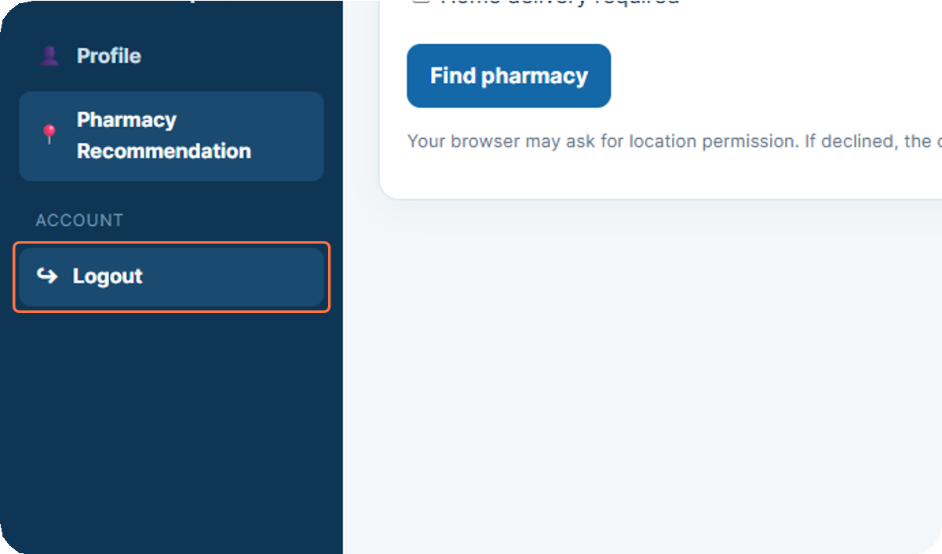
Click on Logout

12

