1. Signing In - Email Address
The patient workflow begins on the Bundoora Family Clinic login page. The patient enters the registered patient email address in the Email address field so the system can identify the correct account.
1. Open the Bundoora Family Clinic sign-in page.
2. Select the Email address field and enter the patient account shown in the workflow: patient@bundoora.test.
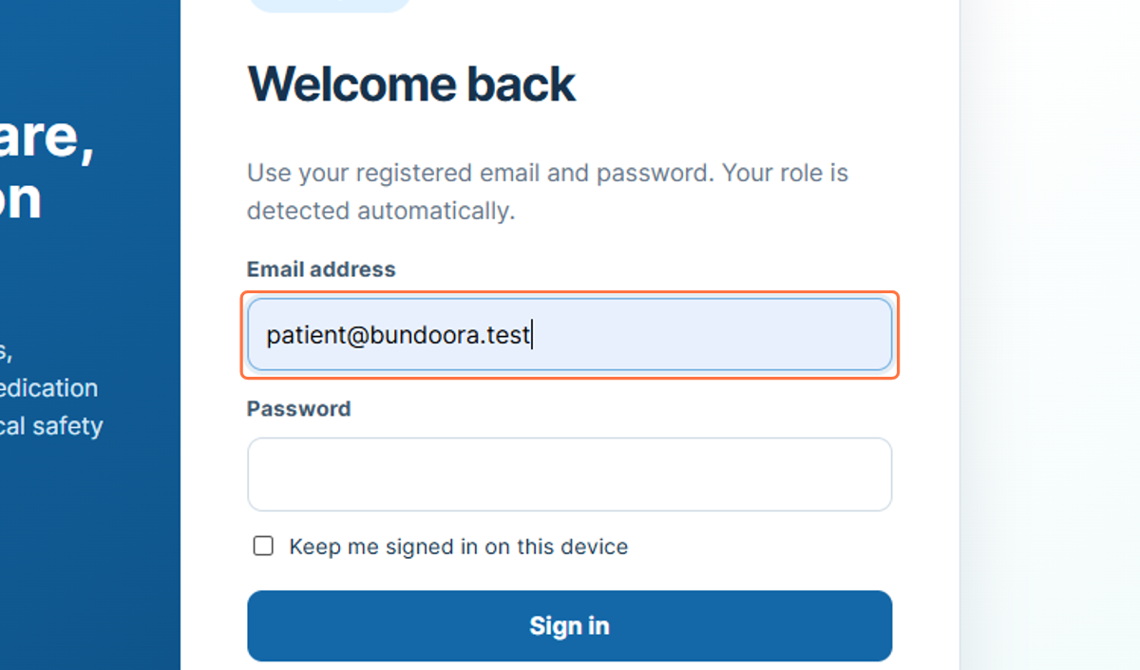
Figure 1: Entering the patient email address

2. Signing In - Password
After the email address has been entered, the patient provides the password for the account. The password is displayed as masked characters to protect the login credentials.
3. Select the Password field.
4. Enter or paste the password associated with the patient account.
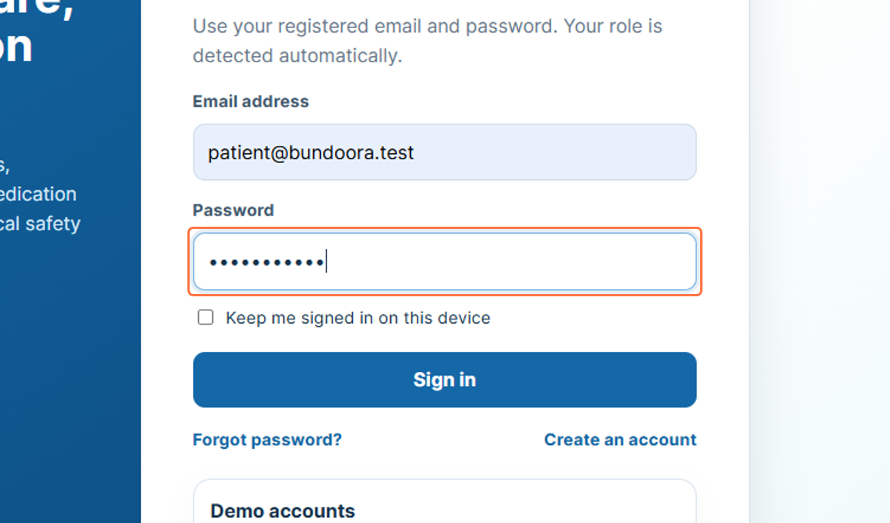
Figure 2: Entering the patient account password

3. Signing In - Submit Credentials
Selecting Sign in submits the entered credentials for authentication. When the credentials are accepted, the system opens the Patient Dashboard and provides access to patient-specific functions.
5. Check that the email address and password fields are completed.
6. Select Sign in.
7. Wait for the Patient Dashboard to load.
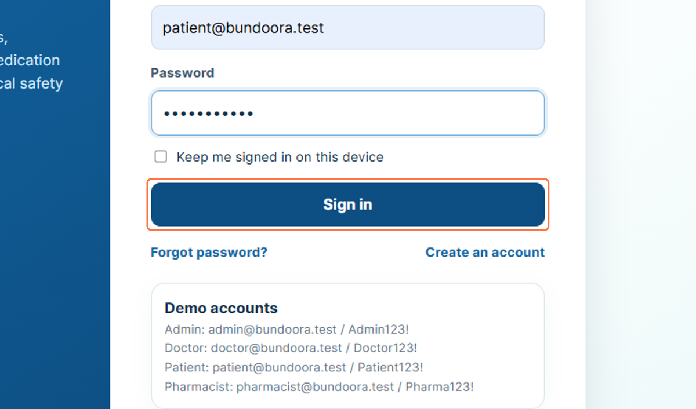
Figure 3: Selecting Sign in

4. Patient Profile Area
The profile card in the left sidebar identifies the patient who is currently signed in. In the workflow, the account is shown as Jordan Brown with the role Patient, allowing the user to confirm that the correct account is active.
8. Confirm the patient name shown in the sidebar.
9. Confirm that the role displayed is Patient.
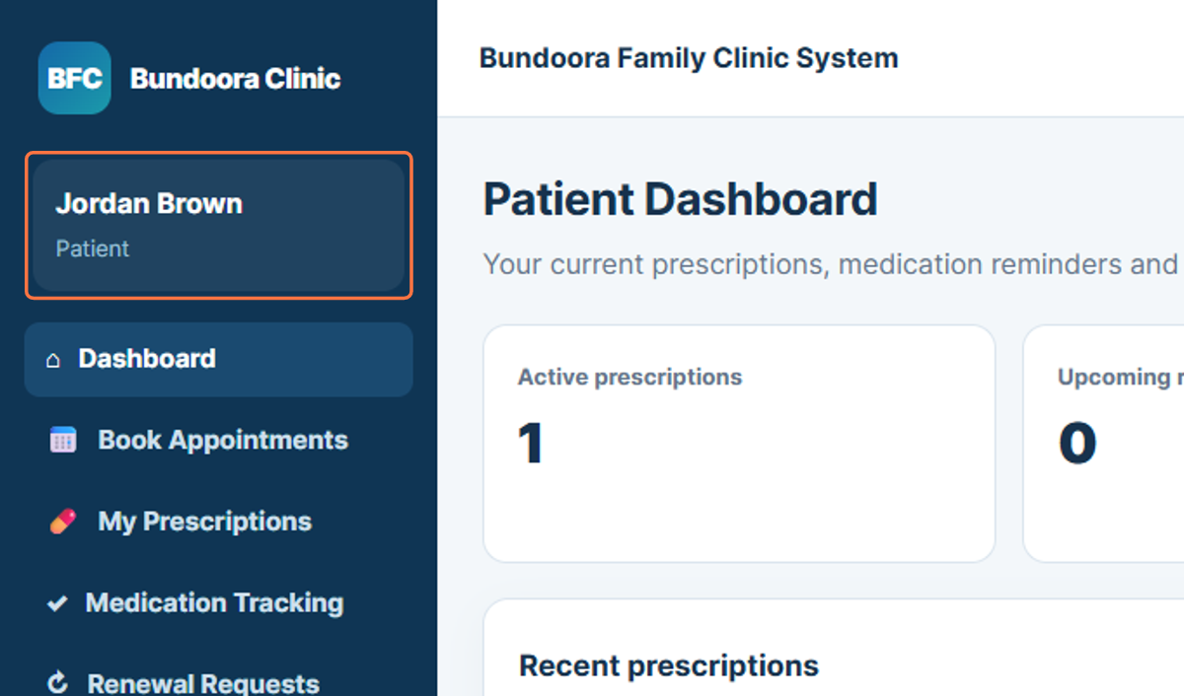
Figure 4: Patient identity and role shown in the sidebar

5. Dashboard
The Patient Dashboard is the main overview page for the patient account. It presents summary information such as active prescriptions, upcoming renewals, and recent prescription activity.
10. Select Dashboard from the sidebar.
11. Review the summary information and recent prescription activity.
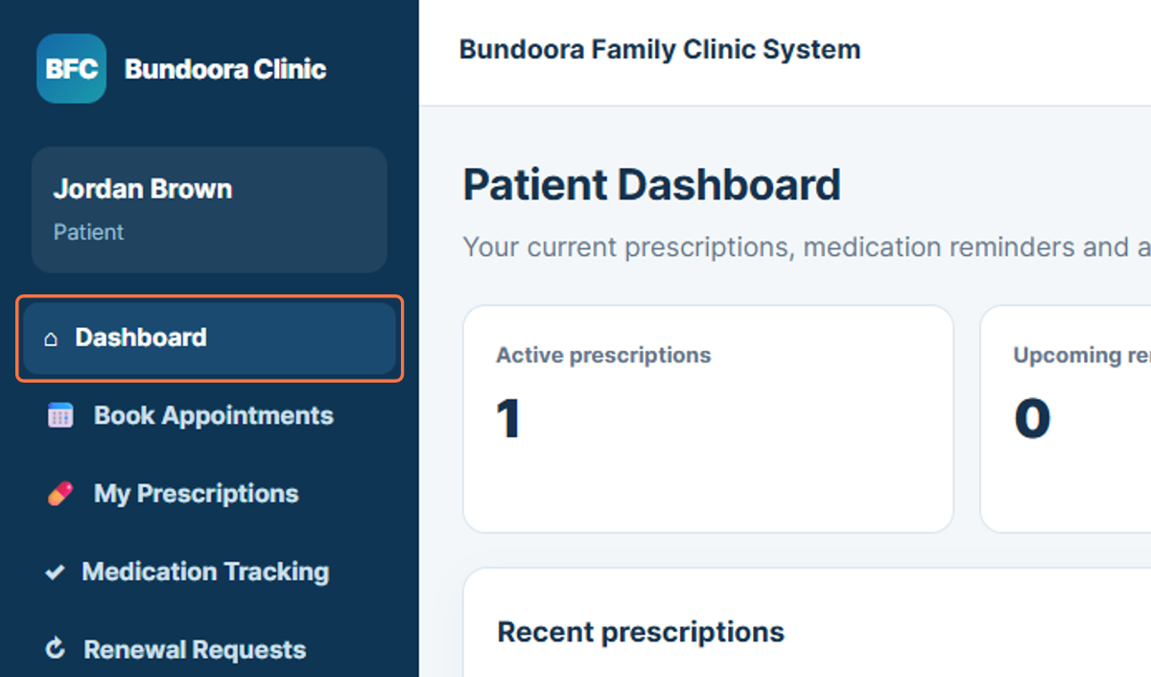
Figure 5: Patient Dashboard navigation

6. Book Appointments
Book Appointments allows the patient to select a doctor and choose an available consultation time. The workflow shows an appointment booking area where the patient can select a doctor, preferred date, and available hourly time slot.
12. Select Book Appointments from the sidebar.
13. Choose the doctor and preferred appointment date.
14. Review the available appointment time slots and continue with the required booking.
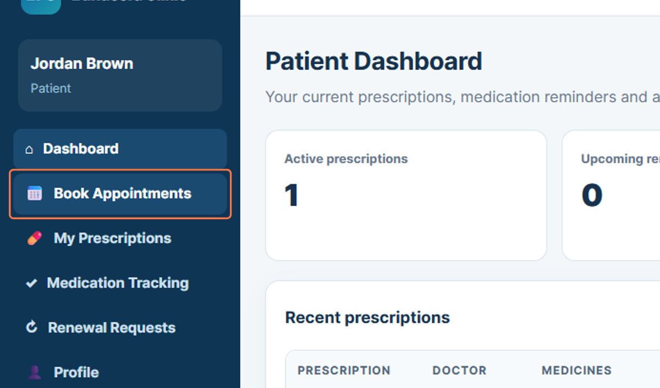
Figure 6: Opening Book Appointments

7. My Prescriptions
My Prescriptions provides access to the patient’s active and past prescription records. The page shown in the workflow displays prescription details together with the doctor and medicine information.
15. Select My Prescriptions from the sidebar.
16. Review the available prescription records and medicine details.
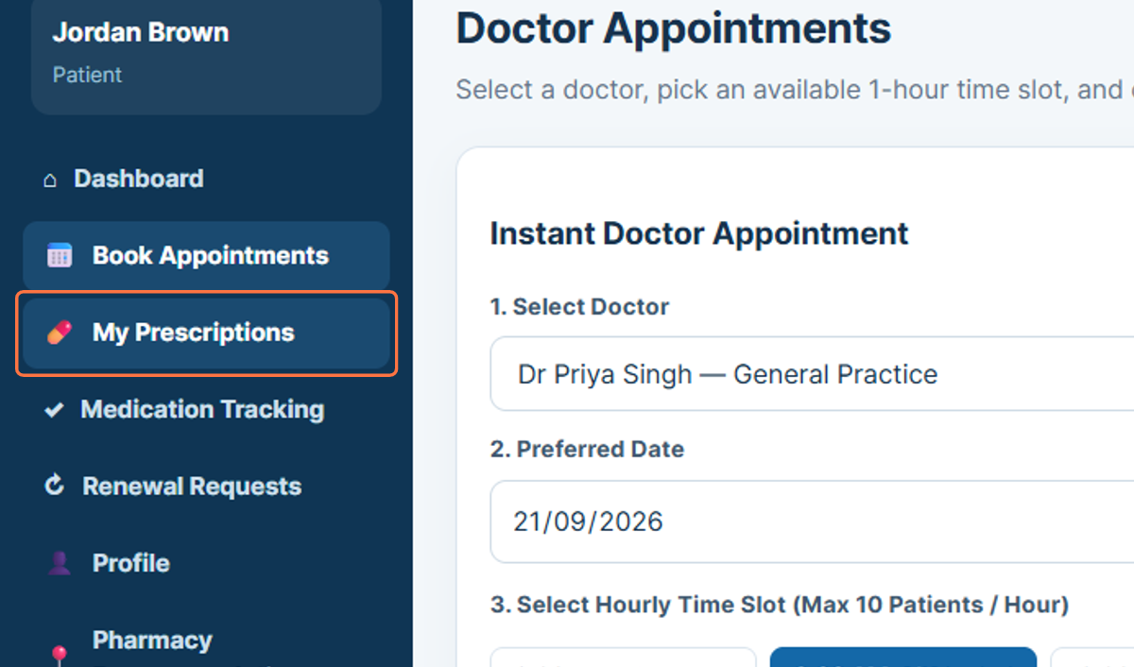
Figure 7: Opening My Prescriptions

8. Medication Tracking
Medication Tracking allows the patient to review prescribed medicines and medication-related information. This section supports ongoing monitoring of medicine schedules and medication status.
17. Select Medication Tracking from the sidebar.
18. Review the listed medicines, dosage information, and schedule details.
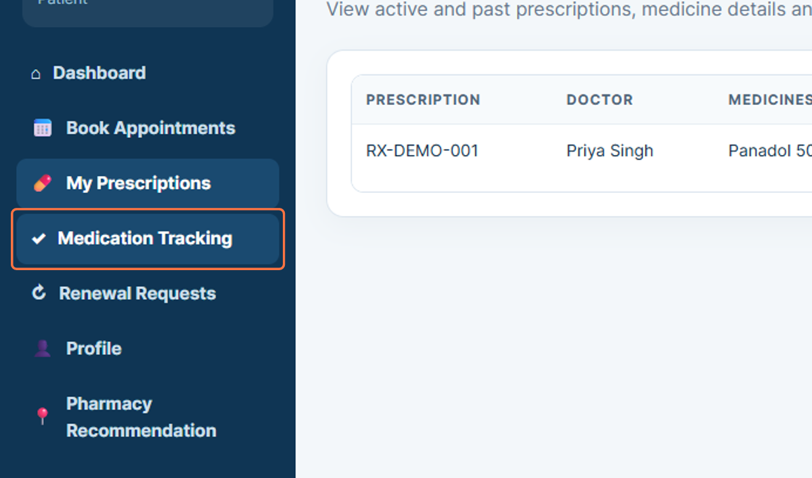
Figure 8: Opening Medication Tracking

9. Renewal Requests
Renewal Requests allows the patient to request a prescription renewal from the doctor. The workflow shows a prescription selection field and a notes area where the patient can provide the reason or additional information for the renewal request.
19. Select Renewal Requests from the sidebar.
20. Choose the prescription that requires renewal.
21. Enter any relevant notes for the doctor.
22. Submit the renewal request when the details are complete.
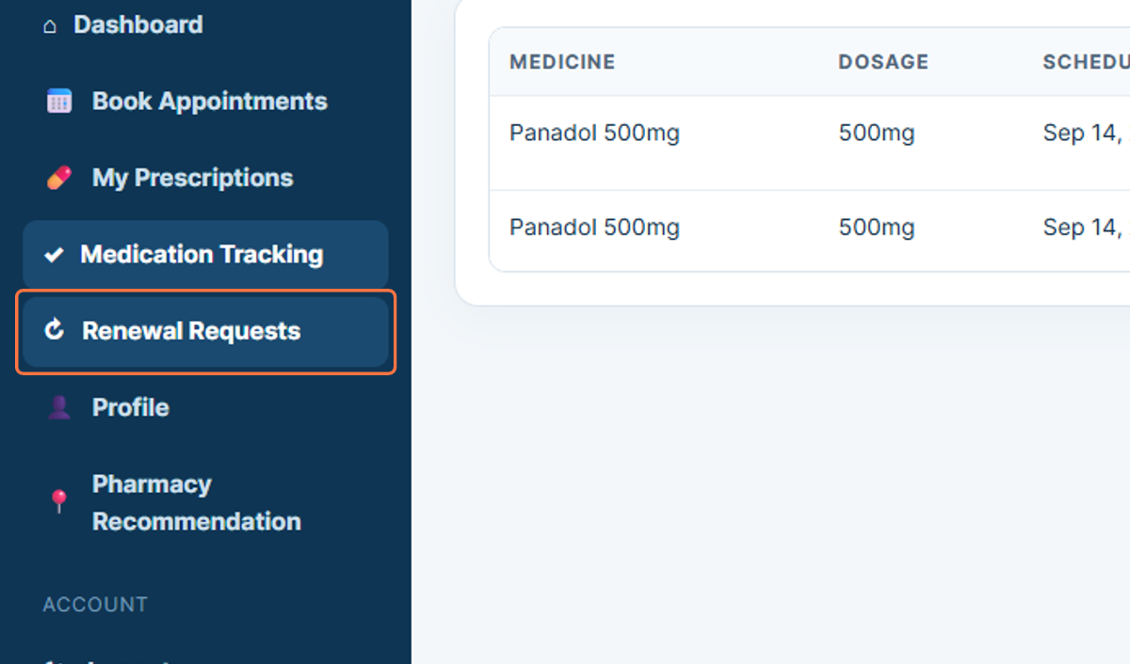
Figure 9: Opening Renewal Requests

10. Profile
The Profile section displays the patient’s personal information stored in the system. The workflow shows details such as date of birth, address, and Medicare number.
23. Select Profile from the sidebar.
24. Review the personal information displayed in the profile area.
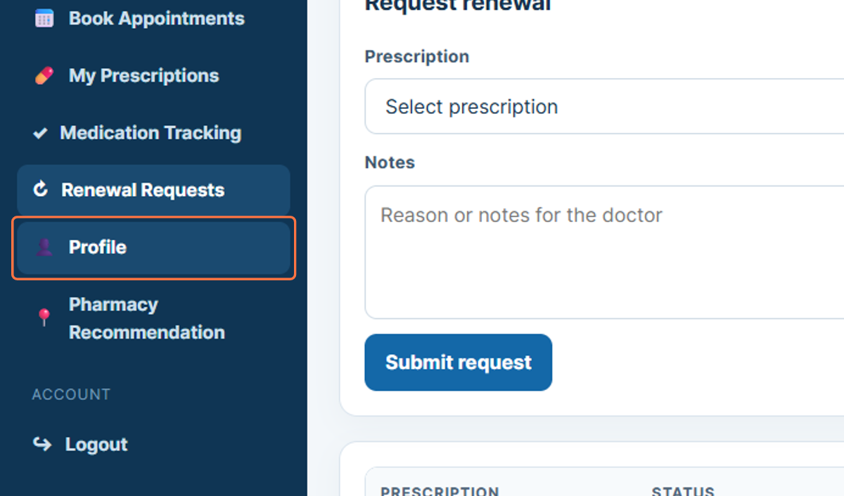
Figure 10: Opening the Patient Profile

11. Pharmacy Recommendation
Pharmacy Recommendation provides a way for the patient to search for a suitable pharmacy. The workflow shows a Find pharmacy option that can be used to locate pharmacy choices related to the patient’s medication needs.
25. Select Pharmacy Recommendation from the sidebar.
26. Review the pharmacy recommendation area.
27. Select Find pharmacy when a pharmacy search is required.
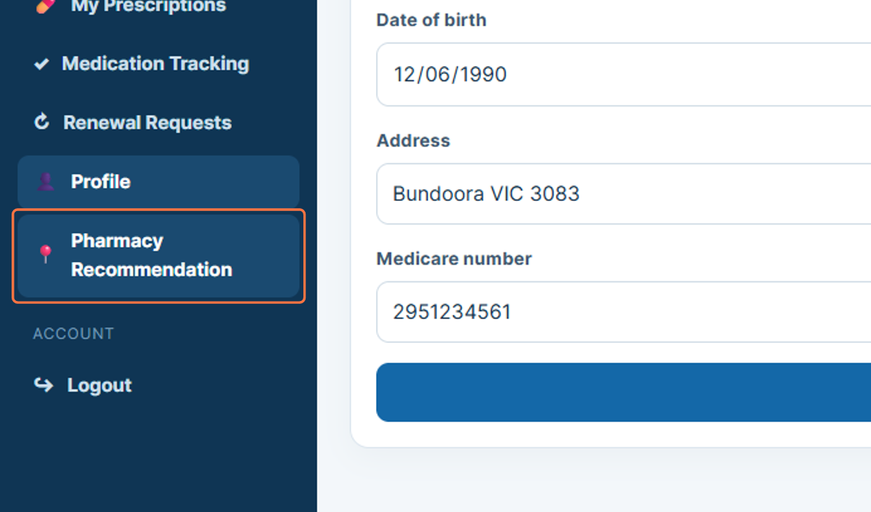
Figure 11: Opening Pharmacy Recommendation

12. Logout
Logout ends the current patient session. Signing out after reviewing prescriptions, renewals, or personal information helps prevent another person from accessing the active patient account.
28. Select Logout from the sidebar.
29. Confirm that the patient session has ended.
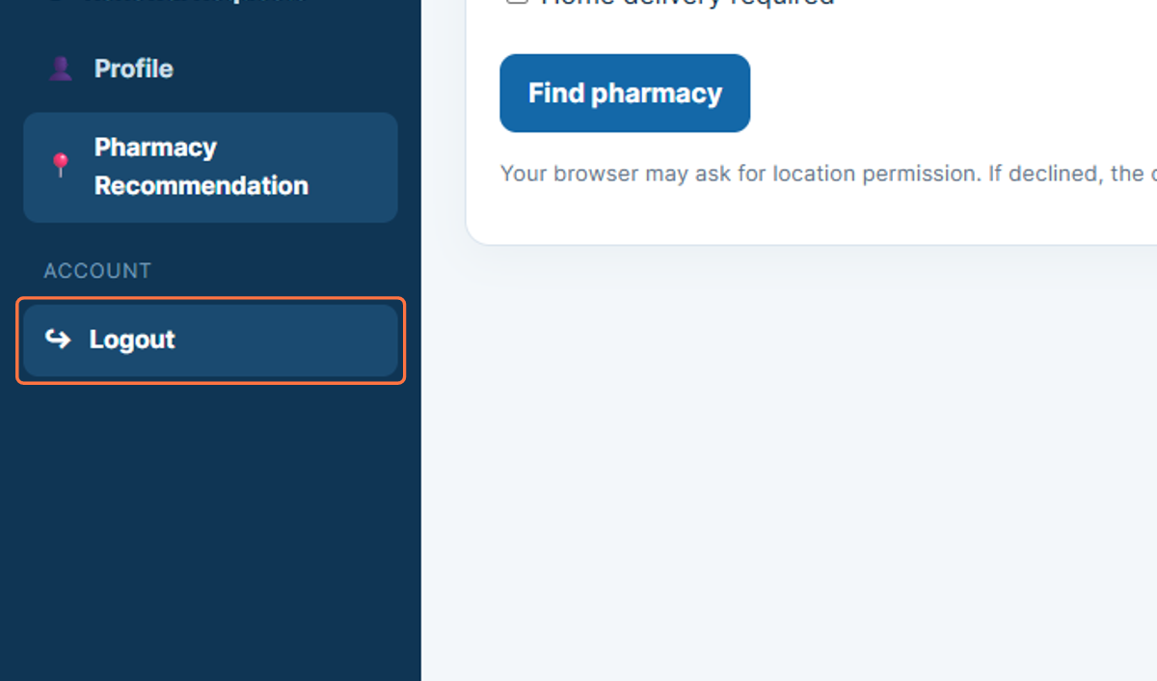
Figure 12: Logging out of the Patient Portal

