HTML VALIDATION TESTING
Bundoora Family Clinic – Public / Authentication HTML Pages
Name: Yam Bahadur Mohatra
Student ID: K230505
Validation tool: Nu Html Checker (file upload)
Purpose: This testing verifies the HTML structure of the clinic’s public and authentication pages. Each page with a reported error or warning was corrected and uploaded again to the Nu Html Checker. The final evidence supplied for this report shows that every listed page completed checking with no errors or warnings.

Result Summary
Page | Before validation | Problem identified | Final result
about.html | 1 error | The footer <h4> heading followed an <h2>, skipping heading level 3. | PASS – No errors or warnings
contact.html | 1 error | The footer <h4> heading followed an <h2>, skipping heading level 3. | PASS – No errors or warnings
forgot-password.html | 0 errors, 1 warning | The promotional text used an additional <h1>, so the checker warned that h1 should be reserved for the top-level page heading. | PASS – No errors or warnings
index.html | 1 error | The footer <h4> heading followed an <h2>, skipping heading level 3. | PASS – No errors or warnings
login.html | 0 errors, 1 warning | The promotional text used an extra <h1>, causing a top-level heading warning. | PASS – No errors or warnings
otp.html | 0 errors, 1 warning | The promotional text used an additional <h1>, producing a top-level h1 warning. | PASS – No errors or warnings
register.html | 0 errors, 1 warning | The promotional heading was an additional <h1>, resulting in a top-level heading warning. | PASS – No errors or warnings
reset-password.html | 0 errors, 1 warning | The promotional text used an additional <h1>, triggering the top-level h1 warning. | PASS – No errors or warnings
services.html | 1 error | An <h3> service heading followed the page <h1>, skipping heading level 2. | PASS – No errors or warnings
logout.html | 0 errors, 0 warnings | No validation issue was reported. | PASS – No errors or warnings
Overall result: All 10 public/authentication HTML pages are supported by final Nu Html Checker evidence showing “Document checking completed. No errors or warnings to show.” Nine pages required heading-structure corrections; logout.html already passed without modification.

1. about.html
Original code (incorrect)
<h2>Our Mission</h2>
...
<h4>Clinic</h4>
<h4>Portals</h4>
<h4>Support</h4>
HTML validation error / warning
1 error. The footer <h4> heading followed an <h2>, skipping heading level 3.
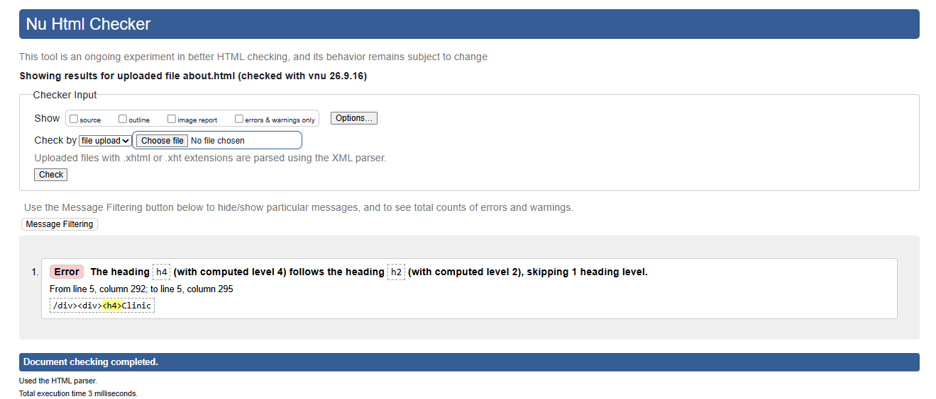
Figure 1A. Original Nu Html Checker result for about.html.
Fix applied
Changed the footer headings from h4 to h3 so the heading structure no longer skips a level.
Corrected code
<h2>Our Mission</h2>
...
<h3>Clinic</h3>
<h3>Portals</h3>
<h3>Support</h3>
Final HTML validation result
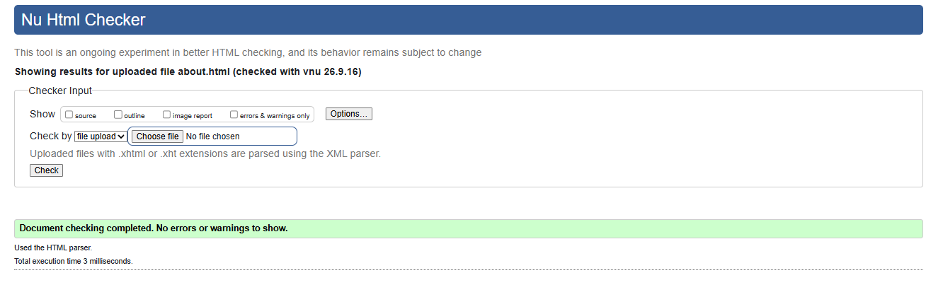
Figure 1B. Final Nu Html Checker result for about.html: no errors or warnings.

2. contact.html
Original code (incorrect)
<h2>Send us a message</h2>
...
<h4>Clinic</h4>
<h4>Portals</h4>
<h4>Support</h4>
HTML validation error / warning
1 error. The footer <h4> heading followed an <h2>, skipping heading level 3.
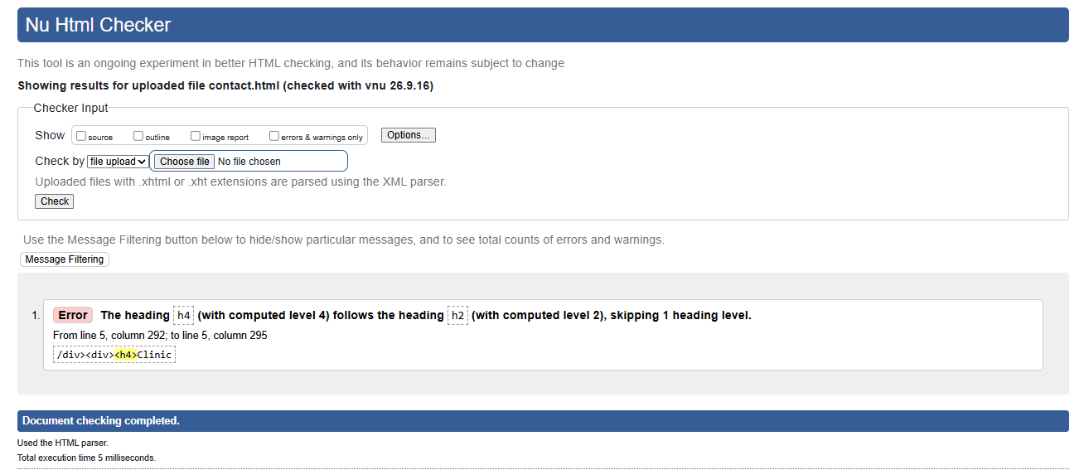
Figure 2A. Original Nu Html Checker result for contact.html.
Fix applied
Changed the footer headings from h4 to h3 to maintain a logical heading hierarchy.
Corrected code
<h2>Send us a message</h2>
...
<h3>Clinic</h3>
<h3>Portals</h3>
<h3>Support</h3>
Final HTML validation result
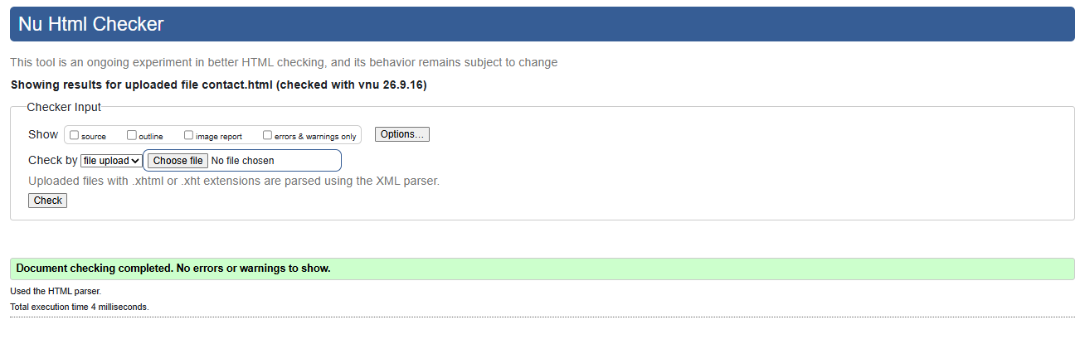
Figure 2B. Final Nu Html Checker result for contact.html: no errors or warnings.

3. forgot-password.html
Original code (incorrect)
<h1 style="font-size:2.4rem;line-height:1.08;margin-top:48px">Secure digital care, from prescription to pharmacy.</h1>
...
<h1>Forgot your password?</h1>
HTML validation error / warning
0 errors, 1 warning. The promotional text used an additional <h1>, so the checker warned that h1 should be reserved for the top-level page heading.
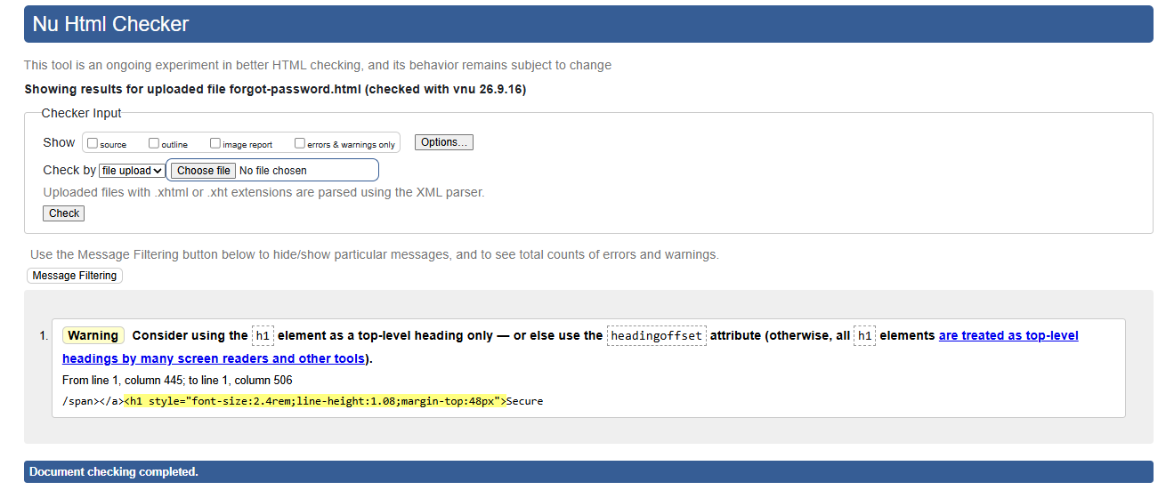
Figure 3A. Original Nu Html Checker result for forgot-password.html.
Fix applied
Changed the promotional heading from h1 to h2 and kept “Forgot your password?” as the page-level h1.
Corrected code
<h2 style="font-size:2.4rem;line-height:1.08;margin-top:48px">Secure digital care, from prescription to pharmacy.</h2>
...
<h1>Forgot your password?</h1>
Final HTML validation result
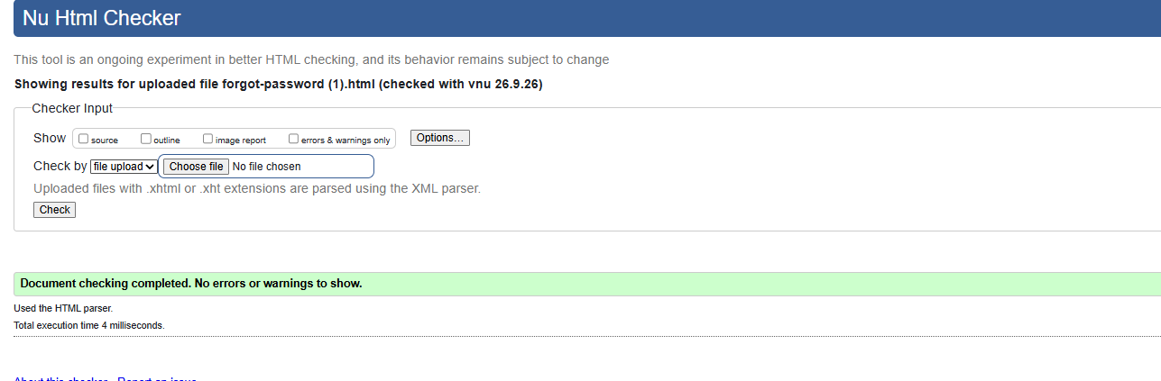
Figure 3B. Final Nu Html Checker result for forgot-password.html: no errors or warnings.

4. index.html
Original code (incorrect)
<h2>Built for every role in the care journey</h2>
...
<h4>Clinic</h4>
<h4>Portals</h4>
<h4>Support</h4>
HTML validation error / warning
1 error. The footer <h4> heading followed an <h2>, skipping heading level 3.
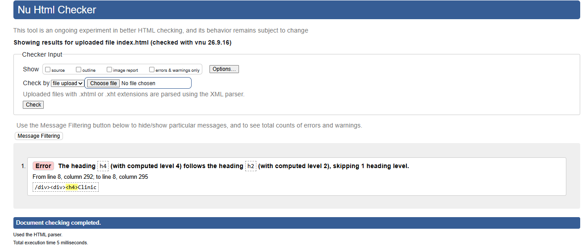
Figure 4A. Original Nu Html Checker result for index.html.
Fix applied
Changed the footer headings from h4 to h3 so the document follows a sequential heading structure.
Corrected code
<h2>Built for every role in the care journey</h2>
...
<h3>Clinic</h3>
<h3>Portals</h3>
<h3>Support</h3>
Final HTML validation result
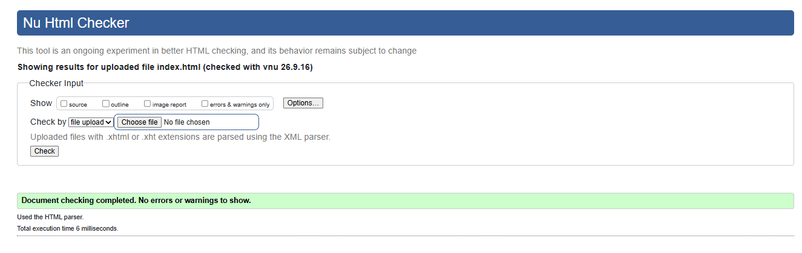
Figure 4B. Final Nu Html Checker result for index.html: no errors or warnings.

5. login.html
Original code (incorrect)
<h1 style="font-size:2.4rem;line-height:1.08;margin-top:48px">Secure digital care, from prescription to pharmacy.</h1>
...
<h1>Welcome back</h1>
HTML validation error / warning
0 errors, 1 warning. The promotional text used an extra <h1>, causing a top-level heading warning.
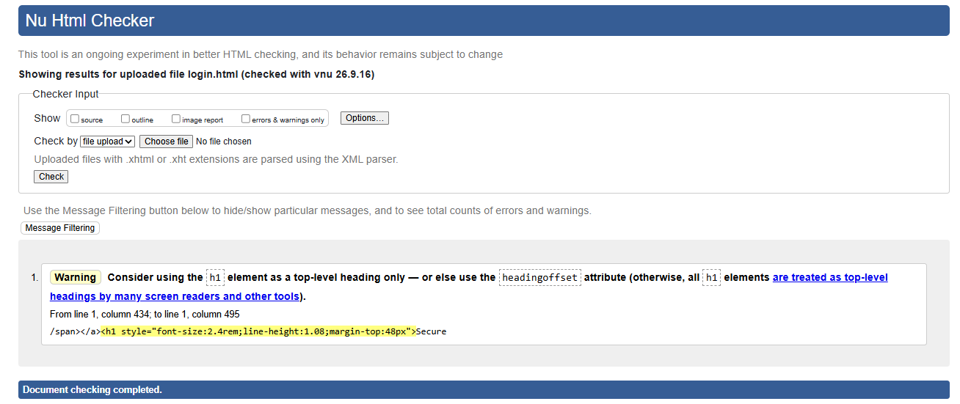
Figure 5A. Original Nu Html Checker result for login.html.
Fix applied
Changed the promotional heading to h2 and retained “Welcome back” as the main h1.
Corrected code
<h2 style="font-size:2.4rem;line-height:1.08;margin-top:48px">Secure digital care, from prescription to pharmacy.</h2>
...
<h1>Welcome back</h1>
Final HTML validation result
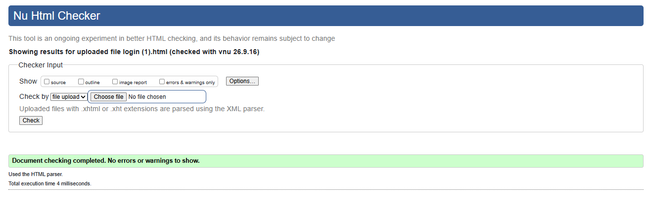
Figure 5B. Final Nu Html Checker result for login.html: no errors or warnings.

6. otp.html
Original code (incorrect)
<h1 style="font-size:2.4rem;line-height:1.08;margin-top:48px">Secure digital care, from prescription to pharmacy.</h1>
...
<h1>Verify your account</h1>
HTML validation error / warning
0 errors, 1 warning. The promotional text used an additional <h1>, producing a top-level h1 warning.
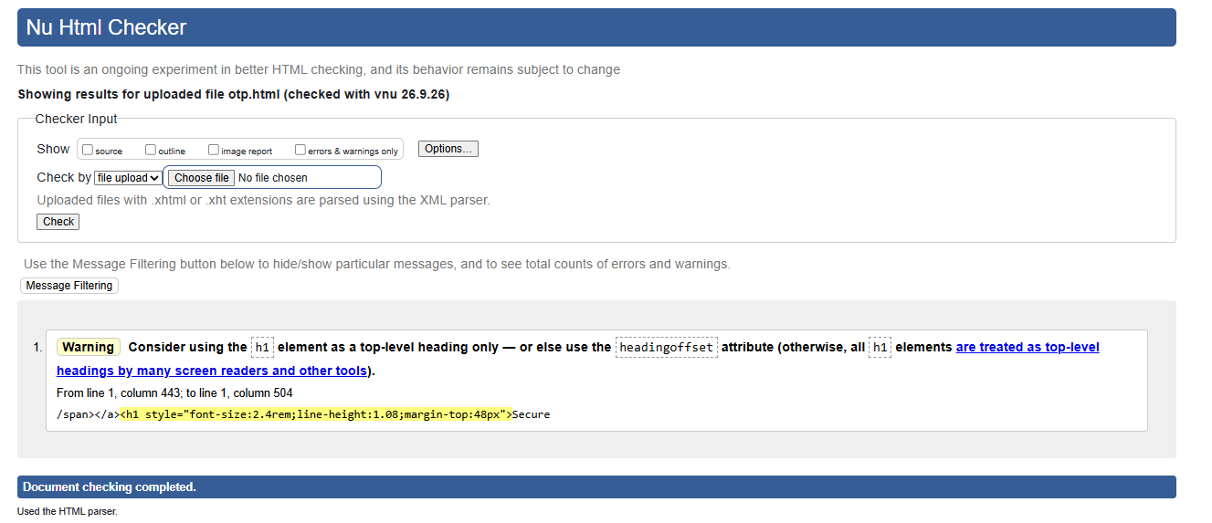
Figure 6A. Original Nu Html Checker result for otp.html.
Fix applied
Changed the promotional heading from h1 to h2 and kept “Verify your account” as the main h1.
Corrected code
<h2 style="font-size:2.4rem;line-height:1.08;margin-top:48px">Secure digital care, from prescription to pharmacy.</h2>
...
<h1>Verify your account</h1>
Final HTML validation result
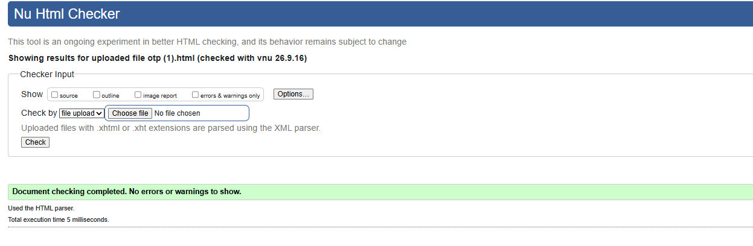
Figure 6B. Final Nu Html Checker result for otp.html: no errors or warnings.

7. register.html
Original code (incorrect)
<h1 style="font-size:2.4rem;line-height:1.08;margin-top:48px">Secure digital care, from prescription to pharmacy.</h1>
...
<h1>Create your Patient Account</h1>
HTML validation error / warning
0 errors, 1 warning. The promotional heading was an additional <h1>, resulting in a top-level heading warning.
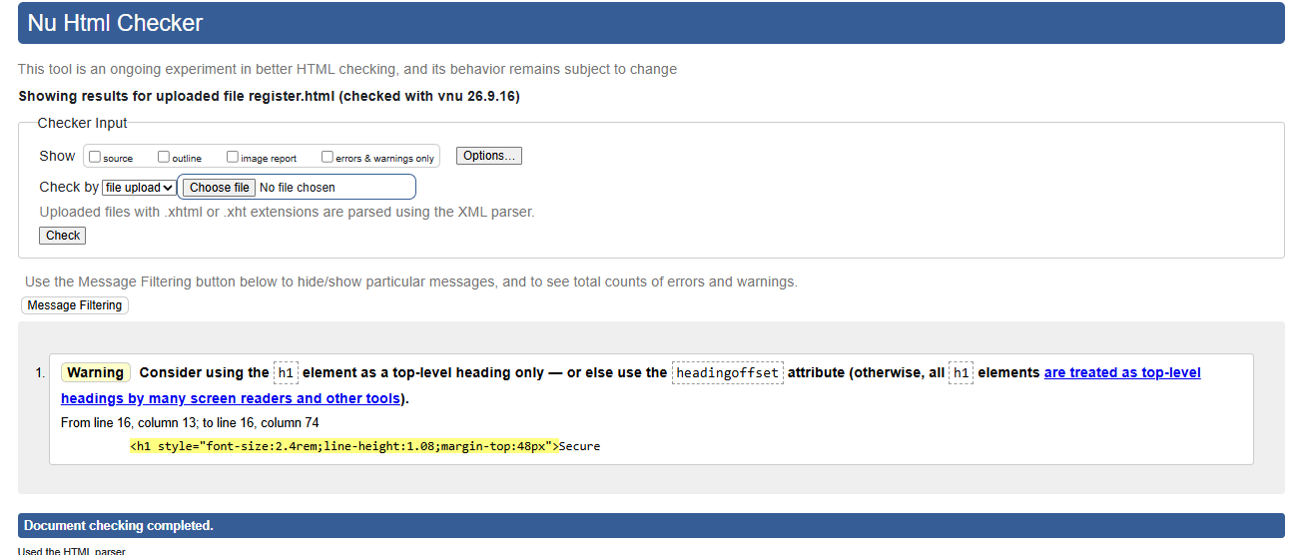
Figure 7A. Original Nu Html Checker result for register.html.
Fix applied
Changed the promotional heading to h2 while keeping “Create your Patient Account” as the page-level h1.
Corrected code
<h2 style="font-size:2.4rem;line-height:1.08;margin-top:48px">Secure digital care, from prescription to pharmacy.</h2>
...
<h1>Create your Patient Account</h1>
Final HTML validation result
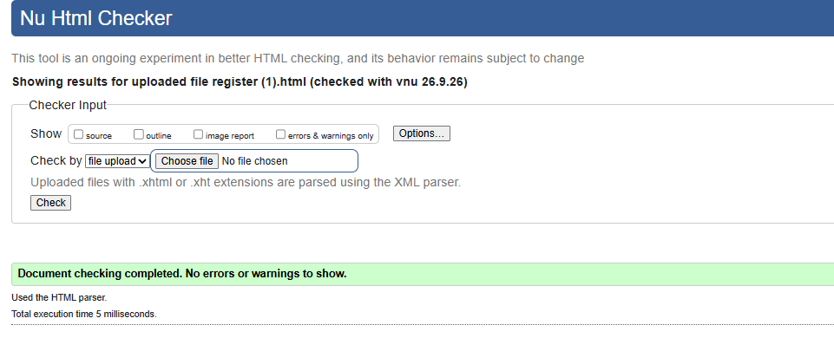
Figure 7B. Final Nu Html Checker result for register.html: no errors or warnings.

8. reset-password.html
Original code (incorrect)
<h1 style="font-size:2.4rem;line-height:1.08;margin-top:48px">Secure digital care, from prescription to pharmacy.</h1>
...
<h1>Choose a new password</h1>
HTML validation error / warning
0 errors, 1 warning. The promotional text used an additional <h1>, triggering the top-level h1 warning.
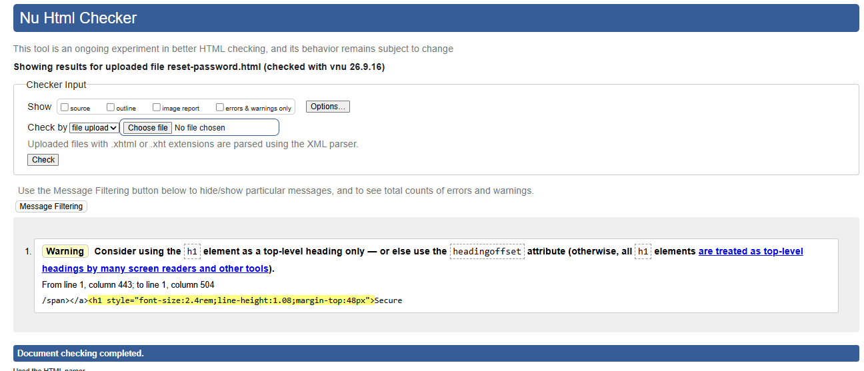
Figure 8A. Original Nu Html Checker result for reset-password.html.
Fix applied
Changed the promotional heading to h2 and kept “Choose a new password” as the main h1.
Corrected code
<h2 style="font-size:2.4rem;line-height:1.08;margin-top:48px">Secure digital care, from prescription to pharmacy.</h2>
...
<h1>Choose a new password</h1>
Final HTML validation result
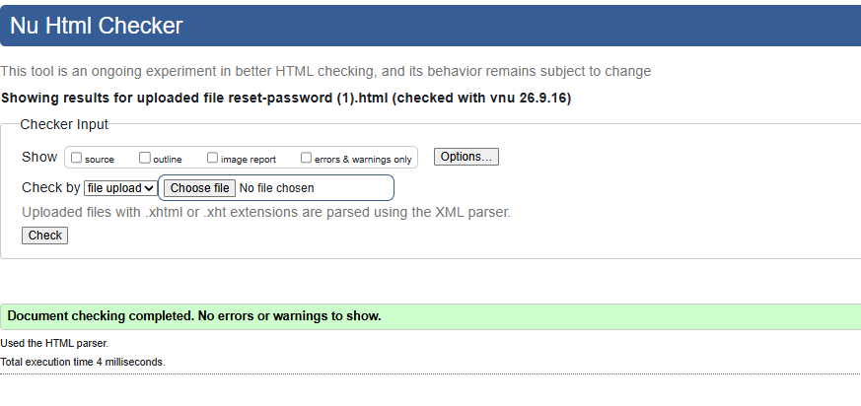
Figure 8B. Final Nu Html Checker result for reset-password.html: no errors or warnings.

9. services.html
Original code (incorrect)
<h1>Services</h1>
...
<h3>General Practice</h3>
<h3>Digital Prescriptions</h3>
<h3>Medication Tracking</h3>
HTML validation error / warning
1 error. An <h3> service heading followed the page <h1>, skipping heading level 2.
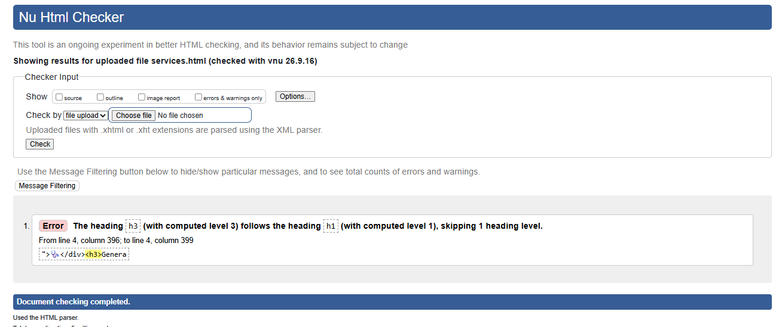
Figure 9A. Original Nu Html Checker result for services.html.
Fix applied
Changed the service-card headings from h3 to h2 so they correctly sit beneath the page h1.
Corrected code
<h1>Services</h1>
...
<h2>General Practice</h2>
<h2>Digital Prescriptions</h2>
<h2>Medication Tracking</h2>
Final HTML validation result
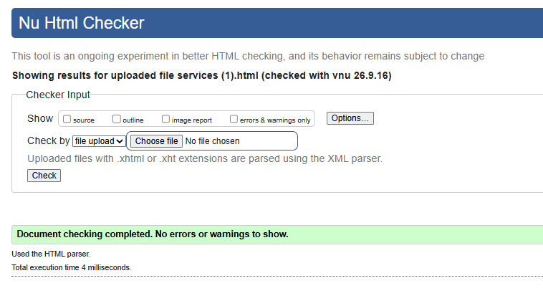
Figure 9B. Final Nu Html Checker result for services.html: no errors or warnings.

10. logout.html
The logout page did not require a correction. Its Nu Html Checker result already showed that the document completed checking with no errors or warnings.
Final HTML validation result
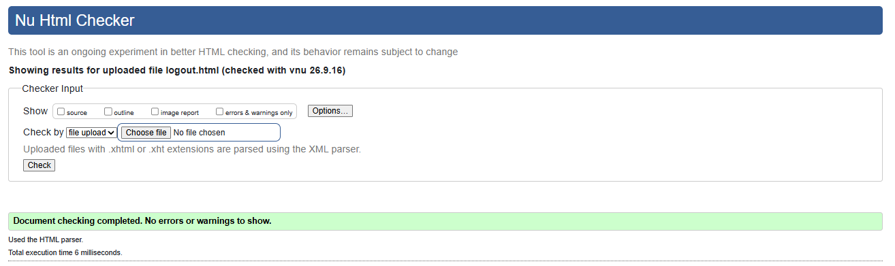
Figure 10. Nu Html Checker result for logout.html: no errors or warnings.

Validation Conclusion
The HTML validation process identified heading-hierarchy problems in the public pages and top-level h1 warnings in the authentication pages. These issues were corrected by using h1 for the main page title and appropriate h2/h3 levels for supporting headings. After the corrections, all tested pages were rechecked and the supplied final results show no remaining HTML errors or warnings.

HTML VALIDATION TESTING - ADMIN PORTAL

HTML VALIDATION TESTING
Bundoora Family Clinic- Admin Portal
Result summary
Page | Before | Issue(s) found | After fix
dashboard.html | 0 errors, 1 warning | No h1 (fix then caused a heading-skip error) | Pass
appointments.html | 0 errors, 1 warning | No h1 | Pass
audit-logs.html | 0 errors, 2 warnings | No h1, section lacks heading | Pass
inventory.html | 0 errors, 2 warnings | No h1, section lacks heading | Pass
notifications.html | 0 errors, 2 warnings | No h1, section lacks heading | Pass
pharmacy-network.html | 0 errors, 1 warning | No h1 | Pass
recalls.html | 1 error, 2 warnings | Required select with no option, no h1, section lacks heading | Pass
reports.html | 0 errors, 1 warning | No h1 | Pass
roles.html | 0 errors, 1 warning | No h1 | Pass
settings.html | 0 errors, 2 warnings | No h1, section lacks heading | Pass
shortages.html | 0 errors, 1 warning | No h1 | Pass
users.html | 0 errors, 1 warning | No h1 | Pass

Detailed Testing Page By Page

Dashboard.html
Original code (incorrect)
<div class="page-head"><div><h2>Admin Dashboard</h2>
...
<div class="panel-title"><h3>Recently registered users</h3>
...
<div class="panel-title"><h3>System health & alerts</h3></div>
W3C error message
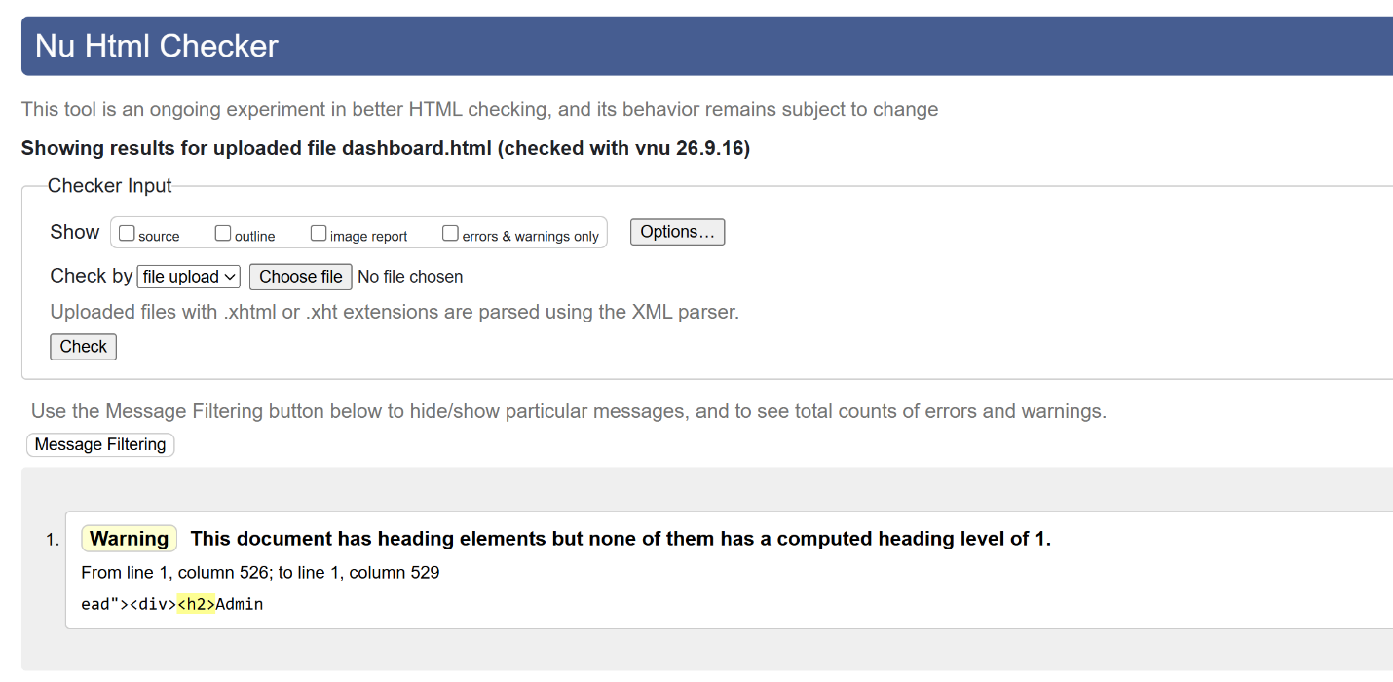
Fix applied
Changed the page title to h1 and the two panel headings from h3 to h2.
Final W3C message
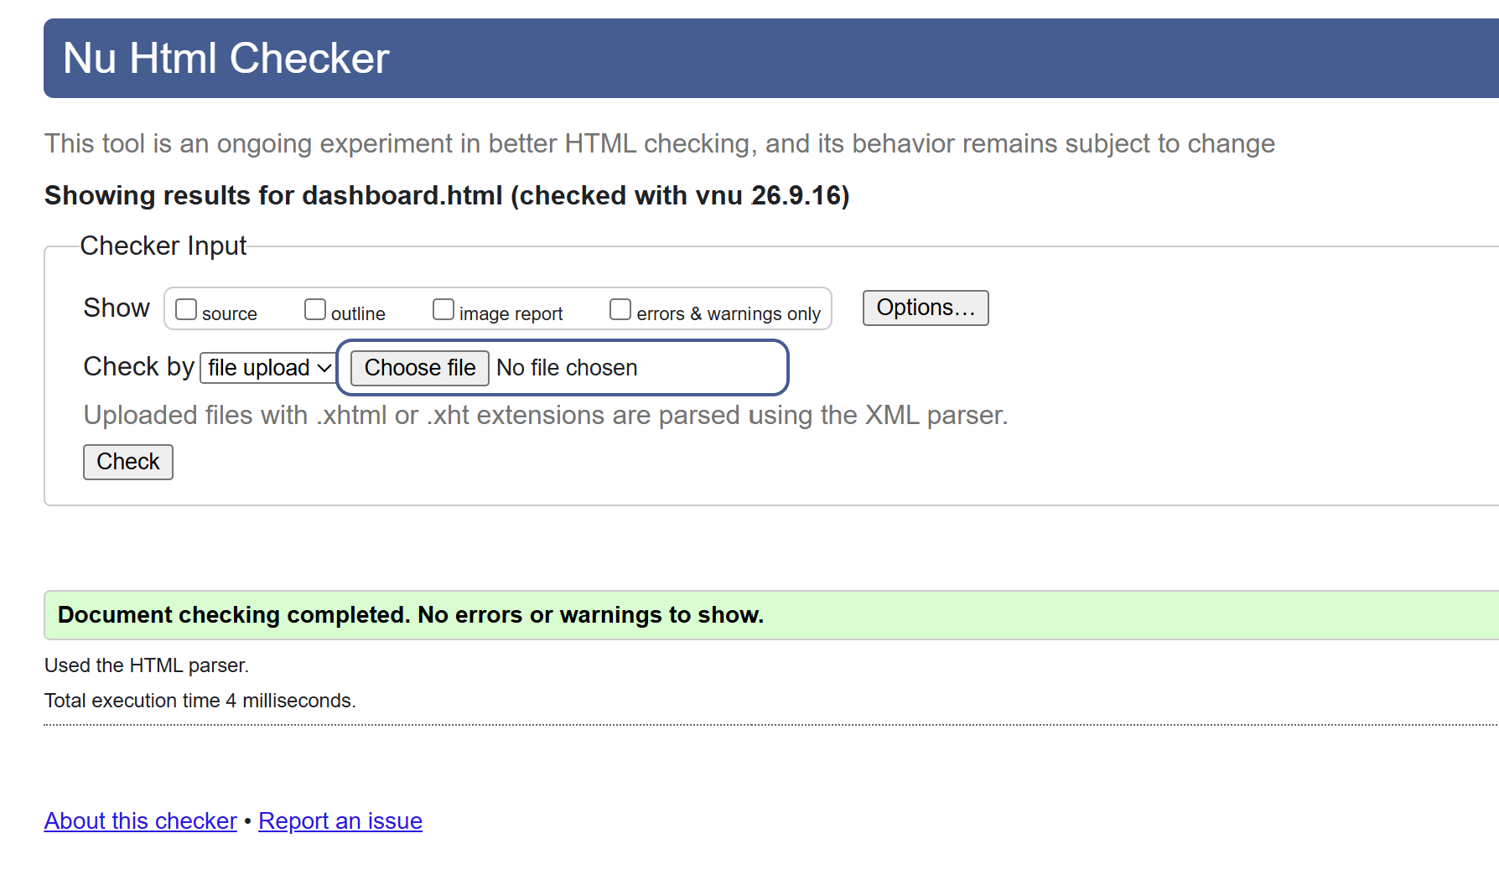

appointments.html
Original code (incorrect)
<div class="page-head"><div><h2>Clinic Appointment Management</h2>
...
<div class="panel-title" style="flex-wrap:wrap;gap:12px"><h3>All Appointments</h3>
HTML validation error / warning message
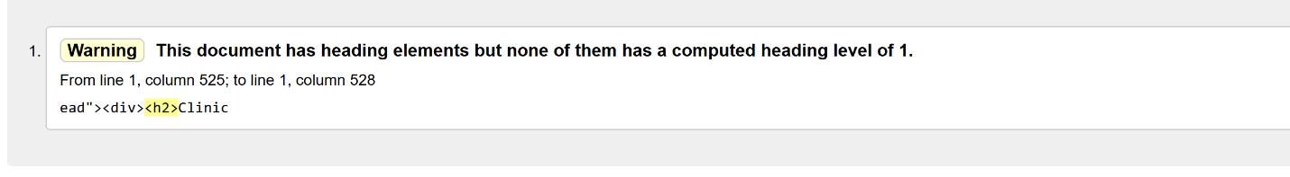
Fix applied
Changed the page title to h1 and 'All Appointments' to h2. Modal headings stay h3. Tab title changed to match other pages.
Final HTML validation result
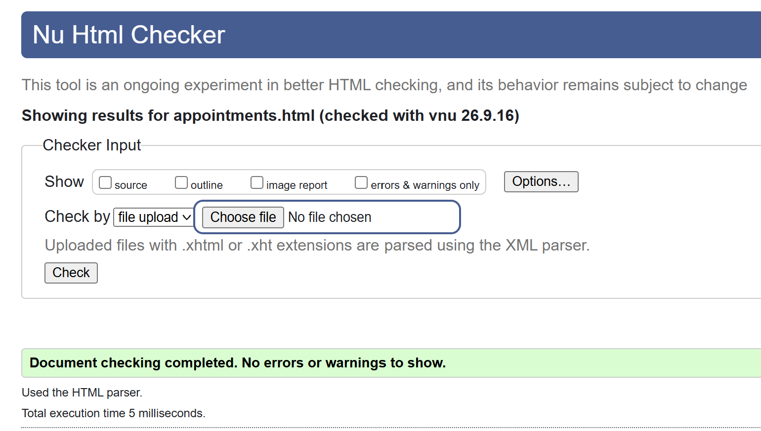

audit-logs.html
Original code (incorrect)
<div class="page-head"><div><h2>Audit Logs</h2>
...
<section class="panel"><div class="table-wrap"><table class="data-table" id="auditTable">
HTML validation error / warning message
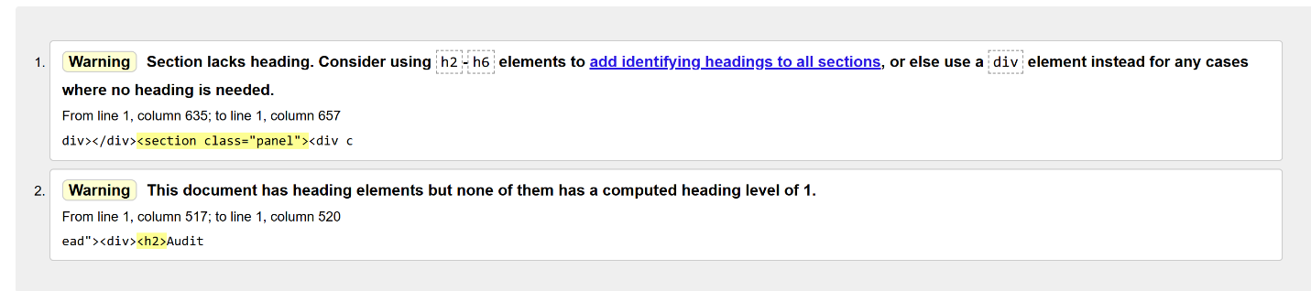
Fix applied
Changed the page title to h1 and added an h2 heading ('System Activity Log') inside the section.
Final HTML validation result
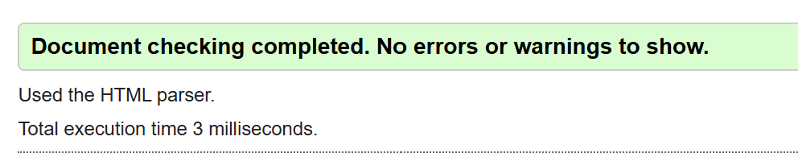

inventory.html
Original code (incorrect)
<div class="page-head"><div><h2>Inventory Overview</h2>
...
<section class="panel"><div class="table-wrap"><table class="data-table" id="inventoryTable">
HTML validation error / warning message
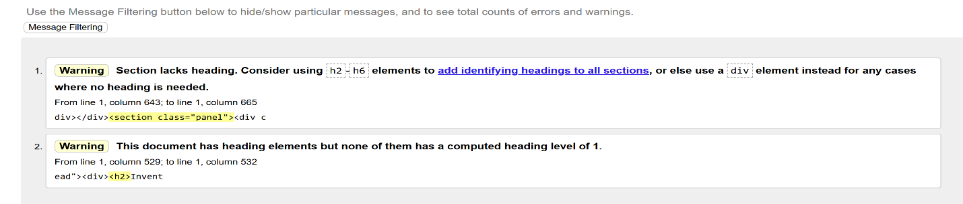
Fix applied
Changed the page title to h1 and added an h2 heading ('Medicine Stock Levels') inside the section.
Final HTML validation result

notifications.html
Original code (incorrect)
<div class="page-head"><div><h2>Notifications</h2>
...
<section class="panel"><div class="table-wrap"><table class="data-table" id="notificationTable">
HTML validation error / warning message
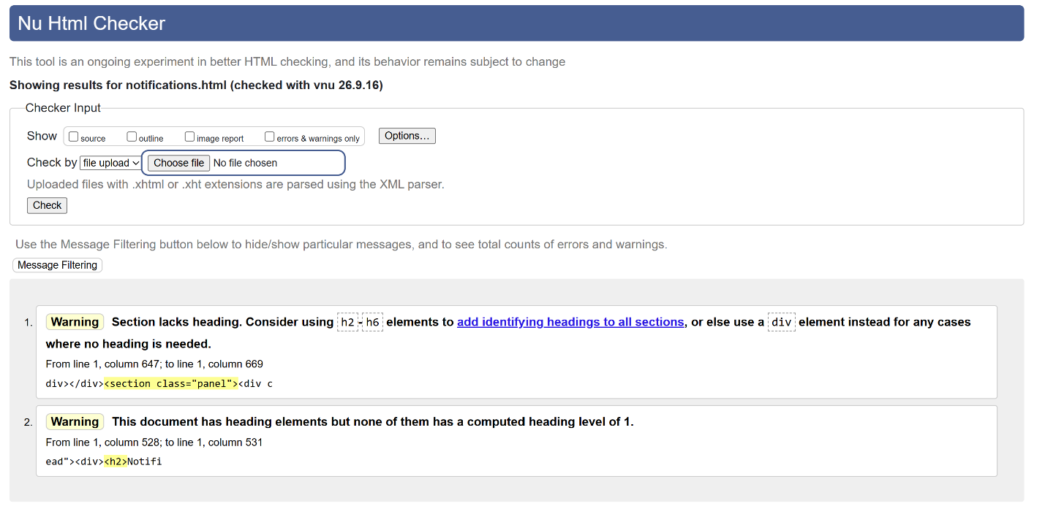
Fix applied
Changed the page title to h1 and added an h2 heading ('Notification History') inside the section.
Final HTML validation result

pharmacy-network.html
Original code (incorrect)
<div class="page-head"><div><h2>Pharmacy Network Overview</h2>
HTML validation error / warning message
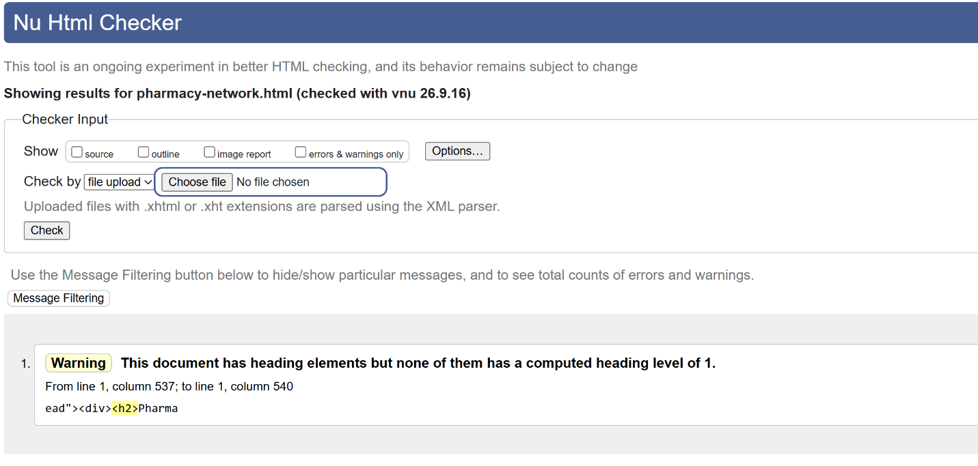
Fix applied
Changed the page title to h1.
Final HTML validation result

recalls.html
Original code (incorrect)
<div class="page-head"><div><h2>Batch Recall Management</h2>
...
<select id="recallBatch" name="batch_id" required></select>
...
<section class="panel"><div class="table-wrap"><table class="data-table" id="recallTable">
HTML validation error / warning message
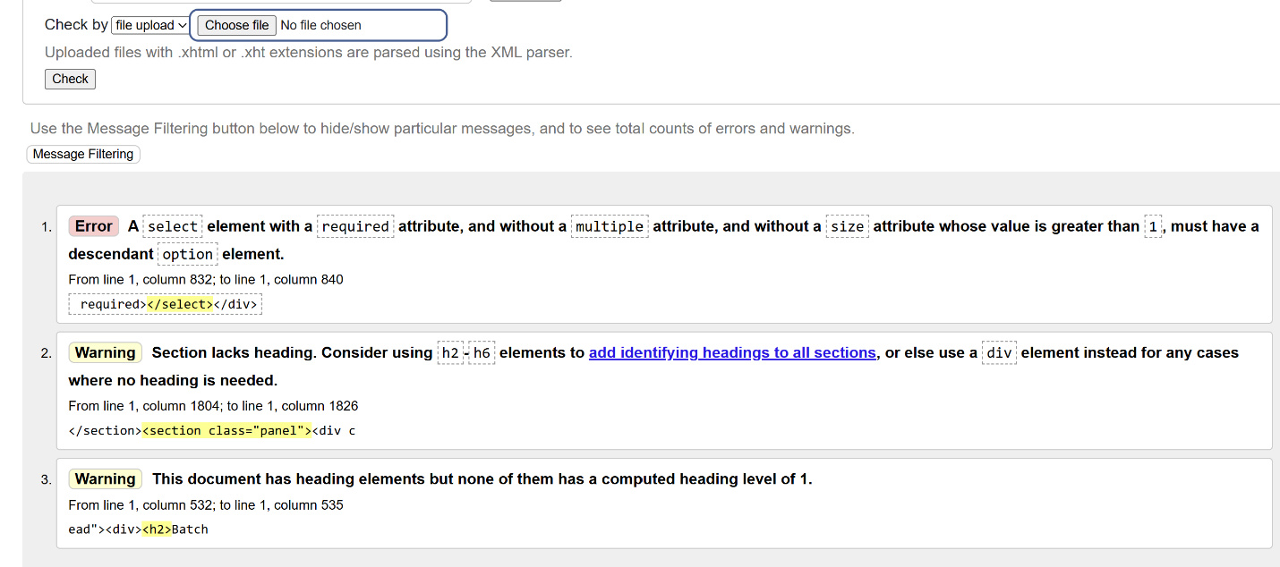
Fix applied
Added a placeholder option to the select, changed the page title to h1, changed panel h3 headings to h2, and added an h2 heading ('Recall History') to the last section.
Final HTML validation result

reports.html
Original code (incorrect)

<div class="page-head"><div><h2>System Reports</h2>
...
<div class="panel-title"><h3>Export reports</h3></div>
HTML validation error / warning message

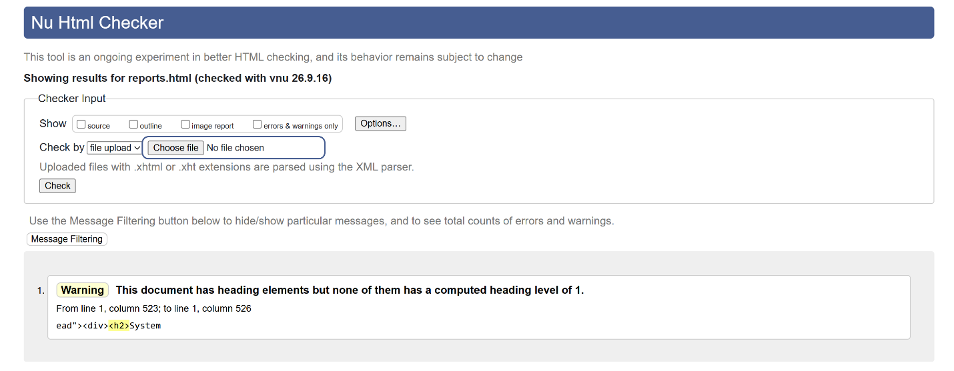
Fix applied
Changed the page title to h1 and 'Export reports' to h2. Card headings stay h3.
Final HTML validation result

roles.html
Original code (incorrect)
<div class="page-head"><div><h2>Role Management</h2>
...
<section class="panel" style="margin-top:20px"><h3>Access model</h3>
HTML validation error / warning message
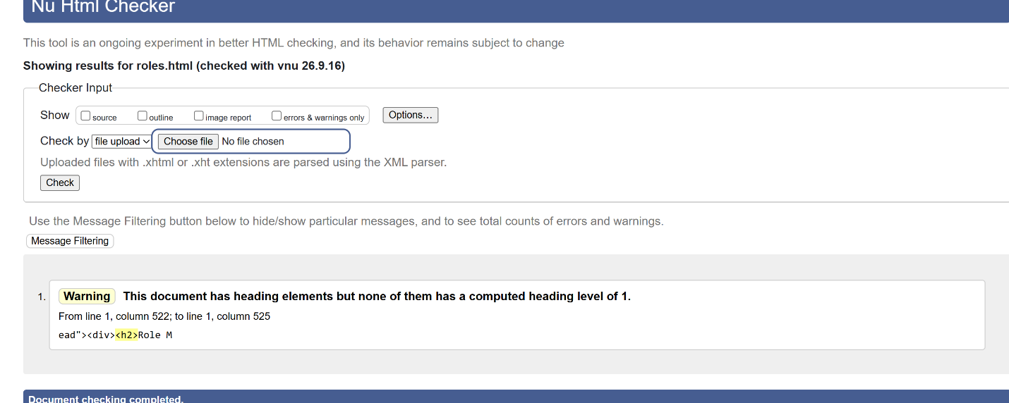
Fix applied
Changed the page title to h1 and 'Access model' to h2.
Final HTML validation result

settings.html
Original code (incorrect)
<div class="page-head"><div><h2>System Settings</h2>
...
<section class="panel"><form id="settingsForm" class="form-grid">
HTML validation error / warning message
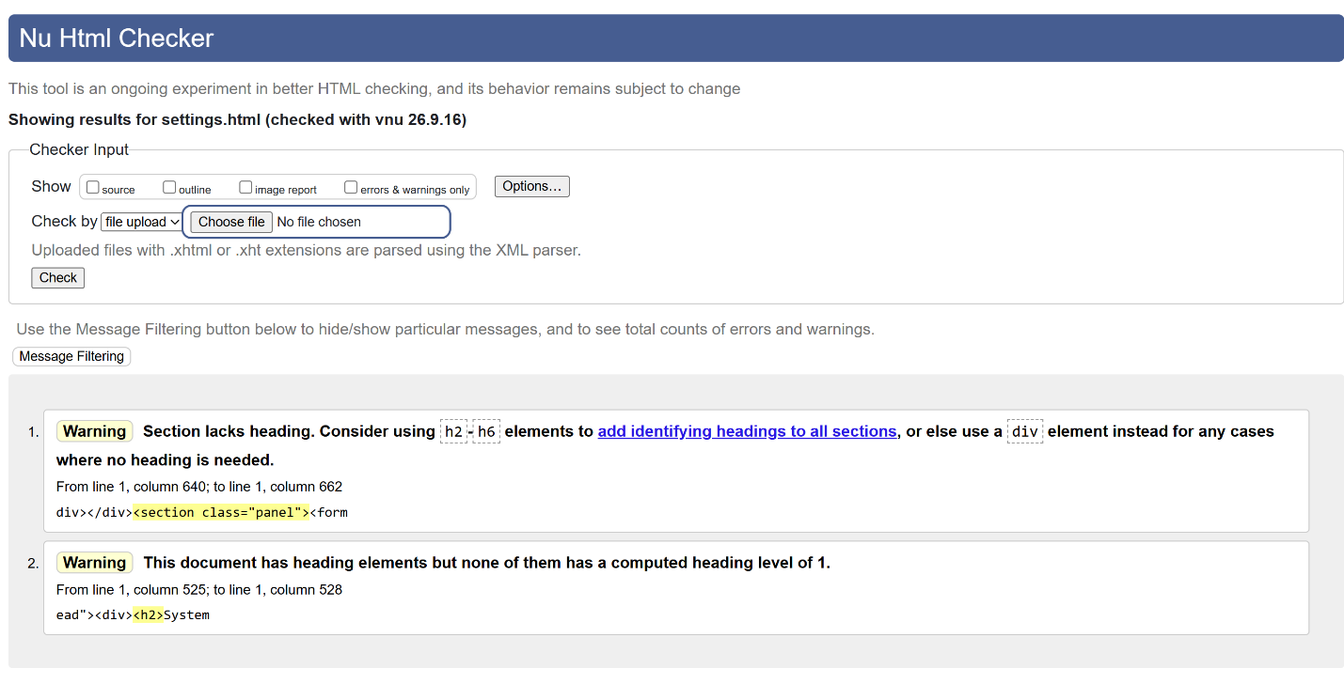
Fix applied
Changed the page title to h1 and added an h2 heading ('Clinic Configuration') above the form.
Final HTML validation result

shortages.html
Original code (incorrect)
<div class="page-head"><div><h2>Shortage Monitoring</h2>
...
<div class="panel-title"><h3>Shortage predictions</h3>
...
<div class="panel-title"><h3>Australian TGA shortage cross-reference</h3></div>
HTML validation error / warning message
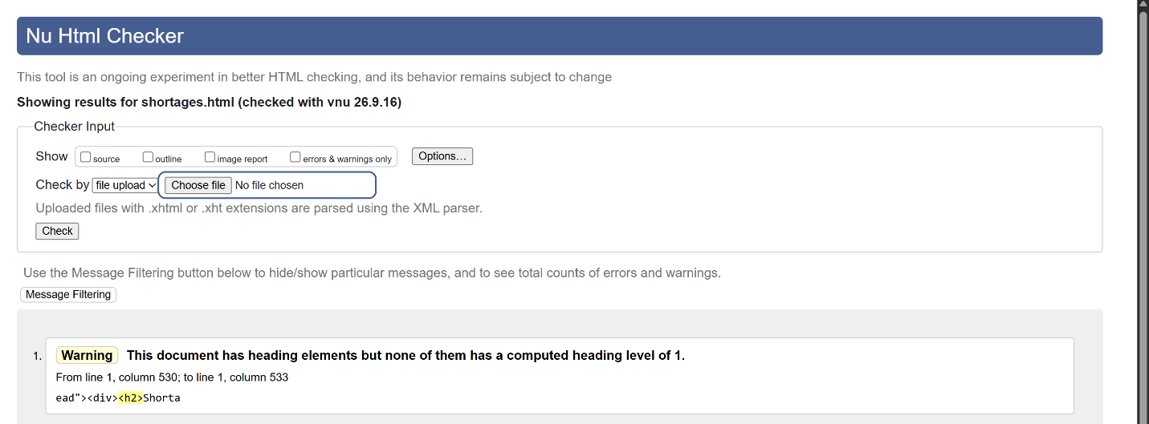
Fix applied
Changed the page title to h1 and both panel headings to h2.
Final HTML validation result

users.html
Original code (incorrect)
<div class="page-head"><div><h2>User & Staff Administration</h2>
...
<div><h3 id="tableTitle">User Accounts</h3>
HTML validation error / warning message
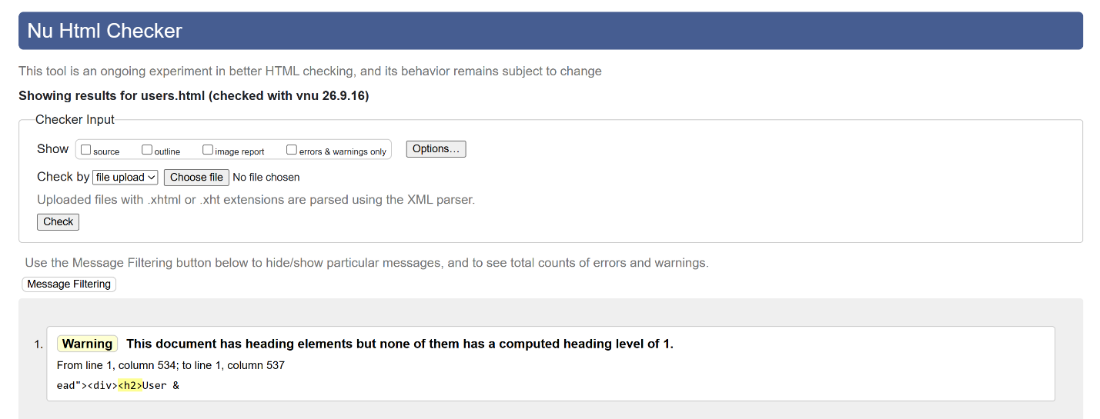
Fix applied
Changed the page title to h1 and 'User Accounts' to h2. Modal heading stays h3.
Final HTML validation result

HTML VALIDATION TESTING - PHARMACIST PORTAL
HTML VALIDATION TESTING
Bundoora Family Clinic - Pharmacist Portal
Name: Yam Bahadur Mohatra
Student ID: K230505

Result Summary
Page | Before validation | Problem identified | Final result
appointments.html | 0 errors and 1 warning. | No computed heading level 1 was present. | PASS - No errors or warnings
assigned-prescriptions.html | 0 errors and 2 warnings. | The main panel section lacked a heading and the page had no computed h1. | PASS - No errors or warnings
batches.html | 1 error and 2 warnings. | A required select had no option, a panel section lacked a heading, and the page had no h1. | PASS - No errors or warnings
dashboard.html | 0 errors and 1 warning. | No computed heading level 1 was present. | PASS - No errors or warnings
dispensing.html | 3 errors and 2 warnings. | Three required selects had no option elements, a section lacked a heading, and the page had no h1. | PASS - No errors or warnings
inventory.html | 1 error and 2 warnings. | A required select had no option, a section lacked a heading, and the page had no h1. | PASS - No errors or warnings
recalls.html | 0 errors and 2 warnings. | A panel section lacked an identifying heading and the page had no h1. | PASS - No errors or warnings
reports.html | 0 errors and 1 warning. | No computed heading level 1 was present. | PASS - No errors or warnings
stock-reservations.html | 0 errors and 2 warnings. | The main panel lacked a heading and the page had no h1. | PASS - No errors or warnings
verification.html | 0 errors and 3 warnings. | Two panel sections lacked headings and the page had no h1. | PASS - No errors or warnings
Overall result: All 10 Pharmacist Portal HTML pages were corrected and rechecked. The supplied final Nu HTML Checker screenshots show no errors or warnings for every page.

Detailed Testing Page By Page

1. appointments.html

Original code (incorrect)
<h2>Doctor Appointments</h2>

W3C error / warning message
0 errors and 1 warning. No computed heading level 1 was present.
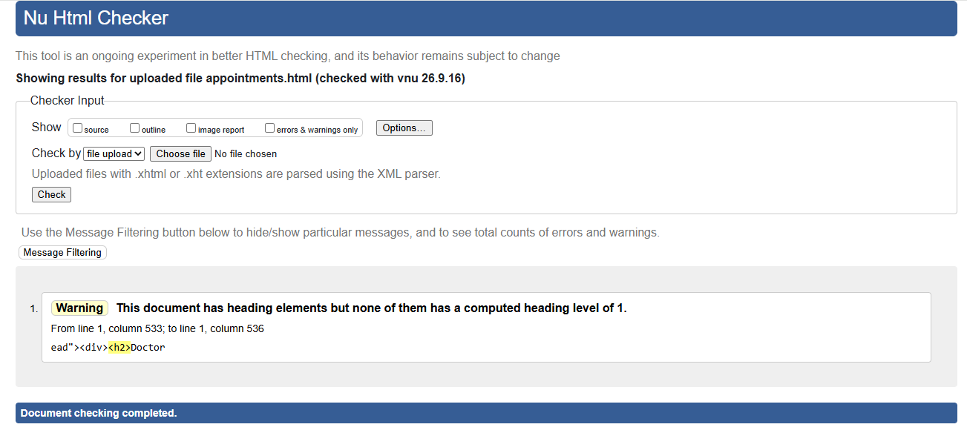
Figure 1A. Original Nu HTML Checker result for appointments.html.

Fix applied
Changed the main page heading from <h2> to <h1>.

Corrected code
<h1>Doctor Appointments</h1>

Final HTML validation result
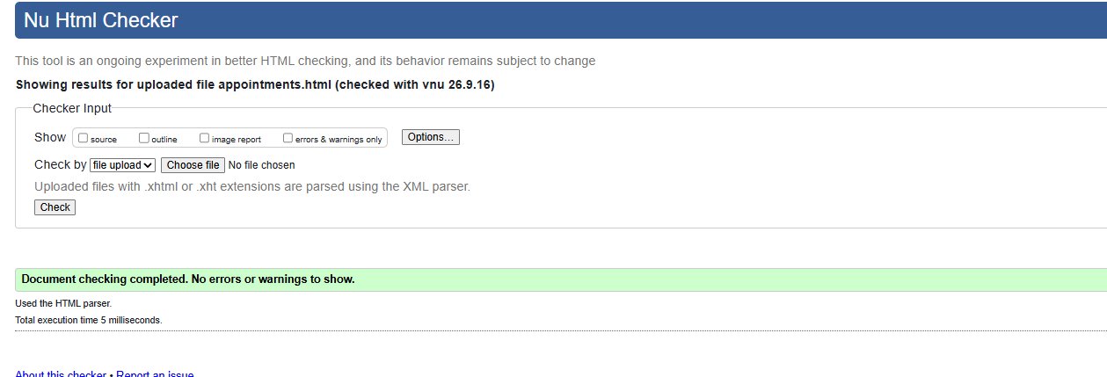
Figure 1B. Final Nu HTML Checker result for appointments.html: no errors or warnings.

2. assigned-prescriptions.html

Original code (incorrect)
<h2>Assigned Prescriptions</h2>
<section class="panel">...</section>

W3C error / warning message
0 errors and 2 warnings. The main panel section lacked a heading and the page had no computed h1.
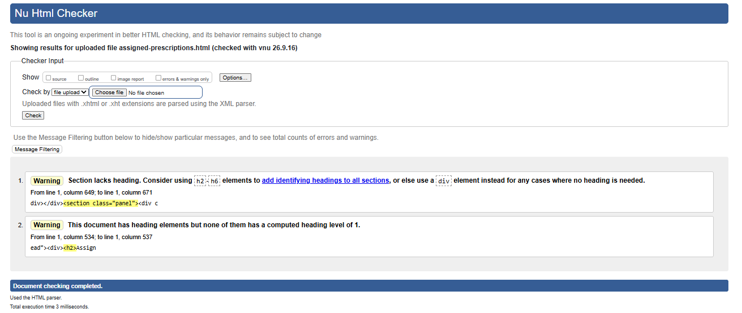
Figure 2A. Original Nu HTML Checker result for assigned-prescriptions.html.

Fix applied
Changed the page title to h1 and added an h2 identifying heading to the prescription panel.

Corrected code
<h1>Assigned Prescriptions</h1>
<section class="panel"><h2>Prescription Queue</h2>...</section>

Final HTML validation result
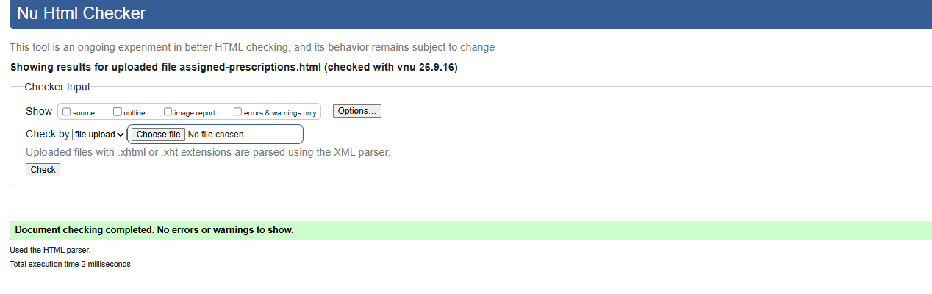
Figure 2B. Final Nu HTML Checker result for assigned-prescriptions.html: no errors or warnings.

3. batches.html

Original code (incorrect)
<h2>Batches</h2>
<select required></select>

W3C error / warning message
1 error and 2 warnings. A required select had no option, a panel section lacked a heading, and the page had no h1.
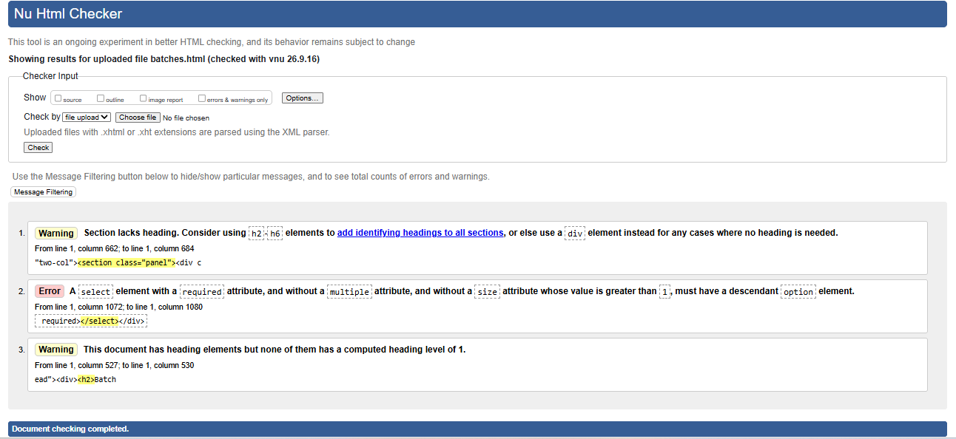
Figure 3A. Original Nu HTML Checker result for batches.html.

Fix applied
Changed the title to h1, added an h2 panel heading, and inserted a placeholder option in the required select.

Corrected code
<h1>Batches</h1>
<h2>Medicine Batch List</h2>
<select required><option value="">Select an option</option>...</select>

Final HTML validation result
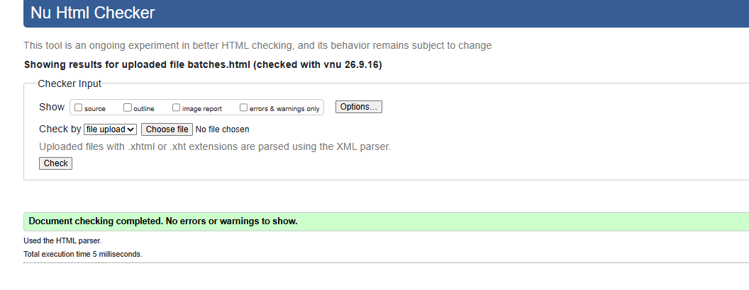
Figure 3B. Final Nu HTML Checker result for batches.html: no errors or warnings.

4. dashboard.html

Original code (incorrect)
<h2>Pharmacist Dashboard</h2>

W3C error / warning message
0 errors and 1 warning. No computed heading level 1 was present.
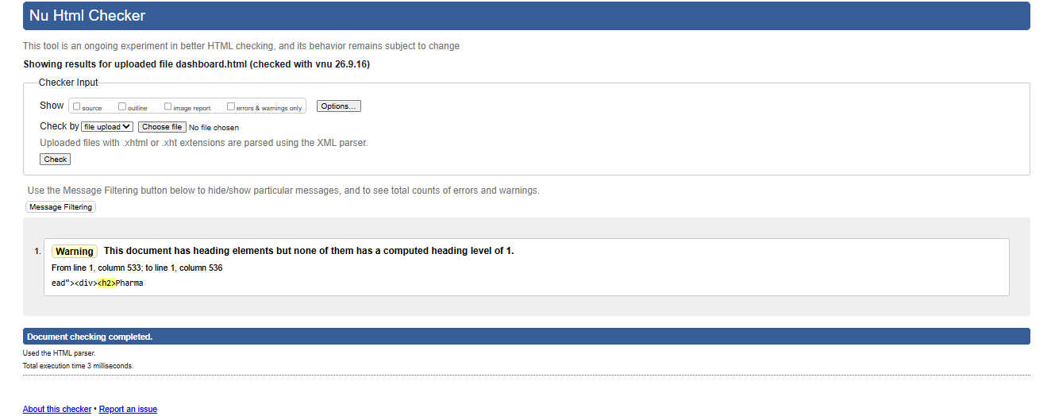
Figure 4A. Original Nu HTML Checker result for dashboard.html.

Fix applied
Changed the Pharmacist Dashboard page title from h2 to h1.

Corrected code
<h1>Pharmacist Dashboard</h1>

Final HTML validation result
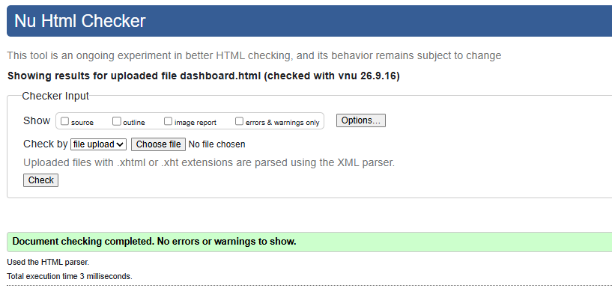
Figure 4B. Final Nu HTML Checker result for dashboard.html: no errors or warnings.

5. dispensing.html

Original code (incorrect)
<h2>Dispensing</h2>
<select required></select>

W3C error / warning message
3 errors and 2 warnings. Three required selects had no option elements, a section lacked a heading, and the page had no h1.
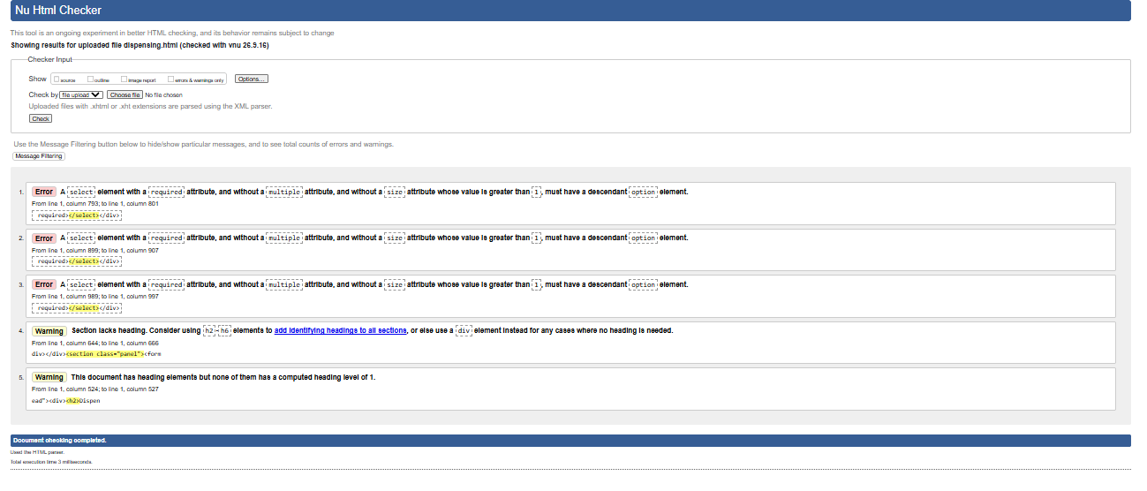
Figure 5A. Original Nu HTML Checker result for dispensing.html.

Fix applied
Changed the title to h1, added an h2 panel heading, and added placeholder options to all required selects.

Corrected code
<h1>Dispensing</h1>
<h2>Dispense Prescription</h2>
<select required><option value="">Select an option</option>...</select>

Final HTML validation result
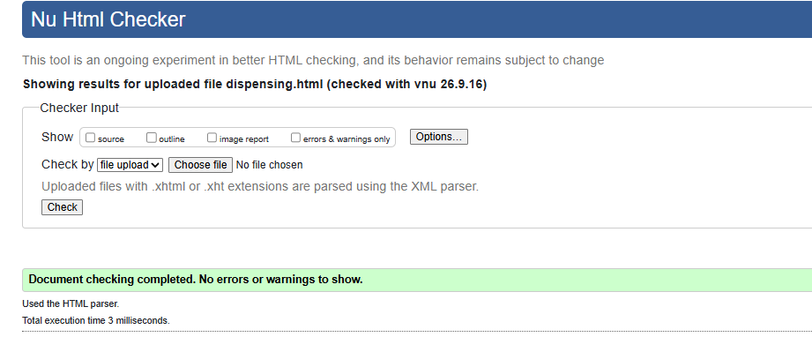
Figure 5B. Final Nu HTML Checker result for dispensing.html: no errors or warnings.

6. inventory.html

Original code (incorrect)
<h2>Inventory</h2>
<select required></select>

W3C error / warning message
1 error and 2 warnings. A required select had no option, a section lacked a heading, and the page had no h1.
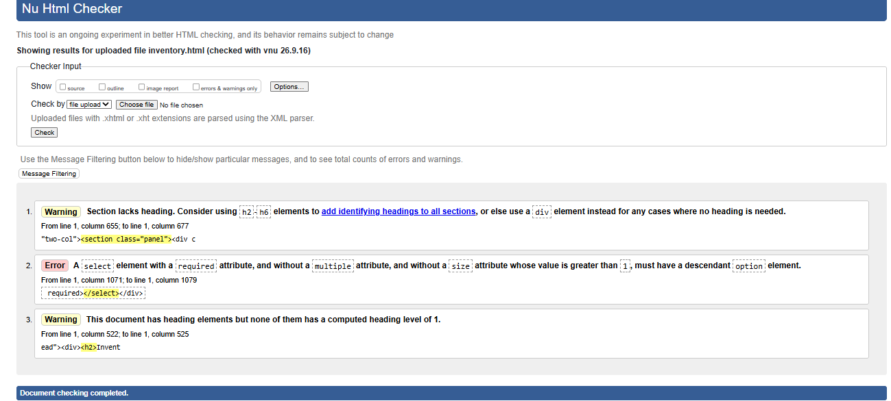
Figure 6A. Original Nu HTML Checker result for inventory.html.

Fix applied
Changed the title to h1, added an h2 section heading, and added a placeholder option to the required select.

Corrected code
<h1>Inventory</h1>
<h2>Medicine Stock Levels</h2>
<select required><option value="">Select an option</option>...</select>

Final HTML validation result
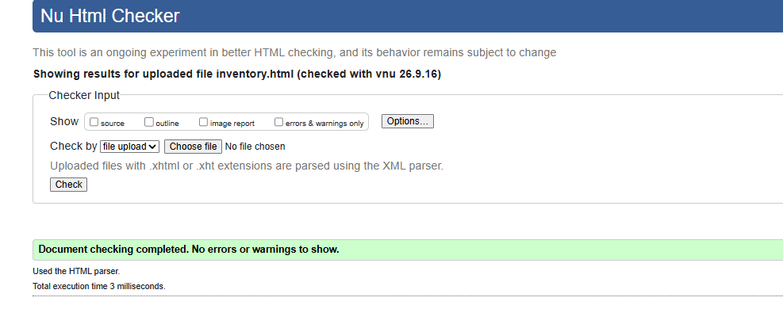
Figure 6B. Final Nu HTML Checker result for inventory.html: no errors or warnings.

7. recalls.html

Original code (incorrect)
<h2>Recalls</h2>
<section class="panel">...</section>

W3C error / warning message
0 errors and 2 warnings. A panel section lacked an identifying heading and the page had no h1.
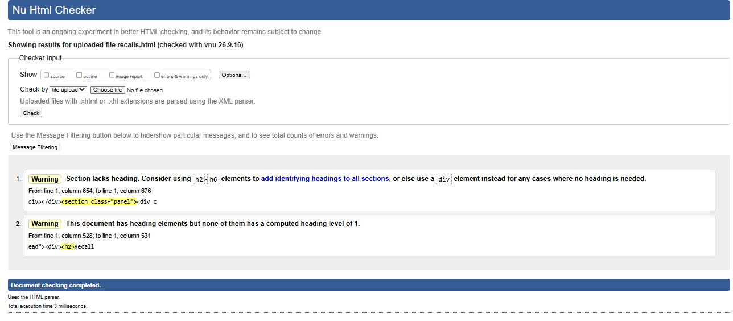
Figure 7A. Original Nu HTML Checker result for recalls.html.

Fix applied
Changed the page title to h1 and added an h2 heading for the recall panel.

Corrected code
<h1>Recalls</h1>
<section class="panel"><h2>Recall History</h2>...</section>

Final HTML validation result
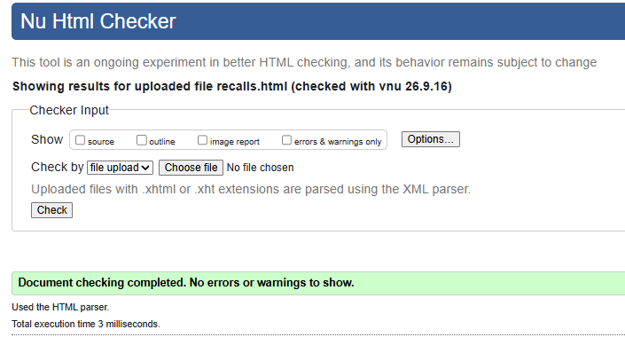
Figure 7B. Final Nu HTML Checker result for recalls.html: no errors or warnings.

8. reports.html

Original code (incorrect)
<h2>Reports</h2>

W3C error / warning message
0 errors and 1 warning. No computed heading level 1 was present.
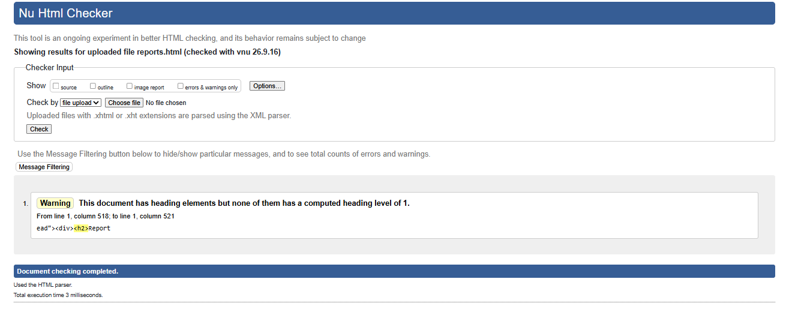
Figure 8A. Original Nu HTML Checker result for reports.html.

Fix applied
Changed the Reports page title from h2 to h1.

Corrected code
<h1>Reports</h1>

Final HTML validation result
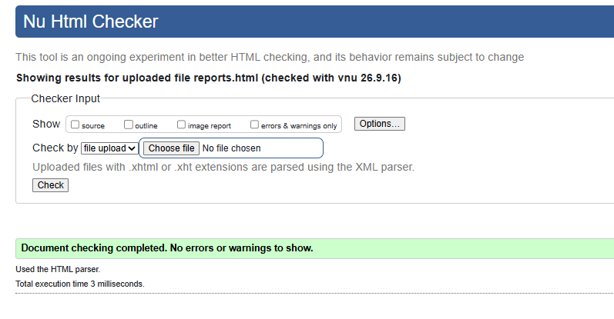
Figure 8B. Final Nu HTML Checker result for reports.html: no errors or warnings.

9. stock-reservations.html

Original code (incorrect)
<h2>Stock Reservations</h2>
<section class="panel">...</section>

W3C error / warning message
0 errors and 2 warnings. The main panel lacked a heading and the page had no h1.
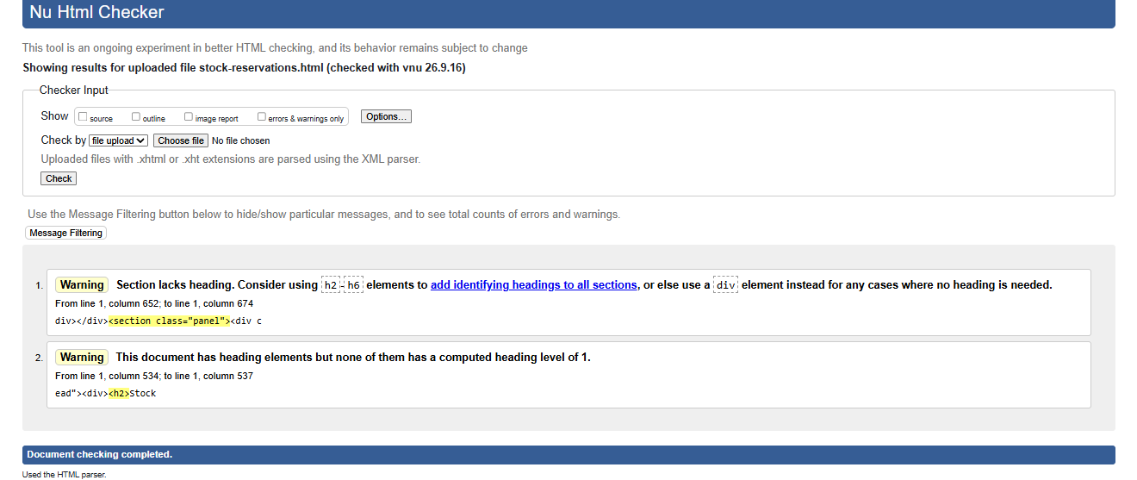
Figure 9A. Original Nu HTML Checker result for stock-reservations.html.

Fix applied
Changed the title to h1 and added an h2 heading to identify the reservations panel.

Corrected code
<h1>Stock Reservations</h1>
<section class="panel"><h2>Current Reservations</h2>...</section>

Final HTML validation result
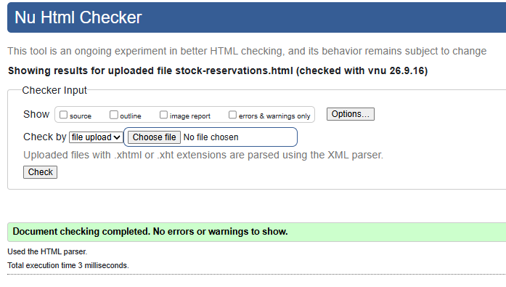
Figure 9B. Final Nu HTML Checker result for stock-reservations.html: no errors or warnings.

10. verification.html

Original code (incorrect)
<h2>Prescription Verification</h2>
<section class="panel">...</section>

W3C error / warning message
0 errors and 3 warnings. Two panel sections lacked headings and the page had no h1.
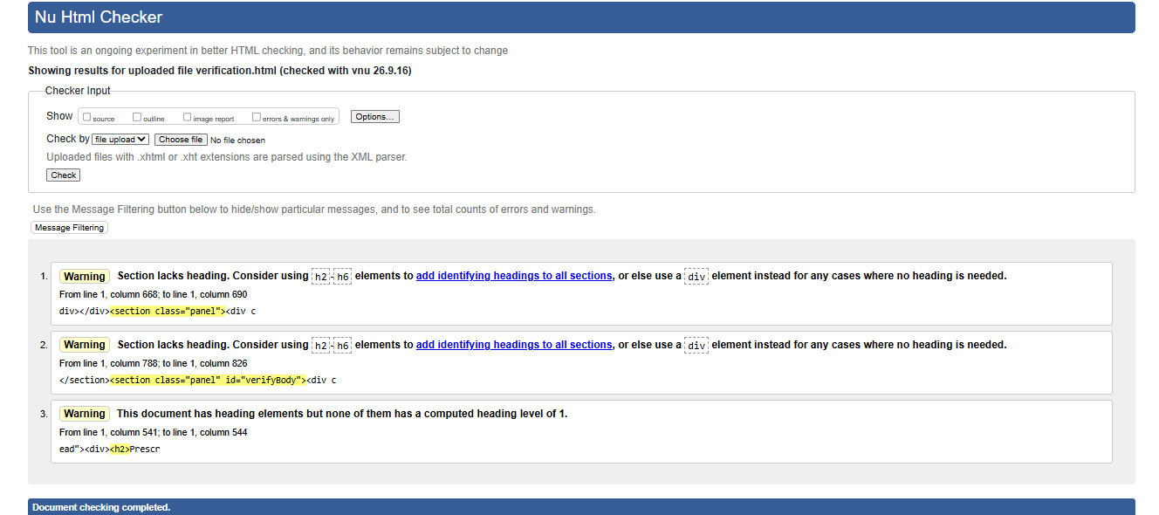
Figure 10A. Original Nu HTML Checker result for verification.html.

Fix applied
Changed the page title to h1 and added h2 headings to both verification sections.

Corrected code
<h1>Prescription Verification</h1>
<section class="panel"><h2>Prescription Selection</h2>...</section>
<section class="panel"><h2>Verification Details</h2>...</section>

Final HTML validation result
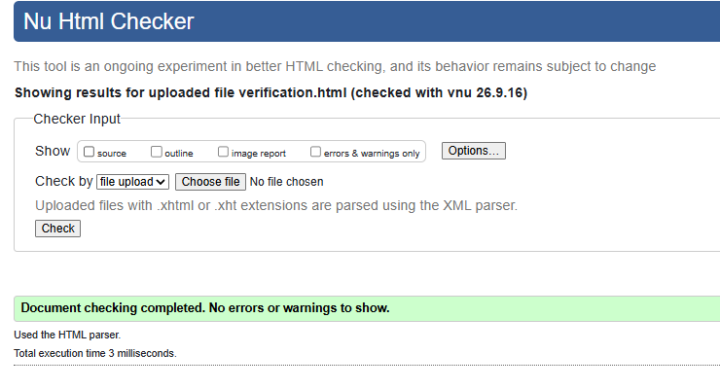
Figure 10B. Final Nu HTML Checker result for verification.html: no errors or warnings.

HTML VALIDATION TESTING - PATIENT PORTAL
HTML VALIDATION TESTING
Bundoora Family Clinic - Patient Portal
Name: Yam Bahadur Mohatra
Student ID: K230505

Result Summary
Page | Before | Issue(s) found | After fix
appointments.html | 2 errors and 1 warning | Invalid required attribute on hidden appointment-time input; no level-1 heading; heading hierarchy required correction. | PASS - No errors or warnings
dashboard.html | 0 errors and 1 warning | No computed heading level 1. | PASS - No errors or warnings
medication-tracking.html | 0 errors and 2 warnings | Section lacks heading; no computed heading level 1. | PASS - No errors or warnings
pharmacy-recommendation.html | 1 error and 3 warnings | Required select had no option; two sections lacked headings; no computed heading level 1. | PASS - No errors or warnings
prescriptions.html | 0 errors and 2 warnings | Section lacks heading; no computed heading level 1. | PASS - No errors or warnings
profile.html | 0 errors and 2 warnings | Profile section lacks heading; no computed heading level 1. | PASS - No errors or warnings
renewals.html | 1 error and 2 warnings | Required select had no option; section lacks heading; no computed heading level 1. | PASS - No errors or warnings
Overall result: All seven Patient Portal pages were rechecked after correction. The supplied final Nu HTML Checker screenshots show “Document checking completed. No errors or warnings to show.” for every page.

Detailed Testing Page By Page

1. appointments.html

Original code (incorrect)
<h2>Doctor Appointments</h2>
<h3>Instant Doctor Appointment</h3>
...
<input type="hidden" id="appointmentTime" name="time" value="09:00" required>

W3C error / warning message
2 errors and 1 warning. Invalid required attribute on hidden appointment-time input; no level-1 heading; heading hierarchy required correction.
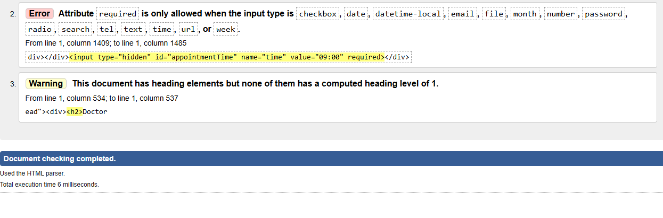
Figure 1A. Original Nu HTML Checker result for appointments.html.

Fix applied
Changed the page title to h1, changed the main panel headings to h2, and removed required from the hidden appointmentTime input.

Corrected code
<h1>Doctor Appointments</h1>
<h2>Instant Doctor Appointment</h2>
...
<input type="hidden" id="appointmentTime" name="time" value="09:00">

Final HTML validation result
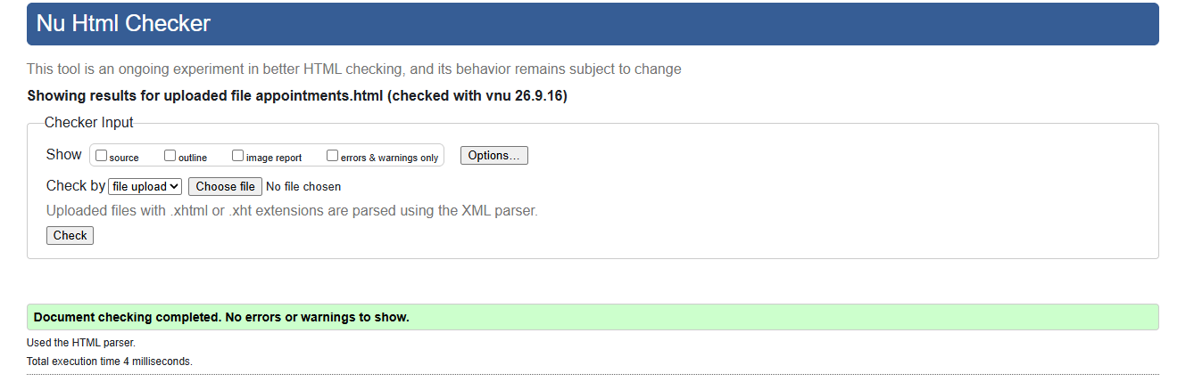
Figure 1B. Final Nu HTML Checker result for appointments.html: no errors or warnings.

2. dashboard.html

Original code (incorrect)
<h2>Patient Dashboard</h2>
...
<h3>Recent prescriptions</h3>

W3C error / warning message
0 errors and 1 warning. No computed heading level 1.
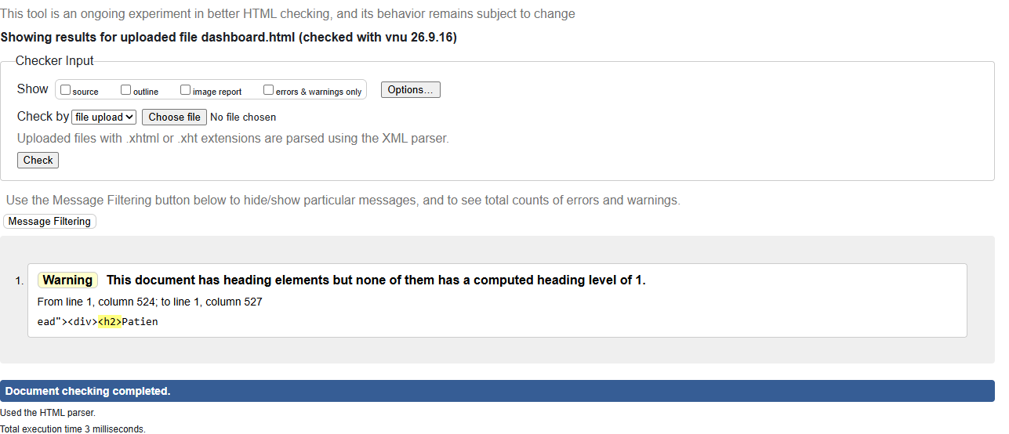
Figure 2A. Original Nu HTML Checker result for dashboard.html.

Fix applied
Changed the page title to h1 and the main panel headings to h2.

Corrected code
<h1>Patient Dashboard</h1>
...
<h2>Recent prescriptions</h2>

Final HTML validation result
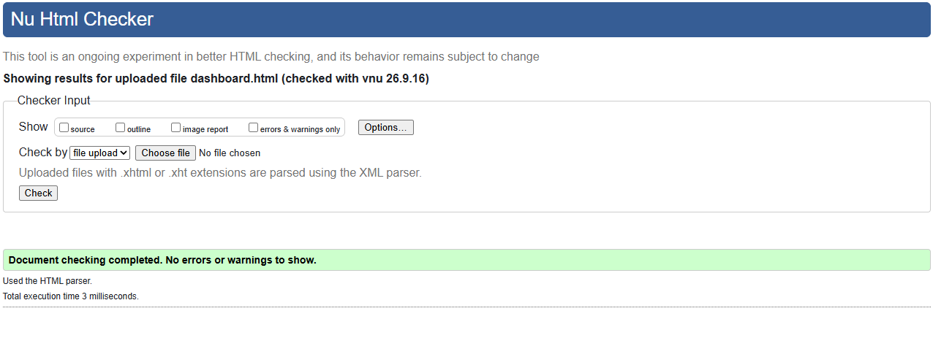
Figure 2B. Final Nu HTML Checker result for dashboard.html: no errors or warnings.

3. medication-tracking.html

Original code (incorrect)
<h2>Medication Tracking</h2>
...
<section class="panel">...</section>

W3C error / warning message
0 errors and 2 warnings. Section lacks heading; no computed heading level 1.
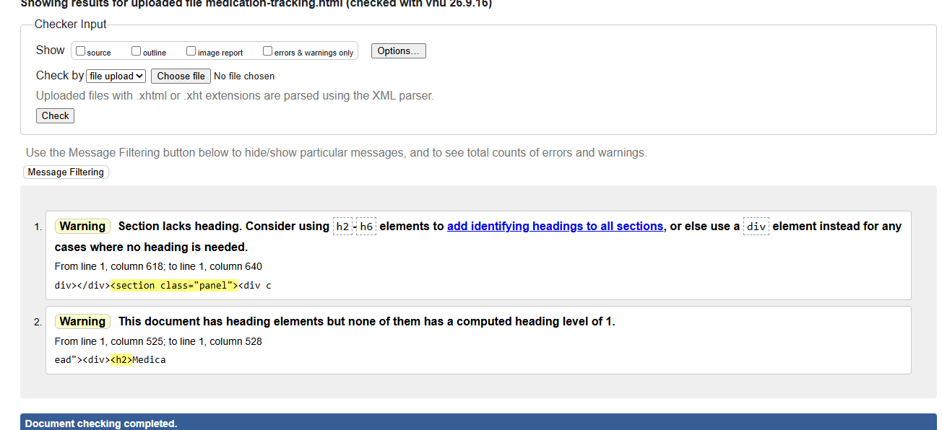
Figure 3A. Original Nu HTML Checker result for medication-tracking.html.

Fix applied
Changed the page title to h1 and added an h2 heading (Medication Schedule) inside the panel.

Corrected code
<h1>Medication Tracking</h1>
...
<section class="panel"><h2>Medication Schedule</h2>...</section>

Final HTML validation result
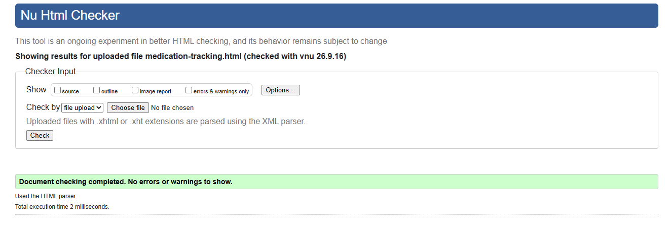
Figure 3B. Final Nu HTML Checker result for medication-tracking.html: no errors or warnings.

4. pharmacy-recommendation.html

Original code (incorrect)
<h2>Pharmacy Recommendation</h2>
...
<select id="medicineSelect" required></select>
...
<section class="panel">...</section>

W3C error / warning message
1 error and 3 warnings. Required select had no option; two sections lacked headings; no computed heading level 1.
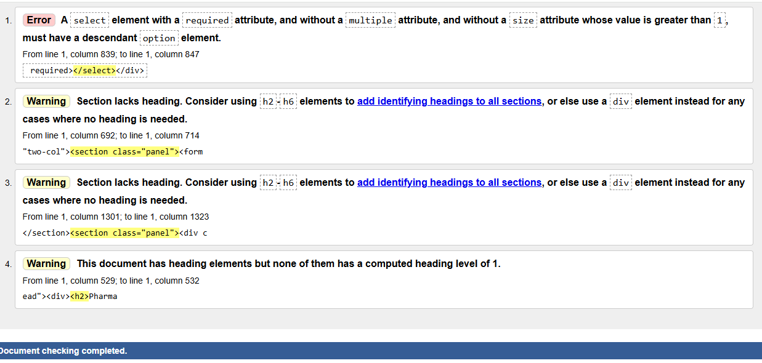
Figure 4A. Original Nu HTML Checker result for pharmacy-recommendation.html.

Fix applied
Changed the page title to h1, added h2 headings to both panel sections, and added a placeholder option to the required select.

Corrected code
<h1>Pharmacy Recommendation</h1>
...
<select id="medicineSelect" required><option value="">Select an option</option>...</select>

Final HTML validation result
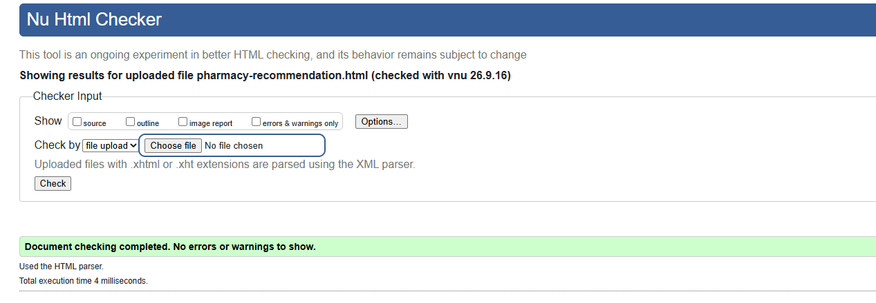
Figure 4B. Final Nu HTML Checker result for pharmacy-recommendation.html: no errors or warnings.

5. prescriptions.html

Original code (incorrect)
<h2>My Prescriptions</h2>
...
<section class="panel">...</section>

W3C error / warning message
0 errors and 2 warnings. Section lacks heading; no computed heading level 1.
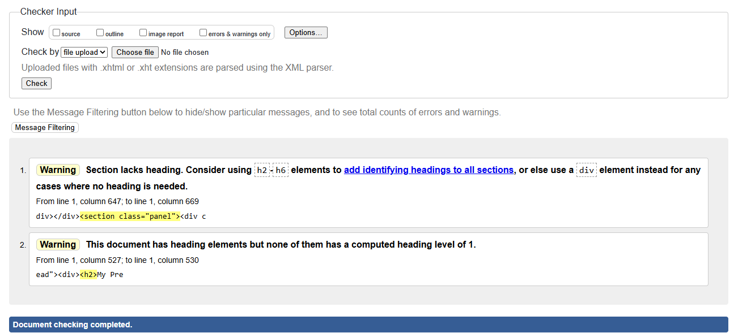
Figure 5A. Original Nu HTML Checker result for prescriptions.html.

Fix applied
Changed My Prescriptions to h1 and added an h2 heading (Prescription History) to the main section.

Corrected code
<h1>My Prescriptions</h1>
...
<section class="panel"><h2>Prescription History</h2>...</section>

Final HTML validation result
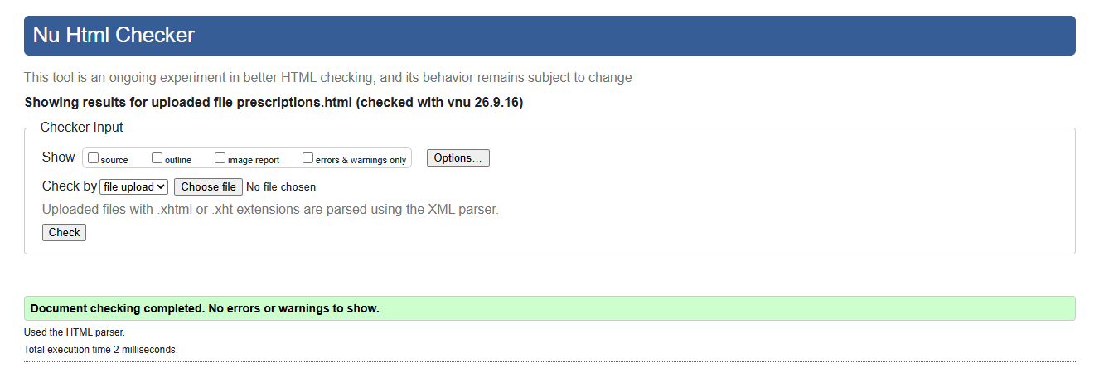
Figure 5B. Final Nu HTML Checker result for prescriptions.html: no errors or warnings.

6. profile.html

Original code (incorrect)
<h2>My Profile</h2>
...
<section class="panel"><form id="profileForm">...</form></section>

W3C error / warning message
0 errors and 2 warnings. Profile section lacks heading; no computed heading level 1.
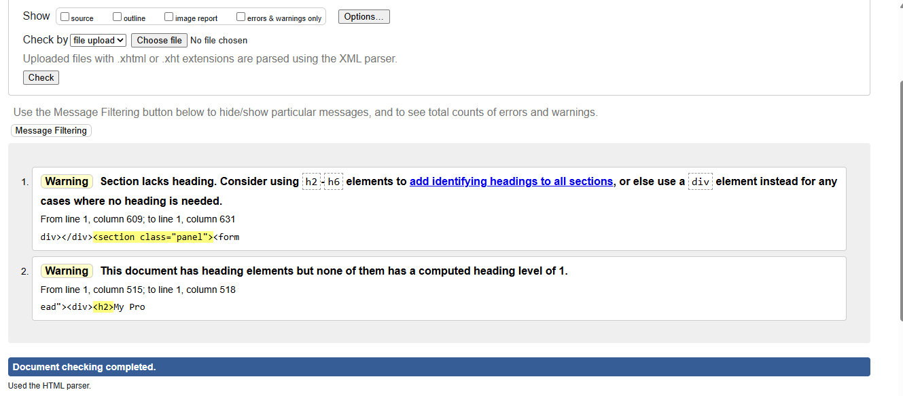
Figure 6A. Original Nu HTML Checker result for profile.html.

Fix applied
Changed My Profile to h1 and added an h2 heading (Personal Details) inside the profile panel.

Corrected code
<h1>My Profile</h1>
...
<section class="panel"><h2>Personal Details</h2><form id="profileForm">...</form></section>

Final HTML validation result
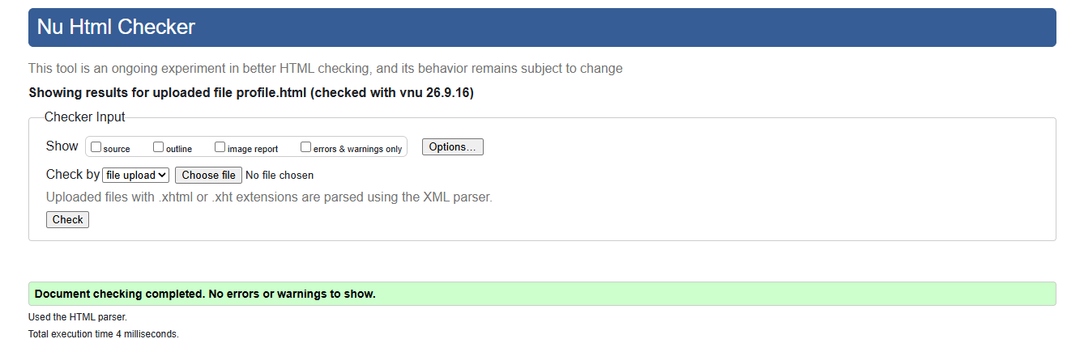
Figure 6B. Final Nu HTML Checker result for profile.html: no errors or warnings.

7. renewals.html

Original code (incorrect)
<h2>Renewal Requests</h2>
<h3>Request renewal</h3>
...
<select id="prescriptionSelect" required></select>

W3C error / warning message
1 error and 2 warnings. Required select had no option; section lacks heading; no computed heading level 1.
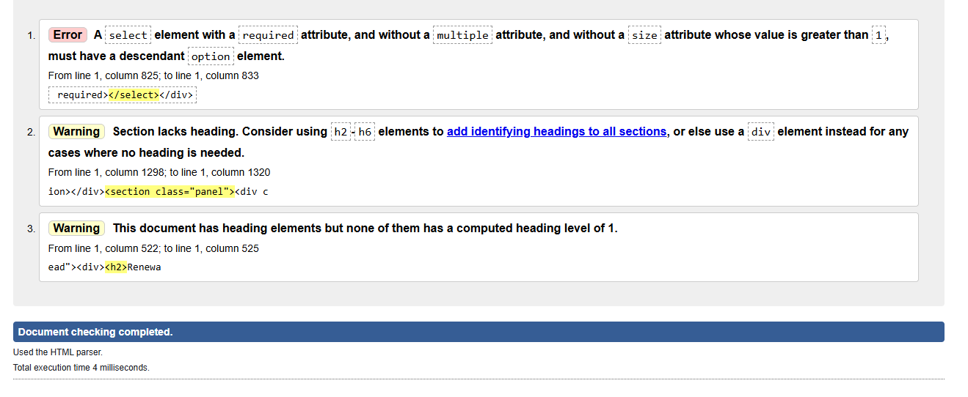
Figure 7A. Original Nu HTML Checker result for renewals.html.

Fix applied
Changed the page title to h1, changed main h3 headings to h2, added an h2 for renewal history, and added a placeholder option to the required select.

Corrected code
<h1>Renewal Requests</h1>
<h2>Request renewal</h2>
...
<select id="prescriptionSelect" required><option value="">Select an option</option>...</select>

Final HTML validation result
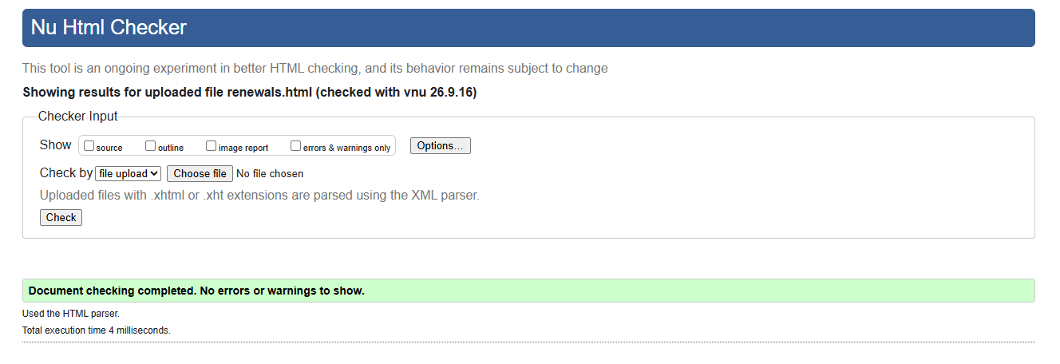
Figure 7B. Final Nu HTML Checker result for renewals.html: no errors or warnings.

HTML VALIDATION TESTING - DOCTOR PORTAL

HTML Validation Testing
Bundoora Family Clinic – Doctor Portal
Tool: W3C Nu Html Checker (vnu 26.9.16), Validate by File Upload. Each doctor page was uploaded, checked, fixed and re-checked.
Summary of results
Page | Before | Issue(s) found | After fix
ai-safety.html | 1 error, 2 warnings | Required select with no option, no h1, section lacks heading | Pass
appointments.html | 0 errors, 1 warning | No h1 | Pass
create-prescription.html | 1 error, 1 warning | Required select with no option, no h1 | Pass
dashboard.html | 0 errors, 1 warning | No h1 | Pass
prescriptions.html | 0 errors, 2 warnings | No h1, section lacks heading | Pass
reports.html | 0 errors, 1 warning | No h1 | Pass

Detailed Testing Page By Page

ai-safety.html
Original code (incorrect)
<div class="page-head"><div><h2>AI Prescription Safety Check</h2>
...
<section class="panel"><form id="aiForm"><div class="field"><label>Patient</label><select id="aiPatient" required></select></div>
...
<section class="panel"><h3>AI-assisted safety analysis</h3>

HTML validation error / warning message
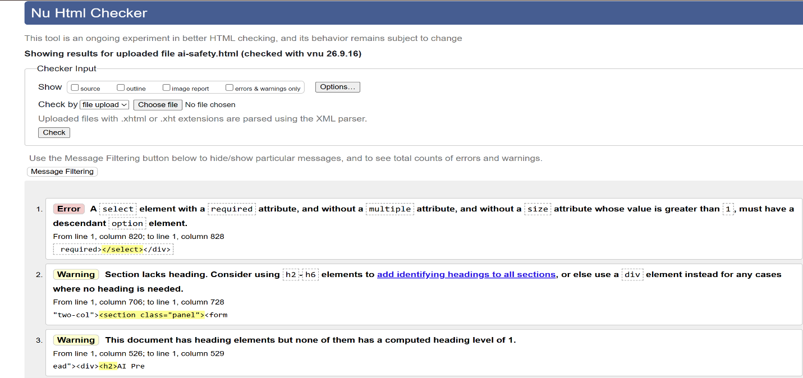

Fix applied
Changed the page title to h1, added an h2 heading to the form panel, changed the analysis panel heading from h3 to h2, and added a placeholder option to the Patient dropdown.
Final HTML validation result
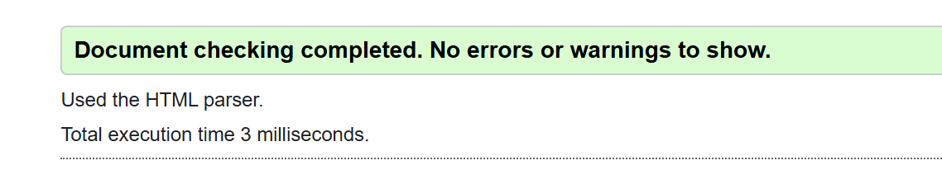

appointments.html
Original code (incorrect)
<div class="page-head"><div><h2>My Patient Appointments</h2>
...
<div class="panel-title" style="flex-wrap:wrap;gap:12px"><h3>Assigned Appointments</h3>

HTML validation error / warning message
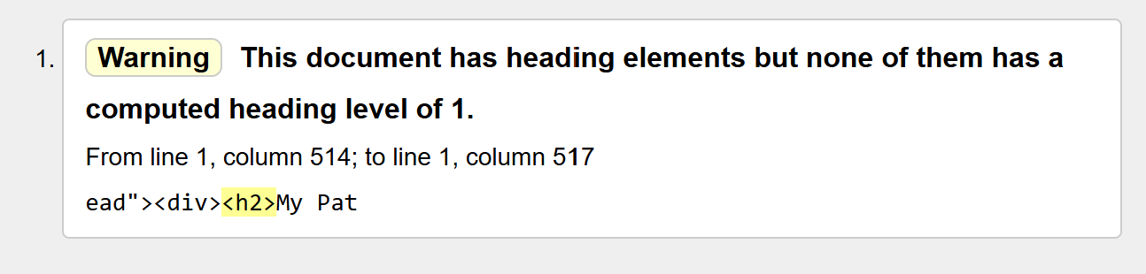
Fix applied
Changed the page title to h1 and the panel heading from h3 to h2. Popup headings stay h3.
Final HTML validation result

create-prescription.html
Original code (incorrect)
<div class="page-head"><div><h2>Create Prescription</h2>
...
<section class="panel"><h3>Patient & clinical information</h3><div class="field"><label>Patient</label><select id="patientSelect" required></select></div>
...
<section class="panel"><h3>AI-assisted prescription safety check</h3>
...
<div class="panel-title"><h3>Medicines</h3>

HTML validation error / warning message
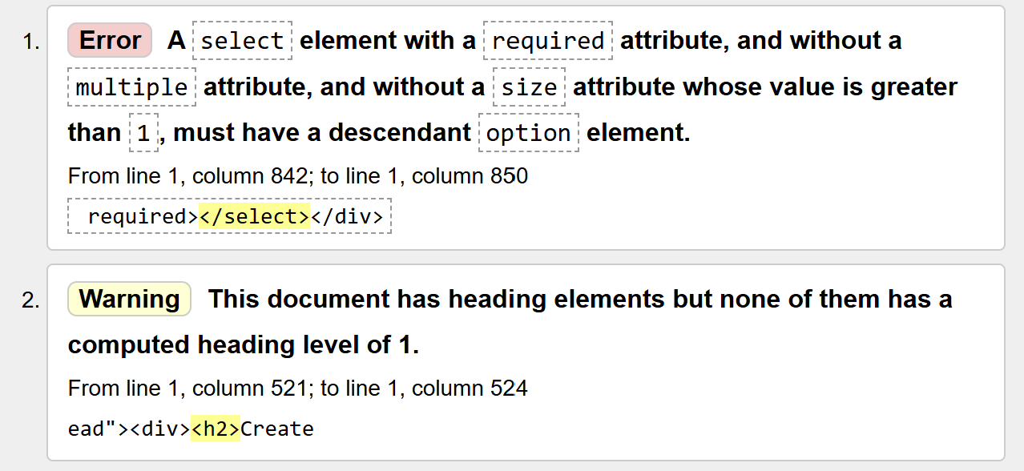
Fix applied
Changed the page title to h1 and the three panel headings from h3 to h2, and added a placeholder option to the Patient dropdown.

Final HTML validation result

dashboard.html
Original code (incorrect)
<div class="page-head"><div><h2>Doctor Dashboard</h2>
...
<div class="panel-title"><h3>Recent prescriptions</h3>

HTML validation error / warning message
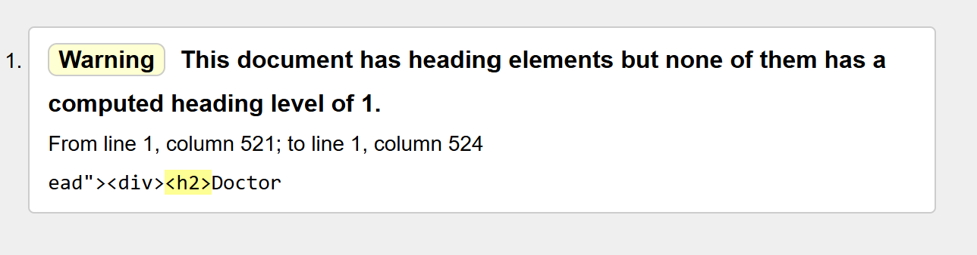
Fix applied
Changed the page title to h1 and the panel heading from h3 to h2.
Final HTML validation result

create-prescription.html
Original code (incorrect)
<div class="page-head"><div><h2>Manage Prescriptions</h2>
...
<section class="panel"><div class="table-wrap"><table class="data-table" id="doctorRxTable">

HTML validation error / warning message
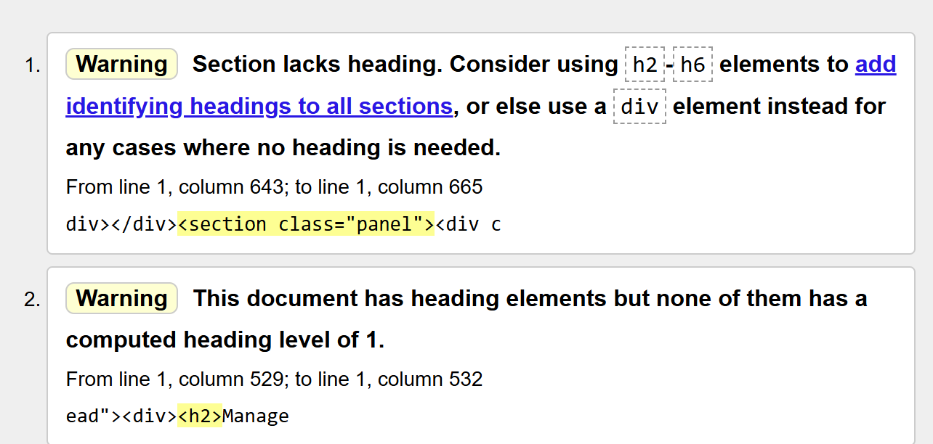
Fix applied
Changed the page title to h1 and added an h2 heading to the table panel. The popup heading stays h3.
Final HTML validation result

reports.html
Original code (incorrect)
<div class="page-head"><div><h2>Doctor Reports</h2>
...
<div class="panel-title"><h3>Daily prescribing activity</h3>

HTML validation error / warning message
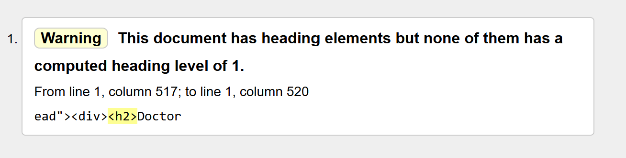
Fix applied
Changed the page title to h1 and the panel heading from h3 to h2.
Final HTML validation result

