1. Signing In - Email Address
The pharmacist workflow begins on the Bundoora Family Clinic login page. The pharmacist enters the registered pharmacist email address in the Email address field so the system can identify the correct user account.
1. Open the Bundoora Family Clinic sign-in page.
2. Select the Email address field and enter the pharmacist account shown in the workflow: pharmacist@bundoora.test.
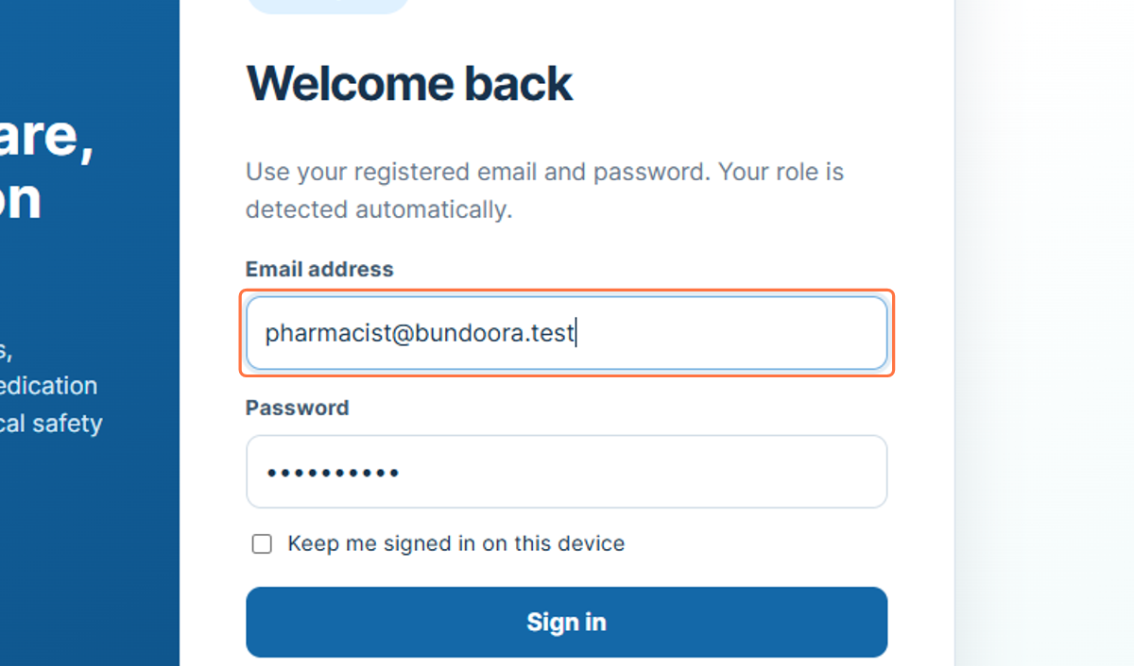
Figure 1: Entering the pharmacist email address

2. Signing In - Password
After the email address has been entered, the pharmacist provides the password for the account. The password is masked on screen to help protect the user credentials.
3. Select the Password field.
4. Enter the password associated with the pharmacist account.
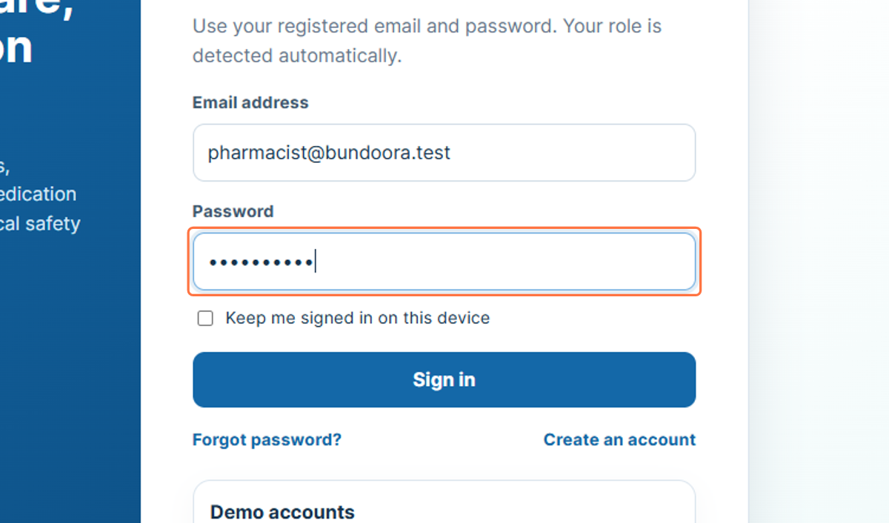
Figure 2: Entering the pharmacist account password

3. Signing In - Submit Credentials
Selecting Sign in submits the entered credentials for authentication. When the credentials are accepted, the system opens the Pharmacist Dashboard and provides access to pharmacist-specific functions.
5. Check that the email address and password fields are completed.
6. Select Sign in.
7. Wait for the Pharmacist Dashboard to load.
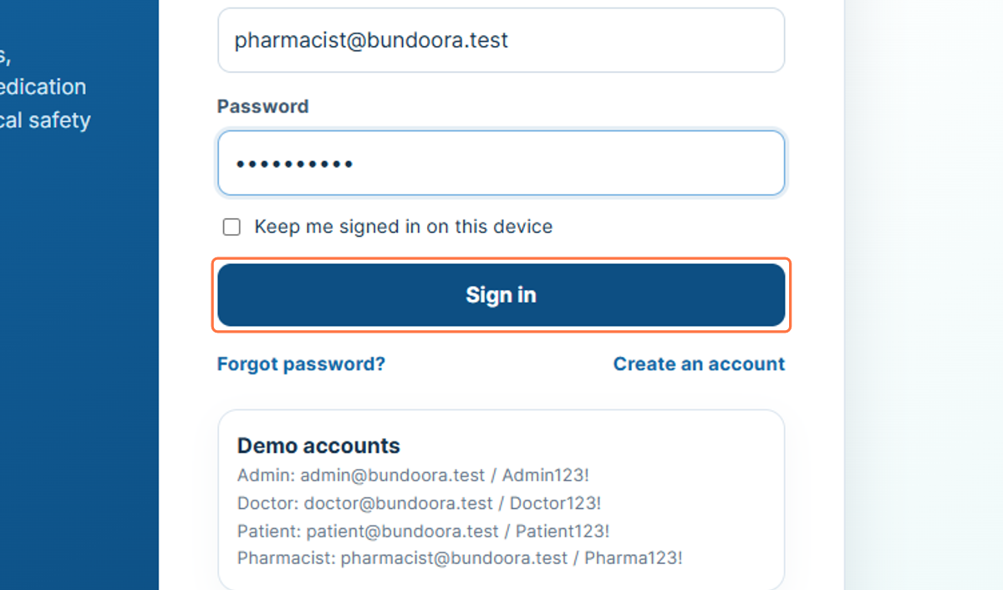
Figure 3: Selecting Sign in

4. Pharmacist Profile Area
The profile card in the left sidebar identifies the pharmacist currently signed in. In the workflow, the account is shown as Sam Miller with the role Pharmacist, allowing the user to confirm that the correct account is active.
8. Confirm the pharmacist name shown in the sidebar.
9. Confirm that the role displayed is Pharmacist.
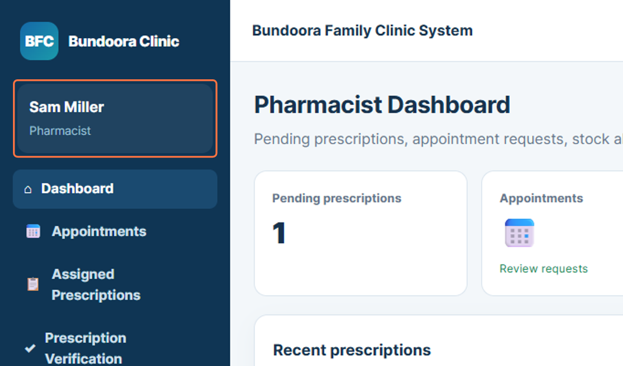
Figure 4: Pharmacist identity and role shown in the sidebar

5. Dashboard
The Pharmacist Dashboard is the main overview page for the pharmacist account. It provides summary information such as pending prescriptions, appointments, and recent prescription activity, and acts as the starting point for the pharmacist workflow.
10. Select Dashboard from the sidebar.
11. Review the summary information and recent prescription activity.
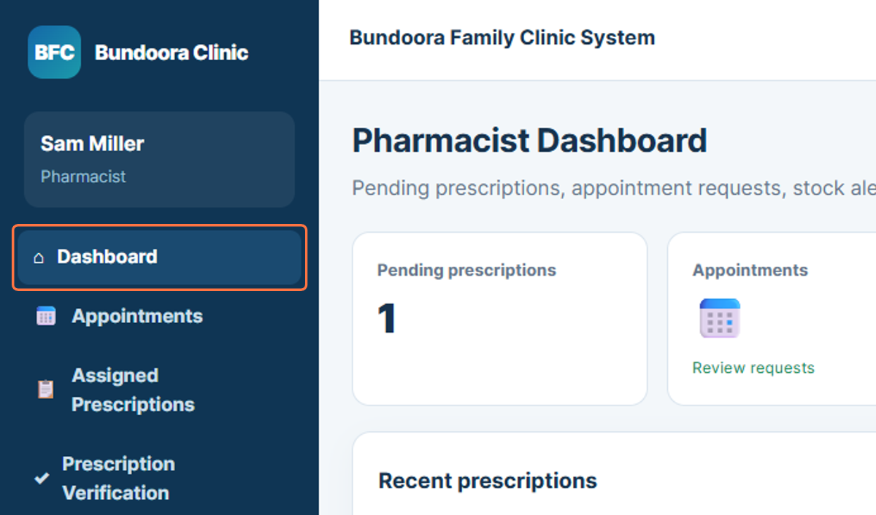
Figure 5: Pharmacist Dashboard navigation

6. Appointments
The Appointments section allows the pharmacist to review appointment-related information available in the system. This helps the pharmacist understand the current consultation activity before working with prescriptions and dispensing tasks.
12. Select Appointments from the sidebar.
13. Review the appointment information shown on the page.
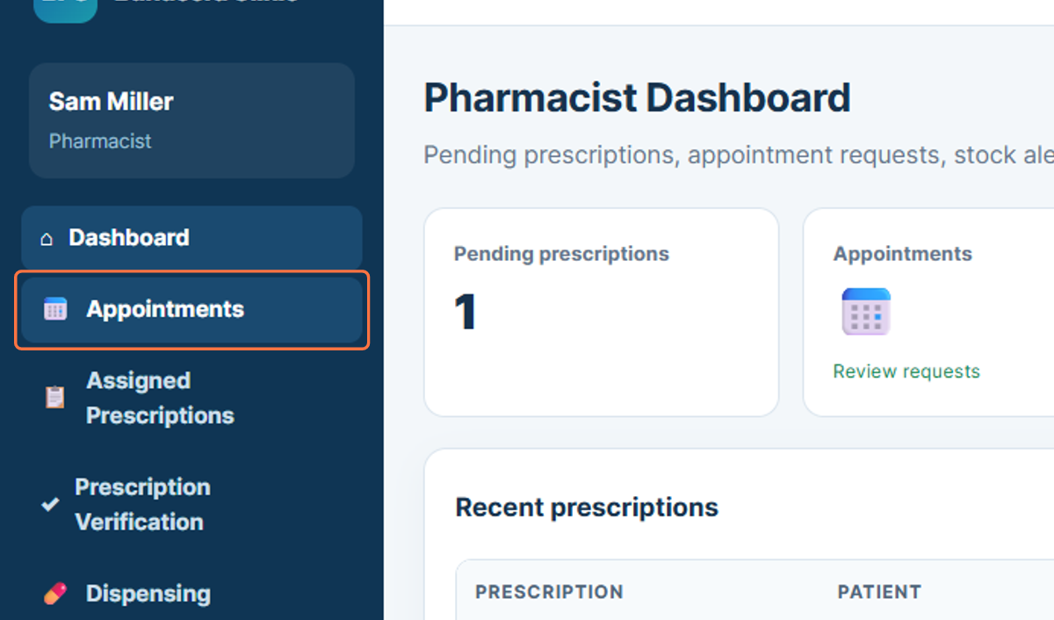
Figure 6: Opening Appointments

7. Assigned Prescriptions
Assigned Prescriptions provides access to prescriptions that are available for the pharmacist to review. The workflow shows prescription information linked with the patient and doctor details.
14. Select Assigned Prescriptions from the sidebar.
15. Review the prescriptions assigned for pharmacist action.
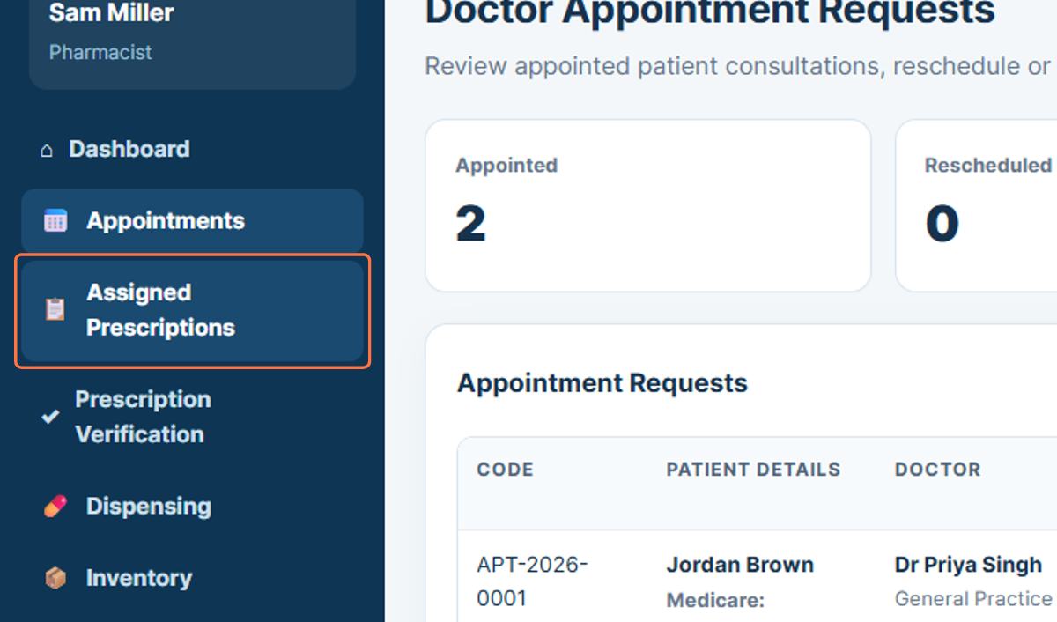
Figure 7: Opening Assigned Prescriptions

8. Prescription Verification
Prescription Verification is used to review prescription records before medication is dispensed. This step supports the pharmacist in checking the prescription information provided by the doctor.
16. Select Prescription Verification from the sidebar.
17. Review the available prescription and patient details before continuing.
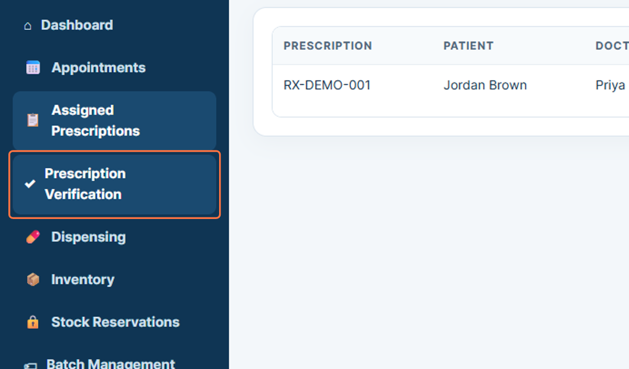
Figure 8: Opening Prescription Verification

9. Dispensing
The Dispensing section is used to process medication dispensing after a prescription has been reviewed. The workflow shows fields for selecting a prescription item and batch information.
18. Select Dispensing from the sidebar.
19. Choose the relevant prescription and review the dispensing information.
20. Enter or select the appropriate batch details when required.
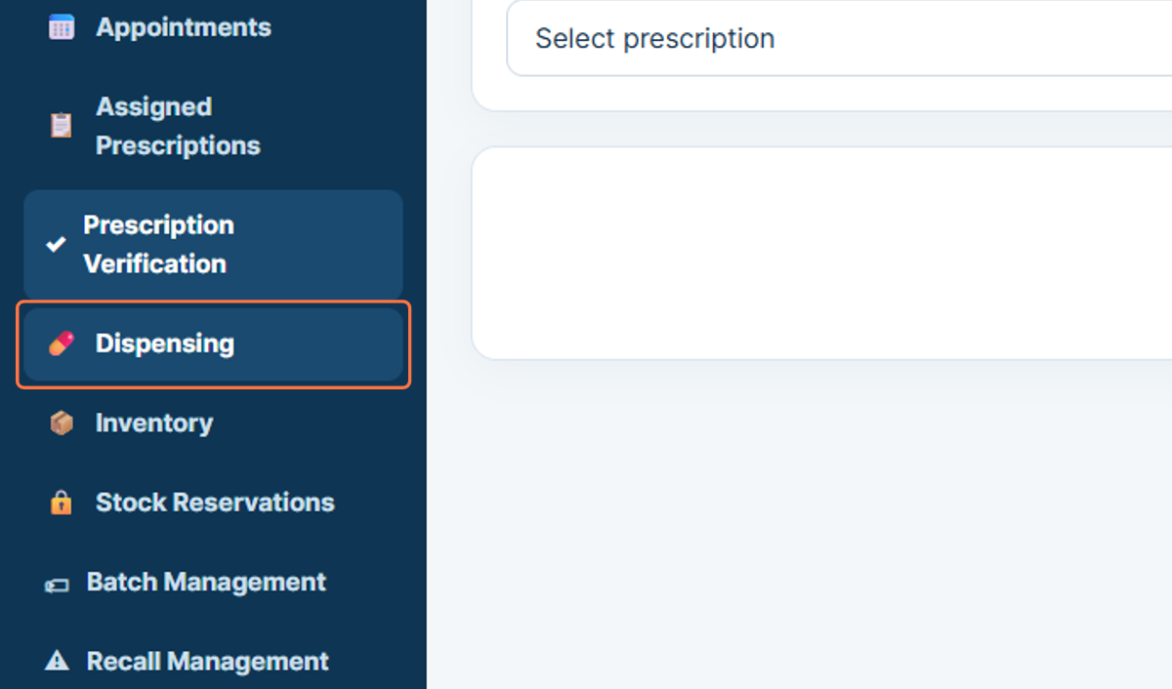
Figure 9: Opening Dispensing

10. Inventory
Inventory provides the pharmacist with a view of available medicines and stock information. This section supports checking stock levels before or during the dispensing process.
21. Select Inventory from the sidebar.
22. Review the available medicines and stock quantities.
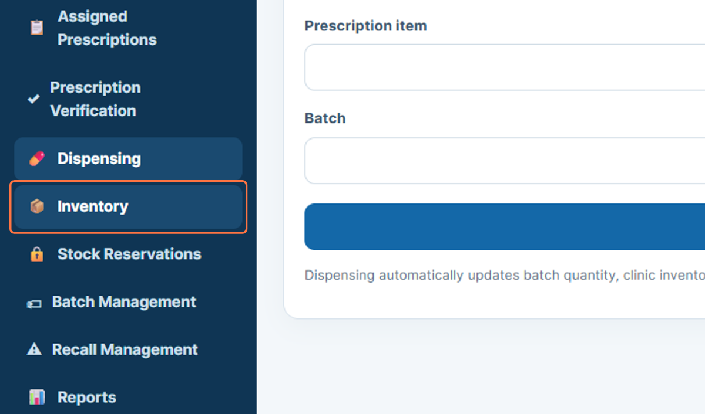
Figure 10: Opening Inventory

11. Stock Reservations
Stock Reservations displays medicines or quantities that have been reserved within the system. This helps prevent the same stock from being allocated to multiple requests.
23. Select Stock Reservations from the sidebar.
24. Review the current reservation information.
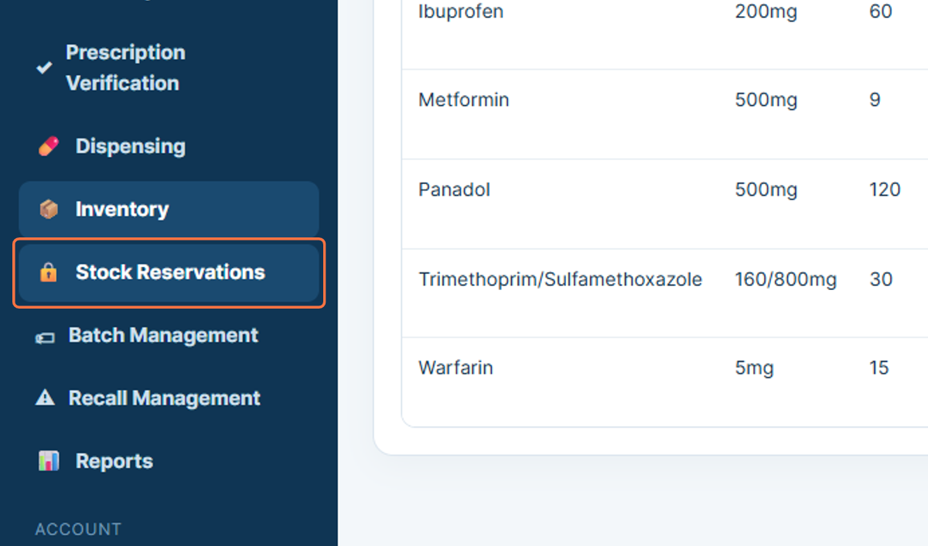
Figure 11: Opening Stock Reservations

12. Batch Management
Batch Management provides access to medicine batch-related information. This area is used for reviewing and managing batch details that support safe inventory and dispensing operations.
25. Select Batch Management from the sidebar.
26. Review the available batch information.
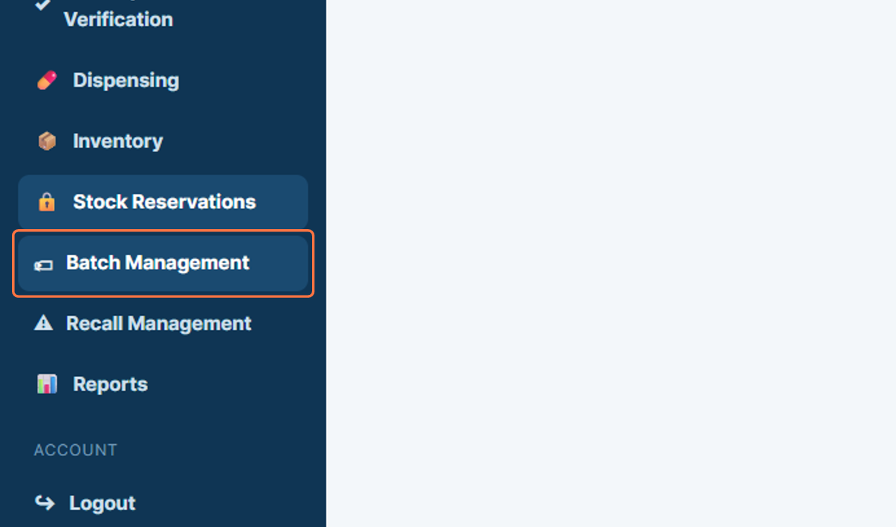
Figure 12: Opening Batch Management

13. Recall Management
Recall Management supports the review of medicines or batches affected by a recall. The workflow shows medicine names, batch identifiers, and stock quantities that may require pharmacist attention.
27. Select Recall Management from the sidebar.
28. Review the listed medicines and batch information for recall-related actions.
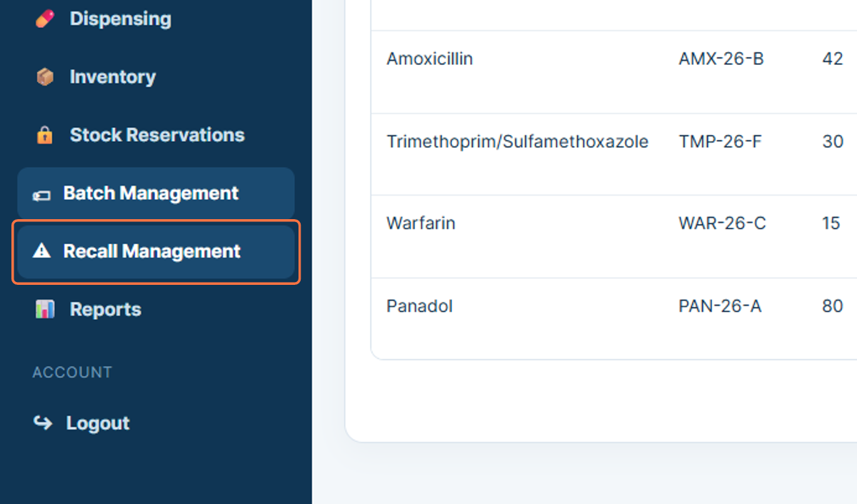
Figure 13: Opening Recall Management

14. Reports
The Reports section provides access to pharmacist-related reporting information. It can be used to review system records associated with prescription, dispensing, inventory, or other pharmacist activities.
29. Select Reports from the sidebar.
30. Review the available report information.
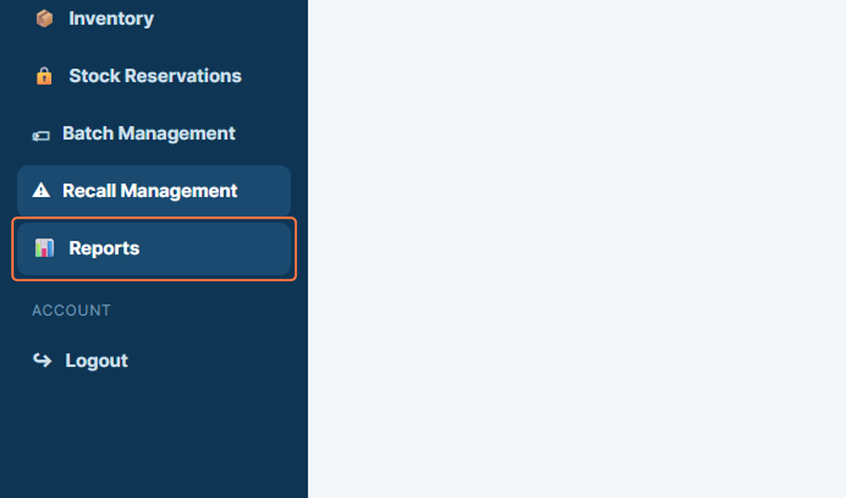
Figure 14: Opening Reports

15. Logout
Logout ends the current pharmacist session. Signing out after completing dispensing and inventory tasks is important, especially when the system is used on a shared clinic workstation.
31. Select Logout from the sidebar.
32. Confirm that the pharmacist session has ended.
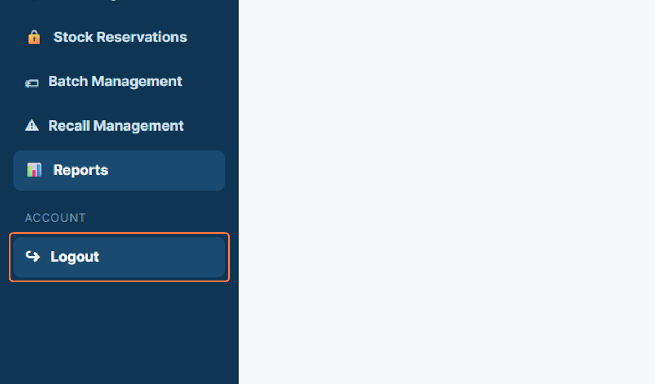
Figure 15: Logging out of the Pharmacist Portal

