SECTION 4.0 SYSTEM ARCHITECTURE
During the system design, the hardware, software, network, security components, and backup components should be identified to ensure that all parts of the system can communicate and operate effectively. The illustration below is the five layer system architecture of Bundoora Family Clinic – Digital Prescription & Medication Tracking System. The architecture demonstrates the interactions between users and devices, the secure transfer of information, processing and storage of application and medication data, and the critical information backup and audit.
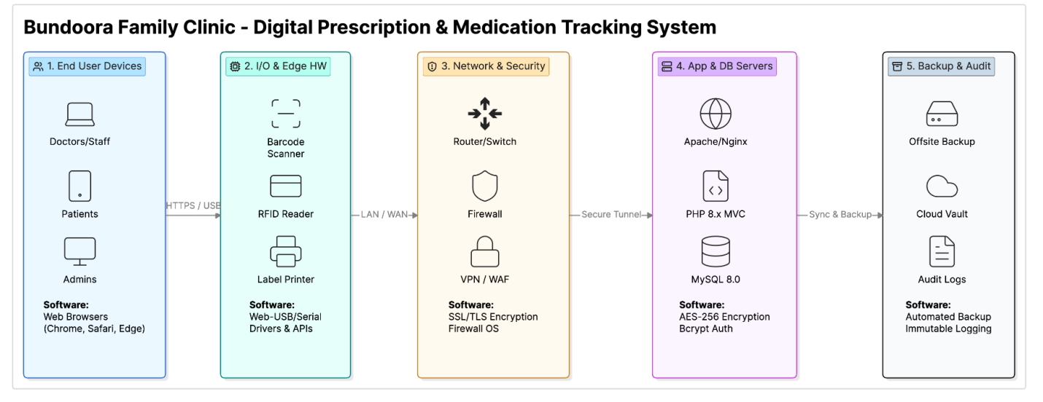
End User Devices – Layer 1
Hardware: Doctors/Staff/patients and administrators' desktop computers, laptops, tablets and smartphones accessing the system.
Requirements: Web browsers (Google Chrome, Safari, or Microsoft Edge).
Function: Enables doctors and staff to create and manage digital prescriptions, patients to access and keep track of their prescriptions and medicine information and administrators to manage users, roles and system activities.

Input/Output & Edge Hardware – Layer 2
Hardware includes a barcode scanner, RFID reader, and label printer.
Software requirements: Drivers and APIs for Web-USB/Serial devices that enable them to communicate with the web-based system.
Use: Medicines, medication batches, and related records can be identified and tracked using barcodes and RFID readers. Labels for medications and/or medications dispensed can be printed using a label printer. This layer is used to minimize the manual input of data and to increase the accuracy of the medication.

Network & Security – Layer 3
Hardware: Routers, network switches, and firewall devices.
Technologies required by software: SSL/TLS encryption, firewall operating software, VPN, and Web Application Firewall (WAF).
Secure Communication between Users, Devices and Application Servers: Apart from the protection provided by SSL/TLS on the transmission of sensitive data, firewalls and VPN/WAF technologies are helpful to prevent unauthorized access to the network and the system.

Application & Database Servers – Layer 4
Web/Application Server's, Database Server's used to host and operate the Digital Prescription & Medication Tracking System.
Requirements: Software: Apache/Nginx Web server, PHP 8.x with the MVC framework, MySQL 8.0 Database, AES-256 Encryption, Bcrypt Authentication.
Main Processing Layer: This is the main processing layer of the system. It handles all aspects of user authentication, the creation and tracking of digital prescriptions, pharmacist verification and dispensing, medication management, patient records, and administrative tasks. The system data is stored in MySQL, and sensitive data is protected by means of encryption and authentication mechanisms.

Backup & Audit – Layer 5
Hardware: Offsite hardware backups and secure storage devices.
Software needs: Backup automation, cloud vaulting, and immutable audit logging.
Purpose: Ensures that key prescription data, medication data, user data, and system data is not accidentally lost or lost due to system failure. Offsite and cloud backups offer extra data recovery options, and audit logs keep track of vital system activity for security, accountability, and monitoring.

In brief, the architecture of the Bundoora Family Clinic Digital Prescription & Medication Tracking System includes five layers which span from user access to medication-related hardware, secure networking, application processing, database storage, and backup and auditing. This architecture assists in creating a secure, reliable, and manageable system to manage digital prescriptions and medication information.

