This is the Pharmacist Dashboard where the pharmacist can view pending prescriptions, prescriptions ready to dispense, medicines dispensed today, and low-stock medicines. It also shows assigned prescriptions, low-stock alerts, quick actions, notifications, and report export options.
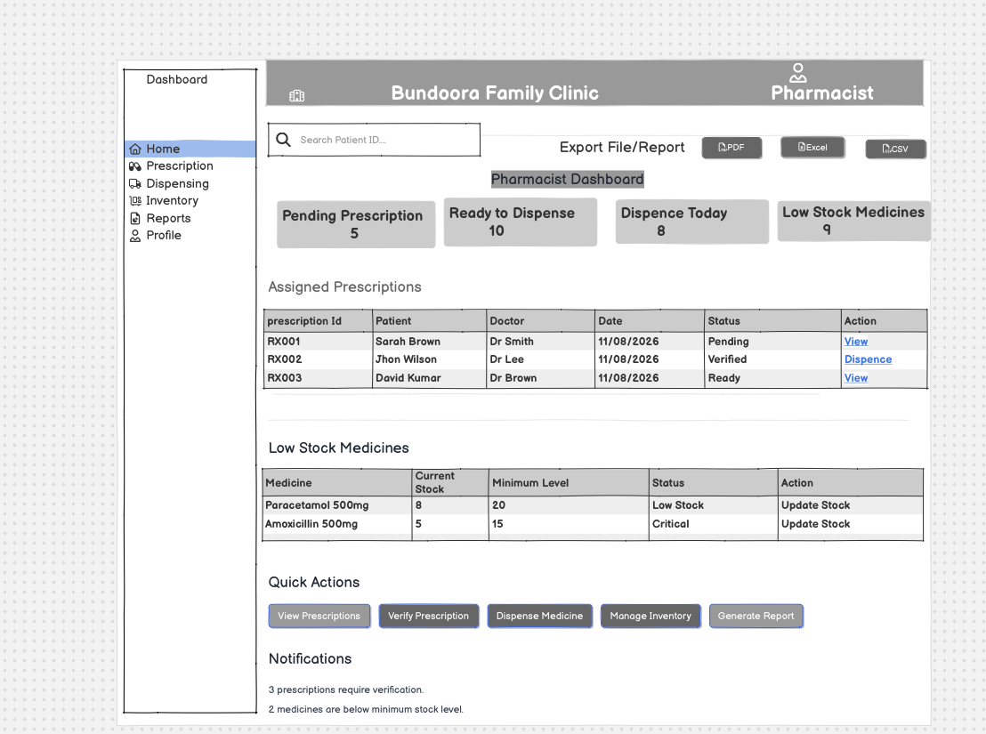

When the pharmacist selects Prescription from the navigation menu, they are directed to the Assigned Prescriptions page. The pharmacist can search by prescription ID or patient, filter prescriptions by status, view prescription details, and proceed to dispensing verified prescriptions.
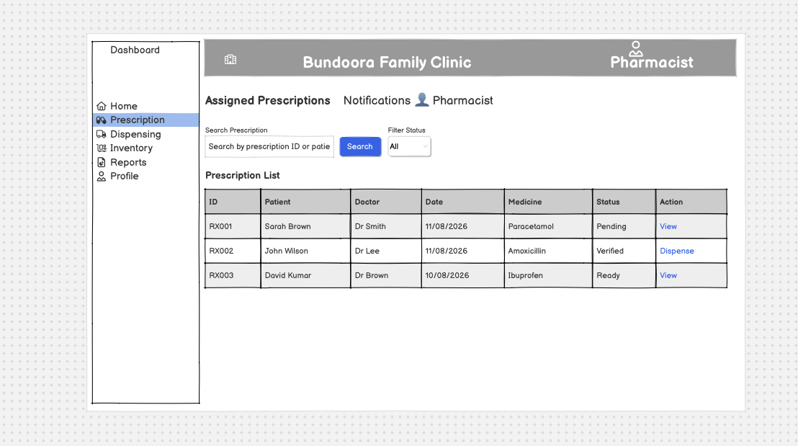

When the pharmacist selects View for a prescription, they are directed to the Prescription Verification page. The pharmacist can review the patient's information, doctor information, and prescription details including medicine, dosage, frequency, duration, and quantity before verification.
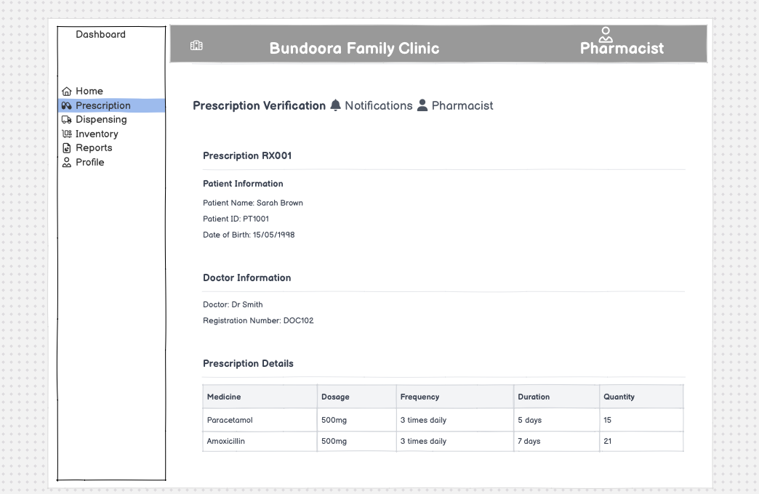

When the pharmacist selects Dispensing, they can review the selected prescription and medicine details before dispensing. The dispensing form records the batch number, expiry date, and quantity to dispense while showing the prescribed quantity and available stock.
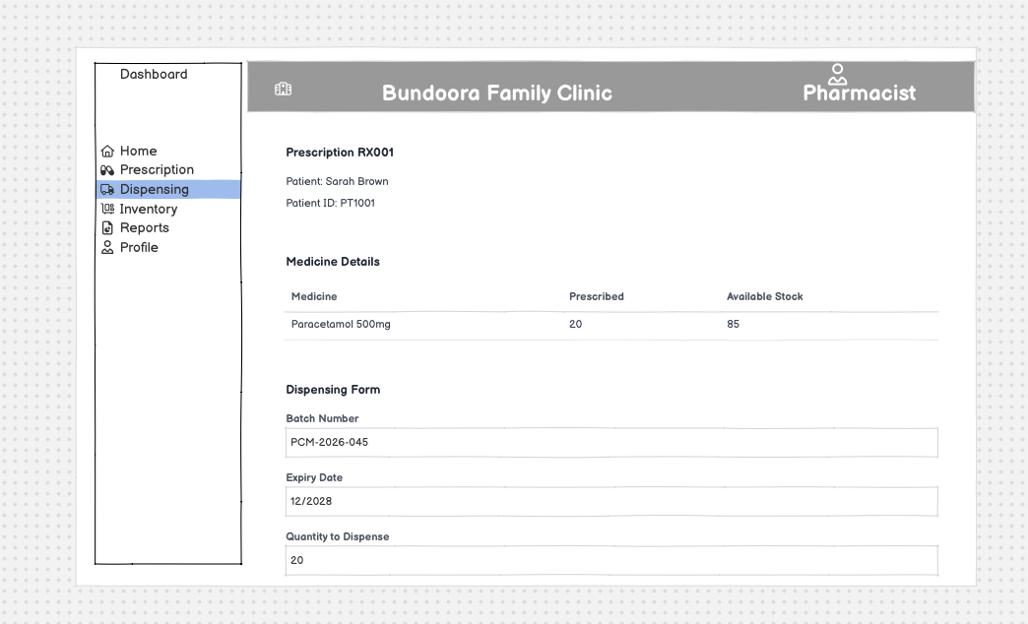

When the pharmacist selects Inventory, they are directed to the Medicine Inventory page. The pharmacist can monitor medicine stock and expiry dates, identify low-stock medicines, add new medicine, update stock, record batch and expiry information, and view stock-related alerts.
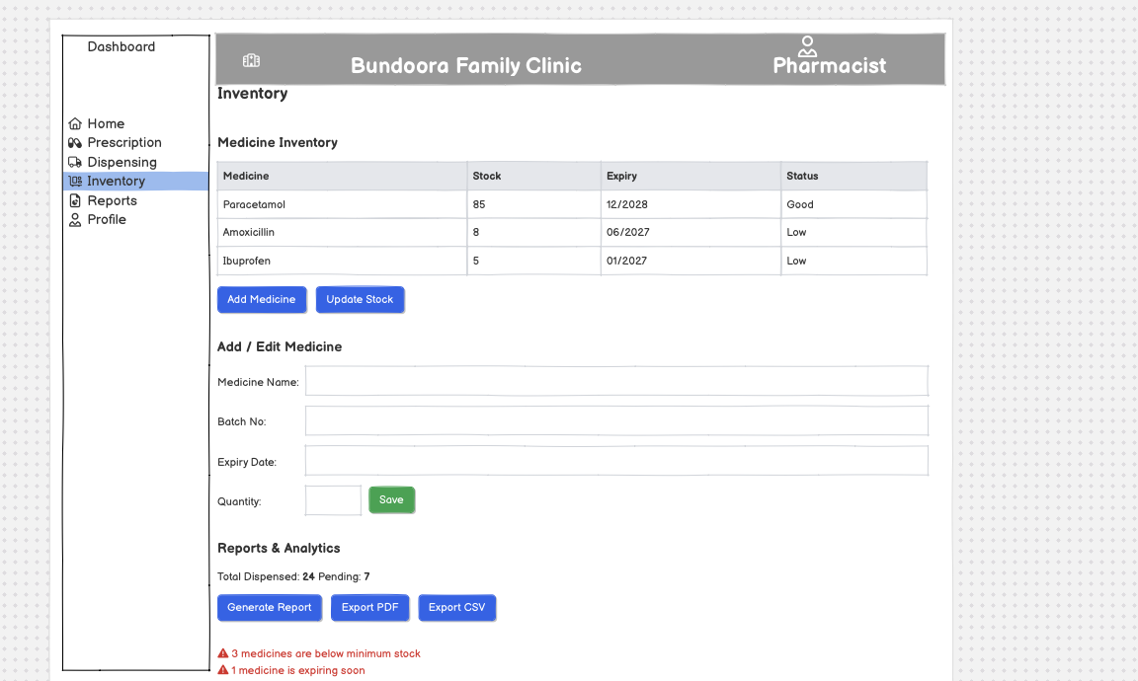

When the pharmacist selects Reports, they are directed to the Reports & Analytics page. The pharmacist can select the required report type and specify a date range for generating dispensing and inventory-related reports.
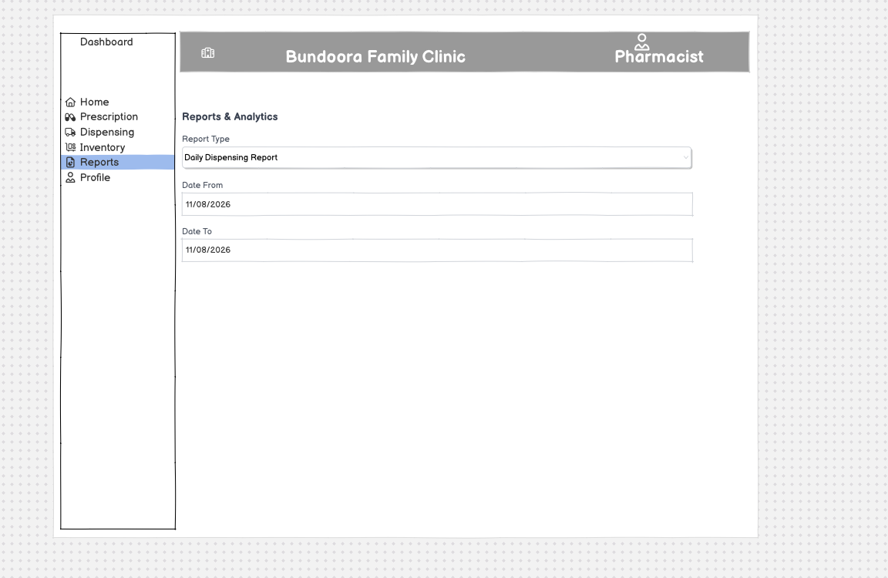

When the pharmacist selects Profile, they can view their personal and professional account information including full name, pharmacist ID, email, phone number, and role. The pharmacist can also edit their profile or change their password.
