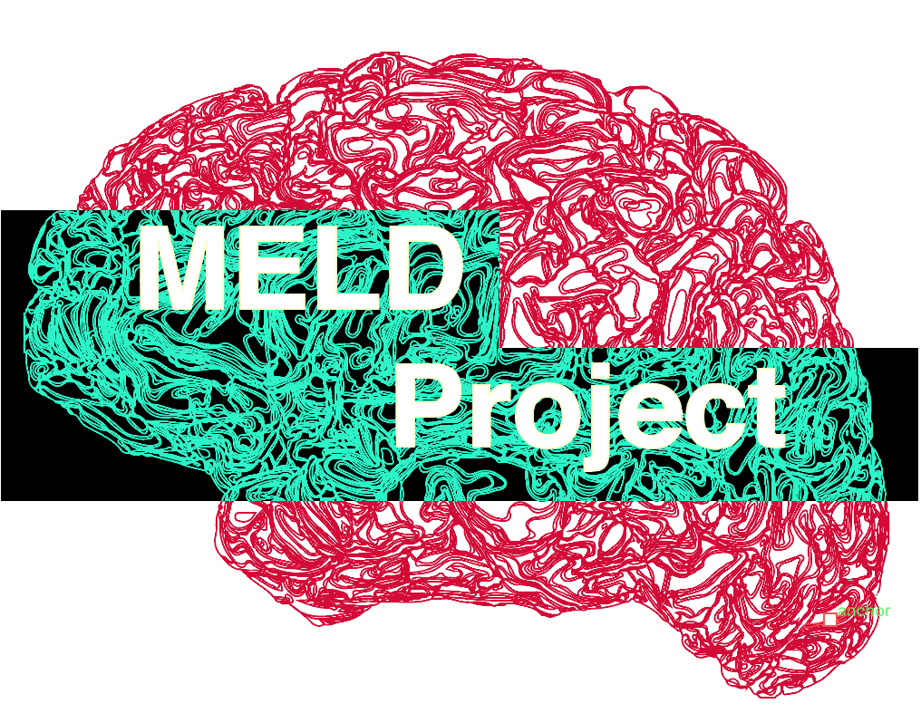**MELD Collaborator List**

**MELD Project Leads:**

**Sophie Adler-Wagstyl – UCL Great Ormond Street Institute for Child Health, UK**

**Konrad Adler-Wagstyl – University College London, UK**

**Clinical lead site: Great Ormond Street Hospital (GOSH)**

|  |  |  |
| --- | --- | --- |
| **First Name** | **Surname** | **Institute** |
| Torsten | Baldeweg | GOSH, UK |
| Martin | Tisdall | GOSH, UK |
| Helen | Cross | GOSH, UK |

**Open-science lead:**

|  |  |  |
| --- | --- | --- |
| **First Name** | **Surname** | **Institute** |
| Kirstie | Whitaker | Turing Institute, UK |

**Computational neuroscience collaborators:**

|  |  |  |
| --- | --- | --- |
| **First Name** | **Surname** | **Institute** |
| Petra | Vertes | University of Cambridge, UK |
| Jakob | Seidlitz | NIH, USA |
| Armin | Raznahan | NIH, USA |

**Deep-learning collaborator:**

|  |  |  |
| --- | --- | --- |
| **First Name** | **Surname** | **Institute** |
| Hannah | Spitzer | HMGU, Munich, Germany |

**Collaborators from clinical sites worldwide:**

|  |  |  |
| --- | --- | --- |
| **First Name** | **Surname** | **Institute** |
| Bernadette | Gaida | Greifswald Epilepsy Center, Germany |
| Felix | von Podewils | Greifswald Epilepsy Center, Germany |
| Martin | Domin | Greifswald Epilepsy Center, Germany |
| Sönke | Langner | Greifswald Epilepsy Center, Germany |
| Carmen | Pérez | Hospital del Mar, Barcelona, Spain |
| Ignacio | Delgado | Hospital del Mar, Barcelona, Spain |
| Sofia | Gonzalez Ortiz | Hospital del Mar, Barcelona, Spain |
| Fernando | Cendes | UNICAMP, Brazil |
| Clarissa | Yasuda | UNICAMP, Brazil |
| Graeme | Jackson | Florey Institute of Neuroscience and Mental Health, Australia |
| Mira | Semmelroch | Florey Institute of Neuroscience and Mental Health, Australia |
| Magdalena | Kowalczyk | Florey Institute of Neuroscience and Mental Health, Australia |
| Pasquale | Striano | Gaslini Institute, Italy |
| Domenico | Tortora | Gaslini Institute, Italy |
| Mariasavina | Severino | Gaslini Institute, Italy |
| Ilaria | Lagorio | Gaslini Institute, Italy |
| Nuria | Bargalló | Hospital Clinic of Barcelona, Spain |
| Saul | Pascual | Hospital Clinic of Barcelona, Spain |
| José | Pariente | Hospital Clinic of Barcelona, Spain |
| Anna | Calvo | Hospital Clinic of Barcelona, Spain |
| Mar | Carreño | Hospital Clinic of Barcelona, Spain |
| Maria | Caligiuri | Catanzaro, Italy |
| Angelo | Labate | Catanzaro, Italy |
| Antonio | Gambardella | Catanzaro, Italy |
| Lucy | Vivash | Royal Melbourne Hospital |
| Ben | Sinclair | Royal Melbourne Hospital |
| Patricia | Desmond | Royal Melbourne Hospital |
| Elaine | Lui | Royal Melbourne Hospital |
| Terry | O'Brien | Royal Melbourne Hospital |
| Anna | Willard | Royal Melbourne Hospital |
| Wenhan | Hu | Beijing Tiantan Hospital, China |
| Kai | Zhang | Beijing Tiantan Hospital, China |
| Jia-Jie | Mo | Beijing Tiantan Hospital, China |
| Matteo | Lenge | Children’s Meyer Hospital Anna Meyer, Florence, Italy |
| Renzo | Guerrini | Children’s Meyer Hospital Anna Meyer, Florence, Italy |
| Claudia | Antoni | Children’s Meyer Hospital Anna Meyer, Florence, Italy |
| Gavin | Winston | The National Hospital of Neurology and Neurosurgery, UK |
| John | Duncan | The National Hospital of Neurology and Neurosurgery, UK |
| Xiaozhen | You | Children’s National Health System, Washington DC, USA |
| William | Gaillard | Children’s National Health System, Washington DC, USA |
| Irene | Wang | Cleveland Clinic, USA |
| Shan | Wang | Cleveland Clinic, uSA |
| Marcus | Likeman | Bristol Children's Hospital, UK |
| Heath | Pardoe | New York, USA |
| Orrin | Devinsky | New York, USA |
| Khalid | Hamandi | CUBIC, UK |
| Shirin | Davies | CUBIC, UK |
| Reetta | Kalviainen | Kuopia, Finland |
| Yawu | Liu | Kuopia, Finland |
| Stephen | Foldes |  |
| Petr | Marusic |  |
| Vlastimil | Sulc |  |
| Serge | Vulliemoz | Geneva University Hospital, Switzerland |
| Christian | Rummel |  |
| Ekhum | Shamshiri | Geneva University Hospital, Switzerland |
| Jonathan | O'Muircheartaigh | Kings College London, UK |
| Alexander | Weil | Universite de Montreal, Canada |
| Lars | Pinborg | Copenhagen University Hospital, Rigshospitalet, Denmark |
| Giske | Opheim | Copenhagen University Hospital, Rigshospitalet, Denmark |
| Jay | Shetty | Edinburgh, UK |
| Camilla | Rossi Espagnet |  |
| Antonio | Napolitano |  |
| Luca | De Palma |  |
| Alessandro | De Benedictis |  |