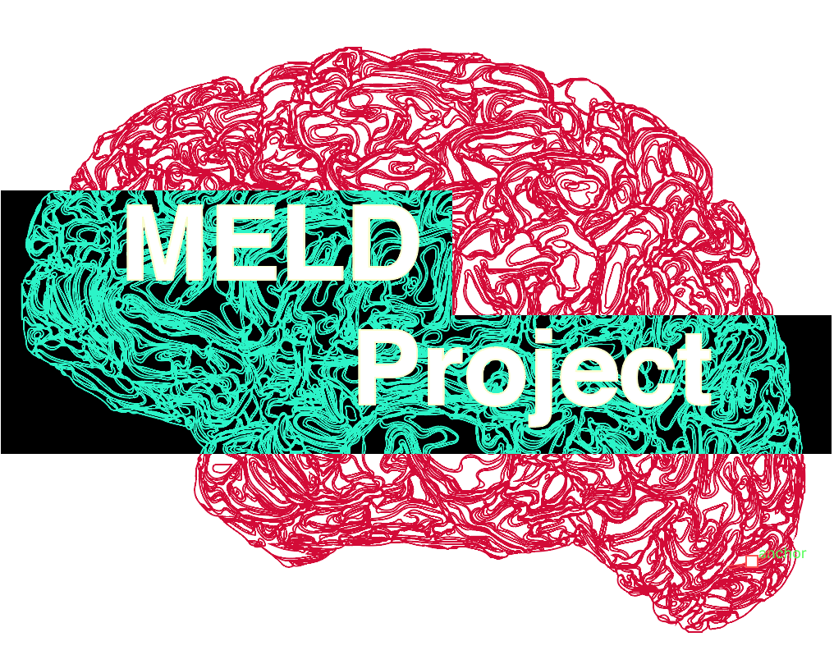
MELD Collaborator List

MELD Project Leads:
Sophie Adler-Wagstyl – UCL Great Ormond Street Institute for Child Health, UK
Konrad Adler-Wagstyl – Biomedical Engineering and Imaging Sciences, King’s College London, UK

MELD Team:
First Name | Surname | Institute
Mathilde | Ripart | King’s College London, UK
Jieun | Seo | UCL Great Ormond Street Institute for Child Health, UK

Computational neuroscience & bioinformatics collaborators:
First Name | Surname | Institute
Petra | Vertes | University of Cambridge, UK
Jakob | Seidlitz | NIH, USA
Armin | Raznahan | NIH, USA
Andrew A | Chen | University of Pennsylvania, USA
Russell T | Shinohara | University of Pennsylvania, USA

Deep-learning collaborators:
First Name | Surname | Institute
Hannah | Spitzer | HMGU, Munich, Germany
Fabian | Theis | Helmholtz Center Munich, Germany
Juan Eugenio | Iglesias | Massachusetts General Hospital & Harvard Medical School, USA
Emma | Robinson | King’s College London, UK
Abdulah | Fawaz | King’s College London, UK
Logan | Williams | King’s College London, UK

Open-science lead:
First Name | Surname | Institute
Kirstie | Whitaker | Turing Institute, UK

Clinical lead site: Great Ormond Street Hospital (GOSH)
First Name | Surname | Institute
Torsten | Baldeweg | GOSH, UK
Martin | Tisdall | GOSH, UK
Helen | Cross | GOSH, UK
Aswin | Chari | GOSH, UK
Kshitij | Mankad | GOSH, UK
Felice | D’Arco | GOSH, UK
Rory | Piper | GOSH, UK
Maria | Eriksson | GOSH, UK

MELD Focal Epilepsies Dataset Collaborators:

First Name | Surname | Institute
Costanza | Parodi | IRCCS Istituto Giannina Gaslini, Genova, Italy
Mariasavina | Severino | IRCCS Istituto Giannina Gaslini, Genova, Italy
Domenico | Tortora | IRCCS Istituto Giannina Gaslini, Genova, Italy
Giulia | Nobile | IRCCS Istituto Giannina Gaslini, Genova, Italy
Alessandro | Consales | IRCCS Istituto Giannina Gaslini, Genova, Italy
Antonella | Riva | IRCCS Istituto Giannina Gaslini, Genova, Italy
Callum | Simpson | Newcastle University, Newcastle upon Tyne, UK
Yujiang | Wang | Newcastle University, Newcastle upon Tyne, UK
Peter | Taylor | Newcastle University, Newcastle upon Tyne, UK
Jane | de Tisi | UCL Queen Square Institute of Neurology, London, UK
John | Duncan | UCL Queen Square Institute of Neurology, London, UK
Antonio | Gambardella | University Magna Graecia of Catanzaro, Catanzaro, Italy
Maria Eugenia | Caligiuri | University Magna Graecia of Catanzaro, Catanzaro, Italy
Francesco | Fortunato | University Magna Graecia of Catanzaro, Catanzaro, Italy
Maria Celeste | Bonacci | University Magna Graecia of Catanzaro, Catanzaro, Italy
Ilaria | Sammarra | University Magna Graecia of Catanzaro, Catanzaro, Italy
Renzo | Guerrini | Meyer Children's Hospital IRCCS, Florence, Italy
Matteo | Lenge | Meyer Children's Hospital IRCCS, Florence, Italy
Carmen | Barba | Meyer Children's Hospital IRCCS, Florence, Italy
Clarissa | Yasuda | UNICAMP University of Campinas, Campinas, Brasil
Lucas | Scárdua-Silva | UNICAMP University of Campinas, Campinas, Brasil
Marina | Alvim | UNICAMP University of Campinas, Campinas, Brasil
Fernando | Cendes | UNICAMP University of Campinas, Campinas, Brasil
Jiajie | Mo | Beijing Tiantan Hospital, Beijing, China
Kai | Zhang | Beijing Tiantan Hospital, Beijing, China
Jose | Pariente | Fundació de Recerca Clínic Barcelona, Institut, Spain
Sofia | González-Ortiz | Fundació de Recerca Clínic Barcelona, Institut, Spain
Nuria | Bargalló | Fundació de Recerca Clínic Barcelona, Institut, Spain
Marcus | Likeman | Bristol Royal Hospital for Children, Bristol, UK
Ting-Yu | Su | Cleveland Clinic, Cleveland, OH, US
Ryuzaburo | Kochi | Cleveland Clinic, Cleveland, OH, US
Irene | Wang | Cleveland Clinic, Cleveland, OH, US
Reeta | Kalviainen | Kuopio University Hospital and University of Eastern Finland, Kuopio, Finland
Yawu | Liu | Kuopio University Hospital and University of Eastern Finland, Kuopio, Finland
Philip | Sequeiros-Peggs | University Hospital of Wales, Cardiff, UK
James | Galea | University Hospital of Wales, Cardiff, UK
Khalid | Hamandi | University Hospital of Wales, Cardiff, UK
Venkata Sita Priyanka | Illapani | Center for Neuroscience, Children's National Hospital, US
Hua | Xie | Center for Neuroscience, Children's National Hospital, US
Nathan | Cohen | Center for Neuroscience, Children's National Hospital, US
William | Gaillard | Center for Neuroscience, Children's National Hospital, US
Alexander | Weil | CHU Sainte-Justine, Montreal, Quebec, Canada
Aristides | Hadjinicolaou | CHU Sainte-Justine, Montreal, Quebec, Canada
Kenza | Lahlou | CHU Sainte-Justine, Montreal, Quebec, Canada
Florence | Henrichon-Goulet | CHU Sainte-Justine, Montreal, Quebec, Canada
Antonio | Napolitano | Bambino Gesù children's hospital, IRCCS, Rome, Italy
Luca | De Palma | Bambino Gesù children's hospital, IRCCS, Rome, Italy
Alessandro | De Benedictis | Bambino Gesù children's hospital, IRCCS, Rome, Italy
Maria Camilla | Rossi-Espagnet | Bambino Gesù children's hospital, IRCCS, Rome, Italy
Siby | Gopinath | Amrita Advanced Centre for Epilepsy (AACE), Amrita Institute of Medical Sciences, Amrita Vishwa Vidyapeetham, Kochi, Kerala, India
Harilal | Parasuram | Amrita Advanced Centre for Epilepsy (AACE), Amrita Institute of Medical Sciences, Amrita Vishwa Vidyapeetham, Kochi, Kerala, India
David | Vaughan | Florey Institute of Neuroscience and Mental Health, Melbourne, Australia
Donna | Parker | Florey Institute of Neuroscience and Mental Health, Melbourne, Australia
Graeme | Jackson | Florey Institute of Neuroscience and Mental Health, Melbourne, Australia
Heath | Pardoe | Florey Institute of Neuroscience and Mental Health, Melbourne, Australia
Surges | Rainer | University Hospital Bonn, Bonn, Germany
Lange | Annalena | University Hospital Bonn, Bonn, Germany
Bauer | Tobias | University Hospital Bonn, Bonn, Germany
Theodor | Rüber | University Hospital Bonn, Bonn, Germany
Adrián | Valls Carbó | Ruber International Hospital, Madrid, Spain
Rafael | Toledano | Ruber International Hospital, Madrid, Spain
Gonzalo | Rojas-Costa | Advanced Epilepsy Center, Clínica las Condes, Santiago, Chile
Agustín | Ibáñez | Latin America Brain Health Institute (BrainLat), Universidad Adolfo Ibanez, Chile
Joshua | Pepper | Birmingham Women's and Children's NHS Foundation Trust, Birmingham, UK
Stefano | Seri | Birmingham Women's and Children's NHS Foundation Trust, Birmingham, UK
Marcel | Heers | University Hospital Freiburg, Freiburg Germany
Horst | Urbach | University Hospital Freiburg, Freiburg Germany
Lara | Bücheler | University Hospital Freiburg, Freiburg Germany
Georgian | Ciobotaru | Central Emergency Military Hospital, Bucarest, Romania
Lillian | Lai | University of Iowa Health care, Iowa City, Iowa
Natally | Alarab | University of Iowa Health care, Iowa City, Iowa
Sedat | Kandemirli | University of Iowa Health care, Iowa City, Iowa
Pascal | Martin | University of Tübingen, Tübingen, Germany
Cornelius | Kronlage | University of Tübingen, Tübingen, Germany
Jonathan | O'Muircheartaigh | Kings College London, UK
Katy | Vecchiato | Kings College London, UK
Nandini | Mullatti | Kings College London, UK
Julien | Jung | CHU Lyon, Lyon, France
Marian | Galovic | University Hospital and University of Zurich, Switzerland
Robert | Terziev | University Hospital and University of Zurich, Switzerland
Kai Michael | Schubert | University Hospital and University of Zurich, Switzerland
Nicolin | Hainc | University Hospital and University of Zurich, Switzerland
Anna | Willard | Department of Neuroscience, Monash University, Melbourne, Australia
Ben | Sinclair | Department of Neuroscience, Monash University, Melbourne, Australia
Terence | O'Brien | Department of Neuroscience, Monash University, Melbourne, Australia
Lucy | Vivash | Department of Neuroscience, Monash University, Melbourne, Australia
Georgia | Ramantani | University Childrens Hospital Zurich, Switzerland
Antonio | Gennari | University Childrens Hospital Zurich, Switzerland
Ruth | Tuura O'Gorman | University Childrens Hospital Zurich, Switzerland
Michael | Hart | St George’s University Hospital, London, UK
Kostakis | Gkiatis | Epilepsy Centre, St. Luke's Hospital, Thessaloniki, Greece
Kyriakos | Garganis | Epilepsy Centre, St. Luke's Hospital, Thessaloniki, Greece
Nikolaos | Kondylidis | Epilepsy Centre, St. Luke's Hospital, Thessaloniki, Greece
Kate | Davis | Department of Neurology, University of Pennsylvania, US
Joel | Stein | Department of Radiology, University of Pennsylvania, US
Nishant | Sinha | Department of Neurology, University of Pennsylvania, US
Mariam | Josyula | Department of Neurology, University of Pennsylvania, US
Ben | Brinkmann | Mayo Clinic, USA
Daichi | Sone | Department of Radiology, National Center of Neurology and Psychiatry, Tokyo, Japan
Noriko | Sato | Department of Radiology, National Center of Neurology and Psychiatry, Tokyo, Japan
Hiroyuki | Maki | Department of Radiology, National Center of Neurology and Psychiatry, Tokyo, Japan
Tomoteru | Imokawa | Department of Radiology, National Center of Neurology and Psychiatry, Tokyo, Japan
Hiroshi | Shirozu | Functional Neurosurgery Center, Fukuoka Sanno Hospital, Japan
Guy | Dunetz | University at Buffalo Neurosurgery (UBNS), USA
Ingeborg | Lopez | Department of Neuroradiology, Neurosurgery Institute Dr. A. Asenjo, Santiago, Chile
Francisco | Sepulveda | Department of Neuroradiology, Neurosurgery Institute Dr. A. Asenjo, Santiago, Chile
Daniel | Mansilla | Department of Neuroradiology, Neurosurgery Institute Dr. A. Asenjo, Santiago, Chile
Andres | Goycoolea | Department of Neuroradiology, Neurosurgery Institute Dr. A. Asenjo, Santiago, Chile
Ed | Hogan | Department of Neurology, Washington University School of Medicine
Luigi | Maccotta | Department of Neurology, Washington University School of Medicine
Gavin | Winston | Queen's University, Kingston, Canada
Matthew | Suppa Modrusan | Queen's University, Kingston, Canada

MELD Focal Cortical Dysplasia Dataset Collaborators:
First Name | Surname | Institute
Carmen | Pérez | Hospital del Mar, Barcelona, Spain
Ignacio | Delgado | Hospital del Mar, Barcelona, Spain
Sofia | Gonzalez Ortiz | Hospital del Mar, Barcelona, Spain
Fernando | Cendes | UNICAMP, Brazil
Clarissa | Yasuda | UNICAMP, Brazil
Laeticia | Ribeiro | UNICAMP, Brazil
Graeme | Jackson | Florey Institute of Neuroscience and Mental Health, Australia
Mira | Semmelroch | Florey Institute of Neuroscience and Mental Health, Australia
Pasquale | Striano | Gaslini Institute, Italy
Domenico | Tortora | Gaslini Institute, Italy
Mariasavina | Severino | Gaslini Institute, Italy
Ilaria | Lagorio | Gaslini Institute, Italy
Nuria | Bargalló | Hospital Clinic of Barcelona, Spain
Saul | Pascual-Diaz | Hospital Clinic of Barcelona, Spain
José Carlos | Pariente | Hospital Clinic of Barcelona, Spain
Estefania | Conde-Blanco | Hospital Clinic of Barcelona, Spain
Maria Eugenia | Caligiuri | Magna Graecia University, Catanzaro, Italy
Angelo | Labate | Magna Graecia University, Catanzaro, Italy
Antonio | Gambardella | Magna Graecia University, Catanzaro, Italy
Lucy | Vivash | Royal Melbourne Hospital, Australia
Ben | Sinclair | Royal Melbourne Hospital, Australia
Patricia | Desmond | Royal Melbourne Hospital, Australia
Elaine | Lui | Royal Melbourne Hospital, Australia
Terry | O'Brien | Royal Melbourne Hospital, Australia
Anna | Willard | Royal Melbourne Hospital, Australia
Wenhan | Hu | Beijing Tiantan Hospital, China
Kai | Zhang | Beijing Tiantan Hospital, China
Jia-Jie | Mo | Beijing Tiantan Hospital, China
Matteo | Lenge | Meyer Children’s Hospital, Florence, Italy
Renzo | Guerrini | Meyer Children’s Hospital, Florence, Italy
Carmen | Barba | Meyer Children’s Hospital, Florence, Italy
Gavin P | Winston | The National Hospital of Neurology and Neurosurgery, UK
John | Duncan | The National Hospital of Neurology and Neurosurgery, UK
Xiaozhen | You | Children’s National, Washington DC, USA
William D | Gaillard | Children’s National, Washington DC, USA
Nathan T | Cohen | Children’s National, Washington DC, USA
Irene | Wang | Cleveland Clinic, USA
Ryuzaburo | Kochi | Cleveland Clinic, USA
Yingying | Tang | Cleveland Clinic, USA
Marcus | Likeman | Bristol Children's Hospital, UK
Khalid | Hamandi | CUBRIC, UK
Shirin | Davies | CUBRIC, UK
Reetta | Kalviainen | Kuopio University Hospital and University of Eastern Finland, Kuopio, Finland
Yawu | Liu | Kuopio University Hospital and University of Eastern Finland, Kuopio, Finland
Stephen | Foldes | Barrow Neurological Institute at Phoenix Children’s Hospital, USA
Zachary | Humphreys | Barrow Neurological Institute at Phoenix Children’s Hospital, USA
Jonathan | O'Muircheartaigh | Kings College London, UK
Katy | Vecchiato | Kings College London, UK
Nandini | Mullatti | Kings College London, UK
Eugenio | Abela | Kings College London, UK
Lars | Pinborg | Copenhagen University Hospital, Rigshospitalet, Denmark
Giske | Opheim | Copenhagen University Hospital, Rigshospitalet, Denmark
Ane G | Kloster | Copenhagen University Hospital, Rigshospitalet, Denmark
Jay | Shetty | Royal Hospital for Sick Children Edinburgh
Ailsa | McLellan | Royal Hospital for Sick Children Edinburgh
Jothy | Kandasamy | Royal Hospital for Sick Children Edinburgh
Drahoslav | Sokol | Royal Hospital for Sick Children Edinburgh
Antonio | Napolitano | IRCCS Bambino Gesù Children's Hospital, Rome, Italy
Luca | De Palma | IRCCS Bambino Gesù Children's Hospital, Rome, Italy
Alessandro | De Benedictis | IRCCS Bambino Gesù Children's Hospital, Rome, Italy
Camilla | Rossi-Espagnet | IRCCS Bambino Gesù Children's Hospital, Rome, Italy
Christopher | Güttler | Charité University Hospital Berlin, Germany
Anna | Tietze | Charité University Hospital Berlin, Germany
Terence | O’Brien | Monash University, Melbourne, Australia
Rafael Toledano | Delgado | Ruber International Hospital and Ramon y Cajal University Hospital, Madrid, Spain
Lennart | Walger | University of Bonn Medical Center, Bonn, Germany
Theodor | Ruber | University of Bonn Medical Center, Bonn, Germany

