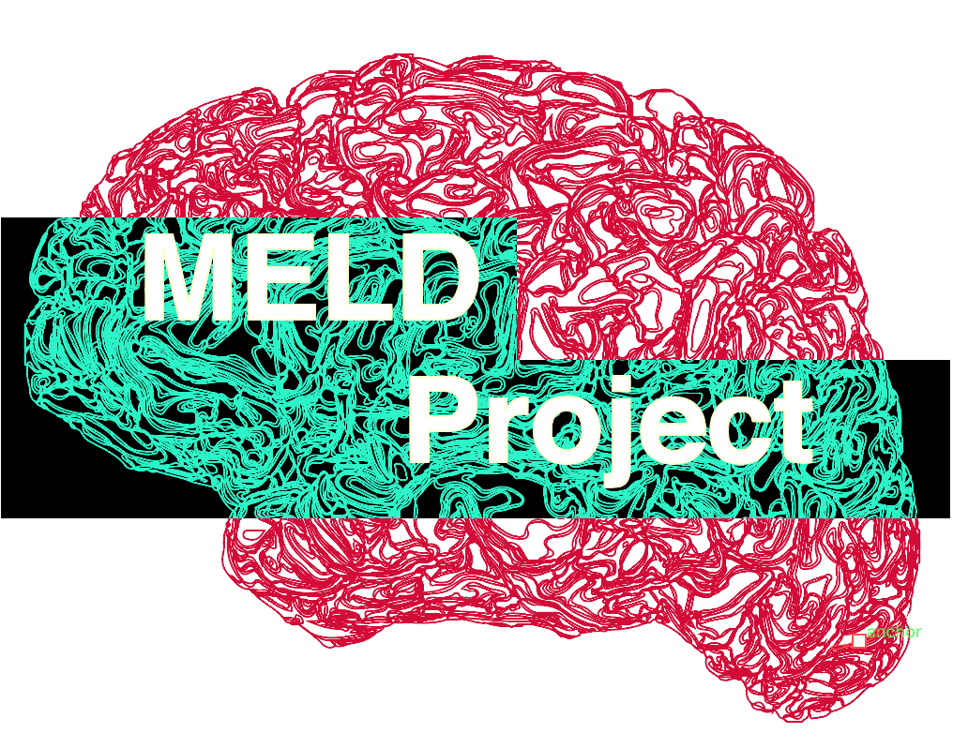**MELD Collaborator List**

**MELD Project Leads:**

**Sophie Adler-Wagstyl – UCL Great Ormond Street Institute for Child Health, UK**

**Konrad Adler-Wagstyl – Wellcome Centre for Human Neuroimaging, UCL, UK**

**UCL MELD Team:**

|  |  |  |
| --- | --- | --- |
| **First Name** | **Surname** | **Institute** |
| Mathilde | Ripart | UCL Great Ormond Street Institute for Child Health, UK |
| Maria | Eriksson | UCL Great Ormond Street Institute for Child Health, UK |
| Niccolo | McConnell | Wellcome Centre for Human Neuroimaging, UCL, UK |

**Computational neuroscience & bioinformatics collaborators:**

|  |  |  |
| --- | --- | --- |
| **First Name** | **Surname** | **Institute** |
| Petra | Vertes | University of Cambridge, UK |
| Jakob | Seidlitz | NIH, USA |
| Armin | Raznahan | NIH, USA |
| Andrew A | Chen | University of Pennsylvania, USA |
| Russell T | Shinohara | University of Pennsylvania, USA |

**Deep-learning collaborators:**

|  |  |  |
| --- | --- | --- |
| **First Name** | **Surname** | **Institute** |
| Hannah | Spitzer | HMGU, Munich, Germany |
| Fabian | Theis | Helmholtz Center Munich, Germany |
| Juan Eugenio | Iglesias | Massachusetts General Hospital & Harvard Medical School, USA |
| Emma | Robinson | King’s College London, UK |
| Abdulah | Fawaz | King’s College London, UK |
| Logan | Williams | King’s College London, UK |

**Open-science lead:**

|  |  |  |
| --- | --- | --- |
| **First Name** | **Surname** | **Institute** |
| Kirstie | Whitaker | Turing Institute, UK |

**Clinical lead site: Great Ormond Street Hospital (GOSH)**

|  |  |  |
| --- | --- | --- |
| **First Name** | **Surname** | **Institute** |
| Torsten | Baldeweg | GOSH, UK |
| Martin | Tisdall | GOSH, UK |
| Helen | Cross | GOSH, UK |
| Aswin | Chari | GOSH, UK |
| Kshitij | Mankad | GOSH, UK |
| Felice | D’Arco | GOSH, UK |

**Collaborators from clinical sites worldwide:**

|  |  |  |
| --- | --- | --- |
| **First Name** | **Surname** | **Institute** |
| Carmen | Pérez | Hospital del Mar, Barcelona, Spain |
| Ignacio | Delgado | Hospital del Mar, Barcelona, Spain |
| Sofia | Gonzalez Ortiz | Hospital del Mar, Barcelona, Spain |
| Fernando | Cendes | UNICAMP, Brazil |
| Clarissa | Yasuda | UNICAMP, Brazil |
| Laeticia | Ribeiro | UNICAMP, Brazil |
| Graeme | Jackson | Florey Institute of Neuroscience and Mental Health, Australia |
| Mira | Semmelroch | Florey Institute of Neuroscience and Mental Health, Australia |
| Pasquale | Striano | Gaslini Institute, Italy |
| Domenico | Tortora | Gaslini Institute, Italy |
| Mariasavina | Severino | Gaslini Institute, Italy |
| Ilaria | Lagorio | Gaslini Institute, Italy |
| Nuria | Bargalló | Hospital Clinic of Barcelona, Spain |
| Saul | Pascual-Diaz | Hospital Clinic of Barcelona, Spain |
| José Carlos | Pariente | Hospital Clinic of Barcelona, Spain |
| Estefania | Conde-Blanco | Hospital Clinic of Barcelona, Spain |
| Maria Eugenia | Caligiuri | Magna Graecia University, Catanzaro, Italy |
| Angelo | Labate | Magna Graecia University, Catanzaro, Italy |
| Antonio | Gambardella | Magna Graecia University, Catanzaro, Italy |
| Lucy | Vivash | Royal Melbourne Hospital, Australia |
| Ben | Sinclair | Royal Melbourne Hospital, Australia |
| Patricia | Desmond | Royal Melbourne Hospital, Australia |
| Elaine | Lui | Royal Melbourne Hospital, Australia |
| Terry | O'Brien | Royal Melbourne Hospital, Australia |
| Anna | Willard | Royal Melbourne Hospital, Australia |
| Wenhan | Hu | Beijing Tiantan Hospital, China |
| Kai | Zhang | Beijing Tiantan Hospital, China |
| Jia-Jie | Mo | Beijing Tiantan Hospital, China |
| Matteo | Lenge | Meyer Children’s Hospital, Florence, Italy |
| Renzo | Guerrini | Meyer Children’s Hospital, Florence, Italy |
| Carmen | Barba | Meyer Children’s Hospital, Florence, Italy |
| Gavin P | Winston | The National Hospital of Neurology and Neurosurgery, UK |
| John | Duncan | The National Hospital of Neurology and Neurosurgery, UK |
| Xiaozhen | You | Children’s National, Washington DC, USA |
| William D | Gaillard | Children’s National, Washington DC, USA |
| Nathan T | Cohen | Children’s National, Washington DC, USA |
| Irene | Wang | Cleveland Clinic, USA |
| Ryuzaburo | Kochi | Cleveland Clinic, USA |
| Yingying | Tang | Cleveland Clinic, USA |
| Marcus | Likeman | Bristol Children's Hospital, UK |
| Khalid | Hamandi | CUBRIC, UK |
| Shirin | Davies | CUBRIC, UK |
| Reetta | Kalviainen | Kuopio University Hospital and University of Eastern Finland, Kuopio, Finland |
| Yawu | Liu | Kuopio University Hospital and University of Eastern Finland, Kuopio, Finland |
| Stephen | Foldes | Barrow Neurological Institute at Phoenix Children’s Hospital, USA |
| Zachary | Humphreys | Barrow Neurological Institute at Phoenix Children’s Hospital, USA |
| Jonathan | O'Muircheartaigh | Kings College London, UK |
| Katy | Vecchiato | Kings College London, UK |
| Nandini | Mullatti | Kings College London, UK |
| Eugenio | Abela | Kings College London, UK |
| Lars | Pinborg | Copenhagen University Hospital, Rigshospitalet, Denmark |
| Giske | Opheim | Copenhagen University Hospital, Rigshospitalet, Denmark |
| Ane G | Kloster | Copenhagen University Hospital, Rigshospitalet, Denmark |
| Jay | Shetty | Royal Hospital for Sick Children Edinburgh |
| Ailsa | McLellan | Royal Hospital for Sick Children Edinburgh |
| Jothy | Kandasamy | Royal Hospital for Sick Children Edinburgh |
| Drahoslav | Sokol | Royal Hospital for Sick Children Edinburgh |
| Antonio | Napolitano | IRCCS Bambino Gesù Children's Hospital, Rome, Italy |
| Luca | De Palma | IRCCS Bambino Gesù Children's Hospital, Rome, Italy |
| Alessandro | De Benedictis | IRCCS Bambino Gesù Children's Hospital, Rome, Italy |
| Camilla | Rossi-Espagnet | IRCCS Bambino Gesù Children's Hospital, Rome, Italy |
| Christopher | Güttler | Charité University Hospital Berlin, Germany |
| Anna | Tietze | Charité University Hospital Berlin, Germany |
| Terence | O’Brien | Monash University, Melbourne, Australia |
| Rafael Toledano | Delgado | Ruber International Hospital and Ramon y Cajal University Hospital, Madrid, Spain |
| Lennart | Walger | University of Bonn Medical Center, Bonn, Germany |
| Theodor | Ruber | University of Bonn Medical Center, Bonn, Germany |

* Collaborators from clinical sites are listed if they have contributed data